

Software Testing of React Components in a Small to Medium Enterprise (SME)

by
Gemma Melanie Dunlop (1801285)

Supervisor: Dr Michael Dacey
Second Marker: Gaynor Thomas

Project submitted as part of the requirements for the award of
MSc Software Engineering

September 2022

ABSTRACT
The aim of this project was to investigate different React software testing approaches and design a testing strategy which is most efficient for a Small to Medium Enterprise (SME) and implementing this strategy on an application for a real life company called Vortex IoT. The project aimed at suggesting a recommended testing strategy to help SMEs decide which approach to use. Fowler’s testing pyramid was explored – which describes three testing strategies: unit testing, integration testing, and end-to-end testing. Testing approaches were compared and contrasted to help design the testing strategy. Qualitative testing was conducted within the company to explore the weaknesses of the current testing strategy used at Vortex IoT, and suggestions of how to improve the testing approach were taken into consideration. The literature review along with performance testing showed that the best testing approach involved the use of Jest for unit testing as it is the simplest approach and can be used as a test runner, assertion library and a mocking library. Enzyme was used for shallow rendering as the majority of component tests can be moved from the end-to-end level to the unit level. This resulted in a faster testing suite, allowing for unit tests to be continuously executed, and the feedback loop was tighter for developers.

DECLARATION

I, Gemma Melanie Dunlop declare that I am the sole author of this Project; that all references cited have been consulted; that I have conducted all work of which this is a record, and that the finished work lies within the prescribed word limits.

This work has not previously been accepted as part of any other degree submission.

Signed : Gemma Melanie Dunlop

Date : 7th September 2022

FORM OF CONSENT

I Gemma Melanie Dunlop hereby consent that my Project, submitted in candidature for the M.Sc. Software Engineering degree, if successful, may be made available for inter-library loan or photocopying (subject to the law of copyright), and that the title and abstract may be made available to outside organisations.

Signed : Gemma Melanie Dunlop

Date : 7th September 2022

TABLE OF CONTENTS
1. ABSTRACT 1
2. DECLARATION 2
3. TABLE OF CONTENTS 4
Table of Figures 7
Table of Tables 9
4. INTRODUCTION 10
4.1. Background 10
4.2. Rationale 11
4.3. Aim and objectives 11
4.1.1. Aim 11
4.1.2. Objectives 11
4.1.3. Problem Analysis 12
4.4. Contribution of the research 12
4.5. Structure of dissertation 12
5. LITERATURE REVIEW 14
5.1. ReactJS Library 14
5.2. Software testing 15
5.2.1. Manual testing 15
5.2.2. Automation testing 16
5.3. Testing levels 16
5.3.1. Unit Testing 17
5.3.2. Integration Testing 17
5.3.3. System Testing (End-to-End Testing) 18
5.4. Unit Testing 18
5.4.1. Jest Vs Mocha 19
The most popular libraries are Jest and Mocha. This section compares the two libraries. 19
Mocha is a JavaScript testing framework which functions on Node.js and within the browser. It is intended for testing synchronous and asynchronous applications and has a very basic interface [29]. 19
Mocha is an established testing framework that has existed for many years. It has a significant user base and is serviced well. Jest is a relatively new technology. It has many of the same characteristics as Mocha as well as some distinct benefits [30]. 19
Jest makes use of Jasmine 2 as its default for assertions and mocking, as well as having its own mocking methods [31]. On the other hand, Mocha is more adaptable, and components can be chosen according to preferences and requirements of the developer. It is compatible with the usage of any other assertions or mock library, such as Chai or Sinon.JS. 19
Some people claim that installing, setting up, and configuring Jest tests is a simpler process than doing so with Mocha. That is likely true given that Mocha requires additional setup, such as the installation of an assertion library, in contrast to Jest, which has everything in a single package. However, this should not be the decisive factor since the amount of work required is really low. 19
When compared to Jest, the level of difficulty associated with using Mocha is somewhat higher [30]. Jest is intended to be user-friendly and uncomplicated, but Mocha has a wider variety of configuration choices and may be more challenging to master. However, once it is mastered, mocha can be very powerful. 19
Additionally, Jest is a lot quicker than Mocha. It includes support for snapshot testing built in, which means that tests are automatically executed whenever there is a change to the code. This makes it simple for most recent versions of tests to be maintained as the project is worked on. 20
The official documentation for React recommends using Jest as a test runner and testing framework. Currently the Vortex Component Library uses Jest, whilst it is possible to use Mocha instead, continuing to use Jest seems to be simpler for the development team and more suitable for a SME, where less complex features are required. 20
5.4.2. Test runner 20
5.4.3. Mocking Library 20
5.4.4. Assertion library 20
5.4.5. Snapshot testing 21
5.5. Integration Testing 21
5.5.1. Comparing Mount Rendering and Shallow Mount Rendering 21
5.5.2. Assessing the Value of Test Automation of React Components within an SME 22
6. RESEARCH AND DEVELOPMENT METHODOLOGY 24
6.1. Research Methodology 24
6.1.1. Research Philosophy – Positivist or phenomenological 24
6.1.2. Research Approach – Deductive vs inductive 24
6.1.3. Research strategy 25
6.1.4. Limitations 26
6.2. Development Methodology 26
6.2.1. Preamble 26
6.2.2. Software Development Methodology 26
7. DESIGN AND IMPLEMENTATION 28
7.1. Design 28
7.1.1. Design Decisions of Vortex Component Library 28
7.2. Implementation 29
7.2.1. Project setup 29
7.2.2. Package.json 31
7.3. Testing 34
7.3.1. UI Testing with Storybook 35
7.3.2. Unit Testing with Jest 39
7.3.3. Shallow Rendering with Enzyme 44
8. RESULTS 46
Performance comparison of tests 46
Integrating alternative testing strategy 46
9. CONCLUSION AND FUTURE WORK 49
10. REFLECTION 50
11. REFERENCES 51

Table of Figures
Figure 1: Testing Pyramid [17]. 17
Figure 2: Application file structure. 30
Figure 3: rollup.config.js 31
Figure 4: package.json configuration. 32
Figure 5: package.json rollup script. 32
Figure 6: dist folder. 32
Figure 7: .gitignore file 32
Figure 8: Package.json updated for the GitHub package. 33
Figure 9: .npmrc file 33
Figure 10: write.packages option for personal access token. 34
Figure 11: vortexcomponentlibrary package. 34
Figure 12: src/components 35
Figure 13: Hello World component. 35
Figure 14: stories folder. 36
Figure 15: HelloWorld story. 36
Figure 16: FancyTable component. 37
Figure 17: Importing two components within one story. 37
Figure 18: Sample data. 38
Figure 19: calling two components. 38
Figure 20: npm run storybook. 38
Figure 21: test rendering with react testing library. 39
Figure 22: Unit testing with Jest. 40
Figure 23: HelloWorld test suite. 40
Figure 24: Example matcher. 41
Figure 25: Mock testing using jest.fn(). 42
Figure 26: Jest Snapshot Testing. 43
Figure 27: Snapshot Example. 43
Figure 28: Running testing environment. 44
Figure 29: Shallow rendering with Enzyme. 44

Table of Tables
Table 1: Design decisions for component library. 26

INTRODUCTION
This chapter contains a summary of this research project and its components. This research project explores and analyses software testing approaches of React components within a Small to Medium Enterprise (SME).

4.1. Background
Developing software is a complicated task which needs a significant amount of time and effort to create a solid, high-quality solution meeting all requirements of the business and the user.
It is important for companies to utilise software development processes such as defining, designing, developing, testing, and deploying [1], [2] to remain competitive and meet quickly changing business requirements.
Software automation testing is an important aspect of the software development process. The term automation refers to the use of automation technologies to test software instead of carrying it out manually.
Before providing a product to a client, automation testing seeks to identify numerous potential defects and problems and verify system functionality at many levels. Furthermore, automated testing provides developers with rapid feedback on the accuracy of their work and compliance with business requirements.
Small to Medium Enterprises (SMEs) make up 99.9% of the UK business population (5.5 million businesses) [3]. However, to survive and expand, many SMEs require effective and efficient software solutions. Unfortunately, the right implementation of software engineering methodologies is a difficult issue for SMEs since they frequently work with limited resources and tight time restrictions [4]. Software testing is a time-consuming and costly process that may consume up to 50 percent of overall development costs [5], [6]. Debugging is among the most time-consuming, and hence costly, tasks that must be completed in order to decrease the amount of delivered errors in an application [7]. Since software debugging is so costly, researchers have looked at software approaches and tools that might help developers.

4.2. Rationale
The purpose of this project is to develop an understanding of the different types of existing software testing methodologies and tools for testing React components and evaluate their advantages and disadvantages. Inspect which software testing tools and methodologies are most suitable for a Small to Medium Enterprise (SME) in regards to finding an approach which offers the most value and least amount of development maintenance effort and cost.
To entirely comprehend the research project’s issue and current solutions, the author will investigate and improve the software testing approach of a React project belonging to a real life SME called Vortex IoT. The author is the only contributor and maintainer of this React project.

4.3. Aim and objectives

Aim
The overall aim of this project is to research the different methods of software testing of React components and investigate approaches for measuring the effectiveness of software testing at an SME.

Objectives
- To research current software testing methodologies, techniques and tools for testing React components to evaluate which approaches would be best for an SME.
- To determine the effectiveness of software testing processes by implementing software tests for a software application within a development team at Vortex IoT.
- To evaluate the benefits and drawbacks of adopting a new approach to software testing at Vortex to establish the main issues that an SME should consider when changing a software testing process.

Problem Analysis
This project investigates software testing frameworks for testing React components for SMEs. It evaluates which software testing approach is the most effective for testing React components within a SME.
This project investigates the different approaches and tools available for testing React components. It evaluates the effectiveness of these software processes by weighing their advantages and disadvantages, assesses the weaknesses of the current testing approach used at Vortex. Qualitative testing collects information about the testing process at Vortex and people’s opinion on React software testing approaches and tools. It suggests the type of testing needed to confidently cover the weaknesses. It implements this software testing approach on an existing Vortex application to test the software approach.

4.4. Contribution of the research
There is a lack of research evaluating testing tools and technologies to test React components, and even less research has been conducted on which tools and technologies should be used for a SME. This project aims to contribute and enrich the literature in this area by providing a suggestion for SMEs to use.

4.5. Structure of dissertation
The structure of this research report is essential for achieving the aims and objectives of this project. This report will be divided into several chapters to portray the author's ideas and experiments and to assist the author in organising their thoughts in a comprehensible manner.
Chapter one gives a general overview of the project; starting with providing a background to the research, followed by the rationale, aims and objectives and problem analysis of the project and contribution of the research.
Chapter two contains a thorough review of academic research surrounding the subject area; focusing on types of software testing, a basic overview of the React library, and React software testing methodologies and tools.
Chapter three explains the research methodology, describing in depth the what, why, and how of the techniques used to develop the solution to the research problem.
Chapter four contains the development methodology, describing the structure of the application and the tools used to create the application.
Chapter five outlines the design and implementation, providing an explanation of the design decisions and describing how the application was implemented, focusing on the tools and techniques used, the challenges that were encountered and an explanation of how the challenges were overcome.
Chapter six is the results and discussion section. This chapter compares the results of this project with other research projects and describes the final working application.
Chapter seven provides the conclusions and recommendations to the project – summarising the project and offering suggestions for further pathways for research.

LITERATURE REVIEW
This chapter will be analysing literature and relating it to this project to research and evaluate and compare different software testing methodologies available for testing React components and determine which methodology is most effective for an SME.
The literature review begins with an explanation of React.js, following on to the importance of acceptance testing, and later describes the different testing levels within Fowler’s testing pyramid. Finally React testing is investigated in depth, comparing and contrasting different testing approaches to aid in deciding a testing approach for an SME.

5.1. ReactJS Library
ReactJS is a JavaScript library used for the development of reusable user interface (UI) components [8].
React enables developers to build feature-rich web apps that update in real time without requiring users to repeatedly reload the page [9]. Within the MVC (Model, View, Controller) architecture, it represents the V (View). Due to its capacity to abstract the DOM (Document Object Model), React makes application development easy, fast, and reliable. Using NodeJS, React primarily does its rendering on the server side, while React Native provides mobile app functionality. By enabling one-way data flow, React reduces the amount of code required, hence making it more user-friendly than traditional data binding.

Advantages of Using React

Virtual DOM
React's unique approach to code composition is possible thanks to Virtual DOM (Virtual Document Object Model) [10]. It was inefficient to carry out DOM operations prior to the introduction of Virtual DOM in JavaScript frameworks, both from a presentational and a design perspective. An understanding of how virtual DOM works is crucial. Each time a component is redelivered, React replaces it with its previous portrayal and refreshes the DOM's actual hubs, which have been modified. The term "compromise" is used to describe this never-ending process of substitution. Thus, in this cycle, React decides whether to maximise productivity by creating DOM hubs, updating the existing DOM, or completely replacing it with a new and improved version. This is a massive boost to the usability, especially when several updates to the data need to be done.

Performance
One of ReactJS's many notable features is its fast performance [9]. This is a major differentiator among the hundreds of other frameworks available in today's market. The framework's virtual DOM is largely responsible for its very fast speed. To do this, ReactJS uses a virtual DOM (document object model) in memory. Rather than immediately updating the browse DOM, when a change has to be reflected on the present web page, the virtual DOM is updated first. After alterations are produced to the virtual DOM, a diff() algorithm is used to compare the two, and only the necessary and desirable nodes of the browser DOM tree are changed, leading to fast application speed.

JSX
The JSX language is very close to XML [9]. Although it is not required, JSX is often used by developers when creating a React-based project because it provides a convenient shorthand for creating the mark-ups that define components and the binding events that connect them. Human nature favours simple and aesthetically pleasing solutions, which is why JSX is so widely used.

5.2. Software testing
Software testing is classified into two types: manual testing and automated testing.

5.2.1. Manual testing
Manual testing is the process of testing software manually, without the use of automated testing tools or test scripts [11]. Testers assume the role of an end user and use the software's functionalities to guarantee the absence of bugs. Following a defined test plan, manual step-by-step testing is performed on the application [12].
Manually testing the same software components each time the code is altered is tedious and time-consuming. Manual testing also offers less test coverage, resulting in a greater amount of errors and needs a significant number of testing staff.
Manual testing is a laborious task which requires the tester to be speculative, whilst also having patience, creativity, and the capacity to consider all potential test data inputs. Furthermore, it is very difficult to undertake repeated manual testing on larger software applications due to it being so time-consuming [13].

5.2.2. Automation testing
Given the limitations of manual testing, there is an increasing need for automated testing procedures.
A conference proceeding called “Automation of Tests and Comparative Analysis between Manual and Automated testing” by Arundhatti Bezbaruah, Bhanu Pratap, and Sandeep B Hake [14] conducts a comparative analysis between manual and automated testing by using Hardware-In-The-Loop simulation technique. Their study showed that automated testing saves 43% less time compared to manual testing. They further state that automated process lowers manual labour and observational errors by executing the test by itself, independent of the test engineer, once the test has been started.

5.3. Testing levels
Automated software testing may be conducted at several levels, ranging from the smallest application components to how the program functions as a whole [15].
The test pyramid, a notion popularised by Martain Fowler [16], is a method for illustrating a testing approach comprising of numerous levels of different kinds of automated tests.
The pyramid specifies three kinds of automated testing: unit, integration, and end-to-end tests, as seen in Figure 1.
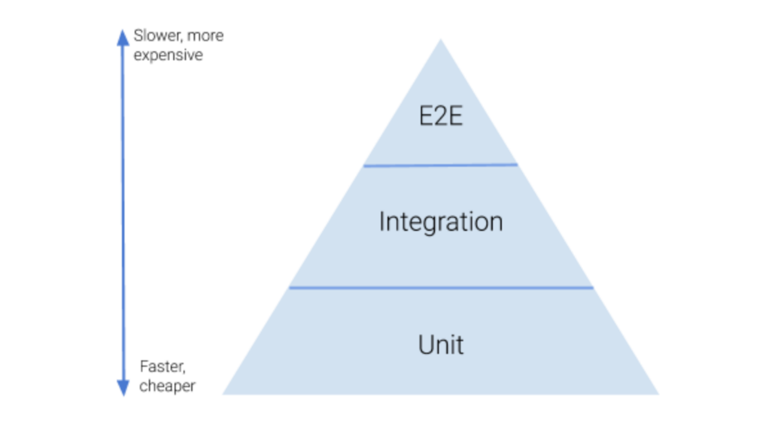
Figure 1: Testing Pyramid [17].
The pyramid strikes a balance between speed and complexity by putting a large number of short, quick-to-execute tasks at the base and progressively slower and more complicated tests at the top [18].
While integration and end-to-end testing are necessary, their higher cost, slow speed, and inherent fragility necessitates a substantial commitment of work. The standard testing pyramid best illustrates this.
This pyramid suggests that developers should put more work into building unit tests than other kinds of tests since they are quick to create and execute.

5.3.1. Unit Testing
Unit testing is performed at the lowest level and is a test that focuses on a single unit of an application [19], which is the smallest testable piece of software and can be referred to as a "unit", "component", or “module” interchangeably [20]. Typically, a single unit within an application is a function, therefore building unit tests involves writing tests for the application's functions. Unit testing verifies that the functionality of an isolated unit conforms to business requirements [21].

5.3.2. Integration Testing
Integration testing a type of black box testing is carried out when two or more tested components are merged into a bigger structure [20]. Integration testing examines how well the units interact with one another, as well as the data flow from one unit to the other. In replace of or in conjunction with writing component unit tests, writing integration tests for a React project may improve code maintainability without slowing down development [22].

5.3.3. System Testing (End-to-End Testing)
System testing (AKA End-to-End or E2E testing) verifies the effectiveness of the entire system from the user's viewpoint.
End-to-end testing is the process of simulating a user's interaction with software in a full application context. It ensures that numerous user flows work as anticipated [23].
The efficiency of these types of testing is immediately apparent. By conducting a comprehensive user scenario with the application, it is simple to identify deviations from the outcomes which are required. Nevertheless, excessive reliance on end-to-end testing has significant drawbacks.
Firstly, end-to-end testing are often flaky and fragile. A flaky test is one that produces “both a passing and a failing result with the same code” [24]. The test's broad scope contributes to its flakiness. Infrastructure problems, concurrency, caching, and dynamic content are potential reasons for test flakiness [25]. The book “XUnit Test Patterns” by Gerard Meszaros [26] cites sensitivity to data, interface, context, and behaviour as causes for fragile testing. This does not imply that end-to-end testing are the only flaky tests. However, because of their broad scope, they are more prone to this issue than unit and integration tests.
Secondly, end-to-end tests may be time-consuming to perform. As previously stated, rapid feedback is critical for software engineers in order to prevent errors entering into production environments. Software development teams are less productive when they are wasting time waiting for tests to finish.
Thirdly, pinpointing the main cause of a failed end-to-end test may be a difficult and time-consuming operation, since minor issues may be masked by bigger issues [27].

5.4. Unit Testing
There are several unit testing libraries that may be used with React, including Jest, Mocha, Tape, Ava, Chai, Enzyme and Sinon - these are the most widely used React unit testing libraries [28].

5.4.1. Jest Vs Mocha
The most popular libraries are Jest and Mocha. This section compares the two libraries.
Mocha is a JavaScript testing framework which functions on Node.js and within the browser. It is intended for testing synchronous and asynchronous applications and has a very basic interface [29].
Jest is a unit testing framework for JavaScript applications developed by Facebook. Jest is built on top of another popular testing framework for JavaScript called Jasmine [19]. Jest offers a simple test architecture.
Mocha is an established testing framework that has existed for many years. It has a significant user base and is serviced well. Jest is a relatively new technology. It has many of the same characteristics as Mocha as well as some distinct benefits [30].
Jest makes use of Jasmine 2 as its default for assertions and mocking, as well as having its own mocking methods [31]. On the other hand, Mocha is more adaptable, and components can be chosen according to preferences and requirements of the developer. It is compatible with the usage of any other assertions or mock library, such as Chai or Sinon.JS.
Some people claim that installing, setting up, and configuring Jest tests is a simpler process than doing so with Mocha. That is likely true given that Mocha requires additional setup, such as the installation of an assertion library, in contrast to Jest, which has everything in a single package. However, this should not be the decisive factor since the amount of work required is really low.
When compared to Jest, the level of difficulty associated with using Mocha is somewhat higher [30]. Jest is intended to be user-friendly and uncomplicated, but Mocha has a wider variety of configuration choices and may be more challenging to master. However, once it is mastered, mocha can be very powerful.
Additionally, Jest is a lot quicker than Mocha. It includes support for snapshot testing built in, which means that tests are automatically executed whenever there is a change to the code. This makes it simple for most recent versions of tests to be maintained as the project is worked on.
The official documentation for React recommends using Jest as a test runner and testing framework. Currently the Vortex Component Library uses Jest, whilst it is possible to use Mocha instead, continuing to use Jest seems to be simpler for the development team and more suitable for a SME, where less complex features are required.

5.4.2. Test runner
A test runner is software which allows developers to create, run, and execute unit tests in an appropriate environment while also delivering a detailed report with test data such as time it takes to execute, number of successful and unsuccessful tests, and test coverage.
Using Jest as a test runner is recommended by the developers of React. It enables the DOM elements within the web application to be accessed using jsdom, which is close enough to simulate browser behaviour in numerous circumstances [32].

5.4.3. Mocking Library
When designing tests for a React application, it may be necessary to only concentrate on the components of interest rather than include other variable factors which may vary from the purpose of unit testing. This is why a mocking library is useful - to unit test React components.
This kind of testing helps maintain a focus on the component being tested and promotes modularity. Jest provides support which is out-of-the-box for producing test doubles, although other libraries such as Sinon also provide comparable mocking capabilities.

5.4.4. Assertion library
There are times when verifying the outcomes of conducted tests, such ensuring that a square's length is equal to its width, is necessary. This is where assertion libraries are useful. Assertion making quickly leads to the requirement for complex "Assertion Matchers," and in a React environment, Jest provides pre-installed assertion techniques that simplify the process of writing test code for React.

5.4.5. Snapshot testing
It is quite beneficial to organise and perform Snapshot testing for web apps. Snapshot testing is a Jest technique designed to identify changes which are unexpected to an application's user interface. Jest introduced the tool initially for the sole aim of testing React components.
Snapshot testing React applications often involves capturing a snapshot of how a React component renders and comparing it to the reference/base snapshot file generated for the purpose of verification [33]. The tests will pass if the snapshots match, and fail if they do not.
In the event that a change in the React component is expected, because new feature is being worked on, the most recent snapshot of that React component or user interface must be generated and most recent snapshot in the test reference folder must be updated. This results in the snapshot tests of that component or user interface will pass.

5.5. Integration Testing
Integration tests are performed when units of code are merged and tested as a group. Integration tests expand on the basics of Jest and Enzyme used for unit testing [34].
React components are subjected to integration tests using the mount() function of Enzyme.

5.5.1. Comparing Mount Rendering and Shallow Mount Rendering
Shallow rendering is specifically designed for React Components unit testing. A thesis conducted by Andrei Vasilev called “Comparison of React Components testing patterns” [21] focuses on comparing several React testing strategies from a developer's perspective using a real-world scenario. It compared the two most commonly used methods for testing React components, shallow mount and mount.
It found that using mount rendering using React Testing Library (RTL) should be utilised for MVP testing and small application testing, when rapid development is crucial and the core functionality of the product should be evaluated with the least amount of work. RTL is also used to test integration across two or more components or DOM interactions from the user viewpoint.
Shallow mount rendering, offered by Enzyme and React Test Renderer, is suited for unit testing in isolation. About 80% of all tests should be shallow-mount. Unit testing should be simple to understand and write. They are quick and distinctive. Shallow rendering is useful for verifying components' contracts and describing their behaviour.
It is advisable to utilise shallow as much as possible since unit tests must be isolated as much as possible.
Mount immediately exposes the developer to the logic of every unit/component in the render tree, making it hard to test just the component.
Using mount is more expensive in terms of execution time since it needs JSDOM [35].

5.5.2. Assessing the Value of Test Automation of React Components within an SME
A thesis called “Unit Test Automation Of A React-redux Application With Jest And Enzyme” by Bogdan Moroz [15] assessed the value of test automation for an SME commissioning company called Observis. They identified an effective unit testing strategy for React applications created at Observis, presented examples of unit testing in accordance with the strategy, and incorporated automated test execution into the application deployment pipeline. At the end of the research, a testing strategy was developed based on an analysis of the case study's technological stack and an overview of existing industry trends and methodologies. Four categories of units which must be tested were identified, and tests for each type were supplied in detail. The automated tests were included into the application's deployment process by setting up a Jenkins project to run the tests for each merge request.
The thesis found that Jest and Enzyme offer a collection of testing tools for React-Redux apps which are flexible and powerful. Jest and Enzyme enable the creation of tests which meet the objectives of test automation. Jest makes it simple and quick to conduct tests, with the execution order selected to maximum speed. Its mocking capability improves the maintainability of tests by allowing developers to generate deterministic test doubles, see how units under test interact with their collaborators, and test each unit in isolation.
Jest's spec-style promotes consideration of the system under test's behaviour during test creation. Enzyme offers a versatile set of capabilities for traversing the output of React components, rendering components with specified properties, and simulating events. Enzyme's shallow rendering capability enables testing of React components in isolation by rendering each component one level deep and avoiding recursive drawing of child components. The isolation afforded by shallow rendering makes it simpler to maintain tests for React components as the codebase develops and evolves, as changes to child components do not influence tests for their parents.
Enzyme, in conjunction with the snapshot testing capability of Jest, helps discover unanticipated changes to React elements.

RESEARCH AND DEVELOPMENT METHODOLOGY

6.1. Research Methodology
This section presents an overview of the research methodologies used during this project, focusing on analysis, followed by the sources of data and the methods used to collect data. Two data research methodologies will be evaluated in order to determine which approach will be employed within the project. This will guarantee that the optimal research methodology is implemented. In addition, there will be an explanation of the data gathering techniques and a discussion of the advantages and disadvantages of utilising interviews.

6.1.1. Research Philosophy – Positivist or phenomenological
Pragmatism, positivism, realism, and interpretivism are the four available research philosophies [51]. Positivism and interpretivism, the two main philosophies, are fundamentally opposites.
The purpose of this study is to research software testing techniques and tools of React components to find a suitable testing approach for an SME. Hence, this research employs a Positivist approach. The job of the researcher in positivist studies is confined to data gathering and interpretation. Positivism research refers to the belief that only data obtained from observation, including measurement, is reliable. This project satisfies the requirements for positivist research since it attempts to collect data by comparing various testing approaches and then drawing a certain conclusion based on the findings. It is Computer Science’s responsibility to provide solutions that are valid, which comply to the internal conditions of a computer system; this would be a positivist approach.

6.1.2. Research Approach – Deductive vs inductive
Due to nature of the project's aim, a deductive approach to research is chosen. The basis of deductive approaches is the development of a hypothesis based on an existing theory, followed by the formulation of a strategy to test this hypothesis. Deductive reasoning focuses on getting and interpreting a conclusion based on a hypothesis.
With regards to this project the aim is to investigate testing approaches and find the most effective approach for an SME. A hypothesis was drawn that the testing approach involving mainly unit testing, using Jest as a test runner, mocking library and assertion library and shallow rendering using Enzyme would be best for Vortex was made. In line with a deductive methodology, this project's hypothesis will be investigated by implementing the testing approach designed to confirm or reject the hypothesis. This study will thus draw results based on the previously indicated hypothesis and method.

6.1.3. Research strategy
This project uses the developmental research strategy. A component library was built and tests were implemented and written to test the application.
Research and experimentation were the main methods used in this research project. The primary research approach was a case study. Case studies include the investigation of a particular concept or theory and the use of different sources of evidence to support results. As data sources, administrative records and documents form the foundation of case studies. The purpose of research for this project was to help come to a decision about which testing approach is best for a SME, and later implementing the chosen testing approach and analysing the approach. Research about the different types of React testing approaches and comparison of each one was essential for drawing a hypothesis, and later testing that hypothesis.

6.1.3.1. Interviews
Users' opinions on the current testing processes conducted at Vortex were collected by asking 3 developers within the company questions about the testing process. The responses indicate which current characteristics work well and which need improving. Opinions and advice was also taken in regards to which testing approaches and tools they prefer or recommend.
Interviews were chosen for qualitative data collection since interviews allow for greater flexibility when providing feedback, therefore providing more thorough information. The ability to ask open-ended questions allows more in-depth answers to be collected.
However, since interviews may take up a lot of time, fewer persons can be questioned in an interview than a survey. Moreover, to get the right responses to the questions, the interviewer must be knowledgeable.
The interviews were semi structured, meaning structured questions were planned for all interviewees but additional unstructured questions were asked if relevant.

6.1.4. Limitations
Only three people were interviewed in this project, as there were a lack of people within Vortex who knew React and could be interviewed. In order to obtain more reliable qualitative data, more people should have been interviewed.
Moreover, only one case study was used to test the hypothesis. What works for one company may not work for another and the hypothesis needs to be tested on more than one SME to truly find out if the chosen testing approach is most effective.

6.2. Development Methodology
This section explains the development process used within the project, focusing on the approach made to design and write the software, as well as the software development methodology.

6.2.1. Preamble
The objective this project is research and investigate software testing processes to test React components to measure the effectiveness of software testing at an SME called Vortex IoT. Vortex has two main web applications to display air quality sensor data. Oftentimes, the same components were used on both websites.
A component library helps decrease the possibility of variance between products or resulting in different components in different locations. A component library was created for the company to allow them to reuse the same component on both websites.

6.2.2. Software Development Methodology
A React component library was created and published and hosted on GitHub.
An Agile Scrum approach is used within Vortex. Whenever project work is completed, the Scrum process is distinguished by brief stages or "sprints" [36]. During sprint planning, the project team chooses a small portion of the scope to be achieved during the upcoming sprint, which lasts four weeks.
This work should be completed by the end of the sprint. Finally, the sprint concludes with a sprint review and retrospective—or, more specifically, lessons learned. This cycle is continued throughout the project lifetime until the whole scope of work is completed.

DESIGN AND IMPLEMENTATION

7.1. Design

7.1.1. Design Decisions of Vortex Component Library
Vortex IoT has multiple public and private portals to display their air quality monitoring data. The same components are sometimes used amongst multiple portals. Previously, the same code was just copied amongst each portal, resulting in code redundancy, and if a change in the code was made in one portal, the same changes will need to be updated within the other portals too. As a result, a component library was created to ensure consistent experience.
Table 1 outlines the design decisions made for creating and publishing the component library.
 | Creating the library |  | Publishing the Library
 | Option 1 | Option 2 | Option 1 | Option 2
Overview | Using create-react-library to create the component library. | Using rollup to create the library from scratch. | Using Lerna to publish the library  A tool for managing JavaScript projects with multiple packages. | Using npm to publish the library
Benefits and risks |  Makes it easy and quick to create a React library   No longer actively maintained  Not as flexible as making from scratch. | Flexible option  Takes more time to start up | Lerna can identify the components which have changed and suggests an update to the version in package.json before they are published.  It is not the easiest to use and there is a big learning curve | Easy to use
Table 1: Design decisions for component library.

7.2. Implementation

7.2.1. Project setup
The Vortex Component Library was created using the following tools:
- Code editor – VS Code
- Node.js/NPM
- Git bash
- Git (for creating a git repository and publishing it to Github)
- React

To create the application, the command “npx create-react-app VortexComponentLibrary” was run in a terminal.
This created the React set up for the project. Within the src file, three folders were made. One for components, one for stories and one for utils, as shown in Figure 2.

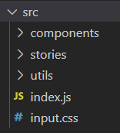
Figure 2: Application file structure.
Rollup was used within the project to bundle individual modules written in JavaScript into a single source which a browser can better comprehend – similar to webpack [37].
Although both rollup and webpack can achieve the same result depending on configuration, webpack is commonly used for application bundling, whereas rollup is best suited for library bundling – hence rollup was best suited to make the component library.
Rollup, like webpack, makes use of a plugin ecosystem. Rollup, by nature, cannot do everything; to add the functionality needed, various plugins must be installed.
Two plugins were installed for the component library:
- @rollup/plugin-babel [38] – which enables seamless integration between Rollup and Babel.
- rollup-plugin-delete [39] – which allows files and folders to be deleted using Rollup.
- rollup-plugin-peer-deps-external [40] – which allows peerDependencies to be automatically externalised in a rollup bundle.
A configuration file named rollup.config.js was created to configure how rollup bundles the library, as shown in Figure 3.
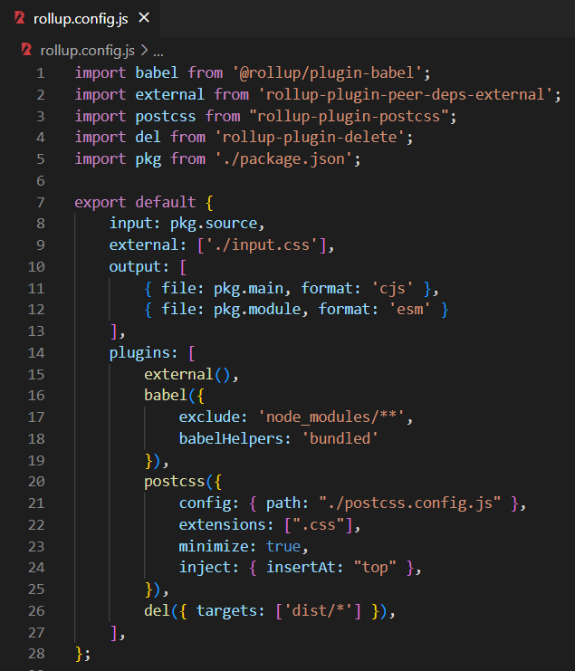
Figure 3: rollup.config.js
Within this file, the two plugins that were installed were imported. The package.json file was also imported as a CommonJS and ES module
input: The entry point to the component(s) which are bundled. The entry point was directly poined to src/index.js file which was used to export the components.
output: This identifies the location where the bundled library are saved. The output paths were imported from package.json were placed in the./dist folder.
plugins: This defines all of the plugins that were used as well as their settings. For example, external is requesting that rollup does not include peerDependencies in the bundle since they are imported individually by the application requesting this package.

7.2.2. Package.json
Package.json was configured to include source, main and module values for the rollup.config.js file, as shown in Figure 4.
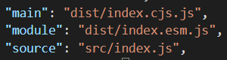
Figure 4: package.json configuration.
Within scripts, rollup was defined to run the rollup package with the -c flag – telling the application to use the rollup.config file, as shown in Figure 5.
Figure 5: package.json rollup script.
The command “npm run rollup” can be run to run rollup which creates a dist file with two files as shown in Figure 6.
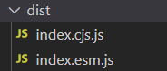
Figure 6: dist folder.

7.2.2.1. Publishing the library
The component library was configured so it was able to be downloaded and used on other applications.
The library was published via NPM by hosting it on Github. A reposititory was created for the library.
Git was initialised within the project locally by running the “git init” command.
A .gitignore file was created within the root of the directory to ignore the dist folder and node_modules, as shown in Figure 7.
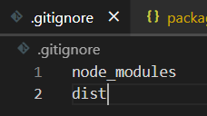
Figure 7: .gitignore file
Package.json was updated to specify where the package should be published, as shown in Figure 8.
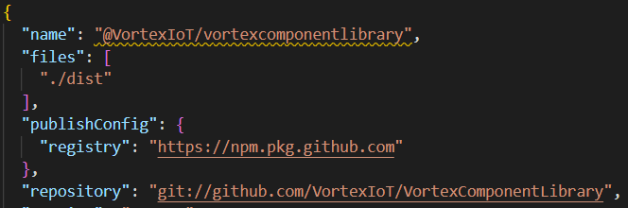
Figure 8: Package.json updated for the GitHub package.
A .npmrc file was created so the local install of NPM was authorised to publish onto the GitHub account,as shown in Figure 9. This was created as a global file in the home directory ‘C:\Users\Gemma’ (the “AUTH_TOKEN” part is replaced with the real token within the application, but is hidden in this report for security purposes).
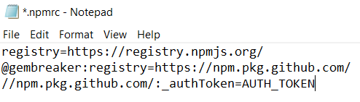
Figure 9: .npmrc file
The auth token was generated via the Github settings;
Github profile: Settings => Developer Settings => Personal access tokens => Generate new token.
The write:packages access value was selected, as shown in Figure 10. This gave the token permission to read and write packages to the Github account.
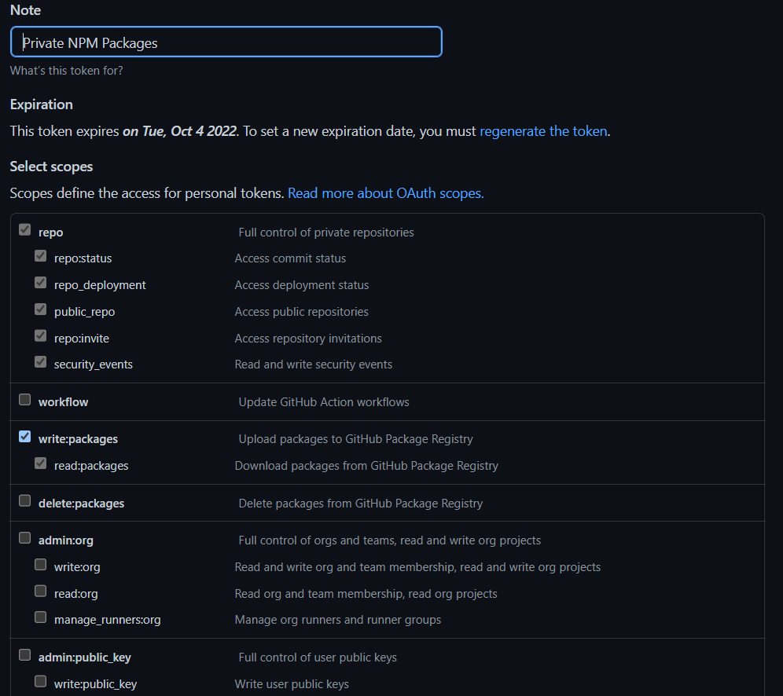
Figure 10: write.packages option for personal access token.
The “npm publish” was run to publish the code to the GitHub package, as shown in Figure 11. This is run each time updates are made to the code.

Figure 11: vortexcomponentlibrary package.

7.3. Testing
Currently, the Vortex Component Library uses Jest and Storybook as testing frameworks.

7.3.1. UI Testing with Storybook
Storybook is a tool for visualising user interface elements outside of the website or application [41]. It is excellent for developing and testing various components visual states to verify they function as intended, without the added burden of having irrelevant components on the screen.
It also provides a simple method to visualise and utilise components whilst working on them within the library project, without requiring an additional testing page to be created to show them.
Tests in Storybook work by creating stories. The rendered state of a UI component is captured by a story. Multiple stories per component are written by developers to explain all "interesting" states a component may handle.
All components written within the component library are stored in src/components folder, as shown in Figure 12.
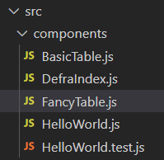
Figure 12: src/components
Figure 13 shows an example component which outputs the words “Hello world”.
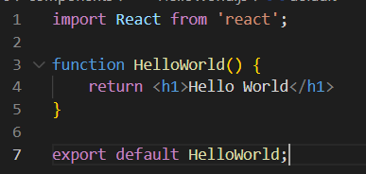
Figure 13: Hello World component.
A story can be created to test this component. Stories are files ending with .stories.js. within the vortex component library, stories are stored within the src/stories folder, as shown in Figure 14.
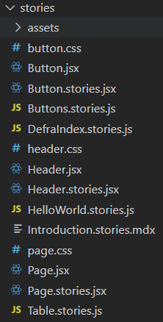
Figure 14: stories folder.
The default export metadata governs how Storybook displays stories and gives information that addons utilise. Figure 15 displays the story for the HelloWorld component. Stories are displayed by importing the component, defining a title for the component and specifying the name of the component, and creating a function to display the component.
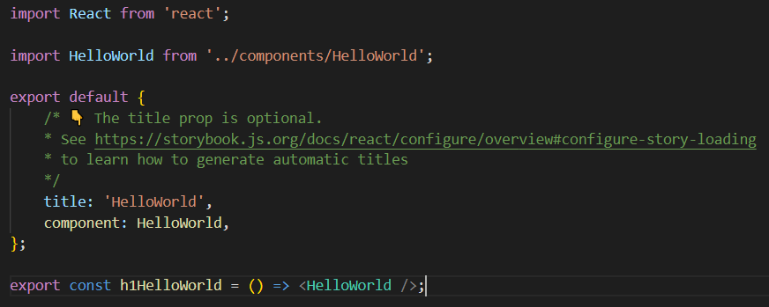
Figure 15: HelloWorld story.
It is possible to call multiple components within one story.
There are two tables within the VortexComponentLibrary. One basic table and one fancy table. Both use the same template which creates a reusable table component for all Vortex applications but the FancyTable component uses the UI library Tailwind, as shown in Figure 16.
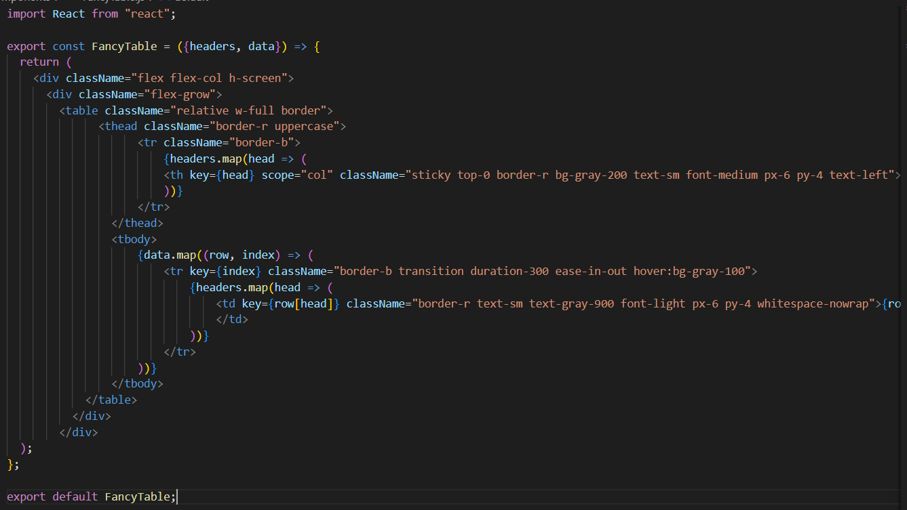
Figure 16: FancyTable component.
The story imports both tables and defines both components, as shown in Figure 17.
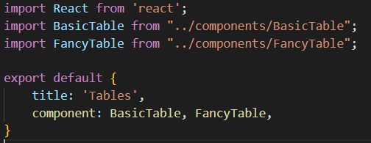
Figure 17: Importing two components within one story.
A function is created within the story which stores random sample data to use when displaying the table within Storybook, as shown in Figure 18.
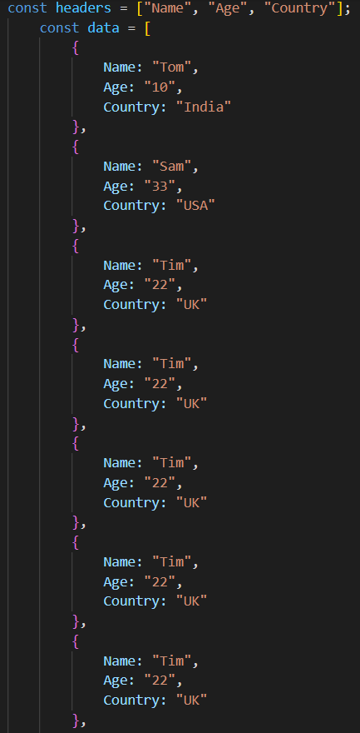
Figure 18: Sample data.
Two functions are written to call and display the components, as shown in Figure 19.
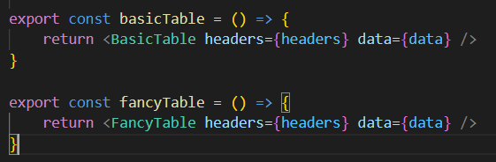
Figure 19: calling two components.
Once stories have been written for the components, storybook can be run by typing the command “npm run storybook”, as shown in Figure 20.
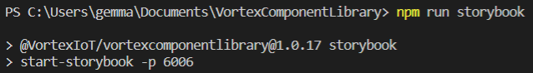
Figure 20: npm run storybook.

7.3.2. Unit Testing with Jest
Jest is a test runner, assertion library, and mocking library [28]. It also offers snapshot testing if required.

7.3.2.1. Test Runner
Jest, as a test runner, identifies and runs tests. More precisely, it searches for test files in a particular project and runs the tests contained inside those files. Jest examines all files in the project's root directory by default. The roots property of the Jest configuration file may be used to provide a specific set of folders to examine. Jest considers all .js, .ts, .jsx, and .tsx files as tests files within _tests_ folders, as well as any file with a .test or .spec suffix. files which are named Spec.js or test.js will also be identified automatically.
The Vortex Component Library currently makes use of Jest for unit testing. Figure 21 shows an example of a test using Jest. The describe() function is used for defining a test suite, which is a collection of tests [15] and the test() function describes the test [42]. The render function is mount testing and is from React Testing Library, another testing framework commonly used alongside Jest, which offers virtual DOMs for testing React components [43].
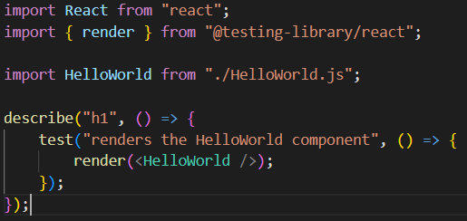
Figure 21: test rendering with react testing library.
The “npm run test” command is written to run the test, as shown in Figure 22.
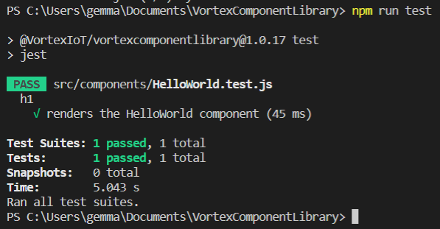
Figure 22: Unit testing with Jest.
Jest is still used in the improved testing strategy, but enzyme is used alongside for shallow rendering, therefore the HelloWorld test suite now looks like Figure 23.
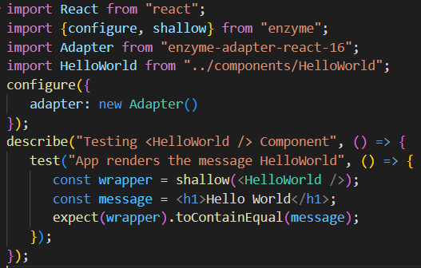
Figure 23: HelloWorld test suite.

7.3.2.2. Assertion Library
Jest, as an assertion library, offers a collection of tools for writing tests in a straightforward, human-readable manner. These are called “matchers”, which are functions [44]. Matchers enable values to be tested in a variety of ways. An expect object must be established in order to test a certain value. A matcher is then called on the expect object. Figure 23 shows an example of a matcher being used for testing that the table content within the FancyTable component matches the test data. The expect() function returns an object that represents an expectation. It accepts a value as an argument (often a value created by the function under test) and returns an object exposing a collection of matchers. The .toEqual() function compares all attributes of object instances recursively - also known as "deep" equality. It uses Object.is for comparing primitive values, which is superior for testing than the === operator [44].
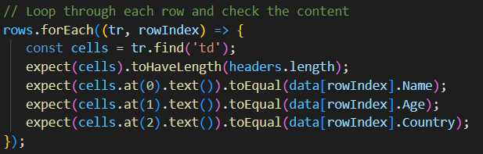
Figure 24: Example matcher.

7.3.2.3. Mocking Library
Jest, being a mocking library, has a tool called mock functions for creating test doubles [45]. Mock functions enable dependencies inside a unit test to be replaced with something controllable and inspectable. This involves the deletion and/or the replacing the actual implementation of a function or module within a test, changing a function's return value, and recording function calls and arguments given in those calls.
Using the jest.fn() function is the most basic and most frequently used approach for creating a mock [46]. If no implementation is supplied, it will return undefined. Figure 24 demonstrates the mock test within the component library, implementing numerous methods on the returned Jest mock which are used for controlling its input, output, and implementation.
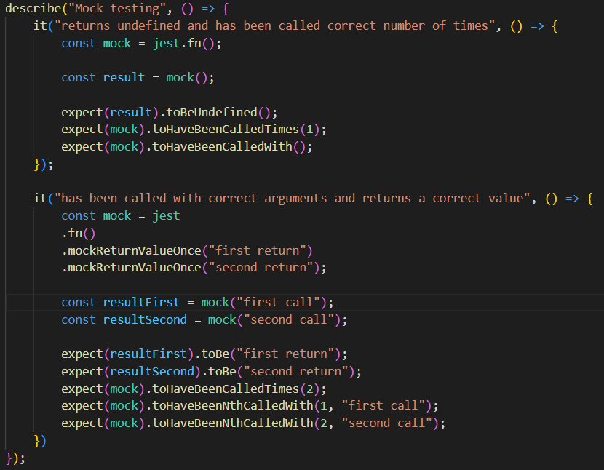
Figure 25: Mock testing using jest.fn().

7.3.2.4. Snapshot Testing
Snapshot testing is a Jest utility for detecting unexpected changes to an application's user interface. Jest first offered the tool for the aim of testing React components. A typical snapshot test case works through rendering a user interface component, taking a snapshot, and comparing it to a reference snapshot file stored with the test. If the two snapshots do not match, the test will fail because either there is an unexpected change or the reference snapshot has to be updated to the current version of the user interface component.
Figure 25 shows snapshot testing within the Vortex Component Library. It uses React Testing Renderer [47] to rapidly create a serialisable value for the React tree [48].
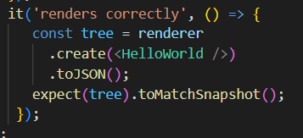
Figure 26: Jest Snapshot Testing.
Jest generates a snapshot file that looks like the example in Figure 26, the first time this test is run.
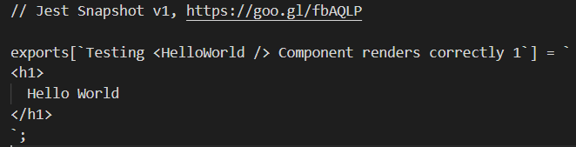
Figure 27: Snapshot Example.
The test is included in the test suite in Figure 23. First, a shallow rendering of the component is performed, and then Jest's toMatchSnapshot() matcher is used to make a comparison of the component to the snapshot.
Running passing tests using these unit testing approaches results in an output that looks like Figure 28.
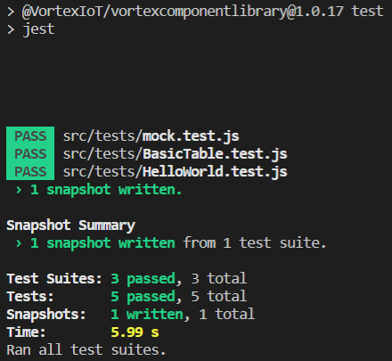
Figure 28: Running testing environment.

7.3.3. Shallow Rendering with Enzyme
Since the literature review showed that shallow rendering is more effective to use than mount rendering, Enzyme was used for shallow rendering instead of RTL for mount, as shown in Figure 23 where shallow rendering is used to render the HelloWorld component. This approach returns an object named a shallow wrapper, which is a wrapper around the component's root node [49].
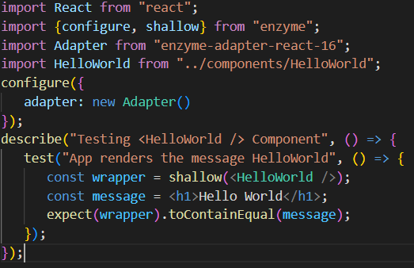
Figure 29: Shallow rendering with Enzyme.

RESULTS

8.1. Qualitative Results
Interviews were conducted to gather information about Vortex’s current testing system and suggestions on what type of testing approaches or tools the company should use instead. Three interviews were conducted individually with three different developers. The interviews were semi structured in that each interviewee was asked 9 planned questions, but other questions were asked depending on the information the developers gave. The interviewees were also given opportunities to provide any additional information that they considered useful.
All three interviewees stated that the current testing process at Vortex was very basic and in need of improvement. Two of the interviewees have experience using Jest and interviewee 1 said that was his preferred framework to use. Interviewee 2 said Jest was a straightforward.
The interviewees all had different job roles and all had different experiences in regards to using React and the Vortex Component Library. Surveying people with a difference in knowledge and skill allowed for a wider variety of results.
The interviews collected staff members thoughts and feelings about testing frameworks, but since there was a lack of people at Vortex IoT who had a large knowledge of testing, the qualitative data did not provide enough useful information to aid the design of the testing strategy.

8.2. Results from the Literature Review
The aim of this research project was to improve on Vortex IoT’s current testing approach, and implement a new testing approach which is most effective for SMEs. Vortex IoT’s existing testing approach was too simple and only covered basic Jest component testing and mount rendering. The literature review explored the different types of testing approaches and compared each technique to find the most appropriate approach. The results of the literature review found that using Jest was the best approach for an SME as it is a similar approach due to the fact that it comes with a preconfigured ecosystem that includes a test runner, assertion library, and other useful utilities, as opposed to using Mocha which requires the installation of other frameworks on top such as Chai for assertion.
The implementation of Jest was simple and effective, and resulted in an effective unit testing strategy that was straightforward and easy to implement. As much as other strategies could have provided similar results, using Jest provided an approach which required less learning curve. Moreover, Jest is also the most appropriate for React applications whereas Mocha is more preferred for large Node.js applications. Vortex IoT applications are written in React.
Using shallow rendering can verify that tests are not asserted depending on the behaviour of any child components of the component that are being tested.
Enzyme also means that DOM elements are rendered completely, which is handy when components that are wrapped within a higher-order component need to be tested.
The literature review showed that it was beneficial to use shallow rendering, especially as it works well alongside snapshot testing. This was proven true when implementing the testing strategy as both snapshot and Enzyme worked really well together. It meant that the component could be shallowly rendered before a snapshot was made, resulting in an effective approach to discovering any unexpected changes in a React component.
The aims and objectives of this project were met as an effective testing strategy was implemented. The weaknesses of the current testing approach were addressed and a new strategy was created to overcome the weaknesses.
If this project were to be conducted again, more unit testing strategies could have been considered such as Puppeteer or Jasmine. This would have provided a more thorough review of the testing tools available for testing React components. However, this was not necessarily needed as most literature state that Jest and Mocha are the winning competitors for unit testing.

CONCLUSION AND FUTURE WORK
This project first involved investigating a Vortex IoT’s current testing strategy and finding weaknesses with the approaches used. Qualitative testing by carrying out interviews with people at the company were then undertaken to obtain staff member’s viewpoints of the current testing system, their preferences in which tools they prefer using, and suggestions on which testing approach they think would be best for Vortex IoT to use. A literature review was conducted to investigate the different types of testing which exist for testing React components, exploring Fowler’s testing table, and exploring testing tools and approaches available for testing in React, comparing and contrasting the most popular ones.
The results of implementing a new testing strategy supported the conclusions made within the literature review, which showed that using Jest for unit testing alongside Enzyme for shallow rendering resulted in the most effective testing strategy which made tests simple to write and allowed the testing process overall to be straightforward but powerful.
Due to the apparent distinction between system testing and unit/integration testing, system testing was not mentioned in this thesis. It has a clear meaning, and it is often difficult to execute incorrectly.
The suggested testing technique will be used to all Vortex IoT React apps and can be utilised by other businesses.

REFLECTION
Completing this research thesis as part of a Masters degree in Software Engineering involved a large amount of research and software development challenges. This chapter describes how the creation of this research report enabled me to improve my personal and professional development.
Throughout this project, I gained knowledge in the different types of testing, and the testing pyramid, which explains unit testing, integration testing, and end-to-end testing and the importance and costs of each one. I gained knowledge of the testing tools available to test React components and I obtained experience with React testing tools, particularly with Jest and Enzyme.
My skills with communication were improved throughout multiple stages of the project as I needed to conduct semi structured interviews with staff members of Vortex IoT. Time management skills were challenged as this project was written alongside having a full time job, resulting in me needing to learn how to structure this project alongside my job.
Overall I have enhanced my technical skills, research skills, and communication skills. The knowledge I have obtained in this project has and will help me with my job which is as a Junior Front End Developer.
This project was a success but if it were to be done again, time management could have been improved since a short amount of time was dedicated for this project, and with more time, more testing strategies could have been conducted.

REFERENCES
[1] K. Brush, “Agile Software Development,” TechTarget. https://www.techtarget.com/searchsoftwarequality/definition/agile-software-development (accessed Aug. 29, 2022).
[2] S. Kumar Dora and P. Dubey, “SOFTWARE DEVELOPMENT LIFE CYCLE (SDLC) ANALYTICAL COMPARISON AND SURVEY ON TRADITIONAL AND AGILE METHODOLOGY,” NATIONAL MONTHLY REFEREED JOURNAL OF RESEARCH IN SCIENCE & TECHNOLOGY, vol. 2, no. 8, Accessed: Aug. 29, 2022. [Online]. Available: www.abhinavjournal.com
[3] T. F. of S. B. FSB, “UK Small Business Statistics,” UK Small Business Statistics, 2021. https://www.fsb.org.uk/uk-small-business-statistics.html (accessed Aug. 01, 2022).
[4] D. Mishra and A. Mishra, “Software process improvement in SMEs: A comparative view,” undefined, vol. 6, no. 1, pp. 111–140, Jun. 2009, doi: 10.2298/CSIS0901111M.
[5] G. Bath and E. van Veenendaal, Improving the Test Process: Implementing Improvement and Change - A Study Guide for the ISTQB Expert Level Module, 1st ed. Santa Barbara: Gerhard Rossbach, 2014. Accessed: Aug. 29, 2022. [Online]. Available: https://www.amazon.co.uk/Improving-Test-Process-Implementing-Improvement-ebook/dp/B00VB46L7A?asin=B00VB46L7A&revisionId=a6600641&format=1&depth=1
[6] M. J. Harrold, “Testing: a roadmap,” pp. 61–72, May 2000, doi: 10.1145/336512.336532.
[7] J. Jones, M. J. Harrold, and J. Stasko, “Visualization for Fault Localization,” 2003.
[8] Facebook, “React – A JavaScript library for building user interfaces,” React.js Docs, 2022. https://reactjs.org/ (accessed Aug. 16, 2022).
[9] S. Aggarwal, “Modern Web-Development using ReactJS,” International Journal of Recent Research Aspects, vol. 5, no. 1, pp. 133–137, Mar. 2018.
[10] G. Psaila, “Virtual DOM: An efficient virtual memory representation for large XML Documents,” Proceedings - International Workshop on Database and Expert Systems Applications, DEXA, pp. 233–237, 2008, doi: 10.1109/DEXA.2008.117.
[11] M. Qasim, “Shortening Testing Time of a Web-based Business Application in Scrum using Automated Testing,” Tampere, Finland, Dec. 2017.
[12] V. Kumar, “COMPARISON OF MANUAL AND AUTOMATION TESTING,” 2012.
[13] R. M. Sharma, “Quantitative Analysis of Automation and Manual Testing,” International Journal of Engineering and Innovative Technology (IJEIT), vol. 4, no. 1, Jul. 2014, Accessed: Aug. 15, 2022. [Online]. Available: https://www.ijeit.com/Vol%204/Issue%201/IJEIT1412201407_46.pdf
[14] A. Bezbaruah, B. Pratap, and S. B Hake, “Automation of Tests and Comparative Analysis between Manual and Automated testing ,” 2020. Accessed: Aug. 15, 2022. [Online]. Available: https://ieeexplore.ieee.org/stamp/stamp.jsp?tp=&arnumber=9236748
[15] B. Moroz, “UNIT TEST AUTOMATION OF A REACT-REDUX APPLICATION WITH JEST AND ENZYME,” 2019.
[16] J. Leung, “The Test Pyramid,” Better Programming, May 21, 2019. https://betterprogramming.pub/the-test-pyramid-80d77535573 (accessed Sep. 03, 2022).
[17] H. Vocke, “The Practical Test Pyramid,” WWW document, Feb. 26, 2018. https://martinfowler.com/articles/practical-test-pyramid.html (accessed Aug. 10, 2022).
[18] A. Fedosejev, React.js essentials : a fast-paced guide to designing and building scalable and maintainable web apps with React.js. Packt Publishing, 2015. Accessed: Aug. 15, 2022. [Online]. Available: https://www.google.co.uk/books/edition/React_js_Essentials/Rhl1CgAAQBAJ?hl=en&gbpv=0
[19] L. Luo, “Software Testing Techniques Technology Maturation and Research Strategy Class Report for 17-939A Software Testing Techniques Technology Maturation and Research Strategies,” Pittsburgh.
[20] A. Vasilev, “Comparison of React components testing patterns,” Helsinki, Finland, Nov. 2021.
[21] A. Rublev, “Increase Code Maintainability With React Integration Testing,” Developers, 2020. https://www.toptal.com/react/react-testing-library-tutorial (accessed Sep. 03, 2022).
[22] S. Pittet, “The different types of testing in software,” Atlassian, 2019. https://www.atlassian.com/continuous-delivery/software-testing/types-of-software-testing (accessed Aug. 18, 2022).
[23] J. Micco, “Flaky Tests at Google and How We Mitigate Them,” Google Testing Blog, May 27, 2016. https://testing.googleblog.com/2016/05/flaky-tests-at-google-and-how-we.html (accessed Aug. 18, 2022).
[24] @thecodegang, “Flaky Tests - A War that Never Ends,” HackerNoon, Dec. 04, 2017. https://hackernoon.com/flaky-tests-a-war-that-never-ends-9aa32fdef359 (accessed Aug. 18, 2022).
[25] G. Meszaros, XUnit test patterns : refactoring test code. Pearson Education, 2007.
[26] M. Wacker, “Just Say No to More End-to-End Tests,” Apr. 22, 2015. https://testing.googleblog.com/2015/04/just-say-no-to-more-end-to-end-tests.html (accessed Aug. 18, 2022).
[27] E. Elrom, React and Libraries Your Complete Guide to the React Ecosystem. 2021. doi: 10.1007/978-1-4842-6696-0.
[28] G. Chinda, “Testing Node.js with Mocha and Chai,” LogRocket, Jul. 13, 2022. https://blog.logrocket.com/testing-node-js-mocha-chai/#what-mocha (accessed Sep. 02, 2022).
[29] R. Fabisiak, “Mocha vs Jest Comparison of Testing Tools in 2022,” Mar. 10, 2022. https://www.blog.duomly.com/mocha-vs-jest/ (accessed Aug. 25, 2022).
[30] S. Teller, “UI Testing a React Component,” Toptal. https://www.toptal.com/react/how-react-components-make-ui-testing-easy (accessed Aug. 25, 2022).
[31] G. Begum, “A Practical Guide to Testing React Applications [React Testing Tutorial],” LambdaTest, Mar. 17, 2022. https://www.lambdatest.com/blog/react-testing-tutorial/ (accessed Sep. 03, 2022).
[32] “Snapshot Testing,” Jest, 2022. https://jestjs.io/docs/snapshot-testing (accessed Sep. 04, 2022).
[33] A. Jarombek, “Unit, Integration, and Snapshot Testing in React with Jest and Enzyme,” Retrospective. https://jarombek.com/blog/feb-5-2020-react-jest-enzyme (accessed Sep. 04, 2022).
[34] W. Wattearachchi, “Testing with Jest and Enzyme in React — Part 4 (shallow vs. mount in Enzyme),” Jan. 14, 2019. https://wasuradananjith.medium.com/testing-with-jest-and-enzyme-in-react-part-4-shallow-vs-mount-in-enzyme-d60cad73f85c (accessed Sep. 04, 2022).
[35] T. Stobierski, “Agile vs. Scrum: What’s the Difference?,” Northeastern University, Mar. 25, 2021. https://www.northeastern.edu/graduate/blog/agile-vs-scrum/ (accessed Aug. 24, 2022).
[36] “webpack,” webpack, 2022. https://webpack.js.org/ (accessed Aug. 24, 2022).
[37] npm, “@rollup/plugin-babel,” Feb. 2022. https://www.npmjs.com/package/@rollup/plugin-babel (accessed Aug. 24, 2022).
[38] npm, “rollup-plugin-delete,” 2020. https://www.npmjs.com/package/rollup-plugin-delete (accessed Aug. 24, 2022).
[39] npm, “rollup-plugin-peer-deps-external,” 2020. https://www.npmjs.com/package/rollup-plugin-peer-deps-external (accessed Aug. 24, 2022).
[40] Storybook, “Introduction to Storybook,” Storybook docs, 2022. https://storybook.js.org/docs/html/get-started/introduction (accessed Sep. 05, 2022).
[41] Jest, “Getting Started · Jest,” 2022. https://jestjs.io/docs/getting-started (accessed Aug. 31, 2022).
[42] J. Cruz Martinez, “React app testing: Jest and React Testing Library,” LogRocket, Mar. 16, 2022. https://blog.logrocket.com/testing-react-apps-jest-react-testing-library/ (accessed Aug. 31, 2022).
[43] Jest, “Expect · Jest,” Jest docs, 2022. https://jestjs.io/docs/expect (accessed Sep. 05, 2022).
[44] Jest, “Mock Functions · Jest,” Jest docs, 2022. https://jestjs.io/docs/mock-functions (accessed Sep. 05, 2022).
[45] P. Grzybek, “Mocking functions and modules with Jest,” pawelgrzybek.com, Apr. 12, 2020. https://pawelgrzybek.com/mocking-functions-and-modules-with-jest/ (accessed Sep. 05, 2022).
[46] React, “Test Renderer,” React Docs, 2022. https://reactjs.org/docs/test-renderer.html (accessed Sep. 05, 2022).
[47] Jest, “Snapshot Testing,” Jest Docs, 2022. https://jestjs.io/docs/snapshot-testing (accessed Sep. 05, 2022).
[48] Enzyme, “Introduction,” Enzyme Docs, 2022. https://enzymejs.github.io/enzyme/ (accessed Sep. 05, 2022).

