

Placement Portfolio

Student Name: | Keira Thomas
Student Number: | 2004624
Name of chosen placement: | Barnardo's Superstore - Swansea

Table of contents

1. Background information of chosen organization
Section A: History of the organisation..........................................................3 & 4
Section B: Mission statement.............................................................................5
Section C: Volunteering opportunities...............................................................6

2. Training/Volunteering process
Section A: Why I chose Barnardo’s…………………………………………………………………7
Section B: Application process……………………………………………………………………….8
Section C: Training………………………………………………………………………………………...9

3. Reflective Logs………………………………………………………………………………………….10, 11, 12

Appendices………………………………………………………………………………………………………13 & 14

References……………………………………………………………………………………………………………….15

1.
Section A: History of Organisation

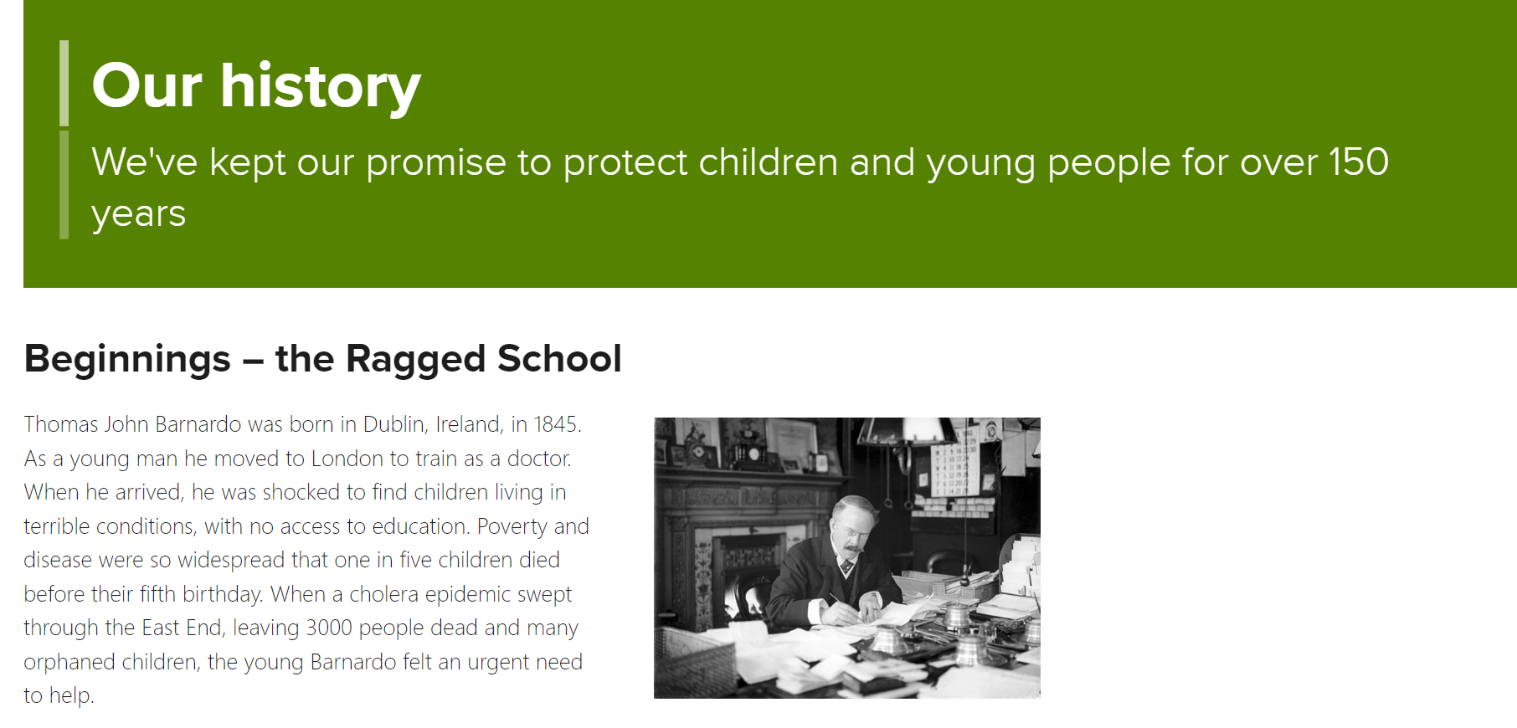
Thomas John Barnardo, born in Ireland in 1845, founded Barnardo's. Thomas Barnardo travelled to London at an early age to train as a doctor. When he arrived in London, he was astounded at the level of poverty and disease affecting young children. It was because of this that young Barnardo felt compelled to assist and make a difference in the lives of young children. (Barnardo’s, 2023)

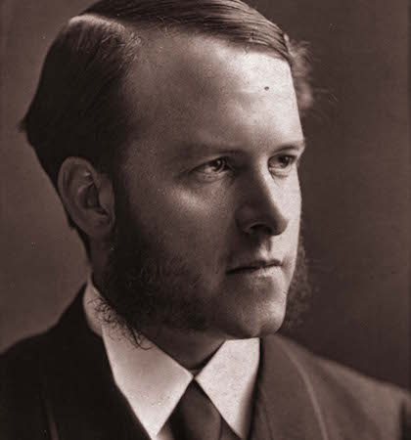
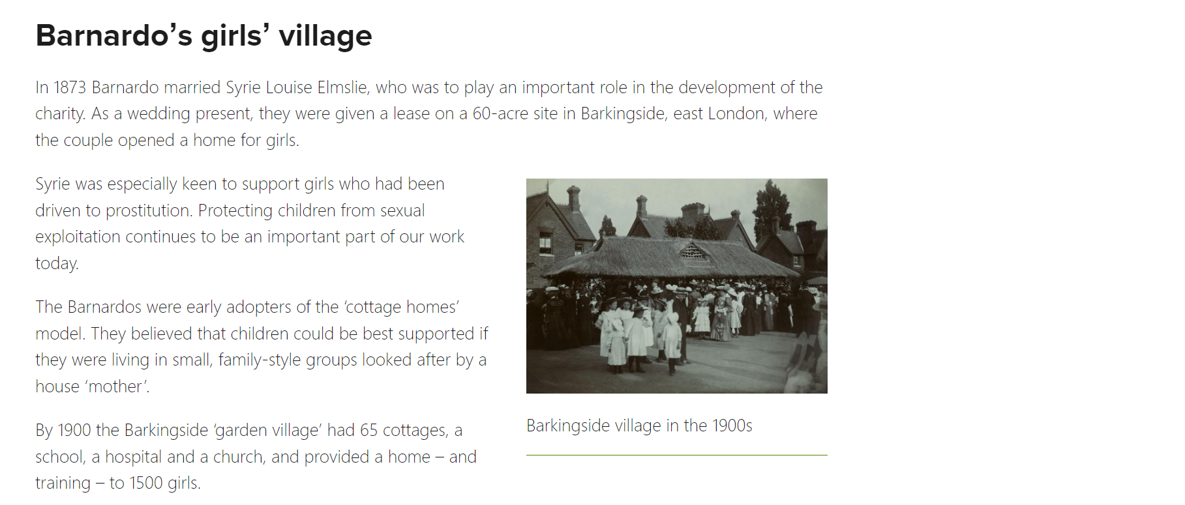
In 1873, Barnardo married Syrie Louise Elmslie. Syrie was influential in the development of Barnardo's as she also had the desire to help young children. Syrie was particularly interested in assisting young girls who had been forced into prostitution. The Barnardo’s partnered and were early adopters of the "cottage homes," which enabled young girls to be sheltered in a safe, caring environment. Protection of minors from sexual exploitation is still an important aspect of the charity's mission 150 years later (Barnardo's, 2023).

Barnardo’s has grown tremendously over the course of 150 years, the charity had 96 homes caring for over 8,500 vulnerable children by the time Thomas Barnardo died in 1905. Despite Thomas Barnardo's death in 1905, the charity continued to grow and expand its services for young children (Barnardo’s, 2023).

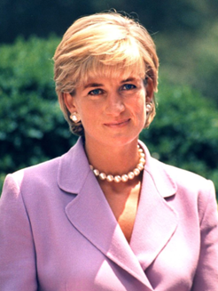
(Barnardo’s, 2023)
1970s
- expansion of fostering and adoption services.
- Development of family centres
for disadvantaged families.
1980-1990s
- established new ways of working with survivors of childhood sexual abuse
- Providing help and support for children affected by HIV and AIDS
- Princess Diana becomes president of Barnardo’s from 1984-1986.

Section B: Mission Statement

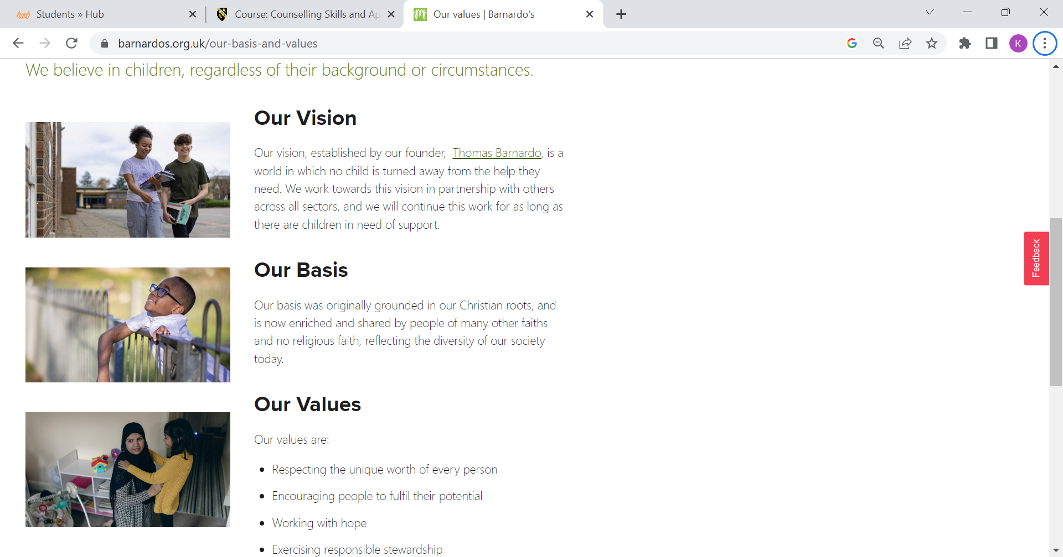
Barnardo's believes that no child, regardless of their background or circumstances, should be denied care and support. The organisation remains devoted to Thomas Barnardo's mission of protecting, supporting, and nurturing vulnerable children. By working to build stronger families, safer childhoods, and brighter futures, the organisation hopes to improve outcomes for more children.

This includes assisting families where possible before problems reach crisis level. It involves safeguarding children from sexual abuse and exploitation while also assisting victims and survivors in their healing and rebuilding processes. Furthermore, their mission involves treating children's mental health and well-being, which is especially important considering the significant proportion of vulnerable children.

(Barnardo’s, 2023)
Section C: Volunteering opportunities

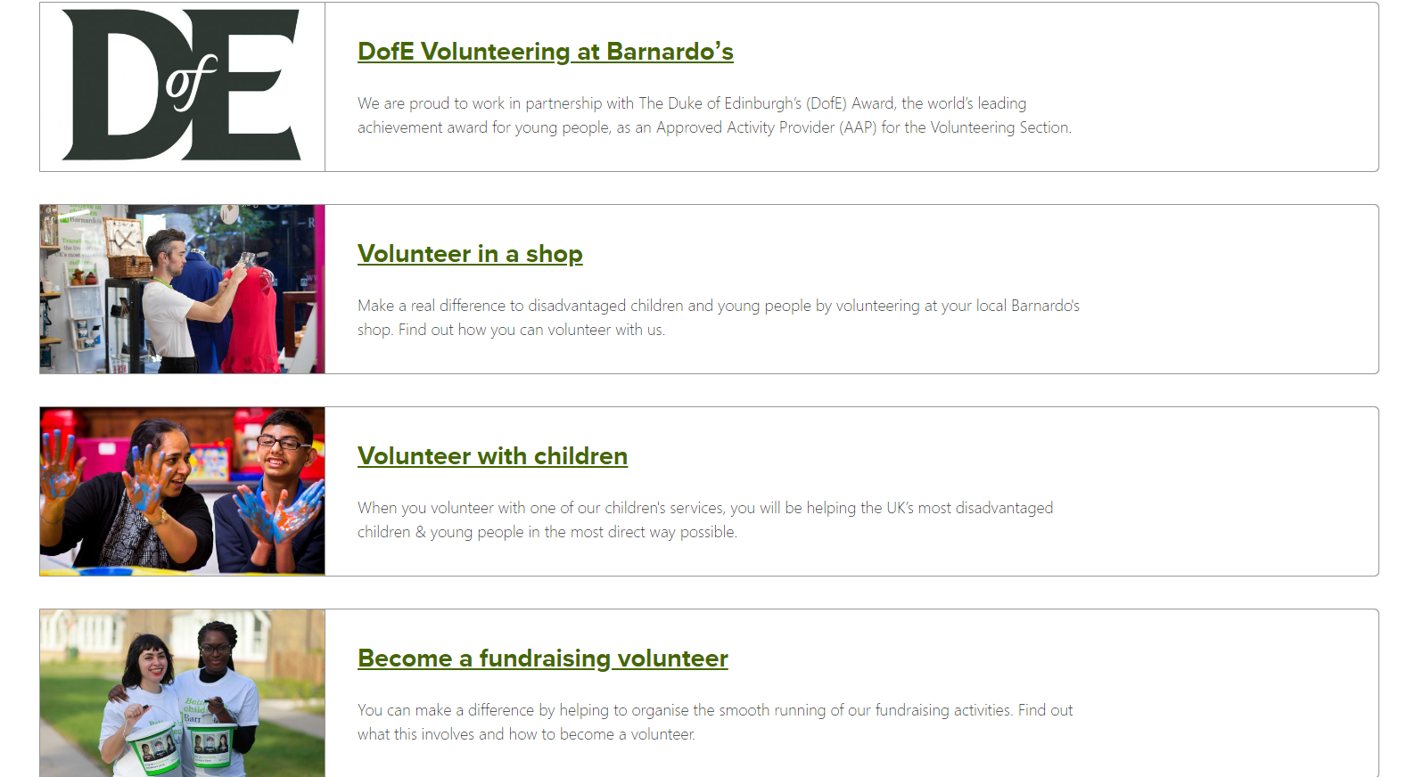

Barnardo’s provides a wide range of volunteering opportunities which can be found on their website. Some of the volunteering opportunities available include volunteering in store, with children, as a fundraiser, or as part of the Duke of Edinburgh award (Barnardo’s, 2023).

Volunteering with Barnardo's is a great opportunity to learn new skills, gain valuable work experience, meet new people, and give back to your community whilst making a real difference to the lives of vulnerable children.

2.
Section A: Why I chose Barnardo’s

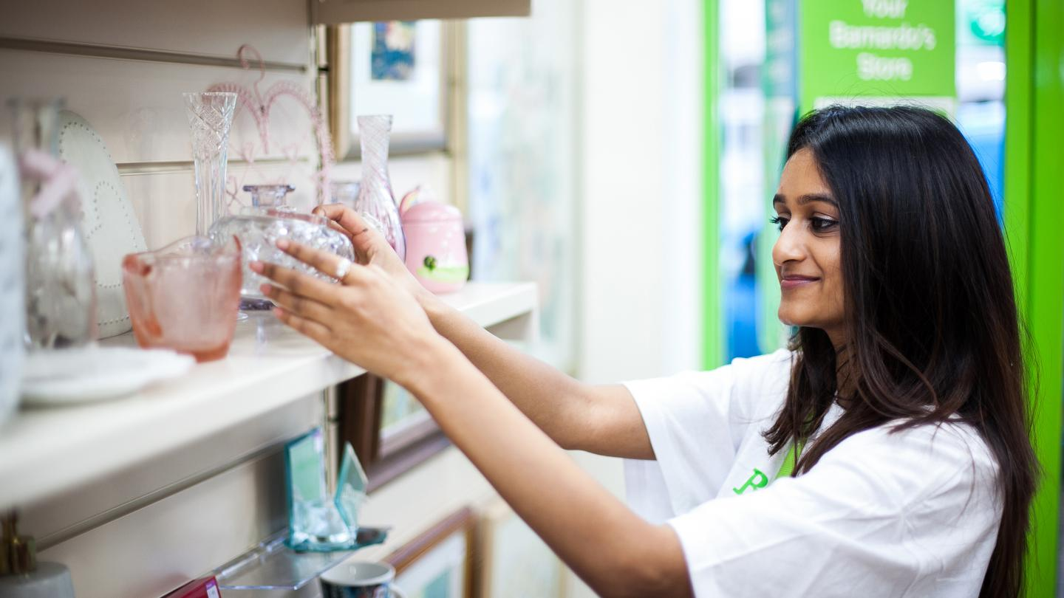

I chose to volunteer for Barnardo's after exploring many volunteering opportunities that I could participate in as part of my placement. There are various reasons why I choose this charity. I truly appreciate their mission statement and the work that they do to protect vulnerable children. I believe that children's mental health is vitally important, and that children should be given all the support and care that they deserve regardless of their individual circumstances or background. Furthermore, according to The Children’s Society (2023) the likelihood of young people experiencing mental health issues has increased by 50% over the last three years. Therefore, there is an urgent need for more mental health services available to young children and Barnardo’s mission works towards tackling these issues. Additionally, I felt that I would have fun working in store as I love to meet new people and work in a team environment. I am also passionate about fashion and regularly purchase second hand clothing so I knew that I would enjoy working in a charity shop.

Section B: Application Process

I applied to volunteer at Barnardo’s through their website which required me to complete an application form filling out my details and providing my reasoning for why I would like to volunteer for the organisation. After completing the application form, my application was shortly cleared, and I was invited to a meeting with the store manager for a brief discussion about the role.

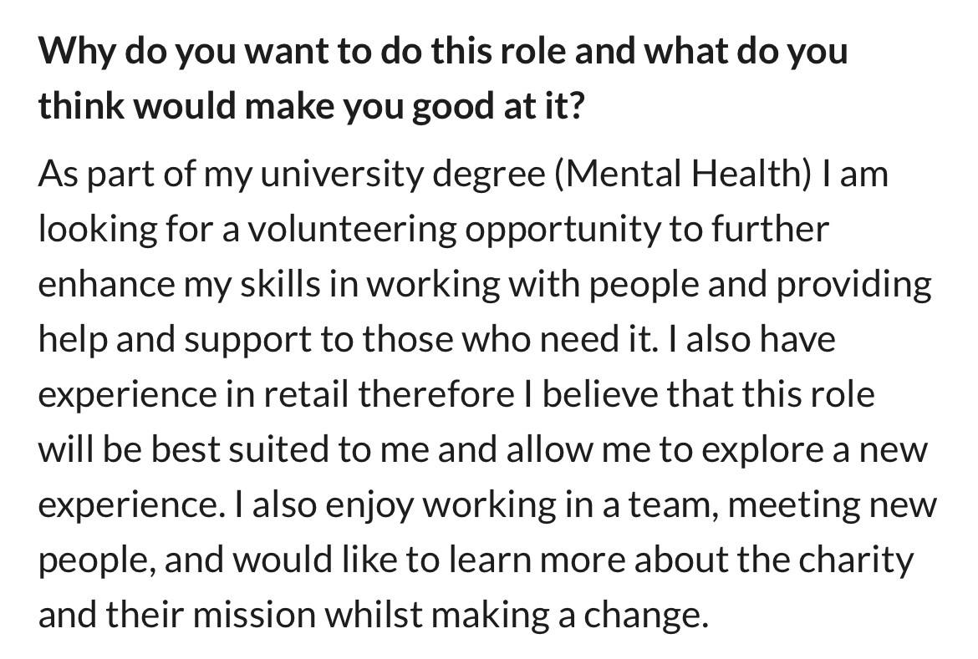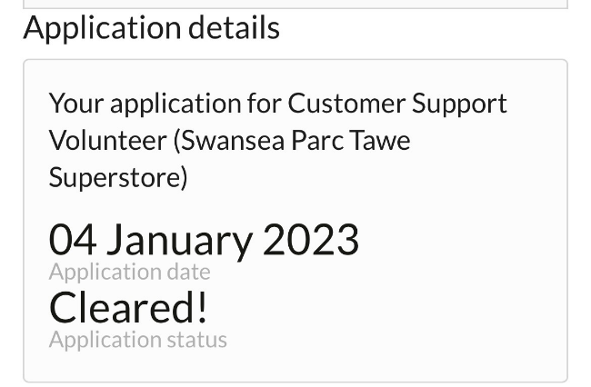

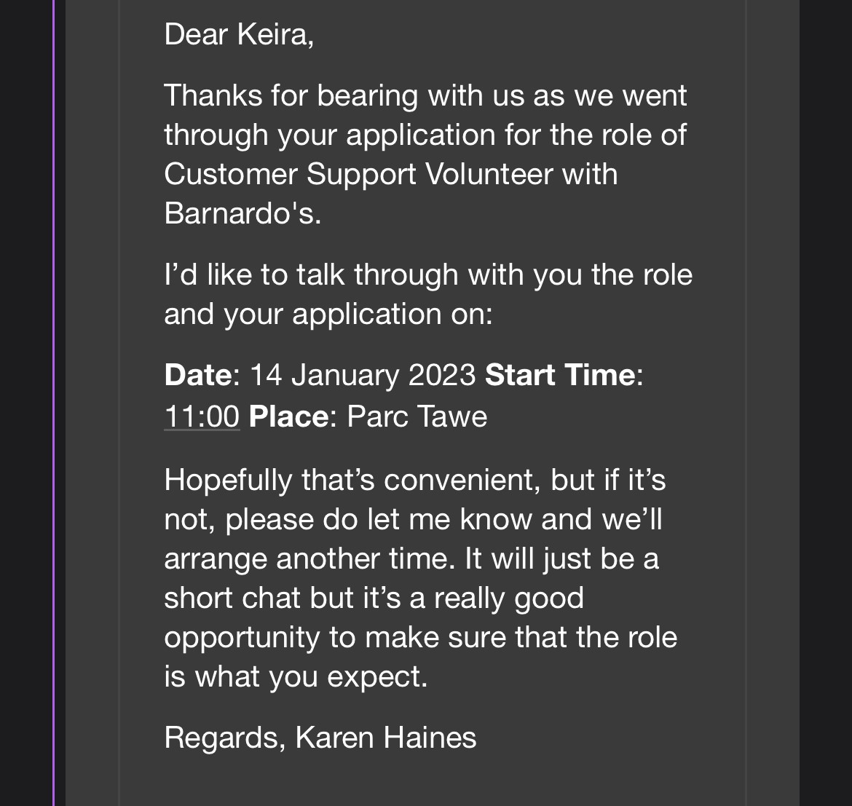

Section C: Training

Before I was able to begin volunteering at Barnardo’s I was required to complete online training. As part of my training, I had to complete various modules which involved watching educational videos and learning more about the organisation and its core beliefs and values.
I was also provided with more insight about the role throughout the videos so that I was well prepared before I began working in store. After completing each module, I was awarded with a certificate indicating that I had successfully completed the task.

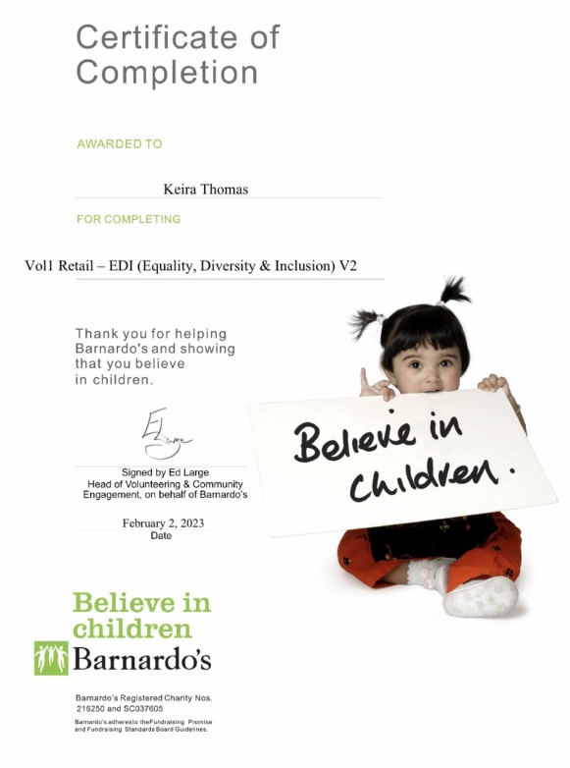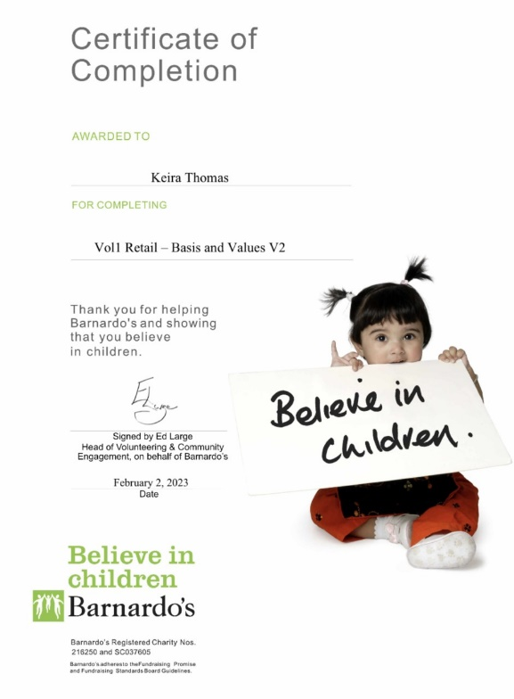

3.
Reflective Logs
A selection of entries from my reflective logbook relating to my volunteering experience can be found below. They describe the various tasks that I completed as part of my placement as well as my thoughts and feelings at the time.
Student Name: | Keira Thomas
Name of Organisation: | Barnardo’s

Date: | February 14th
Tasks Completed: | Induction session
Reflection: | My first day of volunteering at Barnardo's was today. I decided that for my first day I will complete a total of five hours volunteering. When I woke up this morning, I was both nervous and excited about starting my placement. However, after entering the store and meeting some of the employees, I quickly felt at ease and comfortable in my surroundings. The manager then gave me a quick tour of the store, including the shop floor and warehouse. I was also provided with useful information about each department and its purpose in the store. I was somewhat surprised by the size of the store, as it is a superstore rather than a typical charity shop. I was similarly taken aback by the large amount of stock in the store, but I was pleased to see the number of customers who had donated their clothing to a good cause. After being shown around the store I was then taught how to tag clothes and hang them up in a specific way, this was something that I had never done before, so I already felt that I had learnt something new. I feel really pleased with how my first day went and I feel like I will quickly settle in as part of the team.

Date: | February 22nd
Tasks Completed: | Rotating stock and assisting customers
Reflection: | Today I was asked to organise the home décor/ornament section with a fellow colleague. Although this is something I am unfamiliar with, I was happy to learn something new and get to know my co-worker a little better. We were told to take down anything that hadn't sold and replace it with new merchandise while setting up the display. Customers are more likely to make a purchase when the stock is rotated, resulting in more money going to the charity's cause. I tried to make the display as appealing as possible by positioning items in colour coordination so that customers are more likely to be interested in the products. Later in the day I was approached by an elderly customer. She explained to me that she had trouble with her sight and asked If I would help her to pick out a new t shirt for her to wear. She specifically stated that she likes bright colours. I was delighted to assist her and showed her around the store, suggesting items that I thought she might like. I chose a few tops for her that she loved, and she thanked me for my assistance. After this interaction I felt rewarded as I had made someone’s day a little better. I also felt that this interaction helped me to improve my communication and listening skills which are important in counselling.

Date: | March 1st
Tasks completed: | Checkout training
Reflection: | As part of my volunteering today I was asked if I would like to be trained on check outs. Although I was hesitant at first, I thought it would be beneficial to improve my people skills. I was trained on the tills by another colleague who was extremely helpful and patient when teaching me how to use the tills which immediately made me feel at ease. While serving customers at the checkout, I noticed that many of the customers who came into the store were of different ethnicity, background, age, and some had disabilities. I thought this was a great opportunity for me to interact with and help others from different backgrounds, as this may be relevant to my future in counselling. I also observed that many mothers were shopping in store with their children. With the current cost of living crisis, I felt relieved to see that parents were able to shop somewhere where they were able to afford things for their children. I felt delighted to see the happiness on the children’s faces as they received their new toys/clothes from their parents, and it made me feel proud to be a volunteer at an organisation whose purpose is to create a better life for children in need. Furthermore, seeing the joy on the children's faces made me consider working with children in the future, as I believe it would be a very rewarding career in which I would be able to make a real difference in the lives of vulnerable children.
Date: | March 24th
Tasks Completed: | Organising women’s display
Reflection: | While volunteering today, one of my co-workers approached me and asked if I wanted to rearrange the women's bags/shoes display. My co-worker commented that she had recognised my ability to organise a display and make it look enticing to customers. I was glad that my efforts in the store were being recognised, and I felt a sense of accomplishment. I organised the women's display to make it appear stylish/attractive so that it would grab the customer's attention and contribute to more money going to the charities cause. I was quite delighted with the end product and felt very proud after finishing the display. Below is a photo of the women's section, which I organised. Furthermore, I felt today that I had really become a part of the team and had settled into the store. I had grown close to some of my co-workers and felt that I had built some genuine relationships with them. Many of my co-workers were also members of the LGBTQ community, and it was interesting to learn more about their sexuality and identity. I began to learn more about the individuals I was working with and discovered that one of my peers used They/Them pronouns. Working in a team environment with people of various backgrounds, ages, ethnicities, and sexual orientations has taught me a lot about people and their individual differences. This, I believe, will benefit me in my future career in mental health, as I will be working in a non-judgmental setting, assisting those who are suffering regardless of their identity.

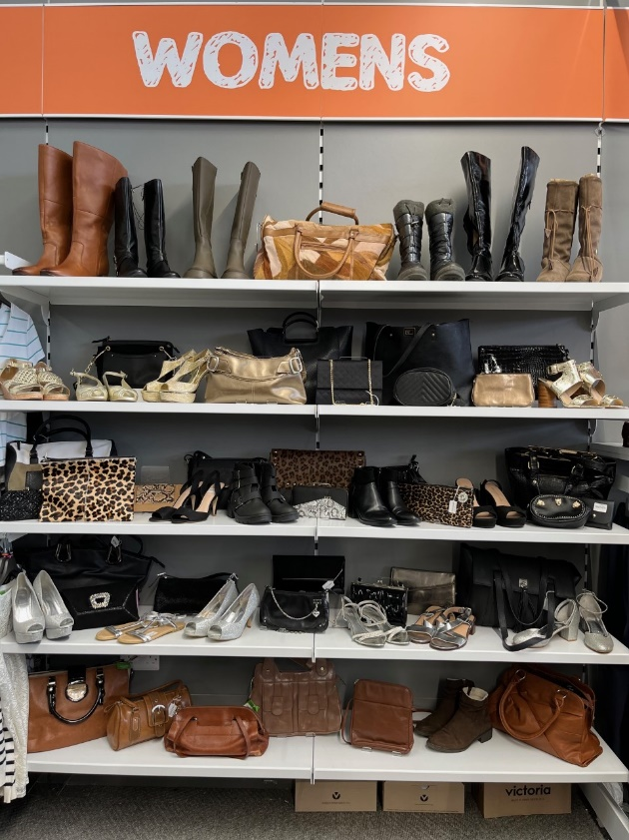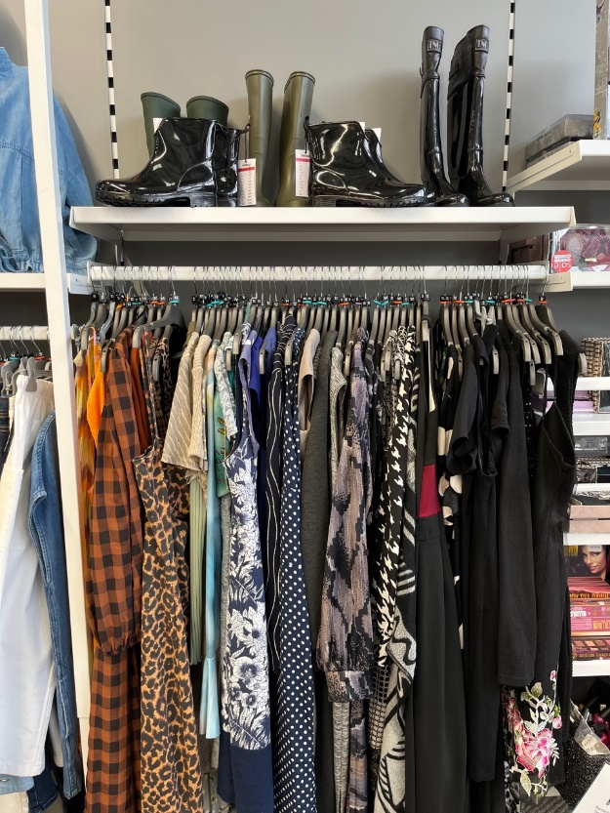
Appendices

Placement Information Form:

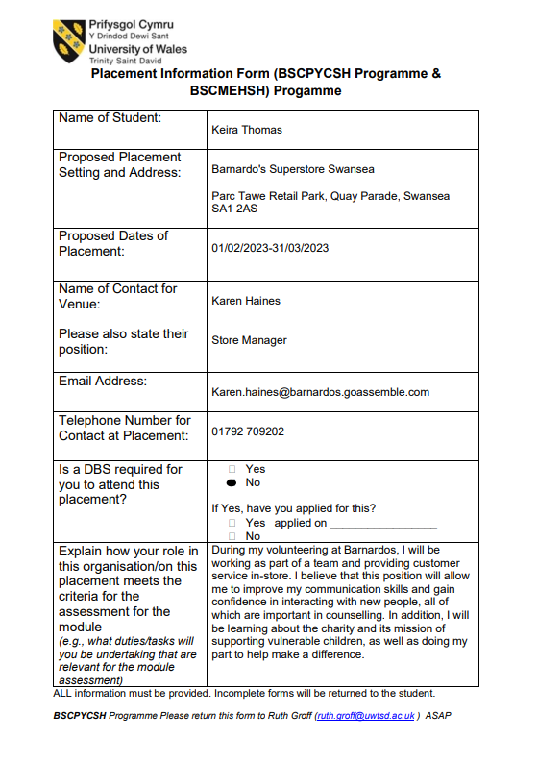

Confirmation of Placement:
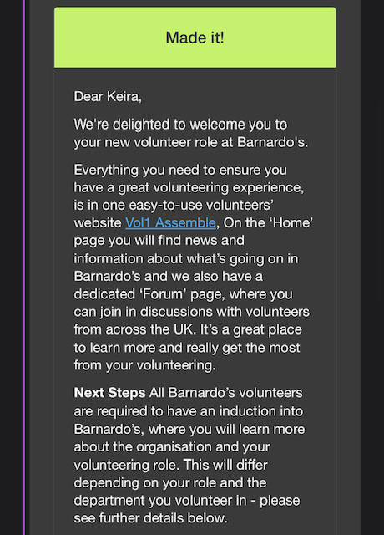

Record of hours:

Date | Time | Number of Hours
February 14th | 10am-3pm | 5
February 22nd | 11am-4pm | 5
March 1st | 11am-3pm | 4
March 8th | 12pm-4pm | 4
March 24th | 11am-4pm | 5
March 28th | 11am-3pm | 4
April 5th | 11am-4pm | 5
April 12th | 12pm-4pm | 4

Total hours completed- 36
References
Children’s Mental Health Statistics | The Children’s Society. (2023, April 5). Childrenssociety.org.uk https://www.childrenssociety.org.uk/what-we-do/our-work/well-being/mental-health-statistics#:~:text=In%20the%20last%20three%20years,have%20a%20mental%20health%20problem.

Our history. (2023). Barnardo’s. https://www.barnardos.org.uk/who-we-are/our-history

Our values. (2023). Barnardo’s. https://www.barnardos.org.uk/our-basis-and-values

Volunteer with us. (2023). Barnardo’s. https://www.barnardos.org.uk/get-involved/volunteer

