Database Report
Contents:
- Introduction
- Development stage
- Future Well-being of Generations Wales ACT 2015
- Compare database and Prosumer data file
- Conclusion

Introduction
Through this report, there will be evidence of a data gathered, to create a table to locate and contact venues and service around the UK. The database is filled with 20 different venues around UK.
A database consisting of relevant information, usually in multilingual format. The approach used for this database was planning & design. The Design was structured, and a mixture of relevant Venues suited for Conference. Planning was a small step, which took hours of continuous suggestions to find the most suitable database.
The implantation of the database was finding all Hotels, Castles, Museums. suitable for the database, finding most obvious selections however adding choice to the Venue options can improve predicted area selections. Maintenance with this specific design was mainly related was keeping on track, allowing time to evaluate the data, whilst writing a report. The data for conference database is gathered from multiple venue compare websites, this includes basic information such as, Venue name, addresses, contact details Etcetera.

Development Stage
The Venue database was created on Microsoft Access 2018. The design was blank, in hope to give access to up-to-date, accurate information for the Conference meeting. For this specific database, I researched evidence which might have an improvement to the table, to make the information as relevant as possible, although to help build a picture for the viewer of how popular the hotels would have been.
Planning the database was simple although taking action was rather a challenge. beginning with a plain blank Microsoft access table. Adding researched information from venue websites in result to find a suitable venue for Future Well Being of Generations Wales Act 2015. with accurate Locations, postcode and contact information. With Thought of an that the database would be accurate to the fitting of a Conference and the assignment. Database design was basic, with a strict, structured with relative relationships and relative data recorded.
The implementation would have been the query within tables, that was a profound struggle. Also, another problem found within the database was time management. Although the Conference Venue wasn’t decided, it became clear that suitability should was left up to the client.

Future Well Being of Generations Wales Act 2015
Future Well Being of Generations Wales Act 2015 is an ACT about improving social, economic, environmental and cultural future well – being of wales. The ACT establishes its role to act as protector for the interests of future generations in Wales. The reason is to better sustainable development (GOV.UK, 2015).
The seven goals in the Welsh Well-being of future Generations ACT is to “be applied for the purpose of measuring progress towards the achievement of the well-being goals” although a seven-step goal to achieve the Well-Being of the Future Generations ACT

- A Prosperous Wales
- A Resilient Wales
- A More Equal Wales
- A Healthier Wales
- A Wales of cohesive Communities
- A Wales of Vibrant Culture & Welsh Language
- A Globally Responsive Wales
The ratio for the chosen location conference venues, was a more random approach. Considering the Well-being of future Generations ACT of Wales, the majority of Venus were within Wales. People from various areas will be able to travel to the chosen location hopefully within the of region the ACT would part take.
The most relative approach to the Well-being of Future Generation ACT, Conference Venue should be maintained within a Welsh district, although there are different Venues available, so the client could decide themselves. (wales, 2019)
The most aligned selection from the Future Well-being ACT of Wales, would be a more equal and globally responsive Wales. This is to ensure future generations have equipment needed and enough training techniques to help the future become a sustainable place. (Wales N. , 2015) with the Act partaking in wales,

Appendices - Captured data: PICTURE OF LINKS

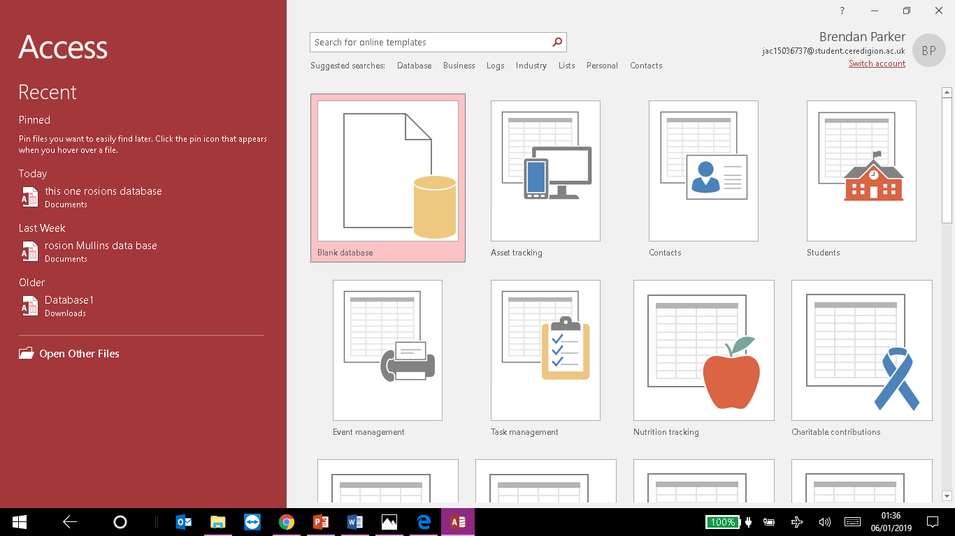

(05/01/2019).
This is the beginning of database, was simple once blank document was opened, there became a real rush to finish with sufficiency intending on using gathered information to insert fields and tally appropriate Venues.

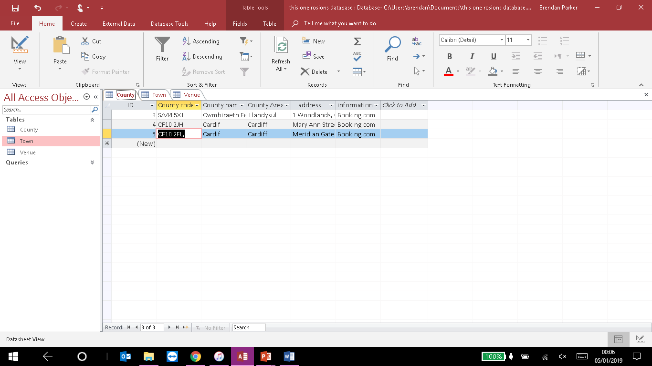(05/01/2019 )
During this screenshot, there is evidence of insertion of Venues around the county are being recorded, for 20/01/2019. Including Maximum of three tables re-named to County, Town, Venue. The reason for these three chosen is to narrow down hotels giving them categories such as one to five-star ratings.
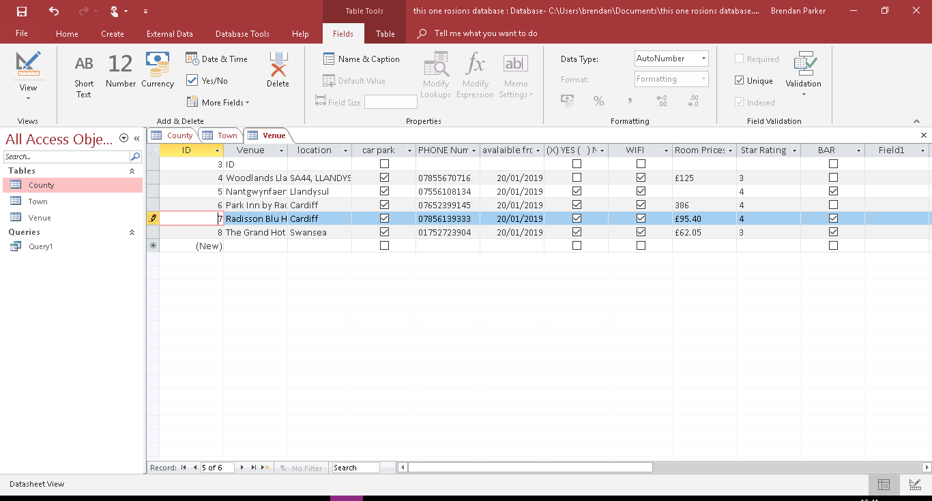
The Data shown in either of these fields, have been filled to specify criteria relevant to the hotel’s, for instance customers need to know names, location and utilities available. Applicable information was recorded in the data, using these fields.
The reason for these choices of Venue’s is because hotels are in competition within a large economy besides respond with satisfying customers by supporting deals into attracting customers, also the fields entered are relevant to the task.

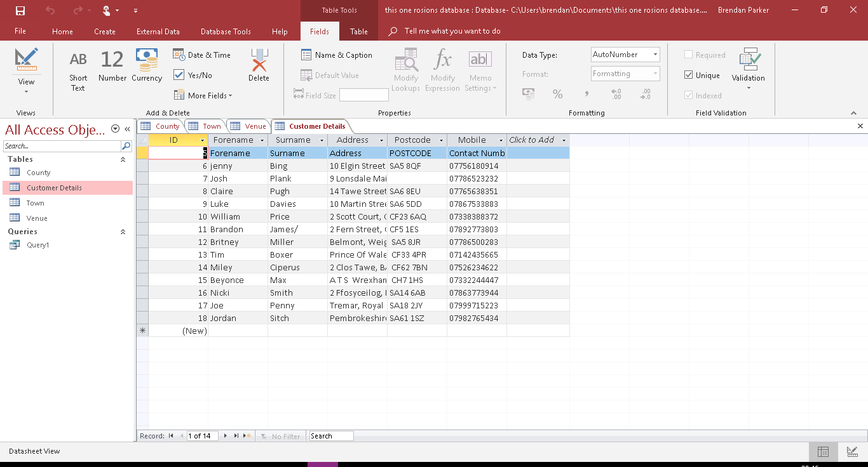
(05/01/2019)
The conference table’s, design was more structured. The Conference clients will analyse their choice, and the database will give the chance to evaluate better choices for venues they would prefer to attend.
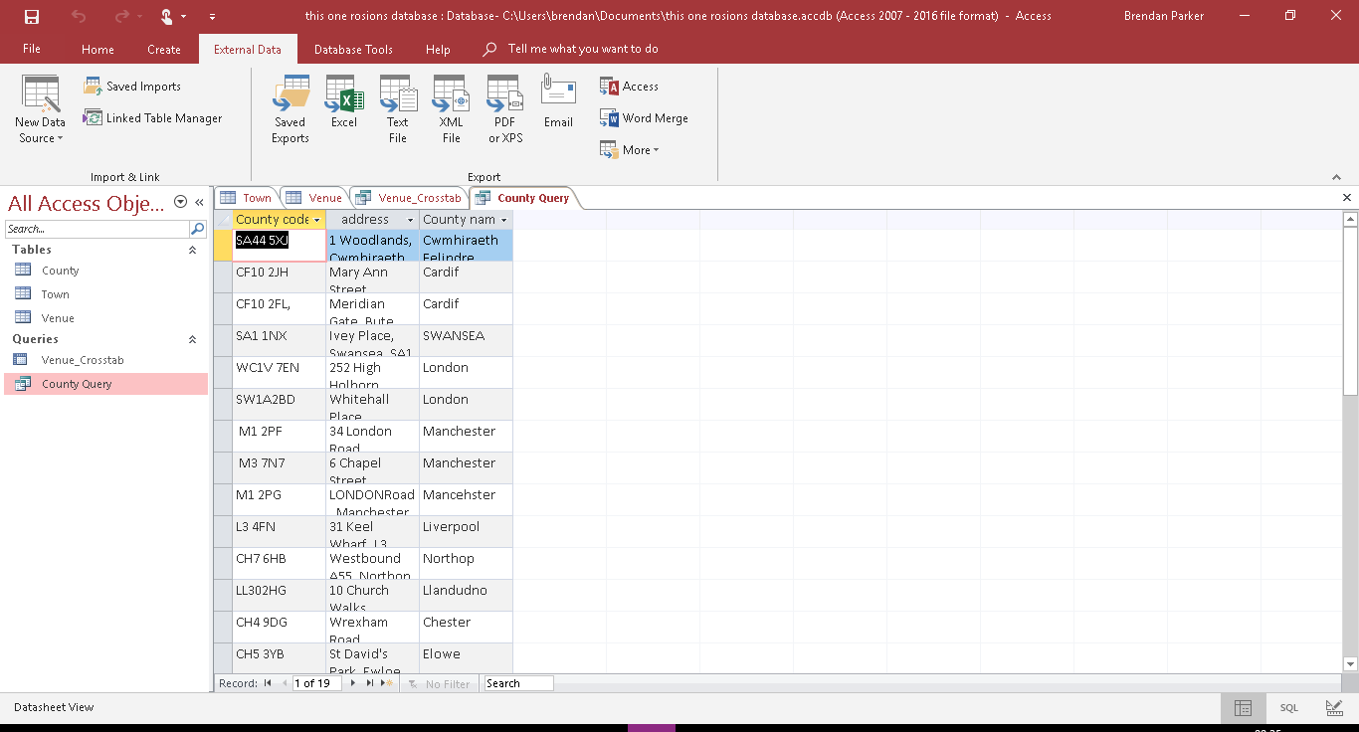 (05/01/2019)

This screenshot was taken after first completion of a query. The idea was to adjust the area codes and addresses to allow all correct information had been added. The clients could see the area’s available.
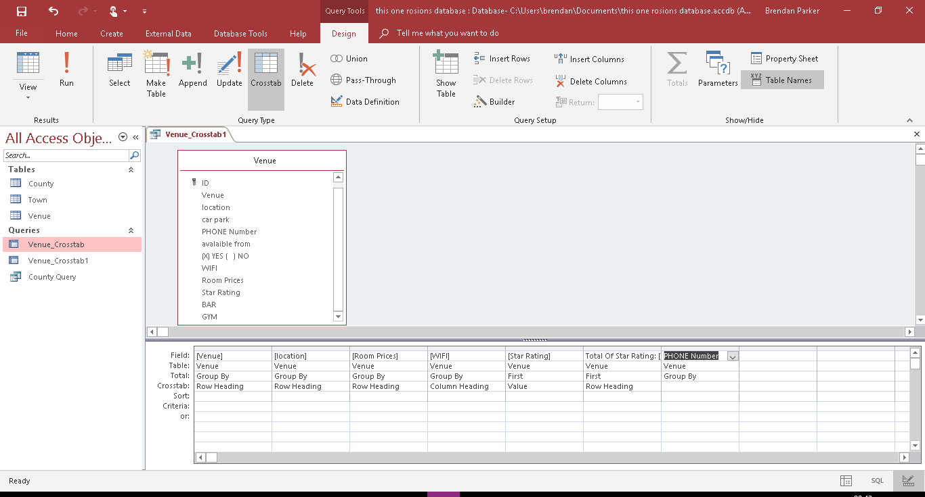
(05/01/2019)
This was the beginning of the run cycle, selecting data from the chosen tables to calculate whether the query gives vital information from other tables. The run cycle initiates the query, to view how it would look within database form.
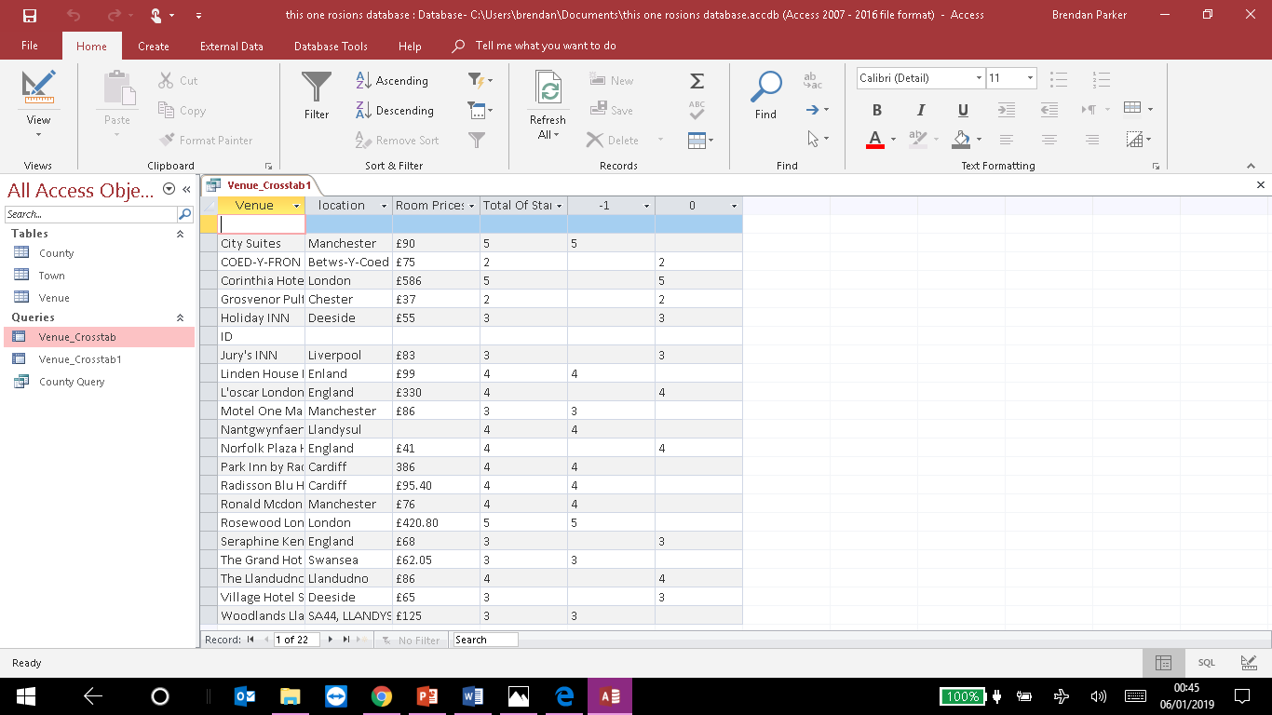(06/01/2019)

Once all the fields are chosen from different tables, in wizard query setting the chosen few will turn into a different form of data. Looking something like this. Benefits of using an online database is to enable full recovery through the cloud, although I did not use this technique.
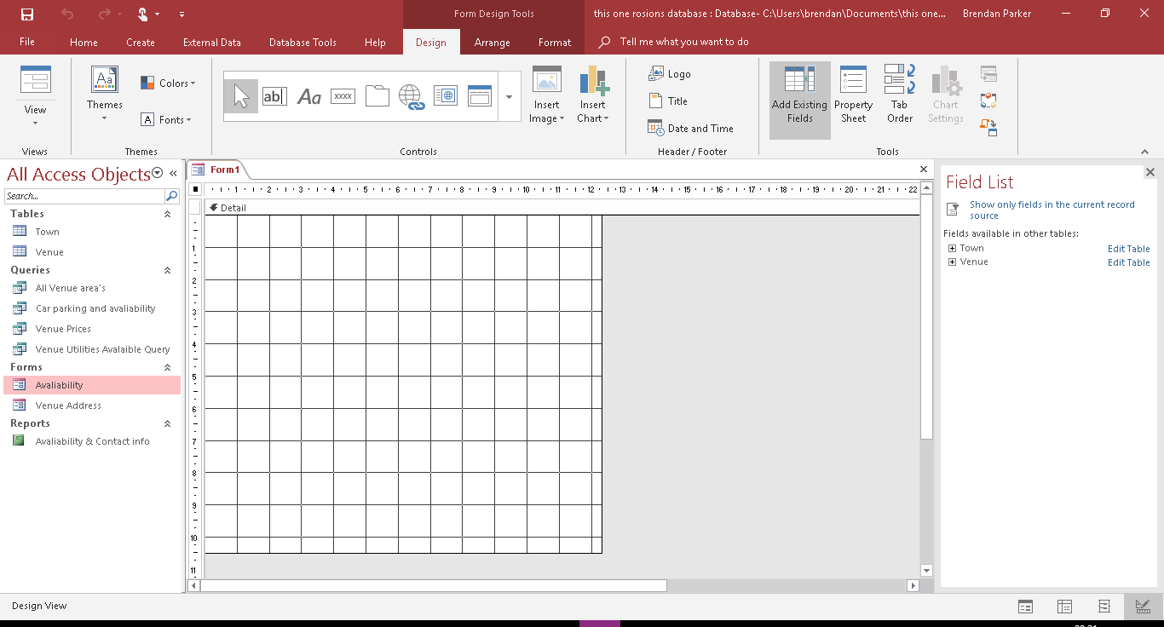
This print screen shows the beginning of a form being created. This form is a direct connection to a data source from tables and queries.
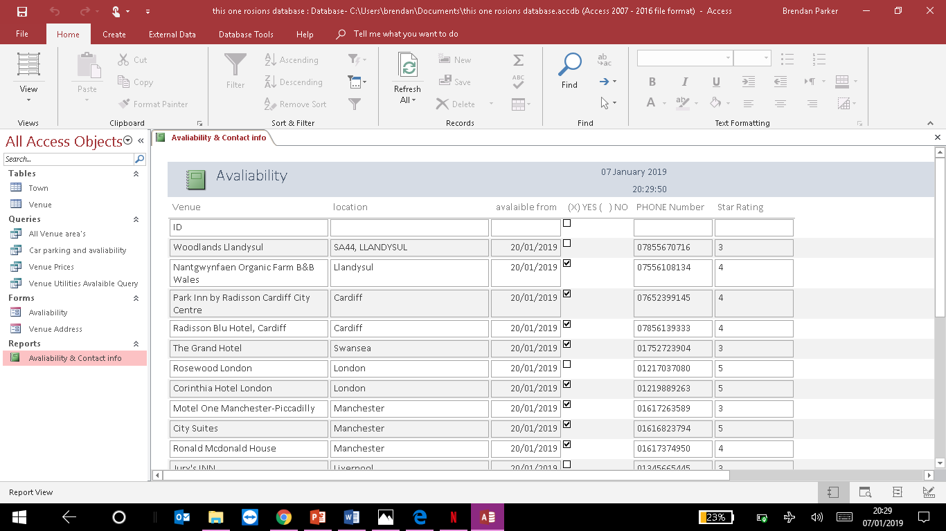
(06/01/2019)
During this screenshot, the first report inside the database had finally been pieced together. By investigating all the data, selecting the most accurate information that could be in interest to customers. From this conference database, there was a benefit of importing data to locate a venue which would be suitable for the future generations of wales Act. Microsoft Access makes it easy to import data, query and from to eventually end up with the end results.

Compare database and Prosumer data file
The prosumer database was considered to be a more expanded structured view of critical information. Although the information gathered for the prosumer document was more difficult. Comparing the two together and analysing differences between them both is firstly the layout. When the prosumer document was handed, there were already fields fill in, to gather the information that the prosumer database needed, entering the criteria in the fields filled out. Although the venue database, was more creative. It allowed me to progress and understand the similarities between the two. The difference between the prosumer and Conference venue was completely different data was required for each document. Another difference between the two databases was the prosumer was created on Excel and the conference was created via Microsoft access. Alternatively, the prosumer database had 10 fields filled in along with the field criteria, which helped greatly into completing it.

CONCLUSION
If I could do the Database again, I would give more time for the database design and plan a lot more, on the structure chosen. Between the prosumer database and conference venue database, I had more fun designing and creating the conference database than I did designing it. Although up to 10 fields of criteria in the prosumer database was filled, improving work ethic to show how the work should have been done. Whilst thinking of important aspects of maintaining a database, I had to ensure back up data was available in case of the worst scenario. The valuable data must be protected, so I recorded every link and source, used to require data from the hotels, venues, museums to locate accurate information to add to the database. Therefor there will be another copy available.
The purpose of this database is to identify a number of Venues around Wales and the UK. The benefits of this database are to access quick reliable data, to offer customers the chance to choose their own venue. To evaluate which could possibly be the best deal regarding area and prices.
Businesses often use databases to manage customers inventory and personal information. Data is a powerful tool and must be organised to allow good quality of data. When databases are accurately recorded, they can benefit businesses for example to contact a previous customer, or to appraise feedback from venue locations. Some businesses use databases to calculate how much products are in the warehouse and how much is available for customers on store shelves. When used effectively, businesses can improve the efficiency and profitability of a business.
The conference database was a struggle, although finding some venues suitable for the conference did come to mind, especially with the Well-Being of Future Generations ACT being in Wales, on the other hand options for the client can draw the client to the main attractions during the major cities of wales such as Cardiff or Swansea.

Works Cited
BOOKING.COM. (2018). THE GRAND HOTEL. Retrieved from https://www.booking.com/hotel/gb/thegrandhotel.en-gb.html?aid=308014;label=msn-oTdx6GHqY0LiwlkQoduYkA-15790294399%3Atikwd-16597484317%3Aloc-188%3Aneo%3Amte%3Adec%3Aqshotels%20in%20swansea;sid=d45f827799172999da8a4f0441fadd45;all_sr_blocks=59180_131274692_
GOV.UK. (2015). The national Archive. Retrieved from http://www.legislation.gov.uk/anaw/2015/2/contents/enacted
Radisson Blu Hotel, C. (2018). Retrieved from Booking.com: https://www.booking.com/hotel/gb/radisson-blu.en-gb.html?aid=308014;label=msn-q7R%2AtYsz3YBCvUS1Jdr1hQ-16803793774%3Atikwd-17461121370%3Aaud-805442846%3Aloc-188%3Aneo%3Amtb%3Adec%3Aqshotel%20venue%20cardiff;sid=d45f827799172999da8a4f0441fadd45;all_sr_bloc
Radisson, P. I. (2018). Booking.com. Retrieved from https://www.booking.com/hotel/gb/park-inn-cardiff-city-centre.en-gb.html?aid=308014;label=msn-q7R%2AtYsz3YBCvUS1Jdr1hQ-16803793774%3Atikwd-17461121370%3Aaud-805442846%3Aloc-188%3Aneo%3Amtb%3Adec%3Aqshotel%20venue%20cardiff;sid=d45f827799172999da8a4f0441fa
wales, C. (2019). FutureGenerations Commissioner for Wales. Retrieved from https://futuregenerations.wales/about-us/future-generations-act/
Wales, N. (2015, 03). Retrieved from https://gov.wales/topics/people-and-communities/people/future-generations-act/national-indicators/?lang=en
Wales, N. O. (2018). Retrieved from Booking.com: https://www.booking.com/hotel/gb/nantgwynfaen-organic-farm-b-amp-b-wales.en-gb.html?aid=308014;label=msn-oTdx6GHqY0LiwlkQoduYkA-15790294399%3Atikwd-16597484317%3Aloc-188%3Aneo%3Amte%3Adec%3Aqshotels%20in%20swansea;sid=d45f827799172999da8a4f0441fadd45;all_

