Debbie Yan Po Ying Student ID #: 2324333Programme: MBA(HKBM7007)
Student ID #: 2324333
Module Code: HKBM 7012
Three-Year Marketing Strategy for Her Own Words Sports (HOWS):
Establishing a Leading Position in the Hong Kong Women's Sportswear Market
Executive Summary
This report is a comprehensive three-year marketing plan for Her Own Words Sports (HOWS), a Hong Kong-based company that is owned by the publicly traded Regina Miracle. Known for its rapid growth, intense competition, and evolving customer preferences, the women's sportswear market in HOWS are founded.
The situation analysis shows HOWS's strong brand reputation, well-established distribution network, and innovative product development abilities. Nevertheless, the company faces challenges with keeping up with market trends, addressing price-sensitive customers, and differentiating its products from competitors.
The report recommends HOWS to adopt a focused segmentation strategy that targetting on health-conscious women. HOWS should strategically promote its products as premium, fashionable, and eco-friendly sportswear that empowers women to embrace and continue living active lifestyles. To strengthen the marketing mix, it is essential to enhance the quality of the product, optimize pricing strategies, expand distribution across multiple channels, and launch a comprehensive digital marketing campaign.
Over the upcoming three years, these strategies are projected to increase HOWS's market share, brand loyalty, and profitability, establishing the company as a leading player in the Hong Kong women's sportswear market.

Table of Contents

- Introduction
Overview of the Women Sportswear Industry in Hong Kong _____________________________ 3
  - Background on Her Own Words Sports and Regina Miracle __________________________ 3

2. Situation Analysis
2.1. External Environment Analysis _______________________________________________ 4-5
2.2. Internal Environment Analysis _______________________________________________ 6-7
2.3. SWOT Summary ____________________________________________________________ 8-9

3. Segmentation, Targeting, and Positioning Strategies
3.1. Market Segmentation Approach _________________________________________________ 10
3.2. Target Market Selection ______________________________________________________ 11
3.3. Positioning Strategies ______________________________________________________ 11-12

4. Evaluation of the Effectiveness of the Marketing Mix
  - The perceptual map of women’s sportswear brands in Hong Kong ______________________ 13
  - Product Strategies ____________________________________________________________ 14
  - Pricing Strategies ____________________________________________________________ 15
  - Distribution Strategies _______________________________________________________ 15
  - Promotion Strategies ________________________________________________________ 16

5. Recommendations and Conclusion for the Coming 3 Years
  - The Gantt Chart _____________________________________________________________ 17
  - Implementation and recommendations ____________________________________________ 18

6. References ________________________________________________________________ 19-20
1. Introduction
In Hong Kong, the women sportswear industry has experienced significant expansion in recent years. The expansion has been attributed to the growing demand for active lifestyles, increasing awareness of wellness, and prevailing sportswear fashion trends. The market characterized by intense competition, as both domestic and international brands strive to capture a portion of the highly prosperous women sportswear industry. The women's sportswear business is being driven by sustainability, customization, product comfortable, and social media impact. Women customers are looking for environmentally friendly, personalized sportswear that is specifically designed to meet their own unique demands. Social media has a significant influence on brand engagement, its decisions. (Kim and Kim, 2020)

  - Background of Her Own Words Sports (HOWS)
Her Own Words Sports (HOWS), a Hong Kong women lifestyle sportswear brand established in 2016, is owned by Regina Miracle, a publicly traded company known for manufacturing high-quality intimate apparel and sports bras. Established in 2011, Her Own Words (HOW) is a lifestyle lingerie brand with the mission of "Engineered for Comfort" that is also owned by Regina Miracle. HOWS's key stakeholders encompass its parent company, Regina Miracle, as well as the HOW brand, a team of experienced designers and product developers, an extensive network of authorized retailers and distributors, and a growing group of devoted customers. HOWS established itself as a key player in the local women sportswear industry especially sports bra expert with 17 sizes tailored for Asian, recognized for its stylish and high-quality athletic apparel offerings. The company utilizes a multi-channel distribution strategy, with an extensive presence in both physical stores and online e-commerce platforms. There are currently 26 physical stores in total for HOW and HOWS, included 2 HOWS individually stores. (Her own words, 2024)

- Situation Analysis
  - External Environment
To gain a thorough comprehension of the external factors that influence HOWS, the PEST analysis is a widely used audit tool for identifying and analyzing the key factors in the macroenvironment that can have an impact on an organization's strategy development (Worthington and Britton, 2006). By understanding the political, economic, social, and technological circumstances, the company can make more knowledgeable strategic decisions (Ward & Rivani, 2005).

Political and legal environment:
The sportswear business is encountering growing government regulations and customer expectations about sustainability and ethical manufacturing processes. Over the next three years, companies such as HOWS will be required to improve their environmentally friendly production methods and raise their supply chain transparency to remain compliant and attract socially conscious consumers (Khurana & Ricchetti, 2016).

Economic environment:
Hong Kong's economy has experienced moderate recovery, with GDP expanding 6.4% in 2021 after contracting in 2020 due to COVID-19 (HKTDC Research, 2023). However, inflationary pressures and potential recessionary risks pose challenges. The sporting goods and activewear industry have shown resilience, with sales rising 8.2% in 2021 (HKTDC Research, 2023). Industry analysts forecast continued growth driven by health and wellness trends, as well as evolving consumer preferences. The Hong Kong women sportswear market is highly competitive, with global brands like Lululemon, Sweaty Betty, Nike and Adidas competing against domestic women activewear focus brands Coffee Sweat, Flow with me and Hoya Kerry, as well as fast-fashion retailers like Uniqlo, H&M and GU at relatively lower price points. It is essential for HOWS to diligently track spending trends and make necessary changes to maintain competitiveness amid economic volatility over the next three years.

Sociocultural environment:
The sportswear market is expected to be primarily influenced by ongoing wellness, health, and female empowerment trends in the next three years. There is a growing trend among consumers, particularly women, for seeking sportswear that is not only functional but also consistent with their personal values regarding sustainability, comfort, and confidence (Khurana & Ricchetti, 2016). HOWS must leverage social media and influencer marketing to engage and reach their target customers. Platforms like Instagram and TikTok have become critical channels of this strategy. Utilizing social media influencers and ambassadors are now an essential component of brand marketing strategies (Keller, 2020).

Technological environment:
The activewear market has undergone significant technological transformation, necessitating strategic considerations by HOWS over the next three years (Thomassey & Zeng, 2018). The proliferation of e-commerce and social media has drastically altered consumer behavior, requiring HOWS to prioritize a digital-first approach to effectively reach its target demographic (Smith, 2020), as well as leverage technology to enhance inclusivity through personalized fit and a wider range of sizing options.

  - Internal Environment
By conducting a value chain analysis, HOWS can thoroughly evaluate its operations and capabilities, thereby identifying its core strengths and areas for strategic improvement (Gereffi & Fernandez-Stark, 2016). The analysis is clearly demonstrated in a graph (Figure 1) with a comprehensive overview of the key activities contributing to HOWS' competitive advantage, enabling the company to identify its strength and potential improvement.
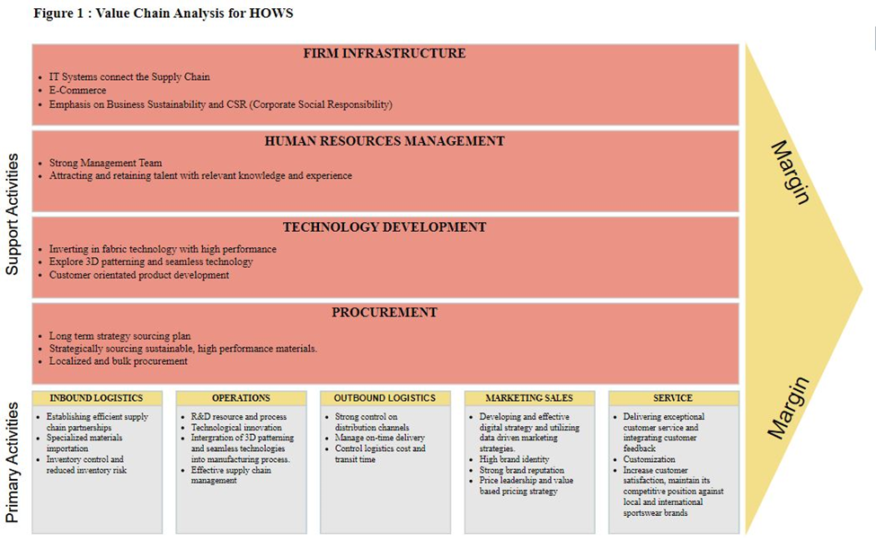
HOWS has built a strong foundation for its operations and competitive advantage in the women sportswear market in Hong Kong. At the core of the company's capabilities is its
robust digital infrastructure, including advanced IT systems, seamless e-commerce capabilities, and integrated supply chain processes (Keller, 2020). HOWS also places a strong emphasis on sustainability and corporate social responsibility, aligning its practices with environmental and ethical standards (Regina Miracle International (Holdings) Limited, 2023). Effective human resource management helps the company attract and retain talented employees to drive innovation and operations. HOWS strategically invests in product development, leveraging technologies like 3D patterning and innovative fabrics to deliver high-quality, customized offerings (Regina Miracle International (Holdings) Limited, 2023). The company's procurement and manufacturing strategies, including optimized use of its own production resources and sourcing of sustainable materials, further enhance its operational efficiency. HOWS has also established effective supply chain partnerships, integrated advanced manufacturing techniques, and maintained tight control over its distribution channels. Underpinning these capabilities is HOWS' data-driven marketing approach, strong brand identity and reputation, as well as its focus on outstanding customer service and customization. By leveraging these core competencies, HOWS is well-positioned to strengthen its position as a leading player in the women's activewear industry in Hong Kong.
The company's strong digital infrastructure, which encompasses sophisticated IT systems, seamless e-commerce capabilities, and integrated supply chain procedures, forms the foundation of its capabilities (Keller, 2020). HOWS builds an important value on sustainability and corporate social responsibility, ensuring that its operations meet to environmental standards. Effective human resource management enhances the company's capacity to attract and retain talented employees to drive innovation and operations. HOWS strategically invests resources to product development, leveraging advanced technologies like as 3D patterning and innovative fabrics development to provide deliver high-quality, customized offerings. Its procurement and manufacturing techniques, including efficient use of its own production capabilities and sustainable material sourcing, maximize operating efficiency. HOWS built excellent supply chain relationships, integrated innovative production techniques, and strictly monitored its distribution channels. HOWS can strengthen its position as an important player in the women's activewear industry in Hong Kong by focusing on its core competencies through enhancing its value chain.

  - SWOT summary
SWOT analysis is a method used to identify a company’s competitive strengths, weaknesses, opportunities and threats, thus organically integrating its strategy with its internal resources and external environment (Benzaghta et al. 2021). Based on the external and internal environment analysis, the following SWOT summary (Table 1) has been conducted for HOWS, it provides valuable insights into HOWS’s current market position. It highlights HOWS’s key assets, such as its strong brand identity, advanced manufacturing capabilities, and sustainability focus, positioning it well to capitalize on growing demand for high-performance activewear. However, weaknesses like limited physical retail presence and talent challenges, along with threats of intense competition and economic uncertainties, require HOWS to address operational agility and continue innovating. It also identifies potential opportunities for growth, such as technological advancements and e-commerce expansion, but also cautions against shifting consumer preferences and supply chain disruptions. HOWS needs to capitalize on its strengths, seize opportunities, and proactively address its weaknesses and threats to fortify its market position.
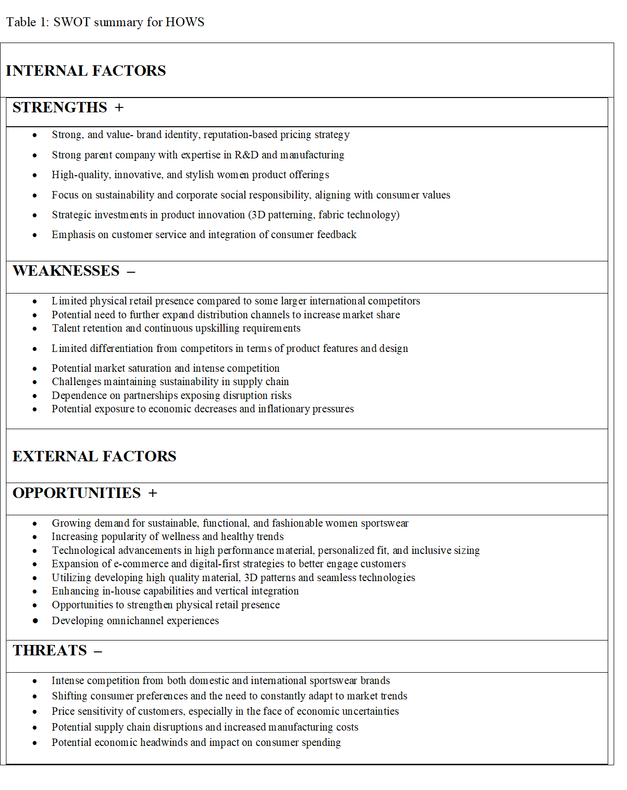

3. Segmentation, Targeting, and Positioning Strategies
3.1. Market Segmentation Approach
HOWS prioritizes the female consumer segment in Hong Kong as one of its primary market segmentation strategies (Solomon, 2020). Demographically, HOWS's market segmentation strategy is gender-focused, with the female consumer segment identified as a key target. This strategic decision aligns with the brand's core self-identification and the growing demand among female consumers in Hong Kong for high-quality, sustainable, and fashionable sportswear.
The women's market in Hong Kong is a significant and rapidly expanding segment. This expansion has been driven by an increased engagement in leisure and sports activities, as well as a greater focus on wellness, health, and personal style (Solomon, 2020). Through deeper segmentation within the broader women's market, HOWS recognized and benefited from this trend.
A study on the Korean female apparel market highlighted the importance of store attributes in consumer segmentation (Hong & Koh, 2002). This suggests that HOWS should prioritize emphasizing the advantages of an n active, healthy lifestyle in its marketing communications to engage with the target demographic of active female consumers in Hong Kong.
By comprehending the specific needs and preferences of its female target market in Hong Kong, HOWS can customize its store environment, product assortment, and customer service to provide a more engaging and satisfying customer experience. This targeted approach to benefit segmentation enables HOWS to efficiently meet the specific requirements of its female consumers, consequently reinforcing its position in the rapidly expanding women's sportswear market in Hong Kong.

3.2. Target Market Selection
HOWS implements a variety of targeting strategies to attempt to efficiently connect with its core segment of health-conscious, active female consumers in Hong Kong. From a psychographic perspective, HOWS needs to focus on women who lead healthy, active lifestyles and participate in various sports and fitness activities (Kotler & Keller, 2016). A study done with the relationships between perceived benefits, barriers to physical activity, physical activity participation, and physical fitness in Hong Kong female adolescents found that promoting the perceived benefits of physical activity, such as improved health, fitness, and social interaction, can effectively encourage greater participation in sports and exercise (Cheng et al. 2003). This is consistent with the brand's positioning as providing functional, fashionable activewear that caters to the needs of the modern, customization and health-conscious consumer. It is important to prioritize demographic targeting, focusing on women between the ages of 25 and 45, as this age group is more likely to have the disposable income and interest in investing in high-quality, versatile activewear (MarketResearch.Biz, 2024).

3.3. Positioning Strategies
HOWS should position its brand as a premium quality sportswear brand that empowers women in Hong Kong to achieve their health and athletic goals. The brand should prioritize highlighting its commitment to quality, innovation, customization, and social responsibility, while establishing itself ahead of competitors by showing its unique brand story and focus on promoting female empowerment (MarketResearch.Biz, 2024). This positioning strategy is in alignment with the growing demand from female customers Hong Kong for sportswear that is of high-quality, sustainable, and fashionable activewear (Solomon, 2020).
It is recommended that HOWS emphasize the performance-driven and versatile nature of its products by leveraging fabric technology advancements to offer products that are moisture-wicking, breathable, and provide the necessary support for various sports and activities. This positioning will attract the physically active and health-conscious female consumers in Hong Kong who seek activewear that can seamlessly transition from the gym to everyday wear (Beran and Evans, 2019). Additionally, HOWS should position itself as a socially responsible and sustainable brand that places a high priority on environmentally friendly operations and materials, connecting to the eco-conscious values of its target market (Berman & Evans, 2019). Offering customization options especially on sport bras Asia sizing in 17 size choices is a great way for the brand to distinguish itself out and demonstrate how it understands about satisfying the specifications of customers (Her own words, 2024).

- Evaluation of effectiveness of the marketing mix
  - The perceptual map of women’s sportswear brands in Hong Kong
The perceptual map of women's sportswear brands in Hong Kong (Figure 2) provides insightful findings that can be implemented into the evaluation of the HOWS marketing mix (product, price, place, and promotion). The brand positioning along price and quality dimensions provides a visual representation of the competitive landscape, which HOWS can leverage to understand its relative positioning and identify opportunities for strategic differentiation (Kotler & Keller, 2016). These findings can inform product development, pricing, distribution, and promotional decisions to better align with target market preferences.
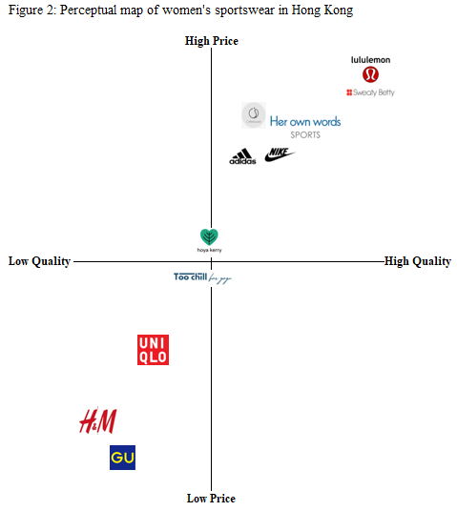

4.2. Product Strategies
The HOWS product line is a key strength of the company's marketing strategy. The brand has positioned itself as a high quality, high-performance activewear brand that caters to the needs of its target consumers. The products utilize innovative fabric technologies to offer moisture-wicking, breathable, high stretchability, and supportive clothes suitable for a variety of sports and activities. As well as their customization fit offering on its sports bra with a wide range of cup and band sizes. This aligns well with the preferences of the target market, who seek activewear that can seamlessly transition from the gym to everyday wear (Berman & Evans, 2019). Another notable strength of the HOWS product line is the brand's strong commitment to sustainability and social responsibility. This positioning as a socially responsible brand further enhances the attractiveness and perceived value of the HOWS product portfolio.
However, a recent evaluation conducted by the Consumer Council discovered that certain HOWS products, including yoga pants and sports bras, have room for improvement in terms of their breathability, quick-drying capability, elasticity, and durability (Consumer Council, 2023). To address those weaknesses in performance, HOWS must keep working in improving its fabric technology, R&D, wear testing and quality control in production processes to remain competitive with the highest quality competitors. HOWS should continue to expand its product portfolio, focusing on high-performance, sustainable material, technologically advanced, and stylish activewear suitable for a variety of sports and fitness activities.

4.3. Price Strategies
HOWS' present positioning as a high-quality, high-performance sportswear brand allows the company to charge middle to high price points that match the willingness of its target market to pay. Research showed that customers in the sportswear market are frequently prepared to spend more money on clothing that enhanced functionality, comfort, and durability (Berman & Evans, 2019). The perceptual map (Figure 2) shows a wide variety of price points, including affordable brands such as UNIQLO and GU to high-end brands like Lululemon and Sweaty Betty. HOWS can leverage this pricing flexibility to provide a variety of price options across its product offering, accommodating different consumer segments and their diverse budgets (Zeithaml, 1988). Implementing a varied pricing approach can enable HOWS to stay competitive, maintain its middle to premium brand positioning, and strengthen its value offer.

4.4. Distribution Strategies
The distribution of HOWS products is an important aspect of the company's marketing mix. By establishing an extensive network of physical retail stores and an e-commerce platform, HOWS offers that its target consumers can access the brand's offerings through their preferred channels. The strategic positioning of HOWS stores in high-traffic, convenience locations enhance the brand's visibility and accessibility. In addition to its own standalone stores, HOWS can expand its brand's reach and expose it to a broader customer base by collaborating with third-party retailers, such as specialty sports multi-brand stores Decathlon and Sportshouse. This will allow HOWS to accommodate a diverse range of consumer choices. Furthermore, the e-commerce landscape presents an opportunity for HOWS to expand its reach. Platforms such as ZALORA HK and HKTVmall enable HOWS to sell beside complementary brands, thus reaching an expanded customer demographic.

4.5. Promotion Strategies
To effectively promote the HOWS brand, a comprehensive promotion strategy should be implemented. Digital marketing should be the backbone of the promotion mix with the aim to reach the proficient with technology target consumers while optimizing the best use of the brand's online presence (Chaffey & Ellis-Chadwick, 2019). This should involve a strong social media plan highlighting the brand's products, sustainable initiatives, and active branding on platforms like YouTube, Instagram, and TikTok. Leveraging influencer marketing collaborations with fitness and fashion influencers can enhance brand recognition and reputation among the target consumers (Schivinski & Dabrowski, 2016).
Moreover, HOWS should continue to build its reputation through word-of-mouth and shared customer experiences. The company can convey its brand values more effectively, such as launching a VIP promotion offering special pricing on new products for loyalty customers (Keller, 2020). Through sponsoring local sporting events and collaborating with community fitness organizations, HOWS can enhance its brand visibility and establish itself as an active and socially responsible brand. By implementing those strategies, HOWS can successfully connect with its target customers and drive sales through its omni-channel distribution.

5. Recommendations and Conclusion for the coming 3 Years
5.1 The Gantt chart
The Gantt chart (Figure: 3) outlines six strategic initiatives for HOWS marketing plan in the upcoming three years.
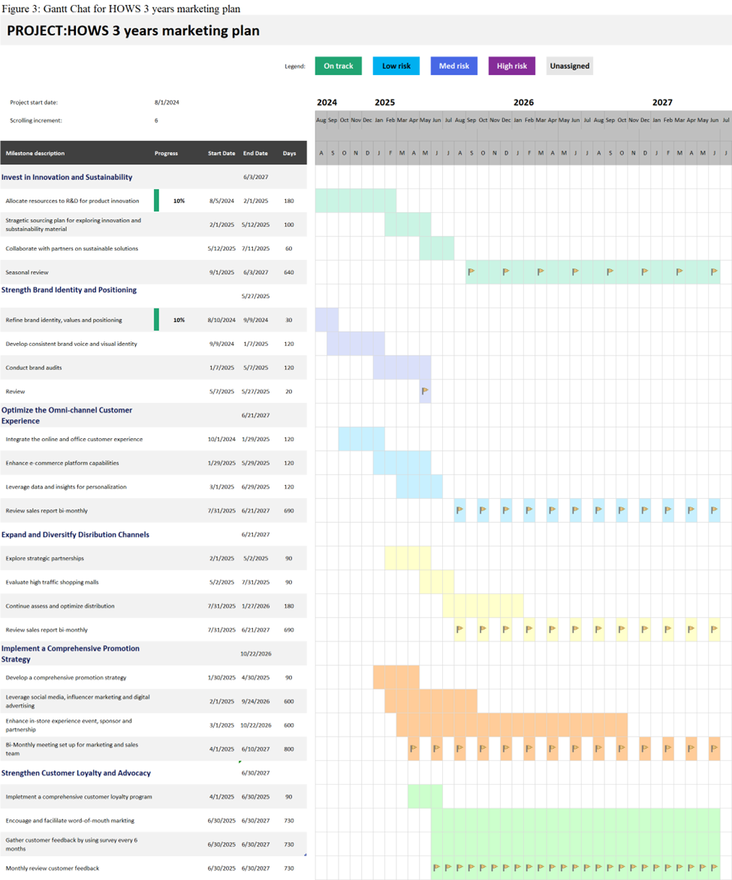
5.2 Implementation and recommendations
The primary focus is the "Invest in Innovation and Sustainability" recommendations, which is aligned with research that emphasizing the importance of product innovation and sustainability in the apparel industry (Caniato et al., 2012). Beyond that, the plan also includes: Strengthen Brand Identity and Positioning through brand refinement, consistent brand voice, and brand audits (Aaker, 2012); Optimize the Omni-channel Customer Experience by integrating online and in-store touchpoints, enhancing e-commerce, and leveraging data for customization (Verhoef, Kannan and Inman, 2015); Expand and Diversify Distribution Channels through strategic partnerships, high-traffic shopping analysis, and distribution optimization (Dutta, Gwebu and Wang, 2020); Implement a Comprehensive Promotion Strategy including a promotion plan, social media marketing, and in-store experience events (Kotler & Keller, 2016); and Strengthen Customer Loyalty and Advocacy via a loyalty program, word-of-mouth marketing, and regular customer feedback (Her Own Words, 2024). To assess the effectiveness of these activities, HOWS can monitor key performance indicators, and reviewing reports and analyzing customer and environmental impact assessments can provide valuable insights into the execution and impact of these initiatives (Pal & Gander, 2018).
By implementing recommended strategies over three years, HOWS can strengthen market position, enhance customer satisfaction and drive sustainable growth. Developing sustainable, customizable products, optimizing pricing, expanding online sales, and investing in digital marketing will enable HOWS to cater to evolving customer needs and stay ahead of competition in the Hong Kong sportswear industry. With coordinating initiatives with the timeline allows HOWS to efficiently plan, schedule, and monitor the implementation to maximize the influence on the business. This approach will keep HOWS at the forefront of trends and consumer demands, while strengthening sustainability commitments (Caniato et al. 2012).



