Operating Systems
Module Name: ANALYSE AND SOLVING PROBLEM

Module Code: ACCA4019 Component 2
Student Name: Malado Fall
Student ID: 2526130
Lecturer Name: Dr Abdullah Usman
Submission date: JULY 23, 2026

Section 1: Deconstruction of the Problem
Because students live in different time zones, have varying schedules, and have limited access to shared resources, organising group meetings in a university context can be challenging. Finding a time that works for everyone frequently results in delays and missed meetings if there is no defined strategy. In order to solve this, the issue was divided into smaller components. This made it possible to establish precise limits and assisted in determining which features are necessary and which are optional.
1.1 Requirements and Constraints
Before designing any solution, it was important to separate what the system needs to achieve from the rules that limit how it can be buil [1],[2].

Requirement ( what the system must do) | Constrain (limit and rules)
The system must collect and show the availability of all group members in one place. | he solution must be built using free, open-source tools with no licensing costs.
The system must automatically identify time slots that are free for all participants. | The system must follow university data protection and privacy policies.
The system must send reminders to all members before a meeting starts. | The project must be completed and submitted before the module deadline.
The system must be accessible on both smartphones and desktop computers. | The system must run directly in a web browser and not require any software installation.
Explanation; The requirement list the key component that make the system beneficial.These include notifying users centralising schedulkes and determining mutual availability. THe restrictions are a representation of the external limitations imposed by time, money, the law and technology. Making a distinction between them. Ensure that the proposes solution is both workable and effective in addressing the problem.

1.2 Moscow Analysis

The MoSCoW prioritising technique was used to control the workload and prioritise the most crucial tasks[3].

Priority | Feature
Must have | • A centralised view of every member's schedule  • Overlapping free times are automatically calculated  • Mobile and desktop web interfaces that are responsive
Should have | Automatic email reminders  • Compatibility with various time zones  • The ability to export meetings to an Outlook or Google calendar
Could Have | • A feature that allows members to vote on meeting times  • A link to the university's current scheduling system
Won t have | • The creation of an independent mobile application  • AI technologies for creating agendas for meetings  • Premium features or paid subscriptions
Justification: The "Must have" features are essential to the system's operation and resolution of the primary scheduling problem. Although they enhance the user experience, "should have" features are not necessary for the initial release. "Could have" things can be added later if time allowed, but they are still desirable. Due to financial and scheduling limitations, "won't have" things are not included in this edition.
1.3 Important Factors
The performance of the scheduling system can be influenced by a number of things. When testing, these factors need to be taken into account.
- Group Size: Finding a common time is directly impacted by the number of students in a group. There are typically fewer overlapping spaces in larger groups.
- Time Zone Spread: The possible meeting window shrinks when members are spread out across different regions. For foreign courses, this is a significant factor.
- Meeting Frequency: The frequency at which the system must process data and provide notifications varies depending on whether meetings are weekly or one-time.
- Data Accuracy: Students must update their availability in order for the solution to work. The recommended times will be off if the data is out of date.
Justification: The system can be tested in many scenarios by determining these factors. The algorithm's scalability can be demonstrated, for instance, by comparing testing with a 3-person local group with a 6-person international group. Keeping an eye on these factors will also make it easier to determine whether the system truly cuts down on meeting scheduling time.

Section 2: Proposed Solution (Approx. 1000 words)
2.1 The Flowchart: Insert your flowchart here. This should show the logical steps for scheduling a group meeting.

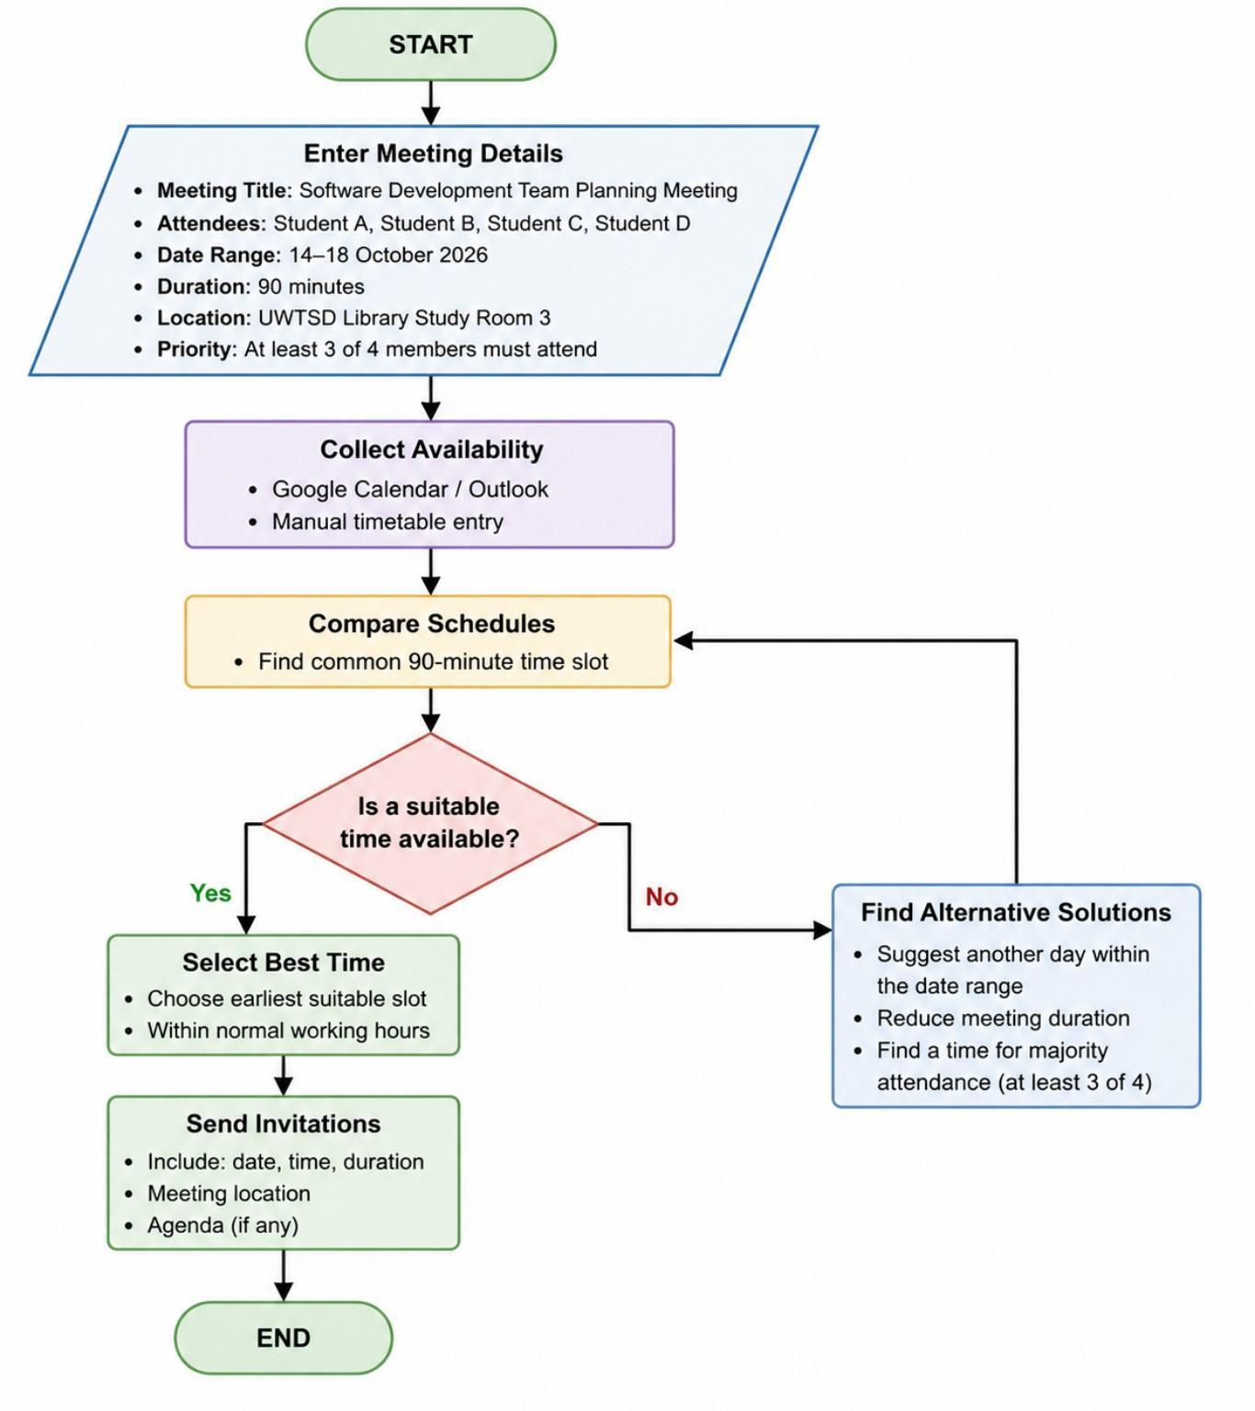
The Flowchart

2.2 Explanation: Write a clear explanation of how your flowchart works.
The proposed Group Meeting Scheduling System is designed to automate the process of arranging meetings for multiple participants. Instead of manually comparing everyone's availability through emails or messages, the system automatically identifies the most suitable meeting time, reducing both the time required and the possibility of scheduling errors.
The scheduling process begins when the organiser selects Enter Meeting Details. This stage provides the information that the system requires before searching for available meeting times.
Example Meeting Details
Meeting Title: Software Development Team Planning MeetingAttendees: Student A, Student B, Student C and Student D
Date Range: 14 October 2026 to 18 October 2026
Duration: 90 minutes
Location: UWTSD Library Study Room 3
Priority: At least three of the four members must attend.
The system looks for a continuous 90-minute time period inside the chosen date range using these details. Instead of needing every member to come, the system looks for a time when at least three people are available because the organiser has stated that only three members are needed.
The system then moves on to Collect Availability when the meeting details have been entered.
The system allows for two ways to record availability in order to provide flexibility. If users already keep digital calendars, they can let the system access their available and busy times from programs like Microsoft Outlook or Google Calendar. As an alternative, users who don't use online calendars can use the application's timetable to manually enter their available times. Every piece of availability data is safely kept in the database.

The system then moves to Compare Schedules, which is the main processing stage. During this step, the scheduling algorithm analyses every participant's timetable and searches for overlapping periods that satisfy the meeting duration and attendance requirement. Every available time slot is evaluated until suitable options are identified.
The next stage is the decision point: a suitable meeting time available?
If the answer is Yes, The Best Time option is still selected by the system. The system uses predetermined parameters to rank the available meeting times. For instance, it might select a time that is inside regular university hours or the earliest time that is accessible.
The system automatically creates and distributes meeting invitations to each participant after the appropriate meeting time has been chosen. The meeting's title, date, start time, duration, and location are all included in the invitation. The scheduling process is finished after the invitations are sent.

If the answer is No, the system does not stop. Instead, it moves to Find Alternative Solutions.
At this stage, the system attempts several alternatives before asking the organiser to make a decision. These alternatives include:
Suggesting another day within the selected date range.
Recommending a shorter meeting duration.
Identifying a time when the majority of participants are available.
Once the organiser chooses one of these options, the updated requirements are sent back to the Compare Schedules stage. This loop continues until an acceptable meeting time has been found.
Assumptions
The proposed system is based on the following assumptions:
The proposed system is based on the following assumptions:
All participants have access to an internet connection and a computer or mobile device.
Users enter accurate availability information.
Participants regularly check meeting notifications and invitations.
The system is intended for university group work and standard workplace meetings.
2.3 Justification
The proposed Group Meeting Scheduling System provides an effective solution for organising meetings by reducing manual effort and improving scheduling accuracy. Compared with traditional methods such as email conversations or messaging groups, the automated approach is considerably more efficient.
1. Improved Efficiency
Arranging meetings manually often requires multiple conversations before a suitable time can be agreed upon. As the number of participants increases, this process becomes increasingly time-consuming.
The proposed system automates both the collection of availability and the comparison of schedules. Tasks that may normally take an organiser several hours can be completed within a few seconds.
2. Improved Accuracy
Manual scheduling increases the possibility of overlooking timetable conflicts or booking participants who are unavailable.
The scheduling algorithm compares every participant's availability against every possible meeting time, ensuring that the selected meeting satisfies the required duration and attendance criteria while reducing human error.
3. Better Communication
The system reduces unnecessary communication between participants. Each participant only needs to provide their availability once, after which the organiser receives the recommended meeting time.
When a meeting has been confirmed, the system automatically distributes invitations containing all relevant meeting information, eliminating repeated discussions within group chats.
4. Flexible Conflict Resolution
A suitable meeting time is not always immediately available. Instead of ending the scheduling process, the system provides several alternative solutions, including changing the meeting date, reducing the meeting duration or selecting a time when the majority of participants are available.
This flexibility makes the scheduling system more practical for real-world situations where complete availability cannot always be achieved.
5. Accessibility
The proposed system is designed as a web-based application, allowing users to access it from any location using a desktop computer, laptop, tablet or smartphone. Since the system operates through a web browser, no additional software installation is required, making it suitable for university students and workplace teams.
Conclusion
The proposed Group Meeting Scheduling System improves the process of organising meetings by automating timetable comparison, reducing scheduling conflicts and simplifying communication between participants. By providing intelligent conflict resolution and automatic invitation generation, the system offers a reliable and efficient solution for managing university group meetings and other collaborative activities.

Section 3: Reflection and Justification (Approx. 500 words)
Section 3: Reflection and Justification
- 3.1 Techniques Used: Describe the tools you used to solve the problem, such as Abstract Thinking (filtering out unimportant details) and Subdividing (breaking a big problem into smaller pieces).
During the development of the group meeting scheduling solution, I used several computational thinking techniques to understand and solve the problem. [4] ,[5].
One technique used was abstract thinking. This involved removing unnecessary details and focusing only on the important information needed to solve the problem. For example, the system does not need to know the details of each person's calendar events, such as the event name or location. It only needs to know whether a person is available or unavailable at a specific time. By focusing on this important information, the problem became easier to manage.
Another technique used was subdividing (decomposition). This involved breaking the larger problem into smaller sections. Instead of trying to solve the entire meeting scheduling problem at once, it was divided into smaller tasks:
Collecting user meeting requirements.
Gathering availability information from group members.
Comparing available times.
Selecting a suitable meeting time.
Sending meeting invitations.
Breaking the problem into smaller parts made the design process clearer and easier to develop.
I also used pattern recognition to identify common problems that occur when arranging group meetings. For example, many groups experience conflicts because members have different schedules. Recognising this pattern helped me include a conflict resolution feature in the solution.
Finally, I used algorithmic thinking by creating a clear set of steps that the system follows. The flowchart represents the order of actions required to find a meeting time and explains how the system makes decisions when problems occur.
- 3.2 Critical Evaluation: Talk about the limitations of your solution. Is your solution perfect? What could be improved if you had more time?
Although the solution provides an effective way to organise group meetings, it is not a perfect system and has some limitations.
One limitation is that the system depends on users providing accurate availability information. If a user forgets to update their calendar or enters incorrect information, the system may suggest unsuitable meeting times.
Another limitation is that the system may struggle when a group contains many members with very different schedules. Finding a time that works for a large group could become more difficult, and the system may need to suggest compromises.
The solution also assumes that all users have access to the internet and suitable devices. Some users may have limited access to technology, which could prevent them from using the system effectively.
If more time was available, the system could be improved by adding more advanced features. For example, it could include automatic calendar updates, reminders before meetings, and a priority system that allows users to mark important members who must attend.
he system could also be improved by adding user preferences, such as preferred meeting times, avoiding weekends, or preventing meetings during personal commitments.
Overall, the solution successfully addresses the main problem of finding a suitable group meeting time. The use of computational thinking techniques helped create a clear and organised approach. However, further improvements could make the system more flexible, accurate, and suitable for larger groups.

REFERENCES
[1] H. Kerzner, Project Management: A Systems Approach to Planning, Scheduling, and Controlling, 13th ed. Hoboken, NJ, USA: Wiley, 2022.
[2] J. Cleland-Huang, O. Gotel, and A. Zisman, Software and Systems Requirements Engineering: In Practice. New York, NY, USA: McGraw-Hill, 2012.
[3] DSDM Consortium, Agile Project Delivery: Dynamic Systems Development Method (DSDM) Handbook. Ashford, UK: DSDM Consortium, 2014.
[4] J. M. Wing, "Computational thinking," Communications of the ACM, vol. 49, no. 3, pp. 33–35, Mar. 2006.
[5] A. V. Aho, "Computation and computational thinking," Computer Education, vol. 1, no. 1, pp. 1–8, 2012.

