

Programme: Master of Business Administration
Module Code: LCMB7035

Dissertation Title: “The Impact of TikTok Short-Form Video Marketing on Generation Z Purchase Intentions in the Fashion Industry‎”

Student Name: DHRUV SANJAYKUMAR PATEL
Student ID: 2431083
Submission Date: 7/06/2026

Declaration
I hereby declare that the dissertation is my original work and has been carried out by me under the guidance and supervision of my professor at the university. I further declare that this dissertation has not been submitted, either in whole or in part, to any other university, institution, or examining body for the award of any degree, diploma, or other qualification. All sources of information and references used in this study have been duly acknowledged.
I affirm that the work presented in this dissertation is the result of my own research and analysis purely based on following the secondary data research.

Acknowledgement
I would like to express my sincere gratitude to everyone who supported and guided me throughout the completion of this dissertation. I extend my heartfelt thanks to my supervisor, for their invaluable guidance, constant encouragement, and insightful suggestions during every stage of this research. Their expertise and patience greatly contributed to the successful completion of this work.
I would like to thank my friends and colleagues for their motivation, constructive feedback, and continuous encouragement throughout this journey.

Abstract
The goal of this dissertation is to examine how TikTok short-form video marketing affects the purchase intentions of Generation Z in the fashion industry. The study examines the impact of the interactive and engaging nature of the platform on consumer behavior, brand perception, and purchase decisions among Gen Z consumers. The study is centered on the growing relevance of influencer authenticity, emotional attachments, entertainment value and algorithmic content in influencing fashion-related purchase behaviour. The study also investigates the role of social influence, Fear of Missing Out (FOMO), trend culture, and user engagement to understand their influence on influencing impulsive and emotional buying behavior.
The research method used in this study was a qualitative secondary research study.This study carried out a qualitative secondary research design to critically analyze the academic literature, industry reports, and market data on TikTok marketing, consumer behavior in the digital age, and the purchasing trend of Generation Z. Data were analyzed using thematic analysis to uncover key patterns and themes related to TikTok short-form video marketing and its impact on the fashion industry. The Theory of Planned Behaviour and the Social Influence Theory are used to support the research to explain the contribution of attitude, peer influence and behavioural control in consumer purchase intentions.
The results show that TikTok is one of the most powerful digital marketing platforms for fashion brands because of its ability to produce highly personalized, relatable and trend-related material. Viral challenges, user-generated content, live streaming and influencer marketing are key factors in how Gen Z consumes and buys products. But the study also highlights obstacles like content fatigue, overconsumption, impulsive shopping habits, sustainability worries and the need to keep up with the authenticity and engagement of content strategies.
Based on the results of this study, TikTok short-form video marketing has a significant effect on the purchase intention of Generation Z in the fashion industry. Fashion companies that focus on authenticity, creativity, emotional connection, and sustainable marketing will more likely be able to build consumer trust and forge loyal relationships with the Gen Z generation.
Keywords: TikTok, Short-form Video Marketing, Fashion Industry, Purchase Intentions, Generation Z, Fashion Marketing, Digital Marketing.

Table of Contents
Chapter 1: Introduction 10
1.1 Background of the Research 10
1.2 Research Rationale 13
1.3 Problem Statement 14
1.4 Research Aim and Objectives 15
1.5 Research Questions 16
1.6 Significance of the Research 16
1.7 Structure of the Research 17
Chapter 2: Literature Review 18
2.1 Introduction 18
2.2 Research Question 18
2.3 Factors Influencing the Purchase Intention of the Gen Z Consumers 18
2.4 Impact of TikTok Short-Form Video on Gen Z Purchase Intentions 20
2.5 Peculiarities of TikTok Short-Form Video Marketing in Fashion Companies 22
2.6 Effect of TikTok Content on the Attitude of Gen Z Consumers Towards Fashion and the Rationale Behind the Selection of TikTok 24
2.7 Connection Between TikTok Activity and Consumer Buying Intents and Process Followed by the Consumers to Make Purchasing Decisions 25
2.8 Challenges Fashion Companies Face in Maintaining Attractive TikTok Videos for Promotion 27
2.9 Theoretical Framework 30
2.9.1 Theory of Planned Behaviour 30
2.9.2 Social Influence Theory 31
2.10 Conceptual Framework 32
2.11 Literature Gap 33
2.12 Chapter Summary 33
Chapter 3: Research Methodology 34
3.1 Introduction 34
Research onion 34
3.2 Research Design 35
3.3 Data Sources 36
3.4 Data Collection Procedure 37
3.4.1 Systematic Literature Review Process 38
Inclusion Criteria 39
3.5 Data Analysis Method 40
3.6 Reliability and Validity 40
3.7 Ethical Considerations 41
3.8 Limitations of the Methodology 41
3.9 Chapter Summary 42
Chapter 4: Data Analysis 43
4.1 Introduction 43
4.2 Secondary Thematic Analysis 43
4.2.1 Theme 1: TikTok short-form video marketing adopted by fashion companies 45
4.2.2 Theme 2: Connection between TikTok activity and consumer buying intentions 47
4.2.3 Theme 3: TikTok content impact on the attitude of Gen Z consumers towards fashion brands 48
4.2.4 Theme 4: TikTok short-form video marketing impact on the fashion industry‎ Gen Z purchase intentions 50
4.2.5 Theme 5: Strategic suggestions to fashion companies to enhance TikTok marketing performance 52
4.3 Chapter Summary 53
Chapter 5: Conclusions and Recommendations 54
5.1 Introduction 54
5.2 Summary of Key Findings 54
5.3 Conclusions 55
5.4 Recommendations 56
5.5 Limitations of the Research 58
5.6 Chapter Summary 58
Reference 59
Appendix 73

List of Figures
Figure 1.1. The Amount of Time Spent by the Gen Z Adult TikTok Users. 9
Figure 1.2. Daily Social Media Usage Patterns By Gen Z. 10
Figure 1.3. Purchasing Decisions Influenced by Digital Marketing Tools. 11
Figure 1.4. Increase in the Purchasing Behaviour in Gen Z. 13
Figure 2.1: Factors Influencing the Purchase Behaviours of Customers 17
Figure 2.2: Impact of Short-Form Videos among Gen Z Consumers 19
Figure 2.3: Growth of TikTok and Instagram Users from 2020 to 2025 21
Figure 2.4: Spending Behaviours of Consumers in the Fashion Industry 23
Figure 2.5: Factors influencing the buying intention of TikTok Consumers 24
Figure 2.6: Fatigue Measurement Methods 26
Figure 2.7: Algorithmic Empowerment 27
Figure 2.8: Theory of Planned Behaviour 28
Figure 2.9: Social Influence Theory 29
Figure 2.10: Conceptual Framework 30
Figure 3.1: Research onion 33
Table 3.1: Search Table 36
Table 3.2: Inclusion and Exclusion Criteria 38

List of Tables
Table 3.1: Search Table 37
Table 3.2: Inclusion and Exclusion Criteria 39

Chapter 1: Introduction

1.1 Background of the Research
The short-form video used on TikTok has the most significant impact on Generation Z, due to it primarily focusing on authenticity and relatability. In the fashion industry, this form of short video is therefore used for providing influence and emotional attachment between the content creator and the TikTok user. Figure 1 depicts the impact of the spending hours of TikTok users in recent times, catching up with the watching hours of television (Smiley, 2024). Wahyudi et al. (2025), on the other hand, have stated that it is the influence of digital marketing through social media apps that caused a significant impact on Gen Z, regarding the use of TikTok. Thus, it is prominent that the new generation is influenced by content that may feel personal and trustworthy to them.

Figure 1.1. The Amount of Time Spent by the Gen Z Adult TikTok Users.
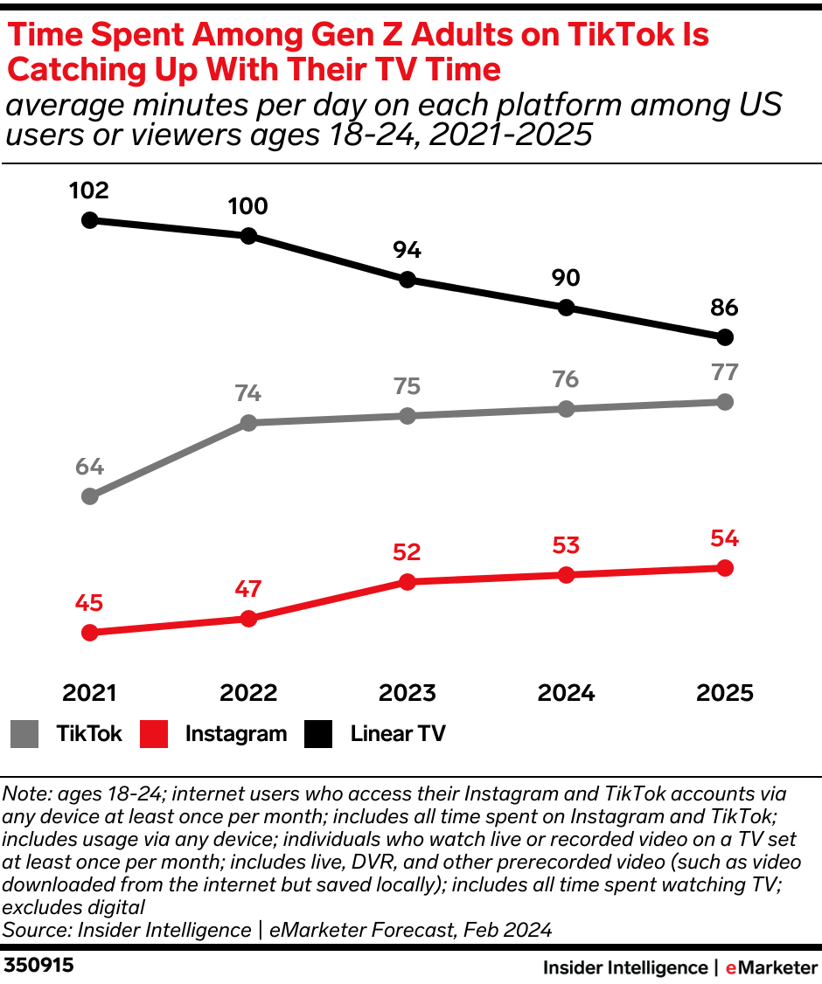
Source: Adopted from: Smiley, 2024.
According to Elad (2025), 35% of Gen Z people spend around 4 hours of their daily lives on social media, whereas only 3% spend less than an hour on various kinds of social media (Refer to Figure 2). TikTok is also a significantly used social media platform for short videos, posts, and chats. Elad (2025) has also mentioned that TikTok users spend about 88 minutes of their daily lives on the app, as presented by a survey done in 2025.

Figure 1.2. Daily Social Media Usage Patterns By Gen Z.
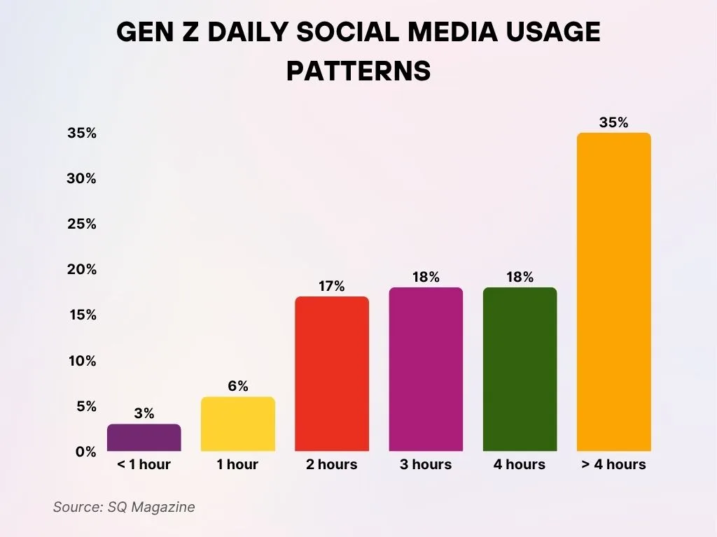
Source: Adopted from: Elad, 2025.
The purchasing behaviour of Gen Z is also a matter of discussion, since the apps present in the digital world create a sense of influence and satisfaction among the Gen Z buyers, and are increasing fast fashion. Since the online and digital market is dynamic and ever-changing, it is significantly influencing Gen Z consumers through various digital tools, such as social media marketing, content marketing, targeted advertising, and other strategies (Refer to Figure 3) (Rosnerova et al. 2025). Therefore, the primary driving factors for Gen Z consumers and their purchasing decisions are influencer relatability, trust, emotional attachment, trendiness, the Fear of Missing Out (FOMO), fashion reviews, a catered “For You” page and other strategies and factors.

Figure 1.3. Purchasing Decisions Influenced by Digital Marketing Tools.
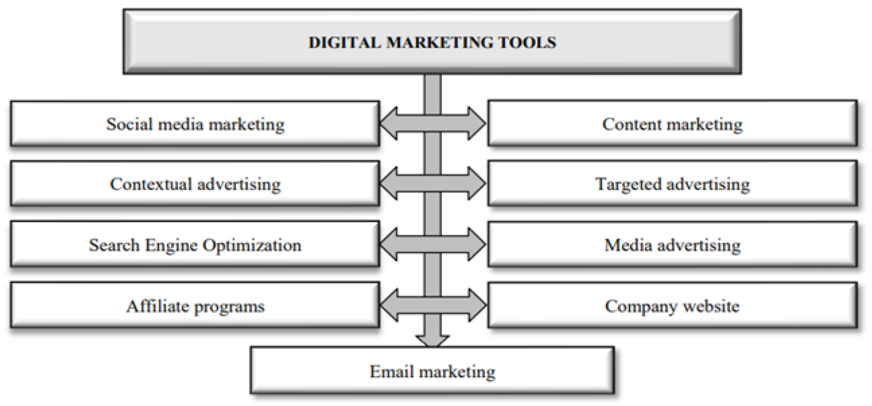
Source: Adopted from: Rosnerova et al. 2025.
Finally, Haron et al. (2025) have emphasised the importance of the short-form videos, not only in TikTok but in other social media platforms as well, such as YouTube, Instagram, Snapchat and more. The short-form video format, also known as SFVM, has, therefore, become a concise, dynamic, and easily shareable content. However, this format of video editing and sharing significantly minimises the attention span of the consumers, most importantly Gen Z’s (Haron et al. 2025). Its influence on the purchase decision therefore creates high conversion rates from one product or service to another and also moving from one influencer to another. Catering to fast fashion, this process therefore accelerates the fashion cycle and micro trends.

1.2 Research Rationale
This research focuses on the impact of TikTok short-form video marketing on Generation Z purchase intentions in the fashion industry‎. Thus, it basically focuses on how Gen Z can navigate through the increasing interactive content, influencer authenticity, and trends focusing on visuals. In this regard, Valeza et al. (2024) have mentioned that the focus of Gen Z buyers is primarily on the quality of the product purchased, rather than its price. They also focus on the emotional and interactive content for entertainment and features to interact with their favourite influencer through likes, comments, sharing, reposting and more.
FOMO, or the fear of missing out, is a significant fear among Gen Z buyers, and it causes them to follow the trends and strategies used by the influencers they follow. This causes a chain reaction and makes the buyers focus on short-lived trends, impulsive buying decisions, and short-term engagement. Oak and Markandeya (2025) have, thus, stated that FOMO creates a psychological fear among Gen Z and also manifests in impulsive buying out of a sense of urgency. This factor also tests the authenticity and trustworthiness of influencers, and how they are perceived by their fans and followers.
On the other hand, Luo et al. (2025) have stated that short-video formats have brought a significant revolution regarding online interaction. It is evident that by 2024, social media users will have significantly increased, up to 5.6%, or by 266 million by 2025 (Luo et al. 2025). This process has become the primary method of entertainment, though low-cost and rapid dissemination. Thus, it can be said that the influencing factors include FOMO, trends, authenticity, characteristics of content, and having the power of social proof, as it acts as a social validation for visual and interactive media.

1.3 Problem Statement
According to a report by PYMNTS (2023), the spending habits of Gen Z, most importantly regarding fast fashion and influencer trends, are a significant challenge that is addressed in this research. The report also mentions that out of all the other generations, including Gen X and Millennials, Gen Z has the highest amount of digital payment through social media, up to 45.9% for browsing and 22.3% for actually buying (Refer to Figure 4) (PYMNTS, 2023). The issues also spread to the target audience of a particular influencer, or in some cases, the entire platform, and thus, the demand of the consumers for synthetic products creates fleeting purchasing motivations and differences in content types.

Figure 1.4. Increase in the Purchasing Behaviour in Gen Z.
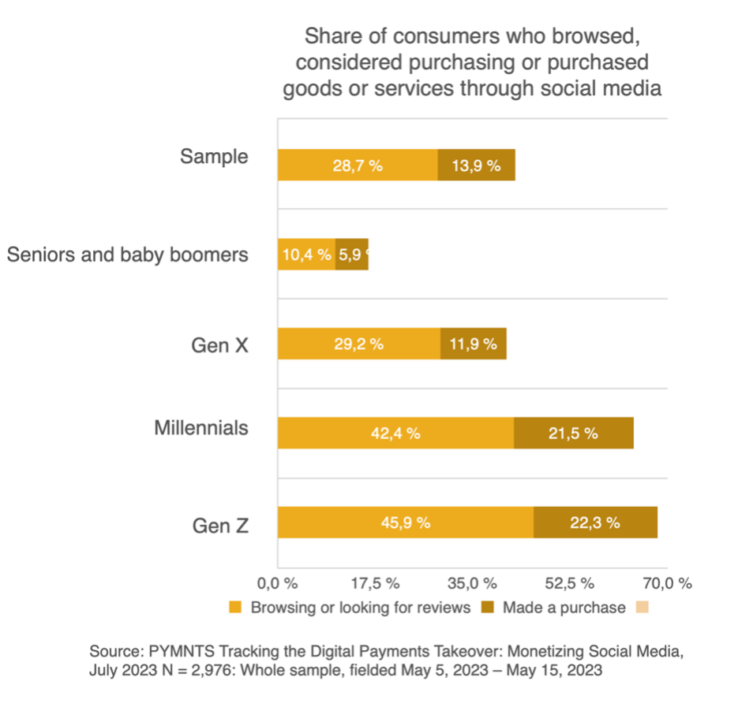
Source: Adopted from: PYMNTS, 2023.
On the other hand, Lacap et al. (2025) have mentioned that the roles and attitudes of Gen Z consumers are also a driving factor for the changes seen in influence regarding short-form video and purchasing habits. Lacap et al. (2025) have also stated that the local fashion brands are also the most curated users of TikTok, and they create a sense of closeness between the brands and their buyers through the app. This can create an impact on the platform regarding influencer impact and emotional connection, since most of the consumers have purchased products through a TikTok short-form video and have experienced a significant emotional connection. This emotional connection, thus, drives them to focus on the authenticity and trustworthiness of the influencers they follow.

1.4 Research Aim and Objectives
Aim
This research aims to understand the effect of TikTok short-form video on the purchasing decisions of Gen Z and how it impacts the fashion industry as well.
Objectives
- In order to establish the main peculiarities of TikTok short-form video marketing adopted by fashion companies.
- To examine the effect of TikTok content on the attitude of Gen Z consumers towards fashion brands.
- To test the connection between TikTok activity and consumer buying intentions.
- To make strategic suggestions to fashion companies aiming at enhancing TikTok marketing performance.

1.5 Research Questions
1. Why do fashion companies use TikTok short videos for marketing strategy instead of other social media platforms like Facebook?
2. Why TikTok influenced Gen Z’s purchase behaviour for the fashion industry instead of other age groups, such as the millennials or Gen X?
3. What is the impact of TikTok short-form video marketing on Generation Z purchase intentions in the fashion industry?

1.6 Significance of the Research
This research is being conducted to understand the impact of the short-form video format on TikTok and its impact on the purchasing decisions of its consumers. Thus, it provides an insight into the shifting consumer behaviours, most importantly focusing on the decision-making of the for traditional browsing and purchasing. Dharomesz (2025) have stated that TikTok engages on a dynamic and direct communication through its short-form video and connects the influencers to their followers. Thus, it is driven through an emotional appeal for entertainment and authenticity; it also gave birth to the “Haul” culture among influencers, which in turn significantly influenced the purchasing and spending habits of Gen Z consumers. However, this process is beneficial for the local brands, as the platform can be used by them to provide short-form video to their customers for higher sales.

1.7 Structure of the Research
Introduction: This chapter focuses on the topic and aligns it with the research already attempted by various researchers. It also provides the aim, objectives and questions for the research.
Literature Review: This chapter focuses on the already existing data and information, and attempts a critical analysis to gain insight into the topic and its problems.
Methodology: This chapter focuses on analysing the correct process of methods for data analysis through a number of steps, along with ethical considerations.
Findings and Analysis: This chapter focuses on analysing the findings gathered from all the previous chapters and what can be assessed from the gathered data through a robust methodology.
Discussion: This chapter focuses on discussing the themes and information gathered from the findings to draw a more generalised conclusion.
Conclusion and Recommendations: This chapter finalises the findings gathered throughout the research and provides forward-looking recommendations for other research in the future.

Chapter 2: Literature Review

2.1 Introduction
The aim and purpose of the chapter are to review literature, survey, summarise, and synthesise the research on a particular subject, thus laying the groundwork of the existing knowledge. Gen Z consumer behaviour is influenced by authenticity, trends, and aesthetics, all of which are crucial in decision-making. There is a positive correlation between engagement on TikTok and purchase intention, especially when users are exposed to the same content repeatedly. Theoretically, this study proposes a conceptual framework for understanding TikTok’s influence on the purchase intentions and attitudes of Gen Z, thereby filling gaps in platform-specific research. The study is based on the Theory of Planned Behaviour and Social Influence Theory.

2.2 Research Question
- Why TikTok influenced Gen Z’s purchase behaviour for the fashion industry instead of other age groups, such as the millennials or Gen X?
- Why do fashion companies use TikTok short videos for marketing strategy instead of other social media platforms like Facebook?

2.3 Factors Influencing the Purchase Intention of the Gen Z Consumers
The purchase intentions of Gen Z consumers are primarily driven by digital convenience and brand ethics for achieving sustainability in products. In this regard, Saut et al. (2021) have used the correlational methodology and stated that the purchase intention and willingness of the customers are significantly evaluated using the theory of planned behaviour, and questionnaires were used for structural equation modelling. The research, therefore, explains that the nature of consumers can create an insight into ecological devastation, environmental degradation, and sustainability (Saut et al. 2021). Due to Gen Z consumers being mostly young, they have a knack for technological advancements, pragmatism, and financial stability in fashion companies for mitigating environmental issues.
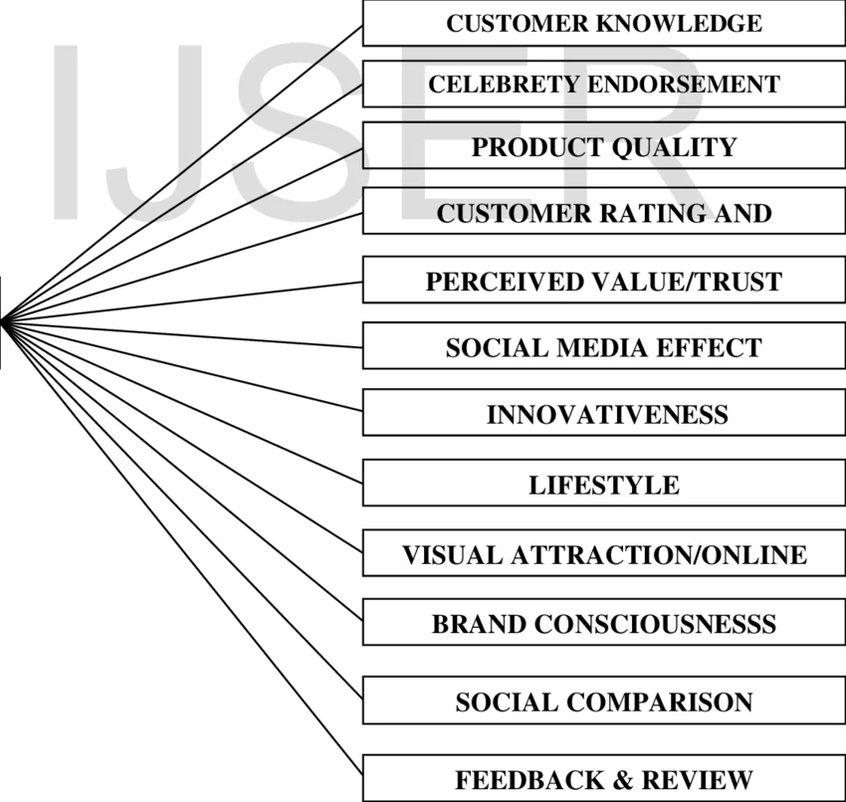

Figure 2.1: Factors Influencing the Purchase Behaviours of Customers
(Source: Raja, 2026)
Figure 5 depicts the factors that influence consumer purchase behaviours in various sectors (Raja, 2026). However, due to the influence of social media platforms, it creates physical challenges for customers in not getting familiarised with the consumers. Therefore, Rini (2023) has stated that the development of the marketplace is significant for influencing the e-commerce industry. This research utilises the primary qualitative methodology for analysing consumers' behaviour between the ages of 20 and 40 (Rini, 2023). Gen Z is already mentioned to have realistic and analytical decisions for creating independence in purchase intention, while also communicating resolutions for conflict mitigation. Therefore, it is evident that both Saut et al. (2021) and Rini (2023) agree that factors such as technological advancements and sustainability are impactful for the customer behaviour among Gen Z, and it is also further proven by the factors described by Raja (2026). Thus, it helps consumers to focus on digital and social influence through convenience and experience in the purchasing process.

2.4 Impact of TikTok Short-Form Video on Gen Z Purchase Intentions
The Short-form video on TikTok has been seen to be significant for purchase intentions of Gen Z consumers, and it creates both positive and negative impacts on the consumers. Nguyen et al. (2024), in this regard, have mentioned that purchase intention is significantly synonymous with the influencers and the Gen Z followers of TikTok. The use of a primary quantitative methodology with SPSS finds that the problem of TikTok Influencing among the Gen Z consumers (Nguyen et al. 2024). Figure 6 also depicts that 81% of followers on TikTok have the greatest number of views, mostly from short-form videos (Nrg, 2024). The purchasing behaviour of the Gen Z consumers can, therefore, be influenced by perceived enjoyment, information availability, and social proof for trend setting and peer validation.
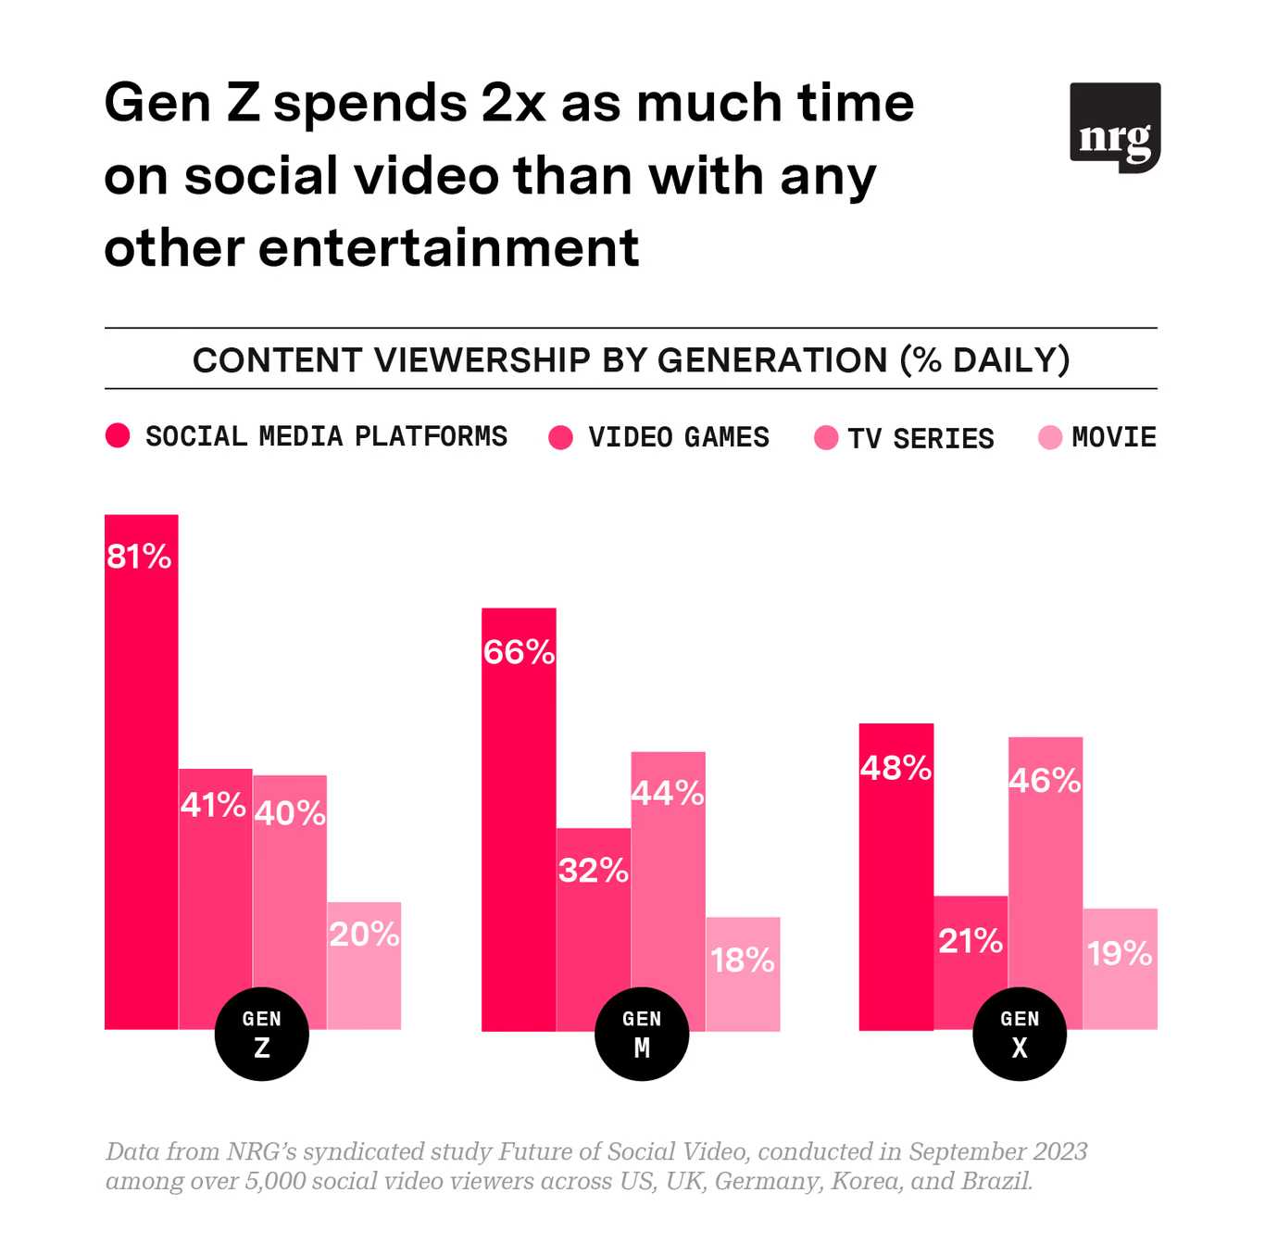

Figure 2.2: Impact of Short-Form Videos among Gen Z Consumers
(Source: Nrg, 2024)
On the other hand, Sharabati et al. (2022) have acknowledged the positive influence of TikTok on the satisfaction of its consumers. The research utilises the positive influence of TikTok and its short-form video format by analysing its use of primary quantitative methodology, and the results indicate that 30.6% of the users have faced a positive impact from the social media app (Sharabati et al. 2022). Meanwhile, Bahatan et al. (2025) mentioned, through the descriptive-correlation quantitative research, that the influence on Gen Z is primarily based on in formativeness, entertainment, price discount, influencer bandwagon and its perception. Even if consumers can face massive changes in their purchase intention, along with improvement and innovation, the short-form videos on TikTok use marketing campaigns for advertising and attaining the target audience (Bahatan et al. 2025). However, the negative impacts of the social media platform can include overconsumption, impulse buying, trend fatigue, unauthentic content, and both financial and mental constraints.
Therefore, it is significant that even if short-form videos by TikTok have a positive impact, they can create a sense of repetition and fatigue for its consumers. Nguyen et al. (2024), Sharabati et al. (2022), and Bahatan et al. (2025) all have similar views on the positive and negative impacts of short-form videos on the purchase intention of their consumers. Thus, it can be said that TikTok is hyper-relevant for providing content based on the target audience it attains, and understanding the content its consumers want.

2.5 Peculiarities of TikTok Short-Form Video Marketing in Fashion Companies
Even though the consumers of TikTok short-form videos are seen to have a significantly positive impact, there are still several peculiarities that the marketing industry has a hard time understanding. The research by Basnet (2025) follows the secondary qualitative methodology, and according to it, in recent times, there has been a significant increase in short-form video marketing, most importantly among small brands and businesses. Even though TikTok does not have the same amount of reach to its customers as Instagram, it still gained almost 1 million users between 2020 and 2025 (Refer to Figure 7) (Basnet, 2025). Peculiarities in this social media platform are not relatively negative, as it can cause positive impacts such as raw and real content, algorithm-driven virility, community-led trends, and differences in content.
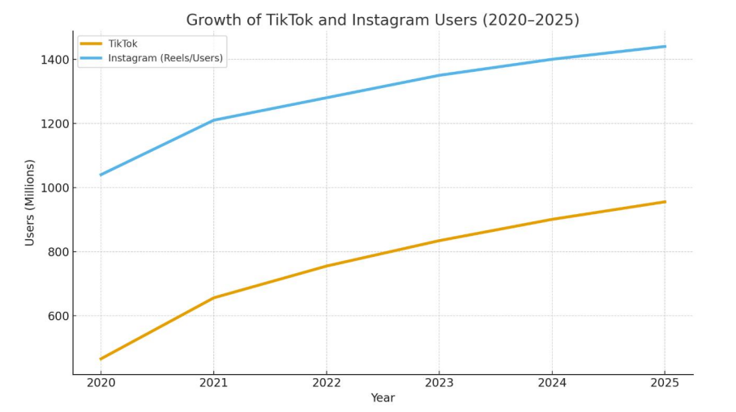

Figure 2.3: Growth of TikTok and Instagram Users from 2020 to 2025
(Source: Basnet, 2025)
On the other hand, Slaton and Lee (2025) have stated that short-form videos on TikTok are a significant weapon for influencing the e-commerce and interactive marketing of the platform. This research utilises primary quantitative methodology with the analysis using confirmatory factor analysis and structural equation model, and analyses that short-form videos can evolve this strategy into a peripheral entertainment tool for driving consumer perception and retail engagement (Slaton and Lee, 2025). Meanwhile, Haron et al. (2025) have mentioned, through a secondary qualitative research, that short-form videos on TikTok create visual dynamics and easy-sharing content across its platform and assess this as a dominant strategy that can be used by other social media platforms as well (Haron et al. 2025). Thus, engagement by the consumers of the platform is a significant determining factor for digital marketing and audience interaction.
Therefore, it is significant that all three articles have a massive focus on the positive impacts of short-form videos on TikTok, which also includes the peculiarities mentioned before. Slaton and Lee (2025) focus on the effectiveness of scrolling for shopping, Haron et al. (2025) explain its impact on marketing, and Basnet (2025) compares the peculiar factors with other social media platforms with the short-form video format. The factors mentioned can influence the fashion brands, since they can enhance their market presence, such as collaborating with diverse creators, creating communities for advertising and bringing cultural conversation.

2.6 Effect of TikTok Content on the Attitude of Gen Z Consumers Towards Fashion and the Rationale Behind the Selection of TikTok
The attitudes of Gen Z consumers are significant, since they can create trend cycles, influencer-driven trust, and an overall positive impact on brand perception. In this regard, Pihkoluoma (2025) has utilised the primary qualitative research for investigating the influences and de-influences of Gen Z perception in the fashion industry. The Gen Z consumers are also known to have a focus on ethical consumption; thus, the short-form videos on TikTok broaden the perspectives of such customers (Pihkoluoma, 2025). Figure 4 also depicts the spending behaviours of the young consumers, presumably Gen Z, and explains that the spending habits decrease by age significantly (Refer to Figure 8) (Schneider and Lee, 2022). According to Pratiwi et al. (2025), TikTok creates a space where fashion trends are constantly evolving, representing the collective identity of Gen Z, especially in Denpasar. The author applied a descriptive qualitative approach to conclude the approach. Thus, this interaction about ethics creates in the consumers a desire for sustainability, for finding themselves caught between value and affordability, in platforms such as TikTok.
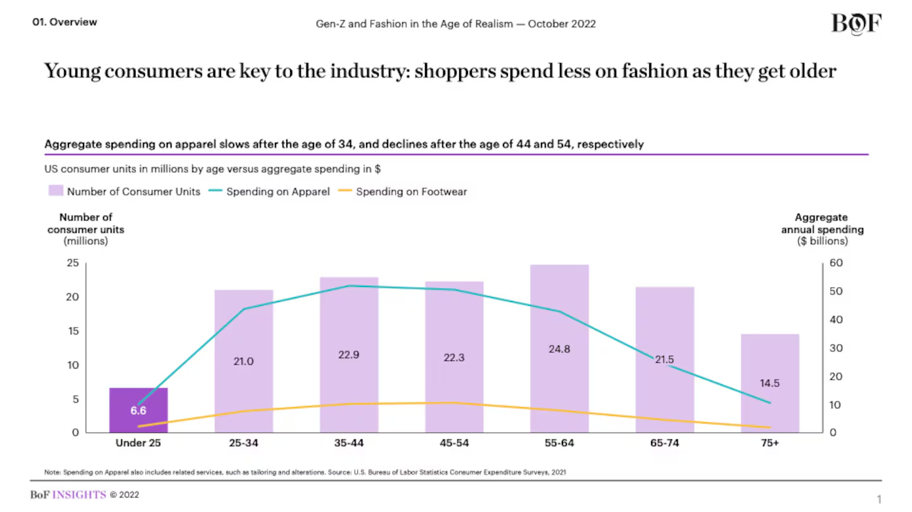

Figure 2.4: Spending Behaviours of Consumers in the Fashion Industry
(Source: Schneider and Lee, 2022)
Meanwhile, Rolando (2025) has utilised cross-sectional quantitative research and stated that the influence of TikTok exposes its consumers to influencer fashion, brand preferences, and complex behaviour for digital marketing. Due to the technology focus of this generation, it has the robust ability to connect with others, using social media and other digital media (Rolando, 2025). Therefore, it creates a significantly positive impact on the content of brand perception among consumers. It helps them to engage, inform, and gain emotional information about TikTok for fast fashion promotion on the platform. On the other hand, Sura and Halim (2026) have used a qualitative approach and stated that the purchase decision of Gen Z consumers is impacted by online fashion, and it is becoming more and more effective for the consumers. The participation of such consumers in technological advancements has created patterns for understanding the consumption and attitudes of the younger generation (Sura and Halim, 2026).
Therefore, a comparison of all the articles provides a generalised effectiveness for understanding the attitude of Gen Z consumers in the fashion industry. Pihkoluoma (2025) focuses on both the influencing and the de-influencing of TikTok for exploring the perception regarding ethics in Gen Z. Meanwhile, Rolando (2025) discusses the impact of TikTok influencers on brand preferences, and finally, Sura and Halim (2026) discuss the effectiveness of consumer behaviour in the online fashion industry, regarding TikTok.

2.7 Connection Between TikTok Activity and Consumer Buying Intents and Process Followed by the Consumers to Make Purchasing Decisions
One of the most significant connections between TikTok activities and the buying intentions of customers is the “TikTok Made Me Buy It” trend. Gale and Chapman (2022) have stated that the consumer buying decision focuses on problem recognition, researching, considering alternatives, selecting, and evaluating after purchasing. Therefore, Vire (2025) have used the qualitative research methodology and mentioned that social media created a significant trend of dominance in a platform, and it creates complex algorithmic outcomes in TikTok. The “TikTok Made Me Buy It” is a hashtag, and it creates a good illustration for catching and evaluating the trend (Vire, 2025). 90% of the global users have taken action to buy after watching a video, and 75% of Gen Z make purchases based on influencer recommendations. Figure 9 mentions several keywords significant for understanding the connection between TikTok activity and buying intent (Vire, 2025). Other than this hashtag, several other activities include impulse buying, high engagement, key drivers of intent, influencer trust, TikTok shop, and live commerce.
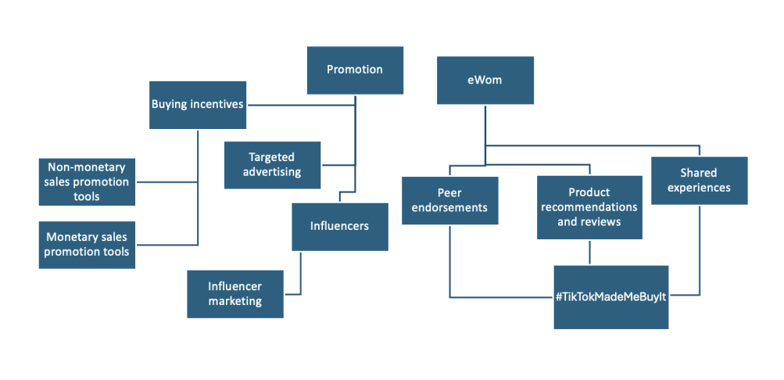

Figure 2.5: Factors influencing the buying intention of TikTok Consumers
(Source: Vire, 2025)
According to the research using a systematic literature review (SLR) and meta-analysis using PRISMA, Damania et al. (2026), live streaming and influencer engagement are also some of the leading activities that enhance consumer intention in TikTok. Thus, it evolved the business interaction and combined marketing with entertainment. Influencers in streaming pose a significant fundamental influence on purchase intention (Damania et al. 2026). The evolved business interaction and combined marketing provide a significant impact on the purchase decision among customers, since it influences their behaviour, and reduces dissonance among them (Longwood University, 2024). TikTok is a platform that has a significantly unique ecosystem for distributing algorithm in the platform, and through a combination of creative content, it helps to create a two-way communication between the influencers and the followers. On the other hand, Putri et al. (2024) have utilised the mixed methodology and mentioned that even though the activities of TikTok and consumer buying have a significant connection, the consumers can also have a focus on trust and privacy among the Gen Z purchasing behaviours. The user interface (UI) of TikTok allows creators and influencers to add links and advertisements to their content, creating an impact on the e-commerce sector.
Therefore, Vire (2025), Damania et al. (2026), and Putri et al. (2024) all have explained the connections between TikTok activities and consumer buying intention, and thus, the relations can be significantly positive. Vire (2025) focused on the hashtags of TikTok, Damania et al. (2026) evaluated the impact of TikTok live streaming and influencer engagement, and Putri et al. (2024) analysed the impact of trust and privacy on their purchasing behaviours. It can also include factors, such as the “For You Page”, visual content, and information experiences.

2.8 Challenges Fashion Companies Face in Maintaining Attractive TikTok Videos for Promotion
Fashion companies are also having difficulties in keeping attractive TikTok promotions, and this is mainly because of the nature of TikTok. Several challenges, such as High Content Velocity and Trend Fatigue, The Authenticity vs. Production Quality Paradox, Algorithmic Competition and Overcoming "Noise", Balancing Sustainability with Fast-Fashion Demands, Managing Creator Partnerships at Scale, and Navigating TikTok's Shifting Algorithm (Maguire and Biondi, 2020). PRISMA-based review maps the trends and methods of fatigue with practical AI techniques used by Kakhi et al. (2025), and based on the result, the author mentioned that from subjective assessments to physiological signals, these techniques provide various but complementary approaches. Fatigue measurement methods, including behavioural-based model, subjective measures, bio-mathematical models, performance-related methods, and physiological signal-based method helps to determine fatigue (Refer to Figure 10). Mandarić et al (2022) discuss how, in the fashion market, more emphasis is given to factors such as price, value, size, quality, style, convenience of purchase, and others. Additionally, the role of the environmental factors is important only to a very small percentage of the population, based on the Google Forms tool for quantitative research in this study. Overall, it is important to integrate advanced fatigue assessment techniques and users’ priorities to achieve both analysis and practicality.
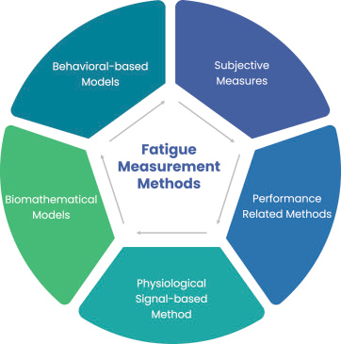

Figure 2.6: Fatigue Measurement Methods
(Source: Kakhi et al., 2025)
Ru et al. (2025) argued that algorithm empowerment is not an abstract concept because algorithmic curation to establish social norms that meet users’ needs for recognition and AI-based decision-making fluidity to overcome barriers to action through large-scale Chinese users’ data. The visual representation shows theoretical evolution from social capital to algorithmic empowerment (Refer to Figure 11). Oliveira et al. (2022) carried out a quantitative and qualitative research process in three stages. According to the authors, fast fashion industries have been publishing that they are improving the sustainability of their production chain. This research demonstrates the ways in which algorithmic systems and industry narratives are influencing users, and thus, the importance of critically examining empowerment and sustainability practices within the digital and fast fashion spheres.
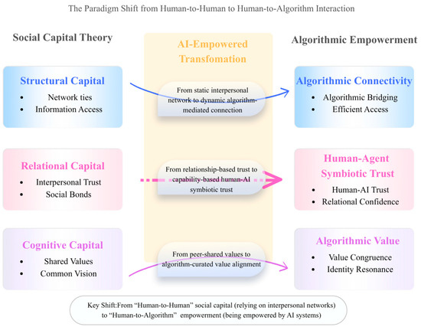

Figure 2.7: Algorithmic Empowerment
(Source: Ru et al. 2025)
According to Hofmann et al. (2022), collaboration has been identified as the overarching theme of overcoming the challenges of the three problem areas, as defined using the qualitative method. The synergy between the algorithm and the visual content on TikTok has a great role to play in the promotion of purchase decisions, especially among the Gen Z and Millennials generation, who are the main target of the fast beauty industry (Fitri and Ananta, 2025). The analysis has been conducted qualitatively, with the main sources of the data originating from the online world, including Google Scholar, Mendeley, various apps, and other relevant digital platforms. Fashion marketing in the TikTok era calls for a balance between speed, authenticity, and sustainability

2.9 Theoretical Framework

2.9.1 Theory of Planned Behaviour
The Theory of Planned Behaviour (TPB) is a general theory of behaviour which describes the behaviour of individuals. The TPB suggests three main antecedents, such as attitudes, subjective norms, and perceived behavioural control, which influence the decision-making process of users (Jiao and Cao, 2024) (Refer to Figure 12).
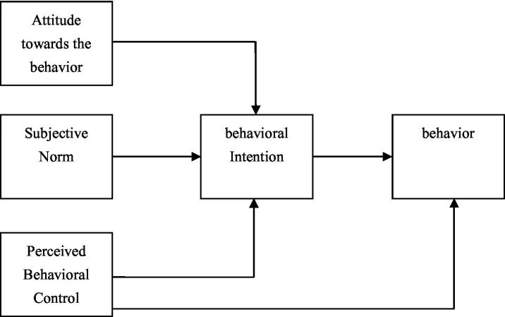

Figure 2.8: Theory of Planned Behaviour
(Source: Jiao and Cao, 2024)
Attitude towards behaviour shows Gen Z’s positive or negative reactions towards the purchase of fashion items after being influenced by the content of TikTok. According to Slaton and Lee (2025), the excitement created through short videos of trending fashion items, fashion, or influencers in the content of TikTok can lead to the development of a favourable attitude towards behaviour. Thus, the increasing of the intention of the audience towards purchasing the fashion items.
Subjective norms of planned behaviour theory rely on peer or social group pressure. The interactive tools of TikTok, such as likes, comments, sharing, and duets, give users social credibility (Lin et al., 2023). Gen Z is influenced by peer groups and social credibility, and therefore, they buy products that they think their favourite social influencers or peer group support for some fashion trends.
Perceived Behavioural Control is related to how easy or hard it is to buy the product. Tran et al. (2024) stated that the availability of shopping links, in-app shopping, and brand partnerships makes users feel in control. The target group is Gen Z, and they are tech-savvy and comfortable with online shopping; with this, they feel capable of making the purchase.
Overall, it can be stated that the TPB model provides insights into how the fashion purchase decision of Gen Z can be influenced through the use of short video marketing on TikTok, as the use of attitude, influence, and control ensures that the purchase decision is made by Gen Z as a result of the short video marketing.

2.9.2 Social Influence Theory
The Social Influence Theory (SIT) is an alteration of behaviour that can be influenced through social influence, which is derived from three levels of psychological attachment. These three factors are compliance, identification, and internalisation (Yi et al., 2021) (Refer to Figure 13). These three processes are considered as a unique set of antecedent conditions, which are associated with the individual’s responses, such as thoughts and feelings, in order to accept the behaviour.
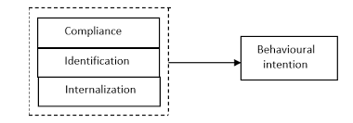

Figure 2.9: Social Influence Theory
(Source: Yi et al., 2021)
Compliance is an individual's act in a certain way to receive a certain reward or to avoid being disapproved by society. Relationship with Gen Z interacts and behaves with TikTok, for instance, Gen Z could be exposed to various forms of viral fashion trends, as well as peer engagement in various challenges, among other things (Theocharis, 2025). For this paper, Gen Z could be motivated to purchase various trending fashion items to "fit in" with society.
Identification is a process in which one behaves in a certain way in a bid to form or sustain a relationship with a certain group of persons. Gen Z has a para-social relationship with a fashion influencer who may have a sense of style, personality, or lifestyle that they admire (Kyneshi et al., 2025). If they decide to flaunt their fashion or a certain brand, Gen Z may decide to do the same in a bid to identify or associate themselves with the influencer’s personality.
Internalisation is where individuals receive influence according to their value system and beliefs. According to Zhong et al. (2025), the value system and beliefs depicted in the brand’s TikTok, such as sustainability, inclusiveness, and responsible fashion, are in alignment with Gen Z’s value system and beliefs. The individuals receive marketing influence according to their beliefs, which would promote brand loyalty.
Overall, all three factors are enhanced by TikTok, and this makes it a powerful tool for influencing Gen Z’s fashion behaviour.

2.10 Conceptual Framework

TikTok Short-Form Video Content
Customer Engagement
Brand Attitude
Purchasing Intention
Gen Z
Fashion Industry

Figure 2.10: Conceptual Framework
(Source: Self-Created)
The Conceptual Framework in Figure 10 for this research depicts the relation between the independent variable and the dependent variable, with two mediating variables. The independent variable is TikTok short-form Video Content, and the dependent variables are Customer Engagement, Brand Attitude, and Purchasing Intention. It is evident from the above literature review that all the factors are significantly connected with the independent variable. This variable also has a somewhat major connection with the mediating factors, including Generation Z and the fashion industry. However, the mediating factors do not impact the dependent variable that much.

2.11 Literature Gap
Based on the literature review, there are several gaps in understanding the marketing of TikTok and the purchasing behaviour of Gen Z in the fashion industry. However, past research was conducted by Nguyen et al. (2024), Sharabati et al. (2022), and Bahatan et al. (2025) on the impact of short video marketing on the purchasing behaviour of Gen Z, this research is mainly based on the influencer aspect, entertainment, and following trends, but the psychological aspect is not deeply explored in this research paper. Similarly, the studies of Basnet (2025), Slaton & Lee (2025), and Haron et al. (2025) on the particularities and marketing opportunities of TikTok also cannot include the sustainability aspects. The values of ethical consumerism have become more and more important to this particular generation of consumers (Saut et al., 2021; and Pihkoluoma, 2025).
Additionally, studies on consumer fatigue and content strategy are limited to the methods of measuring consumer fatigue but have failed to provide frameworks for the integration of algorithmic recommendations and marketing personalisation techniques (Maguire and Biondi, 2020; Kakhi et al., 2025). Therefore, this study has been conducted to evaluate the potential of TikTok's content strategy and address consumer fatigue and sustainable consumption in order to inform fashion marketing practice.

2.12 Chapter Summary
The chapter has discussed the existing literature regarding short video marketing in TikTok and its effect on Generation Z’s purchase intentions in the fashion industry. Additionally, it has been found that main factors that affect Generation Z’s purchase intentions, such as social influence and engagement. The negative and positive impacts of short video marketing on Generation Z’s purchase intentions are also discussed. The use of relevant theoretical frameworks, such as the theory of planned behaviour and Social Influence Theory, helped in determining the impact of marketing on consumer behaviour among young adults. Previous literature gaps were also discussed in this chapter, which are going to be solved with recommendations in this research.

Chapter 3: Research Methodology

3.1 Introduction
The chapter outlines the methodology employed to explore the effect of Tik Tok short-form video marketing on the purchase intentions of Generation Z in the fashion sector (It describes the research design, sources of data, data collection method, method of analysis and ethical considerations that underpin the study (Vire, 2025). According to the principles specified in the dissertation structure guidelines, the methodology chapter should reveal an adequate explanation of research selection and make sure that the methods are relevant to the research aim and objectives. Since this research is exploratory and contemporary in terms of TikTok marketing, the approach of secondary research is used, which enables the synthesis of all available academic and industry data to make meaningful conclusions.

Research onion
This study is informed by the research onion model that organizes the methodological decisions in terms of philosophy up to data analysis . The philosophy of this research is the interpretivist one, as the authors attempt to comprehend how the generation Z understands TikTok marketing. Insights are developed based on existing data, not testing hypotheses in an inductive approach. The research plan relies on secondary archival research whereby scholarly and industry publications are emphasized. They use a mono qualitative approach based on thematic analysis. The research adheres to a cross-sectional time frame, examining the recent data (20192025). Lastly, the systematic collection and analysis of data is done to determine the patterns of consumer behaviour and marketing influence.


Figure 3.1: Research onion
Source:15Writers (2024)

3.2 Research Design
The current research is based on the qualitative secondary research design that aims at the critical analysis and synthesis of the literature that exists with regards to Tik Tok marketing and consumer behaviour. In this regard, secondary research would be especially suitable, as Tik Tok has become a digital platform in a short time and these have created a massive amount of available research, reports and market analyses (Van Nguyen and Tran, 2024).Secondary data allows access to extensive data sets and already proven results that would be hard to achieve during the time- and resource-limited MBA dissertation.
More importantly, through secondary research it is possible to integrate various theoretical perspectives, such as the Theory of Planned Behaviour and Social Influence Theory which are crucial to the understanding of the consumer decision-making process. Nevertheless, there are limitations to this method. The dependency on the available data implies that the researcher cannot control the quality of the data, its scope and context. Moreover, most of the studies are carried out in various geographical settings, thus they might not be applicable to the UK fashion industry. In spite of the aforementioned shortcomings, secondary research is not an unwarranted approach to study since it allows capturing a wider and deeper picture of the research issue, especially in a rapidly changing digital world where a primary data gathering process might soon become obsolete. The ethics form also confirms that the study will be based on secondary data only, and there will be no direct contact with the participants (Nii Laryeafio and Ogbewe, 2023),which will minimise the risk of ethics issues.

3.3 Data Sources
The research is based on extensive pools of secondary data, such as scholarly peer-reviewed journals, industry reports, and other market research publications (Olipp,Woschank and Hoffelner, 2024).The academic sources were mostly found using databases like Google Scholar, ScienceDirect, Emerald Insight and Scopus, which provides assurance that the research is based on credible and scholarly literature. These sources are theoretical in nature with regards to consumer behaviour, digital marketing strategies and engagement of social media.
The study also uses academic sources, as well as industry data, including Statista, Deloitte, and McKinsey, which offer recent statistics and information about the use of Tik Tok, Gen Z behaviour, and trends in the fashion industry. As an example, industry reports show that more than 60 percent of Gen Z consumers are using TikTok as a key source of learning about new fashion items, and about 70 percent are affected by social media content when deciding on purchasing (Boas et al., 2024). Moreover, the average time spent on TikTok is allegedly 90 minutes a day, which emphasizes its tremendous impact on consumer interaction and behaviour.
Critically, although academic sources are rich in methodological rigour and in theoretical depth, they might not be timely as digital platforms evolve fast. On the other hand, industry reports are timely and practical but might lack transparency in the methodology and might be commercially biased. In order to overcome the problems, the present study will be conducted in the form of a triangulation, i.e. comparing the results of various sources to increase the reliability and validity. This practice is in line with Level 7 academic requirements of interacting with various and authoritative sources.

3.4 Data Collection Procedure
The systematic literature review was used as a method of data collection (Paul and Barari, 2022), which guaranteed that those sources were selected and incorporated into the study when they were relevant and of high quality. A structured search strategy was used based on the keywords of TikTok marketing, short-form video content, Generation Z consumer behaviour, and fashion industry digital marketing. Only the studies published in the last two years (2019-2025) were included in the search to make sure that the data are up-to-date and represent the latest trends and advances in digital marketing.
The inclusion criteria were limited to peer-reviewed articles, authoritative industry reports, and research that is directly related to Tik Tok and Gen Z consumer behaviour. Conversely, the outdated, lacked credibility, and sources that were not directly related to the research objectives were not included. The outcome of this process was a refined dataset that records the most pertinent and up-to-date information on the topic of the research.
Nevertheless, there are some limitations of the data collection process. The dependency on the use of key words can lead to the omission of other studies that are relevant (Vaithilingam et al., 2024), but use other terminologies. Also, the researcher may be biased in the selection process, because the decision concerning inclusion and exclusion is subjective. The systematic approach increases the clarity and repeatability of research process despite these challenges.
Search table
Note: The table below presents the databases searched and the keywords used during the systematic literature review process. The final articles selected from each database were drawn from relevant pages and sections within each source. Specific page numbers and paragraph references for each article used in the thematic analysis are cited inline throughout Chapter 4, in accordance with Harvard referencing conventions.

Database | Keywords Used | Results Found | Final Articles Used
Google Scholar | “TikTok marketing AND Gen Z fashion” | 120 | 18
ScienceDirect | “Short-form video marketing” | 75 | 10
Emerald Insight | “TikTok purchase intention” | 42 | 7
Scopus | “Gen Z consumer behaviour TikTok” | 51 | 9

Table 3.1: Search Table
The literature search process involved several stages to ensure the selection of reliable and relevant sources. Initially, duplicate articles identified across multiple databases were removed to avoid repetition and maintain consistency in the review process. Following duplicate removal, relevance screening was conducted by reviewing article titles and keywords to determine alignment with the research objectives related to TikTok marketing, Generation Z consumer behaviour, and the fashion industry.
After the relevance screening stage, abstracts of the shortlisted studies were carefully read to assess their theoretical contribution, methodological quality, and applicability to the research topic. Studies that lacked direct relevance or sufficient academic credibility were excluded at this stage. Finally, a full-text review of the remaining articles was conducted to evaluate the depth of findings, research reliability, and alignment with the study objectives. This systematic screening and review process ensured that only the

3.4.1 Systematic Literature Review Process
A systematic literature review (SLR) process was adopted in this research to ensure transparency, reliability, and relevance in the selection of secondary data sources. The review process involved searching academic databases including Google Scholar, ScienceDirect, Emerald Insight, and Scopus to identify peer-reviewed journal articles and industry reports related to TikTok marketing and Generation Z consumer behaviour. Keywords used during the search included “TikTok marketing”, “short-form video marketing”, “Gen Z purchase intention”, “fashion industry digital marketing”, “consumer behaviour on TikTok”, and “social media influencer marketing”.
The initial database search generated approximately 280 articles and reports. Duplicate studies and irrelevant publications were removed during the screening stage. Abstracts and titles were then reviewed to determine relevance to the research objectives. Studies that focused on unrelated industries, lacked academic credibility, or were published before 2019 were excluded from the review. Full-text analysis was conducted on the remaining studies to assess methodological quality and relevance.
Following the PRISMA-style screening approach, 25 final articles and reports were selected for thematic analysis. This structured process improved the validity and reliability of the research by ensuring that only credible, recent, and relevant studies were included in the final analysis.

Inclusion Criteria
Inclusion Criteria | Exclusion Criteria
Peer-reviewed journal articles and credible industry reports | Non-academic blogs, opinion pieces, and unreliable websites
Studies published between 2019–2025 | Articles published before 2019
Research focused on TikTok marketing and Generation Z consumers | Studies unrelated to TikTok or Gen Z
Studies related to fashion industry, social media marketing, and consumer behaviour | Research conducted in unrelated industries
English language publications | Non-English studies
Studies providing theoretical or practical insights into purchase intention and digital marketing | Sources lacking relevance to the research objectives
Full-text accessible articles and reports | Incomplete or inaccessible studies
Research containing reliable methodological approaches | Studies with unclear or weak methodology

Table 3.2: Inclusion and Exclusion Criteria

3.5 Data Analysis Method
The analysis of secondary data collected in the study uses thematic analysis as the major approach of analysing the data (Kushnir, 2025).Thematic analysis is a qualitative methodology that entails the identification, analysis and interpretation of patterns or themes in the data. This approach is best adapted to the current study because it will be possible to combine the results of various sources and obtain a holistic picture of the factors affecting how Gen Z will make purchases.
The analysis procedure consisted of a number of phases, encompassing familiarisation with data, coding, theme development and interpretation. In this process, some major themes were observed including the impact of short-form video content, the impact of the credibility of the influencers, the impact of user-generated content, and the role of social proof in influencing consumer behaviour. To illustrate, the credibility of the influencers, according to several studies, can increase the trust of Gen Z consumers to a certain extent, and authentic and relatable influencers are more effective than classic celebrity endorsement. On the same note, user-generated content has been found to enhance engagement and purchase intention through social validation and authenticity.
Critically, thematic analysis is flexible and in-depth, as the process of interpreting data is subjective and is determined by the researcher (Braun and Clarke, 2024). It also lacks statistical validation, and this could restrict generalisability of results. However, it is suitable to this study because it allows exploring complex behavioural patterns nuanced and fits the qualitative nature of the research.

3.6 Reliability and Validity
It is necessary to ensure reliability and validity of research, especially in a secondary research (Hossan,Wolfs and Petkovic, 2025). The consistency in data collection procedures and the use of reputable sources help in attaining reliability. The fact that a set of academic databases has been used and various studies cross-referenced also assists in making sure that the results are both coherent and reliable.
The sources will be chosen based on their direct relevance to the objectives of the research and the analysis will be grounded on the existing theoretical frameworks, which will ensure validity. The use of the recent data also adds to the validity of the study as it is the representation of the current trends in digital marketing and consumer behaviour.
Nonetheless, secondary data has its disadvantages in terms of validity with the possibility that the original studies could have been done in a different environment or in different methodology. This can restrict the degree to which the results can be generalised. To deal with this, the paper critically reviews each of the sources and puts them in context and limitation in interpreting the findings.

3.7 Ethical Considerations
The research has complied with the ethical requirements of research as given by the university. As the study relies solely on secondary data, there will be no direct contact with human subjects, and thus, such concerns as informed consent and confidentiality are not relevant. The ethics form confirms that the research is low-risk, and it is based only on data that is publicly available (Hao et al., 2025).
However, the issue of ethics cannot be ignored in academic integrity. All of the sources are referenced appropriately in accordance with the Harvard referencing style and the attempts are made to reflect the results of the previous studies accurately. This prevents plagiarism by paraphrasing and synthesising information instead of repetition that would result in copying information.
Critically, ethical issues associated with secondary research could comprise biased reporting and misinterpretation of information. To eliminate them, the research is quite balanced and transparent, showing both positive and opposing results.

3.8 Limitations of the Methodology
Although it has its advantages, the selected methodology has numerous weaknesses. The use of secondary data implies that the research does not consider the first-hand information of Gen Z consumers, which may be more specific and provide more contextual data. Also, global data usage might not be able to completely reflect the peculiarities of the UK fashion industry (Fu, 2026).
The other limitation is that there is a possibility of data bias since the study relies on already published research, which can be biased by the original authors. Moreover, the swift development of the digital environment, such as TikTok, implies that certain findings might lose their relevance in the near future.
These shortcomings demonstrate the necessity to conduct future studies based on primary data, surveys, or even interviews to support the results of the current research and expand them.

3.9 Chapter Summary
This chapter has given a detailed description of the research methodology employed in this study. The systematic data collection and thematic analysis were the instruments that aided in the qualitative secondary research design. Although this method allows a general and comprehensive perception of TikTok marketing and Gen Z consumer behaviour, it has certain constraints connected with the specificity and subjectivity of data. In general, the methodology is suitable to answer the research objectives and is a good basis for the following data analysis and discussion chapters.

Chapter 4: Data Analysis

4.1 Introduction
The data analysis chapter of this specific research study aims to present findings to answer research questions and meet key objectives. The chapter will focus on interpreting secondary collected data, leveraging different themes corresponding to the core research concept. The chapter will typically focus on the thematic interpretation of data in terms of critically analysing the impact of TikTok short-form video marketing on Generation Z purchase intentions in the fashion industry from an array of perspectives. Secondary databases, including articles, journals, and statistical information, will be relied on in this specific chapter. The chapter will clearly justify research questions and research objectives through thematic analysis.

4.2 Secondary Thematic Analysis
The thematic analysis conducted in this research followed the six-step framework developed by Virginia Braun and Victoria Clarke. The approach was used to identify, analyse, and interpret recurring patterns within the selected secondary data sources related to TikTok short-form video marketing and Generation Z purchase intentions in the fashion industry. Through repeated reading and familiarisation with the selected articles, reports, and academic studies, significant ideas and recurring concepts were identified and systematically coded.
Initial coding focused on concepts such as influencer credibility, authenticity, consumer engagement, fear of missing out (FOMO), viral trends, impulse buying, brand trust, and social proof. These repeated codes were then grouped into broader categories to generate meaningful themes. The themes emerged through continuous comparison of findings across different studies and by identifying similarities and contradictions within the literature.
The final themes were carefully refined and aligned with the research aim, objectives, and research questions. Each theme directly addressed the key objectives of the study, including the analysis of TikTok marketing strategies used by fashion companies, the impact of TikTok content on Gen Z attitudes, the relationship between TikTok activity and purchase intentions, and strategic recommendations for improving marketing performance. This thematic analysis process enhanced the depth, consistency, and credibility of the research findings.
Six-Step Braun and Clarke (2006) Thematic Analysis Process Applied in This Study
Step 1: Familiarising Yourself with the Data – In this step, the researcher immersed in the secondary data by thoroughly reading and re-reading all selected articles, reports, and academic studies. Notes were taken on initial observations regarding TikTok marketing, Gen Z consumer behaviour, and purchase intentions. Sources included peer-reviewed journals from Google Scholar, ScienceDirect, Emerald Insight, and Scopus, as well as industry reports from Statista, Deloitte, and McKinsey. This deep familiarisation allowed the researcher to gain an active understanding of the breadth and depth of the dataset before any formal coding began.
Step 2: Generating Initial Codes – Having familiarised with the data, the researcher systematically generated initial codes across the dataset. Significant phrases, concepts, and patterns were labelled, producing codes such as: influencer credibility, short-form video engagement, FOMO and impulse buying, brand trust, user-generated content, algorithmic amplification, social proof, Gen Z purchasing behaviour, and TikTok marketing strategies. Each code was applied consistently across all 44 sources to ensure rigour. This step produced a comprehensive list of coded features relevant to the research objectives.
Step 3: Searching for Themes – At this stage, all coded data were sorted into potential themes by grouping related codes together. Codes relating to brand strategy, virality, and short-form video adoption were grouped under the theme of TikTok marketing by fashion companies. Codes relating to algorithm-driven discovery, impulse purchasing, and consumer psychology were clustered under TikTok activity and buying intentions. Codes about influencer content, brand image, and attitude formation were grouped under TikTok content impact on Gen Z attitudes. Codes pertaining to purchase frequency, conversion rates, and video marketing impact were placed under a theme on fashion industry purchase intentions. Finally, codes addressing recommendations, live streaming, influencer collaboration, and content optimisation formed the strategic suggestions theme. This sorting process was iterative and involved constant comparison across sources.
Step 4: Reviewing Themes – Each candidate theme was reviewed at two levels. First, the coded extracts assigned to each theme were checked to ensure they formed a coherent pattern. Second, the themes were reviewed in relation to the entire dataset to confirm they accurately reflected the overall picture. During this stage, one initial theme relating to platform comparison (TikTok versus Instagram) was merged into Theme 1, as it was more appropriately contextualised within the discussion of TikTok marketing peculiarities. The five final themes were confirmed as internally consistent and externally distinct from one another, clearly mapping onto the research aim and objectives.
Step 5: Defining and Naming Themes – Each theme was defined by identifying its essence and the aspect of data it captured. Clear, descriptive names were assigned to reflect the scope of each theme: (1) TikTok short-form video marketing adopted by fashion companies; (2) Connection between TikTok activity and consumer buying intentions; (3) TikTok content impact on the attitude of Gen Z consumers towards fashion brands; (4) TikTok short-form video marketing impact on fashion industry Gen Z purchase intentions; and (5) Strategic suggestions to fashion companies to enhance TikTok marketing performance. These names were purposefully aligned with the research questions and objectives to ensure analytical coherence.
Step 6: Producing the Report – The final step involved writing up the thematic analysis in the form of a coherent analytic narrative. For each theme, the researcher selected vivid and compelling examples from the literature to illustrate the themes, discussed contradictions and nuances within themes, and connected the findings back to the research questions and objectives. The write-up moves beyond simply summarising source content, instead providing an interpretation that contributes to understanding the impact of TikTok short-form video marketing on Generation Z purchase intentions in the fashion industry. The five themes are presented in detail in Sections 4.2.1 to 4.2.5 below.

4.2.1 Theme 1: TikTok short-form video marketing adopted by fashion companies
TikTok short video is seen as a credible tool in driving business value through the mode of entertainment and social interaction. Moreover, towards the pursuit of effective marketing communications and enhancing brand awareness, TikTok's short video platform is being highly relied upon across industries, including fashion, to drive substantial traffic and add commercial value. TikTok short video is showing a strong commercial potential in the contemporary process of advertising, and innovating commercial realisation abilities of companies (Fan, 2024). In this regard, Garza (2025) evidenced that popular fashion brands such as Marc Jacobs and Fendi, in addition to the fast fashion global e-commerce platform Shein, use a social media marketing strategy that is driven through the short-form video format. In this instance, Marc Jacobs Branded Hashtag Challenges #PerfectAsIAm, in summer 2020, and the #PerfectAsWeAre campaign in June 2021 on TikTok received 10.4B views and 13.7 billion views, respectively.
Simultaneously, TikTok short videos are being seen as a valuable tool in terms of driving great brand communication value by fashion company marketers. As a result, fashion brands and businesses tend to use social media to transmit and share the brand content, particularly gaining the attention of short-sighted customers, thereby increasing traffic across social media platforms. Moreover, the short video platform in relevance to TikTok cultivates loyalty of target users, eventually enabling fashion brands to establish a sound marketing relationship with customers (Peng et al., 2023). The market statistics report has highlighted that TikTok is dominating in response to the short video platform market by capturing 40% of market share in comparison to other social media platforms (David Ch, 2026). Different industries, including fashion, are leveraging TikTok for the purpose of marketing and advertising fashion products.
From the study conducted among fashion brands, Fatimah and Nasir (2026) found that TikTok short form of video content has potential in increasing brand engagement and visibility. According to the study, short video marketing is used by fashion brands in terms of driving higher engagement of consumers practically, Gen Z by complying with their emotional dimension and purchase intention.
The global fashion market is being reshaped by TikTok, and creative short-form video is being recognised by fashion brands and markets in support of instant social commerce. Besides, eminent and popular fashion brands, Small and medium (SMB) fashion brands effectively leverage TikTok short-form video to gain engagement of potential consumer base (CJ, 2025). In this instance, fashion marketers are viewing TikTok as a marketing goldmine. It is evident that high visual and mobile-first content blend with an algorithm. As a result, more than 50% of Gen X are relying on TikTok for browsing fashion products, and 70% make use of style advice provided by smaller fashion creators (CJ, 2025). Hence, this implies that TikTok short-form video marketing offers users a strong emotional connection, allowing brands to enhance engagement in terms of in-app purchases.

4.2.2 Theme 2: Connection between TikTok activity and consumer buying intentions
According to Grabowska et al. (2025), TikTok is significantly leading by recording an increase of 95% users between 2020 and 2023. TikTok activity has a massive impact on consumers' behaviour, and the psychological dimension is highly leveraged for accessing personalised content. The perceived usefulness of TikTok is highlighting a direct influence on customer attitude, where positive attitudes are shaped by the belief that TikTok delivers useful product information, eventually leading to stronger purchase intention. Nevertheless, perceived usefulness and perceived enjoyment as a result of TikTok activity also lead to impulsive buying behaviour among consumers. In this regard, the study of Zheng (2024 found that TikTok live-streaming short videos significantly leads to impulsive buying behaviour. The significant relationship between TikTok activity and consumer intention is noted, indicating practical benefits and enjoyment in terms of discovering better product-related deals.
The social media engagement pertaining to TikTok usage directly contributes to various interactions, characterised by a deeper connection between consumer and medium. TikTok activity is being seen by consumers as a potential platform for offering a new experience, where short videos are often seen to be instrumental in driving their purchase intentions. The study has found that approximately 92% consumer interacts with brands, particularly fashion, after being exposed through interactive content gained by means of TikTok activity (Santos-Corrada et al., 2026). This highlights a link of this specific social media platform in fostering connection and a high engagement rate, enabling fashion companies to accelerate brand-user bonds.
Investigating the buying intention of Gen Z, Bulazo et al. (2025) found that TikTok is gaining a higher surge in this specific generation. The innovative and fast-moving algorithm of TikTok is found to appeal to young minds through short-form videos, in comparison to other social media sites. In this instance, from the study of Morning Consult, it can be found that nearly 72% of Gen-Z users have reported that their purchasing decisions are influenced by TikTok activity (Bulazo et al., 2025). The algorithm-driven content and viral trends delivered by TikTok through short-form videos are shaping buying intention by recommending products and brands that match their needs and preferences.
This highlights that TikTok is procuring a massive influence on consumer buying behaviour. Particularly among the Gen-Z consumer demographics, TikTok trends are shaping decision making process, highlighting a direct link between TikTok and the actual purchasing intention of consumers. TikTok trends, especially short-form videos is influencing Gen-Z buying intentions, and it extends to various segment, including fashion, allowing brands and businesses to showcase creative and impactful production terms of driving attention and interest of consumers. Thus, TikTok can be seen as a prime social media platform in influencing purchasing decisions and intention, showing an effective link to engage consumers and fashion brands.

4.2.3 Theme 3: TikTok content impact on the attitude of Gen Z consumers towards fashion brands
The social media marketing strategies in terms of TikTok content highlights to be a mediator between brands and consumer purchasing decisions. In this instance, the customer segment from demographics, particularly Gen Z, is viewing TikTok content and feels it favours unique and appealing preferences concerning fashion products (Arifin et al., 2024). Moreover, the combination of short videos with appealing music allows fashion marketers and advertisers to share engaging and creative content. Beyond including purchasing decisions of Gen Z, TikTok is being highlighted as an effective social media medium for enhancing brand image. TikTok allows fashion brands and businesses to focus on the delivery of inspiration-based content in relevance to the latest fashion trends (Arifin et al., 2024). As a result, leveraging the platform, fashion brands are able to significantly shape consumer perceptions and trust, thereby influencing purchasing intention. TikTok is recognised as a mediator in harnessing brand image among the Gen Z consumer segment.
The 2024 Social Media Platform Usage report has highlighted that approximately TikTok users are from the Gen Z demographic. In this regard, TikTok content is being seen as a powerhouse of marketing and advertising, with an estimated projection of $14 billion in revenue by 2023 (Aprilaba, 2025). Fashion brands are increasingly valuing this platform for gaming the reach of target demographics. Additionally, TikTok is determined to project an increase of 2.2 billion users by 2027 (Aprilaba, 2025). This indicates growth trajectory and market penetration for fashion brands in terms of securing relevant growth and substantial earnings. Besides, the fashion market statistics concerning the usage of TikTok by Gen Z customers evidences to encourage direct purchase. In this instance, 2024 indicates that Gen Z TikTok has spent 26% on the apparel wallet (Feger, 2024). This has supported fast-fashion e-commerce brands, such as Shein, to witness a rise in TikTok shopping by around 28% (Feger, 2024). This determines the credible role of TikTok content for fashion brands in shaping consumer attitudes.
The study of Viñals et al. (2024) has evidenced the reliance of leading global fashion brands, such as Zara, on TikTok marketing strategy. The diversification of fashion-related content by Zara is enhancing proactive interaction among users. Zara's context is seen by the majority of TikTok users as a source for obtaining detailed and accurate information in response to upcoming fashion trends. Besides, the social media fashion industry report 2026 highlighted that 25% of fashion brands rely on TikTok content, in addition to which 74% of fashion marketers state that video is important for driving engagement rate, and 65% states massive utilisation of short-form video for the promotion of fashion products (Rawshot Statistics, 2026).
TikTok short-form videos are found to receive a higher engagement rate of 26.86%, as Gen Z users showcase an interaction with brand content at least once per day. This means that Gen Z audience fashion product purchasing is massively inspired by TikTok, where short-form videos record a growth in user interaction by 60% in 2026 (Zote, 2026). From the study of Trissetianto and Ali (2025), it can be analysed that TikTok is found to be impactful in driving brand loyalty and shaping of consumer buying habits. The platform is supporting brands to connect with the younger customer segment by driving their engagement levels and influencing purchasing decisions in alignment with their fashion preferences and trends. As the Gen Z consumer segment is profoundly altered by internet expertise and preference for authenticity, the new marketing pertaining to the TikTok context, particularly short-form video, aims to interact with Gen Z by effectively aligning with the tactics of influencer marketing and user-generated content (Trissetianto and Ali, 2025). TikTok is offering an ideal space for brands to gain engagement of Gen Z, as short videos are crucial for fashion brands and businesses, thereby ensuring contexts that are personalised and offer interactive experiences.
From the analysis, it can be found that the prioritisation of TikTok content by fashion brands is pivotal for shaping Gen Z consumer attitude, particularly short-form videos over traditional advertisements. Thus, fashion brands are leveraging TikTok short-form video for driving Gen Z loyalty and influencing trust with the pursuit of reliable and authentic recommendations, at a time leading to direct platform purchase.

4.2.4 Theme 4: TikTok short-form video marketing impact on the fashion industry‎ Gen Z purchase intentions
Consumer demographics, particularly Gen Z, are highly digital natives and showcase higher reliance on social media platforms, such as TikTok, in support of their purchasing decisions. Moreover, the short and engaging videos are seen as a powerful tool by the marketers of the fashion industry in shaping Gen Z behaviour. The TikTok affiliate videos align with the emotional dimensions of targeted audiences, enabling brands to positively influence purchase decisions and resonate with authenticity and the reliable requirements of Gen Z. Additionally, TikTok short-form videos are found to be crucial in influencing online purchase intentions, as video is generally indicated to drive positive attitude (Valeza and Soriano, 2024). In this instance, the 2025 market research shows that over 90% of Gen Z TikTok users showcase an interest in watching short-form videos (O’Connor, 2025). The video watching view is highly strong with Gen Z, reflecting the popularity of the TikTok platform among specific demographics.
The fashion industry customer segment from Generation Z, as per Macwan et al. (2024) is showcasing higher preferences towards TikTok short videos, reflecting their preference to engage with brands across social media platforms. The emergence of short-form content, particularly in the form of short video is dramatically impacting the engagement of Gen Z with fashion brands and businesses. Moreover, the captivating short videos procure a massive influence on consumer behaviour and purchase intentions, as it emphasises on preferred trends and lifestyle, including consumption habits of this specific demographic. The presence of interactive short videos that align with styles, preferences and responses with an enjoyable experience of Gen Z is significant for nurturing their engagement with fashion brands. In addition, Pandey and Sachan (2025) also evidenced that the short-video is profoundly influencing the buying patterns of Gen Z, as it offers valuable insights to marketers pertaining to their habits, engagement, preferences and others. In this instance, social media platforms, such as TikTok, are gaining a surge among Gen Z by proliferating brand awareness in response to short-form video content. As a result, brands across the industry, including fashion are gaining an opportunity of expanding their potential audience base as TikTok tends to offer greater discoverability and innovative creative tools in substantially facilitating audience engagement.
The viewing of short videos on TikTok by Gen Z is characterised by fashion marketers to significant levels, including consuming, contributing, and creating. This infers the utilisation of TikTok short videos across the fashion industry in gaining high interactivity, thereby encouraging demographics to participate in popular fashion trends. Moreover, the commencement of short video interaction trends by fashion brands and businesses across TikTok is being seen as an appropriate medium for the formulation of content-driven marketing strategies to enhance customer engagement and drive loyalty. The TikTok short videos that typically range from 5 to 90 seconds are highly preferred by fashion industry markers to showcase brand creativity (Dung et al., 2024). In this regard, the Influencer Marketing Hub 2024 report has additionally evidenced that 71% of consumers show a higher preference towards short-form video delivered within a few seconds (O’Rourke, 2025). The short video content delivery format of TikTok allows fashion marketers to quickly gain attention and enhance the popularity of brands among specific demographics, particularly Gen Z.
The rise of TikTok marketing within the fashion industry is gaining popularity for gaining consumer engagement and sales conversion. Social media platforms, particularly TikTok, are reshaping the aspects of fashion marketing in the form of short-form video content, particularly in influencing the purchasing decisions of the targeted consumer base. It is found that nearly 72% of consumers from Gen Z demographics enhance buying decisions by leveraging influencer recommendations in the form of short video content across TikTok (Burns, 2025). This approach of marketing is visualised across the fashion landscape as an effective parameter in terms of building trust and brand credibility, with the delivery of relatable and authentic information that resonates with Gen Z interests and preferences. In this instance, the 2025 fashion industry market report highlights the rising focus towards algorithm amplified short-form videos in terms of gaining the reach of Gen Z consumers. The higher focus on the fashion industry in TikTok trend-driven video form of content delivery is supporting the growth of $41.5 Billion by 2033. Such a trajectory of the fashion segment is driven by catering to consumer preferences, particularly effectively securing the engagement of Gen Z demographics (Market Intelligence, 2025)
With the development of short-form video content, TikTok enables fashion brands to thrive on creativity and authenticity without the potential of being viral, especially among Gen Z. Hence, fashion brands are successfully tapping into video format content, leveraging the rising popularity of TikTok trends in terms of enhancing visibility as per target customer interests.

4.2.5 Theme 5: Strategic suggestions to fashion companies to enhance TikTok marketing performance
The study by Koneti et al. (2025) suggested a focus on micro- and nano-influencers in terms of enhancing engagement rates, managing trust, and fostering conversion efficiency. For fashion companies, this means the social media platform, such as TikTok, can be additionally leveraged for fostering their marketing performance by collaborating with influencers, especially micro and nano influencers. Despite their small size, they highlight the presence of highly engaged followers who rely on them for product recommendations. As a result, leveraging influencers on TikTok will enable fashion brands to foster conversion and delve into the interests and preferences of consumer demographics, preferably, Gen Z.
In boosting the response of Gen Z to the short-form video, Parisi (2025) recommended a focus on digital natives to boost marketing communication across TikTok. As video content delivered leveraging an algorithm often lacks the feeling of being native, making Gen Z lose attention and having an impact on brand conversion rate. In this instance, the immersion of true digital natives will showcase distinct consumption patterns and communication preferences as per the needs of generations who demand authenticity from brands and businesses. This will lead to engagement of Generation Z, thereby addressing the gap posed by algorithm-driven short-form video content.
The impact of TikTok short-form video marketing on Gen Z purchase intentions in the fashion industry. Additionally, in improving TikTok relevance marketing performance, Sonda and Balqiah (2023) suggested driving conversion through live shopping and live streaming. In relation to this, fashion beds can effectively increase word of mouth in terms of gaining positive consumer experiences and social proof to repeat brands. The addition of these new forms of selling methods in TikTok marketing efforts will help brands to offer a space to consumers to interact with streamers and other viewers in real time, and eventually gain an opportunity to retain consumers. In relevance to the study of Zhou (2024), fashion brands are suggested to optimise algorithm-driven user engagement through TikTok. In the process of content discovery, TikTok’s recommendation algorithms are crucial for the personalisation of consumer experience, eventually driving visibility and engagement. Thus, brands will be able to effectively predict user preferences with the utilisation of content-based filtering by offering similar product recommendations.

4.3 Chapter Summary
The chapter has effectively focused on the thematic analysis of data with the consideration of secondary datasets. The chapter has ensured to address the research question and meet key objectives by analysing the impact of TikTok short-form video marketing on Generation Z purchase intentions in the fashion industry. Hence, the chapter has complied with the objectives of data analysis and interpretation. The upcoming chapter will concentrate on the discussion of key research findings.

Chapter 5: Conclusions and Recommendations

5.1 Introduction
In this final chapter, the main findings of this dissertation on how TikTok short-form video marketing influences the purchase intention of Generation Z in the fashion industry are synthesized. In line with the thematic analysis from chapter 4 the chapter reiterates the research aim and objectives, discusses the degree of attainment of the research questions and their implications in the broader frame of the research. The chapter ends with a set of strategic suggestions for fashion companies interested in improving their marketing efforts on TikTok, along with a discussion of the limitations of the research and future directions for research.

5.2 Summary of Key Findings
The study has revealed that TikTok short video marketing has a strong and complex effect on fashion industry generation Z consumers' purchasing intentions. The five themes that emerged from the Braun and Clarke (2006) thematic analysis framework all validate TikTok as a powerful and unique marketing channel, and one that changes the way consumers make their buying decisions for this group.
Theme 1 identified the leading fashion brands that have successfully implemented the short-form video format of TikTok into their marketing strategies, utilising ‘hashtag challenges' with a branded hashtag, ‘collaborative posts' with influencers, and content being distributed through the platform's algorithm to achieve ‘viral exposure' or significant brand awareness. TikTok now accounts for around 40% of the short video platform market (David Ch, 2026), which makes it the key channel for fashion-oriented digital marketing marketing to the younger generation.
Theme 2 validated a significant and direct link between TikTok usage and consumer purchases. TikTok posts were shown to be a significant factor in approximately 72% of Gen Z users' purchasing decisions (Bulazo et al., 2025) and approximately 92% of consumers interacted with fashion brands after seeing their content on TikTok (Santos-Corrada et al., 2026). One key facilitator of spontaneous and impulsive purchasing behaviour identified was the algorithmic curation of the personalised ‘For You Page' on TikTok.
The TikTok content has a significant impact on the consumer mindset of Gen Z regarding fashion brands, which is being discussed in Theme 3.It is highlighted in Theme 3 that tiktok content has a very strong influence on the attitude of Gen Z towards fashion brands, in terms of trust, authenticity, as well as aspirational look. Its forecasted growth to 2.2 billion users by 2027 (Aprilaba, 2025) and expected to generate an estimated $14 billion in revenue by 2023 further highlight its commercial significance. TikTok's direct commercial impact on fashion consumption is demonstrated by the fact that the Gen Z consumer allocates 26% of his/her apparel wallet to browsing on TikTok (Feger, 2024).
The above findings in Theme 4 highlighted the fact that TikTok short-form video marketing has a direct effect on fashion industry Gen Z's purchase intentions, with high conversion rates, viral trend cycles and the FOMO effect. More than 90% of Gen Z TikTok users are interested in viewing short-form videos (O'Connor, 2025), and the platform's impact will drive $41.5 billion in growth for the fashion industry by 2033 (Market Intelligence, 2025). Both the Theory of Planned Behaviour and the Social Influence Theory offer substantial models to explain how attitude formation and subjective norms and perceived behavioural control act as mediators between TikTok and Gen Z purchase decision.
Through Theme 5, key strategic points were identified for fashion companies to pursue to optimize their TikTok presence, such as using micro and nano influencers, investing in live shopping and live streaming, using TikTok's recommendation algorithms, and creating authentic and digitally native content in line with Gen Z preferences.

5.3 Conclusions
Based on the overall findings of this study, it can be concluded that TikTok short-form video marketing has significantly changed how Gen-Z consumers discover, assess, and buy fashion products. TikTok is more than just a marketing platform, it's a revolution in fashion marketing that brings entertainment, authenticity, peer influence and algorithmic personalisation together to create very powerful purchase triggers! Its distinctive creator-consumer interaction, viral trend amplification and in-app commerce have given rise to a new social commerce channel that's uniquely at home with the values, digital lifestyle and buying habits of Gen Z.
This study finds that fashion companies are more inclined to use TikTok short videos for marketing strategy than other social media platforms because it has a unique algorithm that creates virality, the platform has a user base more aligned with Gen Z, and it has a combination of entertainment and social commerce functions that other platforms lack. With its “For You Page” algorithm, TikTok has made it possible for even smaller fashion brands to get mass organic reach with minimal advertising investment and make it a most democratic and lucrative platform.
This study found that the unique factors in Gen Z's purchase behaviour in the fashion industry compared to other age groups are being raised as digital natives, their tendency to succumb to FOMO, their greater preference for engaging with authentic content over advertising, and their ease with in-app purchases, all of which can make them more susceptible to the marketing mechanisms of TikTok. Older generations like Millennials and Gen X are not as into influencer content and are not as deeply integrated into TikTok's culture.
This research finally addresses the third question: how significant is TikTok short-form video marketing on Gen Z's purchase intentions in the fashion industry? This research is finding that there's a significant, measurable, and increasing impact. TikTok is by far the most effective digital marketing channel to engage today's Gen Z fashion consumers, as it cuts consumer decision making in half by combining content discovery, desire building, social validation, and purchases into one platform.

5.4 Recommendations
The conclusions and results of this study provide the following strategic recommendations for fashion businesses looking to improve their TikTok marketing efforts and boost their impact on the purchase intentions of Generation Z.
Recommendation 1: Invest strategically in Micro- and Nano-Influencer Partnerships – Fashion brands should focus on working with micro influencers (10K - 100K followers) and nano influencers (1K - 10K followers) instead of celebrities for better results. These creators will produce more engagement, trust and convincing content that will fit Gen Z's need for relatability. Brands need to create structured ambassador programs, giving micro-creators creative freedom with the added context of brand values and aesthetic identity.
Recommendation 2: Go raw and real with a dedicated TikTok Content Strategy – Fashion brands should steer clear of traditional ads and focus on a gen Z-centric strategy that is raw, behind the scenes, and participatory. Content should capitalize on trends, challenges and cultural events and opportunities to improve organic reach. Brands should recruit or collaborate with content creators who are born into the digital world and can naturally share their content culture. Content should be native to TikTok and not be a remake from another platform.
Recommendation 3: Leverage TikTok Live Shopping and TikTok Shop within the Marketing Mix – Fashion brands should adopt TikTok's built-in commerce tools like TikTok Shop and live shopping to make the purchasing process easier. The ability to purchase products during live streams and to include product links within video content can help brands take advantage of FOMO and impulse buying among Gen Z consumers. Product launches, limited edition drops and real-time influencer styling sessions are especially recommended for investment in live stream events.
Recommendation 4: Use TikTok's algorithm based on data-driven content optimization – Fashion brands can leverage the capabilities of TikTok analytics to gain insights into the performance of their content, user behavior, and algorithm trends. Through systematic testing, brands can optimize their content to ensure it reaches the widest audience possible organically on TikTok's recommendation engine by testing out content formats, posting frequency, hashtag usage, and engagement strategies. Regularly checking metrics of engagement and A/B testing creative formats should be part of the brand's TikTok marketing workflows.
Recommendation 5: Connect TikTok Marketing with Gen Z Values of Sustainability and Ethical Consumption – As sustainability and ethical consumerism become more important for Gen Z in fashion, brands should leverage TikTok to promote their sustainability efforts in a clear and captivating manner. Ethical production, material sourcing and circular fashion can foster long-term brand loyalty of a social-aware Gen-Z audience that is more and more considering the brand values when purchasing.

5.5 Limitations of the Research
The study has a few limitations that are noted. First, the findings are based on secondary information which includes information already published by studies and/or reports, not on first-hand information from Gen Z consumers themselves. This is restrictive in terms of the richness of the context and exploration of specific motives for consumers. Secondly, the research covers the entire global market and fails to consider the particular characteristics of the UK fashion market, which could have different cultural, regulatory, and consumer behaviour features. Thirdly, TikTok has changed so much as a platform, some results might become outdated as the algorithms and features build up, and users evolve. This study would be greatly enhanced and extended by future research using primary data collection techniques (survey or focus group) with Gen Z fashion consumers in the UK setting.

5.6 Chapter Summary
This chapter has compiled the main findings of the dissertation, and reached conclusions with respect to each of the three research questions and the overall research aim. The data collected through the five themes clearly shows that TikTok short-form video marketing is making a significant and ever increasing effect on Generation Z purchase intentions within the fashion industry. Fashion brands have been offered five strategic suggestions to help them improve their TikTok performance and get the best business outcomes from this channel. Despite the constraints of secondary research, this dissertation contributes to the knowledge of TikTok as a fashion marketing transformative factor in modern times.

Reference
15Writers (2024) Research Onion Model. Available at: https://15writers.com/research-onion/ (Accessed: 14 April 2026).
Aponte, N.O., Gómez, J.H., Argüelles, V.T. and Smith, E.D. (2024). Fast Fashion Consumption and Its Environmental impact: a Literature Review. Sustainability Science Practice and Policy, [online] 20(1). doi:https://doi.org/10.1080/15487733.2024.2381871.
Aprilaba (2025). TikTok Statistics, Facts & User Demographics. [online] Aprilaba.com. Available at: https://www.aprilaba.com/resources/tiktok-statistics-facts-user-demographics.
Arifin, Z., Sukaris, S. and Santoso, R.A. (2024). Tiktok Impact: Decoding Fashion Purchase Choices in Generation Z through Social Media Strategies and Product Innovation. Jurnal Pekommas, [online] 9(2), pp.225–232. Available at: https://www.researchgate.net/publication/387112948_Tiktok_Impact_Decoding_Fashion_Purchase_Choices_In_Generation_Z_Through_Social_Media_Strategies_And_Product_InnovationDampak_Tiktok_Dekoding_Pilihan_Pembelihan_Fashion_Pada_Generasi_Z_Melalui_Generasi.
Arsel, Z., Zanette, M.C. and Melo, C. da R. (2024). EXPRESS: Sponsored Content as an Epistemic Market Object: How Platformization of Brand-Creator Partnerships Disrupts Valuation, Co-production, and the Relationship between Market Actors. Journal of Marketing, 89(6). doi:https://doi.org/10.1177/00222429241296459.
Bahatan, C., Barado, J., Bataican, M.K., Bolaños, M., Tuquero, M.V., Mendoza, C.P.T. and Guballo, J.O., (2025). Effectiveness of short-form videos in shaping Gen Z and Millennials’ purchasing decision in the digital age. Asian Journal of Social Science and Management Technology, 7(3), pp.95-114. https://www.ajssmt.com/Papers/7395115.pdf
Basnet, R.B., (2025). The Rise of Short-Form Video Marketing for Small Brands. https://www.theseus.fi/bitstream/handle/10024/901408/Basnet_resham.pdf?sequence=2
Boas, K.V., D’Almeida, I., Alves de Oliveira, B. and Mota, R., 2024. The influence of TikTok on consumer behaviour: An analysis of how TikTok influencers affect Generation Z’consumption in the wellness sector.https://esource.dbs.ie/bitstreams/f845d8f0-73eb-49c6-9a6e-e63bbec971c5/download
Braun, V. and Clarke, V., 2024. Supporting best practice in reflexive thematic analysis reporting in Palliative Medicine: A review of published research and introduction to the Reflexive Thematic Analysis Reporting Guidelines (RTARG). Palliative medicine, 38(6), pp.608-616.https://journals.sagepub.com/doi/pdf/10.1177/02692163241234800
Bulazo, M.A., Sotto, M. and Ryan, B.J. (2025). Influence of Tiktok Trends on the Buying Intentions of Gen-Zs. International Journal of Research and Innovation in Social Science, IX(XIV), pp.438–452. doi:https://rsisinternational.org/journals/ijriss/articles/influence-of-tiktok-trends-on-the-buying-intentions-of-gen-zs/.
Burns, L. (2025). The Impact of Tik Tok Marketing on Consumer Behavior in the The Impact of Tik Tok Marketing on Consumer Behavior in the Fashion Industry: Strategies for Effective Engagement and Sales Fashion Industry: Strategies for Effective Engagement and Sales Conversation Conversation Part of the Fashion Business Commons, and the Marketing Commons. [online] Available at: https://digitalcommons.lindenwood.edu/cgi/viewcontent.cgi?article=2400&context=theses.
CJ (2025). How Small Fashion Brands Are Winning Globally on TikTok. [online] Cjdropshipping.com. Available at: https://cjdropshipping.com/blogs/business-insights/Fashion-Brands-Winning-on-TikTok.
Damania, A., Quro, U., Nurlisyana, W. and Aulia, W., (2026). The Influence of Tiktok Live Streaming and Influencer Engagement on Consumers Purchase Intention: A Systematic Literature Review. ALEXANDRIA (Journal of Economics, Business, & Entrepreneurship), 7(1), pp.78-82. https://jurnalpasca.unram.ac.id/index.php/alexandria/article/download/1344/977
David Ch (2026). Short-Form Video: Industry Statistics (2025). [online] Sendshort.ai. Available at: https://sendshort.ai/statistics/short-video/.
Dharomesz, V.Y. (2025). Gen Z’s purchase intention: Does Tiktok’s advertising value impact them? [online] Undiknas.ac.id. Available at: https://journal.undiknas.ac.id/index.php/revenue/article/download/5150/1522/14849 [Accessed 10 Apr. 2026].
Dung, M., Huynh, H., My, B., Khôi, Mai, T. and Dung (2024). INTERACTION TRENDS THROUGH SHORT VIDEOS ON TIKTOK AMONG GEN Z IN VIETNAM -PROPOSING CONTENT IDEAS FOR BUILDING TIKTOK CHANNELS FOR SMALL AND MEDIUM ENTERPRISES. [online] 4(5), pp.114–131. Available at: https://ijeber.com/uploads2024/ijeber_04_260.pdf.
Elad, B. (2025). Gen Z Social Media Statistics 2025: Platforms, Behaviors & Trends. [online] SQ Magazine. Available at: https://sqmagazine.co.uk/gen-z-social-media-statistics/ [Accessed 10 Apr. 2026].
Fan, H. (2024). Tiktok Short Video Realization Mode and Business Value Analysis. Transactions on Economics, Business and Management Research, [online] 11, pp.412–417. Available at: researchgate.net/publication/387064261_Tiktok_Short_Video_Realization_Mode_and_Business_Value_Analysis.
Fatimah, A.F. and Nasir, M. (2026). Utilization of Short Form Videos (TikTok, Reels, Shorts) to Increase Brand Engagement and Visibility. [online] Polteksci.ac.id. Available at: https://jseo.polteksci.ac.id/index.php/Jseo/article/download/7/18/98.
Fayyaz, Z., Ebrahimian, M., Nawara, D., Ibrahim, A. and Kashef, R. (2020). Recommendation Systems: Algorithms, Challenges, Metrics, and Business Opportunities. Applied Sciences, 10(21), p.7748. https://www.researchgate.net/publication/346585773_Recommendation_Systems_Algorithms_Challenges_Metrics_and_Business_Opportunities
Febriani, D. (2025). A The Influence of TikTok’s Recommendation Algorithm (the ‘FYP Destiny’ Effect) and TikTok Live Chat on Purchase Decisions with Perceived Personalization as an Intervening Variable. JAMI Jurnal Ahli Muda Indonesia, [online] 6(2), pp.95–108. doi:https://doi.org/10.46510/jami.v6i2.388.
Feger, A. (2024). TikTok Shop: Gen Z, off-price shopping, and fast fashion. [online] EMARKETER. Available at: https://www.emarketer.com/content/5-key-stats-on-tiktok-shop-gen-z-off-price-shopping-fast-fashion.
Fitri, S.D. and Ananta, Y. (2025). TikTok Algorithm in Fast Beauty Product Marketing: Influencing Consumer Behavior of the Digital Generation. Greenation International Journal of Engineering Science, 2(4), pp.192–199. doi:https://doi.org/10.38035/gijes.v2i4.358.
Fu, J., 2026. How user-generated content impacts the customer behavior of Generation Z: a systematic literature review for the last 5 years. Journal of Education, Humanities and Social Sciences, 62, pp.368-379.https://drpehss.org/index.php/ojs/article/download/69/56
Gale, C. and Chapman, L. (2022). What are the 5 steps in the consumer buying process? [online] Product Marketing Alliance. Available at: https://www.productmarketingalliance.com/what-are-the-5-steps-in-the-consumer-buying-process/ [Accessed 30 Mar. 2026].
Garza, F.A. de la (2025). Fashion Brands on TikTok: What They Are Doing to Create Online Buzz | ELLE Education. [online] Available at: https://elle.education/en/business/fashion-brands-on-tiktok-what-they-are-doing-to-create-online-buzz/.
Grabowska, J., Jaciow, M. and Strzelecki, A. (2025). The impact of TikTok on consumers’ purchase intentions. Journal of Economics and Management, [online] 47, pp.385–412. Available at: https://www.researchgate.net/publication/394193133_The_impact_of_TikTok_on_consumers'_purchase_intentions.
Hao, J., Nalley, A., Yeung, A.W.K., Tanaka, R., Ai, Q.Y.H., Lam, W.Y.H., Shan, Z., Leung, Y.Y., AlHadidi, A., Bornstein, M.M. and Tsoi, J.K.H., 2025. Characteristics, licensing, and ethical considerations of openly accessible oral-maxillofacial imaging datasets: a systematic review. NPJ Digital Medicine, 8(1), p.412.https://www.nature.com/articles/s41746-025-01818-5.pdf
Haron, H., Esa, N.E.Y., Ahmad, N.A. and Rahman, A.A., (2025) HARNESSING SHORT-FORM VIDEO MARKETING: A REVIEW OF STRATEGIES, IMPACT, AND EMERGING TRENDS. https://www.researchgate.net/profile/Azura-Abdul-Rahman-3/publication/397606991_470_ADVANCED_INTERNATIONAL_JOURNAL_OF_BUSINESS_ENTREPRENEURSHIP_AND_SMES_AIJBES_HARNESSING_SHORT-FORM_VIDEO_MARKETING_A_REVIEW_OF_STRATEGIES_IMPACT_AND_EMERGING_TRENDS/links/69172018d3041376ed0f4a8c/470-ADVANCED-INTERNATIONAL-JOURNAL-OF-BUSINESS-ENTREPRENEURSHIP-AND-SMES-AIJBES-HARNESSING-SHORT-FORM-VIDEO-MARKETING-A-REVIEW-OF-STRATEGIES-IMPACT-AND-EMERGING-TRENDS.pdf
Hofmann, K.H., Jacob, A. and Pizzingrilli, M. (2022). Overcoming Growth Challenges of Sustainable Ventures in the Fashion Industry: A Multinational Exploration. Sustainability, 14(16), p.10275. doi:https://doi.org/10.3390/su141610275.
Hossan, D., Wolfs, B. and Petkovic, M., 2025. Questionnaire validity and reliability: A review with practical guidelines. Journal of Entrepreneurship, Business and Economics, 13(1), pp.135-186.https://www.researchgate.net/profile/Dalowar-Hossan/publication/399121847_QUESTIONNAIRE_VALIDITY_AND_RELIABILITY_A_REVIEW_WITH_PRACTICAL_GUIDELINES/links/6950c7327e61d05b5313cfe2/QUESTIONNAIRE-VALIDITY-AND-RELIABILITY-A-REVIEW-WITH-PRACTICAL-GUIDELINES.pdf
Jiao, J. and Cao, X. (2024). Research on designers’ behavioral intention toward Artificial Intelligence-Aided Design: integrating the Theory of Planned Behavior and the Technology Acceptance Model. Frontiers in Psychology, 15. doi:https://doi.org/10.3389/fpsyg.2024.1450717.
Kakhi, K., Jagatheesaperumal, S.K., Khosravi, A., Alizadehsani, R. and Acharya, U.R. (2025). Fatigue monitoring using wearables and AI: Trends, challenges, and future opportunities. Computers in Biology and Medicine, [online] 195, p.110461. doi:https://doi.org/10.1016/j.compbiomed.2025.110461.
Koneti, C., Seetharaman, A. and Maddulety , K. (2025). Evaluating the Effectiveness of Influencer Marketing in Niche Markets. Journal of Marketing & Social Research, [online] 2, pp.65–79. doi:https://doi.org/10.61336/jmsr/25-05-08.
Kushnir, I., 2025. Thematic analysis in the area of education: a practical guide. Cogent education, 12(1), p.2471645.https://www.tandfonline.com/doi/pdf/10.1080/2331186X.2025.2471645
Kyneshi, Ma., Ortiz, C.G., Gutierrez, F.P., Casibu, J.K., Villoria, J.V. and Sy, R.A. (2025). Parasocial Relationships and Their Influence on Consumer Purchase Intention Among Gen Z. Journal of interdisciplinary perspectives, [online] 4(1), pp.203–215. doi:https://doi.org/10.69569/jip.2025.554.
Lacap, J.P., Discartin, C.M., Kailine, A. and Anthony, J. (2025). How TikTok videos from local fashion brands influence Generation Z’s purchase intentions: the roles of attitude and trust. Young Consumers Insight and Ideas for Responsible Marketers. [online] Available at: https://www.researchgate.net/publication/397071420_How_TikTok_videos_from_local_fashion_brands_influence_Generation_Z [Accessed 10 Apr. 2026].
Lin, C.A., Wang, X. and Dam, L. (2023). TikTok Videos and Sustainable Apparel Behavior: Social Consciousness, Prior Consumption and Theory of Planned Behavior. Emerging Media, 1(1). doi:https://doi.org/10.1177/27523543231188279.
Longwood University (2024). Using Consumer Behavior Research In Business. [online] Longwood Online. Available at: https://online.longwood.edu/business/mba/marketing/how-consumer-decisions-are-researched/ [Accessed 3 Apr. 2026].
Luo, C., Hasan, N.A.M., Ahmad, A.M.Z. bin and Lei, G. (2025). Influence of short video content on consumers purchase intentions on social media platforms with trust as a mediator. Scientific Reports, [online] 15(1). Available at: https://pmc.ncbi.nlm.nih.gov/articles/PMC12075488/ [Accessed 10 Apr. 2026].
Macwan, C., Vidani, C.J. and Vidani, J. (2024). Exploring the Influence of Reels and Short Videos Generation Z: A Comprehensive Study. ResearchGate. [online] Available at: https://www.researchgate.net/publication/382084791_Exploring_the_Influence_of_Reels_and_Short_Videos_on_the_Reading_and_Listening_Habits_of_Generation_Z_A_Comprehensive_Study.
Maguire, L. and Biondi, A. (2020). Fashion started warming up to TikTok. Then turbulence hit. [online] Vogue. Available at: https://www.vogue.com/article/fashion-started-warming-up-to-tiktok-then-turbulence-hit [Accessed 19 Mar. 2026].
Mandarić, D., Hunjet, A. and Vuković, D. (2022). The Impact of Fashion Brand Sustainability on Consumer Purchasing Decisions. Journal of Risk and Financial Management, 15(4), pp.1–17. doi:https://doi.org/10.3390/jrfm15040176.
Market Intelligence (2025). TikTok Fashion Market Size Share & Growth Opportunities. [online] HTF MI. Available at: https://www.htfmarketinsights.com/report/4373136-tiktok-fashion-market [Accessed 29 Apr. 2026].
McIntyre, M.P. (2025). Visibility and Vulnerability: Authenticity and Commercialization in Digital Fashion Media. Springer proceedings in business and economics, pp.351–358. doi:https://doi.org/10.1007/978-3-031-99481-4_26.
Nguyen, N.T.T., Vo, V.T.T. and Nguyen, A.T. (2024). Effects of TikTok Influencers on the Purchase Intention of Gen-Z: Cosmetic Industry. Journal of Economics and Management Sciences, [online] 7(1), pp.p1–p1. Available at: https://j.ideasspread.org/index.php/jems/article/view/1257 [Accessed 19 Mar. 2026].
Nii Laryeafio, M. and Ogbewe, O.C., 2023. Ethical consideration dilemma: systematic review of ethics in qualitative data collection through interviews. Journal of Ethics in Entrepreneurship and Technology, 3(2), pp.94-110.https://www.emerald.com/jeet/article-pdf/3/2/94/1330691/jeet-09-2022-0014.pdf
Nrg. (2024). Empowering consumers through the short-form video revolution. [online] www.nrgmr.com. Available at: https://www.nrgmr.com/our-thinking/entertainment/empowering-consumers-through-the-short-form-video-revolution/ [Accessed 19 Mar. 2026].
O’Connor, M. (2025). New Data: Short Form Video Explodes in Popularity. [online] NuVoodoo. Available at: https://nuvoodoo.com/2025/04/04/new-data-short-form-video-explodes-in-popularity/.
O’Rourke, Z. (2025). How to Use Short-Form Video in Digital Marketing. [online] Digital Marketing Institute. Available at: https://digitalmarketinginstitute.com/blog/how-to-use-short-form-video-in-digital-marketing.
Oak, P.P. and Markandeya, A.A. (2025). FOMO and Impulse Buying: A Behavioral Study of Gen Z in the Fashion Market. International Journal of Engineering and Management Research, [online] 15(3), pp.75–88. Available at: https://ijemr.vandanapublications.com/index.php/j/article/download/1770/1741?inline=1 [Accessed 10 Apr. 2026].
Olipp, N., Woschank, M. and Hoffelner, M., 2024. Exploration of the framework conditions for measures to reduce resource consumption in the manufacturing industry with a focus on the circular economy: a systematic secondary data research. Production & Manufacturing Research, 12(1), p.2431723.https://www.tandfonline.com/doi/pdf/10.1080/21693277.2024.2431723
Oliveira, L.G. de , Miranda, F.G. and Dias, M.A. de P. (2022). Sustainable practices in slow and fast fashion stores: What does the customer perceive? Cleaner Engineering and Technology, [online] 6(100413), p.100413. doi:https://doi.org/10.1016/j.clet.2022.100413.
Pandey, C. and Sachan, P. (2025). Short-Video Platforms and Gen Z: A Comparative Analysis of Reels and YouTube Shorts Consumption Trends. [online] 10(02), pp.104–109. Available at: https://www.researchgate.net/publication/394427597_Short-Video_Platforms_and_Gen_Z_A_Comparative_Analysis_of_Reels_and_YouTube_Shorts_Consumption_Trends.
Parisi, E. (2025). Digital Natives and Marketing Communication: How Gen Z Responds to Short-Form Video Content. [online] doi:https://doi.org/10.56293/IJMSSSR.2025.5903.
Paul, J. and Barari, M., 2022. Meta‐analysis and traditional systematic literature reviews—What, why, when, where, and how?. Psychology & Marketing, 39(6), pp.1099-1115.https://onlinelibrary.wiley.com/doi/pdf/10.1002/mar.21657
Peng, H., Mengni, Z., Yang, L., Juanatas, R., Niguidula, J. and Huiliang, H. (2023). Research on Brand Marketing Strategy on Tik Tok Short Video Platform. SHS Web of Conferences, [online] 159, p.02024. Available at: https://www.researchgate.net/publication/368751968_Research_on_Brand_Marketing_Strategy_on_Tik_Tok_Short_Video_Platform.
Pihkoluoma, P., (2025). From influence to de-influence: exploring gen z perceptions of ethical consumption and fast-fashion on TikTok. https://lutpub.lut.fi/bitstream/handle/10024/169829/Masters_thesis_Pihkoluoma_Patrisia.pdf?sequence=1
Pratiwi, N.I., Sesha Kirani, L.K.L., Arniti, N.K., Anggreswari, N.P.Y. and Srikandi, M.B. (2025). Implications Of Fashion Content On Tiktok As A Gen Z Digital Cultural Phenomenon In Denpasar City. E-Journal of Cultural Studies, 18(4), pp.35–44. doi:https://doi.org/10.24843/cs.2025.v18.i04.p04.
Putri, N., Prasetya, Y., Handayani, P.W. and Fitriani, H., (2024). TikTok Shop: How trust and privacy influence generation Z’s purchasing behaviors. Cogent Social Sciences, 10(1), p.2292759. https://www.tandfonline.com/doi/pdf/10.1080/23311886.2023.2292759
PYMNTS (2023). Gen Z Tops Millennials on Social Media Shopping and Spending. [online] PYMNTS. Available at: https://www.pymnts.com/news/social-commerce/2023/gen-z-tops-millennials-on-social-media-shopping-and-spending/ [Accessed 10 Apr. 2026].
Raja M, A.S. (2026). Showing the factors representing the purchase intention. [online] ResearchGate. Available at: https://www.researchgate.net/figure/c-showing-the-factors-representing-the-purchase-intention_fig2_338697411 [Accessed 19 Mar. 2026].
Rawshot Statistics (2026). Social Media In The Fashion Retail Industry Statistics. [online] Rawshot.ai. Available at: https://rawshot.ai/statistic/social-media-in-the-fashion-retail-industry [Accessed 29 Apr. 2026].
Rini, I.T.C., (2023). Factors Influencing Purchase Intention Against Marketplace Users in Gen Z: Factors Influencing Purchase Intention Against Marketplace Users in Gen Z. International Journal of Economics and Management Review, 1(2), pp.58-68. https://jurnal.smartindo.org/index.php/ijemr/article/download/144/64
Rolando, B., (2025). THE INFLUENCE OF TIKTOK INFLUENCERS ON FASHION BRAND PREFERENCES AMONG GENERATION Z. IJODM: International Journal of Digital Marketing, 1(1), pp.49-68. https://ijodm.dinamikapublika.id/index.php/IJODM/article/download/3/6
Rosnerova, Z., Ponisciakova, O., Kicova, E. and Strenitzerova, M. (2025). The Impact of the Digital World on the Buying Behaviour of Generation Z. Administrative Sciences, [online] 15(12), p.459. Available at: https://www.mdpi.com/2076-3387/15/12/459 [Accessed 10 Apr. 2026].
Ru, X., Liu, L. and Chen, M. (2025). Algorithmic Empowerment and Its Impact on Circular Economy Participation: An Empirical Study Based on Human–Machine Collaborative Decision-Making Mechanisms. Journal of Theoretical and Applied Electronic Commerce Research, 20(4), p.353. doi:https://doi.org/10.3390/jtaer20040353.
Santos-Corrada, M., Flecha-Ortiz, J.A., Lopez-Gonzalez, E., Dones-Gonzalez, V. and Cortina-Mercado, M. (2026). Examining the motivations of Tik Tok use on consumer-related brand online activities on (COBRAs) and purchase intentions via TikTok among generation Z. Spanish Journal of Marketing - ESIC, pp.1–25. doi:https://doi.org/10.1108/sjme-06-2024-0154.
Saut, M. and Saing, T., (2021). Factors affecting consumer purchase intention towards environmentally friendly products: a case of generation Z studying at universities in Phnom Penh. SN Business & Economics, 1(6), p.83. https://scholar.archive.org/work/uppdh6ipz5gsdd6zi5kujsdd3e/access/wayback/https://link.springer.com/content/pdf/10.1007/s43546-021-00085-2.pdf?error=cookies_not_supported&code=facd467a-4298-40ae-9a24-bad317804130
Schneider, B. and Lee, D. (2022). Gen-Z and Fashion in the Age of Realism. [online] The Business of Fashion. Available at: https://www.businessoffashion.com/reports/retail/gen-z-fashion-in-the-age-of-realism-bof-insights-social-media-report/ [Accessed 19 Mar. 2026].
Sharabati, A.-A.A., Al-Haddad, S., Al-Khasawneh, M., Nababteh, N., Mohammad, M. and Abu Ghoush, Q. (2022). The Impact of TikTok User Satisfaction on Continuous Intention to Use the Application. Journal of Open Innovation: Technology, Market, and Complexity, [online] 8(3), p.125. Available at: https://www.mdpi.com/2199-8531/8/3/125 [Accessed 19 Mar. 2026].
Slaton, K. and Lee, H. (2025). From Scroll to Store: How Short-Form Video Drives Foot Traffic in Destination Retail. Journal of Theoretical and Applied Electronic Commerce Research, [online] 20(4). Available at: https://www.mdpi.com/0718-1876/20/4/335 [Accessed 19 Mar. 2026].
Smiley, M. (2024). TikTok can’t count on Gen Z for big gains in time spent anymore. [online] EMARKETER. Available at: https://www.emarketer.com/content/tiktok-can-t-count-on-gen-z-big-gains-time-spent-anymore [Accessed 10 Apr. 2026].
Sonda, A.S.K. and Balqiah, T.E. (2023). TIKTOK LIVE SHOPPING’S USE OF LIVE STREAMING TO INCREASE WORD OF MOUTH. Jurnal aplikasi manajemen, 21(4). doi:https://doi.org/10.21776/ub.jam.2023.021.04.17.
Sura, K. and Halim, M.R., (2026). The Effectiveness of TikTok on Consumer Behavior in Online Fashion Purchase Decisions among Gen Z (Case Study: Students of STIE AMKOP Makassar). Point of View Research Management, 7(1), pp.145-151. https://www.journal.accountingpointofview.id/index.php/POVREMA/article/download/415/338
Theocharis, D. (2025). Peer Dynamics in Digital Marketing: How Product Type Shapes the Path to Purchase Among Gen Z Consumers. Businesses, [online] 5(3), p.43. doi:https://doi.org/10.3390/businesses5030043.
Tran, T.P., Zemanek, J.E. and Sakib, Md.N. (2024). Improving brand love through branded apps: is that possible? Journal of Marketing Analytics. doi:https://doi.org/10.1057/s41270-024-00356-5.
Trissetianto, A.C. and Ali, H. (2025). The Role of TikTok in Shaping Gen Z’s Brand Loyalty and Consumer Behavior. Greenation Management and Business Review, [online] 1(2), pp.77–83. doi:https://doi.org/10.38035/gmbr.v1i2.818.
Vaithilingam, S., Ong, C.S., Moisescu, O.I. and Nair, M.S., 2024. Robustness checks in PLS-SEM: A review of recent practices and recommendations for future applications in business research. Journal of Business Research, 173, p.114465.https://nguyenthanhphuong.com/wp-content/uploads/2026/02/Vaithilingam-et-al.-2024.pdf
Valeza, J., Jamaica, M. and Soriano, C. (2024). THE INFLUENCE OF TIKTOK SHORT-FORM VIDEOS ON GEN Z CONSUMERS’ PURCHASE INTENTION. International Journal of Multidisciplinary Academic Research, [online] 12(1). Available at: https://multidisciplinaryjournals.com/wp-content/uploads/2024/11/Full-Paper-The-Influence-of-TikTok-Short-Form-Videos-on-Gen-Z-Consumers%E2%80%99-Purchase-Intention.pdf [Accessed 10 Apr. 2026].
Valeza, J.M. and Soriano, M.J.C. (2024). THE INFLUENCE OF TIKTOK SHORT-FORM VIDEOS ON GEN Z CONSUMERS’ PURCHASE INTENTION. International Journal of Multidisciplinary Academic Research, [online] 12(1). Available at: https://multidisciplinaryjournals.com/wp-content/uploads/2024/11/Full-Paper-The-Influence-of-TikTok-Short-Form-Videos-on-Gen-Z-Consumers%E2%80%99-Purchase-Intention.pdf.
Van Nguyen, T.T. and Tran, T.T.M., 2024. Exploring student’s perspectives and practices: Using TikTok in the context of sophomore EFL speaking 4 learning at Van Lang University. International Journal of TESOL & Education, 4(2), pp.160-182.https://www.i-jte.org/index.php/journal/article/download/433/150
Viñals, C.R., Pretel, M. and Olmo, D. (2024). Impact of Tiktok on the generation of engagement in fashion brands. VISUAL REVIEW International Visual Culture Review / Revista Internacional de Cultura Visual, 16(4), pp.167–181. doi:https://doi.org/10.62161/revvisual.v16.5289.
Vire, A., (2025). " TikTok made me buy it": Consumers' views on how TikTok encourages their impulse buying behavior. https://osuva.uwasa.fi/bitstreams/5401643b-7046-4fe0-99fb-41fe9107669b/download
Wahyudi, M.A., Rahmadhani, M.V., Mu’is, A. and Evelyna, F. (2025). The Impact of Short-Form Video Marketing, Influencer Relatability, and Trust Signals on Gen Z’s Purchase Intention. International Journal of Business Law and Education, [online] 6(1), pp.855–864. Available at: https://ijble.com/index.php/journal/article/view/1108 [Accessed 10 Apr. 2026].
Yang, C. (2025). The Consumer Fatigue Caused by the Rapid Product Turnover in the Fast Fashion Industry. Advances in Economics Management and Political Sciences, [online] 229(1), pp.187–193. doi:https://doi.org/10.54254/2754-1169/2025.BL28422.
Yi, G., Mohd., M. and Nur (2021). Conceptual Model on Internet Banking Acceptance in China with Social Network Influence. [online] ResearchGate. Available at: https://www.researchgate.net/publication/351489482_Conceptual_Model_on_Internet_Banking_Acceptance_in_China_with_Social_Network_Influence [Accessed 19 Mar. 2026].
Zheng, L. (2024). From Streaming to Direct Buying: Customers’ Impulsive Buying Behaviour in TikTok Live-Streaming Commerce Indonesian context. [online] Available at: https://thesis.eur.nl/pub/74962/16212.pdf.
Zhong, B., Deng, J. and Liu, X. (2025). Analyzing the influence of TikTok on sustainable choices: the moderating role of environmental consciousness. Acta Psychologica, [online] 258, p.105182. doi:https://doi.org/10.1016/j.actpsy.2025.105182.
Zhou, R. (2024). Understanding the Impact of TikTok’s Recommendation Algorithm on User Engagement. International journal of computer science and information technology, [online] 3(2), pp.201–208. doi:https://doi.org/10.62051/ijcsit.v3n2.24.
Zote, J. (2026). TikTok stats to inform your 2026 strategy. [online] Sprout Social. Available at: https://sproutsocial.com/insights/tiktok-stats/.

Appendix

Braun and Clarke's Six-Step Coding Process
Braun & Clarke Step | Application in This Study | Output
Familiarisation with Data | Repeated reading of journal articles, industry reports, and academic studies related to TikTok marketing and Gen Z purchasing behaviour | Initial understanding of recurring concepts
Generating Initial Codes | Identification of concepts such as influencer credibility, authenticity, FOMO, social proof, engagement, and impulse buying | List of preliminary codes
Searching for Themes | Similar codes grouped together according to common meanings and relationships | Potential thematic categories
Reviewing Themes | Comparison and refinement of themes across all selected studies | Validated theme structure
Defining and Naming Themes | Themes aligned with research objectives and research questions | Five final themes identified
Producing the Report | Interpretation and discussion of themes in Chapter 4 | Final thematic analysis findings

Coding Process of Thematic Analysis
Step | Initial Codes Identified from Literature | Categories Formed | Final Theme
1 | Short-form video content, viral challenges, algorithm-driven content, live streaming, user-generated content, trend participation | TikTok marketing techniques adopted by fashion brands | Theme 1: TikTok Short-Form Video Marketing Adopted by Fashion Companies
2 | FOMO, impulse buying, influencer recommendations, TikTok Shop, live commerce, consumer engagement, social validation | Consumer buying behaviour and purchase drivers | Theme 2: Connection Between TikTok Activity and Consumer Buying Intentions
3 | Influencer credibility, authenticity, emotional connection, brand trust, social proof, relatability | Consumer attitudes and brand perception | Theme 3: TikTok Content Impact on the Attitude of Gen Z Consumers Towards Fashion Brands
4 | Purchase intention, behavioural intention, peer influence, trend culture, social influence, purchasing decisions | TikTok influence on consumer decision-making | Theme 4: TikTok Short-Form Video Marketing Impact on the Fashion Industry and Gen Z Purchase Intentions
5 | Content personalisation, sustainability, creator partnerships, audience engagement, authentic communication, strategic content development | Marketing improvement and performance enhancement strategies | Theme 5: Strategic Suggestions to Fashion Companies to Enhance TikTok Marketing Performance
Ethics form

APPLICATION FOR ETHICAL APPROVAL

In order for research to result in benefit and minimise risk of harm, it must be conducted ethically.

The University follows the OECD Frascati manual definition of research activity: “creative work undertaken on a systematic basis in order to increase the stock of knowledge, including knowledge of man, culture and society, and the use of this stock of knowledge to devise new applications”. As such this covers activities undertaken by members of staff, postgraduate research students, and both taught postgraduate and undergraduate students working on dissertations/projects.

The individual undertaking the research activity is known as the “principal researcher”.

This form must be completed and approved prior to undertaking any research activity.

SECTION A: About You (Principal Researcher)
1 | Full Name:
2 | Student Number:
3 | Email address:
4 | Programme of Study: | Master of Business Administration (MBA)
5 | Supervisor:

SECTION B: Internal and External Ethical Guidance Materials
 | Please list the core ethical guidance documents that have been referred to during the completion of this form (including any discipline-specific codes of research ethics, location-specific codes of research ethics, and also any specific ethical guidance relating to the proposed methodology). Please tick to confirm that your research proposal adheres to these codes and guidelines. You may add rows to this table if needed.
1 | UWTSD Research Ethics & Integrity Code of Practice | ☐
2 | UWTSD Research Data Management Policy | ☐
3 |  | ☐
4 |  | ☐

SECTION C: Details of Research Activity
1 | Indicative title: | The Impact of TikTok Short-Form Video Marketing on Generation Z Purchase Intentions in the Fashion Industry
2 | Proposed start date: |  | Proposed end date:
Introduction to the Research (maximum 300 words in each section)
Ensure that you write for a Non-Specialist Audience when outlining your response to the three points below:
- Purpose of Research Activity
- Proposed Research Question
- Aims of Research Activity
- Objectives of Research Activity
Demonstrate, briefly, how Existing Research has informed the proposed activity and explain
- What the research activity will add to the body of knowledge
- How it addresses an area of importance.
3 | Purpose of Research Activity  The purpose of this research is to investigate how TikTok short-form video marketing influences the purchasing intentions of Generation Z consumers in the UK fashion industry. Social media platforms have become key marketing tools for fashion brands, and TikTok has emerged as one of the fastest-growing platforms among young consumers. TikTok allows brands and influencers to promote fashion products through engaging short videos, viral trends, and interactive content.  Generation Z consumers rely heavily on social media platforms when discovering new brands and making purchasing decisions. Influencer endorsements, peer recommendations, and visually appealing marketing content may significantly influence consumer attitudes and brand perceptions. Despite the growing popularity of TikTok as a marketing platform, limited academic research has specifically examined how TikTok marketing strategies affect Gen Z purchase intentions within the UK fashion sector.  This research aims to provide insights into how TikTok marketing content shapes consumer engagement, brand perception, and purchase intentions. The findings will contribute to academic research on digital marketing and consumer behaviour while also providing practical recommendations for fashion brands seeking to effectively engage Generation Z consumers through TikTok marketing strategies.
4 | Research Question  How does TikTok short-form video marketing influence Generation Z purchase intentions in the fashion industry?
5 | Aims of Research Activity  The main aim of this research is to examine the influence of TikTok short-form video marketing on the purchasing intentions of Generation Z consumers in the UK fashion industry.
6 | Objectives of Research Activity  - To identify key characteristics of TikTok short-form video marketing used by fashion brands.  - To examine how TikTok marketing content influences Gen Z consumer attitudes toward fashion brands.  - To analyse the relationship between TikTok engagement and consumer purchase intentions.  - To evaluate the role of influencer credibility and authenticity in shaping purchasing behaviour.  - To provide recommendations for fashion brands to improve their TikTok marketing strategies.
Proposed data collection methods (maximum 600 words)
Provide a brief summary of all the methods that may be used in the research activity to collect data, making it clear what specific techniques may be used. If methods other than those listed in this section are deemed appropriate later, additional ethical approval for those methods will be needed. You do not need to justify the methods here but should instead describe how you intend to collect the data necessary for you to complete your project.
7 | This research will use a secondary research methodology. The study will analyse existing academic literature, peer-reviewed journal articles, industry reports, and published market research related to TikTok marketing, social media engagement, and consumer behaviour in the fashion industry.  Data will be collected through systematic searches in academic databases such as Google Scholar, ScienceDirect, Emerald Insight and Scopus. Relevant literature published between 2019 and 2025 will be reviewed to ensure that the study reflects recent developments in digital marketing.  The collected literature will be analysed using thematic analysis, where key themes related to TikTok marketing strategies, influencer credibility, consumer engagement, and purchase intentions will be identified and synthesised.  Since the research relies entirely on publicly available secondary data, no surveys, interviews, or direct interaction with participants will be conducted.

SECTION D: Scope of Research Activity
 | Will the research activity include: | YES | NO
1 | Use of a questionnaire or similar research instrument? | ☐ | ❎
2 | Use of interviews? | ☐ | ❎
3 | Use of focus groups? | ☐ | ❎
4 | Use of participant diaries? | ☐ | ❎
5 | Use of video or audio recording? | ☐ | ❎
6 | Use of computer-generated log files? | ☐ | ❎
7 | Participant observation with their knowledge? | ☐ | ❎
8 | Participant observation without their knowledge? | ☐ | ❎
9 | Access to personal or confidential information without the participants’ specific consent? | ☐ | ❎
10 | Administration of any questions, test stimuli, presentation that may be experienced as physically, mentally or emotionally harmful / offensive? | ☐ | ❎
11 | Performance of any acts which may cause embarrassment or affect self-esteem? | ☐ | ❎
12 | Investigation of participants involved in illegal activities? | ☐ | ❎
13 | Use of procedures that involve deception? | ☐ | ❎
14 | Administration of any substance, agent or placebo? | ☐ | ❎
15 | Working with live vertebrate animals? | ☐ | ❎
16 | Procedures that may have a negative impact on the environment? | ☐ | ❎
17 | Other primary data collection methods. Please indicate the type of data collection method(s) below. | ☐ | ☐
 | Details of any other primary data collection method:  (this box should expand as you type) | ☐ | ☐

If you have ticked NO to every question then the research activity is (ethically) low risk and you may skip section E and continue to section F.

If YES to any question, then no research activity should be undertaken until full ethical approval has been obtained.

SECTION E: Intended Participants
 | Who are the intended participants: | YES | NO
1 | Students or staff at the University? | ☐ | ❎
2 | Adults (over the age of 18 and competent to give consent)? | ☐ | ❎
3 | Vulnerable adults? | ☐ | ❎
4 | Children and Young People under the age of 18? (Consent from Parent, Carer or Guardian will be required) | ☐ | ❎
5 | Prisoners? | ☐ | ❎
6 | Young offenders? | ☐ | ❎
7 | Those who could be considered to have a particularly dependent relationship with the investigator or a gatekeeper? | ☐ | ❎
8 | People engaged in illegal activities? | ☐ | ❎
9 | Others. Please indicate the participants below, and specifically any group who may be unable to give consent. | ☐ | ❎
 | Details of any other participant groups:  Complete this only if your participants cannot give consent. This includes animals  (this box should expand as you type) | ☐ | ❎

Participant numbers and source
Provide an estimate of the expected number of participants. How will you identify participants and how will they be recruited?
10 | How many participants are expected? | Approximately 150–200 participants
11 | Who will the participants be? | Generation Z individuals aged 18–26 who use TikTok and are familiar with fashion-related content
12 | How will you identify the participants? | Participants will be recruited through online platforms such as social media groups, university student networks, and online survey distribution platforms.

 | Information for participants: | YES | NO | N/A
13 | Will you describe the main research procedures to participants in advance, so that they are informed about what to expect? | ✅ | ☐ | ☐
14 | Will you tell participants that their participation is voluntary? | ✅ | ☐ | ☐
15 | Will you obtain written consent for participation? | ✅ | ☐ | ☐
16 | Will you explain to participants that refusal to participate in the research will not affect their treatment or education (if relevant)? | ✅ | ☐ | ☐
17 | If the research is observational, will you ask participants for their consent to being observed? | ✅ | ☐ | ☐
18 | Will you tell participants that they may withdraw from the research at any time and for any reason? | ✅ | ☐ | ☐
19 | With questionnaires, will you give participants the option of omitting questions they do not want to answer? | ✅ | ☐ | ☐
20 | Will you tell participants that their data will be treated with full confidentiality and that, if published, it will not be identifiable as theirs? | ✅ | ☐ | ☐
21 | Will you debrief participants at the end of their participation, in a way appropriate to the type of research undertaken? | ✅ | ☐ | ☐
22 | If NO to any of above questions, please give an explanation
You should be able to tick YES for all of these questions. If not, then explain why not in this box.

(this box should expand as you type)

 | Information for participants: | YES | NO | N/A
24 | Will participants be paid? | ☐ | ❎ | ☐
25 | Is specialist electrical or other equipment to be used with participants? | ☐ | ❎ | ☐
26 | Are there any financial or other interests to the investigator or University arising from this study? | ☐ | ❎ | ☐
27 | Will the research activity involve deliberately misleading participants in any way, or the partial or full concealment of the specific study aims? | ☐ | ☐ | ☐
28 | If YES to any question, please provide full details
You should be able to tick NO for most of these questions. For any cases that you have ticked YES then provide details in this box. If you are using cameras/voice recorders to record interviews, then please state that in this box.

(this box should expand as you type)

SECTION F: Anticipated Risks

 | Outline any anticipated risks that may adversely affect any of the participants, the researchers and/or the University, and the steps that will be taken to address them.
1 | Risks to participants  For example: sector-specific health & safety, emotional distress, financial disclosure, physical harm, transfer of personal data, sensitive organisational information. If you have identified in section D that there are no participants, then enter N/A and go skip to question 3.
 | N/A – This study does not involve human participants as it relies solely on secondary data sources. | How you will mitigate the risk to participants:  No participant interaction will occur. All information used in the research will come from publicly available academic and industry sources.
2 | If research activity may include sensitive, embarrassing or upsetting topics (e.g. sexual activity, drug use) or issues likely to disclose information requiring further action (e.g. criminal activity), give details of the procedures to deal with these issues, including any support/advice (e.g. helpline numbers) to be offered to participants. Note that where applicable, consent procedures should make it clear that if something potentially or actually illegal is discovered in the course of a project, it may need to be disclosed to the proper authorities
 | N/A
3 | Risks to the investigator  For example: personal health & safety, physical harm, emotional distress, risk of accusation of harm/impropriety, conflict of interest
 | Risk to the investigator:  The researcher may face minor risks such as data management challenges or potential misinterpretation of responses. | How you will mitigate the risk to the investigator:  All data will be carefully stored, analysed objectively, and handled according to university research guidelines.
4 | University/institutional risks  For example: adverse publicity, financial loss, data protection
 | Risk to the University:  There is minimal risk to the university because the research does not involve sensitive topics or controversial subject areas. | How you will mitigate the risk to the University:  The research will comply with the university’s ethical guidelines, data protection policies, and academic integrity standards.
5 | Environmental risks  For example: accidental spillage of pollutants, damage to local ecosystems
 | Risk to the environment:  There are no environmental risks, as the study is conducted entirely online. | How you will mitigate the risk to environment:  (this box should expand as you type)

SECTION G: Feedback, Consent and Confidentiality

If you have identified in section D that there are no participants, then enter skip this section and continue to section H.

1 | Feedback  What de-briefing and feedback will be provided to participants, how will this be done and when?
 | N/A
2 | Informed consent  Describe the arrangements to inform potential participants, before providing consent, of what is involved in participating. Describe the arrangements for participants to provide full consent before data collection begins. If gaining consent in this way is inappropriate, explain how consent will be obtained and recorded in accordance with prevailing data protection legislation.
 | N/A
3 | Confidentiality / Anonymity  Set out how anonymity of participants and confidentiality will be ensured in any outputs. If anonymity is not being offered, explain why this is the case.
 | N/A

SECTION H: Data Protection and Storage

 | Does the research activity involve personal data (as defined by the General Data Protection Regulation 2016 “GDPR” and the Data Protection Act 2018 “DPA”)? | YES | NO
1 | “Personal data” means any information relating to an identified or identifiable natural person (‘data subject’). An identifiable natural person is one who can be identified, directly or indirectly, in particular by reference to an identifier such as a name, an identification number, location data, an online identifier or to one or more factors specific to the physical, physiological, genetic, mental, economic, cultural or social identity of that natural person. Any video or audio recordings of participants is considered to be personal data. | ☐ | ☐ ✅
 | If YES, provide a description of the data and explain why this data needs to be collected:
2 | This includes audio/video data of participants but can also include IP addresses and usernames. Names, addresses and emails also count, as do consent forms.  The study may collect general demographic information such as age group and gender but will not collect names, addresses, or contact details.
 | Does it involve special category data (as defined by the GDPR)? | YES | NO
3 | “Special category data” means sensitive personal data consisting of information as to the data subjects’ –  (a) racial or ethnic origin,  (b) political opinions,  (c) religious beliefs or other beliefs of a similar nature,  (d) membership of a trade union (within the meaning of the Trade Union and Labour Relations (Consolidation) Act 1992),  (e) physical or mental health or condition,  (f) sexual life,  (g) genetics,  (h) biometric data (as used for ID purposes), | ☐ | ❎
 | If YES, provide a description of the special category data and explain why this data needs to be collected:
4 | What counts as ‘sensitive’ will differ between cultures. Any information on behaviour that is not in accordance with cultural norms would count as sensitive personal data.  (this box should expand as you type)

 | Will data from the research activity (collected data, drafts of the thesis, or materials for publication) be stored in any of the following ways? | YES | NO
5 | Manual files (i.e. in paper form)? | ☐ | ✅
6 | University computers? | ☐ | ✅
7 | Private company computers? | ☐ | ✅
8 | Home or other personal computers? | ☐ | ✅
9 | Laptop computers/ CDs/ Portable disk-drives/ memory sticks? | ☐ | ✅
10 | “Cloud” storage or websites? | ☐ | ✅
11 | Other – specify: | ☐ | ✅
12 | For all stored data, explain the measures in place to ensure the security of the data collected, data confidentiality, including details of backup procedures, password protection, encryption, anonymisation and pseudonymisation:
If possible, save your data on computers that are secure and regularly backed up. Many cloud services only provide GDPR-compliant storage for business customers. An example of suitable text is given below.

All data will be kept in password protected cloud storage on the University Office 365 system which
will not be shared. Audio/visual data will be transcribed and would be shown to participants to
check accuracy of reporting. Any USB sticks used to store or transfer data will be password protected. All participants will be given a unique identifier to ensure confidentiality and this list will be kept securely in the password protected folder.

(this box should expand as you type)

 | Data Protection
 | Will the research activity involve any of the following activities: | YES | NO
13 | Electronic transfer of data in any form? | ☐ | ❎
14 | Sharing of data with others at the University outside of the immediate research team? | ☐ | ❎
15 | Sharing of data with other organisations? | ☐ | ❎
16 | Export of data outside the UK or importing of data from outside the UK? | ☐ | ❎
17 | Use of personal addresses, postcodes, faxes, emails or telephone numbers? | ☐ | ❎
18 | Publication of data that might allow identification of individuals? | ☐ | ❎
19 | If YES to any question, please provide full details, explaining how this will be conducted in accordance with the GDPR and Data Protection Act (2018) (and/or any international equivalent):
This includes data such as drafts of your thesis as well as experimental or survey data. An example of suitable text is given below.

All data will be encrypted and kept in password protected cloud storage on the University Office 365 system which will not be shared. Any USB sticks used to store or transfer data will be password protected. All data transfers will be encrypted and password protected. All participants will be given a unique identifier to ensure confidentiality and this list will be kept securely in the password protected folder. The data will be stored until the completion of the project and then deleted. In accordance with the DPA2018, participants will have the right to ask to see what data is held relating to them, and this data will be deleted immediately if the participant requests this, in which case the data will not be used in the project.

(this box should expand as you type)
20 | List all who will have access to the data generated by the research activity:
- Principal researcher (student)
- Dissertation supervisor
- University examiners (if required for academic assessment)
21 | List who will have control of, and act as custodian(s) for, data generated by the research activity:
22 | Give details of data storage arrangements, including security measures in place to protect the data, where data will be stored, how long for, and in what form.
 | (this box should expand as you type)
22 | Confirm that you have read the UWTSD guidance on data management (see https://www.uwtsd.ac.uk/library/research-data-management/) | ☐
23 | Confirm that you are aware that you need to keep all data until after your research has completed or the end of your funding | ☐

SECTION I: Use of AI tools
Use of generative AI and other AI-based tools  There are a number of ethical issues relating to the use of generative AI and other AI-based tools, including data security, output bias, and output errors. In general you should assume that any generative AI or other AI-based tool that you pay to use is more secure and accurate than one which is free to use.  Will the research use AI tools to do any of the following: |  | YES | NO | N/A
1 | Capture data? | ☐ | ✅ | ☐
2 | Generate and/or edit text? | ☐ | ✅ | ☐
3 | Generate graphics? | ☐ | ✅ | ☐
4 | Generate video? | ☐ | ✅ | ☐
5 | Generate sound/music? | ☐ | ✅ | ☐
6 | Generate code? | ☐ | ✅ | ☐
7 | Generate synthetic data? | ☐ | ✅ | ☐
8 | Analyse data? | ☐ | ✅ | ☐
9 | Analyse personal or sensitive data? | ☐ | ✅ | ☐
10 | Classify data? | ☐ | ✅ | ☐
11 | Do you intend to use the free version of any AI tools? | ☐ | ✅ | ☐
If you have answered YES to any of questions O1-O11, please provide justification detailing why this is necessary for the research.
12 | State which AI tool or tools you will be using, and where they are based (or store their data – you may need to check their webpages or user agreement for this). If you are planning to use Copilot then say if you’re using the UWTSD version of it or the public version. You should also show how you are complying with current UWTSD guidance/policy of the use of AI.  AI tools such as ChatGPT may be used to assist with grammar checking, editing text, and organising written content. However, all research design, data collection, analysis, and interpretation will be conducted by the researcher. AI tools will not be used to generate research data or fabricate results.  AI Tool Used:  ChatGPT (OpenAI – cloud based service).

SECTION J: Declaration
The information which I have provided is correct and complete to the best of my knowledge. I have attempted to identify any risks and issues related to the research activity and acknowledge my obligations and the rights of the participants.

In submitting this application I hereby confirm that I undertake to ensure that the above named research activity will meet the University’s Research Ethics and Integrity Code of Practice which is published on the website: https://www.uwtsd.ac.uk/research/research-ethics/
 | 1 | Signature of applicant: |  | Date:
2 |  | Supervisor: |  |  | Date:
3 |  | Signature: |  |  | Date:

