
Applied Leadership and Management Outreach
Module Assignment Submission
Student Name: | Armin Tiberiu Polyak
Student Number: | 1904920
Module No: | BMSK4014
Module Title: | Problem Solving and Decision Making

Statement of Confirmation of Authenticity
By the act of making this submission, the student declares that this is the work of the student named above. The work has not, in whole or in part, been knowingly presented elsewhere for assessment, or where assessment has been built on a previous assessment, this has been identified. Where materials have been used from other sources it has been properly acknowledged. If this statement is untrue, the student acknowledges that an assessment offense has been committed.
Attention is drawn to the plagiarism and unfair practice policies of UWTSD.

Table of Contents
Define a complex problem in the workplace, including its scope and impact 2
Analyse information on the identified problem, to help inform the decision-making process 4
Propose a range of alternative solutions to the problem 5
Using a decision-making technique, evaluate a range of solutions to identify the most appropriate option 10
Develop a detailed plan for implementing the solution 13
Communicate the plan to relevant stakeholders 15
Assess appropriate monitoring and review techniques to ensure the successful implementation of the solution 18
References 24
Appendix 1 26

Define a complex problem in the workplace, including its scope and impact
Job dissatisfaction is a complex problem that affects a variety of unfavorable feelings, attitudes, and experiences among workers in an organization.
Scope:
It can show up in a variety of ways, including:
1. Employee Engagement: Lower levels of employee engagement cause people to feel disengaged from their work, lack passion and show less dedication to both their positions and the company.
2. Poor Morale: A widespread feeling of poor morale that lowers motivation, and productivity, and creates a hostile environment at work.
3. High Turnover Rates: Increased turnover rates as dissatisfied workers look for better possibilities elsewhere, resulting in higher expenses for hiring and training new personnel as well as a loss of institutional knowledge.
4. Reduced Performance: Reduced job performance and work quality may affect an organization's capacity to achieve its aims.
5. Health and Well-Being: Negative effects on employees' physical and mental health, including stress, anxiety, and burnout, which can lead to absences and higher healthcare expenditures (De Clercq et al., 2019).

Maintaining Job Satisfaction
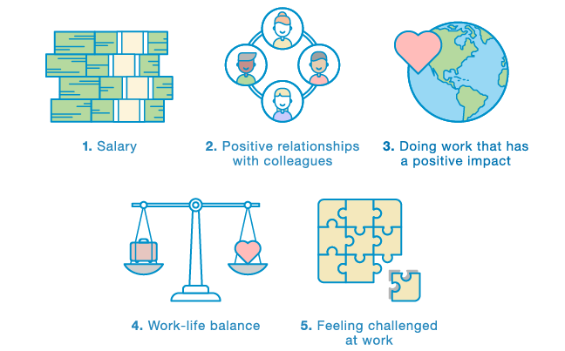
Figure 2 (Source: contextofthings, 2023)
Impact:
Job dissatisfaction has a significant and wide-ranging influence on both people and organizations:
1. Employee Well-Being: People who are unhappy in their jobs are more likely to have stress-related diseases, anxiety, and a lower quality of life. This can result in a vicious cycle of discontent that includes absenteeism, presenteeism (being physically present but mentally disengaged), and lower work satisfaction.
2. Reduced Productivity: Unhappy workers are frequently less efficient, which leads to missed deadlines, mistakes, and poor job quality. The company may suffer financial consequences as well as reputational damage.
3. High Turnover Costs: Hiring, onboarding, and training costs are significantly increased by frequent employee turnover brought on by job discontent. It also interferes with team chemistry and workflow.
4. Reputational harm: It might be difficult to recruit qualified workers if the company has a reputation for having unsatisfactory working conditions (Pandita and Domnic, 2019).
Causes of Job Dissatisfaction
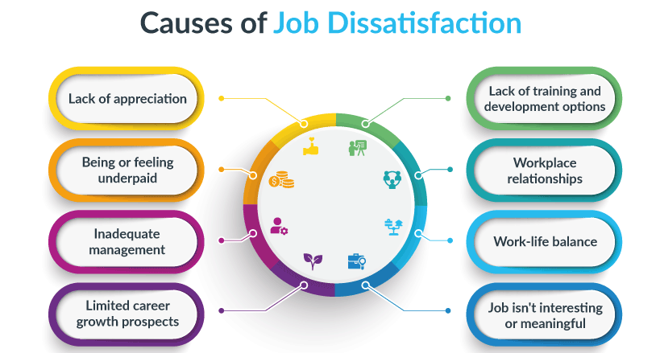
Figure 1(Source: aihr.com, 2023)

Analyse information on the identified problem, to help inform the decision-making process
1. Root Causes: Determine the fundamental reasons why a person is unhappy at their employment. To get input from employees, use focus groups, one-on-one interviews, and questionnaires. Lack of recognition, poor work-life balance, little prospects for professional advancement, incompetent management, and workplace disputes are some common causes.
2. Analyse Quantitative Data: Look at quantitative data like as performance indicators, absenteeism, and staff turnover rates. To identify the areas where work discontent has the biggest influence, analyze trends and correlations. For instance, a high turnover rate in one area may be a sign of problems unique to that department (Extremera et al., 2020).
3. Qualitative Data: By using open-ended surveys or interview questions, qualitative data can yield more in-depth information. Examine recurring themes and opinions that employees have about their jobs. Keep an eye out for repeating trends or issues.
4. Benchmarking: Evaluate your company's work satisfaction levels in comparison to industry averages or rivals. This might assist you in evaluating the performance of your workplace and identifying areas that need improvement.
5. Cost Analysis: Determine how much job discontent will cost. Take into account the costs of hiring, training, lost productivity, and medical bills connected to stress-related disorders. This can show how solving the problem will have real financial advantages.
6. Employee Feedback: Pay attention to recommendations for improvement made by workers. They frequently have insightful ideas on how to improve their job happiness. Create avenues for continuing input, and monitor the application of suggestions made by employees (Brewer et al., 2020).
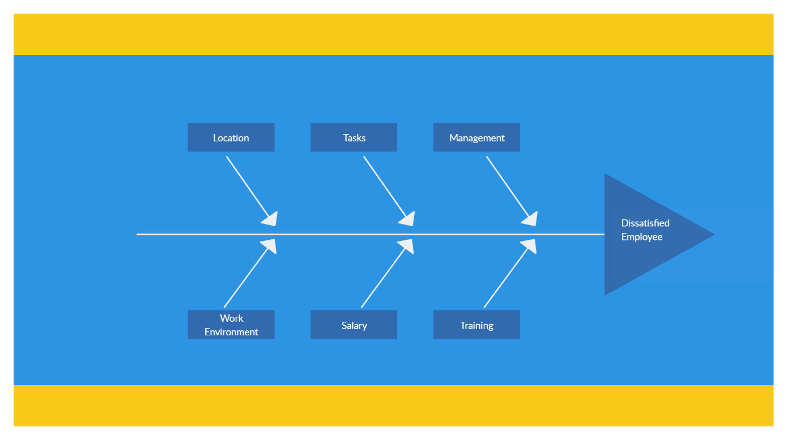
Figure 4(Fish Bone Diagram Source: Pinterest, 2023)

Propose a range of alternative solutions to the problem
1. Remuneration and Benefits Adjustment: To ensure equitable remuneration, raise base pay or award performance-based incentives.
- Improve benefit packages for employees, such as health insurance, retirement programs, and flexible spending accounts.
2. Acknowledgement and Rewards:
- Introduce a staff appreciation program to recognize and celebrate exceptional work.
- Provide non-cash rewards, such as additional paid time off, an employee of the month honors, or career advancement possibilities (Sadiq, 2022).
3. Professional Growth:
- Offer chances for skill improvement and professional progression through mentoring programs, workshops, and training.
- Encouraging staff members to establish and attain professional objectives within the company.
4. Work-Life Harmony:
- Encourage flexible work schedules and remote employment opportunities.
- Promote a work-life balance culture and encourage workers to use paid time off.
5. Better Leadership and Management:
- Provide managers with leadership training to help them become better communicators and people managers.
- To address issues and promote open communication, management, and staff should regularly use feedback methods (Loh and Snyman, 2020).
6. Programmes for Employee Engagement:
- Create and implement engagement initiatives that emphasize cooperation, teamwork, and promoting a great workplace culture.
- Provide chances for workers to participate in decision-making.
7. Support for wellness and mental health:
- Make mental health resources available, such as employee help programs or counseling services.
- Promote health programs including mindfulness exercises, fitness classes, and stress management courses.
Initiatives for diversity and inclusion:
- Promote a diverse and inclusive workplace through the use of inclusion-focused programs, diversity hiring objectives, and diversity training.
- Form Employee Resource Groups (ERGs) to aid underrepresented groups.
9. Mediation and Conflict Resolution:
- Create a structured conflict resolution procedure to handle disputes at work swiftly and fairly.
- Provide HR and management with mediation and conflict resolution training.
10. Reliable Feedback Sources:
- Conduct routine staff surveys to get input on areas for growth and work satisfaction.
- Hold frequent town hall gatherings or feedback sessions to discuss issues with staff members and provide updates.
11. Performance administration:
- Update performance management programs to guarantee honest and open evaluations.
- Connect staff development programs and chances for career progression with performance reviews.
12. Clearly defined career paths
- Establish clear avenues for professional advancement inside the company, including chances for lateral transfers and promotions.
- Offer suggestions on how staff members might grow in their professions.
13. Flexible Compensation:
- Provide employees with the freedom to select benefits that meet their particular needs, such as individualized benefit packages.
- Permit workers to spend some of their benefits budget on what they choose.
14. Job redesign
- Redesign job descriptions to better reflect the talents and interests of employees and to make them more interesting.
- To improve ownership and happiness, encourage employees to participate in the job design process.
15. Moral leadership and company principles:
- Assure that the organization's leadership upholds strict moral principles and promotes an environment of openness and trust.
- To foster a feeling of purpose and alignment among workers, communicate and support the organization's basic principles.
16. Conflict Resolution Education:
- To handle and prevent disputes at work, train managers and employees in communication and conflict resolution techniques.
17. Coaching and mentoring
- Create mentoring and coaching programs to offer direction and assistance for professional development.
18. Flexible Time Management:
- To meet the different demands of your workforce, use flexible schedule choices like reduced workweeks, job sharing, or staggered hours.
19. Programs for Employee Assistance (EAPs) 19
- Provide EAPs, which offer services and discreet counseling to staff members dealing with personal or professional difficulties.
20. Accountability in Leadership
- Include increasing employee happiness and establishing a pleasant work environment in performance assessments for leaders and managers (Liu et al., 2019).
Grid Analysis
Solutions | Cost | Effectiveness | Feasibility | Employee Impact
1. Compensation and Benefits Adjustment | Moderate | High | Moderate | High
2. Recognition and Rewards | Low | Moderate | High | Moderate
3. Professional Development | Moderate | Moderate | High | High
4. Work-Life Balance | Moderate | High | Moderate | High
5. Improved Management and Leadership | Moderate | High | Moderate | High

Cost Benefit Analysis
Solutions | Cost (Euros) | Benefit (Euros) | Net Benefit (Euros)
Compensation and Benefits Adjustment | 50,000 | 200,000 | 150,000
Recognition and Rewards | 10,000 | 50,000 | 40,000
Professional Development | 30,000 | 100,000 | 70,000
Work-Life Balance | 40,000 | 180,000 | 140,000
Improved Management and Leadership | 35,000 | 160,000 | 125,000

Using a decision-making technique, evaluate a range of solutions to identify the most appropriate option
A SWOT analysis may be used to assess a variety of alternatives for resolving job discontent in the workplace. SWOT stands for Strengths, Weaknesses, Opportunities, and Threats. Here is a SWOT evaluation of the suggested remedies:
1. Adjustment of Compensation and Benefits
- Strengths:
- Capable of recruiting and keeping top talent.
- Deals with a typical source of job unhappiness.
- Weakness:
- Could put financial stress.
- Ignores non-financial elements that affect satisfaction.
- Opportunities
- Increases retention and overall staff morale.
- Exhibits a dedication to just recompense.
- Threats
- May result in pay compression or compensation discrepancies.
- If other problems continue, there is no guarantee that work satisfaction will rise.
2. Acknowledgement and Rewards:
- Strengths:
- Increases motivation and morale.
- Relatively inexpensive.
- Weakness
- Dissatisfaction-causing underlying problems may not be addressed.
- Employees have different preferences for recognition.
- Opportunities
- Improves the working culture.
- Promotes good performance and behavior.
- Threats
- Biassed or inconsistent recognition might backfire.
- If not properly maintained, efficacy may deteriorate over time.
3. Professional Growth:
- Strengths:
- Provides possibilities for skill development and progress for employees.
- Exhibits a commitment to their future.
- Weakness:
- Requires effort and money.
- Could take time to affect job satisfaction.
- Opportunities
- Increases worker engagement.
- Attends to needs for long-term professional growth.
- Threats
- Workers may go after developing new skills.
- Might not be adequate for workers with deeper levels of unhappiness.
4. Work-Life Harmony:
- Strengths:
- Improves worker wellbeing.
– Enhances general job satisfaction.
- Weakness:
- Difficult to execute in all positions or industries.
- A shift in organizational culture could be necessary.
- Opportunities
- Decreases burnout and stress.
- Draws workers looking for work-life balance.
- Threats
- May be viewed as an advantage rather than a problem.
- Could lead to job inequities among employees.
5. Better Leadership and Management:
- Strengths:
- Deals with a major cause of work unhappiness.
- May result in enhanced team relations and communication.
- Weakness:
- Requires education and a culture shift.
- The current leadership might object.
- Opportunities
- Increases the overall efficacy of leadership.
- Has a favorable effect on the entire organization.
- Threats
- Implementation issues might impede development.
- Leadership changes have the potential to undo gains.
A SWOT analysis of these alternatives reveals that a mix of methods would probably be the most efficient course of action. Dealing with work unhappiness is a difficult problem that sometimes has several causes (Purpora et al., 2019).

Develop a detailed plan for implementing the solution
For the chosen approach to address job discontent in the workplace to be implemented successfully, a thorough strategy must be created. Suppose the solution is "Implementing an Employee Recognition Programme." Here is a detailed implementation strategy:
Step 1: Establish Specific Goals
- Clearly state the goals of the employee recognition program, such as promoting general productivity, enhancing staff morale, and increasing work satisfaction.
Step 2: Establish a project team
- Create a cross-functional project team with managers, HR experts, and representatives from other departments.
Step 3: Needs Evaluation
- Complete a thorough requirements analysis to pinpoint the unique preferences and needs of workers in terms of recognition. Surveys, focus groups, and one-on-one interviews could be used for this.
Step 4: Create the Award Programme
- Create a thorough recognition program in line with the culture and values of the company.
- Establish the standards for reward and recognition.
- Choose the channels (such as monthly awards, peer-to-peer recognition, or public acknowledgments) and frequency of the recognition.
- Create a program budget.
Step 5: Training and Communication
- Inform all staff members about the program's goals, regulations, and advantages.
- Offer managers and staff training on how to use the recognition program well.
- Create marketing materials and enthusiastically introduce the program.
Step 6: Put into practice
- Start the recognition program by the planned timeline.
- Keep an eye on and keep track of recognition activities to make sure they adhere to program rules.
– Motivate staff members to actively engage in the program by praising their colleagues.
Step 7: Assessment and Recommendations
- Create a method for gathering employee feedback on the success of the recognition program.
- Constantly evaluate if the program is accomplishing its goals.
- Modify plans in response to comments and changing organizational requirements.
Step 8: Acknowledgement Rewarding and Motivating
- Choose the proper incentives and awards for recognized employees. These can be certificates, gift cards, extra vacation days, or other intangible compensation.
- Check that the prizes are reasonable, regular, and in line with the degree of recognition.
Step 9: Performance Metrics
- Establish key performance indicators to gauge the effectiveness of the program, such as employee satisfaction surveys, turnover rates, and productivity.
- Analyse and report on these indicators regularly to determine the program's effectiveness.
Step 10: Culture of Recognition
- Encourage the development of a culture of recognition by incorporating it into the goals and objectives of the company.
- Encourage managers and leaders to set a positive example for staff members by publicly praising them.
Step 11: Honour accomplishments
- Recognise the program's beneficiaries in public to mark the program's accomplishments.
- Share case studies and success stories to encourage others to get involved.
Step 12: Continuous Improvement
- Constantly evaluate and improve the recognition program in light of data and user input.
- Keep abreast of the finest employee appreciation practices and change as necessary.
Step 13: Continued Assistance
- Offer continuing assistance to managers and staff members taking part in the recognition program.
- To keep program enthusiasm high, swiftly address any problems or challenges.
Step 14: Sustainability
- Integrate the recognition program with the organization's culture and financial strategies to ensure its long-term viability.
Step 15: Monitor and adapt
- Regularly assess the program's effectiveness and tweak it as necessary to meet shifting employee demands and organizational objectives (Chen et al., 2019).

Communicate the plan to relevant stakeholders
1. Identify Key Stakeholders: - List all important parties, such as top management, department managers, HR staff, and staff members of all ranks.
2. Create a Strategic Communication Plan:
- Develop a thorough communication strategy that specifies the essential messages, distribution methods, and timing of communication.
3. Address Specific Stakeholders with Specific Messages:
- Tailor your communications to the unique requirements and preferences of each stakeholder group. while speaking to top management, for instance, emphasize the program's influence on productivity; while speaking to front-line staff, emphasize the program's advantages for employee morale.
4. Hold stakeholder gatherings.
- Schedule meetings with senior leadership to go over the strategy in depth and highlight how it aligns with those goals.
- Hold separate meetings with department managers to discuss how they contribute to the success of the program and get their feedback.
5. Produce Visual Content:
- Create eye-catching resources to support your communication efforts, such as presentations, infographics, and brochures.

6. Use several channels for communication:
- Speak with stakeholders through a variety of communication channels to make sure they receive the information:
- Email: Use email to communicate updates and comprehensive plans.
- Intranet/Employee Portal: Post information about the program and resources there.
- In-Person Meetings: To promote face-to-face engagement, hold town hall meetings, workshops, or training sessions.
- Use internal social media networks or messaging applications for conversations and updates.
- Print Materials: Posters and printed materials should be distributed in public spaces.
7. Create Possibilities for Questions and Comments:
- Encourage stakeholders to submit questions and feedback via specific communication channels, such as surveys, Q&A sessions, or feedback forms.
8. Success Stories of Note:
- To illustrate the impact of the recognition program, share employee success stories and testimonials.
9. Define Timelines and Expectations Clearly:
- Make sure everyone is aware of the program's start date and any particular deadlines for completion of implementation milestones.
- Clearly state the manner and timing of stakeholder participation in the process.
10. Define Who Is Responsible:
- Clearly, state who is in charge of each program component, such as the HR team managing it, department managers driving recognition initiatives, and workers actively taking part.
11. Address objections and worries:
- Have well-thought-out replies ready to address any concerns or objections stakeholders may have.
- Demonstrate that you have thought about potential obstacles and have strategies in place to address them.
12. Strengthen how the program is in line with organizational objectives:
- Continue to stress how the organization's larger objectives, such as enhancing employee engagement, retention, and general work satisfaction, are aligned with the recognition program.
13. Consistent Updates:
- Offer frequent updates on the execution of the program's progress and its effects on work satisfaction.
- Disseminate measurements and statistics to show the program's efficacy.
14. Mark Significant Occasions:
- To keep stakeholders' interest and motivation high, recognize significant program implementation milestones and accomplishments.
15. Open Communication:
- Assure stakeholders that they may contact you with any questions or concerns as the program is being implemented (Singh et al., 2019).

Assess appropriate monitoring and review techniques to ensure the successful implementation of the solution
1. Key performance indicators, or KPIs, include:
- Establish precise KPIs, such as employee engagement ratings, attrition rates, productivity indicators, and the frequency of recognition events, that are in line with the program's goals.
- Monitor and assess these KPIs regularly to gauge the program's effectiveness over time (Aslan et al.,2022).
2. Surveys of employees:
- Survey employees regularly to get their opinions on the recognition program and how it affects their job happiness.
- Ask questions regarding how well the program is seen as being fair, efficient, and in line with employee preferences and needs.
3. Reaction Systems:
- Create simple ways for staff to offer feedback on the program, such as suggestion boxes, online discussion boards, or specific email addresses.
- Assure fast assessment and response to input.
4. Analysis of Recognition Data
- Examine recognition data, such as frequency and types of awards, to spot patterns and potential areas for development.
- Analyse trends in the teams or departments that receive the greatest and least accolades.
5. Consistent Reporting:
- Create consistent reports on the program's development and results to communicate with key stakeholders, such as senior management, managers, and staff.
- Make sure these reports contain both quantitative and qualitative data.
6. Interviews and focus groups:
- Hold focus groups or one-on-one interviews with workers to get a more in-depth understanding of how they felt about the recognition program.
- To pinpoint particular examples of success and potential improvement areas, use qualitative data.
7. Benchmarking
- Evaluate the results and procedures of your recognition program in comparison to industry standards and best practices.
- Determine any areas where your program may need to be modified to remain competitive and efficient.
8. Managerial Recommendations:
- Motivate managers to regularly share their thoughts on how the program is having an impact on their departments.
- Gather information on how employee morale and team dynamics are affected by recognition activities.
9. Anecdotal Proof:
- Collect first-hand accounts from staff members who have benefited from recognition to demonstrate the program's effectiveness.
- Share these tales with others to encourage and uplift them.
10. Teams for Continuous Improvement:
- Create cross-functional teams that are in charge of routinely assessing the success of the recognition program.
- Charge these teams by coming up with suggestions for improvements and handling problems when they appear.
11. Metrics for Employee Participation:
- Keep tabs on how many employees participate in events and activities for recognition.
- Look for any trends that would point to poor engagement in particular departments or among particular staff categories.
12. Tracking of resources and budget:
- Keep an eye on the money allotted to the recognition program and make sure resources are distributed properly.
- Determine if the program is cost-effective and whether any modifications are required.
13. Continual Communication with Leadership:
- Arrange for regular meetings with top leadership to give an update on the program's development and results.
- Ask for their advice and backing to continue making changes.
14. Constant Education and Training:
- Provide managers and staff with continuing training and instruction on how to get the most out of the recognition program.
- Assess the success of the instruction through comments and evaluations.
15. Quarterly or yearly evaluations:
- Conduct formal quarterly or yearly assessments of the effectiveness and results of the recognition program.
- Make the most of these reviews to develop your goals and strategy for the upcoming period.
16. Flexibility and Adaptation:
- Be ready to modify the monitoring and review procedures as necessary as the organization's needs and the recognition program develop.

References
Aslan, M., Yaman, F., Aksu, A. and Gungor, H., 2022. Task performance and job satisfaction under the effect of remote working: Call center evidence. Economics & Sociology, 15(1).
Brewer, K.C., Oh, K.M., Kitsantas, P. and Zhao, X., 2020. Workplace bullying among nurses and organizational response: An online cross‐sectional study. Journal of Nursing Management, 28(1), pp.148-156.
Chen, Y.C., Guo, Y.L.L., Chin, W.S., Cheng, N.Y., Ho, J.J. and Shiao, J.S.C., 2019. Patient–nurse ratio is related to nurses’ intention to leave their job through mediating factors of burnout and job dissatisfaction. International journal of environmental research and public health, 16(23), p.4801.
De Clercq, D., Haq, I.U., Azeem, M.U. and Ahmad, H.N., 2019. The relationship between workplace incivility and helping behavior: roles of job dissatisfaction and political skill. The Journal of psychology, 153(5), pp.507-527.
Extremera, N., Mérida-López, S., Quintana-Orts, C. and Rey, L., 2020. On the association between job dissatisfaction and employee’s mental health problems: Does emotional regulation ability buffer the link?. Personality and Individual Differences, 155, p.109710.
Liu, J., Zheng, J., Liu, K., Liu, X., Wu, Y., Wang, J. and You, L., 2019. Workplace violence against nurses, job satisfaction, burnout, and patient safety in Chinese hospitals. Nursing outlook, 67(5), pp.558-566.
Loh, J. and Snyman, R., 2020. The tangled web: consequences of workplace cyberbullying in adult male and female employees. Gender in Management: An International Journal, 35(6), pp.567-584.
Pandita, R. and Domnic, J., 2019. Overcoming workplace discrimination and job dissatisfaction in academic libraries: A Study. Library Philosophy and Practice, pp.1-24.
Purpora, C., Cooper, A., Sharifi, C. and Lieggi, M., 2019. Workplace bullying and risk of burnout in nurses: a systematic review protocol. JBI Evidence Synthesis, 17(12), pp.2532-2540.
Sadiq, M., 2022. Policing in pandemic: Is perception of workload causing work–family conflict, job dissatisfaction and job stress?. Journal of Public Affairs, 22(2), p.e2486.
Singh, M.M., Amiri, M. and Sabbarwal, S., 2019. Role of job stress on job satisfaction. International Journal of Management Studies, 6(4), pp.57-60.

Appendix 1
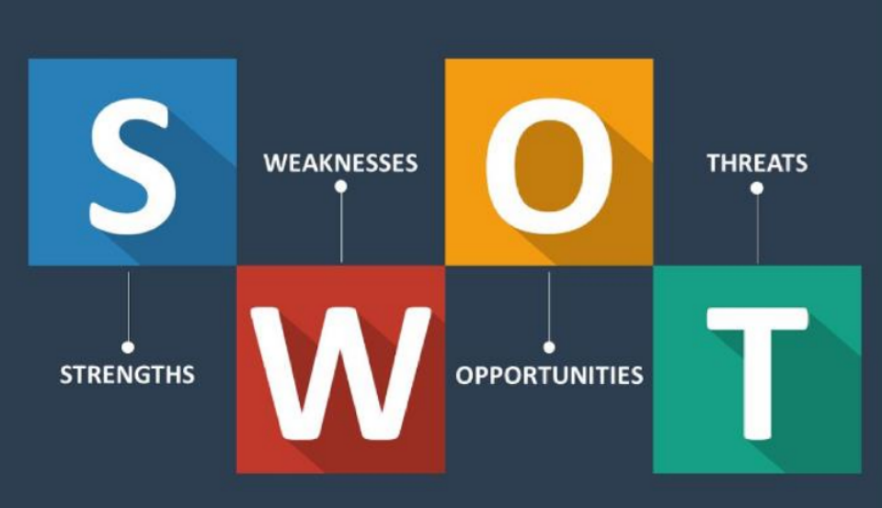
Figure 5(Source: Medium, 2023)

