Name – Mohammed Ajmal

Student number – 2112398

Module code and title – BMSW4005 Professional and Career Development

Lecturer name – Besty Jose

Assignment title – Portfolio of Work – Task 1 Open Book Assessment

Date 14th June 2022

Title
Having read the case study, in your own words explain self-harm. Identify and explain the circumstances that makes people self-harm.

Introduction
What is self-harm?
Self-harm is when a person intentionally injures or harms oneself. This can happen for a variety of reasons, in a variety of situations, and in a variety of ways, including:

- an overdose is when you take too many pills ;

- self-mutilation ;

- self-incineration ;

- slamming your head into anything or throwing yourself against something ;

- self-puncturing ;

- putting objects in your body ;

- ingesting items that should not be ingested.

When someone self-harms, they are frequently in a state of emotional and psychological anguish. Self-harm is described by many as a technique to cope with overwhelming emotions. Some people plan of time, while others do things spontaneously. While some people self-harm only once or twice, others do so on a regular basis, making it difficult to stop.
How common is self-harm?
According to the 2014 Adult Psychiatric Morbidity Survey, the proportion of adults aged 16–74 who reported ever self-harming grew from 2.4 percent in 2000 to 3.8 percent in 2007, and 6.4 percent in 2014. This rise was seen in both men and women, and in people of all ages.

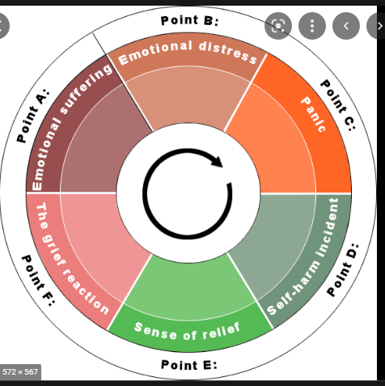

The above self-harm cycle is courtesy of Nottingham University and best describes the vicious circle one encounters on this journey.

Main body of discussion

What makes people self-harm
Many people who self-harm is dealing with intolerable distress or unpleasant conditions, and they have often been dealing with these issues for a long time before they self-harm.

The following are examples of common issues:

- I am feeling down ;
- you are feeling down about yourself ;
- abuse of any kind, whether physical or sexual ;
- problems with lovers, friends, and family relationships ;
- being unemployed or having work-related challenges.

If you have the following feelings, you are more likely to injure yourself:

- people do not seem to understand you or pay attention to you ;
- hopeless ;
- I am alone and isolated ;
- You have no control or authority over your life.

Many people who self-harm problems with alcohol or drugs have, although this is not always the case.

Impact of self-harm
Self-harm can offer you a sense of control and help you cope with stressful and distressing situations. It can feel like you are punishing yourself if you are feeling guilty. In either case, it can become a coping mechanism for negative emotions and distress.

Conclusion
There is way out of this vicious circle of self-harm.
The doctors and nurses in the emergency department have the right to treat you with kindness and respect.
Many emergency rooms now have easy access to a health professional who is knowledgeable in self-harm. A psychiatric nurse, a doctor, or a social worker could be the person in charge. They will chat to you about how you are feeling and produce solutions to help you. Staff may want to do a risk assessment with you by filling out a form.

