
APPENDIX GA36d

LEVEL 7 ASSESSMENT SPECIFICATION

Student name: | Benjamin Howells | Student ID number: | 1800641
Programme: | Secondary PGCE
Module: | Curriculum Development and Enhancement
Module code: | ECSP7002 | Contribution to Overall Module Assessment (%): | 100%
Lecturer: | Helen Denny | Internal Verifier:
Assignment Title: | Research Study including Ethics Form | Word count (or equivalent): | 10.000 words in total including an Ethics form (to be given in on January 11th 2019)
Submission deadline: | May 13th 2019 | Return date of provisional marks & written feedback: | June 10th 2019
Submission method: | All written assessments, where practical and possible, must be submitted via Turnitin unless otherwise instructed by the Lecturer. (Please DO NOT put this assessment specification into Turnitin or it will match many similarities with other students’ submissions.)  Alternative submission method (if applicable):  Late submission of the assessment will result in a late penalty mark. Penalties for late submission: Up to one week late, maximum mark of 50%. Over one week late, 0%. Only the Extenuating Circumstances Panel may approve a change to submission dates.
Academic honesty / referencing: | Academic honesty is required. In the main body of your submission you must give credit to authors on whose research and ideas your work is based. Append to your submission a reference list that indicates the books, articles, etc. that you have used, cited or quoted in order to complete this assessment.

Dual Coding as an effective way of teaching vocabulary in the MFL classroom

Introduction
This research activity was carried out in a secondary mixed school, located in what could be considered a more deprived area of South Wales. This school teaches from age 11 to 16 and does not teach sixth form. For ethical reasons, this school will from now on be referred to as School X as to comply with BERA’s ethical considerations when carrying out Action Research. When it came to carrying out my research, I decided to use a Year 8 mixed ability Spanish class that took place in the afternoon. Despite being defined as a mixed ability class, the overall ability in this class was quite high and they are generally very well behaved; a factor that could be considered important when it comes to carrying out this type of research. I made the decision to research the use of Dual Coding as a method for teaching new vocabulary in the Modern Foreign Languages classroom which links to Cognitive Load Theory; a theory that plays a fundamental role in the use of Dual Coding. According to Conti (Conti, 2015), “Vocabulary Acquisition” is at the top of the list when it comes to research carried out by Modern Foreign Languages teachers and I, therefore, decided to pursue this line of research with the aim to discover a more effective method of teaching new vocabulary.

Literature Review
Firstly, Gianfranco Conti identifies that one of the first hurdles when learning vocabulary in a modern foreign language is that the current timetable doesn’t allow for a great deal of contact time between students and their teachers (Conti, 2016). He also remarks, therefore, that due to this lack of time dedicated to MFL on the timetable, students’ retention and understanding of the language is “poor and often defective.” With this in mind, it could be said that finding a more effective way of teaching vocabulary is essential to enhance students’ retention of new vocabulary which informed my decision to research this method of teaching new vocabulary in Spanish.
Similarly, Tom Sherrington, headteacher at King Edward VI Grammar School in Chelmsford identifies that MFL doesn’t have enough time on the curriculum however, he then goes on to say that pedagogical approaches to learning grammar and vocabulary are “too often standard pedagogical approaches are limiting and formulaic” (Sherrington, 2013). He continues to say that far too often vocabulary is taught in isolation and the quickly forgotten by the students. This further informed my decision to pursue this line of research as to innovate the way that vocabulary is taught in the classroom.
According to Steve Smith, one of the debates in the teaching of Modern Foreign Languages is that of “implicit learning” which prioritizes learning through the exposure to meaningful messages which focuses almost entirely on meaning. Contrary to this, the second debate is that of grammar being taught by translation and thus calling on meaningful practice of the new language as to move the learnt grammar and vocabulary from the short term to the long term memory (Smith, 2018). Given the previously mentioned time constraints of MFL on the curriculum, it could be said that the first method of implicit learning would be more beneficial to research as it doesn’t rely on constant repetition but on meaningful representations of concepts already identifiable. Therefore, Dual Coding theory could be used in this instance as it calls on the use of images as a stimulus and not constant repetition.
Another issue highlighted by Gianfranco Conti is students forgetting new vocabulary. His theory suggests that the reason for forgetting a word is not due to the weakening of the memory but due to failure to find that word (Conti, 2016, p49). He goes on to say that a more effective association to a word may result in a more effective retrieval of the word. With this in mind, association between terms in the target language and images to represent them, i.e. “Dual Coding”, could essentially be a more successful way of teaching vocabulary as it could provide more stimulating associations to the new vocabulary and result in better retrieval of these words.
Allan Paivio and James Clark define the Dual Coding Theory as “associative processes that operate on a rich network of modality specific verbal and nonverbal (or imagery) representations.” (Paivio, Clark, 1991, 149). In the same article, both authors go on to explain that Dual Coding “explains psychological phenomena by the collective action of nonverbal and verbal mental systems that are specialized for the processing of imagery and linguistic information” (Paivio, Clark, 1991, p150). This theory links directly to the aim of this study as a method for processing new linguistic information; in this case, new vocabulary in a modern foreign language. By using Dual Coding Theory in this study, it could be said that this method of acquiring new vocabulary is more natural as this is the way that infants would usually learn their mother tongue; by image and then word association. I therefore decided to use genuine images and the vocabulary purely in the target language to teach physical description adjectives in Spanish.
According to Sadoski and Paivio, our five senses are “orthogonal” when it comes to Dual Coding Theory (Sadoski, Paivio, 2004 p3,). That’s to say that each sense has “subsets of mental representations that are qualitatively different due to the different sensory experiences from which they originated.” This same article goes on to explain that the visual representation of items is linked to the “verbal” code as well as the “non-verbal” code, for example the representation of new vocabulary. We make a link between the things we see and the word that represents that image. It could be said that by using images instead of translation from the mother tongue to the target language would be a more effective way of learning vocabulary and thus informed my decision to pursue this line of research further.
A source by Tracy Schiffmann suggests that Dual Coding “works” because it takes advantage of two channels for processing information. She goes on to explain that combining an image along with text or explanation is effective as we have different channels for each of these elements in our memories (Schiffmann). The article suggests that students who are learning vocabulary this way have two different ways of processing the vocabulary they have seen as they associate the text and/or speech with an image to identify the new vocabulary. It also suggests that there is an increased likelihood of students remembering this vocabulary as they would have two different ways to store the information provided. This theory furthered my interest in researching the use of Dual Coding Theory as it refers to an improvement in the way students remember vocabulary more effectively.
In addition to the aforementioned, it is said that Dual Coding Theory can aid the “concretizing” language-based information and that “concrete cues” are more capable of generating a visual image and thus more capable of facilitating recall by bringing to mind the object or event stored in the memory (Lwin et al, 2010). It could, therefore, be said that Dual Coding Theory would be an excellent method of teaching new vocabulary in the target language as students would, in theory, facilitate the recall of said vocabulary in future sessions.
When discussing the recall of new vocabulary, it is important to consider Cognitive Load Theory as it could give a deeper understanding as to how information is processed. According to John Sweller Cognitive Load Theory refers to the amount of information that working memory can hold at one time and that overloading that memory will ultimately result in impaired acquisition of knowledge (Sweller, 1988). Research suggests that reducing cognitive load is important to not overwhelm the student when introducing new information (Shibli, West, 2018) and to use short tasks when it comes to reducing Intrinsic Cognitive Load. It could be said that taking this approach to teaching new vocabulary in MFL would benefit the recall of new words as students would not feel overwhelmed by learning new vocabulary.
It is also mentioned that information overload, for example extensive information on a PowerPoint slide while the teacher is talking, can lead to working memory failures (Shibli, West, 2018). With this in mind, it could be said to be important to keep the written information to a minimum when it comes to teaching new vocabulary as not to draw attention away from the words the students are learning.
Gianfranco Conti argues that the Working Memory is but a temporary storage facility and that constant rehearsal is essential to ensure that the information we receive isn’t lost in seconds. He says that after only a few seconds “spontaneous decay” sets in and without this continuous rehearsal, information will be forgotten (Conti, 2015). With this in mind, constant repetition of the vocabulary in question could be essential to ensure that students recall the new vocabulary more effectively.
Furthermore, it is said that Working Memory cannot contain more than between 5 and 9 items of information at once (Miller, 1956). Conti expands on this theory by saying that this may be true for university students but the average person is only able to retain 4 or 5 different items (Conti, 2015). Taking these two theories into account, this informed my decision to ensure that the number of new words I would be teaching the students were concise and manageable at the time of recall.
According to retrievalpractice.org, Retrieval Practice is defined as the theory that “gets information out” of the students and by bringing this information to mind it is strengthened and is less likely to be forgotten (Retrieval Practice, 2018). Agarwal argues that when students are engaged with retrieval activities, such as end unit tests, learning is strengthened by the challenge it presents to recall the information (Agarwal, 2019, p191). By continuously recalling the new vocabulary throughout the lesson, it could be said that this will enhance the transfer of information from the short term to the long term memory and thus informed my decision to use mini-whiteboards throughout the intervention process as a method of recalling the new vocabulary.
It could also be argued that this is a form of Mastery Learning technique. Mastery Learning can be defined as simply focusing on one thing and not moving on until is it mastered (Renard, 2017). Bloom argues that students should not move on to more advanced learning objectives until they have demonstrated proficiency in the one in hand (Bloom, 1976). Together with what has been mentioned regarding Retrieval Practice and Mastery Learning, it informed my decision to ensure that mini-plenary tasks were present in order for the students to continuously recall the vocabulary being taught in the lesson. It could be said that this would significantly enhance their recall in the post-test stage of the project.
When conducting this research I also opted to teach the vocabulary entirely through the use of the Target Language, in this case Spanish, with only the aid of the images on screen as the second “code”. Ernesto Macaro states that the target language should be “the predominant language of interaction in the classroom” (Macaro, 2000). In the same study, Macaro found that the majority of modern foreign language teachers used code switching (from the L1 to the L2) within the same conversation and found it to be useful. Contrary to this belief, I opted to use the target language entirely when teaching the vocabulary in this project as research indicates that target language use is considered to be “best practice” when it comes to teaching and learning a Modern Foreign Language (Moeller, Roberts, 2013).
Another study carried out in Italy by Macaro himself revealed that some teachers found the “over-use” of the target language in the classroom was counterproductive (Macaro, 1997, p77). The teachers went on to explain that discipline was not a problem in the target language (Macaro, 1997, p77), however given the context of School X, this would be an issue and therefore I opted to maintain my interpersonal communication in the L1 to ensure that behavior would not be a problem during this project.
The use of target language in the classroom is an issue that has been highlighted in the 2016 Estyn Review. This document states that since the previous report in 2009, the use of the target language in the classroom has diminished and has resulted in the lessening of students opportunities to hear and respond to the target language (Estyn, 2016, p15). The report goes on to say that teachers use “basic transactional language” in the classroom that has resulted in students rarely seeking explanations in more complex target language which, if addressed, could result in a better oral fluency (Estyn, 2016, p19). These suggestions informed my decision to maintain the teaching of the new vocabulary in the target language throughout this project and also to maximize my use of target language during the intervention stage.
A further argument for the maximizing of Target Language use in the classroom is that of motivation. It has been said that use of the target language in the classroom leads to increased motivation in learning amongst students (MacDonald, 1993) and in her book “Target Language Toolkit”, Allison Chase explains that new vocabulary should be introduced in the Target Language and that use of the Target Language in the classroom will result in encouragement for students to use this language with each other in the classroom (Chase, 2015). It could be said that only using the target language to introduce the vocabulary in question would be nothing but beneficial to the students when it comes to motivating them in modern foreign languages. In addition, Dr Olenka Bilash says that teaching in the Target Language sustains a “foreign atmosphere” in the classroom (Bilash, 2011) which further informed my decision to maximize my use of the target language during this project.
Continuing the theme of motivation, Language Trends 2018 conducted by The British Council revealed that attitudes towards language learning have changed due to Brexit. They say that 34% of schools have said that the departure of the United Kingdom from the European Union has negatively impacted the uptake of Modern Foreign Languages in regards to students’ attitude towards the subject. It was mentioned that parents and students alike questioned the value of learning a language as they felt that “everyone should speak English.” (British Council, 2018, p7) However, contrary to this argument, the same article mentions that Senior Management at certain schools are using Brexit as a tool to encourage students towards the learning of another language, stressing the importance of maintaining intercultural relationships in a post-Brexit United Kingdom (British Council, 2018, p7). Similar attitudes can be observed in Wales as Language Trends Wales reports that 37% of schools are experiencing negative attitudes towards learning a foreign language due to Brexit. (Language Trends Wales, 2018, p9) Considering both of these arguments, it could be said that the need for motivating students in the Modern Foreign Languages classroom is currently of great importance and thus informed my decision to use a high quantity of Target Language during this project to create the most authentic atmosphere possible.
The time of day that the classes were carried out could also be considered a factor when looking at achievement and results amongst students. According to Shouppe and Wile, research indicates that students’ reading scores increase after having had instruction in the afternoon rather than the early morning (Shouppe, Wile, 2011, p22). In the same article, it is also mentioned that reading comprehension relies on previous knowledge and the long term memory when applying the skills. However, according to Pope and a study that looks into how the time of day affects productivity, his conclusions state that productivity is higher in the morning than in the afternoon (Pope, 2016, p10). It could be said, therefore, that the time of day could be a factor that affects the results of this study and due to timetabling issues, one that cannot be mitigated as two classes will take place in the morning and one in the afternoon.

School Policy and Practice
In the absence of a school policy when it comes to teaching vocabulary in Modern Foreign Languages, School X appears to follow many of the guidelines and recommendations expressed by the latest ESTYN report, Language Trends Wales and other sources which inform the teaching of new vocabulary in MFL.
In accordance with the observations of Language Trends Wales, where it has been mentioned that some teachers feel that one of the barriers to teaching MFL in schools is having time to work with other departments when it comes to Language and Literacy (Language Trends Wales, 2018, p48) School X works closely with the Welsh department to create triple literacy resources and reinforce the use of cognates when it comes to teaching vocabulary. This can be seen in the Spanish and French classrooms at this particular school and is effective when reinforcing the teaching of vocabulary. Furthermore, in accordance with Donaldson’s successful futures (Donaldson, 2015) the use of the Welsh language as a point of reference to new vocabulary taught in MFL can be seen as a step towards the implementation of the new curriculum in School X.
In ESTYN’s report in 2016 for Modern Foreign Languages in Wales, one of the main findings was that there were “repeated mistakes with intonation and pronunciation” (ESTYN, 2016, p4). This greatly informed the methods by which vocabulary is taught at School X mainly as a traditional drill exercise in which students work on the pronunciation of the vocabulary they are taught immediately before recall. Furthermore, as Gianfanco Conti suggests (Conti, 2016, p54) partner games are a big part of the way vocabulary is taught at the school to reinforce the speaking element and improve pronunciation.
A recommendation in the same report was to “make sure that learners of all abilities are fully challenged and engage in creative language activities that develop their mastery of the language.”(ESTYN, 2016, p7) This can be seen to be addressed in School X by the variety of activities employed in the MFL classroom from real-life questionnaires in the target language to role plays that involve communicating purely in the target language.
This creativity is also supported by the way that the school encourages further learning across the subject base from all of its teachers. It can be seen that every door contains a poster introducing every teacher and their subject along with what they are reading and studying for further professional development. It could be said, therefore, that there is a strong ethos towards research in School X and that all professionals are encouraged to innovate in their classrooms and this is more than evident in the MFL classroom as the recommendations from the ESTYN report 2016 are addressed head on.

Methodology and Ethics
The type of research that was decided upon when carrying out this research question was Action Research. According to Richard Sagor, Action Research can be defined as “a disciplined process of inquiry conducted by and for those taking the action. The primary reason for engaging in action research is to assist the “actor” in improving and/or refining his or her actions.” (Sagor, 2000, p3) In accordance with this definition, as a teacher, this research method proved to be the most informative as the research question proposed addresses the improvement of teaching vocabulary in the MFL classroom.
In the same book, Sagor addresses the three purposes of Action Research; building a reflective practitioner, making progress on school wide priorities and building professional cultures (Sagor, 2000, p7). These could be seen as advantages of using this type of research as it could improve practice across the board and not only inform individuals’ practice but that of other professionals also. Other advantages include that of it being a link between the real world and the academic world as well as that of it being relevant to people in the real world (Fritzsche, Just).
Disadvantages of this type of research include; subjectivity - the over-involvement of the researcher, time consumption and vulnerability to pressure (Anon, 2018). It could be said that the over involvement of the teacher as the researcher in this project could create a bias towards the results obtained. Furthermore, the time limitations of being a full time teacher as well as a researcher could have an impact on the question proposed as the school day can change drastically very quickly during the course of a day.
The stages of the research were as follows; a pre-test- to create a baseline set of data, an intervention stage - to carry out the proposed experiment with the class in question and a post-test - to see the “after” effect of the proposed experiment.
According to Kumaa, one of the main advantages of this design is that “it is the most appropriate design for measuring the impact or effectiveness of a programme” (Kumaa, 2011, p107). He continues to say that one of the limitations of using a “pre-test” is that people “may withdraw from the experiment” (Kumaa, 2011, p108). This could be true for this context as students may withdraw or may not be present for this element of the research thus reducing the size of the sample number immediately. Another limitation of using a pre-test could be that of “test anxiety”. Students who feel that they are having a test without having the opportunity to study for the test may perform poorly due to the stress of the test, therefore results would be affected. This process could have been improved by using different terminology when involving the students in the test as to not create this anxiety.
Moreover, Kumaa also suggests that this design could be problematic in terms of younger subjects in that if there is a large time lapse between conducting the pre-test and the post-test, subjects may go through the maturation effect and this can impact results (Kumaa, 2011, p108). Furthermore, according to Manion and Morrison, ensuring there isn’t too long or too short a gap between the two tests is of importance when it comes to the validity of results (Manion, Morrison, 2007, p145). Therefore it was of the utmost important to conduct the post-test after having a completed the intervention stage of the research to obtain the most valid results possible.
Quantitative data was used in this project and there are strengths and limitations of using this type of data. Rahman suggests that one of the strengths to using this type of data would be that data is easier to analyse this way and is less time consuming, however he suggests that one of the limitations to this type of data is that it doesn’t account for deeper underlying meanings and explanations (Rahman, 2016, p106). This could be a limitation for this study as qualitative data would give us a deeper understanding as to how the students have benefited from this type of instruction.
Further advantages of using quantitative data would include the data being “descriptive” and therefore allowing us to see trends in the data however, the limitation that this presents us is that we are unable to see why these trends occur (Madrigal, McClain, 2012).
When conducting this research, ethical considerations were essential in order to carry out this research question. Before starting this research, ethical approval was sought by the submission of an ethics form to the University and according to BERA’s Ethical Guidelines to Educational Research, 2018 I took the necessary measures to ensure guidelines were followed.
Firstly, I endeavoured to mitigate any negative effects of the research by clearly outlining my question to the students in the class and the purpose of my research. All participants were given the opportunity to withdraw from the research at any time and their parents were also informed of the proposed research before engaging in the experiment.
In accordance with BERA’s guidelines, all data was stored on a password protected pen drive to protect the participants’ right to privacy and all names were changed to simply “Student” and a randomly assigned number when storing the data (BERA, 2018, p21).
Furthermore, in accordance with Art. 7 of the GDPR for Europe, all participants gave consent to their data being used by means of verbal agreement after having outlined the research proposal at the beginning of the class.
It could also be said that research could have a potentially damaging effect on children as there are many ethical dilemmas when it comes to carrying out educational research; one of which being the mental stress of being a participant (Manion, Morrison, 2007, p63). By following BERA’s ethical guidelines, these dilemmas were mitigated and all participants were able to withdraw from the research at any point in the activity.
Anonymity was also maintained not only by not using their names when it came to publishing results but also by outlining the school as School X and by not revealing the name of the class to which the students belonged (BERA, 2018, p17).

Evaluation
As mentioned in the introduction, the class in question was a mixed ability Year 8 Spanish class and was made up of 22 participants in total who took part in the entire sequence of classes for the purposes of this research assignment. To protect their anonymity in accordance with BERA’s ethical guidelines for academic research (BERA, 2018), this class shall now be referred to as Class X.
The first task in my sequence of lessons consisted of a pre-test of ten vocabulary words in Spanish for which the students had to provide the English translations without having previously seen them. Students had five minutes at the start of the class to do as best they could without any previous knowledge of these words, relying entirely on their cognitive ability to work them out. The average mark out of ten for this test was 1.435 therefore it could be said that this was a good benchmark for improvement. Individual results can be see for this test in Appendix 1. It could be said that one of the restraints of giving students this type of test is that many could suffer from “Test Anxiety”. According to PsyCom.net, this anxiety causes a “fight or flight” reaction in many people and good thinking gets converted into “high alert” thinking (Smith, 2019). This could have affected these results negatively as the students had no warning that they would be subject to a test. An example of this can be seen from Student 13 (Appendix 3), a strong candidate who suffers enormously from this type of anxiety, as they did not attempt the majority of this test.
Moving on to the intervention, the opening task consisted of drilling vocabulary purely through the medium of Spanish using pictures and the adjective in Spanish underneath to represent the images on the screen. True to Paivio and Clarke’s definition of Dual Coding (Paivio, Clark, 1991, 149), I used images of famous celebrities to depict the adjective in question and then moved on to the mini plenary in which I called the adjectives in English and students had to translate these terms into Spanish using the adjectives they had just seen. This mini-plenary could be seen as both a method of Retrieval Practice (Retrieval Practice, 2018) and of Mastery Learning (Bloom, 1976) as students weren’t encouraged to move on until they had a firm grasp on the new vocabulary. This technique was particularly successful after having used dual coding to teach the new vocabulary as it gave myself and the students a quick indication of the progress being made in class and the majority of students were able to recall the vocabulary quickly. Using this technique could also be seen as a form of formative assessment as Wiliam suggests improves student learning by providing feedback that moves them forward (Dyer, 2019).
The following task of this intervention consisted of a game of “Guess Who?” in which students had to use the vocabulary to guess the name of the celebrity that was on the board behind them. One student asked the class the questions in the Target Language to which the rest of the class answered “Sí” or “No”. In accordance with Estyn, as it has been mentioned that the use of the target language has “diminished” in classrooms (Estyn, 2016, p15) the decision to conduct the lesson primarily in the target language resulted in the students being more confident in this task and a majority of students recognized the vocabulary their peers were using in the descriptions given. This is also backed up by Allison Chase when she mentions that constant use of the target language will result in students being encouraged to use the Target Language with each other (Chase, 2015). This task also falls into agreement with Bilash’s opinion on maintaining a “foreign atmosphere” in the classroom (Bilash, 2011).
The final task of this intervention lesson consisted of a writing exercise that called on their knowledge of the new vocabulary and structures seen in previous sessions. Students had to create a “Personal Profile” card which consisted of their name, age, whether they had pets, siblings and then a physical description of themselves in Spanish and draw a visual representation of themselves alongside. All students were given a worksheet and less able students were given a placemat (Appendix 5) to enable them to complete the task more effectively. This task was particularly successful as it gave the students an opportunity to create a piece of work using new and previous knowledge, calling on the “Synthesis” part of Bloom’s Taxonomy of cognitive domain (Bloom, 1956). All students completed the profile using all of the correct vocabulary and more able and talented students were pushed to use more complex vocabulary to extend their writing. These terms were highlighted in red and purple thus providing a visual representation of the type of word used. In accordance with Lwin et al. Dual Coding allowed for these more able students to recognize and utilize these extension words more quickly than if they weren’t color-coded (Lwin et al, 2010), facilitating recall from previous sessions.
Following the sequence of activities in the intervention lesson, the post test results showed improvement for all students from their previous pre-test results. As we can see in Appendix 2, the average improvement score was of 8 points, with boys improving by an average of 7.923 points and girls by exactly 8. It has been said that the gender gap when it comes to learning languages favours females and according to Schepens et al. In study carried out by van Hout, van der Slik and Schepens, females outperformed males regardless of their country of origin in second language Dutch acquisition (Schepens et al, 2015). However, this is not evident in this particular project as the difference in results between boys and girls did not indicate a bias towards either sex. It could be said, therefore that Dual Coding is an effective method for keeping both sexes motivated in the MFL classroom.
Wales has also shown that the uptake of MFL amongst eFSM students is lower than that of non-eFSM students (Language Trends Wales, 2018, p30). Language Trends Wales also mentions that schools that statistically encourage all students to take MFL are more likely to have lower levels of eFSM pupils in their student body (Language Trends Wales, 2018, p34). Given the percentage of eFSM students at School X being at 18.8%, this has not discouraged the uptake of MFL nor the motivation to study MFL as can be seen in Appendix 4; a male eFSM student who has achieved a 100% improvement from pre-test to post-test. It could be said therefore that the engagement students have with the materials using Dual Coding has a positive effect on students who may not otherwise be motivated to study MFL.
Absence was a factor that may have affected the results as it essentially reduced the sample size from which I obtained results. According to Kumaa, when conducting quantitative research there is a great importance on the size of the sample used to conduct the research as a larger sample size will represent a more diverse and larger part of the population (Kumaa, 2011, p176). This could be said to be a limitation of this research as not all students were able to participate in all three parts of the research process thus reducing the sample set from 30 students down to 22. Therefore, given the opportunity, I feel the data would show a broader range of results had there been a bigger sample size or if the experiment had been carried out with various classes of similar characteristics.
As previously mentioned in the literature review section of this paper, time of day was considered a factor that could have affected the results of this study. Pope reveals that productivity is higher in the morning (Pope, 2016, p10) however, the time of day did not seem to affect the results of this study as the post-test part of the experiment was carried out in the afternoon. If we refer ourselves to Appendix 2, the average class improvement score was of 8 points, which is a significant improvement from the pre-test which was carried out in a morning session. It could be said that as the intervention stage of the experiment was carried out in the morning, this could have influenced the results of the post-test, however, the time of day did not seem to be an important overall factor in affecting the results of the study.
Using the target language in the classroom appeared to have a positive influence on the students and may have added to the motivation within the classroom as behaviour was not a problem during any of the sessions that formed part of the study. Contrary to the beliefs of Macaro, who says overuse of the target language can be counterproductive (Macaro, 1997, p77), and following the ESTYN recommendations of 2016, which indicated a diminished use of target language in the classroom (Estyn, 2016, p15), my use of the target language without the translation of the terms into English seemed to have a positive effect on the students. Furthermore, by not translating these terms into English and by simply giving the students an image of what they represent, it could be seen as a step towards Donaldson’s Successful Futures (Donaldson, 2015) in which students are expected to be “ambitious capable learners”. This way students were able to work out the terms themselves in English which seemed to have a positive effect on the learning as all students displayed a vast improvement in their knowledge (Appendix 1).
Continuing with the use of the target language in the classroom and following another of ESTYN’s recommendations (Estyn, 2016, p19) in that a more complex use of the target language would improve students’ oral fluency, students’ pronunciation of terms given to them when giving oral feedback was very accurate. Therefore, it could be said that the use of dual coding combined with the use of pure target language when teaching vocabulary improves students’ pronunciation in the target language.
Given that all the terms were also written in the target language underneath the photos that represented them, it could be said that by seeing the terms written as the students repeated them after me helped them with the pronunciation. Idahosa Ness from “The Mimic Method” says that “in general, Spanish is quite regular” when it comes to pronunciation so long as you are aware of the phonetic sounds of the alphabet in Spanish (Ness, 2017). Therefore, it could be said that Dual Coding played a part in the improvement of pronunciation of the vocabulary given that there was no confusion by writing the English translations for this vocabulary.

Conclusions
In light of my research, the results of this study suggest that using Dual Coding as a method for teaching new vocabulary is one that works for many different reasons. Firstly, true to the research conducted by Gianfranco Conti (Conti, 2015) it can be said that the transfer of knowledge from the working memory to the long term memory is facilitated by the use of Dual Coding as the results have demonstrated in this test. All students have shown a vast improvement from pre-test to post-test after having been subject to this style of teaching vocabulary.
In addition to the aforementioned, the research also suggests that Dual Coding aids recall (Lwin et al, 2010) as all students were able to participate confidently in the Mastery Learning tasks that consisted of quick-fire translations from English into the target language. Consequently it could be said that this recall facilitated the final recall of the new vocabulary in the post test part of the study.
My decision to teach this lesson using the terms purely in the target language with only an image to facilitate the understanding of the term has shown to be successful also after this study as the results show an improvement across the class. Following the ESTYN’s recommendations to use more target language in the classroom, as there has been a decline in its use (Estyn, 2016, p15), could have been a factor in the improvement of pronunciation of the terms given to the students during the class. Furthermore, it could be said that using the target language to create a more foreign atmosphere in the classroom (Bilash, 2011) improved the motivation of the students and consequently facilitated students’ motivation to use the target language themselves in the classroom.
This research also suggests that the time of day was not a factor when it came to the productivity of the students in the classroom. As two of the classes were carried out in the morning and one in the afternoon session, it could be said that comparisons could be drawn between the morning’s performance and the afternoon’s performance. However, the results showed that this was not a factor that affected the learning in the classroom as all students showed an improvement in the post test stage of the study; a test that was carried out in an afternoon session after lunch. We could therefore conclude that Pope’s observations of higher productivity in the morning (Pope, 2016, p10) were not true to this particular study and that Dual Coding can be effective at any time of the school day.
As absence was an issue with this study, I have also arrived at the conclusion that the sample size was not large enough to give conclusive evidence of the effectiveness using Dual Coding as a method for teaching vocabulary in MFL. True to Kumaa’s observations on the importance of sample size (Kumaa, 2011, p176), I do not believe that the sample size used in this study covered a diverse range of students and therefore the conclusions to be drawn from this experiment cannot account for the range of students that should be included in this style of research. I believe the research should have been conducted with a larger sample size with students with far more diverse backgrounds to gain a more rounded understanding of Dual Coding’s effectiveness in the classroom.
The studies carried out by Schepens et al regarding females outperforming males in second language acquisition (Schepens et al, 2015) have not proven to be true for this particular study as both male and female participants performed at the same level when it came to improvement in the post test section of the study. It could be said, therefore, that using Dual Coding does not favour either male nor female candidates when it comes to teaching vocabulary via this method. Furthermore, it could be said that the level of engagement among the male participants of the study was increased as there was a more visual stimulus involved in Dual Coding i.e. the use of images rather than English translations.
Language Trends Wales mentions that students who are eFSM (Language Trends Wales, 2018, p30) are less likely to take up MFL at a later stage in their education and schools with a lower percentage of eFSM students are more likely to have a higher uptake of MFL. However, eFSM students were equally as motivated as non-eFSM students in this particular study as we can see in Appendix 4; a 100% improvement from a male eFSM student from pre-test to post test. Therefore, we could conclude that Dual Coding is an effective manner of teaching vocabulary regardless of a child’s socio-economic situation as it relies on engagement with images which has a universal appeal to people of all backgrounds.
The type of data used in this study, quantitative data, has shown us that there is a relationship between my teaching methods and educational outcomes, however it is difficult to establish a cause and effect relationship between Dual Coding and vocabulary acquisition as no comparative research took place during this study. Therefore we cannot establish that Dual Coding was the sole factor leading to the improvement in learning vocabulary in MFL.

Limitations and future development
One of the limitations mentioned when it came to the methodology of this study was its use of quantitative data instead of qualitative data when expressing the results of the study (Rahman, 2016, p106). This has proven to be true as this study has shown that there is a positive correlation to learning vocabulary through the use of Dual Coding to present new vocabulary however, the study has not revealed the specific elements of Dual Coding that helped the students retain the vocabulary taught in the lesson. Therefore, given the opportunity to repeat this study at a later date, I would opt to obtain qualitative data as well quantitative data to gain a deeper understanding of why this method of teaching vocabulary is effective for MFL students.
In developing this study further, selecting a larger sample size to conduct a comparative study would ultimately favour the validity of the results as to the effect Dual Coding has on the teaching of new vocabulary in MFL. As previously mentioned, it would have been favourable to carry out this research with a larger sample size as to gain a more diverse set of results and this combined with using some quantitative data in the form of a questionnaire could give us a deeper understanding as to why Dual Coding has validity as a method for teaching new vocabulary. Due to the lack of being able to conduct a comparative study as to how Dual Coding affects the teaching of new vocabulary, this study has only revealed the impact of this style of teaching vocabulary for this particular set of people and does not give a broad understanding of how it has affected learning. Therefore, coupled with using a larger sample size, it would be of more benefit to use a comparative study to see the true benefit of using Dual Coding in the classroom.
Time was also another constraint in this study as, due to the nature of school life, there were interruptions to the time slots allocated to this study. Therefore, in developing this study further it would be my recommendation to allocate more time to this study as to mitigate the effects of reducing the small amount of allocated time given to this study. Furthermore, it could be said that with more time in the intervention stages of the study, there could be a far clearer indication as to how Dual Coding affects the learning of vocabulary. In addition, it could be said that by reducing disruption during the stages of the study would be more beneficial to maintaining focus amongst the students which could in turn give a clearer understanding to the effectiveness of Dual Coding.
This study has revealed that the boys and girls achieved the same average points difference from the pre-test to the post-test which could indicate that Dual Coding is effective with both sexes. However, to conclusively determine which sex would greater benefit from this style of teaching vocabulary it would be more useful to conduct this experiment on single sex classes and compare their results; thus gaining a deeper understanding of its effectiveness on male and female candidates.
As Class X was a mixed ability class, this could also be seen as a limitation given that we were unable to measure the effectiveness of using this method of teaching vocabulary with higher achieving students alone and consequently, lower achieving students alone. Therefore, it could be said that in developing this study further, conducting this study with classes of different abilities would give a broader range of results and would allow us to pinpoint its effectiveness with classes of different abilities. Similarly to this recommendation, it could also favour the experiment to conduct the study with a range of ages as well as their ability levels as this study was conducted solely with Year 8 students. By conducting this experiment with a range of age groups, it could give a deeper understanding to the use of this method of teaching vocabulary on a whole-school level rather than just one year group which would consequently improve the validity of the results obtained from this study.

Reading List
Agarwal, K, (2019). Retrieval Practice & Bloom’s Taxonomy: Do Students Need Fact Knowledge Before Higher Order Learning? Journal of Educational Psychology, 111, No 2, 189-209.

Allison, M, (2015) Target Language Toolkit: 90 Ideas To Get Your Language Learners Using More Target Language. Createspace Independent Publishing Platform.

Arthur, J. (Ed.). (2012). Research methods and methodologies in education. Sage publications.

British Educational Research Association (BERA) (2018) Ethical guidelines for educational research. 4th edn. Available at: https://www.bera.ac.uk/researchers-resources/publications/ethical-guidelines-for-educational-research-2018 [Accessed: 11 May 2019].

Bloom, B. S. (1976). Human characteristics and school learning. New York: McGraw-hill.

Bloom, B.S. (1956) Taxonomy of educational objectives; the classification of educational goals. New York: Longmans, Green.

Clark, J, Paivio, A, (1991) Dual Coding Theory and Education. Educational Psychology Review, 3, 149-210.

Cohen, L, Manion, L, Morrison, L, (2007) Research Methods in Education, Routledge.

Conti, G, Smith, S, (2018) The Language Teacher Toolkit. Createspace Independent Publishing Platform.

Conti, G, The Language Gym. (2019). Eight important facts about Working Memory and their implications for foreign language teaching and learning | The Language Gym. [ONLINE] Available at: https://gianfrancoconti.wordpress.com/2015/07/05/eight-important-facts-about-working-memory-and-their-implication-of-mfl-teaching-and-learning/. [Accessed 11 May 2019].

Costandi, M, (2016) If you can't imagine things, how can you learn? The Guardian, 4 June 2016.

Doležal, N, Tinsley, T. Language Trends (2018), Language Teaching in Primary and Secondary Schools in England Survey Report AVAILABLE AT https://www.britishcouncil.org/sites/default/files/language_trends_2018_report.pdf [Accessed 11 May 2019]

Donaldson, G. (2015) Successful Futures – Looking at the Curriculum and Assessment Arrangements in Wales Available at https://beta.gov.wales/sites/default/files/publications/2018-03/succesful-futures-a-summary-of-professor-graham-donaldsons-report.pdf

ESTYN (2016) Modern Foreign Languages, Cardiff, Available at
https://www.estyn.gov.wales/sites/default/files/documents/Modern%20foreign%20languages.pdf [Accessed 11 May 2019]

Fritzsche, B, Just, I (.n.d.) Action Research, Media Informatics Munich, AVAILABLE AT: https://www.medien.ifi.lmu.de/lehre/ss14/swal/presentations/topic5-fritzsche_just-ActionResearch.pdf [Accessed 11 May 2019]

Kumar, R, (2011) Research Methodology - A step by step guide for beginners. 3rd ed. Los Angeles: SAGE.

Lwin, M., et al, (2010) Exploring the superadditive effects of scent and pictures on verbal recall: An extension of dual coding theory.. Journal of Consumer Psychology, 20, 317-326.

Macaro, E. (1997). Target language, collaborative learning and autonomy. Clevedon: Multilingual Matters.

Macaro, E. (2000). Issues in target language teaching. In K. Field (Ed.,). Issues in Modern Foreign Language
Teaching, 171-189.

MacDonald, C. (1993). Using the target language. Cheltenam: Mary Glasgow Publications.

Mayer, R., (2014) The Cambridge Handbook of Multimedia Learning. 2nd ed. New York: Cambridge University Press.

Miller, G, (1956) The Magical Number Seven, Plus or Minus Two: Some Limits on Our Capacity For Processing Information. The Psychological Review, 63, 2, 81-96.

Moeller, A, Roberts, A, Keeping It in the Target Language (2013). Faculty Publications: Department of Teaching, Learning and Teacher Education. 178.

Pope, N, (2016). HOW THE TIME OF DAY AFFECTS PRODUCTIVITY: EVIDENCE FROM SCHOOL SCHEDULES. The Review of Economics and Statistics, 98, 1-11.

PsyCom.net - Mental Health Treatment Resource Since 1986. 2019. Managing Test Anxiety: How to Cope and Perform Better. [ONLINE] Available at: https://www.psycom.net/managing-test-anxiety/. [Accessed 11 May 2019].

Rahman, S, (2017) The Advantages and Disadvantages of Using Qualitative and Quantitative Approaches and Methods in Language “Testing and Assessment” Research: A Literature Review. Journal of Education and Learning, 6, 102-112.
Sadoski, M. & Paivio, A. (2004). A dual coding theoretical model of reading. In R. B. Ruddell & N. J. Unrau (Eds.), Theoretical models and processes of reading (5th ed.) (pp. 1329-1362). Newark, DE: International Reading Association.
Science of Education 2013. (2019). The Dual-Coding Hypothesis in Education (Blog 2, Week 3, 11th February) | Science of Education 2013. [ONLINE] Available at: https://scienceofeducation2013.wordpress.com/2013/02/11/the-dual-coding-hypothesis-in-education-blog-2-week-3-11th-february/. [Accessed 11 May 2019].

Shibli, D, West, R, Impact Chartered College. (2019). Cognitive Load Theory and its application in the classroom | Impact Chartered College. [ONLINE] Available at: https://impact.chartered.college/article/shibli-cognitive-load-theory-classroom/. [Accessed 11 May 2019].

Shouppe, G, Wile, A, (2011) Does Time-of-Day of Instruction Impact Class Achievement?. Perspectives in Learning: A Journal of the College of Education & Health Professions, 12, 21-25.

Smith, S. Impact Chartered College. (2019). A reflection on modern languages pedagogy and how teachers might engage with research | impact.chartered.college. [ONLINE] Available at: https://impact.chartered.college/article/reflection-modern-languages-pedagogy-how-teachers-might-engage-research/. [Accessed 11 May 2019].

Sweller, J. (1988). Cognitive load during problem solving: Effects on learning. Cognitive Science, 12(2), 257-285.

Target Language Use. (2019) Target Language Use. [ONLINE] Available at: https://sites.educ.ualberta.ca/staff/olenka.bilash/Best%20of%20Bilash/targetlanguage.html. [Accessed 11 May 2019].

Teach. Learn. Grow. (2019) 5 Formative Strategies to Improve Student Learning from Dylan Wiliam and NWEA. [ONLINE] Available at: https://www.nwea.org/blog/2019/5-formative-strategies-to-improve-student-learning-from-dylan-wiliam-and-nwea/. [Accessed 11 May 2019].

Tes. (2019). The ten greatest shortcomings of foreign language learning. [ONLINE] Available at: https://www.tes.com/blog/ten-greatest-shortcomings-modern-language-provision-england. [Accessed 11 May 2019].

The Guardian. (2019) Lost in translation: why modern foreign languages in schools needs an overhaul | Teacher Network | The Guardian. [ONLINE] Available at: https://www.theguardian.com/teacher-network/teacher-blog/2013/mar/21/overhaul-modern-foreign-languages-teaching-british-schools. [Accessed 11 May 2019].

The Language Gym (2019) The top 10 foreign language learning research areas MFL teachers are most interested in | The Language Gym. [ONLINE] Available at: https://gianfrancoconti.wordpress.com/2015/08/02/the-top-five-foreign-language-learning-research-areas-mfl-teachers-are-most-interested-in/comment-page-1/. [Accessed 11 May 2019].

The Learning Scientists (2019) Weekly Digest #45: Dual Coding, Sketchnoting, and Aphantasia — The Learning Scientists. [ONLINE] Available at: http://www.learningscientists.org/blog/2017/2/5/weekly-digest-45. [Accessed 11 May 2019].

The Mimic Method (2019) Spanish Pronunciation: The Ultimate Guide | The Mimic Meth. [ONLINE] Available at: https://www.mimicmethod.com/spanish-pronunciation-ultimate-guide/. [Accessed 11 May 2019].

Tinsley, T. Language Trends Wales (2018) The state of language learning in secondary schools in Wales AVAILABLE AT https://wales.britishcouncil.org/sites/default/files/language_trends_wales_2018.pdf [Accessed 11 May 2019]

Tracy Schiffmann Consulting, Inc (2019) Using Words with Visuals: Dual Coding as a Teaching Strategy — Tracy Schiffmann Consulting, Inc.. [ONLINE] Available at: http://www.tracyschiffmann.com/blog/2017/3/3/using-words-with-visuals-dual-coding-as-a-teaching-strategy. [Accessed 11 May 2019].

UKEssays. November 2018. Criticism of Action Research. [online]. Available from: https://www.ukessays.com/essays/education/research-methods-and-critique-action-research-in-education-education-essay.php?vref=1 [Accessed 11 May 2019].

Use of Target Language in Language Learning | American Council on the Teaching of Foreign Languages. (2019) [ONLINE] Available at: https://www.actfl.org/guiding-principles/use-target-language-language-learning. [Accessed 11 May 2019].

van der Slik, F. W., van Hout, R. W., & Schepens, J. J. (2015). The Gender Gap in Second Language Acquisition: Gender Differences in the Acquisition of Dutch among Immigrants from 88 Countries with 49 Mother Tongues. PloS one, 10(11), e0142056. doi:10.1371/journal.pone.0142056

What is cognitive load theory? (2019). What is cognitive load theory?. [ONLINE] Available at: https://frenchteachernet.blogspot.com/2017/04/what-is-cognitive-load-theory.html. [Accessed 11 May 2019].

Appendix 1 – Class results for Pre-test and Post Test

Student | Pre-test | Post-test | Difference
Student 1 | 0 | 10 | 10
Student 2 | 1 | 10 | 9
Student 3 | 2 | 10 | 8
Student 4 | 1 | 10 | 9
Student 5 | 1 | 10 | 9
Student 6 | 2 | 10 | 8
Student 7 | 0 | 10 | 10
Student 8 | 1 | 10 | 9
Student 9 | 3 | 10 | 7
Student 10 | 1 | 9 | 8
Student 11 | 1 | 10 | 9
Student 12 | 2 | 10 | 8
Student 13 | 0 | 10 | 10
Student 13 | 1 | 10 | 9
Student 14 | 2 | 10 | 8
Student 15 | 3 | 10 | 7
Student 16 | 2 | 5 | 3
Student 17 | 3 | 10 | 7
Student 18 | 3 | 6 | 3
Student 19 | 2 | 7 | 5
Student 20 | 0 | 10 | 10
Student 21 | 2 | 10 | 8
Student 22 | 0 | 10 | 10

Average Pre-Test | 1,435
Average Post-Test | 9,435

Appendix 2 – Average improvements for Boys, Girls and as a Class

Average Difference Class | 8
Average Difference Boys | 7,923
Average Difference Girls | 8

Appendix 3 – Student 13, Pre-Test and Post Test example
Student 13 is a female candidate and a generally very strong student in this class. It can be seen that the pre-test has hardly been attempted whereas the post-test shows a perfect understanding of the vocabulary.
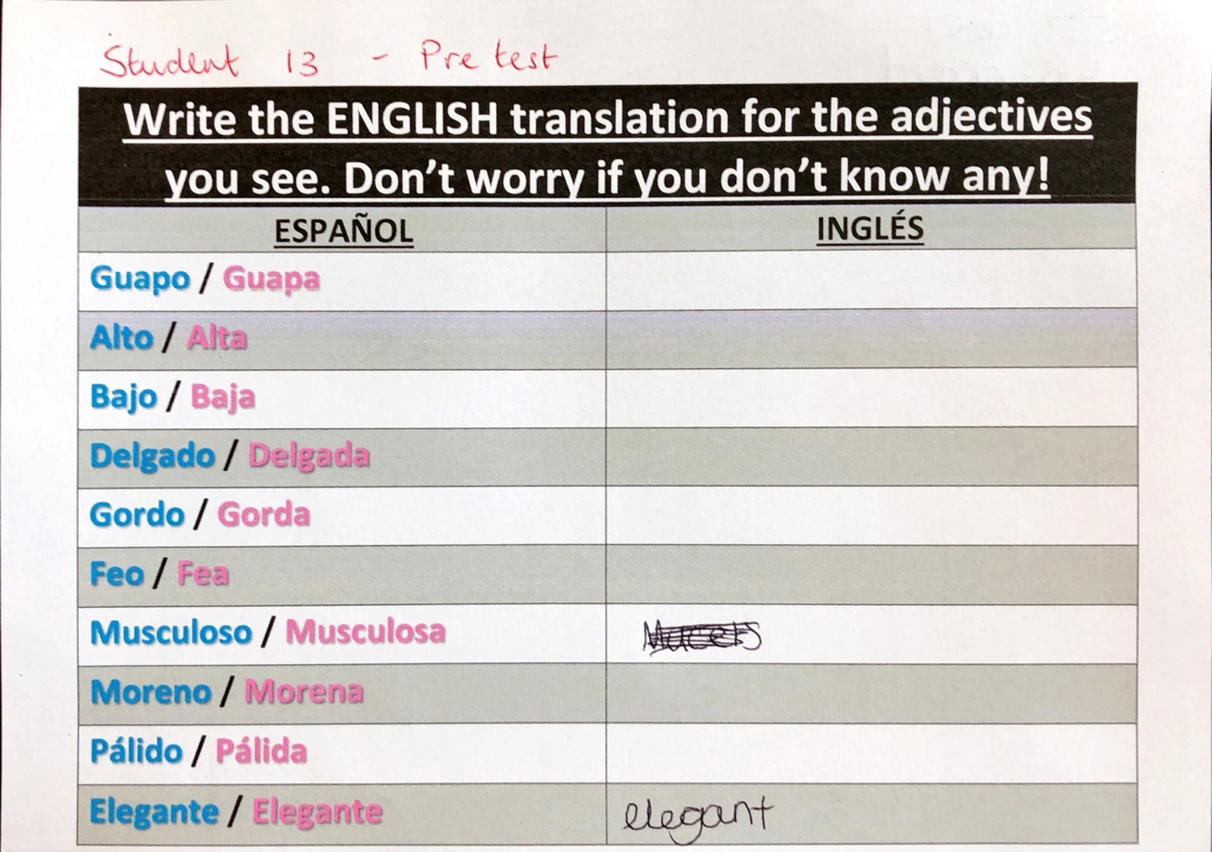
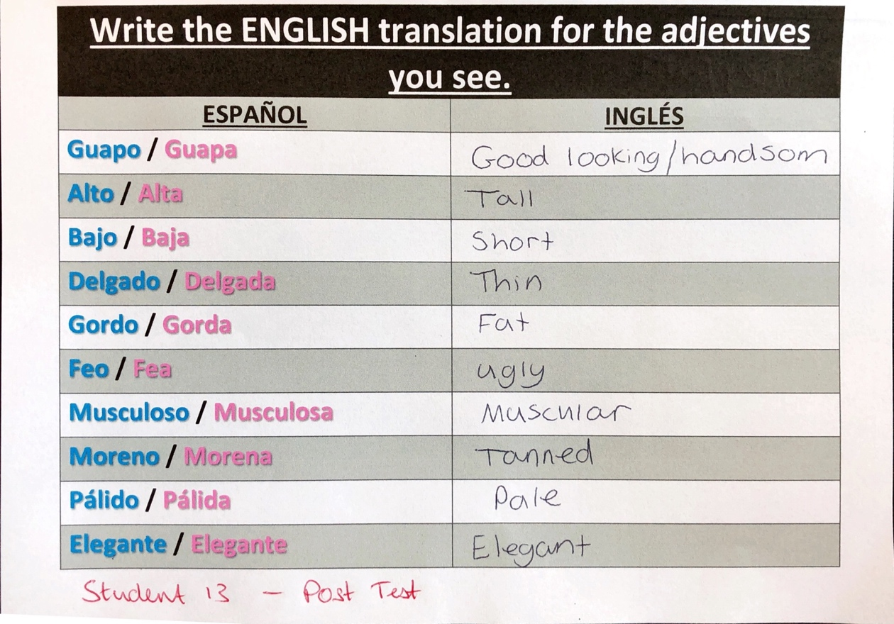

Appendix 4 – Student 1, Pre-Test and Post Test example
Student 1 is male, currently receiving Free School Meals and is also a “looked aftered” child. Here we can see that these circumstances have not affected his performance in the classroom, especially in Spanish.

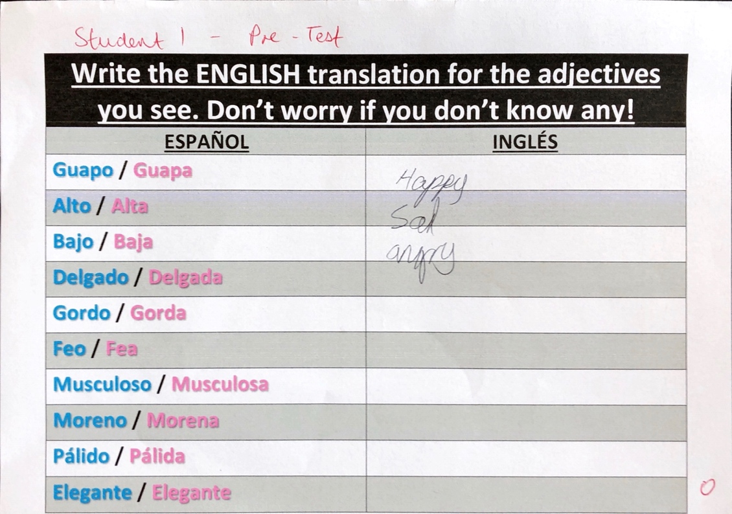

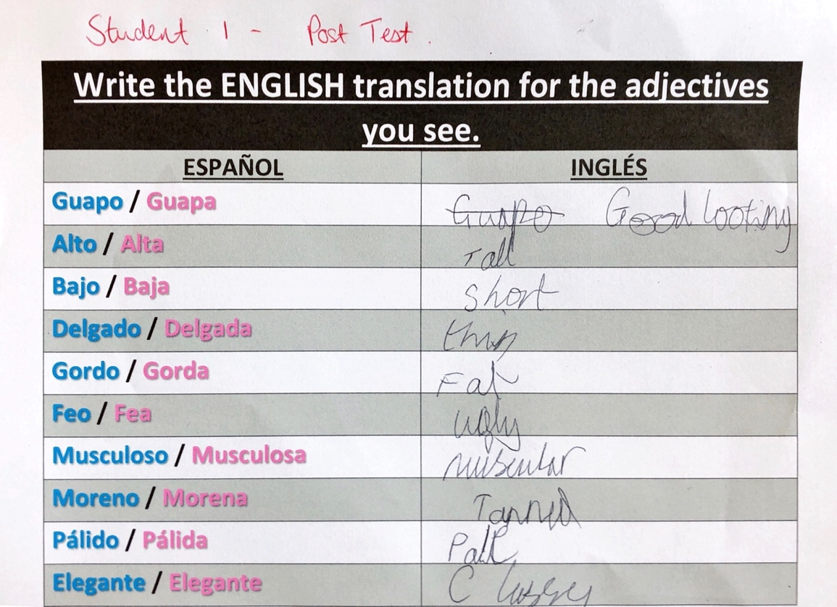

Appendix 5 – Placemat for less able students


