University Wales Trinity Saint David
Institute of Science & Art

Alternative Propulsion Systems
ACHA5010

Aulon Pashoja
2009355
January 2023

​​

​
Contents
Introduction 2
Chosen vehicle 2
Dynamic characteristics 2
WLTP 3
Cumulative wheel energy over the WLTP cycle 3
Largest KERS power input moments in each cycle 4
Chosen KER system 4
Recovered kinetic energy 4
Implemented KER System 5

​
​
​
​
​
​​

Introduction
The following report will analyse how a vehicle powered exclusively by an internal combustion engine (ICE) can have its fuel consumption reduced through the application of a Kinetic Energy Recovery System. The Worldwide Harmonised Light Vehicle Test Procedure (WLTP) will be used to predict the total power generated by a Mazda MX-5 during a complete test cycle; the data will then be used to calculate the amount of tractive and breaking energy that can be recovered to a battery.
A battery and kinetic energy recovery system will be selected based on the dimensions of the MX-5 and the amount of KERS power that can be recovered by the vehicle.

Chosen vehicle
13,518 first and second generation MX-5’s remain on UK roads today(“Vehicle licensing statistics: July to September 2022 - GOV.UK”, n.d.), making lightweight sports car ownership accessible to almost everyone, although rising emission regulations such as low emission zones and tax prices are causing many to no longer afford running these cars. By exploring how such a small chassis can be adapted to run KERS a hypothetical solution can be found for classic sports car owners who wish to meet higher emission standards whilst maintaining the characteristics of their vehicles ICE.

Dynamic characteristics
In order to work out the vehicles behaviour in the Worldwide Harmonised Light Vehicle Test Procedure (WLTP), specific figures were required from the MX5, first and second generation cars have a slight change to body dimensions but maintain the same chassis and drivetrain, the mk2 was chosen for this task. Test Mass was the first measurement taken, the curb weight of the mx5 was shown to be 1,065 KG. Frontal area was worked out next, by multiplying the height and width found in a Haynes manual for the vehicle then multiplying by a factor of 0.85 to gain an estimate of the frontal area. Rolling resistance coefficient was taken to be 0.015 as an average ranging between 0.008 to 0.02, Coefficient of aerodynamic drag was found to be 0.38 based on the figures provided by Mazda. Figure 1 shows the total forces over the WLTP cycle for the MX-5, the first thing to note is the acceleration force peaking over the total force, this occurs when the vehicle transitions from accelerating to breaking, with the aerodynamic drag working with it when breaking, causing the vehicle to reduce speed faster, the aerodynamic drag peaks higher in each test phase, creating a greater impact on the vehicle breaking as the speed increases.
(Łukasz Wargula1 et al., 2019; “Rolling Resistance”, n.d.; “Tyre rolling resistance measurement | Continental tyres”, n.d.)
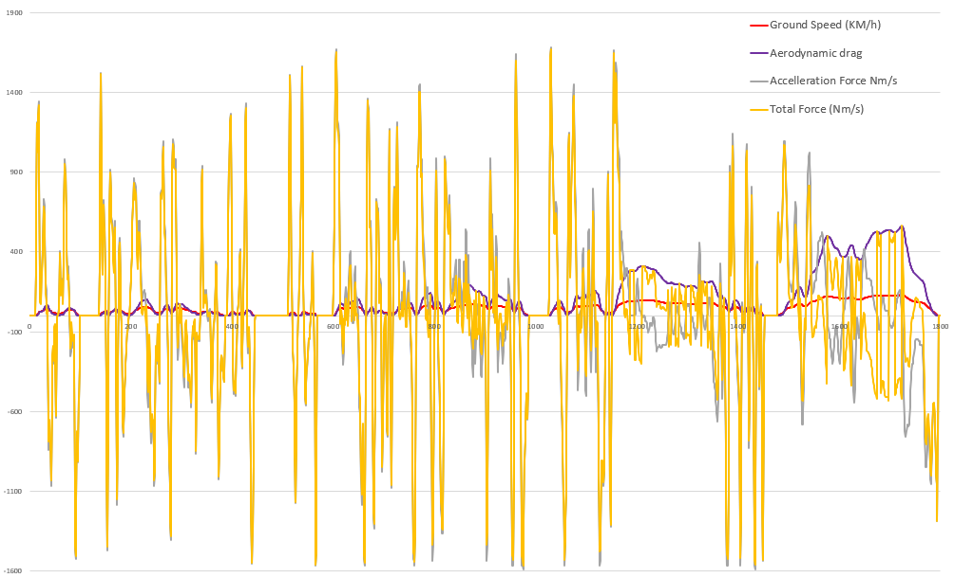
Figure 1: Forces distributed in the WLTP

WLTP
The WLTP is a procedure introduced in 2017 that measures the fuel consumption and emissions of passenger cars. Progressing over four driving phases for low, medium, high and extra high average speeds, the car is tested through stops, acceleration and breaking. There are multiple WLTP test variations depending on the category that the vehicle tested falls into. The Mazda MX-5 would be tested under class 3 conditions, tailored to passenger vehicles with a power to weight ratio over 34, and exceeding 135km/h. Figure 1 shows a table of the WLTP cycle and the acceleration of the Mazda. Figure 2 shows a graph of the acceleration in m/s^2 against the speed in Km/h over each driving phase, whilst the acceleration range is consistent in each phase, it can be seen how greater speeds are reached as each phase progresses.(“What is WLTP: the Worldwide Harmonised Light Vehicle Test Procedure?”, n.d.)
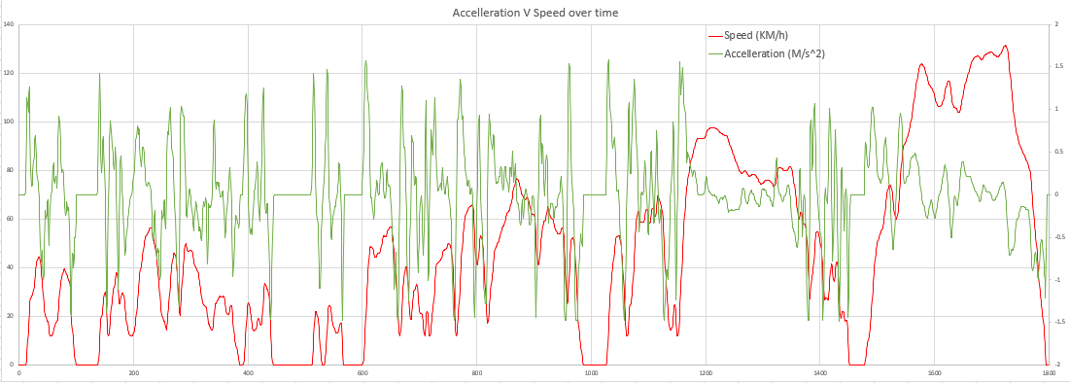
Figure 2: Speed and Acceleration over time

Cumulative wheel energy over the WLTP cycle
Figure 3 shows the cumulative tractive and braking energy throughout the WLTP cycles. Both follow a similar trajectory, as the energy generated through breaking must counteract the energy generated when accelerating, the difference between them shows wasted potential energy during the WLTP cycle, energy loss is greater as the cycles progress, due to higher speeds requiring greater breaking.
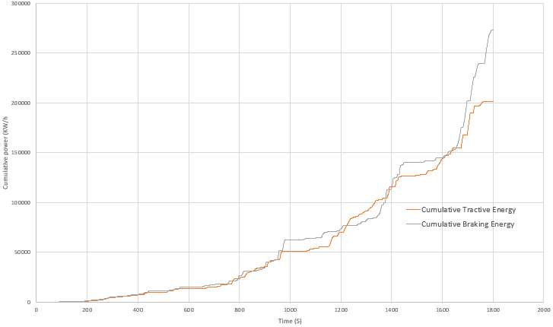
Figure 3: Cumulative Tractive & Braking Energy

Largest KERS power input moments in each cycle
Table 1 shows the highest KERS moments recorded during the WLTP, the highest output in watts is shown; the highest amount of power recorded being 5100W. The motor generator unit selected would ideally need to be able to recover at least 5100W, any less and the efficiency of the KERS system would be greatly reduced due to potential energy not being recovered and stored.
Highest output (W)
Low | Medium | High | Extra High
4234 | 6822 | 6722 | 5100
Table 1: Highest Wattage measured in each WLTP Phase

Chosen KER system
As the highest levels of braking were recorded under braking, it was decided that the vehicle would implement a recovery system from the wheels, by implementing brushless motors to the front axles a brushless motor was also explored at the crank of the vehicle with an additional inverter, however both systems proved impractical due to a larger battery requirement, so the former was chosen due to the potential to send energy back to the motors to spin the front wheels.

Recovered kinetic energy
Figure 4 below shows the potential power regenerated at the front wheels under breaking, by reducing the cumulative power by an estimated 25%. Most power would be regenerated in the periods of heavy breaking, as can be seen on the graph where rises occur in sharp series.
Figure 4: Cumulative braking at front wheels estimated.

Implemented KER System
The vehicle would have brushless electric motors fitted to the wheel hubs at the front wheels of the vehicle, as this is where on average 70% of the breaking force is generated, figure 5 shows a schematic of the chosen motor, is rated to 3000W per wheel, exceeding the required Wattage.
In order to maintain the weight distribution of the MX-5, one battery would be placed in the boot between the rear wheels, rated to store 6.5KW/h, any larger would increase the weight of the vehicle too far. The motors would send a current through a 6KW inverter, converting to AC at the battery. The power would then be returned to the front wheels when setting off to assist with the vehicles acceleration.
In addition to the KER system, a custom ECU would need to be installed that tracks the throttle position in order to send the data to a second ECU for the front motors; the front motors would need to be programmed to accelerate based on defined conditions, specifically when a minimum amount of power has been reserved at the battery and when the car is accelerating.
(“LG Chem RESU 6.5 Lithium-Ion Solar Battery Storage 6.5kWh (48V) | DIY”, n.d.)
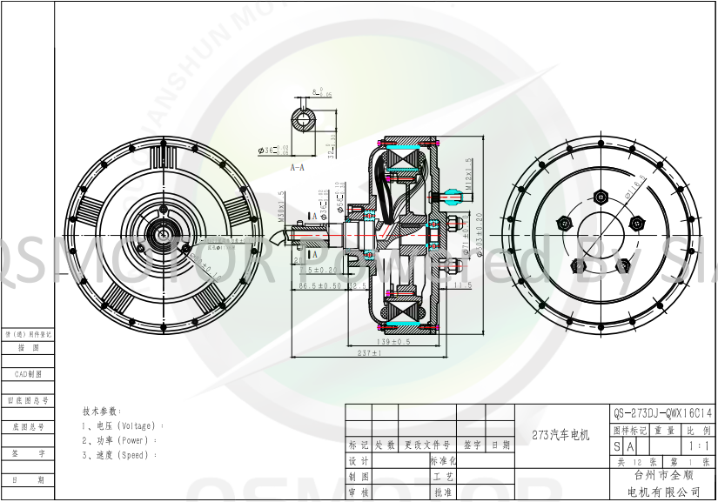
Figure 5: Schematic of brushless wheel hub
(“Powerful QSMOTOR 3000W - 14000W 273 BLDC Electric Car Single Shaft Wheel Hub Motor for electric cars”, n.d.)

Citations

“LG Chem RESU 6.5 Lithium Ion Solar Battery Storage 6.5kWh (48V) | DIY”. (n.d.). , available at: https://www.zerohomebills.com/product/lg-chem-resu-6-5-li-ion-battery-storage-6-5kwh-48v/ (accessed 15 January 2023).
Łukasz Wargula1, Bartosz Wieczorek and Mateusz Kukla. (2019), “The determination of the rolling resistance coefficient of objects equipped with the wheels and suspension system – results of preliminary tests”, in Grzegorz Domek and Kateryna Kravchenko (Eds.), Poznan University of Technology, Chair of Basic of Machine Design, MATEC Web of Conferences, Poznan.
“Powerful QSMOTOR 3000W - 14000W 273 BLDC Electric Car Single Shaft Wheel Hub Motor for electric cars”. (n.d.). , available at: http://www.cnqsmotor.com/en/article_read/QS%20Motor%203000W~8000W%20273%20Electric%20Car%20Hub%20Motor/566.html (accessed 15 January 2023).
“Rolling Resistance”. (n.d.). , available at: https://www.engineeringtoolbox.com/rolling-friction-resistance-d_1303.html (accessed 15 January 2023).
“Tyre rolling resistance measurement | Continental tyres”. (n.d.). , available at: https://www.continental-tyres.co.uk/b2b/business-know-how/tyre-rolling-resistance-measurement.html (accessed 15 January 2023).
“Vehicle licensing statistics: July to September 2022 - GOV.UK”. (n.d.). , available at: https://www.gov.uk/government/statistics/vehicle-licensing-statistics-july-to-september-2022 (accessed 15 January 2023).
“What is WLTP: the Worldwide Harmonised Light Vehicle Test Procedure?” (n.d.). Www.WLTPfacts.Eu, available at: https://www.wltpfacts.eu/what-is-wltp-how-will-it-work/ (accessed 12 January 2023).

