Student Name: Courtney Thomas
Student Number: 1803924
Programme of Study: Ba (Hons) illustration Word count: 2466
Module: Research in Practice (ADAD5004) Tutor: Louise Burston

Stereotypes of image, Gender, Beauty
Do beauty standards negatively affect women, within the art world?

As a woman with an interest within the art community, the female form has been visually front and center my entire life. Countless paintings, sculptures, and other pieces center around the feminine form but are these homages to women as a being? Or just their visual appeal? In this essay, I will be discussing how standards are placed on the shoulders of women. I also will select and discuss three keywords and images to support my work and theories.

As a spectator it is common to make judgments based on an image, in turn, this can change how we view the model. In modern society do Conventional Beauty standards blind us from appreciating art? do they cloud our vision to deeper layers of meaning and context?
To be open-minded about these topics it is important to reflect upon the language commonly used when discussing women. How does society view women? When they are present in poems, books, and other written work; it is incredibly common for the author to focus on her physical image over other qualities.

Author Abhijit Naskar reflected on the portrayal of women and said: “The representation of women in society, especially through mass media has been the most delusional act ever done on the grounds of human existence.” (Naska,www.books.google.co.uk, 2017)
True, it is important to establish a solid description of a character to paint a larger picture so that the story may progress, however in some pieces of literary work, it seems that women are written in such a way that their beauty is their only value.

Stereotypes of image

An example of correlating beauty and social value would be the response given to the statue titled Verity by Damien Hirst. The giant bronze and steel titan towers above spectators on the harbor in Ilfracombe. Verity depicts a pregnant woman standing upon a pile of books, draped in cloth while holding the weights of justice in one hand and a sword pointed skywards with the other. One of her most unusual features, however, would be that on one side her skin appears to be missing or removed, showing the intricate muscle and flesh within. Even the fetus is visible upon closer inspection, resembling a biological diagram of the human body.
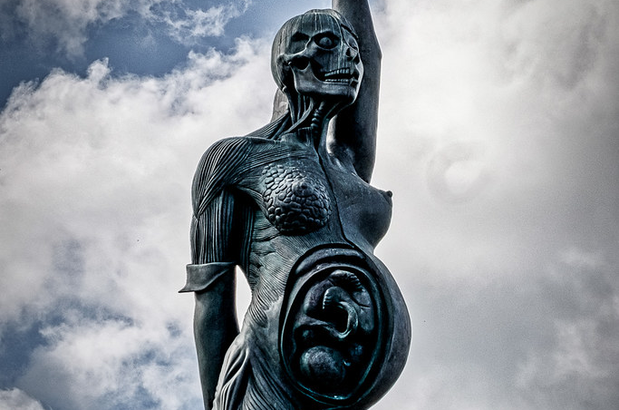
Verity (statue) - Damien Hirst 2012

This statue certainly received a mixed reception from the locals of Ilfracombe, when preparing to begin the initial build members of North Devon Council received 100 letters from those who opposed the installation of the statue whilst also receiving 177 letters supporting the piece. Those that were against it made consistent comments about Verity’s appearance, calling the art piece “ugly” and “hideous”.
One Observer columnist named Catherine Bennet had much to say about Verity’s image. In an article titled ‘Damien Hirst has brought public art to a new low’, Bennet says; “The Hirst sculpture is further equipped with realistic hair and a bottom as well as her controversial fetus and any amount of pick-your-own allegorical content” (Bennett, www.theguardian.com/uk, 2012)
It could be said that Bennet, along with several other locals, are focused more on the visual aesthetic of the statue and the cosmetic ideal women are held to by those who observe. Beauty is so much more than what is on the skin and yet it dictates the opinions of so many.

With her sword held high and with weights in hand, one interpretation of Verity could be a beacon of strength and balanced judgment. Being pregnant; mothers might look towards her and see themselves as they are also trying to be strong, protective, and make the correct choices for their children throughout their lives.
In regards to Bennet’s comments about Verity’s body, she mentions features that are conventionally seen as attractive by highlighting the statue’s hair and bottom, not in a manner that highlights the structure and intricate detail of the statue to show the effort made by Hurst but instead she was referring to the statues visual appeal.

She moves on to discuss “her controversial fetus”. This comment is problematic because of the way she is speaking, due to her bluntness and direct language it is quite apparent that on this occasion Bennett is talking about pregnancy in an uptight and shallow manner. Pregnancy is arguably one of the most difficult trials a woman can experience and yet Bennet would deem it “controversial”, this is because it does not fall into the bracket of conventional beauty and in the eyes of those who distance themselves from this topic; an un-glamourized perspective on pregnancy is seen as a controversy.

The overall message she delivers with her statement is that within society; a piece of art will not want to be seen unless the figure is considered to be attractive, on this occasion all context is dissolved because the figure is not seen as appealing, therefore, is not acceptable.

I am exploring female stereotypes because there is so much to unlock,
Many stereotypes are harmful, within my research I will determine if the presence of these stereotypes strip away meaning and context behind pieces of artwork and instead demeans them by objectifying and sexualizing the female body. I want to discuss the notion that women are considered no more than the appeal of their bodies, and that this is present within a communal and unspoken standard throughout modern society,
In later work, I will continue to research this topic and explore other artists that express these themes. I will be specifically looking into the preface of judgment we experience consistently; as if a woman's social value is defined by her conformity to her role of being attractive.

Gender

Throughout history the female body has been viewed in different lights and aspects, usually painted in flattering angles to highlight features that are deemed desirable. Many European renaissance paintings depict a certain stylization of the slender woman with soft facial features; an example of these features would be their presence in the renowned painting ‘The Birth of Venus’ by Sandro Botticelli.
In this piece the goddess Venus stands upon a seashell amongst the shore, her physique is soft and shapely. She was painted in a manner that allowed her to be portrayed as delicate and statuesque, this depiction of women has been seen throughout history.

Throughout time it has been possible to go to art galleries and gaze at these figures, and so comes my interest on the keyword of Gender; of course, male nudes exist and a majority are famous pieces, such as the statue 'David' by Michelangelo. It is notable, however, that the male nude may be seen from a different perspective as opposed to the female nude due to stereotypes surrounding the female form.

In many ways, the female nude is to view the woman's body as a vessel to be seen and admired by the spectator, and many nudes are created to pay homage to the attraction of the slim body type I previously referred to.
The thin yet shapely body type has been gazed at for centuries, and yet there are endless shapes and sizes of women. One author named Lynda Nead discussed the female physique in regards to bodybuilding;

“On one hand, it seems to offer a certain kind of liberation, a way for women to develop their muscularity and physical strength”. A few sentences later she follows this up with “on the other hand, this revised femininity seems simple to exchange one stereotype for another - one body beautiful for another, possibly racier, image of women which can easily be absorbed within the patriarchal repertoire of feminine stereotypes” (Nead, 3 Dec. 1992)

One artist that steps outside this boundary is a renowned British painter, Jenny Saville.
Saville paints women in a manner that shows that we truly are flesh and blood, muscle and bone, living breathing creatures who are capable of unwavering potential, all without being conscious of being palatable to the world.
Columnist Aline Cohen focuses on writing a monthly piece for the site Artsy titled ‘Body issues’. In one of her pieces discussing Saville she wrote;
“Throughout the 1990s, Saville would continue exploring her fascinations with the unairbrushed female form.” they went on to say “Saville proclaimed herself “anti-beauty” and focused, instead, on exaggerating bodily elements that society generally deemed unsightly” (Cohen, artsy.net, 2018)
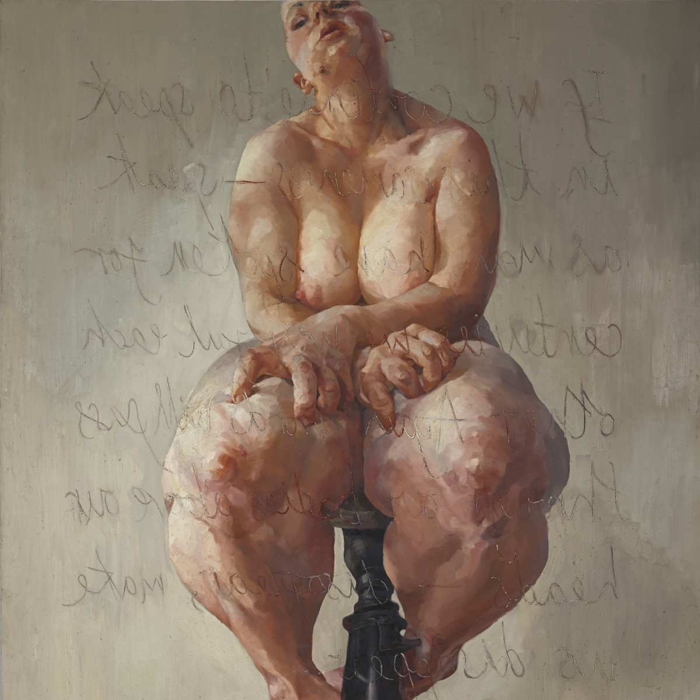
‘Propped’ - Jenny Saville (1992)

One iconic painting by Saville is the piece titled 'Propped' in which a larger woman is depicted, sitting on a beam in white heels. This painting is incredibly symbolic as it shows the diversity between each female body shape, thus overshadowing the myth that the ideal body type is thin and slender. This image reveals the reality that there is a non-conventional beauty outside the common stereotype of form.

Inscribed on this piece is a quote from a Belgian author named Luce Irigaray; who focuses on topics revolving around feminism. The quote says:
“If we continue to speak in this sameness—speak as men have spoken for centuries, we will fail each other. Again, words will pass through our bodies, above our heads—disappear, make us disappear”

The text appears to be loosely sketched across the background and onto the model’s skin but the most unusual feature of this text would be that it is written onto the canvas backwards. I thought about this for a while and reflected on the purpose of this creative decision and I realized that by mirroring the text, it faces the model, as if the words are written for her eyes and not ours.

In this way, this piece reclaims the notion that a woman's body is for the gaze of men, and flips the dynamic in such a way that it is as if the painting is for the model herself so that she can gaze upon herself as she is. I will be searching deeper into the wonderful world of Jenny Saville later on as she is a wonderful example of the acceptance of body diversity and anti-beauty.

Beauty

The cosmetic appeal of feminine beauty is pushed onto us daily; from imposed visual standards set by social media, to the booming world of advertisements, the pursuit to achieve beauty is an aggressive experience. Women, in particular, are constantly targeted for adverts that promise a fictional 'beauty in a bottle' so to speak. To some degree, it could be said that certain companies profit from revealing flaws within the female form that can be stripped and removed by using their product, making the customer beautiful and in turn; happy.

The term "beauty is pain" really opens the door on how ugly the pursuit of beauty truly is; French Author Albert Camus once said, "Beauty is unbearable, drives us to despair, offering us for a minute the glimpse of an eternity that we should like to stretch out over the whole of time". (Camus www.goodreads.com,1935)

One artist who pushed aside the concept of beauty to reflect her physical body as it truly was, would be Ana Mendieta. In her collection titled; Untitled (Glass on Body Imprints–face), she contorted her body in a series of unusual positions using sheets of glass and then creating prints from these images. Within these prints, she disregards any concept of concern for her appearance and by distorting her face in such a way she appears to embrace the unflattering contours and crevices of the flesh.

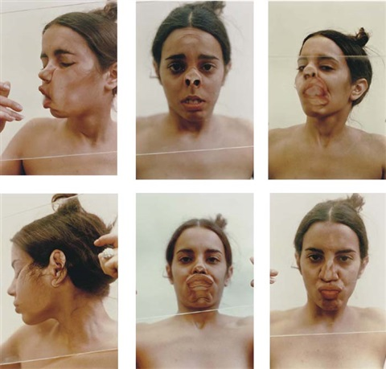
Ana Mendieta, Untitled (Glass on Body Imprints–face), 1972

One description of this collection commended her method of using her skin to create art, stating: "By using her own body as a malleable, sculptural material, Mendieta eliminates traditional visual components of image-making, relying instead on the power of her own body as a tool to reexamine the archetype human subject and the gaze in photography." (Institute of Contemporary Art Miami, www.icamiami.org/, (N.D)

The series of images is certainly powerful, resembling Saville’s approach of depicting the female body in its true form and not shying away from the flesh that holds our being together. The idea of any woman being artificially attractive every second of her life is simply unrealistic and arguably an unhealthy standard to live by, the pieces made by both Saville and Mendieta remind us that women are not mannequins, created with the purpose of looking pretty, but rather that we are living creatures that should not be refined by the standards of beauty.

Another description of this series stated: “When we speak of feminism, it’s important to know that anytime a woman, especially a beautiful woman uses her body and distorts it, it is, in essence, a political act. So often women are the subject of the male gaze, all over art history. That’s what we see – women as objects – and here, Mendieta like many women of her generation are transposing that relationship to make women a subject of her own gaze and therefore of our gaze and that it’s a very empowering step.” (Marie Sabbatino, N.d. Quoted in Ana Mendieta And Body Subjectivity)

To distort beauty in this manner is to divert the stereotypes that women face and in turn creates a bold statement, one that reveals that artwork can be created for oneself and not to attract the male gaze, that our body belongs to ourselves and we are free to venture away from the concept of being slaves to visual perfection without being seen as unfeminine.

In conclusion, I estimate that these keywords will be very beneficial for further research when I move forward and begin my dissertation. I will continue to dissect each keyword and reflect upon how they each correlate with the way women are perceived by artists and the audience. I will continue looking into artists who delve into recreating the female body without filters or restraint, as well as several feminist artists who challenge stereotypical gender roles and their impact upon women.

I will continue to discuss the stereotypes that affect how we see women and how said stereotypes alter how the female form is perceived. I will also delve deeper into the topic of Gender and further debate about how differently art pieces surrounding female bodies are received as opposed to male figures, and what this means as a whole. Finally, I will examine the weight of beauty standards in an attempt to unfold the obscured negative aspects within the concept of beauty, and how this can affect women overall.
In contrast, however, I will also be looking into female artists that reclaim their beauty and thrive by being free of the burden of visual perfection as human beings.

My overall goal is to research and analyze artists that are passionate about highlighting gendered stereotypes and explore work revolving around the female form and the many different things that it represents.

Bibliography

EBooks:

Abhijit Naskar 2017
https://books.google.co.uk/books/about/The_Bengal_Tigress.html?id=HY9IDwAAQBAJ&printsec=frontcover&source=kp_read_button&redir_esc=y#v=onepage&q&f=false. The Bengal Tigress: A Treatise on Gender Equality. Accessed on 08/05/20.

Lynda Nead,1992
https://books.google.co.uk/books/about/The_Female_Nude.html?id=A2uIAgAAQBAJ&printsec=frontcover&source=kp_read_button&redir_esc=y#v=onepage&q&f=false
The Female Nude: Art, Obscenity, and Sexuality. Accessed on 08/05/20

Websites:

Catherine Bennett, 2012,
https://www.theguardian.com/commentisfree/2012/oct/21/damien-hirst-ilfracombe-public-sculpture
Damien Hirst has brought public art to a new low, The Guardian
Accessed on 08/05/20

Alina Cohen, 2018
https://www.artsy.net/article/artsy-editorial-jenny-saville-changed-way-view-female-form-painting
How Jenny Saville Changed the Way We View the Female Form in Painting’, artsy.net, Accessed on 10/05/20

Albert Camus, 1935
https://www.goodreads.com/quotes/133780-the-beauty-of-a-woman-is-not-in-a-facial
Notebooks 1935-1942
Accessed on 12/05/20

Institute of Contemporary Art Miami, N.D
https://icamiami.org/collection/ana-mendieta-untitled-glass-on-body-1972/
‘Ana Mendieta Untitled (Glass on Body), 1972’
Accessed on 12/05/20

Marie Sabbatino, N.D
https://scalar.usc.edu/works/body-decolonization/page-2.15
ANA MENDIETA AND BODY SUBJECTIVITY BY MARIANA ROMERO
Accessed on 12/05/20

