
APPENDIX GA36a

LEVEL 4 ASSESSMENT SPECIFICATION

Student name: | Emma Hill | Student ID number: | Hil17833867
Programme: | HNC/D MECHANICAL ENGINEERING  HNC/D ELECTRICAL & ELECTRONIC ENGINEERING
Module: | Engineering Applications & Study Skills
Module code: | GOEN4000 | Contribution to Overall Module Assessment (%): | 60%
Lecturer: | C. Williams | Internal Verifier: | R. Kadhim
Assignment Title: | Designing and simulating pneumatic circuits for process control. | Word count (or equivalent): | 1000
Submission deadline: | 8/05/2023 | Return date of provisional marks & written feedback: | 22/05/2023
Submission method: | All written assessments, where practical and possible, must be submitted via Turnitin unless otherwise instructed by the Lecturer. (Please DO NOT put this assessment specification into Turnitin or it will match many similarities with other students’ submissions.)  Alternative submission method (if applicable):  Late submission of the assessment will result in a late penalty mark. Penalties for late submission: Up to one-week late, maximum mark of 40%. Over one week late, 0%. Only the Extenuating Circumstances Panel may approve a change to submission dates.
Academic honesty / referencing: | Academic honesty is required. In the main body of your submission you must give credit to authors on whose research and ideas your work is based. Append to your submission a reference list that indicates the books, articles, etc. that you have used, cited or quoted in order to complete this assessment.

Objectives
- To calculate the loading on an actuator in a given industrial scenario and determine circuit pressure requirements to operate safely and within given parameters.
- To design a three cylinder non repeat pattern sequence that complies with given process requirements.

Module Learning Outcomes
(from module syllabus)
- Demonstrate knowledge and understanding of specific engineering concepts and how their theoretical characteristics are used in discipline specific engineering applications.

- Apply practical engineering skills and demonstrate know-how of practices, skills, safety and standards with respect to laboratory and workshops.

TASK DESCRIPTION

Introduction.

The assessment in this module will involve individual students designing and simulating a pneumatic circuit. They will apply the acquired knowledge of pneumatic systems to arrive at a design solution and test using the Fluidsim software the correct operation and timings of individual cylinder actuation. The solution will need to be accompanied by circuit diagrams, state diagrams and calculations.

Introduction
As part of the tasks I need to use fluidsim software to build the circuits and show how they operate. I will also need to know what components are the right ones to make it work correctly. For one of the tasks I will be adding in a sequence to make it operate as it’s a more different circuit and it will need it to operate in the correct form.

What to do
Task 1

You work as a pneumatic design engineer and your organisation has just received the following enquiry from a local production company.

Design Solution required
In a production setting, a double acting cylinder with stroke length of 250mm has to raise a load of 100kg up an inclined surface of 30 degrees. Tests at the production centre have measured that the coefficient of static friction is 0.19 and the coefficient of sliding friction is 0.13. The operating pressure of the production compressed air supply is a maximum of 0.7 Mpa. An operator uses a normally closed 3/2 push button switch to raise the load which they hold until the load is dispatched. The button is then released allowing the cylinder to retract.

Using this information:
- calculate the force required to move the load [10]
- select a suitable cylinder that will meet the requirements [10]
- design the circuit and using Fluidsim check that it operates successfully. [10]
- give a brief explanation of why you have selected each of the components in the circuit. [10]

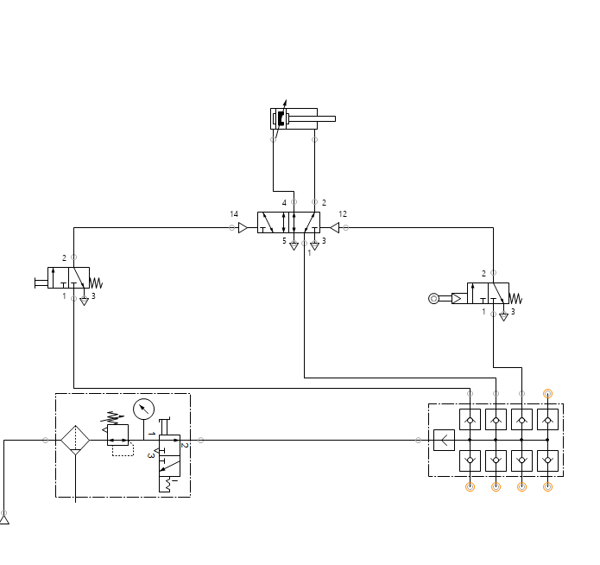
This is a double acting cylinder with a change stroke length of 250mm it also has a function of 0.19 and a change in the sliding function which is now 0.13. I have also added a compressed air supply and with that I needed to add a maximum of 0.7 Mpa. To make the operator it normally needs a 3/2 push button which need to be closed because it needs to hold a load until the dispatch is released. When its released the cylinder will retract.

Building this is a tester on how they function and how they connected in order to build a more difficult one. This shows how the software operates.

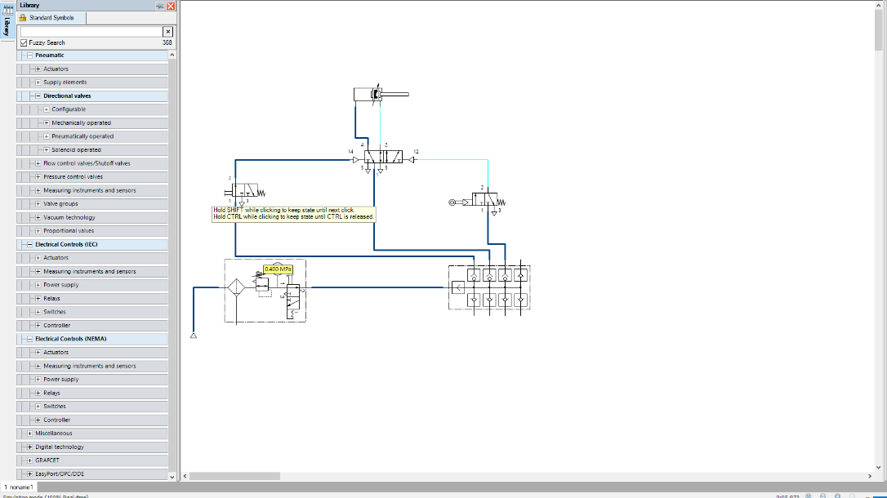
In this diagram it shows how it operates successfully. Using this software to build the diagram has all of the components on the side of the page and also a search bar to make things a lot easier to find. When it’s held down it pushes the cylinder out and when its released the cylinder will go back to normal. It has a dark blue line and a light blue line to show how it works.

Task 2

The local production company is pleased with the results of your work and have another design issue they would like you to solve.

Design parameters
Three double acting cylinders have the following actuating sequence and operating requirements. The control system must have a pneumatic solution to meet production requirements.

- Sequence A+ C+ B+ B- C- A-
- A time delay of 2 seconds after B+
- C & B are to extend rapidly and take between 1.5 to 2 seconds to retract
- A is to take between 3 to 3.5 seconds to extend and retract rapidly.
- The sequence is started using a latch switch and the system must run continuously until the latch is switched. Once the latch is switched back, the circuit must continue and finish its cycle and stop.

Using this information:
Design the circuit and using Fluidsim and state diagrams check that it operates successfully

- Sequence is correct [20]
- Time delay is correct. [20]
- Cylinders extend and retract meeting customer requirements [20]

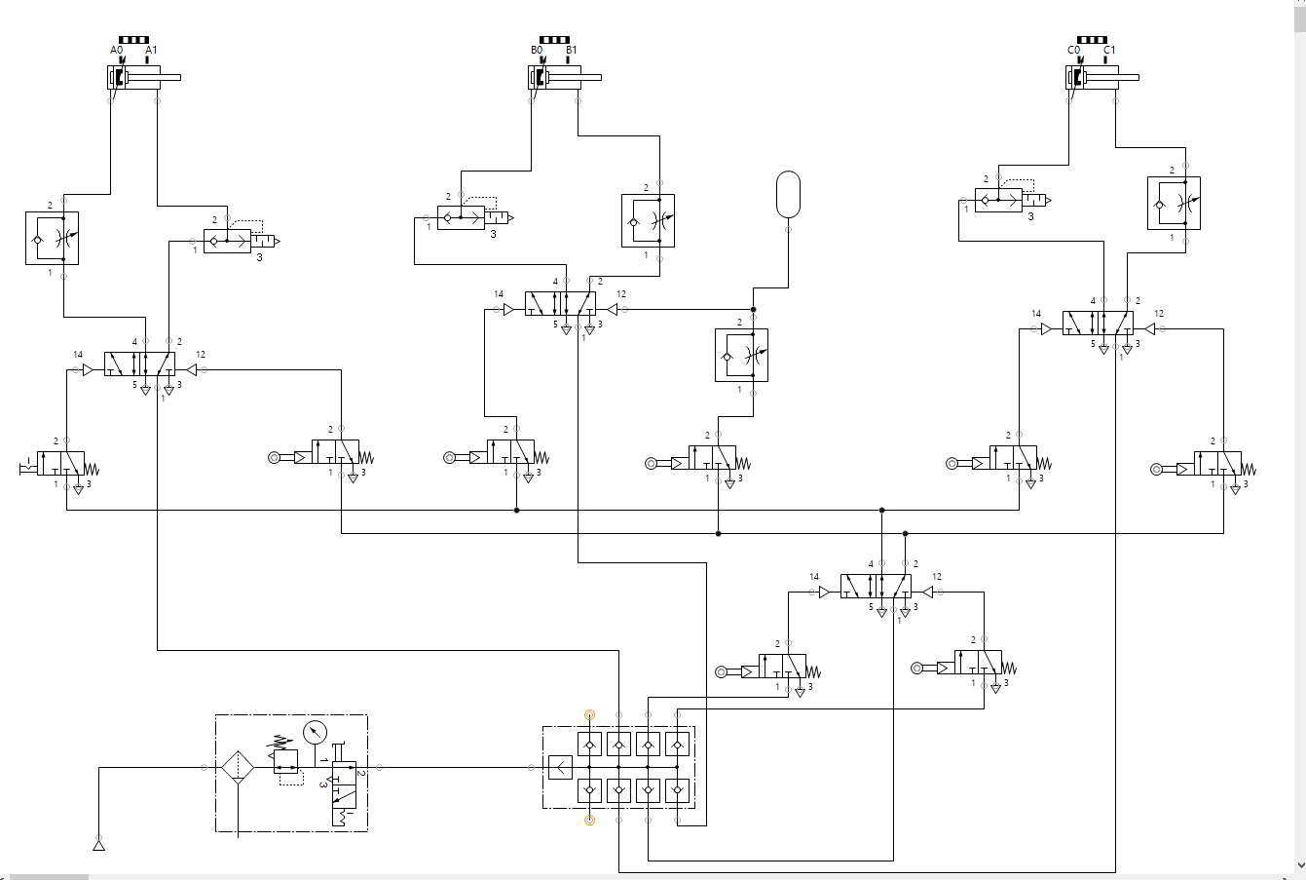

Using the knowledge from the first diagram to build this on its using mostly the same components but come are a bit different compared to the first one. With this diagram it has a sequence, a time delay and a cylinders extend and retracts.

The sequence added to the circuit is A+, C+, B+, B-,C- and A- and with that there will need to be a time delay which will be down as 2 seconds after B+. C and B need to be extended rapidly and take between 1.5 to 2 seconds to retract. A needs to between 3 to 3.5 seconds to extend rapidly.

This sequence is set up to run continuously using the latch switch once’s its switch it should run until its switched back and then will continue and finish the cycle.

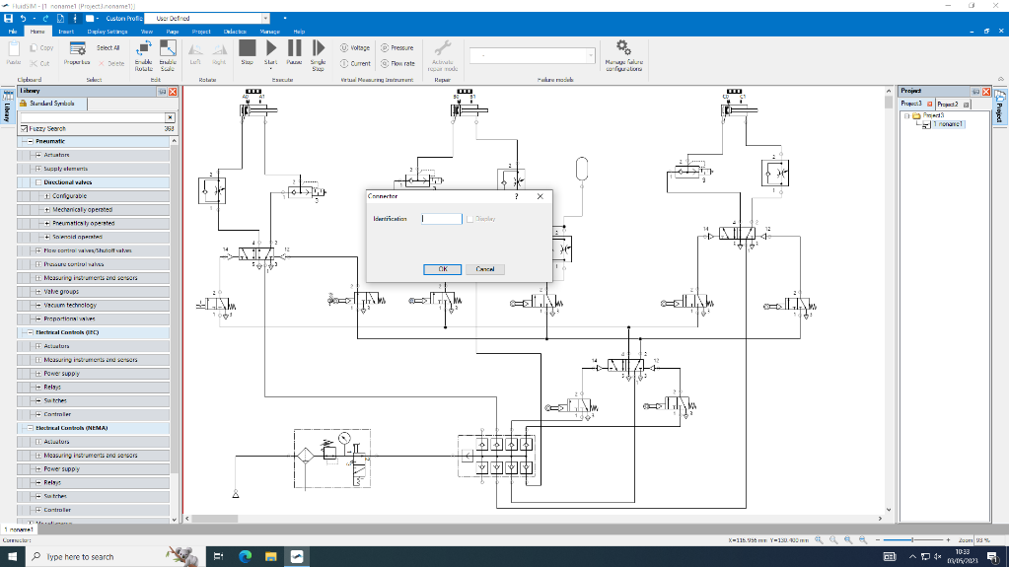
This is a screenshot of what is happening and how to set up the sequence.

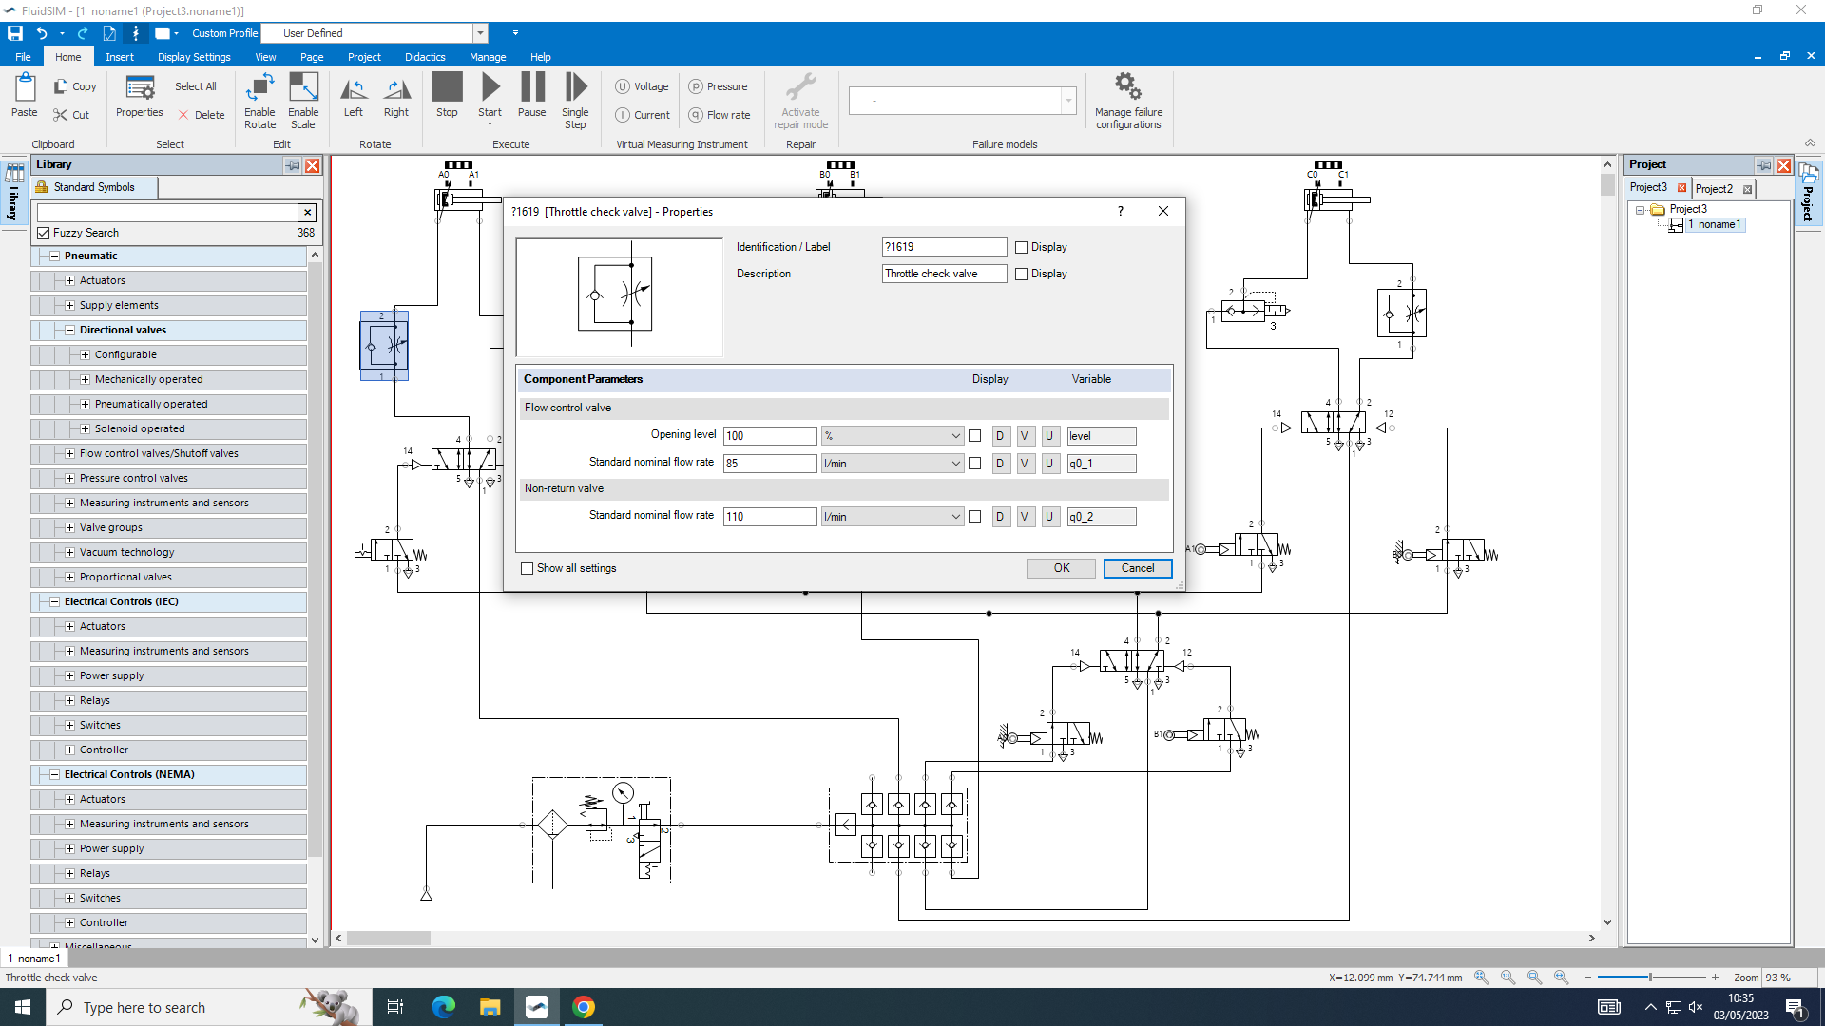

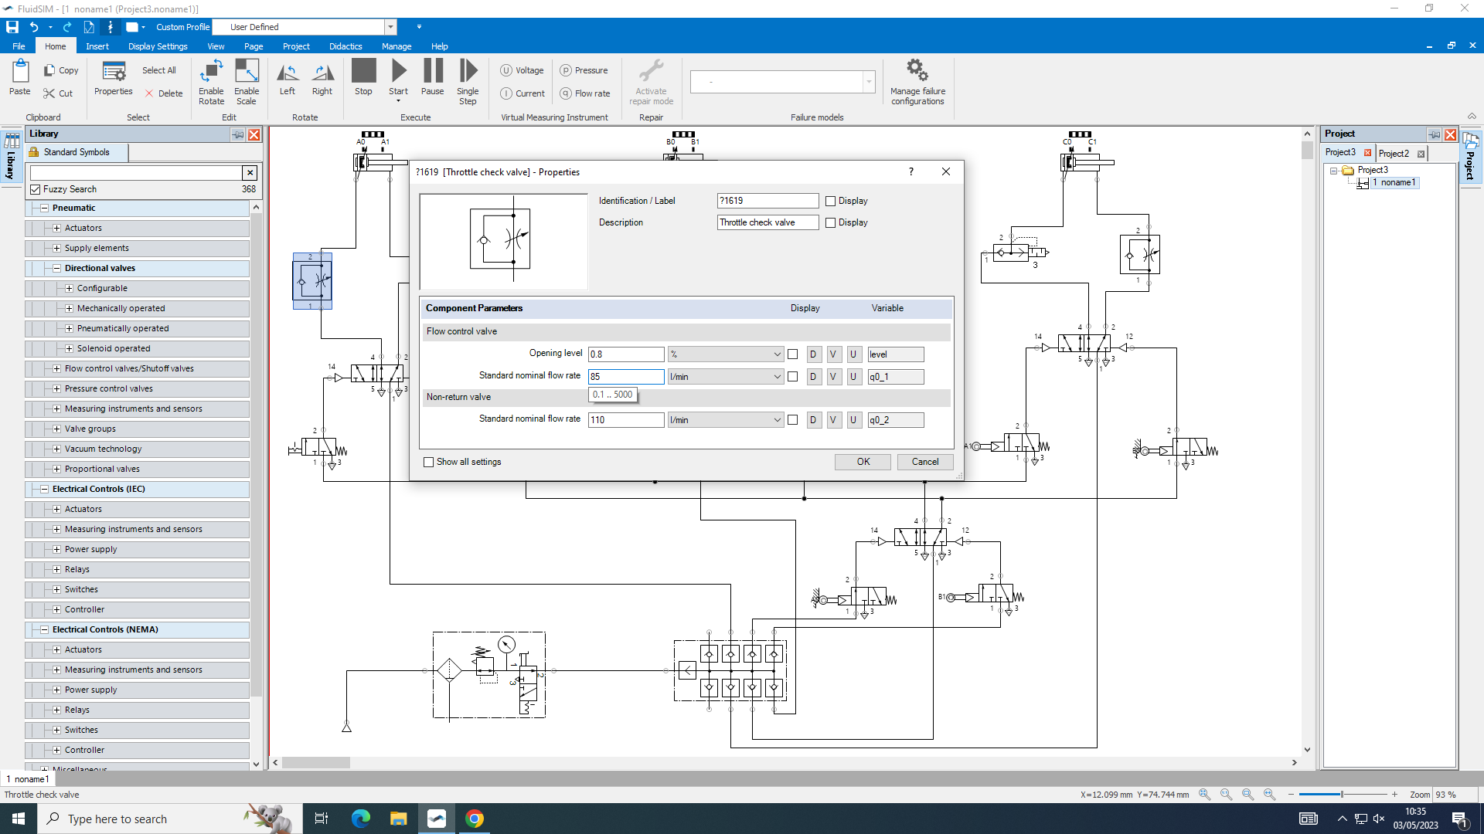

This is a screenshots of the opening level and the standard nominal flow rate being changed.

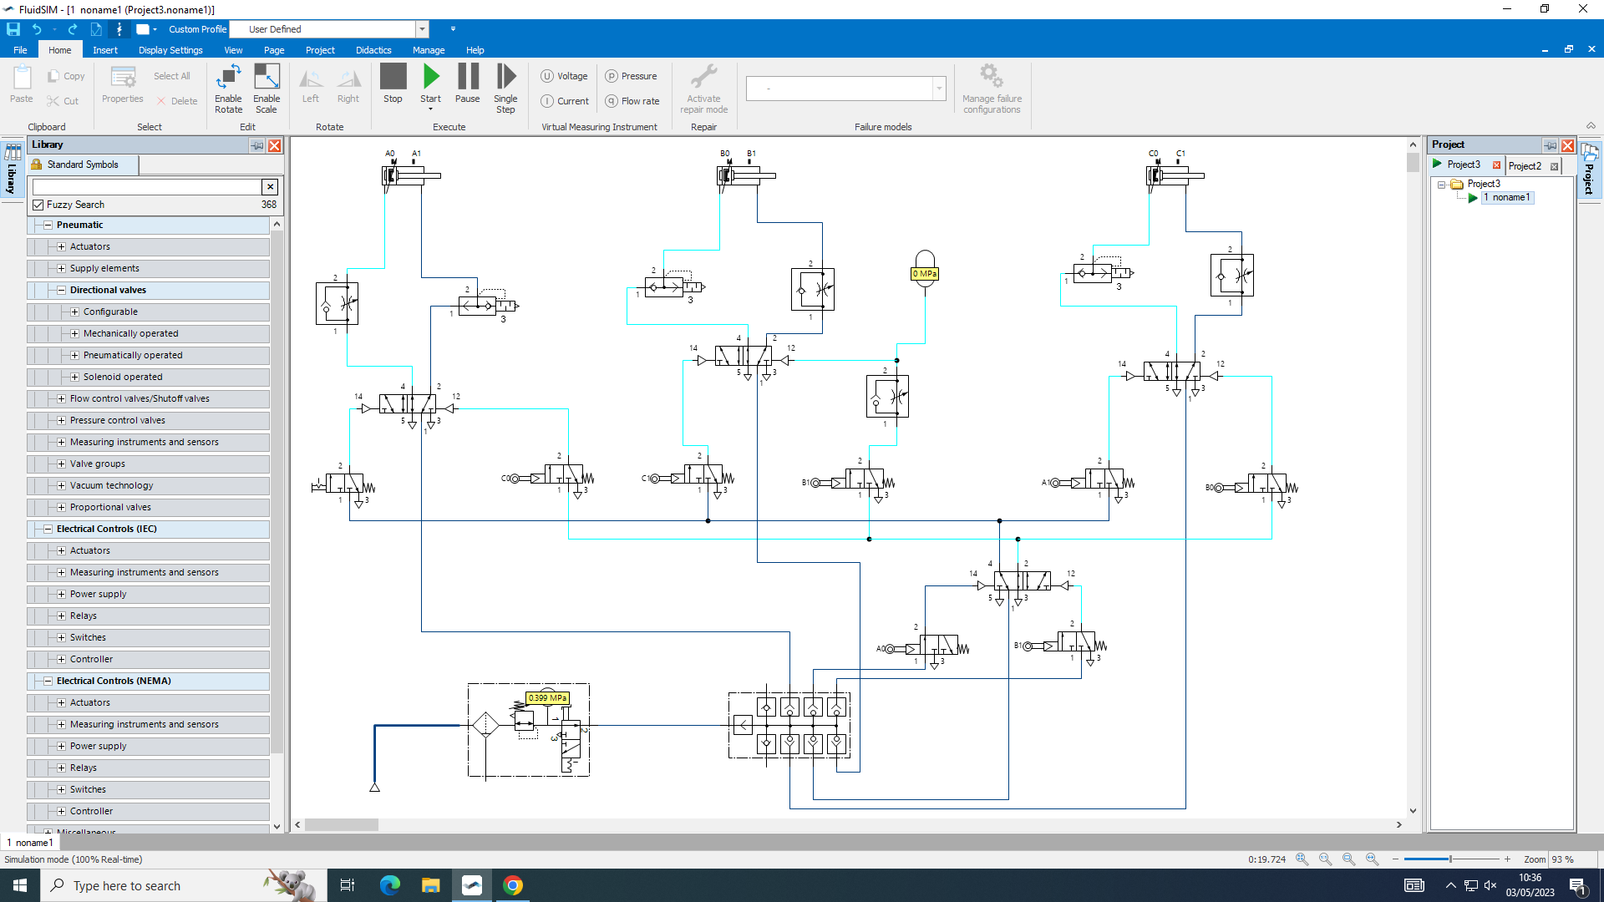

This is a screenshot of the diagram working with the sequence.

Area = $\frac{force}{pressure}$
$\frac{388.35}{3.14}$ = 123.61
$\sqrt{123.61}$ = 11.11

Conclusion
In conclusion making the first diagram helped a lot with the second diagram as the first one makes it easier to find the components and how the components worked within the diagram. Making the second one is a bit harder as new components are added and finding out how they connect and how they work. Overall using the knowledge from building them is a lot easier to see how it all works and how the sequence makes a difference being added.

GUIDANCE FOR Students IN THE COMPLETION OF TASKS

NOTE: The guidance offered below is linked to the five generic assessment criteria overleaf.

- Engagement with Literature Skills
Your work must be informed and supported by scholarly material that is relevant to and focused on the task(s) set. You should provide evidence that you have accessed an appropriate range of sources, which may be academic, governmental and industrial; these sources may include academic journal articles, textbooks, current news articles, organisational documents, and websites. You should consider the credibility of your sources; academic journals are normally highly credible sources while websites require careful consideration/selection and should be used sparingly. Any sources you use should be current and up-to-date, mostly published within the last five years or so, though seminal/important works in the field may be older. You must provide evidence of your research/own reading throughout your work, using a suitable referencing system, including in-text citations in the main body of your work and a reference list at the end of your work.

Guidance specific to this assessment: This assignment requires that you carry out some research on the background theory of your circuit designs. The research element of this unit will therefore be limited but the normal rules apply. Such as choose a wide level of reading, from a variety of sources including textbooks, academic journals and academic based websites .It is permissible to include industry-focused and governmental sources. However, do not use less credible sources, for example internet sites such as Tutor2U and Wikipedia.
If do include any relevant research ensure you use the Harvard system of referencing to evidence research. Give credit to respected authors on whose work your discussion is based; this avoids accusations of plagiarism and reflects the depth of your research. ALL of your sources should be cited - every paragraph should contain at least one in-text citation. Your use of in-text citations and the reference list at the end of the report will be closely examined to ensure that you are conforming to referencing convention. An extensive reference list and good use of in-text citations will earn marks, limited references and errors in citations will result in a loss of marks.

- Knowledge and Understanding Skills
At level 4, you should be able to demonstrate knowledge of the underlying concepts and principles associated with your area(s) of study. Knowledge relates to the facts, information and skills you have acquired through your learning. You demonstrate your understanding by interpreting the meaning of the facts and information (knowledge). This means that you need to select and include in your work the concepts, techniques, models, theories, etc. appropriate to the task(s) set. You should be able to explain the theories, concepts, etc. to show your understanding. Your mark/grade will also depend upon the extent to which you demonstrate your knowledge and understanding.

Guidance specific to this assessment: Based on your knowledge of the design and construction of pneumatic circuits you should demonstrate the ability to solve set tasks and evaluate the outcome of your findings. Your knowledge will be demonstrated through circuit design and analysis using relevant simulation software.
Use appropriate equations where required to analyse your results and explain the theories and concepts relating to your findings.

- Cognitive and Intellectual Skills
You should be able to present, evaluate and interpret qualitative and quantitative data, in order to develop lines of argument and make sound judgements in accordance with basic theories and concepts of your subject(s) of study. You should be able to evaluate the appropriateness of different approaches to solving problems related to your area(s) of study and/or work. Your work must contain evidence of logical, analytical thinking. For example, to examine and break information down into parts, make inferences, compile, compare and contrast information. This means not just describing what! But also justifying: Why? How? When? Who? Where? At what cost? You should provide justification for your arguments and judgements using evidence that you have reflected upon the ideas of others within the subject area and that you are able to make sound judgements and arguments using data and concepts. Where relevant, alternative solutions and recommendations may be proposed.

Guidance specific to this assessment: You should show cognitive skills with respect to circuit design and applying mathematical methods of analysis, where appropriate. Your lab report should therefore reflect this in a logical manor. Present, evaluate and interpret your findings using tables and or graphs. Compare your findings to theoretical results and make sound judgements and arguments using appropriate data and concepts. Errors should be recorded, and suggestions made on how to avoid them or improve your results.

- Practical Skills
At level 4, you should be able to apply the basic underlying concepts and principles to evaluate and interpret these within the context of your area of study. You should be able to demonstrate how the subject-related concepts and ideas relate to real world situations and/or a particular context. How do they work in practice? You will deploy models, methods, techniques, and/or theories, in that context, to assess current situations, perhaps to formulate plans or solutions to solve problems, or to create artefacts. This is likely to involve, for instance, the use of real-world artefacts, examples and cases, the application of a model within an organisation and/or benchmarking one theory or organisation against others based on stated criteria.

Guidance specific to this assessment:
Your ability to apply appropriate theoretical and practical methods to the analysis and solution of engineering problems relating to structures will be tested here. The design and simulation of pneumatic circuits on relevant software will be essential in this subject. Clear logical layout and effective circuit design will be rewarded with higher marks.

- Transferable Skills for Life and Professional Practice
Your work must provide evidence of the qualities and transferable skills necessary for employment requiring the exercise of some personal responsibility. This includes demonstrating that you can communicate the results of your study/work accurately and reliably, and with structured and coherent arguments; that you can initiate and complete tasks and procedures, whether individually and/or collaboratively; fluency of expression; clarity and effectiveness in presentation and organisation. Work should be coherent and well-structured in presentation and organisation.

Guidance specific to this assessment: Your ability to demonstrate key transferrable skills in problem formulation and decision making, communicating effectively and interpreting experimental results will be tested here. Drawing sound conclusions and logical recommendations from your results will be awarded more marks.

Student FEEDBACK FORM

This section details the extent to which the assessment criteria are demonstrated by you, which in turn determines your mark. The marks available for each category of skill are shown. Lecturers will use the space provided to comment on the achievement of the task(s), including those areas in which you have performed well and areas that would benefit from development/improvement.

Generic Assessment Criteria | Marks available | Marks  awarded
1. Engagement with Literature Skills
.
 | 10
2. Knowledge and Understanding Skills

 | 30
3. Cognitive and Intellectual Skills

 | 25
4. Practical Application Skills

 | 30
5. Transferable Skills for Life and Professional Practice

 | 5

Assessment Mark (Assessment marks are subject to ratification at the Exam Board. These comments and marks are to give feedback on module work and are for guidance only until they are confirmed. ) | Late Submission Penalties (tick if appropriate) |  | %
 | Up to 1 week late (40% Max) |  | %
 | Over 1 week late (0%) |  | %

GENERIC ASSESSMENT CRITERIA

Level 4
In accordance with the Framework for Higher Education Qualifications, at the end of Level 4 students will be expected to have demonstrated knowledge of the basic underlying concepts and principles of a subject, and an ability to evaluate and interpret these within the context of that area of study. They should be able to present, evaluate and interpret qualitative and quantitative data in order to develop lines of argument and make sound judgements in accordance with basic theories and concepts of their subject(s) of study. They will have learned how to evaluate different approaches to solving problems, and will be able to communicate the results of their study/work accurately and reliably, and with structured and coherent arguments. They will be able to undertake further training and develop new skills within a structured and managed environment and will have the qualities and transferable skills necessary for employment requiring the exercise of some personal responsibility.

Level 4 | FAIL | MARGINAL FAIL | SATISFACTORY  (3rd / Pass) | GOOD  (2.2 / Pass) | VERY GOOD  (2.1 / Merit) | EXCELLENT  (1st / Distinction) | EXCEPTIONAL  (1st / Distinction)
Category | 0-29% | 30-39% | 40-49% | 50-59% | 60-69% | 70-84% | 85-100%
Engagement with literature (including reading, referencing,  academic conventions and  academic honesty) | Little or no evidence of reading and/or reliance on inappropriate sources.  Views and findings mostly unsupported and non-authoritative.  Referencing conventions used incoherently or largely absent. | Poor engagement with essential reading. No evidence of wider reading. Reliance on inappropriate sources, and/or indiscriminate use of sources. Heavily reliant on information gained through class contact. Inconsistent and weak use of referencing. | Engagement with a limited range of mostly relevant and credible sources but with some reliance on information gained through class contact. Some omissions and minor errors.  Referencing conventions evident though not always applied accurately or consistently. | Engagement with an appropriate range of literature, including sources retrieved independently. Some over-reliance on texts rather than other sources. Referencing may show minor inaccuracies or inconsistencies. | Engagement with a wide range of literature, including sources retrieved independently.  Selection of relevant and credible sources. Generally sound referencing, with no/very few inaccuracies or inconsistencies. | Engagement with an extensive range of relevant and credible literature. Consistently accurate application of referencing. | Exceptional engagement with an extensive range of relevant and credible literature. High-level referencing skills consistently applied.
Knowledge and understanding (Knowledge of the basic underlying concepts and principles of a subject.) | Major gaps in knowledge and understanding of the basic underlying concepts and principles of the subject matter. Inclusion of irrelevant material. Substantial inaccuracies. | Gaps in knowledge of the basic underlying concepts and principles, with flawed or superficial understanding. Some significant inaccuracies and/or irrelevant material. | Limited knowledge and understanding of the basic underlying concepts and principles within the subject area. Some elements may be missing. | Knowledge of the basic underlying concepts and principles is accurate with a good understanding of the field of study but lacks depth and/or breadth. | Competent knowledge of the basic underlying concepts and principles. Exhibits very good understanding. | Excellent knowledge and understanding of the basic underlying concepts and principles of the subject. | Exceptional, detailed knowledge and understanding of the basic underlying concepts and principles
Cognitive and intellectual skills  (Evaluate underlying concepts and principles of a subject and interpret qualitative and quantitative data in order to develop lines of argument and make sound judgements.) | Wholly or almost wholly descriptive work. Little or no evaluation of the underlying concepts and principles.  Failure to develop arguments, leading to illogical or invalid judgements. Minimal or no use of  evidence to back up views. | Largely descriptive work, with superficial evaluation of the underlying concepts and principles. Weak interpretation of data, flawed development of arguments and judgements. Information accepted uncritically, uses generalised statements made with scant evidence and unsubstantiated opinions. Ideas sometimes illogical and contradictory. | Limited attempt at evaluation of the underlying concepts and principles, tending towards description.  Can interpret qualitative and quantitative data but with some errors. Some evidence to support emerging arguments and judgements but these may be underdeveloped or with a little inconsistency / misinterpretation. | Good evaluation of the underlying concepts and principles. Can interpret qualitative and quantitative data, with minor errors.  An emerging ability to use evidence to support the argument.  Mostly valid arguments and logical judgements. | Sound evaluation of the underlying concepts and principles. Can interpret qualitative and quantitative data accurately. Ability to devise arguments using evidence to make mostly appropriate and valid judgements. | Excellent evaluation of the underlying concepts and principles. Can interpret qualitative and quantitative data accurately and with some insight. Excellent ability to devise arguments using evidence and make appropriate and valid judgements. | Exceptional evaluation of the underlying concepts and principles-based evidence. Outstanding interpretation of qualitative and quantitative data.  Exceptional ability to devise arguments using evidence and make wholly appropriate and valid judgements.
Practical skills  (Different approaches to solving problems in particular contexts.) | Limited or no use of taught, basic methods, materials, tools and/or techniques.  Little or no appreciation of the context of the application.  Very weak evidence of different approaches to problem-solving in particular contexts. | Rudimentary application of taught, basic methods, materials, tools and/or techniques but without consideration and competence. Flawed appreciation of the context of the application.  Weak evidence of different approaches to problem-solving in particular contexts. | An adequate awareness and mostly appropriate application of basic methods, materials, tools and/or techniques.  Basic appreciation of the context of the application.  Can identify problems in particular contexts and propose basic alternative approaches or solutions though there may be errors. | A good and appropriate application of basic methods, materials, tools and/or techniques.  Clear appreciation of the context of the application.  Good evidence of different approaches to problem-solving in particular contexts and proposes mostly appropriate solutions. | A very good application of a range of basic methods, materials, tools and/or techniques.  Very good consideration of the context of the application. Very good evidence of different approaches to problem-solving in particular contexts and proposes appropriate solutions. | An advanced application of a range of taught, basic methods, materials, tools and/or techniques.  The context of the application is well considered, and insightful.  Excellent evidence of different approaches to problem-solving in particular contexts and proposes appropriate solutions. | Exceptional levels of application and deployment skills in particular practical contexts. Outstanding identification of problems in particular contexts and formulation of wholly appropriate, thoughtful solutions / different approaches.
Transferable skills for life and professional practice  (Communicate the results of their study/work accurately and reliably, and with structured and coherent arguments; the qualities needed for employment requiring the exercise of some personal responsibility within a structured and managed environment.) | Work is poorly structured, disorganised, inaccurate and/or confusingly expressed. Very weak use of language and/or very inappropriate style. Failure to work effectively individual or as part of a group. Little or no evidence of the skills for employment requiring the exercise of some personal responsibility. | Work is poorly presented in a disjointed manner. It is loosely, and at times incoherently, structured, with information and ideas often poorly expressed. Weak use of language and/or inappropriate style. Flawed approach to individual or group work, meeting only partial obligations to others. Limited evidence of the skills for employment requiring the exercise of some personal responsibility. | Mostly ordered presentation and structure in which relevant ideas / concepts are reasonably expressed. Work may lack coherence and/or accuracy in places. Can work as part of a group, meeting most obligations to others but perhaps with limited involvement in group activities.  Demonstrates the basic skills for employment requiring the exercise of some personal responsibility, with some areas of minor weakness. | Mostly coherent, organised and accurate work, in a suitable structure and is for the most part clearly expressed. Can work effectively independently and/or as part of a team, with clear contribution to group activities.  Demonstrates the skills for employment requiring the exercise of some personal responsibility, with some areas of strength and some of minor weakness. | Work is accurate, coherent, fluent, well-structured and organised.  Can work effectively independently and/or as part of a team, with very good contribution to group activities. Demonstrates very good skills for employment requiring the exercise of some personal responsibility, with just occasional minor weakness. | Work is coherent, very fluent and is presented professionally. Can work effectively independently and/or as part of a team, with an excellent contribution to group activities. Demonstrates excellent skills for employment requiring the exercise of some personal responsibility with an appetite for further development. | Work is accurate, exceptionally coherent, very fluent and presented well. Can work effectively independently and/or as part of a team, with an exceptional contribution to group activities. Demonstrates exceptional skills for employment requiring the exercise of some personal responsibility with an appetite for further development.

THIS DOCUMENT IS ALSO AVAILABLE IN Welsh.

