Mental Health: Is enough being done to protect Police Officers mental wellbeing when being exposed to extreme trauma during their day-to-day duties.

BSc (Hons) Professional Policing Practice
Sean Davies 2023849

Acknowledgements
First and foremost, I want to thank my wife Hollie and my family and friends for their unending support and generosity. I have been inspired to persevere and keep going when times have become difficult. Their help and advice have shown me that any obstacle can be overcome when you have the right support system in place. I have no words to adequately express my gratitude or how fortunate I feel to have this base of support both now and in the future.
In addition, I'd like to thank my dissertation tutor, Stephanie Brown, for all her help and support throughout this process. I would like to thank all the university employees and the police officers I trained with for their assistance. In addition, I want to thank all my colleagues who have always been helpful and supported me throughout my time in university and work.

Declaration
This work has not previously been accepted in substance for any degree and is not being concurrently submitted in candidature for any degree.
Signed: Date:

STATEMENT 1
This dissertation is being submitted in partial fulfilment of the requirements for the degree of BA.
Signed: Date:

STATEMENT 2
This dissertation is the result of my own independent work/investigation, except where otherwise stated.
Other sources are acknowledged by footnotes giving explicit references. A bibliography is appended.
Signed: Date:

STATEMENT 3
I hereby give consent for my dissertation, if accepted, to be available for photocopying and for interlibrary loan, and for the title and summary to be made available to outside organisations.
Signed: Date:

STATEMENT 4
I hereby give consent for my dissertation, if accepted, to be available on the university’s IT system to those who have consent to use the system.
Signed: Date:

Abstract
Despite a great deal of academic literature surrounding Mental health in general, it is fair to suggest that most of the research focuses mainly on incidents that Police attend as opposed to that of the Police officers themselves.
The aim of this study is to explore the effects of traumatic incidents Police officers are exposed to while carrying out their day-to-day duties and to look at the support available to officers following any incident they have dealt with. The researcher also investigated how traumatic incidents effect serving officers.
The researcher carried out an in-depth critical analysis of relevant and existing academic literature surrounding the topic of mental health of Police officers. The researcher then conducted their own primary research in the form of questionnaires to gather quantitative data, which was then compared to the secondary data to see if any themes emerged.
The finding from this project were then documented, and as a result, recommendations were made to assist in raising awareness and to improve support services for Police officers and staff who are exposed to traumatic incidents when carrying out their daily duties. It is hoped that these recommendations may help to destigmatise societies and Police officer’s perceptions of mental health and improve support available to officers.

Table of Contents
Acknowledgements 2
Declaration 3
Abstract 4
Table of Contents 5
1.0 Introduction 6
1.1 Background 6
1.2 Aims and Objectives 7
1.3 Rationale 7
2.0 Literature Review 8
3.0 Research Methodology and Planning 14
3.1 Research Strategy 15
3.2 Data Collection & Data analysis 15
3.3 Limitations & Potential problems 16
4.0 Analysis of results 16
5.0 Findings and conclusions 22
5.1 Assess how such trauma is affecting serving officers. 23
5.2 Evaluate information from serving officers in the ways of what support is available to them. 23
5.3 Outline what could be done to help support officers in dealing with traumatic incidents. 24
5.4 Questionnaire 24
5.5 More TRIM trained officers 24
5.6 Decompression time 24
5.7 Support groups 24
6.0 Conclusion 25
7.0 Bibliography 26
8.0 Appendices 27
8.2 Appendix B – Copy of Questionnaire 28
8.3 Appendix C – Ethics Form 32

1.0 Introduction
This chapter aims to deliver a background and rationale for the study. It will outline and explain the aim and objectives of the research, with its description and structure.
This research aims to examine the current support available to Police officers and to explore the effects of dealing with traumatic incidents while carrying out their daily duties. Police officers can be subjected to multiple exposures of traumatic events throughout their Police career and are at an increased risk of psychological disorders such as Post traumatic stress disorder, PTSD. (Violanti, 2006)
This research will look to obtain data from serving police officers in relation to their own mental wellbeing through the means of questionnaires and to offer recommendations to South Wales Police based on the findings.
The researcher chose this topic because it is something they have personal experience with. They feel that greater awareness is required for this crucial topic in order to support serving officers' mental health. All people are affected by mental health, regardless of age, gender, or ethnicity; it does not discriminate.
Furthermore, mental health plays a significant role within everyday policing. It would be extremely beneficial for serving police officers to be able to recognise signs of struggle when it comes to their mental health, and to identify symptoms of PTSD early to ensure they do not suffer. It is important that officers have the confidence to speak openly about their mental health and to fight the stigma of being weak when seeking support. It is intended that by doing so, early intervention would be implemented, providing greater support for officers whilst encouraging them and others to seek help.

1.1 Background
The goal of this study is to examine the effects of traumatic events that police officers encounter while performing their everyday duties. It also aims to examine the existing support systems in place for serving officers and determine whether more can be done to ensure their protection. Psychological, social, and emotional well-being are all components of mental health. It has an impact on our decisions, actions, and interactions with others. Your whole health and quality of life depend on your mental health, which is more than just the absence of mental illnesses. If you have a mental illness, self-care can aid in ensuring the preservation of your mental health as well as the treatment and recovery processes. (NIMH, 2022)
Often when dealing with incidents, police officers can be subjected to serious trauma, which may be experienced in different ways. As a result of the trauma officers are exposed to, they could be susceptible to experiencing difficulties with their mental wellbeing and possibly experience Post Traumatic Stress, or PTSD as its more commonly referred to.

1.2 Aims and Objectives
The aims and objectives of this research is to,
- Assess how such trauma is affecting serving officers.

- Evaluate information from serving officers in the ways of what support is available to them.
- Outline what could be done to help support officers in dealing with traumatic incidents.

- Recommend some changes that could be adopted to ensure the wellbeing officers is a priority.

1.3 Rationale
Through working in the police force it has highlighted the amount of trauma officers are exposed too. The severity of which can vary however each incident needs to be treated with the same sensitivity. An increase in awareness of protecting an individual’s mental wellbeing is now becoming a top priority, especially within a working environment. This has led to question what is being done to protect frontline officers against extreme trauma within nationwide forces. Researching into the effectiveness of the support that is currently available and policies currently in place, will highlight whether there is in fact a need to offer more protection against post-traumatic stress disorder (PTSD). While it is known that being a frontline serving police officer will see individuals face situations that are traumatic, there is a need for employers to recognise the impact this may have on their lives. Preserving the mental wellbeing of officers needs to be done by offering the most effective tools, support, and advice, therefore there is a need to question whether enough is being offered to achieve this.

1.4 Structure
Chapters will be devoted to making sure each of the above objectives is accomplished in order to guarantee their successful completion.
Chapter two of the dissertation will examine both previous and current academic understanding of mental health within Policing, as well as analyse the current support available to serving officers after experiencing traumatic incidents.
The goal of chapter three is to determine the best research methodology and technique for gathering primary data.
The data that has been gathered as a consequence of the suggested methodology described in chapter three will then be analysed in chapter four, with the goal of identifying common themes or understandings derived from data analysis.
Finally, chapter five will conclude the dissertation and accomplish the dissertation's main goal by discussing the outcomes of the research and offering recommendations derived from the academic observations made as a result of the research.

1.5 Conclusion
The background of the research topic of mental health in policing has now been effectively presented in this first chapter, together with the main goals and objectives of the project and the reasons why this independent project is necessary to further explore the issue. As stated previously, the next chapter will conduct a critical analysis of the available academic work in this field.

2.0 Literature Review
This literature review will be focused on Mental Health within the Police. The purpose of this literature review is too research if enough being done to protect Police Officers mental wellbeing when being exposed to extreme trauma during their day-to-day duties.
Between 2016 and 2022 The Trauma Resilience in UK Policing project explored how to better support the brain's ability to process trauma exposure and maintain resilience in contemporary operational policing. The project was sponsored by Police Care UK and works in collaboration with the Department of Sociology. Together, we provided practical techniques, training material and evidence-based insight to bring real effective change to trauma management for police officers, staff, and their families- material and training that is still available today. (Miller, 2022)
The project was featured in the national press, including newspapers, digital coverage, and radio throughout 2019. It was also covered by BBC News, BBC Inside out, Channel 4 Dispatches, and The One Show. The study was also selected for the Cambridge Research Evaluation Framework (REF) 2021 and nominated for the Vice Chancellor’s Research Impact and Engagement Awards 2019.
Within this project evidence would have needed to be gathered to help build a better understanding of what Police officers and Police staff are exposed to. This was needed to establish what resources were available to them. The Project conducted a 15-minute survey which was shared to Police forces across the United Kingdom. The survey was targeted serving Police Officers and Police Staff who were working between October and December 2018. (Miller, 2018)
The survey was designed using case studies carried out in June 2018 which provided a pilot with 20 Forces across the UK in August 2018. Force-level reports were made available to those forces where more than 300 serving officers or personnel completed the poll when analysis started in the spring of 2019. On the 9th of May 2019 the initial findings on trauma management and working conditions were published to the press with Police Care UK advising policy changes and intervention as soon as possible. (Miller, 2018)

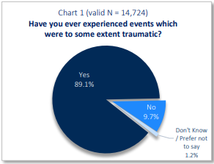
Figure 1 - Officers who have experienced traumatic events.

Almost 17,000 Serving Police officers and staff responded to the survey where they answered questions around trauma exposure, post-traumatic stress disorder (PTSD) and Complex Post Traumatic Stress Disorder (CPTSD) a staggering 89.1% answered yes to experiencing events which were traumatic. 98% of all police officers and staff that answered yes to the above question stated that the trauma they experienced was work related. (Miller, 2018)

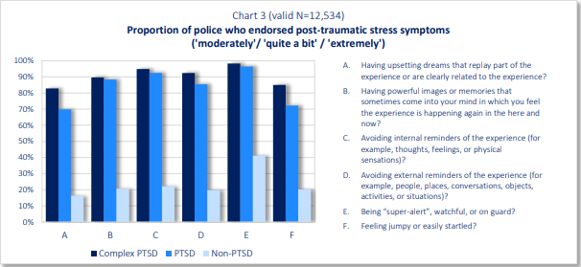
Figure 2 - Proportion of Police who endorsed PTSD symptoms.
Throughout the research only 31% of staff and officers report having symptoms of PTSD in the past year. And 27% of those with PTSD or CPTSD have ever been diagnosed with PTSD. These figures showed that for every 100 Police officers or staff that were exposed to traumatic events one fifth of them are likely to have a current diagnosis of PTSD or CPTSD, yet the study found that only 5 out of the 20 officers will ever be told and only 1-2 will be medically diagnosed with PTSD or CPTSD. (Miller, 2018)

Millers study found 73% of respondents who disclosed mental health concerns related to their employment as police officers indicated they sought out official or informal support for such issues. Only 16 % of formal help came from within their force (either Occupational Health or staff association) and this typically included counselling or CBT, TRiM and EMDR. The majority of support was sought independently, away from the force and typically included medication, counselling or CBT and mindfulness. Talking, being signed off, and still waiting to access treatment featured prominently in comments about seeking help. Miller found that 55% of officers who have experienced or have been exposed to trauma said that they rarely have time to absorb its effects at work and 65% of officers said that their force's approach to dealing with those effects was inadequate. (Miller, 2018)
In 2016, both serving and retired police officers across the UK called for more support after attending difficult or traumatic incidents on the job. A joint survey was conducted by Police Dependants’ Trust more commonly known as Police Care UK the University Surrey and Surrey Police which asked 11,000 Police officers and staff participants questions around on duty injuries and any time off, they have received as a result. The survey found 81% of respondents said they had experienced at least one physical injury or mental health issue due to their police work. 76% of respondents said this was in the past 5 years. 45% of respondents said this resulted in them taking a week, or longer, off work. (Police Care UK, 2016)

In the same year research in into neuropsychology found that activating the hippocampus region of the brain can improve the processing of trauma. (Miller, 2017) “The hippocampus, which is located in the inner (medial) region of the temporal lobe, forms part of the limbic system, which is particularly important in regulating emotional responses. The hippocampus is thought to be principally involved in storing long-term memories and in making those memories resistant to forgetting.” (Yassa, 2023)

Miller implied Information processing is a crucial concept in contemporary theories of PTSD that have been derived from cognitive theories and clinical studies. A predominant theory is that of dual representation. Dual Representation Theory describes how trauma processing operates with two types of memory representations in the limbic system: those which are associative and those which are contextual. Trauma-related associative representations are frequently uncontrollable, fear-based, and come from the amygdala. Contrarily, contextual representations are deliberately recovered and are mediated by the hippocampus. Dual Representation Theory states that in order to effectively absorb trauma, sensory and evocative events must be placed in context in order to be stored in long-term memory. Miller suggested that “quantifying the impact of Brain Derived Neurotrophic Factor on trauma and spatial processing is critical and may well explain individual differences in clinical trauma treatment outcomes and in navigation performance.” (Miller, 2017)
The world was shocked by the wave of terror attacks carried out in the United Kingdom in 2017. During March of 2017, Khalid MASOOD drove a car over Westminster Bridge, mounted the pavement and hit pedestrians walking on the bridge. He then entered the grounds of the Palace of Westminster and fatally stabbed a police officer. Five individuals were killed in the attack with many more seriously injured.
On the 22nd of May 2017, SALMAN Abedi detonated an improvised explosive device (IED) in the foyer of Manchester Arena. Twenty-two people were killed, including a number of children and teenagers. Over 100 others were injured.
In June of the same year, Khuram BUTT, Rachid REDOUANE and Youssef ZAGHBA used a van to run over pedestrians on London Bridge, before continuing their attack on foot. Eight people were killed in the attack with many more injured.
On 19th of June, Darren OSBORNE drove a vehicle into a group of people gathered near an Islamic Centre in Finsbury Park in north London. One person was killed, and ten others sustained serious injuries.
Parsons Green Train Station was the victim of a failed terror attack on the 15th of September. When Ahmed HASSAN left an IED on a District line commuter train. The device partially exploded after the train arrived at Parsons Green station. Twenty-three people sustained burn injuries as a result of the partial explosion whilst 28 people suffered crush injuries as crowds surged to exit the train. (Rutnam, 2018)
Off the back of these attacks the need to understand what can be done to enhance and protect trauma resilience in policing became a pressing public issue. (Miller, 2021)
In 2021 a review was carried out which looked at the mental health systems of police officers following extreme traumatic exposures. In this study it was found Police Officers can be subjected to numerous different types of traumatic exposures both natural disasters and human action. It found that exposure led to a number of different adverse reactions including PTSD, Acute stress disorder, major depressive disorder and anxiety disorders. The findings showed that reported rates of mental changes varied, but there were also some definite patterns. In general, police officers' rates of PTSD are consistently lower than those of civilians and are generally lower than those of other professions. This study clearly demonstrates the mental resilience and preparation that police officers get before to reporting for their duties. The Study also reveal that certain populations' reported suffering from acute stress disorder, anxiety, and depression increases over time. This suggests the necessity for mental health assistance to be made available later after the occurrence. (Regehr Et Al, 2021)
It is said that (Gershon, et al., 2002) found evidence to support problems among officers related to suicide. It found that Police officers are approximately four times more at risk of being exposed to traumatic events during their duties. The study found that Police officers are three times more at risk of exhibiting PTSD symptoms, four times more at risk of alcohol abuse and four times more likely to display aggressive behaviour.
It would seem that in recent years many people have become more open about their mental health and the stigma around suffering with mental health has somewhat subsided. There is still a culture within policing that scrutinises anyone suffering with mental health. “Police officers are shaped within a culture where mental health wellness is an undesirable topic. Because police officers are being scrutinized differently, it is possible the police culture may continue to impose inconspicuous negative attitudes about mental health treatment.” (Velazquez & Hernandez, 2019) Although this may be true (Waddington, 1999) refers to policing culture as being ‘Canteen Culture’ what he means by this is that officers will speak openly and honestly with supervisors and other officers around certain subjects. He suggests that although there is a stigma around speaking openly about mental health ‘Canteen culture’ could be used to break the stigma and negativity of speaking out and paving the way for a more supportive and inclusive environment for officers experiencing mental health issues.
In relation to this (Bell & Eski, 2016) completed a study which looked into the attitudes of Police officer’s colleagues who were suffering with Mental health. It noted the same stigma around seeking help in relation to their mental health and even deemed it ‘career destroying’ The study found an inherent cynicism, lack of empathy and a macho culture which is said to impede the discussion of access to support services. The study found recommendations could be made to improve the effective management of mental health within police forces. They recommended that and a lack of knowledge could be the mitigating factor of effectively recognizing the impact of the workplace mental health problems that Police officers face. (Bell & Eski, 2016)
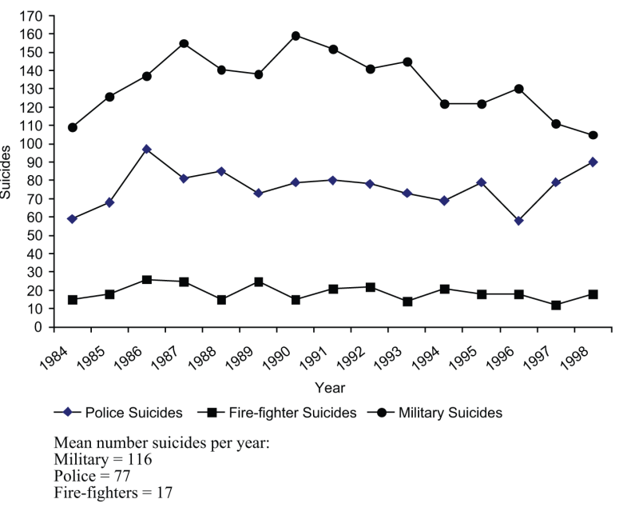
(Violanti, 2010) conducted a study into the international Police suicides and their comparison with Firefighters and Military personnel. Violanti chose these occupations as they closely resemble the extreme trauma that Police officers would face in their line of duty. (Violanti, 2010) Within the study it is said that (Guralnick, 1963) found the suicide ratio of male Police officers to be 1.8 times that of the average white male population. Suicides accounted for 13.8 percent of Police deaths compared to that of 3 percent of deaths within all other occupations. He found that more Police officers died from suicide that homicide. While these figures were based in America (Darragh, 1991) conducted research in the United Kingdom where he analysed 558 consecutive cases of suicide which revealed a dramatic increase in suicide among security forces.
Figure 3 - Number of occupational suicides between 1984-1998

(Violanti, 2010) From viewing the data above although it shows military personal having a higher suicide rate than that of Police officers and Firefighters its data also shows a dramatic decline in numbers from 1990- 1998. Whereas Police officers see a minor decline before then a sharp increase in suicides.
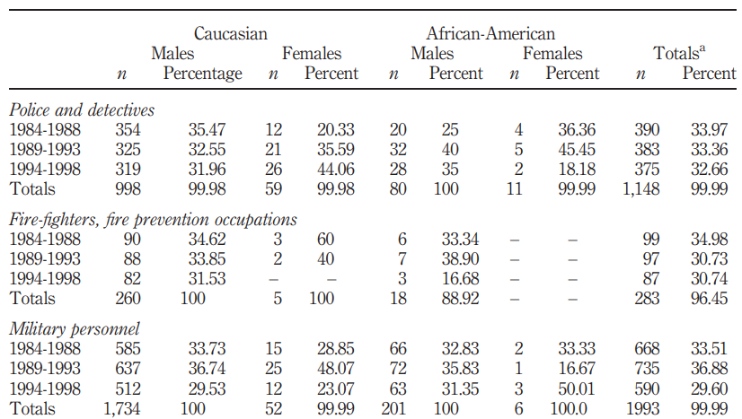

Figure 4 - Suicide by five-year categories across gender, ethnicity and occupation
(Violanti, 2010)
From the above data it is clear to see that the majority of all suicides were found to be male. The study found suicides occurred among the younger age groups ages 21-30: Police ¼ 20:8 percent, military 29 percent fire-fighters 10.6 percent. Approximately 18.34 percent of suicides for males and 33.9 percent for female police occurred in the 21-30 age group. It has been suggested that, although the suicide rate of 18.1/100,000 for law enforcement personnel is higher than the 11.4/100,000 in the general population. (Violanti, 2010)
While there is clear evidence to prove that suicides in Police officers were rising at the time (Stack & Kelley, 1994) have opposing views. They would argue that there is a problem due to the lack of control for demographic factors. They have argued that while the suicide rate of 25.5/100,000 which is twice the national average at the time. When the suicide rate was Police suicide: a national comparison found 271 matched gender and age which found there was no significant difference in suicide rates. They also argued that the Police are predominantly white males who are deemed as a high-risk suicide group. Other researchers also argued the point that the Police officer is a male dominant occupation, and it is statistically proven that males are at higher risk of committing suicide than that of females. (Alpert & Dunham, 1988)

3.0 Research Methodology and Planning
The purpose of this chapter is to conduct research and ask questions to serving Police officers and staff around being exposed to extreme trauma during when carrying out their duties. It is to gain a better understanding of what current measures are in place with Police forces and to identify any areas that can be developed to offer greater care for the mental wellbeing of officers. From reviewing the literature review it is easy to see that enormous amount of officer’s face extreme trauma day to day. Many officers are being offered mental health assessments following the exposure to trauma, but the majority feel they have no time, or they would be seen as weak by other members. Officers then tend to not speak about their mental health issues which in some cases, sadly results in them taking their own lives. My objective is to identify any gaps in what Forces currently offer in terms of support and to make suggestions to help develop any existing support. I have chosen this subject as from personal experience when dealing with incidents involving trauma, there was only an email offer for a Trim assessment that was provided. Although this is currently force-policy with demands of the job changing and officers being subjected to trauma more now than that of previous years. Potential changes to force policies may be needed to better protect officers and staff’s mental wellbeing.

3.1 Research Strategy
The research method of choice is a survey, this has been chosen as it would be the most appealing to officers to complete. Being mindful of their time constraints due to the fast-paced nature of the role I feel that a survey would be the most time efficient and most suitable to the targeted audience. I will use the likes of social media and internal Police intranet to assist in sampling, this approach has been chosen as I feel that it would be more accessible to serving officers. This should in turn should provide more responses, with the hopes of gaining more data for analysis. Using the internal Police intranet will also make the survey accessible to officer’s force wide which would also return data from various sectors and demographics. This will provide more data in the form of which sectors officers are being subject to more trauma that those of other sectors. I will be looking to obtain genders from serving officers as this can be analysed against existing mental health data and national suicide figures to see where changes can be made.

3.2 Data Collection & Data analysis
I will be looking to obtain data through the form of online surveys which will be targeted towards serving Police officers. I will be looking to present my data findings in both quantitative and qualitative methods. As I feel this would provide a better overall view of the data findings. I will be looking at different age demographics as well as gender and what sectors officers work. I feel that this will provide a broad spectrum of data which will help in identifying potential problem areas. When presenting the data, I will be looking to highlight any areas where Police forces can provide better support to their officers and potentially identify new areas where Police forces are not currently providing support. With these data findings I will be looking to then make suggestions to Police forces of the highlighted areas to make changes in the hopes of better protecting serving officers.

3.3 Limitations & Potential problems
I do foresee some potential problem areas when looking to obtain the data. I understand that Police officers work very long hours and a very fast paced role. I can see time to complete the survey being a potential issue for the targeted group. I can also see that officers after having worked long demanding shifts may not want to spend 5-10 minutes of their time filling out a survey. Due to the survey being conducted online I can see that it would be limiting the accessibility of survey.
Due to the survey being posted onto the Police intranet there is also potential for internal IT issues as well as the survey being lost in the vast amounts of daily posts. To combat this, I will be looking to post the link to the survey over a series of days, at different times of the day. This will potentially make it more accessible to officers working on different shift patterns.
Force wide there are certain sectors which are known to be more demanding than others. With this in mind I can see a potential problem of reaching out to these sectors and receiving data due to the relentless demand forced on officers. This could result in inconsistent data for the force due to a lack of responses from busier sectors.
On other area I have identified which could pose a great risk is that Mental health is a subject that not many officers openly speak about. I feel that openly advertising the fact that the survey would be conducted around this subject may put some officers off. As well as this many officers completing the survey may already be battling mental health conditions from experiencing extreme trauma during their service. In light of this at the end of the survey I will be looking to signpost any mental health services and Force wellbeing support that is available to officers and staff.

4.0 Analysis of results
This purpose of this study is to explore the effects of traumatic incidents Police officers are exposed to while carrying out their day-to-day duties. It will assess how such trauma has affected serving officers, evaluate information from serving officers and outline what could be done to help support officers in dealing with traumatic incidents and ensure their own mental wellbeing is a priority. The aim of the study is to identify any areas for improvement for police forces to better protect their officers from things like post-traumatic stress disorder and complex post-traumatic stress disorder.
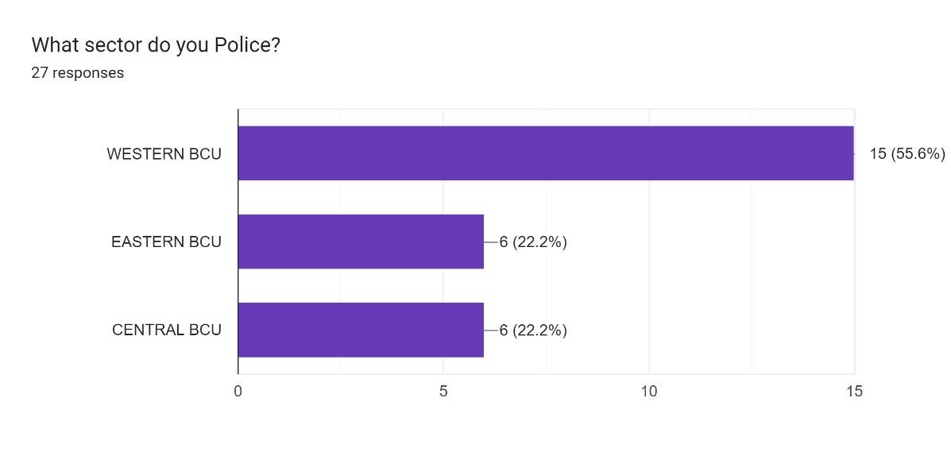
Officers and police staff currently employed by South Wales Police were the targeted demographic and they were asked a series of questions surrounding the area that they work, if they had experienced any traumatic incidents, mental health and their own coping mechanisms. The questionnaire is completely anonymous and received 27 responses.

Figure 5 - Questionnaire, Question 1 - What sector do you Police?
55.6% of respondents stated that they work in the western basic command unit of south Wales Police ‘s force area which covers Swansea, Neath and Port talbot. 22.2% of respondents stated that they work within Eastern basic command unit which covers Cardiff and the Vale while 22.2% of respondents stated they work in the Central basic command unit which cover Bridgend, Maesteg and Merthyr Tydfil.

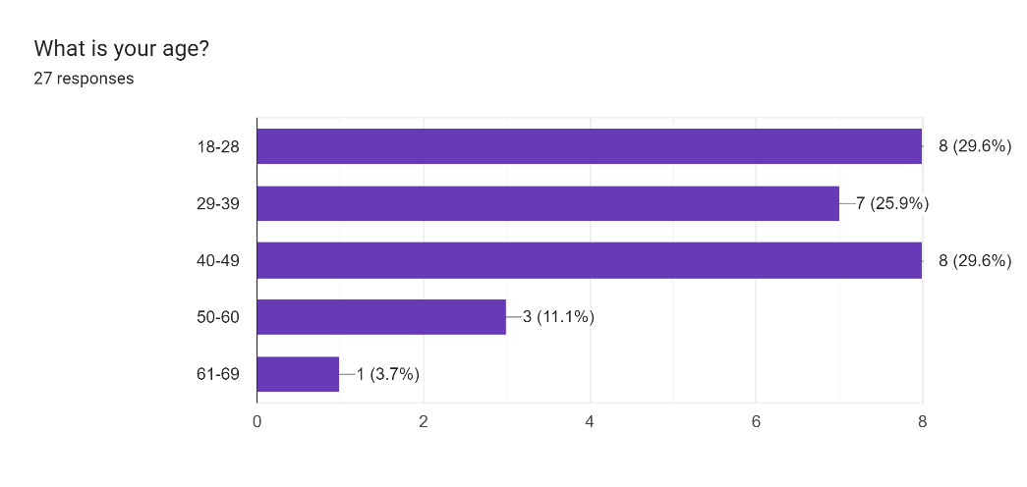
Figure 6 - Questionnaire, Question 2 - What is your age?

Respondents were then asked their ages. 29.6% of respondents stated they were between the ages of 18-28 and 40-49. 25.9% of respondents answered the question that they were 29-39 years old. 11.1% of respondents answered 50-60 years of age and 3.7% of the targeted demographic answered that they were 61-69 years of age.
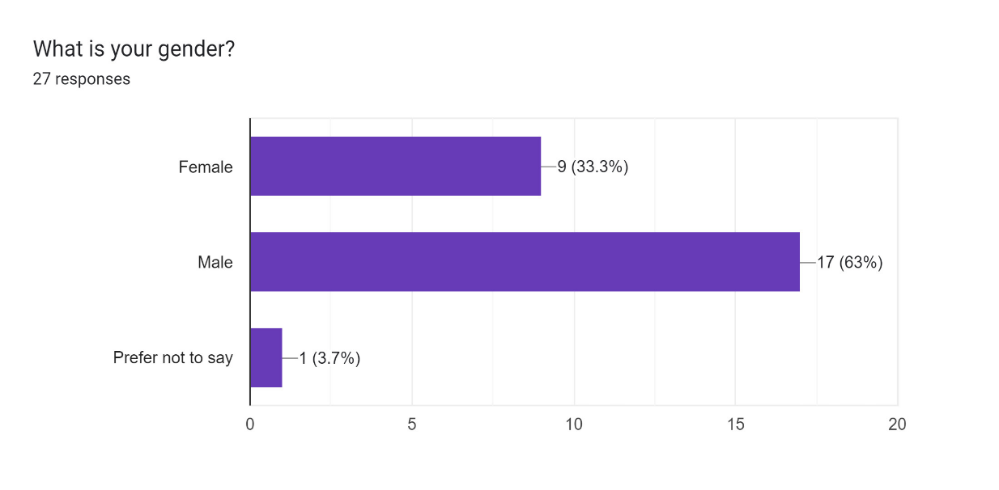
Figure 7 - Questionnaire, question 3 - what is your gender?

Over half of participants answered that they were male resulting in 63% of responses. 33.3% of participants answered that they were female, and 3.7% answered that they would prefer not to say.

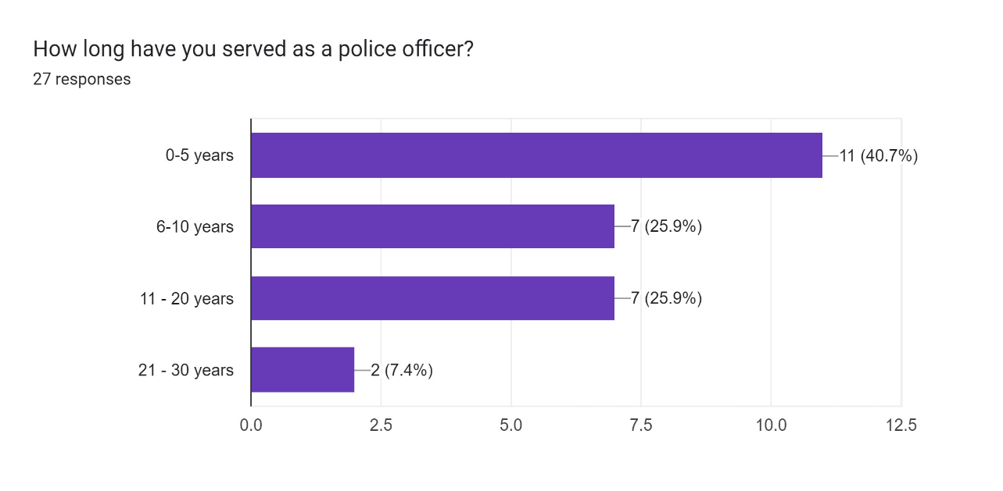
Figure 8 - Questionnaire, question 4 - How long have you served as a police officer?

Participants were asked how long they have served as an officer for, 7.4% answered they had between 21- 30 years’ experience. 25.9% of respondents answered they had 11-20 years and 6-10 years’ experience. 40.7% of participants answered they had 0-5 years’ experience as a serving police officer.
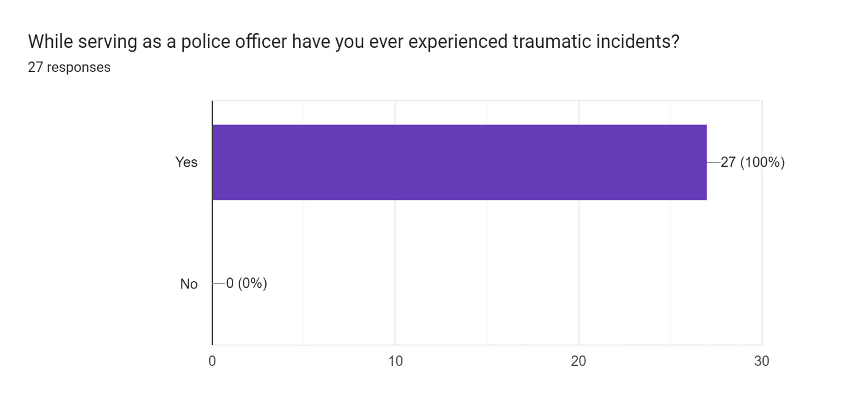
Figure 9 - Questionnaire, Question 5 – While serving as a police officer have you experienced traumatic incidents?

Respondents were asked if they had ever experienced any traumatic incidents while serving as a police officer or police staff. 100% of participants answered yes.

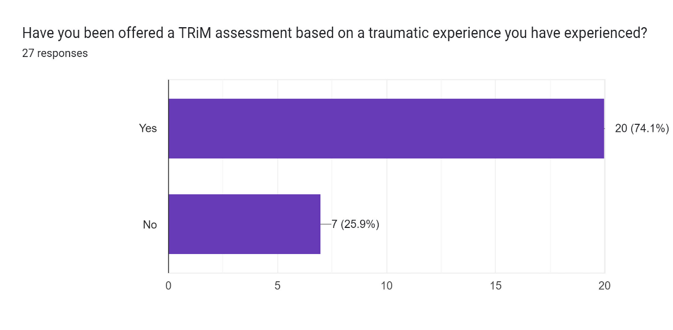

Figure 10 - Questionnaire, question 6 - Have you been offered a TRiM assessment?
Participants were asked if they had received a TRiM assessment after they had been experienced a traumatic incident. 25.9% answered no while 74.1% answered yes.
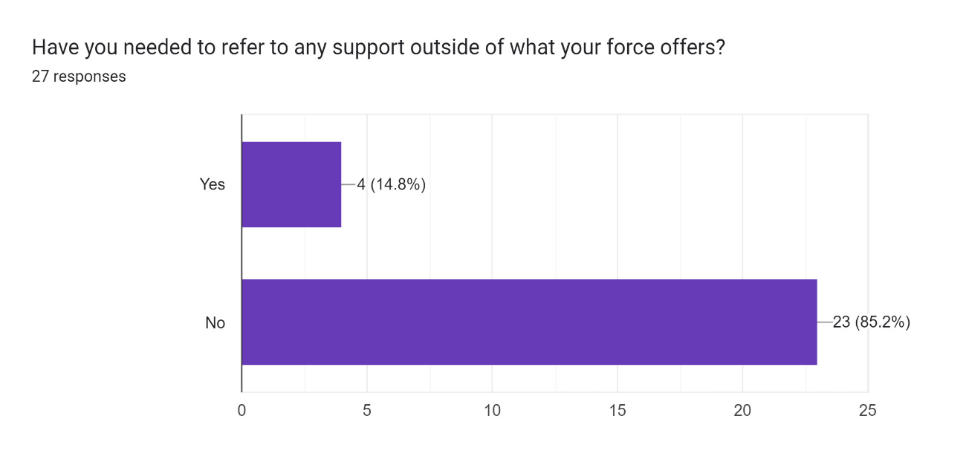
Figure 11 - Questionnaire, Question 7 - Have you needed to refer to any support outside of what your force offers?

Respondents were asked if they had needed to seek support outside of what the force already had in place. And if yes, why. 85.2% of participants said no, 14.8% of the demographic answered yes. One of the respondents who answered yes did not want to say why they looked for more support. Another participant stated that after experiencing a traumatic incident they required more support due to the incident bringing back memories of previous trauma. Another stated that they did not receive any kind of support or assessment from the force, while another stated they just felt like they needed more support.

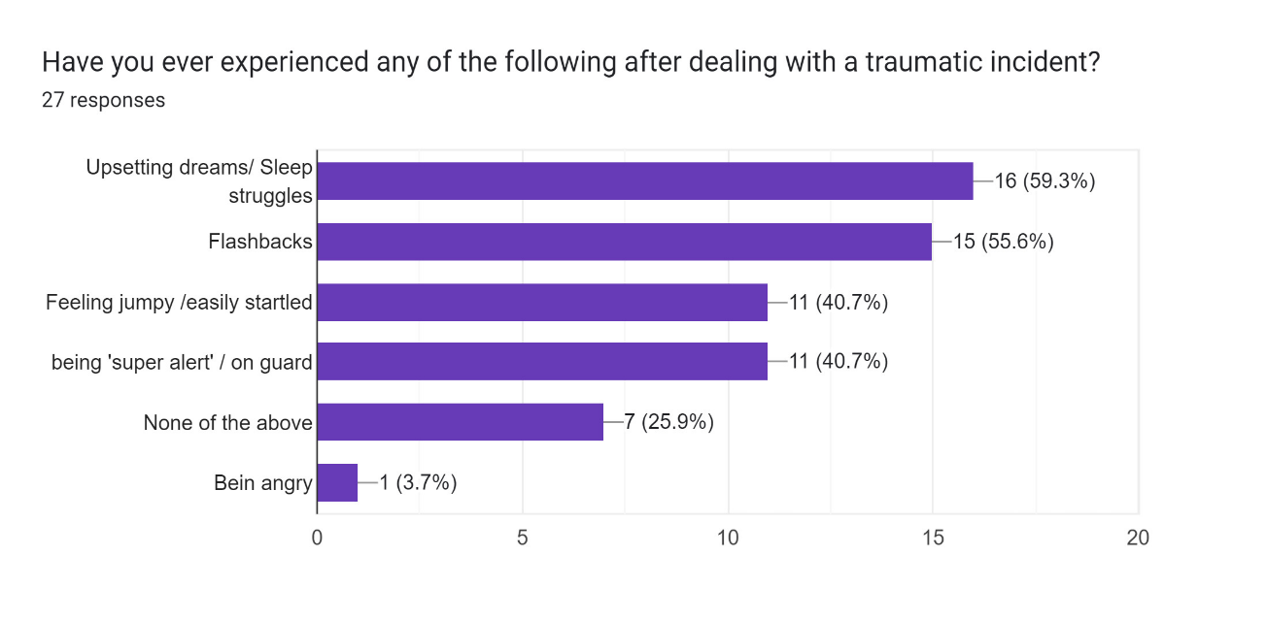

Figure 12 - Questionnaire, Question 8 - Have you ever experienced any of the following after dealing with a traumatic incident?

Participants were asked if they had experienced any signs or symptoms of PTSD and CPTSD. This question was multiple choice allowing participants to answer one or more. Upsetting dreams and sleep struggles was answered the most with 16 answers. Flashbacks was the second most popular answer with 15. Feeling jumpy/ easily startled and being ‘super alert’/on guard both had 11 responses. 7 participants answered they had no symptoms and one participant answered that they felt they were being angry.

Participants were asked about their coping mechanisms after dealing with traumatic incidents. There was a large verity of responses across the demographic, some of the more common answers were speaking about the incident with team members and family members. Taking exercise and exerting energy levels to release endorphins, walking and spending time outdoors in the fresh air and decompressing by surrounding themselves with nature. Some respondents did state that they feel alcohol helps them to deal with traumatic incidents.

Respondents were asked to give their opinion on team sergeants being trained to carry out TRiM assessments for their team members. The majority of responses felt this would be a positive idea, as it would make TRiM assessments far more accessible to officers than they currently are. However, there were several respondents that felt team Sergeants already have a demanding role as it is without having to add any additional work. A number of respondents felt that they have a close working relationship with their Sergeant and felt that it would make them feel awkward having to disclose any personal information to them. A common pattern among respondents seemed to suggest that there are not enough TRiM trained officers readily available to officers and staff.

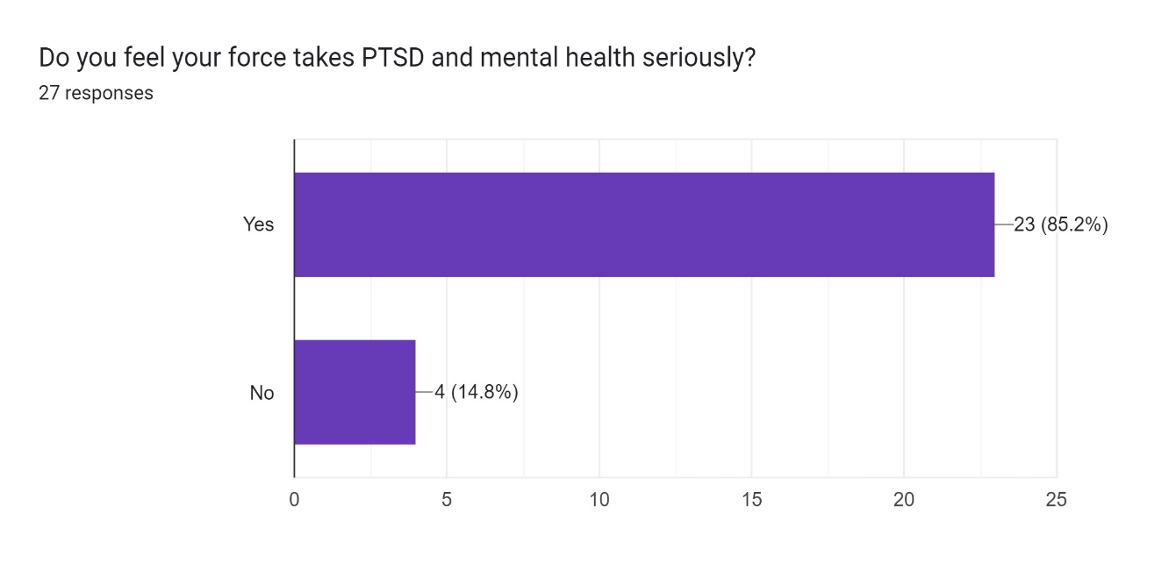

Figure 13 - Questionnaire, Question 11 - Do you feel your force takes PTSD and mental health seriously?
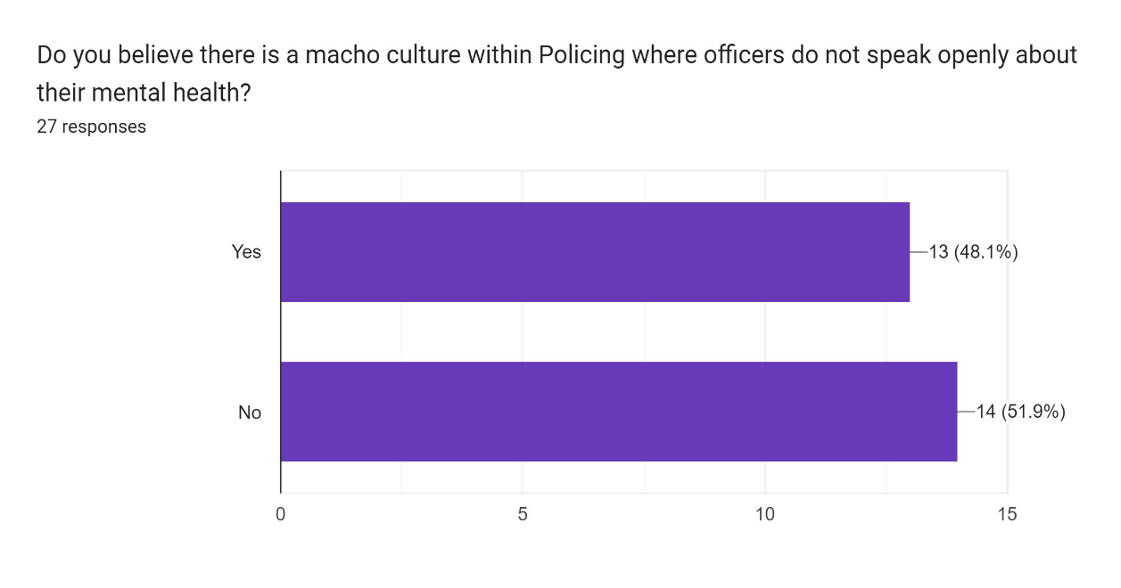
Participants were asked if they felt that their force takes PTSD and Mental health seriously, they were asked if they answered No, why. 85.2% felt that their force did take mental health seriously while 14.8% answered No. When these respondents were asked why they stated that they feel that they have a large workload with no time to decompress after traumatic events. Others answered that they feel more can always be done. One respondent answered, they felt that if you were professionally diagnosed with PTSD then the force would take it seriously, however prior to the diagnosis they felt it’s just a get on with it culture. Another respondent stated that their experience with force TRiM assessments was very poor.

Figure 14 - Questionnaire, Question 12 - Do you believe there is a macho culture within Policing where officers do not speak openly about their mental health?

Participants were asked if they felt there was a macho culture within policing, where officers and staff do not speak openly about their mental health. 48.1% answered yes to this question while 51.9% answered No.

From viewing the results, it is clear that every respondent has experienced trauma while carrying out their day-to-day duties. This coincides with research conducted by (Miller, 2018) whereby 98% of their respondents answered yes to the same question. All respondents answered that they have experienced one or more symptom of PTSD. Which is staggeringly higher than that of (Miller, 2018) survey which only 31% of respondents experienced these symptoms. One factor that did arise from this survey is that over 65% of respondents have less than 10 years of service. With the majority of participants being young in service, one could question is this the reason for such a high number of respondents experiencing symptoms of PTSD. What I mean by this is, do more experienced officers feel de-sensitised when dealing with traumatic incidents as it is likely they have experienced trauma on multiple occasions during their service.
Participants were asked what recommendations they would suggest making to the force in relation to protecting Mental Health amongst staff. There was a wide variety of responses for this question. Some responses from participants suggested that more TRiM trained officers would be beneficial. As it would make it more accessible to officers immediately after dealing with traumatic incidents, some suggested 24-hour accessibility to internal support and having wellbeing team members in stations that can provide drop-in sessions. While others suggested more training for serving staff and officers to help identify signs and symptoms if they or colleagues are beginning to struggle. A number of participants suggested that more wellbeing days and social events.
One respondent suggested that TRiM is what needs to be addressed and questions need to be raised as to whether it is adequate. Another respondent stated the force could be more considerate to police officers, in terms of expectations, cancelled rest days, training days and expected to work overtime for free. The force needs to remember police officers are people with lives, family, friends, and other commitments - those of which if given the opportunity often aid in good mental health.
One common factor from this questionnaire is that mental health assessments for officers need to be more accessible. Many suggestions have been made around how this can be done and it would seem that more staff would need to be trained to allow this to happen.

5.0 Findings and conclusions
The study's primary goals were the ones listed below. It is intended that by concentrating on these goals, South Wales Police and police forces across the United Kingdom would be able to learn additional information from officers and apply the necessary training and recommendations. This is to make sure that policies and practises within the force prioritise improved care and mental wellbeing for officers. It is envisaged that this paper will contribute to the advancement of South Wales Police's protection of their officers and employees by examining the articles from the literature review and carrying out a study inside the force.
- Assess how such trauma is affecting serving officers.

- Evaluate information from serving officers in the ways of what support is available to them.
- Outline what could be done to help support officers in dealing with traumatic incidents.

- Recommend some changes that could be adopted to ensure the wellbeing officers is a priority.

5.1 Assess how such trauma is affecting serving officers.
This study covered vast amount of literature which was taken from serving Police officers and staff. This was to enable readers to put themselves in their shoes and to view life from the officer’s perspective. One article from the literature “The Job & The Life” (Police Care UK, 2018) looked at 17000 responses from officers and Police staff who had been exposed to traumatic incidents. The study found that at least one in five serving officers and police staff suffer with post-traumatic stress disorder or complex post-traumatic stress disorder. The study found that for every 100 respondents twenty are likely to have a current diagnosis of PTSD or CPTSD, yet only five will ever be told professionally and only one or two are likely to be clinically diagnosed. (Police Care UK, 2018)
This study asked the question to officers if they had ever experienced any symptoms of PTSD or CPTSD after being exposed to traumatic incident while carrying out their day-to-day duties. Approximately 80% of respondents answered that they have experienced symptoms.

5.2 Evaluate information from serving officers in the ways of what support is available to them.
As part of this study a questionnaire was sent to serving officers from South Wales Police to find out what support was available to them after experiencing traumatic incidents. One common factor found from the majority of respondents was that they were offered a TRiM assessment. “Trauma Risk Management (TRiM) is a proactive peer-group model of psychological risk assessment used by the Royal Marines for over 10 years. It aims to promote recognition of psychological illness and keep personnel functioning after traumatic events by enhancing the understanding and acceptance of stress reactions within an appropriate environment.” (Frappell-Cooke et al, 2010)
Responses from some officers stated that their experiences with TRIM was very poor and felt that there was little support available to them which resulted in them seeking support outside of the force.

5.3 Outline what could be done to help support officers in dealing with traumatic incidents.
From reviewing the material submitted by officers, it would seem that more support is required to better protect officers in dealing with traumatic incidents. Respondents from the questionnaire felt that they had little to no time to decompress after being exposed to traumatic events. A number of respondents felt that receiving an email after dealing with an incident was not offering support but felt it was more of a tick box exercise. Respondents felt that having more trained staff readily available to officers would be beneficial, allowing them to be on hand 24 hours a day to provide support.

5.4 Questionnaire
The first recommendation I would make to South Wales Police would be to further investigate this subject with a similar internal questionnaire targeted towards frontline officers as opposed to office-based staff. This is because front line officers are far more likely to be exposed to traumatic incidents. This will allow South Wales Police to gain a better understanding of the current mental wellbeing of staff.

5.5 More TRIM trained officers
The second recommendation I would make is to have more TRIM trained staff on hand to offer support to officers after experiencing traumatic incidents. I feel that TRIM trained staff could conduct an early assessment on officers immediately after the event. I feel this will give officers a friendly approachable face should they be struggling with the impact of any event they have been exposed to as opposed to an email offering support. By training more officers there would be a significant cost to the force, although senior management may be startled by the initial costings of this recommendation it is important to remember the bigger picture here, officers and staff’s mental wellbeing. I feel that by implementing this it could lead to happier officers across the force which in turn would lead to better work being produced.

5.6 Decompression time
The third recommendation I would like to make, would be to allow officers time to decompress and reflect on a traumatic incident allowing them time to process the incident while being supported by staff from the second recommendation. A number of officers who took part in the questionnaire noted that they were subjected to a traumatic incident before then being expected to move on to the next without adequate time to process the first. This recommendation is likely to be the hardest to implement. With Police officer shortages across the United Kingdom, it and response officers being stretched to carry out their duties, having time away from shift is highly unlikely unless it is drastically needed. Not only would this cause greater demand on shifts but it would also result in officer’s workloads being left untouched until they return to work. This could result negatively in victim satisfaction.

5.7 Support groups
The fourth recommendation I would like to make would be to start support groups managed by TRIM/Mental health professionals. These could be set up as drop-in sessions to provide support to officers struggling with their mental health. These could be created as open platforms for officers to speak with one and other about any traumatic experiences they have been exposed to allowing peer to peer support as well as trained professionals being on hand to step in if needed. This recommendation could be the most practical to implement. I feel this because cost to the force would be very little if they used their own trained staff to carry out the groups. As well as this I feel this could be used as a steppingstone for implementing recommendation 5.5-More TRiM trained officers. What I mean by this is senior management and the trained staff could keep a tally of how many officers attend these group sessions to gauge if more action is needed.

6.0 Conclusion
This study not only addressed the question: Is enough being done to protect Police Officers mental wellbeing when being exposed to extreme trauma during their day-to-day duties., but also successfully attained the objectives and goals of the research. As well as informed the reader how in depth the issue of mental health is within Policing is.

Key findings from this dissertation have been provided on issues associated with age, gender, mental health, and PTSD, as well as what kind of support is offered to police officers who have experienced horrific events. The project's overall objective has been to determine whether enough is being done to protect the mental health of active police officers and personnel.

Chapter One identifies the external observations and the project's justification. Chapter Two compiles the pertinent data already available regarding this issue. Chapter Three outlines the best model for analysis. Chapters Four and Five present the research's findings and offer recommendations.

To conclude this project appropriately would be to highlight the real and actual issue of mental health within Policing and how as evidenced throughout this research that can be done to support serving officers and staff who are facing traumatic events while carrying out their day-to-day duties. It is important to note that there is room for further research in this area that can be done to better understand this issue, and arguably everyone would stand to benefit if this were to happen. Although this research has been conducted and the data that has been extracted is from a small population of serving officers. It is clear that there is a call for more research in this field and that South Wales Police should conduct their own internal investigation into this matter, as highlighted with in the recommendations. This could result in further findings which in turn may result in further support becoming available to officers.

7.0 Bibliography
Alpert, G. & Dunham, R., 1988. Policing Urban America, Illinois: Waveland Press.
Bell, S. & Eski, Y., 2016. Break a Leg - It's all in the mind: Police Officers Attitudes towards Colleagues with Mental Health Issues. Policing: A Journal of Policy and Practice, Volume 10, Issue 2, pp. 95-101.
Darragh, P., 1991. Epidemiology of suicide in Northern Ireland. Irish Journal of Medical Science Vol 160, pp. 354-357.
Frappell-Cooke et al, 2010. Does trauma risk management reduce psychological distress in deployed troops?. Occupationl Medicine (Oxford), 60 (8), pp. 645-650.
Gershon, R., Lin, S. & Li, X., 2002. Work stress in aging police officers. Journal of Occupational environmental Medicine Volume 44, pp. 160-167.
Guralnick, L., 1963. Mortality by occupation and the cause of death among men 20-64 years of age, Vital Statistics Special Reports, Vol 53, s.l.: Department of Health Education and Welfare.
Miller, J., 2018. Establishing the evidence base:'Policing: The Job & The Life' Survey. [Online]
Available at: https://www.policingtrauma.sociology.cam.ac.uk/survey
Miller, J., 2021. Trauma Impact Prevention Techniques. [Online]
Available at: https://www.policingtrauma.sociology.cam.ac.uk/techniques
Miller, J., 2022. Police Care UK - Trauma Resilience in UK Policing. [Online]
Available at: https://www.policingtrauma.sociology.cam.ac.uk/
Miller, J. e. a., 2017. The impact of the brain-Derived Neurotrophic Factor Gene on Trauma and Spatial Processing. Journal of Clinical Medicine 6.
NIMH, 2022. Caring for Your Mental Health. [Online]
Available at: https://www.nimh.nih.gov/health/topics/caring-for-your-mental-health#:~:text=Mental%20health%20includes%20emotional%2C%20psychological%2C%20and%20social%20well-being.,to%20your%20overall%20health%20and%20quality%20of%20life.
Police Care UK, 2016. Injury on Duty Research. [Online]
Available at: https://www.policecare.org.uk/research/injury-on-duty/
Police Care UK, 2018. Policing: The Job & The Life, Cambridge: University of Cambridge.
Regehr Et Al, 2021. A systomatic review of mental health symptoms in Police Officers following extreme traumatic exposures. Police Practice and Research, pp. 225-239.
Rutnam, S. P., 2018. Intelligence and Security Committee of Parliment, London: House of Commons.
Stack, S. & Kelley, T., 1994. Police suicide: An analysis. American Journal of Police Vol 8, pp. 73-90.
Velazquez, E. & Hernandez, M., 2019. Policing; Bradford. Effects of police officer exposure to traumatic experiences and recognizing the stigma associated with police officer mental health: A state-of-the-art review, pp. 711-724.
Violanti, 2010. Police suicide a national comparison with firefighter and military personel. Policing: an International Journal of Police Strategies & Management Volume 33, pp. 270-286.
Violanti, J. M., 2006. The Police: Perspectives on Trauma and Resiliency. Traumatology, 12(3), pp. 167-169.
Waddington, P., 1999. Policing (Canteen) Subculture. British Journal of criminology 39, pp. 287-309.
Yassa, M. A., 2023. Hippocampus. [Online]
Available at: https://www.britannica.com/science/hippocampus. Accessed 6 April 2023

8.0 Appendices
8.1 Appendix A- Table of figures.
Figure 1 - Officers who have experienced traumatic events. 9
Figure 2 - Proportion of Police who endorsed PTSD symptoms. 9
Figure 3 - Number of occupational suicides between 1984-1998 13
Figure 4 - Suicide by five-year categories across gender, ethnicity and occupation 13
Figure 5 - Questionnaire, Question 1 - What sector do you Police? 16
Figure 6 - Questionnaire, Question 2 - What is your age? 17
Figure 7 - Questionnaire, question 3 - what is your gender? 17
Figure 8 - Questionnaire, question 4 - How long have you served as a police officer? 18
Figure 9 - Questionnaire, Question 5 – While serving as a police officer have you experienced traumatic incidents? 18
Figure 10 - Questionnaire, question 6 - Have you been offered a TRiM assessment? 19
Figure 11 - Questionnaire, Question 7 - Have you needed to refer to any support outside of what your force offers? 19
Figure 12 - Questionnaire, Question 8 - Have you ever experienced any of the following after dealing with a traumatic incident? 20
Figure 13 - Questionnaire, Question 11 - Do you feel your force takes PTSD and mental health seriously? 21
Figure 14 - Questionnaire, Question 12 - Do you believe there is a macho culture within Policing where officers do not speak openly about their mental health? 21

8.2 Appendix B – Copy of Questionnaire
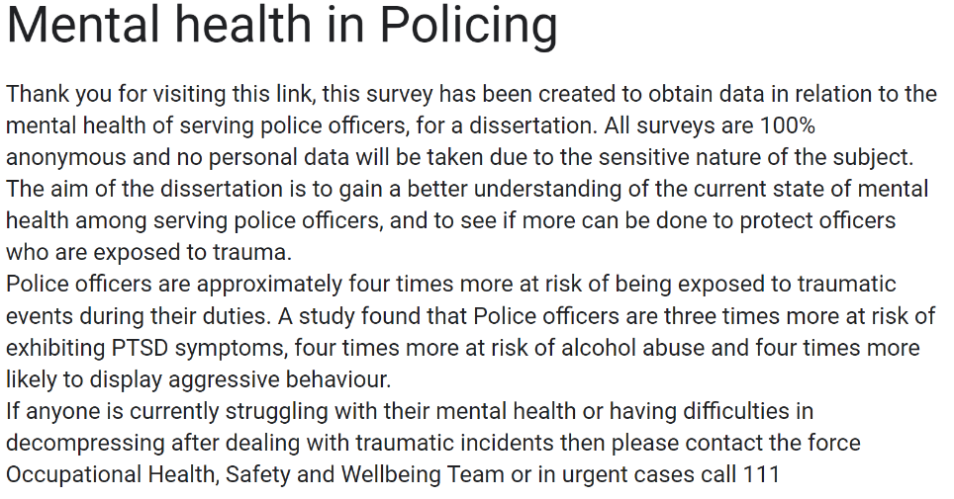
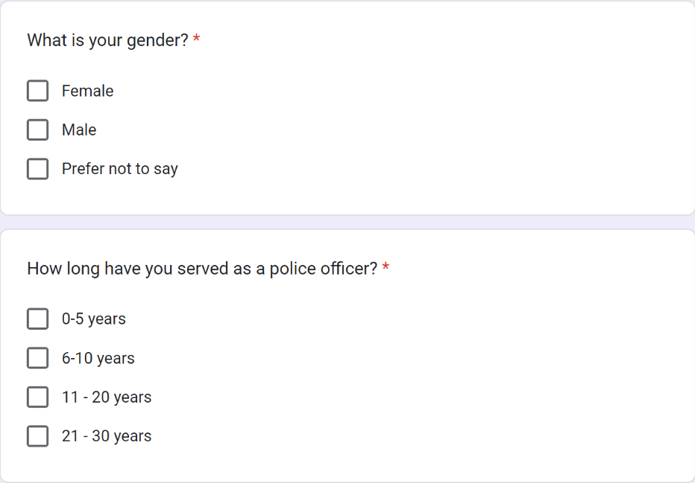
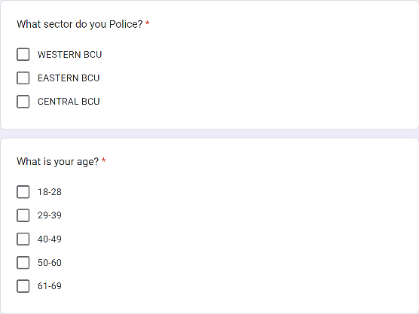

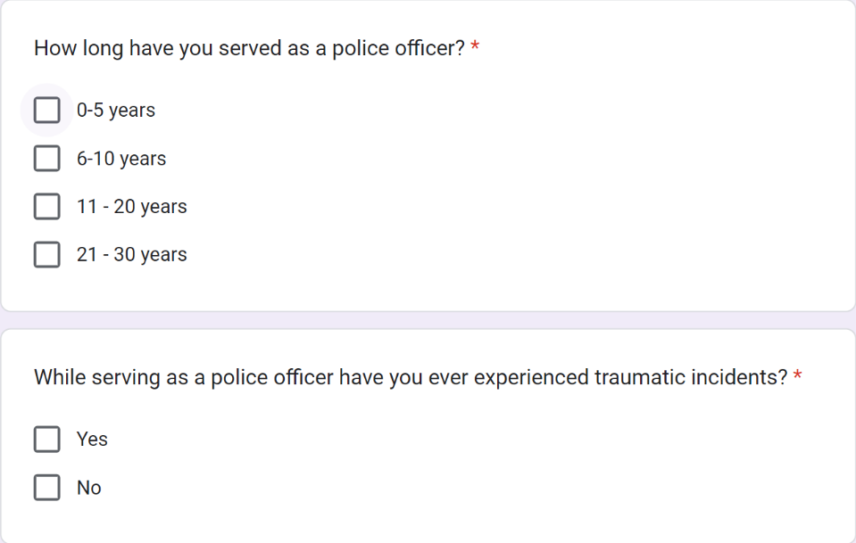
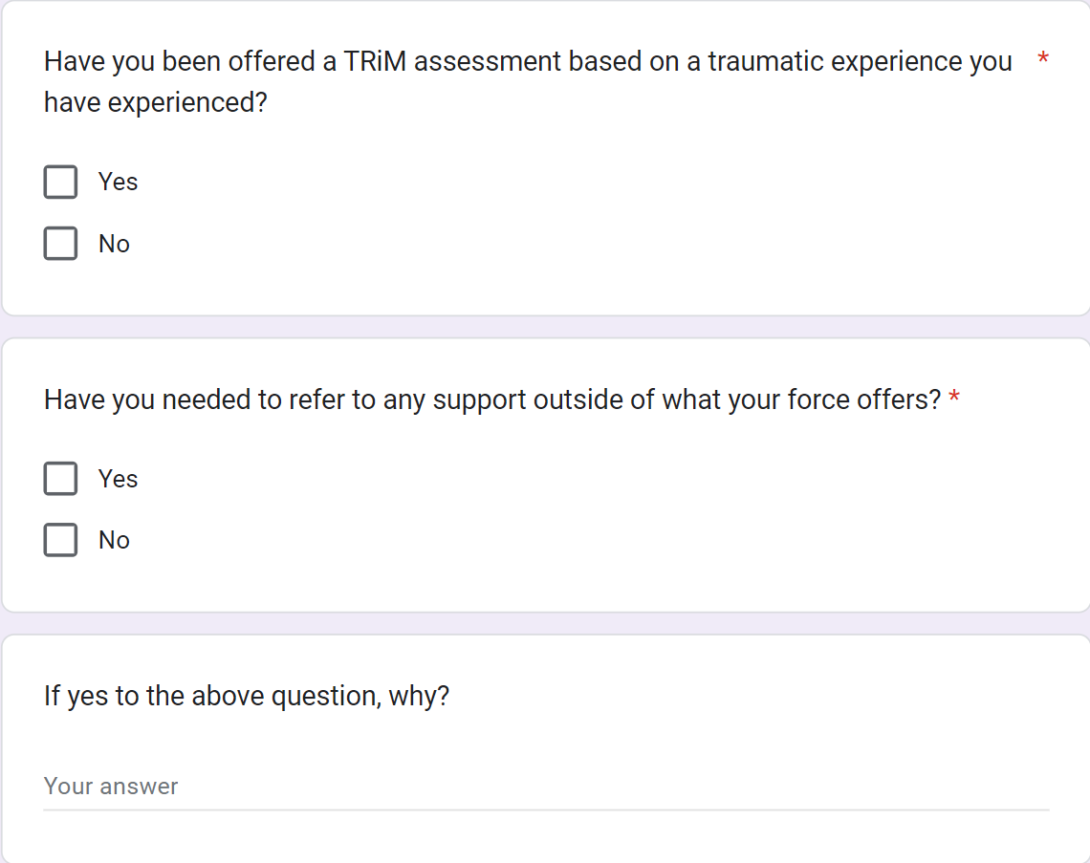
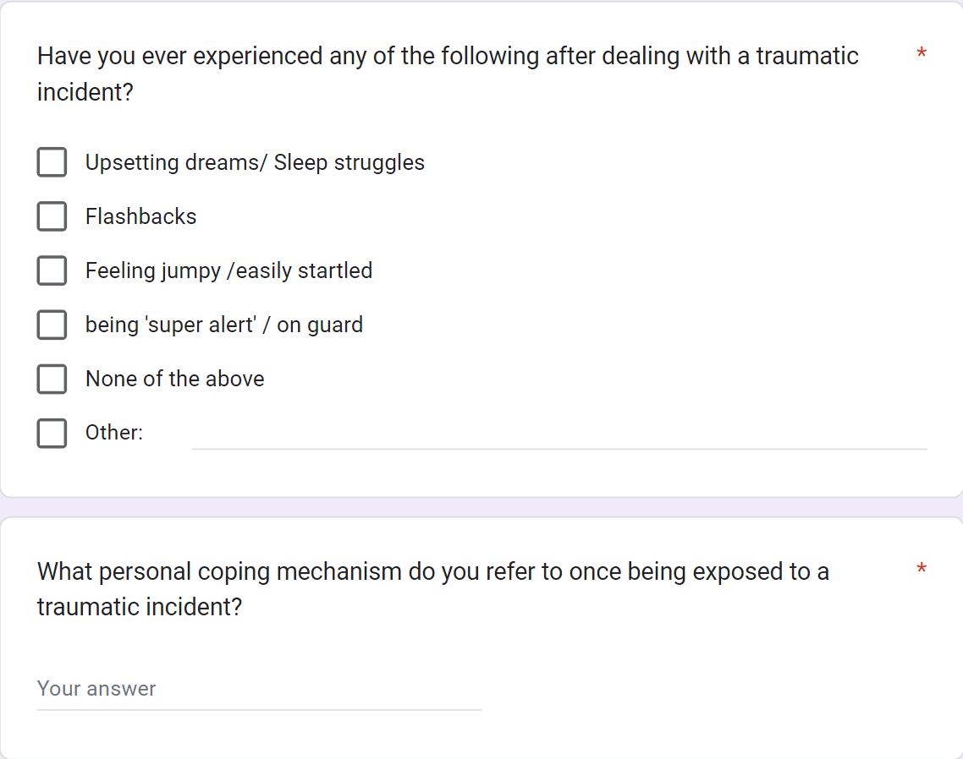
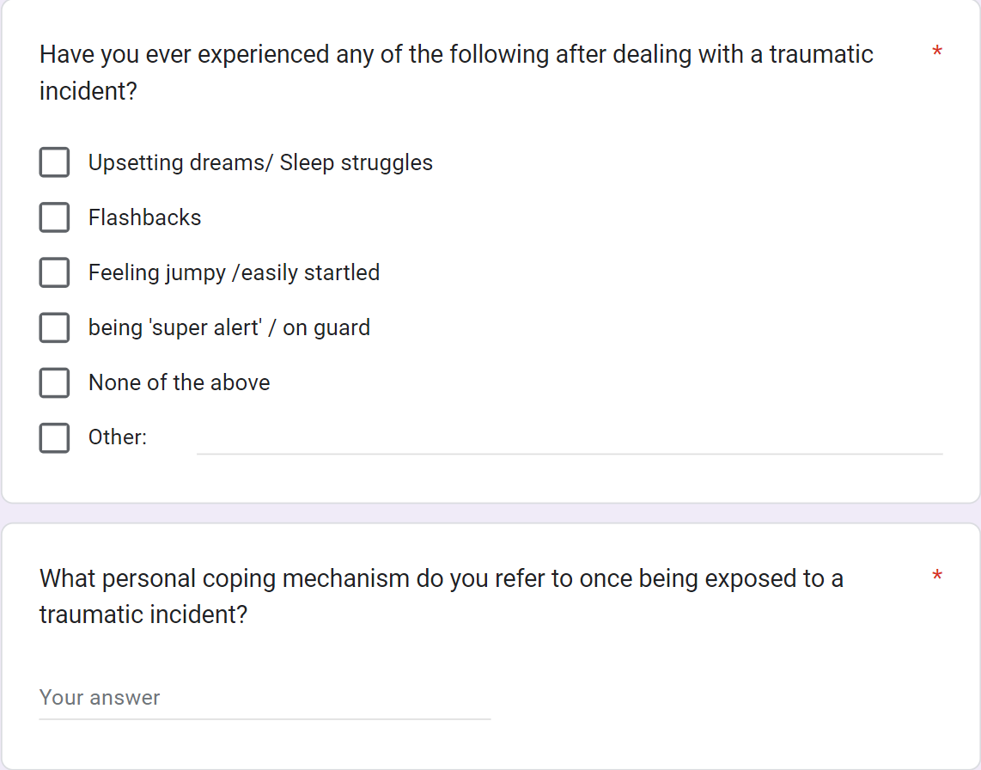
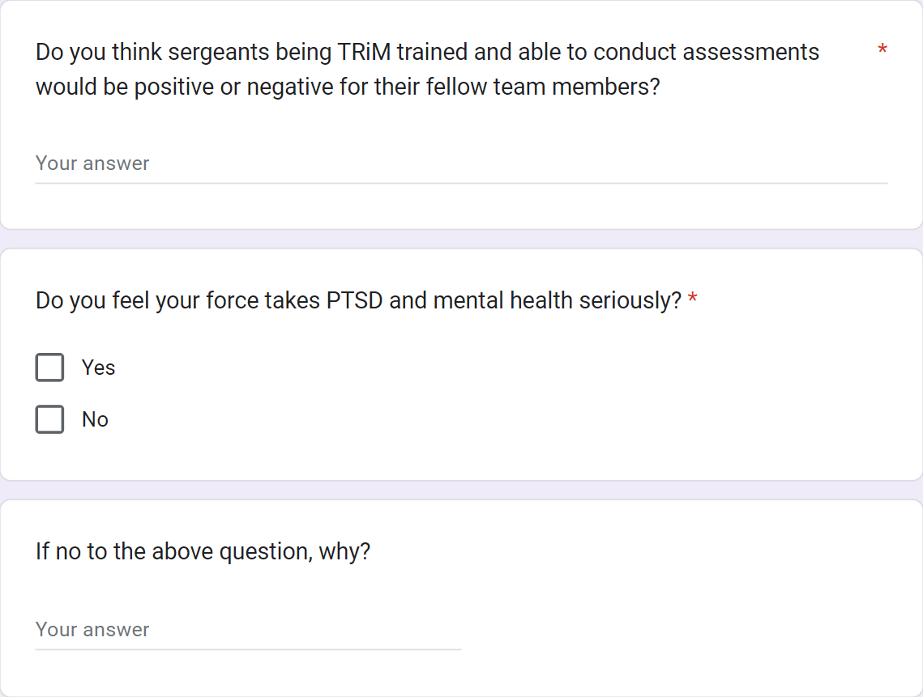
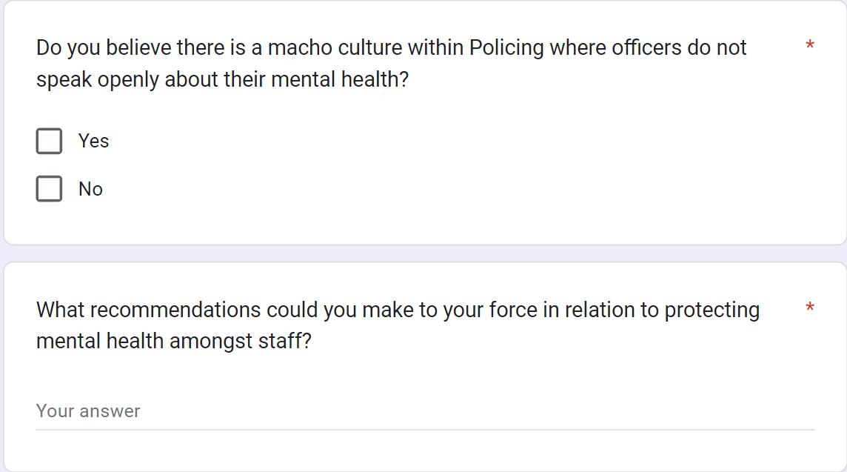

8.3 Appendix C – Ethics Form

APPLICATION FOR ETHICAL APPROVAL

In order for research to result in benefit and minimise risk of harm, it must be conducted ethically. A researcher may not be covered by the University’s insurance if ethical approval has not been obtained prior to commencement.
The University follows the OECD Frascati manual definition of research activity: “creative work undertaken on a systematic basis in order to increase the stock of knowledge, including knowledge of man, culture and society, and the use of this stock of knowledge to devise new applications”. As such this covers activities undertaken by members of staff, postgraduate research students, and both taught postgraduate and undergraduate students working on dissertations/projects.
The individual undertaking the research activity is known as the “principal researcher”.
Ethical approval is not required for routine audits, performance reviews, quality assurance studies, testing within normal educational requirements, and literary or artistic criticism.
Please read the notes for guidance before completing ALL sections of the form.
This form must be completed and approved prior to undertaking any research activity. Please see Checklist for details of process for different categories of application.
Delete the Guidance Notes at the end of the form BEFORE submitting your application

SECTION A: About You (Principal Researcher)
Full Name: |  | Sean Davies
Tick all boxes which apply: |  | Member of staff: | ☐ | Honorary research fellow: | ☐
Undergraduate Student | ☒ | Taught Postgraduate Student | ☐ | Postgraduate Research Student | ☐

Institute/Academic Discipline/Centre: | Business School or Other
Campus: | Swansea
E-mail address: | 2023948@student.uwtsd.ac.uk
Contact Telephone Number: | 07773058501
For students:
Student Number: | 2023948
Programme of Study: | Professional Policing
Director of Studies/Supervisor: | Dr Stephanie Brown

SECTION B: Approval for Research Activity
Has the research activity received approval in principle?  (please check the Guidance Notes as to the appropriate approval process for different levels of research by different categories of individual) |  | YES | ☒ | NO | ☐
 |  |  |  | Date
If Yes, please indicate source of approval (and date where known): Approval in principle must be obtained from the relevant source prior to seeking ethical approval | Research Degrees Committee |  | ☒
 | Institute Research Committee |  | ☐
 | Other (write in) |  | ☐

SECTION C: Internal and External Ethical Guidance Materials
Please list the core ethical guidance documents that have been referred to during the completion of this form (including any discipline-specific codes of research ethics, and also any specific ethical guidance relating to the proposed methodology). Please tick to confirm that your research proposal adheres to these codes and guidelines.
UWTSD Research Ethics & Integrity Code of Practice | ☒
UWTSD Research Data Management Policy | ☒
 | ☒

SECTION D: External Collaborative Research Activity
Does the research activity involve collaborators outside of the University? |  | YES | ☐ | NO | ☒
If Yes, please provide the name of the external organisation and name and contact details for the main contact person and confirmation this person has consented to their personal data being shared.as part of this collaboration.
Institution
Contact person name
Contact person e-mail address

Has this individual consented to sharing their details on this form? |  | YES | ☐ | NO |  | ☒
Are you in receipt of a KESS scholarship? |  | YES | ☐ | NO |  | ☒
Is your research externally funded |  | YES | ☐ | NO |  | ☒
Are you specifically employed to undertake this research in either a paid or voluntary capacity? | Voluntary | YES | ☐ | NO |  | ☒
 | Employed | YES | ☐ | NO |  | ☒
Is the research being undertaken within an existing UWTSD Athrofa Professional Learning Partnership (APLP) | If YES then the permission question below does not need to be answered. | YES | ☐ | NO |  | ☒
Permission to undertake the research has been provided by the partner organisation | (If YES attach copy)  If NO the application cannot continue | YES | ☐ | NO |  | ☒

Where research activity is carried out in collaboration with an external organisation
Does this organisation have its own ethics approval system? | YES | ☐ | NO | ☒
If Yes, please attach a copy of any final approval (or interim approval) from the organisation

SECTION E: Details of Research Activity
Indicative title: | Mental Health: Is enough being done to protect Police Officers mental wellbeing when being exposed to extreme trauma during their day-to-day duties.
Proposed start date: | 4th January 2023 | Proposed end date: | 9th October 2023
Introduction to the Research (maximum 300 words)
Ensure that you write for a Non-Specialist Audience when outlining your response to the three points below:
- Purpose of Research Activity
- Proposed Research Question
- Aims of Research Activity
- Objectives of Research Activity
Demonstrate, briefly, how Existing Research has informed the proposed activity and explain
- What the research activity will add to the body of knowledge
- How it addresses an area of importance.
Purpose of Research Activity

This purpose of this study is to explore the effects of traumatic incidents Police officers are exposed to while carrying out their day-to-day duties.

(this box should expand as you type)
Research Question

Is enough being done to protect Police Officers mental wellbeing when being exposed to extreme trauma during their day-to-day duties.

(this box should expand as you type)
Aims of Research Activity

The aims of this research activity is, to Determine the impact of such trauma on active officers. Assess the information provided by serving officers regarding the types of support that are available to them. Recommend possible actions that would assist police in coping with traumatic events. Suggest some modifications that might be made to make sure the wellbeing of the officers is a top priority.

(this box should expand as you type)
Objectives of Research Activity

The aims and objectives of this research is to,
- Assess how such trauma is affecting serving officers.
- Evaluate information from serving officers in the ways of what support is available to them.
- Outline what could be done to help support officers in dealing with traumatic incidents.
- Recommend some changes that could be adopted to ensure the wellbeing officers is a priority

(this box should expand as you type)
Proposed methods (maximum 600 words)
Provide a brief summary of all the methods that may be used in the research activity, making it clear what specific techniques may be used. If methods other than those listed in this section are deemed appropriate later, additional ethical approval for those methods will be needed.
There are many methods in which data can be collected. In this case an extensive literature review will be completed through multiple online open sources.

Data will also be gathered via the means of anonymous questionnaires completed by serving officers. This will provide using quantitative approach which will provide a clear insight into what officers are currently experiencing or have experienced, and what measures were put in place to support them.

(this box should expand as you type)

Location of research activity
Identify all locations where research activity will take place.
Research will be conducted via open source outlets on the internet as well as questionnaires that would be sent to serving officers.

(this box should expand as you type)
Research activity outside of the UK
If research activity will take place overseas, you are responsible for ensuring that local ethical considerations are complied with and that the relevant permissions are sought. Specify any local guidelines (e.g. from local professional associations/learned societies/universities) that exist and whether these involve any ethical stipulations beyond those usual in the UK (provide details of any licenses or permissions required). Also specify whether there are any specific ethical issues raised by the local context in which the research activity is taking place, for example, particular cultural and/or legal sensitivities or vulnerabilities of participants.
N/A

(this box should expand as you type)

Use of documentation not in the public domain: Are any documents NOT publicly available? | NO | ☒
 | YES | ☐
If Yes, please provide details here of how you will gain access to specific documentation that is not in the public domain and that this is in accordance with prevailing data protection law of the country in question and England and Wales.

(this box should expand as you type)

SECTION F: Scope of Research Activity
Will the research activity include: | YES | NO
Use of a questionnaire or similar research instrument? | ☒ | ☐
Use of interviews? | ☒ | ☐
Use of diaries? | ☐ | ☒
Participant observation with their knowledge? | ☐ | ☒
Participant observation without their knowledge? | ☐ | ☒
Use of video or audio recording? | ☒ | ☐
Access to personal or confidential information without the participants’ specific consent? | ☐ | ☒
Administration of any questions, test stimuli, presentation that may be experienced as physically, mentally or emotionally harmful / offensive? | ☐ | ☒
Performance of any acts which may cause embarrassment or affect self-esteem? | ☐ | ☒
Investigation of participants involved in illegal activities? | ☐ | ☒
Use of procedures that involve deception? | ☐ | ☒
Administration of any substance, agent or placebo? | ☐ | ☒
Working with live vertebrate animals? | ☐ | ☒
Other primary data collection methods, please explain in this box  For example, ‘focus groups’. Please indicate the type of data collection method(s) in this box and tick the accompany box. | ☐ | ☒
Details of any other primary data collection method:  (this box should expand as you type) | ☐ | ☒
If NO to every question, then the research activity is (ethically) low risk and may be exempt from some of the following sections (please refer to Guidance Notes).

If YES to any question, then no research activity should be undertaken until full ethical approval has been obtained.

SECTION G: Intended Participants
Who are the intended participants: | YES | NO
Students or staff at the University? | ☐ | ☒
Adults (over the age of 18 and competent to give consent)? | ☒ | ☐
Vulnerable adults? | ☐ | ☒
Children and Young People under the age of 18? (Consent from Parent, Carer or Guardian will be required) | ☐ | ☒
Prisoners? | ☐ | ☒
Young offenders? | ☐ | ☒
Those who could be considered to have a particularly dependent relationship with the investigator or a gatekeeper? | ☐ | ☒
People engaged in illegal activities? | ☐ | ☒
Others (please identify specifically any group who may be unable to give consent) please indicate here and tick the appropriate box. | ☐ | ☒
Other – please indicate here:  (this box should expand as you type) | ☐ | ☒

Participant numbers and source
Provide an estimate of the expected number of participants. How will you identify participants and how will they be recruited?
How many participants are expected? | 50-100 participants  (this box should expand as you type)
Who will the participants be? | The participants will be serving police officers and staff as these will have the best insight into the current support systems for people exposed to trauma.  (this box should expand as you type)
How will you identify the participants? | These survey’s will be done completely anonymously as questions will be asked about their own mental health and wellbeing.  (this box should expand as you type)

Information for participants: | YES | NO | N/A
Will you describe the main research procedures to participants in advance, so that they are informed about what to expect? | ☒ | ☐ | ☐
Will you tell participants that their participation is voluntary? | ☒ | ☐ | ☐
Will you obtain written consent for participation? | ☒ | ☐ | ☐
Will you explain to participants that refusal to participate in the research will not affect their treatment or education (if relevant)? | ☐ | ☐ | ☒
If the research is observational, will you ask participants for their consent to being observed? | ☐ | ☐ | ☒
Will you tell participants that they may withdraw from the research at any time and for any reason? | ☐ | ☐ | ☒
With questionnaires, will you give participants the option of omitting questions they do not want to answer? | ☒ | ☐ | ☐
Will you tell participants that their data will be treated with full confidentiality and that, if published, it will not be identifiable as theirs? | ☒ | ☐ | ☐
Will you debrief participants at the end of their participation, in a way appropriate to the type of research undertaken? | ☐ | ☒ | ☐
If NO to any of above questions, please give an explanation
By debriefing participants the anonymity surrounding the participation would be void.

(this box should expand as you type)

Information for participants: | YES | NO | N/A
Will participants be paid? | ☐ | ☒ | ☐
Is specialist electrical or other equipment to be used with participants? | ☐ | ☒ | ☐
Are there any financial or other interests to the investigator or University arising from this study? | ☐ | ☒ | ☐
Will the research activity involve deliberately misleading participants in any way, or the partial or full concealment of the specific study aims? | ☐ | ☒ | ☐
If YES to any question, please provide full details
(this box should expand as you type)

SECTION H: Anticipated Risks

Outline any anticipated risks that may adversely affect any of the participants, the researchers and/or the University, and the steps that will be taken to address them.

If you have completed a full risk assessment (for example as required by a laboratory, or external research collaborator) you may append that to this form.
Full risk assessment completed and appended? |  | Yes |  | ☐
 |  | No |  | ☒
Risks to participants
For example: emotional distress, financial disclosure, physical harm, transfer of personal data, sensitive organisational information
Risk to Participant:  There are some risks involved for the participants due to the nature of the survey.  Stage 1: The recruitment. The participants could be emotional distressed when they recall some of the traumatic incidents they have been exposed to.  Stage 2: The fieldwork. The participants could concern about the questions related to sensitive organisational information.  Stage 3: Reporting. The participants could concern about confidentiality and anonymity of personal data.  (this box should expand as you type) | How will you mitigate the Risk to Participant  Mitigation of the risks posed will be as follows  1.If the participant has potential emotional challenges, the emotional distance strategy needs to be considered. For instance, remind participants of their right to withdraw from research or limit their participation. if they become uncomfortable, provide support for those who experience distress. At the end of each survey contact details for the police force’s wellbeing unit will be provided.  2. Protect confidential data collected as well as the fact that the subject is participating in the research project itself.  3. Protect confidentiality of research data and ensure all relevant local laws. The development of science and technology also puts forward higher requirements for data storage.  should expand as you type)
If research activity may include sensitive, embarrassing or upsetting topics (e.g. sexual activity, drug use) or issues likely to disclose information requiring further action (e.g. criminal activity), give details of the procedures to deal with these issues, including any support/advice (e.g. helpline numbers) to be offered to participants. Note that where applicable, consent procedures should make it clear that if something potentially or actually illegal is discovered in the course of a project, it may need to be disclosed to the proper authorities
N/A

(this box should expand as you type)
Risks to investigator
For example: personal safety, physical harm, emotional distress, risk of accusation of harm/impropriety, conflict of interest
Risk to Investigator:  Open to scrutiny for creating more demand on current wellbeing support systems within the police force.  (this box should expand as you type) | How will you mitigate the Risk to Investigator:  Speaking with senior officers and wellbeing unit prior to commencing the survey to give them advanced warning of potentially higher workload.  (this box should expand as you type)
University/institutional risks
For example: adverse publicity, financial loss, data protection
Risk to University:  N/A  (this box should expand as you type) | How will you mitigate the Risk to University:  N/A  (this box should expand as you type)

Disclosure and Barring Service
If the research activity involves children or vulnerable adults, a Disclosure and Barring Service (DBS) certificate must be obtained before any contact with such participants. | YES | NO | N/A
Does your research require you to hold a current DBS Certificate? | ☐ | ☒ | ☐

SECTION I: Feedback, Consent and Confidentiality
Feedback
What de-briefing and feedback will be provided to participants, how will this be done and when?
No de-briefing will take place however participants will be encouraged to contact various support outlets if they feel it is necessary.

(this box should expand as you type)
Informed consent
Describe the arrangements to inform potential participants, before providing consent, of what is involved in participating. Describe the arrangements for participants to provide full consent before data collection begins. If gaining consent in this way is inappropriate, explain how consent will be obtained and recorded in accordance with prevailing data protection legislation.
I'll make sure that the Ethic committee must approve both the consent procedure and the consent form. It is necessary to provide adequate information to potential volunteers who are able to volunteer for research studies so they may decide whether or not to join. After the permission form is drafted, signed, and during the research project, I will make sure the participant is aware of all the crucial details. Prior to the commencement of those online surveys, prospective participants will be given the same details necessary in a formal consent declaration (either verbally or in writing).

(this box should expand as you type)
Confidentiality / Anonymity
Set out how anonymity of participants and confidentiality will be ensured in any outputs. If anonymity is not being offered, explain why this is the case.
I'll use a variety of techniques to protect the privacy and anonymity of my participants' identities. First and foremost, utilise password-protected files and encryption when exchanging information over the internet to ensure that the information safe. make sure that the first step in protecting a participant's identity is to remove the contributor's name. Moreover, stay away from information that is offered in multiples, such as work title, age, gender, service duration, club membership, and strongly held beliefs. (this box should expand as you type)

SECTION J: Data Protection and Storage
In completing this section refer to the University’s Research Data Management Policy and the extensive resources on the University’s Research Data Management web pages (http://uwtsd.ac.uk/library/research-data-management/).
Does the research activity involve personal data (as defined by the General Data Protection Regulation 2016 “GDPR” and the Data Protection Act 2018 “DPA”)? | YES | NO
“Personal data” means any information relating to an identified or identifiable natural person (‘data subject’). An identifiable natural person is one who can be identified, directly or indirectly, in particular by reference to an identifier such as a name, an identification number, location data, an online identifier or to one or more factors specific to the physical, physiological, genetic, mental, economic, cultural or social identity of that natural person. | ☐ | x
If YES, provide a description of the data and explain why this data needs to be collected:
(this box should expand as you type)
Does it involve special category data (as defined by the GDPR)? | YES | NO
“Special category data” means sensitive personal data consisting of information as to the data subjects’ –  (a) racial or ethnic origin,  (b) political opinions,  (c ) religious beliefs or other beliefs of a similar nature,  (d) membership of a trade union (within the meaning of the Trade Union and Labour Relations (Consolidation) Act 1992),  (e) physical or mental health or condition,  (f) sexual life,  (g) genetics,  (h) biometric data (as used for ID purposes), | x | ☐
If YES, provide a description of the special category data and explain why this data needs to be collected:
The participants of the survey will be asked questions around their mental health and wellbeing as it will assist in gaining information vital to the research.

(this box should expand as you type)

Will the research activity involve storing personal data and/or special category data on one of the following: | YES | NO
Manual files (i.e. in paper form)? | ☐ | ☒
University computers? | ☐ | ☒
Private company computers? | ☐ | ☒
Home or other personal computers? | ☐ | ☒
Laptop computers/ CDs/ Portable disk-drives/ memory sticks? | ☒ | ☐
“Cloud” storage or websites? | ☐ | ☒
Other – specify: | ☐ | ☒
For all stored data, explain the measures in place to ensure the security of the data collected, data confidentiality, including details of password protection, encryption, anonymisation and pseudonymisation:
All data stored will be kept under bit locker security and encrypted.
(this box should expand as you type)
All Data Storage
Will the research activity involve any of the following activities: | YES | NO
Electronic transfer of data in any form? | ☐ | ☒
Sharing of data with others at the University? | ☐ | ☒
Sharing of data with other organisations? | ☐ | ☒
Export of data outside the European Union or importing of data from outside the UK? | ☐ | ☒
Use of personal addresses, postcodes, faxes, emails or telephone numbers? | ☐ | ☒
Publication of data that might allow identification of individuals? | ☐ | ☒
Use of data management system? | ☐ | ☒
Data archiving? | ☐ | ☒
If YES to any question, please provide full details, explaining how this will be conducted in accordance with the GDPR and DPA (and/or any international equivalent):
(this box should expand as you type)
List all who will have access to the data generated by the research activity:
Myself
(this box should expand as you type)
List who will have control of, and act as custodian(s) for, data generated by the research activity:
Myself

(this box should expand as you type)
Give details of data storage arrangements, including security measures in place to protect the data, where data will be stored, how long for, and in what form. Will data be archived – if so how and if not why not.
Data will be stored on a laptop which is protected by bit locker security key. The data will be encrypted and stored until the submission of the research before then archived in an encrypted file which will only hold details of the research.

(this box should expand as you type)
Please indicate if your data will be stored in the UWTSD Research Data Repository (see https://researchdata.uwtsd.ac.uk/ ). If so please explain. (Most relevant to academic staff)
N/A

(this box should expand as you type)
Confirm that you have read the UWTSD guidance on data management (see https://www.uwtsd.ac.uk/library/research-data-management/) | YES | ☒
 | NO | ☐
Confirm that you are aware that you need to keep all data until after your research has completed or the end of your funding | YES | ☒
 | NO | ☐

SECTION K: Declaration
The information which I have provided is correct and complete to the best of my knowledge. I have attempted to identify any risks and issues related to the research activity and acknowledge my obligations and the rights of the participants.

In submitting this application I hereby confirm that I undertake to ensure that the above named research activity will meet the University’s Research Ethics and Integrity Code of Practice which is published on the website: https://www.uwtsd.ac.uk/research/research-ethics/
Signature of applicant: | S. Davies | Date:  24/02/2023

For STUDENT Submissions:
Director of Studies/Supervisor: | Dr Stephanie Brown | Date:
Signature: |  | Date:

For STAFF Submissions:
Academic Director/ Assistant Dean: |  | Date:
Signature: |  | Date:

Checklist: Please complete the checklist below to ensure that you have completed the form according to the guidelines and attached any required documentation:
☒ | I have read the guidance notes supplied before completing the form.
☒ | I have completed ALL RELEVANT sections of the form in full.
☒ | I confirm that the research activity has received approval in principle
☒ | I have attached a copy of final/interim approval from external organisation (where appropriate)
☒ | I have attached a full risk assessment (and have NOT completed Section H of this form) (where appropriate) ONLY TICK IF YOU HAVE ATTACHED A FULL RISK ASSESSMENT
☒ | I understand that it is my responsibility to ensure that the above named research activity will meet the University’s Research Ethics and Integrity Code of Practice.
☒ | I understand that before commencing data collection all documents aimed at respondents (including information sheets, consent forms, questionnaires, interview schedules etc.) must be confirmed by the DoS/Supervisor, module tutor or Academic Director.
☒ | I have deleted the guidance notes before submitting the PG2 for consideration

RESEARCH STUDENTS AND STAFF ONLY
All communications relating to this application during its processing must be in writing and emailed to pgresearch@uwtsd.ac.uk , with the title ‘Ethical Approval’ followed by your name.
You will be informed of the outcome of your claim by email; therefore it is important that you check your University and personal email accounts regularly.

STUDENTS ON UNDERGRADUATE OR TAUGHT MASTERS PROGRAMMES should submit this form (and receive the outcome) via systems explained to you by the supervisor/module leader.

This form is available electronically from the Academic Office web pages: https://www.uwtsd.ac.uk/academic-office/appendices-and-forms/

Application Process

All staff research projects and all research students must submit the Ethical Approval Form to the University Research Ethics Committee via the Academic Office (pgresearch@uwtsd.ac.uk). Staff research directly in relation to personal study for taught undergraduate or Masters programmes should be submitted via the Institute procedures explained below.

Taught masters and taught undergraduate research Ethical Approval Forms are considered within Institutes. Institutes will provide details of the specific processes for this. Where the Ethical issues within any single ethical application are of particular concern the Institute will refer these to the University Research Ethics Committee. Any student activity that involves the collection of primary data needs to undergo Ethical approval, this includes assignment work as well as dissertations.

