Advanced Application of Employment Law – Task 2

Course Module Code: BMHR7019

Daniel Lee Davies

Student ID Number: 2115251

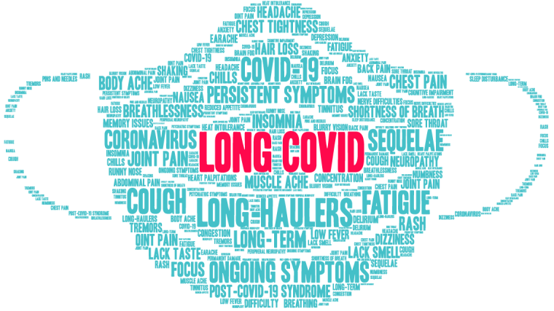
Nuffield Department of Primary Care Health Sciences (2021)

The following guidance is to help managers when dealing with employees who are suffering from the effects of long COVID, what the risks are if not dealt with properly and what can managers do to provide support when employees return to work.

What is long COVID?

- The definition of long COVID (NICE, 2021) is ‘’signs and symptoms that develop during or following an infection consistent with COVID-19 which continue for more than 12 weeks and are not explained by an alternative diagnosis’’.
- With long COVID, an estimated one in five people will ‘’experience symptoms lasting between 5 and 12 weeks’’ (CIPD, 2022).
- An estimated one in ten will ‘’experience symptoms after 12 weeks or longer’’ (CIPD, 2022).

- Symptoms aren’t always the same for everyone and can flare up when least expected. Even after periods of time where an individual feels well they can suddenly relapse, leaving them struggling to perform simple tasks (CIPD, 2022).
- During each relapse the symptoms may vary (CIPD, 2022).
- It has been proven that ‘’85% of people with long COVID report that their symptoms had deteriorated after a period of improvement’’ (CIPD, 2022). The link between the causes of symptoms to reappear resulting in a relapse are unclear, however can happen due to ‘’physical activity, mental activity, stress, heat and alcohol’’ (CIPD, 2022). With some, there is no clear trigger for a relapse to happen.
- People of all ages can suffer from the symptoms of long COVID ‘’regardless of underlying health conditions’’ (CIPD, 2021).

Is long COVID a serious illness?

- The long-term impact that long COVID has on an individual’s health is still not clear. The most common symptoms reported are ‘’fatigue, breathing issues and cognitive dysfunction (memory loss/brain fog)’’ (CIPD, 2022).

- Make sure to follow the Sickness Absence Policy for sufferers of long COVID to ensure that they are not being treated less favourably than employees suffering from non-COVID related absences (CIPD, 2021). Usual rules for sickness pay ‘’apply when someone is off work because of long COVID’’ (acas, 2022).
- A potential risk of ignoring how employees suffering from long COVID feel on their return to work (i.e. are they ready to be back in work?) is that they will leave. If they feel unsupported by managers they’ll move to somewhere that will support them – this could mean a severe loss of workforce talent (CIPD, 2022).
- Should the duties of a post involve heavy lifting or some other kind of exertion, those employees would need to be cleared by Occupational Health before returning to work (SOM, 2021).
- A badly managed return to work meeting could result in the employee leaving and ‘’claiming unfair dismissal or discrimination’’ (CIPD, 2021).
- As a business we need to be vigilant and do everything we can to stop the spread of COVID in the workplace. Measures that would need to be in place include ‘’social distancing, ventilation, hand hygiene and shielding’’ (CIPD, 2021).
- If, following referral to Occupational Health a phased return is advised, ensure that this is put in place in order to avoid any claims in relation to disability, unfair dismissal etc. During phased return the employee will receive their normal rate of pay for contractual hours (acas, no date).
- Carefully consider whether you need to put in place a performance management or capability process (for example for persistent lateness, or if they are unable to fulfil their duties following absence and workplace adjustments have been unsuccessful) (acas, no date). However, be cautious if this route is considered.
- Carefully consider whether hybrid/home working would allow employees to fulfil their duties away from the workplace. This would decrease the possibility of a claim due to direct discrimination – an example of this would be ‘’refusing to allow a female employee with children to undertake hybrid working’’ due to the stereotype that ‘’mothers are not as productive as fathers when working at home’’ or if they are single parents (Equality and Human Rights Commission, 2021).

The risks faced when managers fail to deal with l long COVID

- Ensure awareness of relevant legal legislation:
- (Equality Act 2010) - familiarise yourself with the nine protected characteristics. This will be to avoid treating somebody who falls into (at least) one of the nine characteristics differently to others (example such as due to a medical condition which is likely to be classed as a disability) (CIPD, 2021).
- (Health and Safety at Work etc. Act 1974) - as employers we have a duty to ensure ‘’the health, safety and welfare of employees’’ (CIPD, 2021) as much as we possibly can.
- (Employment Rights Act 1996) – covers the rights of an employee not to be unfairly dismissed ‘’on ill-health grounds’’ (CIPD, 2021).
- (Working Time Regulations 1998) – provides information on ‘’the minimum conditions relating to weekly working time, rest entitlements and annual leave in the UK’’ (CIPD, 2021). Although employees are able to ‘opt-out’ of a ‘maximum’ 48 contracted hours per week, the UK’s legal position is that employers should protect their workers’ health and safety ‘’which includes protecting their workers from overwork and consistently long hours’’ (CIPD, 2021). For example, employees who work and send e-mails outside the normal working hours of the business ‘’can encourage a long-hours culture’’ (CIPD, 2021). As a business we do not encourage this kind of working practice from our employees as we want to promote a healthy work-life balance.
- There is a possibility that employees who are suffering from long COVID may be classed as being disabled, however there has yet to be a case where it’s been tested at court (CIPD, 2021).
- If an employee has an existing medical condition (such as asthma) and also suffers from long COVID, the symptoms are likely to be more severe. In this case they will more than likely be defined as disabled under the Equality Act 2010 (CIPD, 2021).
- Research has found that long COVID will affect some people in society worse than others. These include:
- Older people
- Ethnic minorities
- Women
‘’Employers must avoid discriminating by age, disability, race or sex’’ (acas, 2022).

- Make sure to follow the Sickness Absence Policy for sufferers of long COVID to ensure that they are not being treated less favourably than employees suffering from non-COVID related absences (CIPD, 2021). Usual rules for sickness pay ‘’apply when someone is off work because of long COVID’’ (acas, 2022).
- A potential risk of ignoring how employees suffering from long COVID feel on their return to work (i.e. are they ready to be back in work?) is that they will leave. If they feel unsupported by managers they’ll move to somewhere that will support them – this could mean a severe loss of workforce talent (CIPD, 2022).
- Should the duties of a post involve heavy lifting or some other kind of exertion, those employees would need to be cleared by Occupational Health before returning to work (SOM, 2021).
- A badly managed return to work meeting could result in the employee leaving and ‘’claiming unfair dismissal or discrimination’’ (CIPD, 2021).
- As a business we need to be vigilant and do everything we can to stop the spread of COVID in the workplace. Measures that would need to be in place include ‘’social distancing, ventilation, hand hygiene and shielding’’ (CIPD, 2021).
- If, following referral to Occupational Health a phased return is advised, ensure that this is put in place in order to avoid any claims in relation to disability, unfair dismissal etc. During phased return the employee will receive their normal rate of pay for contractual hours (acas, no date).
- Carefully consider whether you need to put in place a performance management or capability process (for example for persistent lateness, or if they are unable to fulfil their duties following absence and workplace adjustments have been unsuccessful) (acas, no date). However, be cautious if this route is considered.
- Carefully consider whether hybrid/home working would allow employees to fulfil their duties away from the workplace. This would decrease the possibility of a claim due to direct discrimination – an example of this would be ‘’refusing to allow a female employee with children to undertake hybrid working’’ due to the stereotype that ‘’mothers are not as productive as fathers when working at home’’ or if they are single parents (Equality and Human Rights Commission, 2021).

- Request medical advice from Occupational Health – they would be able to advise on workplace adjustments and whether a phased return is needed.
- Any adjustments to workload should be on a case-by-case basis – e.g. if the employee is operating heavy machinery are they safe to do so on their return?
- Encourage open and honest conversations between yourself and staff you line manage – if you don’t, they will hide how they truly feel and this could lead to further periods of absence (CIPD, 2022).
- A return to work meeting shouldn’t be a ‘one-off event’ – organise catch-up meetings with employees to discuss how the return to work is coming along and whether there’s anything you can do to alleviate any issues that have arisen following their return.
- Depending on job role, managers could discuss home or hybrid working with employees – this would significantly decrease commuting times and increase ‘’the flexibility of working hours’’ (CIPD, 2022).
- Providing employees with contact details for counselling services can give them the tools to deal with their symptoms and increases the chances of them remaining in work following long-term absences (CIPD, 2021).
- Ask whether the addition of additional breaks, altered tasks or workload or ‘buddying up’ with a colleague will help the employee on their return to work (SOM, 2021).
- Before allowing an employee suffering with long COVID back into the workplace it is good practice to undertake a ‘’COVID risk assessment’’. As employers we would look to minimise the risk of further infection on their return (CIPD, 2021).
Support that managers can give

- Managers should keep in mind the fact that, for some individuals, a return to work can help with their recovery. By focusing their minds on work and ensuring that they avoid potential financial hardship by being on long-term sickness can help improve their mental health and wellbeing (CIPD, 2022).
- Providing support to employees who are suffering from long COVID can result in huge benefits not only to them as individuals, but how the organisation is seen to treat its staff (CIPD, 2022).
- Show kindness – remember that the uncertainty of suffering from long COVID can have a massive impact on employee mental health (CIPD, 2022).
- Remember that as line managers you are ‘’often the employee’s first contact point’’ (CIPD, 2021) and are able to influence how employees feel on their return to work and whether the workload pressure is too much.
- Keep the lines of communication open whilst employees are absent from work – it will help them feel valued and could ensure a smoother transition back into the workplace (CIPD, 2021).
- Whilst an employee is absent ensure that their work has been distributed amongst colleagues to alleviate workload stress on their return (acas, 2022).
- Do not share details of their absence with colleagues without the employee’s consent – it is up to them how much details of their illness they would like to share (acas, 2022).
- Ensure that employees don’t feel like they are being rushed back to work – have you thought about suitable adjustments to workload? Have you undertaken a return to work meeting with the employee? Have you discussed a phased return to work? (CIPD, 2022)

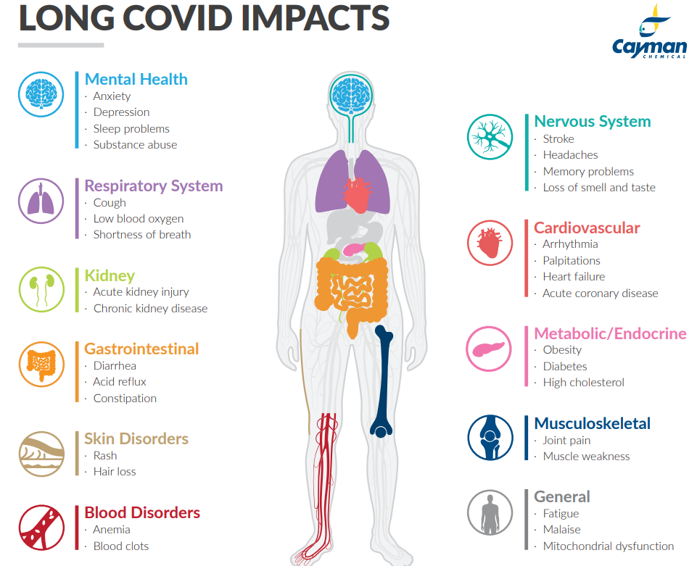

Cayman Chemicals (2021)

REFERENCE LIST

- acas (no date) Absence from work. Available at: https://www.acas.org.uk/absence-from-work/returning-to-work-after-absence (Accessed: 12 February 2022).

- acas (no date) Capability procedures. Available at: https://www.acas.org.uk/capability-procedures (Accessed: 12 February 2022).

- acas (2022) Long COVID – advice for employers and employees: sickness and absence because of long COVID. Available at: https://www.acas.org.uk/long-covid (Accessed: 12 February 2022).

- acas (2022) Long COVID – advice for employers and employees: whether long COVID is treated as a disability. Available at: https://www.acas.org.uk/long-covid/whether-long-covid-is-treated-as-a-disability (Accessed: 12 February 2022).

- Cayman Chemicals (2021) In It for the Long Haul: Research Tools for Long COVID Syndrome. Available at: https://www.caymanchem.com/news/research-tools-for-long-covid-syndrome (Accessed: 13 February 2022).

- CIPD (2021) Long COVID FAQ’s. Available at: https://www.cipd.co.uk/knowledge/coronavirus/faqs/long-covid (Accessed: 11 February 2022).

- CIPD (2021) Managing a return to work after long-term absence – Guidance for line managers. Available at: https://www.cipd.co.uk/Images/line-manager-guide-managing-return-to-work-after-long-term-absence_tcm18-97859.pdf (Accessed: 10 February 2022).

- CIPD (2021) Working hours and time off work. Available at: https://www.cipd.co.uk/knowledge/fundamentals/emp-law/working-time/factsheet (Accessed: 12 February 2022).

- CIPD (2022) Working with Long COVID – Research evidence to inform support. Available at: file:///C:/Users/danield/Downloads/long-covid-report-feb-22_tcm18-106089.pdf (Accessed: 10 February 2022).

- Employment Rights Act 1996, c. 1. Available at: https://www.legislation.gov.uk/ukpga/1996/18/part/X/chapter/I (Accessed: 11 February 2022).

- Equality Act 2010, c. 1. Available at: https://www.legislation.gov.uk/ukpga/2010/15/part/2/chapter/1 (Accessed: 11 February 2022).

- Equality and Human Rights Commission (2021) Coronavirus (COVID-19) guidance for employers. Available at: https://www.equalityhumanrights.com/en/advice-and-guidance/coronavirus-covid-19-guidance-employers (Accessed: 12 February 2022).

- Health and Safety at Work etc. Act 1974, s. 37. Available at: https://www.legislation.gov.uk/ukpga/1974/37/section/37 (Accessed: 11 February 2022).

- NICE (2021) COVID-19 rapid guideline: managing the long-term effects of COVID-19. Available at: https://www.nice.org.uk/guidance/ng188 (Accessed: 10 February 2022).

- Nuffield Department of Primary Care Health Sciences (2021). Available at: https://www.phc.ox.ac.uk/news/new-research-to-explore-family-experiences-of-long-covid (Accessed: 13 February 2022).

- Supporting Occupational Health and Wellbeing Professionals (SOM) (2021) COVID-19 Return to Work Guide – For Recovering Workers. Available at: https://www.som.org.uk/COVID-19_return_to_work_guide_for_recovering_workers.pdf (Accessed: 11 February 2022).

- Working Time Regulations 1998, s. 4. Available at: https://www.legislation.gov.uk/uksi/1998/1833/regulation/4 (Accessed: 11 February 2022).

