COURSEWORK (INNOVATIVE PRODUCT PLAN)

STUDENT NAME | SADIA ANJUM
STUDENT NUMBER | 1708775
MODULE NUMBER | BMSK6002
MODULE TITLE | DEVELOPING INNOVATION AND CREATIVITY FOR BUSINESS ADVANTAGE
LECTURER | DR MD NAZMUL HASAN
LEARNER GROUP | 1

Task 1:
Product proposition
COVID-19 crisis has changed the whole dynamic of this world today. It has impacted every aspect of our lives, our social life, workplace and businesses, some are short term and some are long term impacts. Everyone is struggling during this pandemic and lockdown period, financially, socially, mentally, etc. A lot of people are struggling to do their day to day activities such as: shopping, cleaning house, gardening, repairing things. A lot of people who were affected by the virus find it difficult to regain the physical and emotional strength needed to return to their average, day to day life, especially as the recovery time for this particular virus can vary from a few weeks to a few months. During this lockdown period, the option for delivery is extremely rare for supermarkets. Some people feel anxious to go out and do shopping, groceries or other, non-essential, tasks. As most small businesses are closed, people are struggling to find proper, reliable services for gas and electric repairing, plumbing, car repairing, etc. Even though all these services are available separately, it takes a lot of time and efforts to find a reliable provider. It is difficult for a lot of people, especially the older generation, to use the internet to search and get the right services.
On the other hand, in this current situation, a lot of people are struggling to keep their jobs or have already lost their jobs. A lot of small organisations have been forced to close down, as a result of this, more people are unemployed. Even though the government is helping as much as they can, people are still finding themselves struggling financially.
My innovation idea is an app, which can be downloaded on any smart devices such as: phone, laptop, tablet, computer, etc. for free. You can choose services through this app. The provided services will be:
- Cleaning the house
- Gardening
- Personal shopper
- Grocery shopping
- Gas and electric repair
- Plumbing
It will be a collaboration with other businesses, such as Uber-eat, Just-eat, etc. We will find the perfect person (DRB checked, with the right knowledge and qualification and equipment, full PPE) to provide the desired services to the customers. Our services can be personalised. For example, for grocery shopping, some people can have special dietary requirements, such as: halal, kosher, vegan, vegetarian, dairy-free, etc. we will get their required groceries from their preferred shops. Another example, for gardening: some people want to plant vegetables while others prefer flowers. So we will send specialised gardeners for their desired services.
The type of innovation
Market-orientated innovations identify the needs and desires of consumers and create products and services accordingly, to satisfy those needs and desires (Jaworski and Kohli, 1993). Market-orientated businesses consider the opinions and needs of their target market as a critical component of their research and development (R&D). They use their resources and capabilities effectively to ensure sustainable competitive advantage for the business (Lado, Maydeu‐Olivares and Rivera, 1998). This app is a market-oriented innovation.
This business idea combines internal and external product/services into one and involvement of external channels can generate additional value (Chesbrough, Vanhaverbeke and West, 2006). In my opinion, ours is an open innovation.
Customers
Anyone above the age of 18 with a PayPal account or a credit card can be a customer of this app. The consumers can order services for themselves or their friends and family. We will start off by providing our services in some big cities and their surrounding areas, such as: Birmingham, London, Manchester, Liverpool, Bradford, etc. But our aim is to extend our domain to the whole of the UK.
Service providers can also register with us through the app to offer their services, such as: CORGI registered gas engineers, NICEIC registered electricians, CRB checked cleaners and gardeners, etc.
Where and how to sell it
It will be free to download from any android play store. The consumers will only pay for the desired services at fixed prices. The service providers will get a fixed sum of money per job. We will keep a minimum of 30% from that payment. All financial transactions will be through PayPal and credit or debit card.

Name and significance of the name
I want to name the app “Virtual Personal Assistant” or “VPA”. For people to get services through this app, all they have to do is place an order. Like a personal assistant or PA, we will act as a first point of contact. We will deal with the correspondence and phone calls. We will book the services at our customer’s convenient time and we will ensure to find the most qualified person to provide the desired service.
Our competitors
Our competitors are all the local Cleaning Services, Maid Services, Uber-Eat, Just-Eat, Gas engineers, electricians, professional gardeners, Plumbers etc. even though, they are our competitors, they are our collaborators too. They can get jobs through us as we can connect them with the customers.
How to sustain the business proposition
There are a lot of individual service providers available but we are providing a few services with one app. We aim to gradually add more services to the list, such as:
- Car repairing and cleaning
- Bulky waste collection
- Carpet cleaning
- Indoor and outdoor painting, etc.
We will provide good quality and safety assurance for each service. We are fully responsible for customer satisfaction.
We will regularly update the app by adding new amenities according to customer demand and expand our service area. We will constantly make improvements according to user feedback.

Task 2:
Developing the app
Building the initial app and making it available across all platforms will require at least 6 weeks of development work by one full-time software developer. Ongoing maintenance will require approximately a week’s worth of work every month. Followings are some steps taken to create an app:
- Develop a prototype of the app to see if its meets our requirements
- Make the app’s graphic design to make it visually attractive
- Build the app landing page which explains what the app does, whom it is for and how it is helpful
- Make the app with Xcode and Swift
- Launch the app in the App Store
- Market the app to reach the right people
- Update and improve the app with user feedback (de Vries, 2020).
There are lots of app builders available to develop a new app, such as:
- AppyPie
- AppSheet
- Yapp
- AppYourself, etc.
E-commerce
The app would have to be available on mobile platforms, i.e. on Android and iOS, since that is the biggest platform to reach users. However, it is crucial to also have a presence on the web, so that users can reach our services via search-engines such as Google, Bing, etc. Therefore, building a web-app is the best way to have the biggest reach across all platforms. Once built, the app will require ongoing improvement and maintenance.
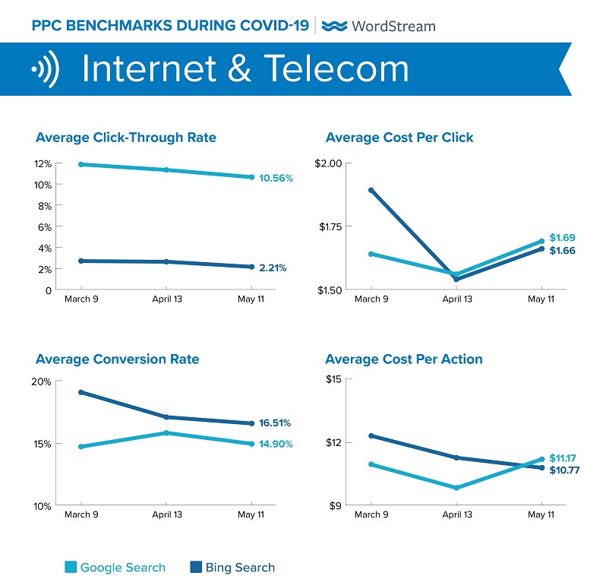
Figure: 1
According to the data in Figure 1, the Click Through Rate is high on Google, while the Conversion Rate is higher on Bing. It is therefore necessary to put ads on both search engines (Shewan, 2020).

Payment service:
PayPal: PayPal is one of the best option as a money transaction platform for any business in the UK. So we are choosing PayPal to get paid, either by invoicing the customers or taking payment online via our website or app. To use PayPal to take payments for businesses, there are fees. The fee varies depending on how the businesses want to use PayPal, and the volume and type of payments they are receiving. From our research, we expect our PayPal fee to be a flat payment of £2.00 for each business transaction (How to get paid through PayPal, 2020).
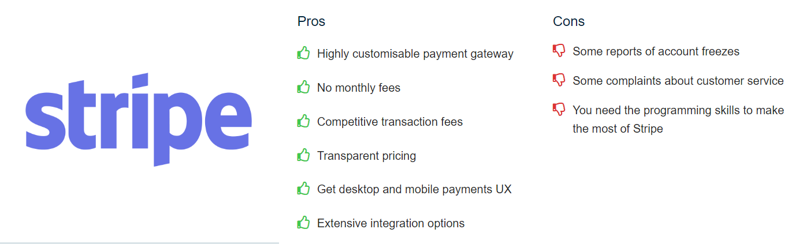

Source: stripe.com
Figure 3

Debit/ Credit card payment: To run our ecommerce business, we will need to have an internet merchant number and a secure payment page. On this page the consumers can provide their card details to make payments. We will use a Payment Service Provider (PSP) to provide this service for our business. PSPs usually charge both a set-up fee and a per transaction fee. In my opinion, the most suitable PSPs for our business are Amazon pay and Stipe. The pros and cons of these two PSPs are in Figure 3 and Figure 4 (Merchant Savvy, 2020).
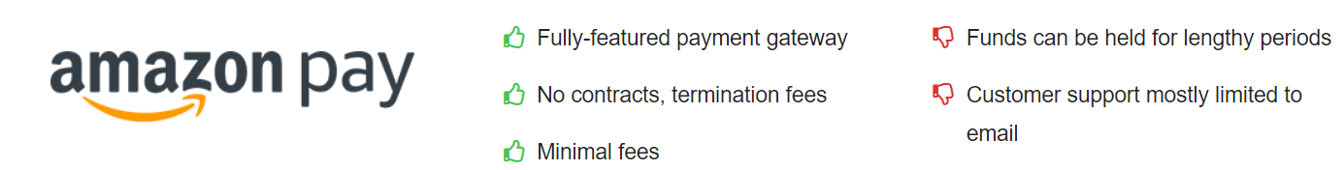Source: pay.amazon.com
Figure 4

To prevent forgery, we will add Verified by Visa or MasterCard Secure Code to our security measures. Our website will clearly state that our payment process is completely secured so that people can use our app without any concern (www.startupdonut.co.uk, 2020).

GDPR compliant
The General Data Protection Regulation, abbreviated as GDPR, which is the new European data protection legislation that enters into force on 25th May 2018 (Yuan and Li, 2019). When we are developing the app, we have to make sure our app is GDPR (General Data Protection Regulation) complaint. Personal data is information that relates to an identified or identifiable natural person, an identifiable person is one who can be identifies directly or indirectly, in particular by reference by an identifier such as, name, an identification number, location data, an IP address or a cookie identifier, or other factors. What identifies an individual could be as simple as a name or a number or could include other identifiers such as an IP address or a cookie identifier, or other factors (Denley, Foulsham and Hitchen, 2019). For our website and app, we have to consider how to collect and store personal identifying details such as names and email addresses, but also consider things such as users’ IP addresses and device IDs (unique IDs that devices share with external SDKs for ads and analytics). We will need to explore ideas about how to obtain, transfer, store, and handle our user data. We will have to ensure data security for our users, and we will constantly work on ways to improve this in order to have a GDPR compliant app.
- Be alert about privacy even before designing the app
- Ask for Explicit Consent
- Providing visibility and transparency
- Respond to user requests
- Respect user’s Right to Be Forgotten
- Review services and SDKs used
- Data Breach Notifications
- Take guidance of a Data Protection Officer
- Log and Justify the Data Collection (2017)

Task 3:
Marketing:
Exchange is the indispensable link between the problems we face and the solutions to those problems. The act of exchange is the consummation and confirmation of the marketing process, and brings the marketing concept to life (Anderson, Challagalla, and McFarland, 1999). Marketing is essential for the success of a business. As our app is new to the market, we will need to have a marketing strategy ready before launching the app, pre-launch strategies, launching strategies and marketing strategies. We have to focus on product lifecycle while preplanning these strategies.
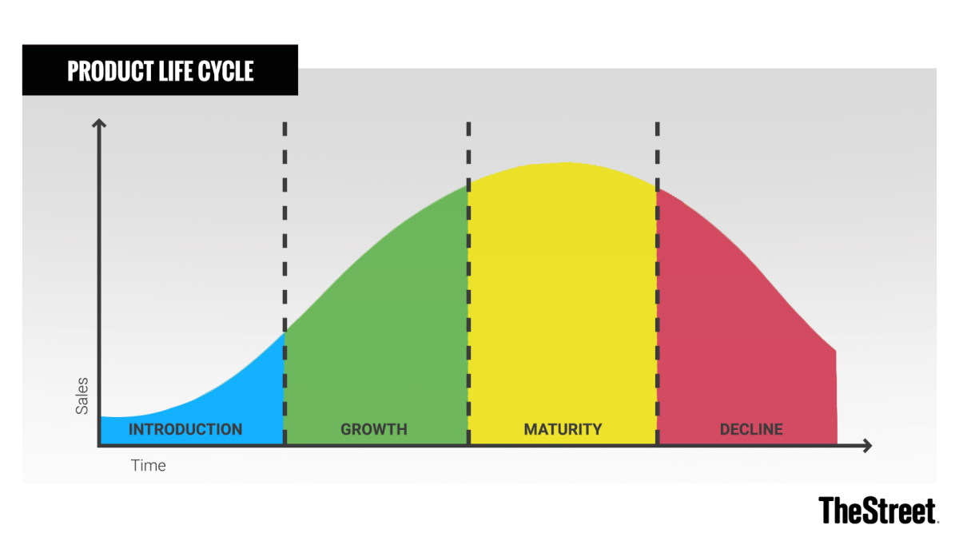
[Source: thestreet,com]
Figure: 2

Preparing to Launch the app
Generally, the lifecycles of successful products and services are described by the pattern illustrated by Figure 2. Important policies and practises for the product/services can be generated from this concept. For a business who is about to launch a new product, the life cycle concept can be proven to be extremely valuable (Levitt, 1965). The aim of preplanning and having strategies in place is to extend, or stretch out, the life of the product. Planning in advance before launching a new product can enable a business to take specific actions in different stages of the life cycle. These actions can lead to sustaining its growth and profitability, which appears to have great potential as a tool of long-term product strategy (Susterova, Lavin and Riives, 2012).
Pre-launch strategy:
There are some steps we can take as pre-launch strategy:
- Perform research on target market and the competitors
- Create an unique landing page for the app which displays all the key elements of the app
- Create viral promo video focusing on the best features of the app
- Start a blog about the app (Sandberg and Rollins, 2013).
Special offers:
We will offer some special prices from time to time to keep the customers coming, such as: introductory discount offer, multi-service discounts, introduce friends, etc.
Promotional channels online:
Word-of-mouth: Even though word of mouth is a very basic way of promoting, it is a low cost, low scale (start off with low scale but has potential to be higher), high return on investment (ROI) marketing channel. It can start off by friends and family and has the potential to spread out to a whole country. Word-of-mouth can be through social media like Facebook. Instagram, twitter, etc. (Lu, Ba, Huang and Feng, 2013).
Social media platform: I will use social media platform to promote my app, such as: Facebook advertising, Facebook messenger advertising, YouTube ads, etc. Social media marketing is a great way to spread the word and connect with potential customers. To make the social media marketing successful, the content needs to be engaging, educating and entertaining. Researching trending hashtags, engaging with consumers, and analysing performance can be time consuming, but social media can become one of the most successful marketing channel if done properly. Social media marketing is a medium-high cost, high scale and medium-high return on investment (ROI) marketing channel (Tuten, 2020).
Search engine marketing: Search engine marketing (SEM) is the practice of marketing a business using paid advertisements that appear on search engine results pages. This is available with Bing, Google and Apple. For my app, I will use Google and Bing. The greatest advantage SEM offers is the opportunity to present the ads to the motivated consumers who are ready to purchase at the precise moment (Search Engine Marketing (SEM): How to Do It Right | WordStream, 2020). SEM is a low-medium cost, low-medium scale, medium-high ROI marketing channel.
Email marketing: For email marketing, the customers must actively sign up in order to be added to marketing email campaign which shows that they are interested in the product. We will be pulling emails from our own contacts, signing users up from our website or acquiring them through an email ad campaign on Facebook or Twitter and thus build up an email list. As our app gets more positive feedback and more popularity, our email list will keep growing. We will put attractive offers on the emails to compel the customers to open the emails and not discard it. Email marketing is a medium cost, low-medium scale, high ROI channel of marketing.
Target customers:
Anyone with a PayPal account or whoever owns a debit or credit card is my potential customer. We have kept the age limit to 18 for this app. Because in the UK, under 18s are not allowed to own credit cards or have a PayPal account.
We will provide personalised services for people from any cultural background and any religion. From our app, people can order services for themselves and for others. For example: if an elderly couple is living on their own and they are not very digitally literate but they need someone to fix their boiler. The couple’s children or any friend or family member or even neighbours can order the service for them and we can send a CORGI registered gas engineer to them to fix the boiler. During this pandemic and lockdown period, people can help their friends and family members who are affected by this virus without actually physically doing anything or breaking any rules and regulations, through our app.

Reference list:
- Anderson, W., Challagalla, G. and McFarland, R., 1999. Anatomy of Exchange. Journal of Marketing Theory and Practice, [online] 7(4), pp.13-14. Available at: <https://www-jstor-org.ezproxy.uwtsd.ac.uk/stable/23232696?seq=7#metadata_info_tab_contents> [Accessed 10 November 2020].
- Chesbrough, H., Vanhaverbeke, W. and West, J., 2006. Open Innovation. 1st ed. Oxford: Oxford University Press, pp.1-2.
- Denley, A., Foulsham, M. and Hitchen, B. (2019). GDPR : how to achieve and maintain compliance. Abingdon, Oxon ; New York, Ny: Routledge.
- de Vries, R. (2020). How To Make An App. App Development. Available at: https://learnappmaking.com/how-to-make-an-app/#mockups [Accessed 13 Nov. 2020].
- Jaworski, B. and Kohli, A., 1993. Market Orientation: Antecedents and Consequences. Journal of Marketing, 57(3), p.53.
- Lado, N., Maydeu‐Olivares, A. and Rivera, J., 1998. Measuring market orientation in several populations. European Journal of Marketing, 32(1/2), pp.23-39.
- Levitt, T., 1965. Exploit the Product Life Cycle. Harvard Business Review, [online] pp.8-9. Available at: <http://marketch.cloud/pdf/Exploit_the_Product_Life_Cycle.pdf> [Accessed 10 November 2020].
- Lu, X., Ba, S., Huang, L. and Feng, Y., 2013. Promotional Marketing or Word-of-Mouth? Evidence from Online Restaurant Reviews. SSRN Electronic Journal, 24(3).
- Merchant Savvy. (n.d.). Best 12 Payment Gateways For UK Businesses. [online] Available at: https://www.merchantsavvy.co.uk/payment-gateways/.
- Sandberg, R. and Rollins, M., 2013. The Business Of Android Apps Development. 1st ed. New York: Business Media New York.
- Shewan, D., 2020. How Much Does Google Ads Cost? [2020]. [online] Wordstream.com. Available at: <https://www.wordstream.com/blog/ws/2015/05/21/how-much-does-adwords-cost> [Accessed 9 November 2020].
- Susterova, M., Lavin, J. and Riives, J., 2012. RISK MANAGEMENT IN PRODUCT DEVELOPMENT PROCESS. DAAAM International, [online] 23(1). Available at: <https://www.daaam.info/Downloads/Pdfs/proceedings/proceedings_2012/0225_Susterovaatal.pdf> [Accessed 10 November 2020].
- Transfer Wise, 2020. How to get paid through PayPal. Available at: <https://transferwise.com/gb/blog/how-to-get-paid-through-paypal-uk> [Accessed 11 November 2020].
- Tuten, T., 2020. Social Media Marketing. 4th ed. London: SAGE Publications Ltd, pp.109-125.
- Wordstream.com. 2020. Search Engine Marketing (SEM): How To Do It Right | Wordstream. [online] Available at: <https://www.wordstream.com/search-engine-marketing> [Accessed 10 November 2020].
- www.startupdonut.co.uk. (2020). How to take payments. [online] Available at: https://www.startupdonut.co.uk/financing-a-business/cash-flow/how-to-take-payments [Accessed 12 Nov. 2020].
- Yuan, B. and Li, J. (2019). The Policy Effect of the General Data Protection Regulation (GDPR) on the Digital Public Health Sector in the European Union: An Empirical Investigation. International Journal of Environmental Research and Public Health, [online] 16(6), p.1070. Available at: https://www.mdpi.com/1660-4601/16/6/1070 [Accessed 10 Oct. 2019].
- (2017). Privacy and data protection in mobile applications. [online] www.enisa.europa.eu. ENISA. Available at: file:///C:/Users/home/Downloads/WP2017%20O-2-2-4%20GDPR%20Mobile.pdf [Accessed 13 Nov. 2020].

