

Linda`s Cuddles Bowtique
Business Plan

University of Wales Trinity Saint David
MODULE CODE: BMSW4006
MANAGING ENTERPRISE IN THE 21ST CENTURY
Tutor: Yajesh Kumar

Group.
Priscila Benicchio Nichida 1906406 Team Leader
Gladys Adomako 1905509
Victorine Azonga 1908938
Bernard Agbenyegah 1908933
Isaiah Ojo 1907284

Cover Letter

Linda`s Cuddles bowtique
Priscila Nichida, owner/Designer
357 Chancery Road
Notthing Hill Gate
W11 5ht
11 May 2020

Wimbledon College of Arts
Professor David Crow (head of College)
Merton Hall RD, London
Sw19 3qa

Dear Mr. Crow.

I am pleased to provide the Business Plan for Linda`s Cuddles Bowtique.
Enclosed you will find a considerable amount of information about my business, a thorough assessment of all opportunities that we can find in the marketplace as a detailed plan for laying hold of them. I look forward to work with you and have you as partner transforming Linda`s Coddles Bowtique a even greater success in the coming time.
I am willing to hear from you; answer any doubt or question you may have and eager to hear your comments.
You can contact me by phone (44) 07871491864 or email prinichida@hotmail.com

Thank you for your attention

Yours sincerely,

Priscila Nichida.

Linda`s Cuddles Bowtique
Executive summary

The Business is all about unique accessories. Handmade, designed and crafted special accessories to give a finish touch for our special garments and making every moment unique.
Children clothes and accessories are our speciality however we work with some accessories for all family.
We have excellence in personalised handmade accessories. So, to make sure all family leaves happy we got some special touch for the beloved pets. Everyone can match.

Nowadays everyone wants to have something made especially for them, not only a simple letter but everything unique making almost impossible to find. As the Internet market is something that is growing very fast and present all over the world, families starts so becoming the most probably used models to sell not only products but a dream of a perfect and happy family. They want to show perfection exclusive items and perfect combination of styles something difficult to find in one place.
Not only Families as girls and their pets brothers and sisters and even the influencers all of them wants to be unique and show to the world they are the difference so everyone feels they want to be unique as well.
Some web stores he started to create a personalised session but only on simple things as colours and letters. How can a store have enough people and time to deal with customers without having to charge so much for the product? There is no way to be affordable for some families.

Our service got a big differential, we like to treat each one in their special way, everyone is unique. Unique people deserves are unique touch, we have some types of accessory's already done so the client can have an idea of what he can get, if he decides to change the colour, beads, fabric or letters we can do it. We even can create something completely out of scratch for this special treatment request I special designer which we got. The clients can choose a variety of clothes jewellery's and shoes for the little ones and accessories for the rest of the family. we got since everyday accessories to a special occasion. If you are looking to surprise and make the biggest impression on a special date, I am sure you can count on us, we can transform your dream accessory in reality.

As a strategy we are using different types of material to show that everything is possible with recycle materials from industries an even using the small pieces which used to go in the rubbish we can do incredible and stylish products. Sustainable materials helping the world to help us. Not only ribbons and laces but creativity and love with this everything is possible. Being part of a great partnership, it is a key for the success as if one designer is good imagine a group of artists working together. As a business we want to grow and sell everywhere in the world, as people we want to give freedom to imaginative persons create and show their talents. Probably we can see this business getting incredible proportions in less than a year choosing the right families to take part over grand opening. Internet makes they spread of the news as fast you can probably imagine.

In terms of money we are not much worried but looking forward to finding designer's which can meet our requirements of creative and comfortable matters and where is more convenient then a college full of imaginative and amazing artists.
Table of Content

- Cover Letter

- Executive summary

- Business Description and history

- products and service

- market analysis and trends

- operations

- technology plan

- management an organisation

- social responsibility and sustainability

- development, milestones, an exit plan

- financial data

- appendix

Business History

“A business owner who fails to plan, plans to fail.” (Covello & Hazelgren, 1995,p.2)
The business came from a simple idea starting from the transformation of a woman to become a mother. When my daughter born, I started should look around trying to find the perfect accessories but in vain. My expectations failed when I only found all these simple and not great mellow headbands. Intrigued With this situation I decide to use the materials I found in my house and start to create my own Delicate and unique gorgeous accessories for my new-born baby. Whenever I went with my daughter Linda everyone was amazed by her accessory's asking me where I bought from and every time, I say I create them someone always asked me why would not sell. So, the idea started to become a reality.

Business Structure

I started sole proprietorship And the work he started to flow very well beginning the sales for close friends and soon enough in less than six months I already started to filled up my own clients list, having even to create a waiting list because the orders were piling up as only one designer (my own ) was working, buying materials, creating, producing and leaving everything ready to dispatch. Leaving complicated to expand the business by myself.
Beginning the advertisement mouth to mouth going through opening a Facebook, Facebook page, Instagram and WhatsApp business. Since this growing everyday more.

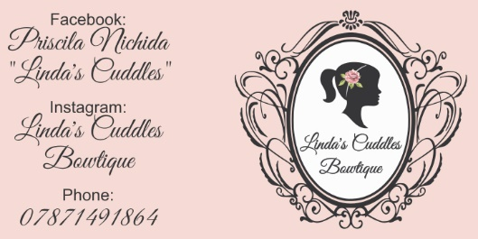

Products and services

Handmade products with great material and all made as the client wish, details since colour, embellishments, model the client can choose between headbands, Barrett, clips, elastic and many other materials. Only the best quality of services and infinity types of materials.
In our business we are always looking for new creations and materials to introduce the most especial and unique finished product to each and every customer. Satisfaction and extraordinary finish are essential, we are always looking for delivering the best and making the dream come true.

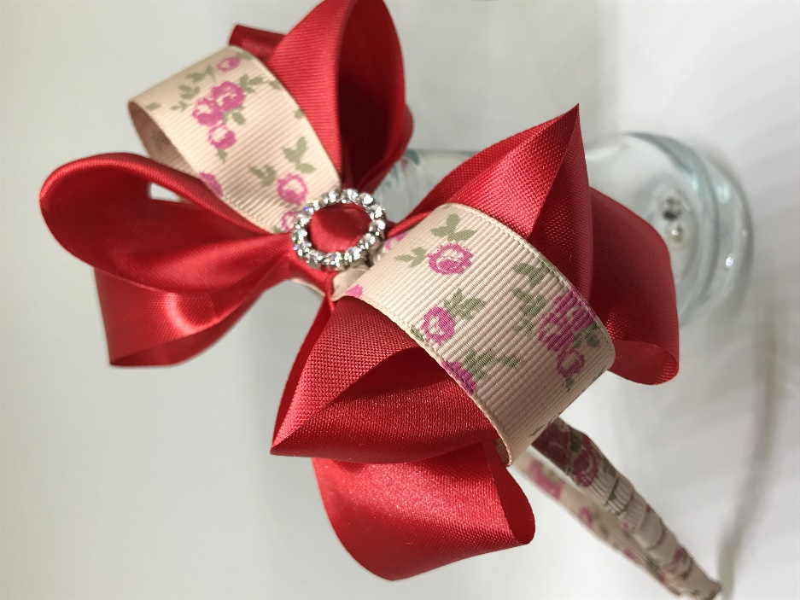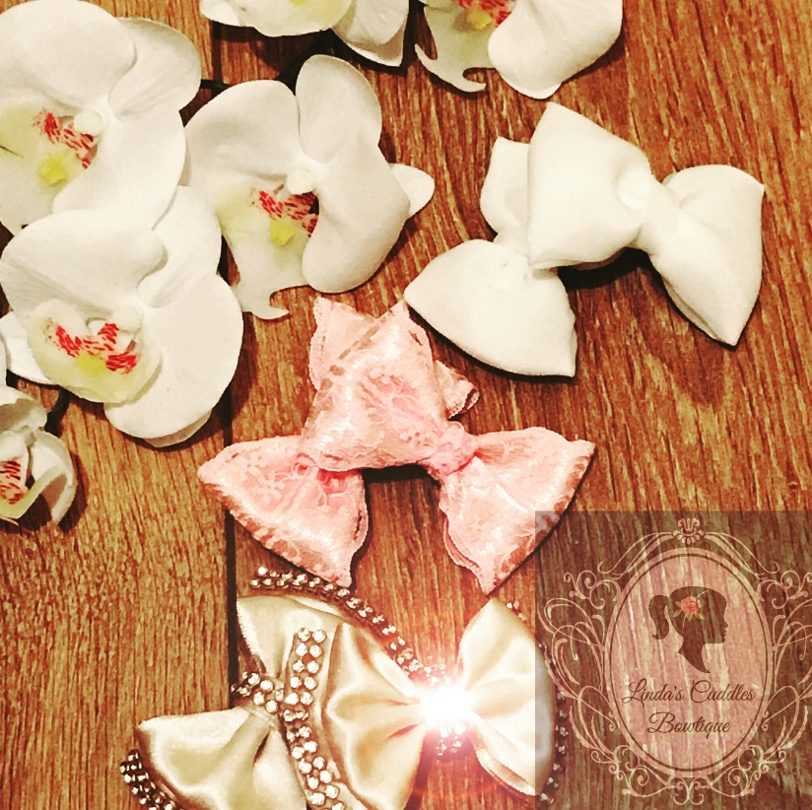

When Local we use the method of courier delivery, if further away the method used is always first-class delivery with Royal mail. The parcels are well packed making sure the products will arrive safely and in time for best serve you.

Marketing and Analyses Trend

Our market to team worked hard to analyse the best clients in our niche we discovered that London it is the best place to start and consolidate our business. We can find the perfect and well-structured families and the most important families who likes fashion, unique items and quality.
We can see the picture of perfection on the most important family of this country, the Royals.
In London we can find all sorts of trends, we can take from start the most important event which is London Fashion Week which happens twice a year and becomes the economy most important event of fashion, the best designs an amazing brands come all together creating the new and most follow it trends in all over the world.
If we merge fashion and family, we are always going to find the same answer The Royal family. heaven in mind all this information and knowing the capacity of our brands we could not be happier to launch and consolidate in a better place.

Operations

Heaven in mind we are still a small business, we passed from have a space of a sofa to now have a space of a studio in our own house. For now, it is convenient as we do not need to pay extras becoming easy to maintain and always to be around.
Unfortunately, at this moment it is hard to find the materials I like to use as normally I need to bring from Brazil leaving the expensive away to buy them. In London I could find most of the materials on local stores making the prices elevate so I am using them for now unto I could find a cheaper but still good quality products. It's not impossible to find better manufacturing suppliers but as one person doing most of the work is getting quite difficult to find the time to manage this issue nevertheless even buying the materials if a higher price I can still get approximately 60% Profit.
At the moment I have been using customers satisfaction feedback as a primordial base for my quality control and his working perfectly every day, new clients are coming and make part of our client list. As discussed, before we use a motor service to deliver inside London area making express and safe delivers with a great satisfaction from clients. The clients further we are always using The Royal Mail not leaving any clients disappointed incontrare the package and delivery is always on time, clients are happy giving amazing feedbacks and bringing more clients.

Financial plan for Linda’s Boutique
Content plan
Overview Start costs and projections Profits and loss forecast Cash flow forecast Balance sheet forecast & Financial ratio explained Financial ratios Conclusion References
Overview
In this financial plan we will examine and evaluate “Linda’s Boutique” in Wimbledon a for profit organisation. The product they provide ranges from Haute couture style shoes to cloth for custom-fitted children and women’s suites and dresses, to handmade jewellery and hair accessories. This all needs to be taken into consideration when designing an appropriate full financial plan. As they only have 1 employee it is a great example to demonstrate how the business set-up, explain their capital and cash and analyse future balance sheet and based on this to generate their financial ratio figures. This will improve stability and profits of the business. (Arkebauer and Miller, 1999)
Start costs and projections
The initial investment for starting operations was provided by the owner Linda. Her plan was to form a private limited liability company by setting a budget of £25 000 of her own life savings for location and initial materials needed, such as stationery, cloth for custom fitted Haute couture style fashion, jewellery etc. The location of Linda’s Boutique is good for its target audience, as it is near similar indie boutiques and chic cafes, which line Wimbledon Village and the area surrounding its train station. Due to its proximity to London businesses set up there, as seen in the total budget above, not much of that sum can be used for rent due to material costs and projected running costs. (Abrams, 2010)
As Linda’s business did not require her to have an office space, she could use the PC she has at home and her landline and telephone for day-today business. Her first step was to enter into a 1 year rental agreement with a letting company providing shop floor style spaces. By doing that she managed to work out a deal by paying £9000 of her initial capital upfront for her store location, meaning she would be paying £750 per month, as opposed to entering into a monthly renting agreement, which would be more expensive, at £840 in monthly instalments. This is the first sign of good initial capital investment. By committing to long term relations with a business partner you give them the security of regular cash inflow, as opposed to not knowing how much money they will make from you. That mostly leads to them trying to get as much money as they can every opportunity they can, because they have no guarantee it will not be their last. (Valentin, 2015)
Profits and loss forecast
The abovementioned £9000 of the initial investment of £25 000 will be used as the bar, as to whether or not the company broke even at the end of the year. In the report we will cover all other material costs and how they will be covered by their sales.
Running costs such as electricity, gas and water for the year are presumed to be up to £2000. This leaves £14 000 which will only be used to generate profit and break even in relation to the business yearly accommodation and running costs. (Schilit, 1990)
The products such as cloth and shoes will be provided by external contractors at a projected yearly cost of £5000, jewellery and hair accessories will be provided by university alumni or current students by paying £4000 Wimbledon College of Arts (W.C.A.). Yet more stability due to fixed cost of the supply contract with W.C.A. and possibility for work experience to students. A win- win situation for both entities in this contract. The remainder of the initial budget is for promotion and unforeseen expenses.
After supplying a venue, products and determining what their sales need to be in order to fix prices for various items. First month profit is expected to be more than £3000 due to initial promotional offers which will include free home-made lip balms and wax candle gift basket, for purchases over £50. Of course free for the customers means that £1000 needs to be invested in the “free” product of lip-balm and candles. To get the vouchers to people a further £3000 is projected for local cold calling companies to distribute leaflets and put up online advertisement. (Yescombe, 2002)
Cash flow forecast
Jan – Mar Apr – Jun Jul – Sep Oct – Dec
Sales cash inflow £9000 ~£6500 ~£6500 ~£8000
Investment £25 000
Total £34 000
Cash outflow
Electricity, Gas, Water £4500 ~£4500 ~£4500 ~£4500
Promotion £3000 ~£1000
Accommodation £9000 Prepaid Prepaid Prepaid
Tax £1500 ~£1500 ~£1500 ~£1500
Sub-contractors £9000
Total £27 000 ~£7000 ~£6000 ~£6000
Net cash flow £7000 ~ £-500 ~£500 ~£2000
~£ are approximations
All costs were presented in a simple cash flow table above, detailing how the company will and did in fact operate after the initial investment at the beginning of the year. It has shown that planning is the best way to ensure stability. The figures generated above are astoundingly accurate when compared to the balance sheet forecast below. The first 3 months are actual capital the business generated after the initial investment. We can see that an initial loss in capital was anticipated after initial hype and more money being put in than is generated. This occurred, yet it is encouraging to see the progress of projected continuous capital growth towards the end of the year, with shopping trends being what they are during holiday periods. (Yescombe, 2002)
In the following 3 month periods is where the high initial investment will result in more capital as projected and generate back the cash outflow through 2019. Minimum projected was £30 000 profit before tax.
Balance sheet forecast & Financial ratio
Below is the balance sheet. It is a declaration and overview of assets and liabilities of Linda’s Boutique. The assets and liabilities are grouped to show business activities and developments. The percentage of assets should be at least equal to liabilities in order for operations to be up and running. It shows which areas the business has spent and where they came up with a return or a loss. The balance sheet functions as a guide for investment and operation scale. (Spurga, 2004)
The figures under Cash and cash equivalents represents the sum of money which needs to be kept from the initial £25 000 for bills and running cost of the rented space, as those are not included in yearly rent price. Further down, short term investments represent the money invested in sourcing cloth material, paying external contractors to sow desired outfits from before mentioned cloths and all other products from external contractors. As it is a new business and a low risk limited investment there are no accounts receivable figures, as the business does not let itself get into debt to suppliers or external contractors due to fixed ling running costs. The inventories is similar to the short-term investment, however, it represent the money spent on Wimbledon College of Arts contract, where students provide materials for the Boutique and in exchange the boutique offers job placement programs for volunteers, this includes someone to help Linda at the beginning, as the budget does not allow for other employees to be paid apart from Linda. (Rogers and Makonnen, 2014)
Her prepaid expenses are the rent for the store which brings her assets to £20 000. £1000 went for laptops, clothes racks and shop décor under fixed assets, because the store is rented and is an on-going cost. A projected yearly cost can be seen under long-term cash investments as that provides the opportunity to start of a great business relationship with colleges and students who look to sell their work, but have not made the name for them yet so they are not able to charge premium prices. This is a projection for down the line, not the 2018 – 2019 year costs. The rest is divided for promotion and taxes on previous assets, without including revenue from sold product, like in the cash flow projection. (Barrow and Barrow, 2008)
Loans payable and current portion long-term debt is a precaution loan, for unforeseen circumstances. The sum of £5,000 is the maximum amount of loss this organisation can incur after the initial £25 000 investment. Accounts payable and accrued expenses once again are for bills, tax etc. - £2,000. Income taxes payable are a projected £6,000 on a £30 000 income before tax. The current liabilities and projected income are not equal, due to budget being designed with worst case scenario in mind. Realistically after products are sold the profit for reinvestment will be plenty to continue growing and eventually expand with more employees and eventually branches. (Barrow and Barrow, 2008)
Linda's boutique Balance Sheet For the Period
Ending 01/01/2019
Stated in 000s £
ASSETS % of ASSETS
Current assets
Cash and cash equivalents [D] 2,000 8.0%
Short-term investments 5,000 20.0%
Accounts receivable [for first year] - 0.0%
Inventories [C] 4,000 16.0%
Deferred income taxes - 0.0%
Prepaid expenses and other current assets 9,000 36.0%
Total current assets £ 20,000 80.0%
Fixed assets
Property, plant and equipment at cost 1,000 4.0%
Less accumulated depreciation - 0.0%
Total fixed assets £ 1,000 4.0%
Other assets
Long-term cash investments 4,000 16.0%
Equity investments - 0.0%
Deferred income taxes - 0.0%
Other assets - 0.0%
Total other assets £ 4,000 16.0%
Total assets £ 25,000 100.0%
LIABILITIES & OWNERS' EQUITY % of ASSETS
Current liabilities
Loans payable and current portion long-term debt
[H] 5,000 20.0%
Accounts payable and accrued expenses 2,000 8.0%
Income taxes payable 6,000 24.0%
Accrued retirement and profit-sharing contributions - 0.0%
Total current liabilities [B] £ 13,000 52.0%
Other liabilities
Long-term debt [G] - 0.0%
Accrued retirement costs - 0.0%
Deferred income taxes - 0.0%
Deferred credits and other liabilities - 0.0%
Total other liabilities £ - 0.0%
Total liabilities £ 13,000 52.0%
Total owners' equity [F] £ 12,000 48.0%
Total liabilities + owners' equity £ 25,000 100.0%
Financial ratio
One other helpful ratio to calculate is the profit margin which is calculates the ratio between net profit (£30000) and total revenue (£24000). In this case 80%
Financial ratios offer entrepreneurs a way to evaluate their company’s performance and compare it other similar businesses in their industry.
Ratios measure the relationship between two or more components of financial statements. They are used most effectively when results over several periods are compared. This allows you to follow your company’s performance over time and uncover signs of trouble. (Financial ratios–What they are and how to use them l BDC.ca, 2020)
Current ratio [A/B] 1.54
Quick ratio [(A-C)/B] 1.23
Cash ratio [D/B] 0.15
Debt-to-equity ratio [(G+H)/F] 0.42
Debt ratio [(G+H)/E] 0.20
Conclusion
The financial plan designed above is the safest and best way to start out a business organisation. It was developed with awareness of trends, in line with self-employment and the level of skills on hand to create a successful business. Every business process flows easier with a financial plan.
References:
Abrams, R., 2010. Successful Business Plan. Palo Alto: Planning Shop, pp.p. 240 - 245.
Arkebauer, J. and Miller, J., 1999. Leading Edge Business Planning For Entrepreneurs. Chicago, Ill.: Dearborn.
Barrow, C. and Barrow, C., 2008. Practical Financial Management. London: Kogan Page.
Business Development Bank of Canada. 2020. Financial Ratios–What They Are And How To Use Them L BDC.Ca. [online] Available at: <https://www.bdc.ca/en/articles-tools/money-finance/manage-finances/pages/financial-ratios-what-are-how-use.aspx> [Accessed 24 April 2020].
Rogers, S. and Makonnen, R., 2014. Entrepreneurial Finance. New York: McGraw-Hill Education.
Schilit, W., 1990. Entrepreneurs Guide To Preparing A Winning Business Plan And Raising Venture Capital. Englewood Cliffs: Prentice Hall.
Spurga, R., 2004. Balance Sheet Basics. New York: Portfolio.
Valentin, E., 2015. Business Planning And Market Strategy. Los Angeles: Sage, pp.193 - 200.
Yescombe, E., 2002. Principles Of Project Finance. Amsterdam: Academic Press.

Priscila Nichida – Work
First page until the end of Content.

Gladys Adomako – Work
Financial Plan until the end.

