

Data Security, Governance and Compliance (ACCA7028)

Research of Security Frameworks and Design of CoffeeBlue’s Cybersecurity Frameworks

Submitted by:
Chaoxing Luo
Student Number: 2106261

Abstract: With the rapid development of IT technology, data security has increasingly become a vital research field in both industry and academy. Information security gradually has been seen as a major concern among most organizations. This essay conducts a research on three information security frameworks, which are COBIT 5, COSO, and NIST respectively, with analysis and critiques. Besides, with the research, a cybersecurity framework has been designed for the CoffeeBlue company, which will meet the company’s urgent need on data protection and governance as well as the protection of intellectual property rights
Key Word: data security framework, Business, information system security, intellectual property.

CATALOGUE

1.Introduction 4
2. Research of security frameworks 5
2.1 COBIT 5
2.2 COSO 10
2.3 NIST 13
3. Blue-Mountain Coffee case study 16
3.1 Background 16
3.2 Design of the framework 17
3.2.1 Governance and Strategic Planning for Security 17
3.2.2 Risk Management 18
3.2.3 Security Management Models and Practices 20
4. Conclusion 21

1.Introduction
As global use of the Internet keeps rising, the demand for access to and reliance on Internet-based information grow dramatically. The Internet has become a huge reliance for Business, which can put information assets in a vulnerable position with increasing threat of cyber attacks if not properly protected. Therefore, the need for greater number of information security professionals has soared over the years. This can perfectly explain the growing gravity and importance of cybersecurity frameworks in the industry. In this article, a research on three information security frameworks is conducted together with analysis and critiques about them. Then, by taking the essence of the researched frameworks, a cybersecurity framework is built for the CoffeeBlue company to solve its burning problems revolving data security and intellectual property rights and hope to provide and gain some fresh insights about cybersecurity frameworks.

2. Research of security frameworks

2.1 COBIT
According to Steven And Wim [1], COBIT, currently in its fifth edition, serve as an excellent framework for the enterprise governance of IT, developed by ISACA. The COBIT framework was designed and spread by members of ISACA communities in the financial and IT audit field. With the environments becoming more and more automated, those audit professionals developed the initial COBIT framework to guide their work for the execution of IT audit assignments. Over multiple updates of version, COBIT framework become a broader IT governance and management framework. Management tools such as metrics, critical success factors, maturity models, and tools for the assignment of roles and responsibilities for IT processes were also integrated into the framework.
In April 2012, COBIT 5, the most recent edition of COBIT, was launched, adding the idea of business IT governance as a basis. COBIT 5, according to ISACA, is a comprehensive framework that helps businesses accomplish their goals for corporate IT governance and management. COBIT 5 allows IT to be regulated and managed holistically for the entire organization, including all end-to-end business and IT functional areas of responsibility, as well as the IT-related interests of internal and external stakeholders. Theories and definitions that were previously dissipated are all integrated into the COBIT 5. It is systematically upgraded compared with the earlier edition, covering the life cycle of data governance and strategic management process.
The COBIT framework focuses on IT governance and management. For successful IT governance, the framework defines 37 core IT control and security procedures (activities and hazards). Plan and organize (plan), acquire and implement (build), deliver and support (run), and monitor (monitor) are the four domains that correspond to the principal areas of responsibility within IT (evaluate).

The essential components of COBIT 5 framework are 5 core principles:
- Meeting the stakeholder needs
- Covering the enterprise end-to-end
- Applying a single, integrated framework
- Enabling a holistic approach
- Separating governance from management
Principle 1 (Meeting stakeholder needs) can also be translated into the notion of strategic business alignment with IT, which was initiated by Henderson and Venkatraman (1993). The COBIT 5 development team started researches to understand how IT-related goals and enterprise goals are connected to each other. In order to achieve this, the discussion and communication between the board of directors and stakeholders have to happen.
The second principle (Covering the enterprise end-to-end) states that COBIT 5 should cover all functions and procedures within the company. “IT function” is not the only concentration of COBIT 5. Information and associated technologies are considered as assets or capabilities that must be examined alongside other important assets inside the company
Principle 3 (Applying a single, integrated framework) articulates that relevant standards and frameworks are compatible with COBIT 5. It can be the overarching framework for governance and risk management. Earlier ISACA governance contents in COBIT 4, Val IT, and Risk I are all integrated into COBIT 5. As an overarching framework, COBIT includes 37 IT processes across governance and management domains.
Principle 4 (Enabling a Holistic Approach) clarifies that efficient and effective implementation of governance and management of enterprise IT requires an all-rounded approach, which takes several interactive components into consideration, such as process, organizational structures and human resources.
Finally, principle 5(Separating governance from management) is about the distinction between governance and management. In the earlier versions of COBIT, governance elements were included within management aspects, which makes the whole system low-efficient. However, in COBIT 5, the governance processes are separated from the miscellaneous structure and they are distributed as the responsibilities of the board, making sure that the enterprise is achieving its goals efficiently.
Figure 1 [1] depicts a number of basic IT governance and IT management frameworks along two dimensions: the level of abstraction of the framework and the extent to which the framework spans the IT lifecycle from governance system design through tactical IT management. COSO and other general-purpose corporate governance frameworks operate at a high level of abstraction, addressing solely governance and organizational concerns.（Steven De Haes et al . 2013）. Standards like TickIT (a quality software development standard) are most closely linked to IT Tactics at the opposite end of the horizonal axis. Both ITIL and CMMI have moved more toward strategy and at least some areas of governance in recent editions. COBIT 5, on the other hand, covers the majority of the lifecycle, from governance to IT strategy to IT tactics, while keeping a certain degree of abstraction in the midst, indicating that it is superior to the others to some degree.
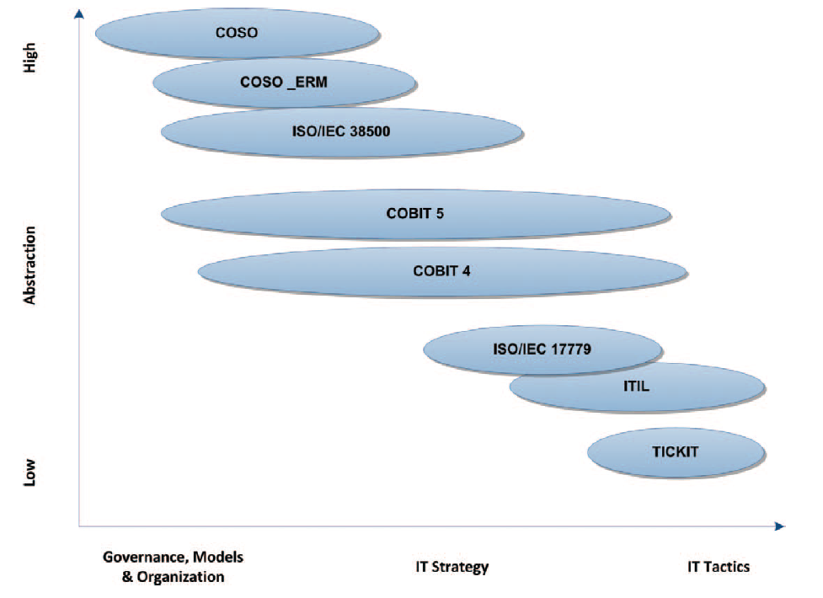
Figure 1 IT-Related Frameworks-Level of Abstraction and Lifecycle of IT
However, there are still some drawbacks about COBIT. According to a research conducted in Netherland [3], COBIT's intricate principles and structure are one of its practical flaws. Researchers, as well as the case study managers, agree that the COBIT framework is difficult to grasp. Furthermore, learning all of its ideas and techniques takes a lot of time. There are up to 34 IT processes with 222 control goals and over 300 KPIs and KGIs, said by Shengnan Zhang and Hans Le Fever [3]. Most individuals, understandably, find it overwhelming. Even for individuals with relevant experience, capturing the core of COBIT as quickly as possible is difficult. Furthermore, COBIT's broad character makes it difficult for enterprises to understand and implement. It does not give businesses with clear and explicit approaches or instructions for customizing the COBIT framework and integrating it into their own environment. Only a few case studies are accessible from the book's publishers, ITGI and ISACA, but they don't give any further information.

2.2 COSO
As organizations' major focus becomes tackling the developing risks connected with cyber security, either the COSO Internal Control or the Enterprise Risk Management Integrated Framework (2004) can provide an effective and efficient strategy to assessing and managing such risks. Indeed, both frameworks offer mechanisms that will guide firms down comparable routes when it comes to tackling cyber risk via the COSO lens.
The fact regarding cyber risk is that it cannot always be avoided; rather, it must be managed [5]. Despite this massive cyber danger, it is obvious that securing all data is impossible. As an organization's goals, objectives, and technology will grow to support its operations, it increases the possibility for exposure. Even if the risk of exposure can be lowered to a bare minimum by carefully handling evolution, there is no way to be certain. Cyber attackers, on the other hand, are constantly evolving, finding new ways to exploit flaws. As a result, to safeguard its most valuable assets, management must invest in cost-effective security procedures.
As stated by the COSO framework and shown in the following figure 2 [5], “in order to manage cyber risks in a secure, vigilant, resilient manner, organizations may view their cyber profile through the components of internal control”, which contains the following 5 different aspects to be taken into consideration:
Control Environment- The board of directors should be informed of how the organization is managed as the cyber risk management faces are continually evolving to become aware of the whole environment of management.
Risk Assessment- The organization and its stakeholder must conduct evaluations about operations, reporting process and compliance objectives, with information gathered on how these metrics can be influenced by cyber risk.
Control Activities- Control activities need to be developed and deployed, enabling the organization to manage cyber risk within a certain amount of tolerance
Information and Communication- To manage internal control, organizations should first identify information requirements. Aside from that, the internal and external communication channels, as well as all the protocols that enable the job of internal control, must be defined.
Monitoring Activities- In order to identify the system's flaws, evaluations of the operational efficacy of internal controls must be undertaken while dealing with the cyber risk. Meanwhile, the organization is in a position where procedures and policies to monitor the cyber risk profile must be developed.
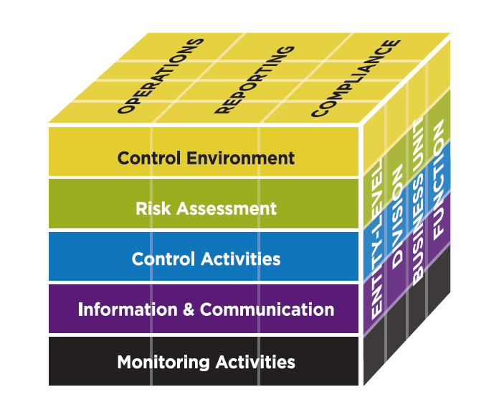
Figure 2 The COSO Cube
The following figure 3 [5] is a summary of the 17 internal control principles by internal control component as presented in the 2013 Framework.
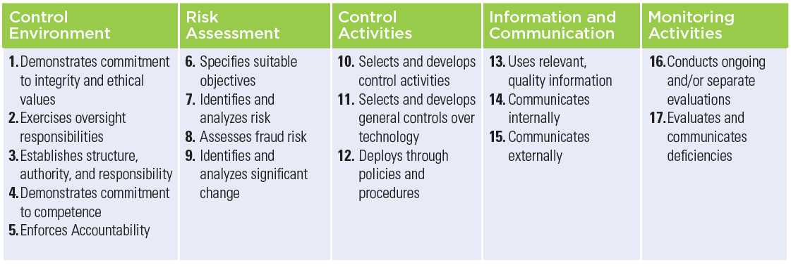
Figure 3 internal control principles of COSO
The Control Environment and Monitoring Activities components are foundations for preventing and handling cyber risk. Aiming to become secure, vigilant, and resilient in organizations, these components of internal control must be up-to-date and functioning — if not, it is likely that an organization will be unable to understand cyber risks sufficiently, deploy effectively designed control activities, and respond appropriately to address the cyber risks.
Overall, the excellent COSO frameworks can be used to set up a reliable and effective data security system, including fraud prevention policies and processes.
However, one of the most significant limitations in any ERM framework is likely to be found not in the framework's principles, but in a side that may be sophisticatedly disguised by practitioners, namely human error. Even with a precisely built internal control system, COSO admits that purposeful risks, such as poor judgement, management overrides, and staff collaborating to circumvent internal control, cannot always be recognized by internal auditors.
To overcome the flaws in these frameworks, an increasing number of companies are replacing human operations with automated technologies. This not only addresses many of the shortcomings of COSO frameworks, but it also makes it simpler to decrease risk and overcome internal control flaws.

2.3 NIST
The Cybersecurity Framework developed by the National Institute of Standards and Technology (NIST) has quickly become a generally acknowledged way to aiding cybersecurity risk management within enterprises. The clear acknowledgement that the actions involved with managing cybersecurity risk are organization specific is an insightful aspect of the NIST Cybersecurity Framework which also recognizes that Organizations should evaluate their cybersecurity risk management on a cost–benefit basis.
The NIST Cybersecurity Framework focuses on aiding organizations to execute the process of cybersecurity risk management. Three major components of the framework are the Core, Implementation Tiers, and Profiles [4]. The Core is made up of a set of cybersecurity activities that are intended to generate specific cybersecurity outcomes. These activities are specified in terms of the following five basic functions: Identify, Protect, Detect, Respond, and Recover, as depicted in Figure 4 [2]. The Core should not be seen as a checklist of actions to perform. It presents key cybersecurity outcomes identified by stakeholders as helpful in managing cybersecurity risk.
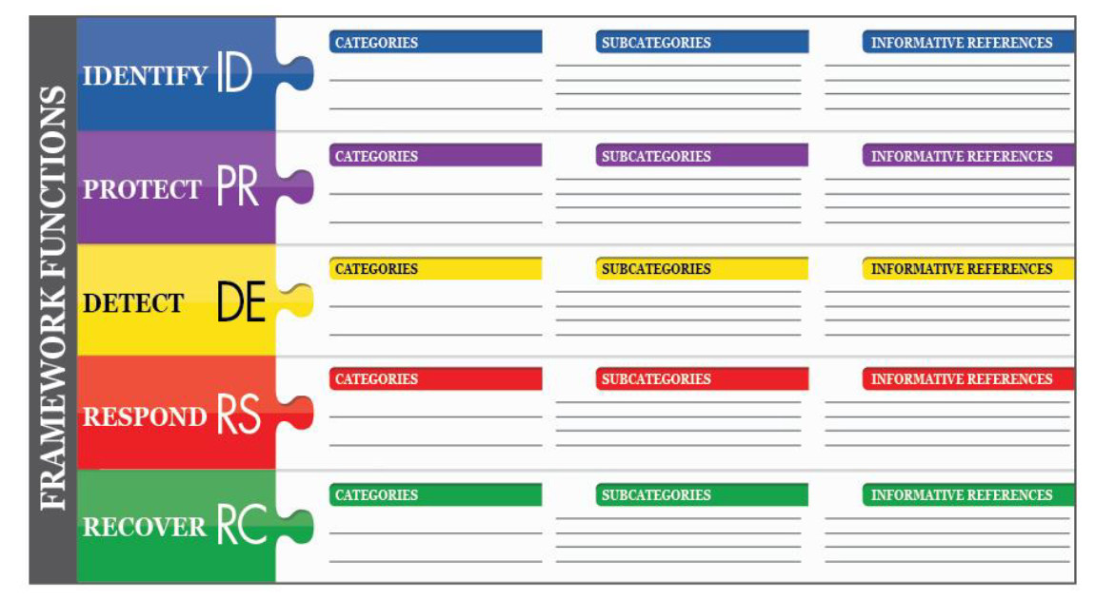
Figure 4 The Core of NIST
There are four levels of tires that an organization can be placed during the risk assessment: Partial, Risk Informed, Repeatable, and Adaptive, corresponding from Tier1 to Tier4 respectively. According to NIST, “Ranging from Partial (Tier 1) to Adaptive (Tier 4), Tiers describe an increasing degree of rigor and sophistication in cybersecurity risk management practices.” [2] In other words, higher the tier level, the more rigorous and sophisticated an organization’s risk management process can be.
The four Tiers serve as a criterion for assessing cybersecurity risk management procedures and determining what needs to be done to advance to the next tier. [6] The Tiers can also be used to assess the financial obligations associated with an organization's approach to cybersecurity risk management.
A Profile enables organizations to create a roadmap for reducing cybersecurity risk that is well aligned with organizational and sector goals. Many businesses, due to their complexity, may opt to have many profiles, each linked with certain components and recognizing their unique demands.
Framework Profiles can be used to define the existing status of cybersecurity efforts or the desired state. The Current Profile shows the cybersecurity results that have been achieved thus far. The Target Profile determines the results that must be achieved in order to meet the targeted cybersecurity risk management objectives. Business requirements can be supported by profiles and aided in communicating risk between organizations. Flexibility is another feature of this framework, since it does not prescribe templates for the whole industry.
Because it is technology agnostic while referencing a range of current standards, rules, and practices that grow with technology, the NIST Framework continues to be useful when new technological innovations emerge. The tools and methods available to achieve the Framework's outcomes will scale across borders, acknowledge the global nature of cybersecurity risks, and evolve with technological advances and business requirements if they are based on global standards, guidelines, and practices developed, managed, and updated by industry.
However, according to Baan Alsinawi, founder and managing director for TalaTek, who wrote in her blog “(NIST) Cybersecurity Framework, also known as the Framework for Improving Critical Infrastructure Cybersecurity and commonly referred to as CSF whose control tiers are not a maturity model”, the NIST framework does have certain significant drawbacks. First and foremost, NIST does not provide control "requirements." The framework merely specifies a very basic requirement. While this enables enterprises to do a security assessment against the CSF, the complexity of the evaluation is determined by corporate interpretation and preference. This might result in an evaluation that misses flaws, providing the company a misleading impression of security posture and risk exposure. Furthermore, it is unclear how these categories enhance the outcomes of risk assessments. The control categories supplied with CSF (IRM, RM, and EP) are available, but it is up to the implementing organization to define how each control aligns with their risks.

3. Blue-Mountain Coffee case study

3.1 Background
According to the case scenario, it is clear that the CoffeeBlue company has business influences around the globe, as one of the best and most sought-after brands in the world. And, the company deploys cloud technology to deliver services to its staff and customers, which means that one of the most significant features of the company’s network is being wireless. The company also has a massive online presence and social media presence to promote its activities.
However, information security has increasingly become a first priority to CoffeeBlue, since the company started to allow its staff and clients to access the company's network/resources through their own devices owing to its rising customer base. Due to this, the cybersecurity framework’s major concern of the company should be placed on security of personal staff’s data and client’s data. Also, there should be some policy established covering their security needs.

3.2 Design of the framework
As mentioned before, the company’s top concern is security of personal staff’s data and client’s data. Therefore, some privacy principles and cybersecurity system must be incorporated into the framework, For instance, data minimization in the collection, disclosure, and retention of personal information material connected to the cybersecurity incident; usage constraints on any information gathered expressly for cybersecurity activities outside of cybersecurity operations, and so on. Besides, the protection of the company’s intellectual property rights should not be neglected.
Based on such requirements, there are three factors considered and designed to meet the company’s need in information security, including Data Security Governance, Risk Management and Security Management Models and Practices.

3.2.1 Governance and Strategic Planning for Security
Based on the above ideas, the following data security governance model is constructed
Figure 5 CoffeeBlue Data Security Governance Model
As is clearly depicted in the figure 5 above, the stakeholders discuss their requirements with the board of directors to set up the strategic planning for the company to provide guides on InfoSec Evaluation which are reviewed by CEO and reported to the board. Meanwhile, the some of the staff are responsible for the Risk Assessment, creating feedback on the InfoSec Evaluation and also for the purpose of monitoring and governance.

3.2.2 Risk Management
According to the definition by NIST, risk management is the process of identifying, assessing, and responding to risk[2]. As the company moves toward RM development efforts, it is very important to specify key responsibilities to roles of governance group. In most organizations, either the CIO, CISO, or their equivalent leads the RM effort. And in many instances, the CIO serves as the champion and the CISO as the project manager
In this company, there will be a whole new RM team set up for the independence on implementation of risk management program and neutralization of the whole process to achieve better performance and security levels when protecting the intellectual property of the company.
Here is the risk management framework in figure 6:
Figure 6 CoffeeBlue Risk management Frame work
After the members of Risk Management team have been settled, the governance group should communicate its intent and priorities with them in the process of designing Risk Tolerance. Once a police or a plan has been developed, the governance should support RM team with resources which are needed by them allocated in the process of implementation and review

3.2.3 Security Management Models and Practices
One of most important purposes of the cybersecurity management model for CoffeeBlue is to guarantee and protect the security of the client’s data and staff’s data. Consequently, it is necessary to set up some privacy protection methodologies for the sake of civil liberties.
To the extent that identity management and access control procedures entail the collection, disclosure, or use of personal information, steps are made to identify and address the privacy concerns. Staff and employee can find applicable information from cybersecurity training and awareness activities, such as sessions or workshops. According to NIST, there should be process in place to assess and address whether, when, how, and the extent to which personal information is shared outside the organization as part of cybersecurity information sharing activities. Conducting a privacy review of an organization’s cybersecurity mitigation efforts is in place as well. The following figure 7 is the prototype framework for the Security Management Models and Practices.
Figure 7 CoffeeBlue Security Management Models and Practices

4. Conclusion
This article researched three existing data security management frameworks and provides some insights about the understanding of the frameworks and structures. Then a cybersecurity framework which is designed for the CoffeeBlue company is constructed by taking the essence of the frameworks which are previously researched and analyzed. However, it is admitted that this framework is relatively incomplete and there are still some approaches to be improved. This framework proposes certain solutions to the corresponding problems faced by the company.

References

[1] | S. D. Haes, W. V. Grembergen and R. S. Debreceny, “COBIT 5 and Enterprise Governance of Information Technology: Building Blocks and Research Opportunities,” JOURNAL OF INFORMATION SYSTEMS,Vol. 27, No. 1 ,Spring 2013, p. 307–324.
[2] | National Institute of Standards and Technology, Framework for Improving Critical Infrastructure Cybersecurity, Gaithersburg: National Institute of Standards and Technology, 2018.
[3] | S. Zhang 和 H. L. Fever, “An Examination of the Practicability of COBIT Framework and the Proposal of a COBIT-BSC Model,” Journal of Economics, Business and Management, Vol. 1, No. 4, November 2013, pp. 391-395.
[4] | L. A. Gordon, M. P. Leob 和 L. Zhou, “Integrating cost–benefit analysis into the NIST Cybersecurity Framework via the Gordon–Loeb Model,” Journal of Cybersecurity, p. 1–8, 23 January 2020.
[5] | M. E. Galligan and K. Rau, “COSO IN THE CYBER AGE,” Committee of Sponsoring Organizations of the Treadway Commission, 2015.
[6] | D. S. Kerr 和 U. S. Murthy, “The importance of the CobiT framework IT processes for effective internal control over financial reporting in organizations: An international survey,” Information & Management, pp. 590-597, 30 July 2013.

