
Skills for the Workplace
Module Assignment Submission
Student Name: | Ashleigh Williams
Student Number: | 1910982
Module No: | BMSK4002
Module Title: | Effective Team Working and Communication  Part 2

Statement of Confirmation of Authenticity
By the act of making this submission, the student declares that this is the work of the student named above. The work has not, in whole or in part, been knowingly presented elsewhere for assessment, or where assessment has been built on a previous assessment, this has been identified. Where materials have been used from other sources it has been properly acknowledged. If this statement is untrue, the student acknowledges that an assessment offence has been committed.
Attention is drawn to the plagiarism and unfair practice policies of both the University and of ILM.

Table of Contents
Part 2 Communication 3
1.0 3
Communication Cycle 3
2.0 5
Assessing Own Communication Skills 5
Gap Analysis 6
PDP 6
References 7
Appendix A 7
Skills You Need Communication Quiz 7
Mind Tools Communication Quiz 9

Part 2 Communication

What is communication? Why is communication important in the workplace? How do people communicate? these are the questions I’ll be looking to answer in part 2 of my assignment. I will also look at my communication skills and how communication is such a vital part of any workplace whether there are 2 employees, or 200 good communication is vital to a successful business. The ability to communicate an idea effectively is just as important as the idea itself (Brunch. B)

What is communication?
Communication is the process of sending and receiving information through verbal or non-verbal means. This includes speech, writing, signs, signals and body language. All creatures can communicate and display their emotions however it’s the ability of humans to uses words and language to relay specific messages and meanings that sets us apart. In any communication there is a sender, a receiver, a message and an interpretation. The receiver will give feedback to the sender through methods such as verbal or non-verbal, Communication has evolved in the 21st century due to technology people can now communicate. advancements such as mobile phones, computers and the internet have now enabled people to keep in contact from anywhere in the world. Technology have also enabled workplaces to become more efficient and productive. Management can easily communicate a message around a business instantly with the introduction of emails.

Why is communication important?
C

1.0

Communication Cycle

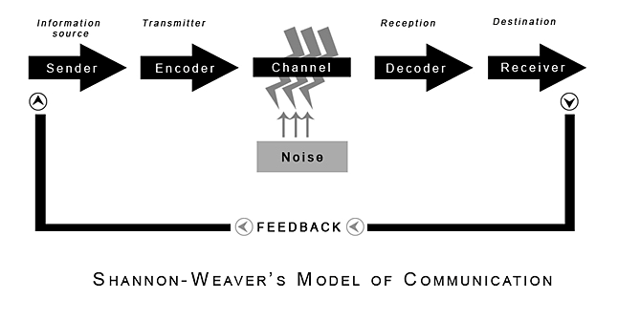
(Shannon and Weaver, 1949)

2.0

Assessing Own Communication Skills

Gap Analysis

Objective | Current Position | Deficiency | Action
What do I want to do? | What can I already do? | What am I lacking? | How do I fix this?

PDP

Objectives | Tasks | Success Criteria | Time Frame | Resources
List your Goals | What do you need to do to achieve these goals? | How will you identify your success? | When do they need to be done by? | Who or what do you need to help you?

References

Blenkinsop, P. (2010) The Communication Cycle. [online] Available at: http://manyana-education.blogspot.com/2010/10/communication-cycle.html Accessed: 15.05.19
MindTools (2019) How good are your communication skills? [online] Available at: https://www.mindtools.com/pages/article/newCS_99.htm Accessed: 15.05.19
Shannon, C. and Weaver, W. (1949) The Mathematical Theory of Communication. Urbana: University of Illinois Press.
Skills You Need (2019) Interpersonal Skills Self-Assessment. [online] Available at: https://www.skillsyouneed.com/ls/index.php/343479 Accessed: 15.05.19

Appendix A

Skills You Need Communication Quiz

Mind Tools Communication Quiz

