Assessment Component 2- Individual Reflection
Leadership and Management Theory and Practice
Student Name: Radu Acris
Student Number:2239621
Lecturer Name: Dr Samson Oladejo
LCBB6003_BIRM
2025

Contents:
1.Introduction: 3
2. Understanding of Emotional and Cultural Intelligence. 4
3. Future Application of Emotional and Cultural Intelligence. 4
4.Conclusion: 6
5.References: 7

,,Understanding and Future Application of Emotional and Cultural Intelligence’’.

1.Introduction:

Emotional and cultural intelligence are important skills for successful leadership in today’s global and diverse workplaces. Emotional intelligence (EI) helps leaders identify and control their own feelings, as well as recognise and respond to the feelings of other colleagues, building trust and compassion within teams. Cultural intelligence (CQ) supports this by helping leaders understand and adjust to different cultural values, communication styles, and behaviours (Cherniss, 2010).
This reflection explores both ideas using the Gibbs Reflective Cycle (1988) as a framework to analyse experiences and learning outcomes. It applies well-known theories and business examples to discuss the importance of emotional and cultural intelligence and how they are applied in modern organisations.

2. Understanding of Emotional and Cultural Intelligence.
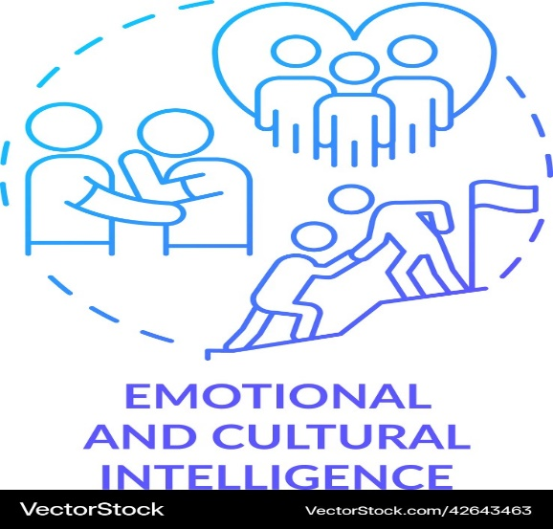
Emotional and cultural intelligence are essential qualities that help leaders work effectively with people from different backgrounds (Aldhaheri, 2017). Emotional intelligence (EI), refers to the capability to recognise, appreciate and accomplish one’s own reactions and the reactions of others. According to Daniel Goleman, EI contains self-awareness and self-regulation, motivation and empathy, also common skills, all being significant for building durable relations and resolving conflicts.
Fig.1.
Cultural intelligence (CQ), is the aptitude to relate to and work efficiently across cultures (Ma, 2020). Leaders with high CQ can communicate better, respect different values and create inclusive workplaces. Both EI and CQ are closely connected, as emotional awareness supports cultural understanding. Together, they enable leaders to manage diverse teams successfully, improve collaboration and promote a positive organisational culture.

3. Future Application of Emotional and Cultural Intelligence.

Through learning about emotional and cultural intelligence, I have gained a deeper understanding of how both are essential for personal growth, leadership and effective teamwork. Emotional intelligence (EI) helps individuals identify and manage their own emotions while also recognising how others feel. This ability encourages empathy, improves communication, helps reduce tension in the workplace. Leaders who demonstrate extraordinary EI are well prepared to inspire others, resolve conflicts peacefully and also build a confident team atmosphere (Earley, 2006).

Cultural intelligence (CQ) drives a step further by helping individuals and leaders work effectively with individuals from diverse cultural backgrounds. It involves understanding cultural values, opinions and communication styles, adapting behaviour to suit different contexts. CQ enables leaders to avoid misunderstandings, show respect for diversity and create an inclusive atmosphere where everyone feels respected and understood (John D. Mayer, 2009).
To develop these capabilities further, I plan to reflect regularly on my reactions to challenges, paying attention to my emotional initiations and learning to manage them more effectively. I will also seek feedback from colleagues to improve my interpersonal approach and emotional awareness. In addition, I aim to participate in multicultural projects or international collaborations to extend my experience and strengthen my adaptability. Learning cultural frameworks, such as Hofstede’s Cultural Dimensions, will also help me anticipate and manage differences in communication and leadership expectations.
By continuing to improve both EI and CQ, I hope to become a leader who can inspire others, build trust and manage diverse teams with understanding and confidence. These skills will not only support my professional development but also help me contribute to more inclusive and successful organisations.

4.Conclusion:

In conclusion, Emotional and Cultural Intelligence are essential attributes for effective leadership in varied business situation. Emotional intelligence, helps leaders to understand how to manage emotions, to build trust and to foster positive team relations, while Cultural Intelligence allows them to navigate and adapt to different cultural contexts (Lin & Chen, 2012).
Together, these competencies enhance communication, collaboration and inclusivity within organisations. By continuously developing self-awareness, empathy, and cross-cultural understanding, leaders can create supportive and high-performing teams capable of thriving in complex international settings.

5.References:

Aldhaheri, A., 2017. Cultural intelligence and leadership style in the education sector. International Journal of Educational Management, 31(6), p. 718–735.
Cherniss, C., 2010. Emotional Intelligence: Toward Clarification of a Concept. Industrial and Organizational Psychology, 3(2), pp. 110 - 126.
Earley, P. C., 2006. Leading cultural research in the future: a matter of paradigms and taste. Journal of International Business Studies, Volume 37, p. 922–931.
John D. Mayer, P. S. &. R. C., 2009. TARGET ARTICLES: "Emotional Intelligence: Theory, Findings, and Implications". An International Journal for the Advancement of Psychological Theory, 15(3), pp. 197-215.
Linn Van Dyne, S. A. K. Y. N. T. R. M. L. T. C. K., 2012. Sub-Dimensions of the Four Factor Model of Cultural Intelligence: Expanding the Conceptualization and Measurement of Cultural Intelligence. Social and Personality Psychology Compass, 6(4), pp. 295-313.
Lin, Y.-c. & Chen, A. S.-y., 2012. Does your intelligence help to survive in a foreign jungle? The effects of cultural intelligence and emotional intelligence on cross-cultural adjustment. International Journal of Intercultural Relations, 36(4), pp. 541-552.
Ma, A. K., 2020. The Relationship between Cultural Intelligence and Trust between Chinese-American and Anglo-American Entrepreneurs, s.l.: Pepperdine University ProQuest Dissertations & Theses.

