Virtual workplace culture and its impact on organizational efficiency
Table of Contents
ASSESSMENT 1 3
Introduction 3
Organisational detail 3
Industry scenario 3
PESTLE 3
Evaluation of the competitive environment of Sainsbury by using Porter's Five Force Analysis 6
Analysing the changes in organisational processes due to COVID-19 7
Analysis of the impact of COVID-19 on organisational culture and employee performance 8
Evaluate the relationship culture of Sainsbury in maintaining organisational structure 9
Analysing the role of relationship culture in developing organisational performance 10
Explanation of ethical dilemma and identification of at least two ethical dilemmas in Sainsbury’s that can affect the performance of the organization 11
Recommendations to resolve the identified ethical dilemma and justification 12
Conclusion 12
Task 2 13
Introduction 13
Gibb’s reflection 13
Conclusion 15
References 16

ASSESSMENT 1

Introduction
Organisational culture is the most important component to determine the workplace infrastructure and manage diversity. After the outbreak of covid 19 pandemic global business scenario has changed due to the emergence of virtual work culture. The adoption of realistic provision of employee management gives rise to a new paradigm to deal with the changes observed in organisations (Nasution et al. 2018). The pandemic has worked as a catalyst to bring fundamental changes in the working environment and give rise to the remote work culture. The study aims at analysing multiple dimensions of agile and flexible approaches followed by Sainsbury's to deal with the post-pandemic impact.

Organisational detail
Sainsbury's is a UK-based retail company which occupies a 14.9% share in the retail supermarket of the nation. It has its headquarters situated in London UK. It deals with products of grocery and merchandise. Since the last decade company has made a considerable amount of progress in value addition of the GDP of the nation by 2% every year. Unlike any other organisation, it has faced the issue of post-pandemic economic stagnation (Paris and Pattiruhu, 2020). To deal with the post-pandemic impact the organisation has formulated a strategy to develop a virtual communication channel to ensure the adoption of transitionary business solutions in the era of crises.

Industry scenario
Industry of retail is one of the most promising and growing industries in the UK. As per the financial data available from 2021, the industry has created sales of 30% of the total revenue, a growth rate is 4.5% per year and provided employment opportunities to 11% of the total population. Post-pandemic economic stagnation and the creation of inflationary impact have created difficulty for the sustainability of industry growth (Kawiana et al. 2018). Thus companies operating in this industry adopted an agile and flexible management approach to deal with the situation and monitor the level of performance. Motivating and inspiring staff members in such decentralised phenomena are the basis of it.

PESTLE
Factors | Impact | Strength or weakness
Political | The ruling party of the nation has signed an agreement with many Asian countries post-2020 to increase sales generation potential and increase the number of customers. After the outbreak of Ukraine, the war government targeted all those countries with which Ukraine has business interactions. | Strength
Economic | The nation experienced a 5% yearly growth before the pandemic outbreak. After 2019 economic stagnation and inflationary impact have reduced it to 3% per year. It helps in making the distribution of profit in a different industry. | Strength
Social | The social structure of the UK is flexible and progressive. Due to the constructive socio-economic infrastructure chances of business expansion is comparatively easier. The nation has accomplished growth of education by 3% since last year and it has made it more progressive. People of the nation have preferences for purchasing from the retail supermarket. | Strength
Technological | The adoption of modern technology and the use of different digital platforms have helped the nation to progress in business (Widarko, A. and Anwarodin, 2022). In terms of digital intervention, the nation gained progress of 6% post-pandemic. | Strength
Legal | The Company Act of 2004 and its amended erosion published in 2022 have helped to interpret guidelines to define basic business norms and evaluation of organisational culture (Nikpour, 2017). | Strength
Environmental | Since 2018 government of the nation has imposed many restrictions and legal norms to deal with the issue of global warming and environmental degradation. | Weakness
Table: PESTLE analysis
Source: Created by the learner
From the above-mentioned analysis of external factors, it can be stated that business dynamics are changing at a very high speed. The rise of virtual work culture is creating chances for business sustainability along with the reduction of business operation costs. In the UK government intervention and technological upgradation have provided opportunities for the growth of the business. Though economic stagnation and inflationary impact have caused difficulty have increased challenges for the companies dealing in the industry of retail. Analysing the impact of external components it can be stated that the adoption of a flexible management approach will increase the chances of accomplishing sustainability in the case of the existing business model.

Evaluation of the competitive environment of Sainsbury by using Porter's Five Force Analysis
To get success in the competitive market, it is very important to analyse different aspects of the competitive environment which help to develop effective strategies to manage production and operational management in organisations. To understand the dynamics of the UK retail market to understand the success rate of Sainsbury in the particular market helps the organisation to incorporate different strategies to maintain an organisational structure which helps to gain success in changing marketing environment. The study has considered porter's five force analysis to understand different aspects of the competitive environment in the UK retail market and its impact on the organisational growth of Sainsbury.
- The threat of competitors: In the UK, the retail market is known for high competition and renowned retail organisations which have loyal customer bases and brand popularity in the global market. There are many renowned retail organisations such as Tesco, Walmart, Marks and Spencer, ASDA, and many more retail companies which have effective sales rates and organisational value in the market that develops challenges for Sainsbury in the UK retail market (Nash, 2018). The competitors of the organisation also provide premium quality retail products at a reasonable price which creates threats for the organisation in attracting customers and increasing sales rate in the UK market. Therefore, it has been understood that the threat of competitors is high in the UK retail market which creates challenges for Sainsbury.
- The threat of new entrants: Sainsbury is a renowned retail organisation with high market value and a loyal customer base which helps the organisation to generate more revenue in the UK market. It is very difficult for startup organisations to enter the retail market of the UK because of the high competition in the industry and the presence of renowned organisations creates barriers for new companies to enter the UK retail market (Ruiz et al., 2018). It is also very difficult for startup retail organisations to get effective economic support to maintain the quality of products and services which creates barriers to holding the market share in the UK retail market. Therefore, the threat of new entrants is low in the UK market.
- Bargaining power of customers: The bargaining power of customers is high in the UK market because there are many retail organisations which provide high-quality products at a reasonable price with different offers and discounts which attract the attention of customers. Renowned organisations have adopted product diversification strategies and offered various types of innovative products which motivate the purchasing intentions of customers and develop challenges for Sainsbury in attracting customers and increasing the profit rate in the UK market. It is very difficult for the organisation in attracting customers in the competitive market of the UK. However, the organisation has also adopted different marketing strategies to promote its product and services as well as offer innovative products to hold the market share and gain advantages in the UK market.
- Bargaining power of suppliers: The bargaining power of suppliers is low in the UK retail market because there are many suppliers who provide premium quality resources at a reasonable price which helps to maintain effective relationships with suppliers in the UK market. Sainsbury has developed effective strategies in supply chain management which help to maintain effective relationships with suppliers and reduce extra expenses (Genakos and Pagliero, 2022). The high availability of suppliers and low cost of resources help the organisation to maintain economic structure in the organisation as well as maintain the quality of products and services.
- Threat of substitutes: The threat of substitutes is low in the UK market because there is no substitute for retail products that helps the organisation to increase the sales rate in the target market and expand businesses to get organisational success. The organisation provides premium quality organic and fresh products which help to increase the profit rate of the organisation as well as gain competitive advantages in the UK retail market (Nash, 2018). Customers of the UK market prefer high-quality products at a reasonable price which helps the organisation to increase brand awareness in the market and establish loyal customers based in the UK market.

Analysing the changes in organisational processes due to COVID-19
COVID-19 has changed organisational practices and operational activities because of the governmental restrictions and shutdown of organisations which create challenges for organisations to continue organisational activities to gain success in the competitive market and generate revenue to maintain economic structure (Aulia et al., 2021). The COVID-19 situation has introduced remote working square employees can continue their roles and responsibilities from their homes by using technological development which creates challenges for organisations to make the employees understand the importance of remote work environment to maintain organisational growth and hold the market share in the competitive market. The new form of work environment developed challenges for managers in monitoring the performance level of employees and motivating them to enhance their efficiency level because of a lack of physical communication and technical errors. It also creates challenges for employees because of their lack of understanding regarding technological development and a sense of isolation which decreases their performance level as well as decreases the quality of products of Sainsbury (Mitchell et al., 2020). The lack of physical communication and lack of employees in the manufacturing process because of the governmental restrictions create challenges for the organisation in maintaining the supply flow in the market which create dissatisfaction among customers.
However, the changing work environment during the COVID-19 situation also develops the technical skills of employees and enhances their potential to accomplish their roles and responsibilities in the remote working process. It presents a new dimension of organisational work which help organisations to reduce different expenses in a crisis situation and motivates employees to enhance their performance level to generate more revenue to maintain their salary structure (Ramanathan et al., 2021). Sainsbury has developed effective strategies and provided proper training to employees to enhance their technical skills which helps the organisation to make the employees flexible to adopt change management.
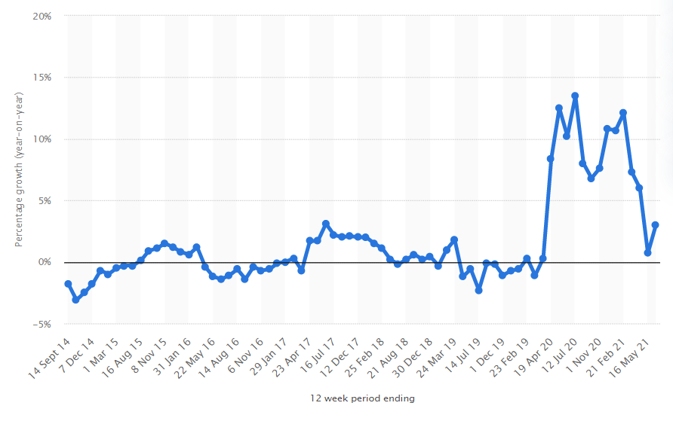
Figure: Sainsbury's sales growth Great Britain 2022
(Source: Statista, 2022)

Analysis of the impact of COVID-19 on organisational culture and employee performance
COVID-19 has changed the culture and performance level of employees by introducing remote working and developing economic challenges in different organisations. Sainsbury focuses on maintaining governmental restrictions and policies of the UK to avoid COVID contamination in the workplace and maintaining the well-being of employees. The organisation provides effective training and learning processes to employees to develop technical skills and enhance flexibility to get success in the changing environment of the organisation and accomplish their roles and responsibilities in an effective way (Mitchell et al., 2020). The organisation has also focused on developing technological infrastructure in the organisation to reduce the workloads of employees and maintain the quality of products which helps to increase the sales rid of the company. By incorporating technological advancement in production management, the organisation has succeeded to increase the operating income by around 21% during the COVID-19 situation which helps the organisation to maintain economic sustainability in the organisation (BBC, 2021). The organisation has also developed communication with employees by using technological tools and social media platforms which help the company understand the challenges faced by the employees in the changing environment.
The organisation has also incorporated digital marketing strategies during the pandemic situation which help the organisation to increase brand awareness in the target market and promote its products and services to maximise the profit rate. The organisation promotes products and services on social media platforms which helps the organisation to increase the sales rate in the target market by attracting customers with different offers and discounts. Digital marketing strategy helps the organisation to increase the sales rate by 10.5% during the pandemic situation which helps the organisation to overcome economic challenges (BBC, 2020).

Evaluate the relationship culture of Sainsbury in maintaining organisational structure
Sainsbury focuses on developing effective relationships with employees by developing communication with them and understanding their challenges in the new work environment to develop effective strategies to maintain viable work culture in the organisation to maintain organisational structure (Kim et al., 2020). The organisation has developed effective relationships with employees by maintaining equality and reducing discrimination in the workplace which help to motivate employees to enhance their performance level and efficiency rate. Sainsbury focuses on developing diverse teams in the workplace and recruiting skilled employees from different cultures to maintain effective relationship culture in the organisation and maintain organisational structure in the competitive market. By developing diverse teams, the organisation encourage employees to present innovative ideas to hold the market share in the competitive market and expand its business in different countries to get competitive success in the global market. This strategy also helps to maintain cooperation and coordination among team members as well as develop healthy competition in the workplace which helps to accomplish different roles and responsibilities in the organisation to maintain organisational structure in an effective way (Khan et al., 2019). It also helps to develop effective decision-making processes in the workplace and ensure the quality of products.
Sainsbury maintains an equal salary structure in the organisation which help to motivate employees to enhance their performance level and competency in the workplace to manage effective relationship culture in the company. The organisation also provides training and learning opportunities for employees to enhance their capabilities and potential to accomplish their roles and responsibilities by overcoming challenges in the workplace (BBC, 2018). The organisation also provide healthcare facilities for employees to maintain there's physical and psychological well-being which helps to maintain the quality of products and services as well as hold the market share in the competitive market by satisfied customers.

Analysing the role of relationship culture in developing organisational performance
Relationship culture plays important role in enhancing organisational performance by motivating employees to enhance their efficiency and competence in the workplace to get success in the competitive market. Sainsbury focuses on developing diverse teams in the workplace by recruiting skilled employees from different cultures which helps to incorporate innovative ideas in product development and strategy development to beat competitors and gain competitive advantages in target markets (BBC, 2022). By developing effective relationship culture, the organisation focuses on maintaining effective work environments and providing independent work opportunities to employees to enhance their dedication and sense of responsibility to accomplish organisational goals and objectives. Sainsbury also provides career growth opportunities for employees which helps to motivate them to enhance their performance level and efficiency rate in the workplace to maintain the quality of products and increase the productivity level of the organisation to hold the market share. The organisation also develop interaction with employees which makes a positive impact on organisational performance and establishes organisational values in the workplace to get success in the UK retail market (BBC, 2018).
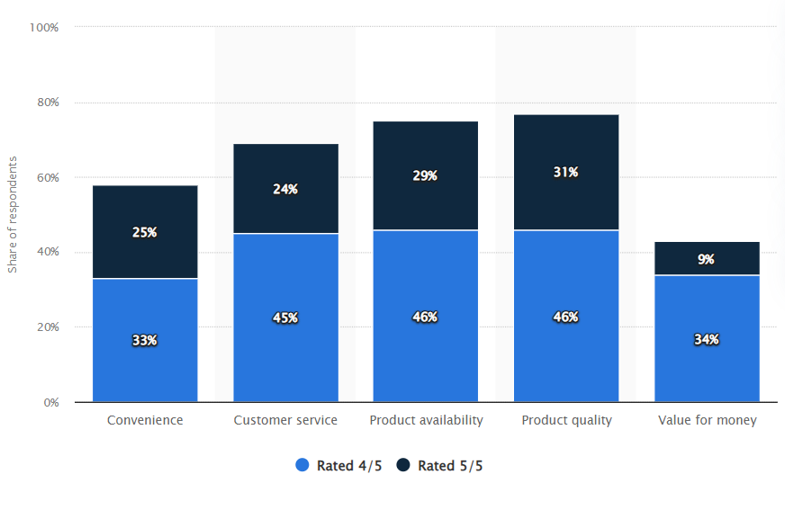
Figure: Sainsbury's performance: customer evaluation UK 2015
(Source: Statista, 2022)
Sainsbury maintains equality in developing diverse teams and motivates employees to develop respect for each other which help to maintain effective relationship cultures in the workplace and increases the productivity level of employees. The organisation also distribute roles and responsibilities among employees according to their skills and abilities which help to increase their interests and efficiency in accomplishing their roles and responsibility which help to maintain effective business sustainability in the organisation (BBC, 2018). The organisation also develops reward management to satisfy employees and establish healthy competition in the workplace. This strategy also increased the engagement of employees in the workplace and attract skilled candidates to accomplish the roles and responsibilities in the organisation.

Explanation of ethical dilemma and identification of at least two ethical dilemmas in Sainsbury’s that can affect the performance of the organization
After the era of the COVID-19 pandemic, while the advantages of implementing a virtual work structure are extensively highlighted, ethical considerations underlying the practices of virtual work are largely ignored. Some gaps have been identified in the virtual work structure of Sainsbury's as well. These are mentioned below:
- Mischarging of duty hours- Since the commencement of the pandemic and the initiation of the virtual work structure, the shift toward physical distance has resulted in a lack of supervision of the employees as to when and how they are working. Some employees of Sainsbury's have been less focused on attending meetings and client dealings while working from home structure. They violated the basic norm of remote work which is timekeeping. Improper reporting time and impunctuality have been the major constraints due to personal and familial responsibilities to be maintained by the employees at home. All these responsibilities led to an increased opportunity for the workers to intentionally or unintentionally time mischarging. Consequently, an ethical dilemma arose in the virtual workplace of Sainsbury's (Antono et al., 2021).
- Delayed supervision and approval- Another ethical issue observed among the supervisors and managers of Sainsbury's includes dilemmas in approval and supervision. When working from home, the managers used to fail to approve the propositions of the employees in time. This might be due to familial or personal responsibilities that the managers could not maintain their work decorum properly. The supervisors also sometimes missed out on vigil daily work reports of the employees as a result of which the timeline could not be maintained for particular work delivery. Given the strong virtual presence of the brand, most customers used to order for online delivery following the COVID-19 era. Thus, it required substantial efforts from the managers or supervisors to perform their duties timely. However, personal engagement caused an ethical violation in the setting of the virtual workforce where both the managers and supervisors failed to monitor their employees timely (Sholihin et al., 2020).

Recommendations to resolve the identified ethical dilemma and justification
To address the ethical dilemma identified in the virtual work structure of Sainsbury’s, the following recommendations are provided so that employees, managers, and workers can work remotely by maintaining ethical norms at the same time:
- Involvement of contractors: Some contractual posts can be created by the organization Sainsbury’s and contractors can be engaged to remind the employees about their reporting obligations while working from home. Contractors can maintain the worksheet where daily work progress should be noted on an hourly basis. Hence, the duty hours can be calculated in terms of delivered jobs.
- Video meetings: Video meetings should be arranged frequently among the employees and the managers so that they can feel the virtual presence of their colleagues. Team meetings on a video call on a regular basis can increase the involvement of the employees and also surveillance over them, simultaneously. Besides, on video conferencing, team members can share their views and clear doubts if they have any.
- Cybersecurity requirements: Unintended use of irrelevant software and technology usually violate ethical practices. The employees of Sainsbury's must know the basic cybersecurity requirements such as the use of potentially tested and approved software systems, inflexibility in using technology whatever they want, and obligations of information security.
- Use of apps like clockify: The employees and managers of Sainsbury’s can be asked to download clockify or similar apps in their systems so that their working hours can be calculated by the software. The total working hours should be aligned with the delivered jobs per working day or daily work reports of the employees.

Conclusion
From the above discussion, it can be concluded that the present report has focused on workplace culture and its impact on organisational efficiency and organisational growth in the competitive market. It has selected Sainsbury as the chosen organisation and evaluated the environment of the organisation by using PESTLE analysis and Porter's Five Forces analysis to understand the impact of the external environment and competitive environment on the organisational growth. By analysing the external environment and competitive environment, the report has evaluated the opportunities and challenges of Sainsbury in the UK retail market. It has also analysed the impact of COVID-19 on the organisational culture and change management as well as organisational performance. It has analysed the changing environment of the workplace during the pandemic situation when employees are forced to adopt remote working which makes impacts on organisational growth and performance level of employees. The study has evaluated the importance of maintaining a relationship culture in enhancing the satisfaction level and engagement of employees in the workplace. It has analysed the impact of relationship culture in maintaining organisational performance and ensuring organisational success in the competitive market. It has also analysed the ethical dilemmas of the organisation which make a negative impact on performance level as well as provided effective recommendations to overcome those dilemmas and ensure success rate in the competitive market.

Task 2

Introduction
Virtual workplace building has become an emerging component in determining better workplace infrastructure. It is the responsibility of the management of an organisation to form better work culture along with the provisions to determine the stakeholders’ management plan. While dealing with multi-dimensional business challenges Sainsbury's has tried to evaluate the virtual workplace building process. The purpose of the study is to make a proper evaluation of the required skill for ensuring the development of virtual work culture. This study will focus on the proper evaluation of this concept along with the adoption of a reflective approach.

Gibb’s reflection
Reflection
While researching the importance of developing a virtual workplace for the organisation named Sainsbury's I have conducted in-depth surveys on different companies who have already been following virtual workplace infrastructure. Analysing information from those organisations I have observed that we need to give more focus on the evaluation of a strategic intervention to implement virtual work culture. I have observed that the amount of competition in the industry of retail is gradually increasing in the UK. Thus we need to evaluate the intensity of the use of different digital to increase the effectiveness of virtual working provisions. Analysing changes in organisational business processes it has been observed that we need to generate consumers' awareness about the strategy of managing virtual interactiveness to attract more investors. I have tried to make a proper evaluation of the concept of virtual working along with the provision of developing an integrated structure of the team.
Feeling
Successful implementation of a new concept is completely dependent on the development of the level of understanding among team members. I have observed many stages of a gap of understanding among team members have created issues for us in making evaluating the concept of virtual workplace building. At the initial stage, I observed a lack of coordination in the level of my understanding. At those stages, I felt less confident. I have understood the newly evolved digital tools help to increase the involvement of team members. In terms of business ventures, Sainsbury has prioritised the importance of interpreting business ideas logically and realistically. In the UK I have observed the implementation of virtual workplaces can get improved with the increase in the involvement of team members. I felt confident along with the increase in the level of my participation in different tasks performed to achieve excellence in this task. It helps to ensure the adoption of a proper strategy for business operations.
Evaluation
In the case of ensuring the implementation of a new concept, it is important to focus on the development of long-term planning. While taking part in this module I have observed a strong trend of progress in the involvement of team members. To develop a proper innovative approach to work teamwork was performed. It was observed by me that due to the involvement of team members we successfully performed the task of the initial level of preparation. I have evaluated my level of improvement and I have felt that I have made a considerable amount of progress in increasing my potential in teamwork. At this stage, I have used my strong skill of communication to make my team members realise the impact of effective communication. I strongly feel that virtual work-culture building will become successful with the adoption of an integrated approach. I feel every team member needs to play an active role in the development of understanding of the virtual workplace and the strategy to formulate it. It develops chances of accomplishing better outcomes in formulating strategic interventions.
Analysis
I feel that a proper understanding of the manner of developing proper understanding about the shift in virtual working principles can help to provide better business opportunities to the chosen organisation. I believe it will provide opportunities for skill development and better employment option to explore future options. I have realised that it needs a proper understanding of the required structural segmentation. It directly impacts the overall process of increasing employability and ensuring the adoption of balance to gain better outcomes. In the initial stage, we faced issues in increasing the effectiveness of the virtual working principles adopted. It will increase the chances of gaing progress and thus better outcomes will get accomplished.
Concussion
It can be stated that the adoption of a proper strategy helps to increase the chances of skill development in an individual. It is important to focus on the evaluation of a better strategy to increase the involvement of stakeholders. In this context, a proper understanding of virtual working principles will support the requirement of the situation. It will increase the chances to observe the trends of change. Skill development at the individual level will ensure chances to fill the gap. In this manner, progress will be observed in gaing better outcomes and accomplishing success. It will increase the chances of gaing success in accomplishing desired project goals. It will help to gain better outcomes in the process of performance management of team members.
Action plan
Areas of focus | Process to accomplish | Time required
Adoption and implementation of understanding on the manner of increasing efficiency of a virtual workplace | Skill development and training of team members and managing desired integration of this strategy with the particular business goal. | One year
The process of implementing skills related to different desired tools | It is important to develop an integrated pattern of skill development and focus on the formulation of a better outcome in gaining the desired outcome. | One year

Conclusion
From the above discussion, it can be concluded that the development of virtual work culture has become the need of the hour. Providing proper training to the team members helps to maintain proper alignment with the desired goal. It is observed that proper analysis of the strengths and weaknesses of team members will support the business requirement of Sainsbury. It is observed that the company has made a considerable amount of resource investment to overcome the gap observed. The purpose of this practice is to focus on accomplishing business sustainability and ensure value addition in terms of the business model.

References

Antono, B., Willis, J., Phillips, R.L., Bazemore, A. and Westfall, J.M., 2021. The price of fear: an ethical dilemma underscored in a virtual residency interview season. Journal of graduate medical education, 13(3), pp.316-320.
Aulia, T.R. and Soetjipto, B.W., 2021, December. Effect of Openness to Change, Empowerment, Customer Orientation, and Marketing Innovation to Resilience and Survival of a Convenience Store Business in the Midst of Covid-19 Pandemic. In 3rd International Conference on Business and Management of Technology (ICONBMT 2021), pp. 100-106.
BBC, 2018. Will 'bigger is better' approach work for Sainsbury's?. Available at: https://www.bbc.com/news/business-43954632 (Accessed: 17 November 2022).
BBC, 2020. Sainsbury's sees online sales soar during lockdown. Available at: https://www.bbc.com/news/business-53246091 (Accessed: 17 November 2022).
BBC, 2021. Sainsbury's: Cost of Covid has been high. Available at: https://www.bbc.com/news/business-56912064 (Accessed: 17 November 2022).
BBC, 2022. Sainsbury's pressed to pay more to subcontracted workers. Available at: https://www.bbc.com/news/business-61952914 (Accessed: 17 November 2022).
Febianti, F. and Nurwan, T.M., 2021. THE EFFECTS OF ORGANIZATIONAL CULTURE ON EMPLOYEE PERFORMANCE IN SUMEDANG SELATAN DISTRICT OFFICE SUMEDANG REGENCY. JHSS (JOURNAL OF HUMANITIES AND SOCIAL STUDIES), 5(1), pp.06-10.
Genakos, C. and Pagliero, M., 2022. Competition and pass-through: evidence from isolated markets. American Economic Journal: Applied Economics, 14(4), pp.35-57.
González-Rodríguez, M.R., Martín-Samper, R.C., Köseoglu, M.A. and Okumus, F., 2019. Hotels’ corporate social responsibility practices, organizational culture, firm reputation, and performance. Journal of Sustainable Tourism, 27(3), pp.398-419.
Kawiana, I.G.P., Dewi, L.K.C., Martini, L.K.B. and Suardana, I.B.R., 2018. The influence of organizational culture, employee satisfaction, personality, and organizational commitment towards employee performance. International research journal of management, IT and social sciences, 5(3), pp.35-45.
Khan, N.A., Khan, A.N. and Gul, S., 2019. Relationship between perception of organizational politics and organizational citizenship behavior: testing a moderated mediation model. Asian Business & Management, 18(2), pp.122-141.
Kim, W., Kim, H. and Hwang, J., 2020. Sustainable growth for the self-employed in the retail industry based on customer equity, customer satisfaction, and loyalty. Journal of Retailing and Consumer Services, 53, p.101963.
Meng, J. and Berger, B.K., 2019. The impact of organizational culture and leadership performance on PR professionals’ job satisfaction: Testing the joint mediating effects of engagement and trust. Public Relations Review, 45(1), pp.64-75.
Mitchell, R., Maull, R., Pearson, S., Brewer, S. and Collison, M., 2020. The impact of COVID-19 on the UK fresh food supply chain. arXiv preprint arXiv:2006.00279.
Nash, J., 2018. Exploring how social media platforms influence fashion consumer decisions in the UK retail sector. Journal of Fashion Marketing and Management: An International Journal, pp.5-30.
Nasution, F.N., Mariatin, E. and Zahreni, S., 2018. The influence of career development and organizational culture on employee performance. International Journal of Scientific Research and Management, 6(01), pp.57-65.
Nguyen, L.H. and Watanabe, T., 2017. The impact of project organizational culture on the performance of construction projects. Sustainability, 9(5), p.781.
Nikpour, A., 2017. The impact of organizational culture on organizational performance: The mediating role of employee’s organizational commitment. International Journal of Organizational Leadership, 6, pp.65-72.
Paais, M. and Pattiruhu, J.R., 2020. Effect of motivation, leadership, and organizational culture on satisfaction and employee performance. The Journal of Asian Finance, Economics and Business, 7(8), pp.577-588.
Ramanathan, U., Aluko, O. and Ramanathan, R., 2021. Supply chain resilience and business responses to disruptions of the COVID-19 pandemic. Benchmarking: An International Journal, pp.2-21.
Ruiz-Real, J.L., Uribe-Toril, J., Gázquez-Abad, J.C. and de Pablo Valenciano, J., 2018. Sustainability and retail: analysis of global research. Sustainability, 11(1), p.14.
Saad, G.B. and Abbas, M., 2018. The impact of organizational culture on job performance: a study of Saudi Arabian public sector work culture. Problems and Perspectives in Management, (16, Iss. 3), pp.207-218.
Sholihin, M., Sari, R.C., Yuniarti, N. and Ilyana, S., 2020. A new way of teaching business ethics: The evaluation of virtual reality-based learning media. The International Journal of Management Education, 18(3), p.100428.
Statista, 2022. Sainsbury's performance: customer evaluation UK 2015. Available at: https://www.statista.com/statistics/534508/uk-sainsburys-supermarket-performances-customer-evaluation/ (Accessed: 17 November 2022).
Statista, 2022. Sainsbury's sales growth Great Britain 2022. Available at: https://www.statista.com/statistics/386729/sainsburys-sales-percentage-change-great-britain-uk/ (Accessed: 17 November 2022).
Widarko, A. and Anwarodin, M.K., 2022. Work Motivation and Organizational Culture on Work Performance: Organizational Citizenship Behavior (OCB) as Mediating Variable. Golden Ratio of Human Resource Management, 2(2), pp.123-138.

