

Programme of study: BA (Hons) Business Management
Module name: Entrepreneurship
Module code: LCBB5013
Assignment title: Business Plan for VerdiPod: An AI-Powered Smart Indoor Food-Growing Solution
Student name
ID number:
Lecturer’s name: Balendran Kandasamy

Table of Contents
3
Slide 1: Title slide 3
Slide 2: Business Overview and Business Opportunity 3
Slide 3: Business Idea & Unique Selling Proposition 4
Slide 4: SWOT & Competitor Analysis 5
Slide 5: Target Market & Marketing Strategy 6
Slide 6: Financial Plan & Business Objectives 7
Slide 7: Conclusion 8
Slide 8: References 9

TASK 2: Business Plan Presentation

Slide 1: Title slide
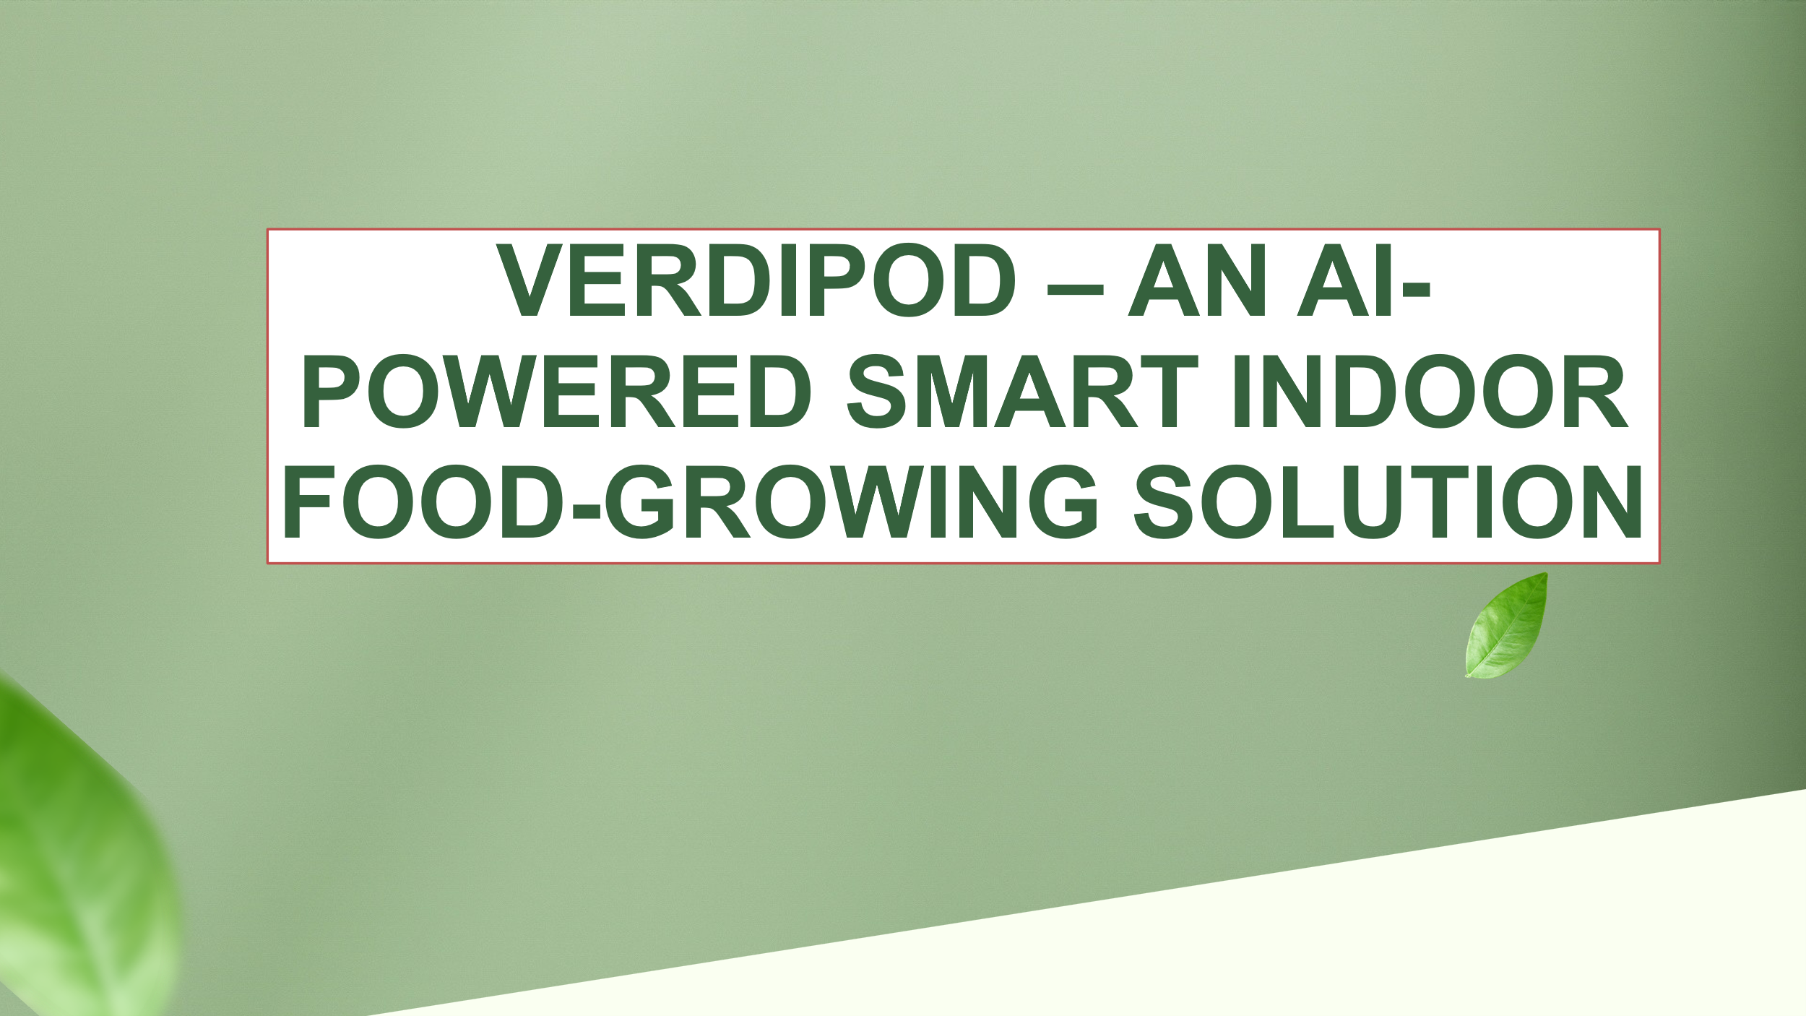

Slide 2: Business Overview and Business Opportunity
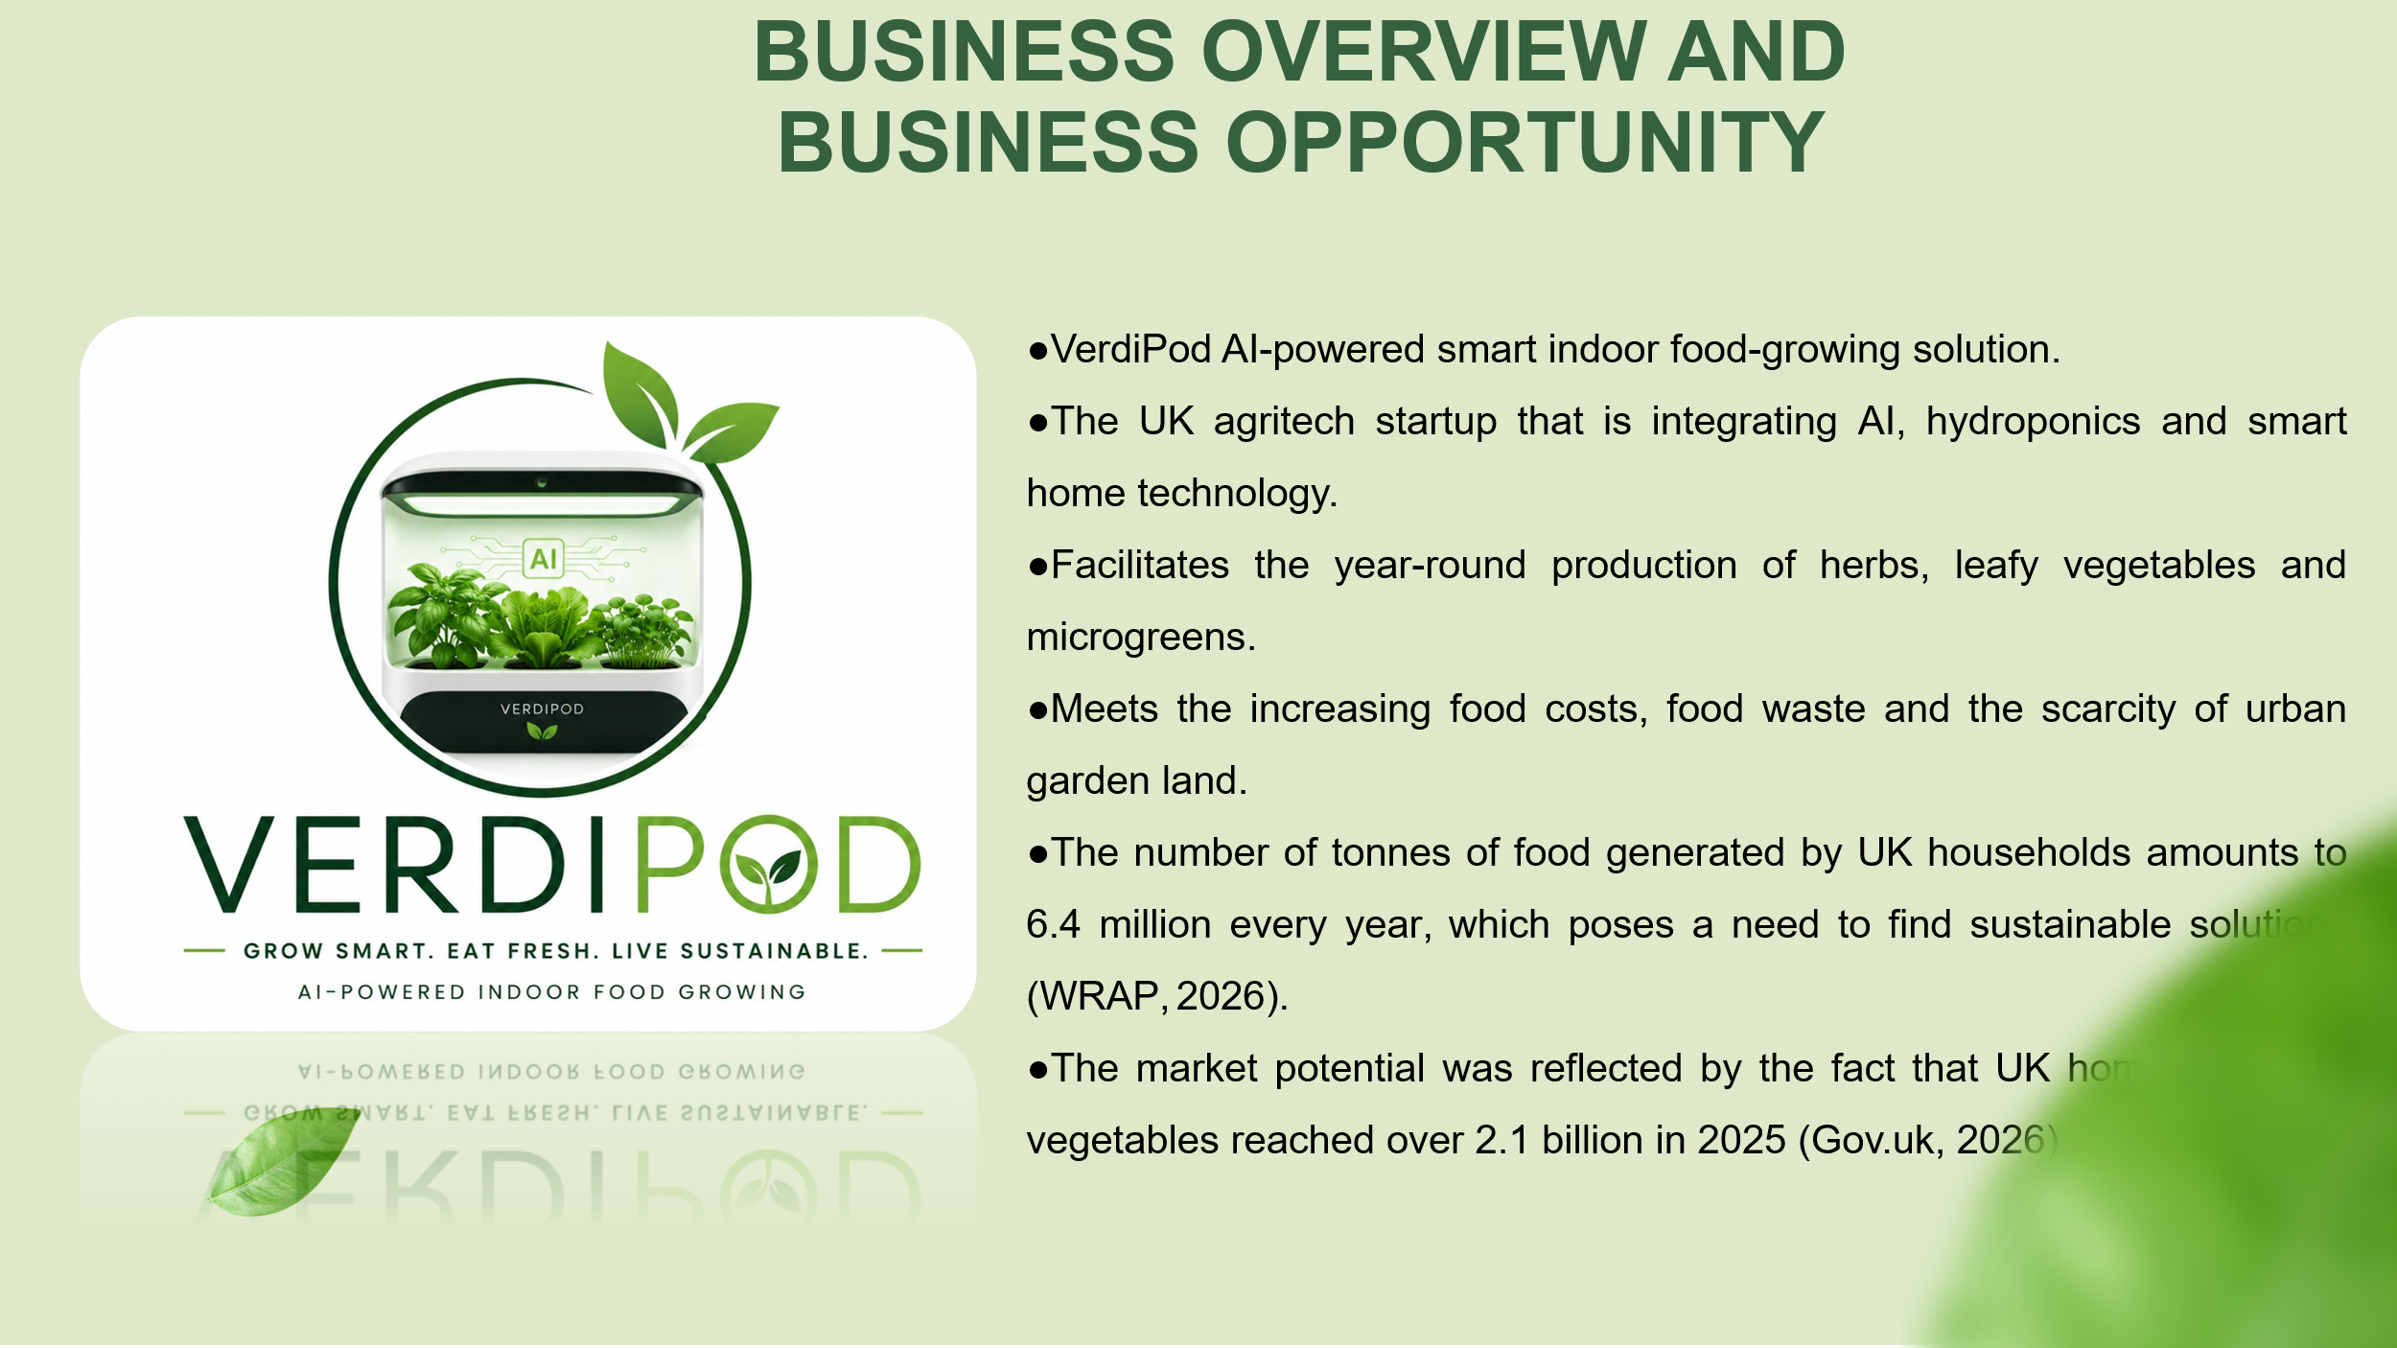
- VerdiPod AI-powered smart indoor food-growing solution.
- The UK agritech startup that is integrating AI, hydroponics and smart home technology.
- Facilitates the year-round production of herbs, leafy vegetables and microgreens.
- Meets the increasing food costs, food waste and the scarcity of urban garden land.
- The number of tonnes of food generated by UK households amounts to 6.4 million every year, which poses a need to find sustainable solutions (WRAP, 2026).
- The market potential was reflected by the fact that UK home-produced vegetables reached over 2.1 billion in 2025 (Gov.uk, 2026).

Slide 3: Business Idea & Unique Selling Proposition
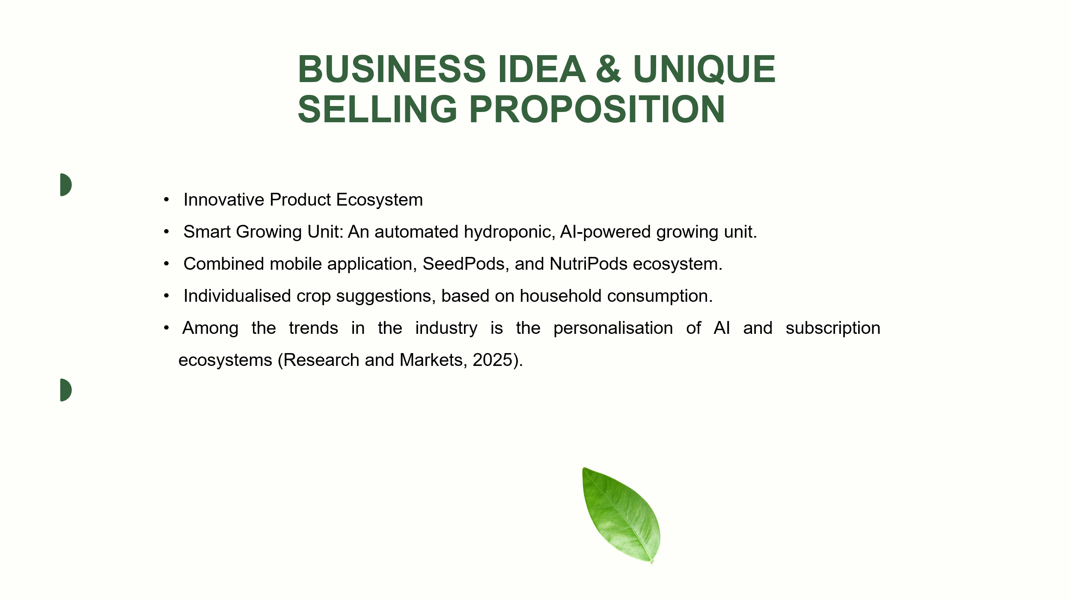
- Innovative Product Ecosystem
- Smart Growing Unit: An automated hydroponic, AI-powered growing unit.
- Combined mobile application, SeedPods, and NutriPods ecosystem.
- Individualised crop suggestions, based on household consumption.
- Among the trends in the industry is the personalisation of AI and subscription ecosystems (Research and Markets, 2025).

Slide 4: SWOT & Competitor Analysis
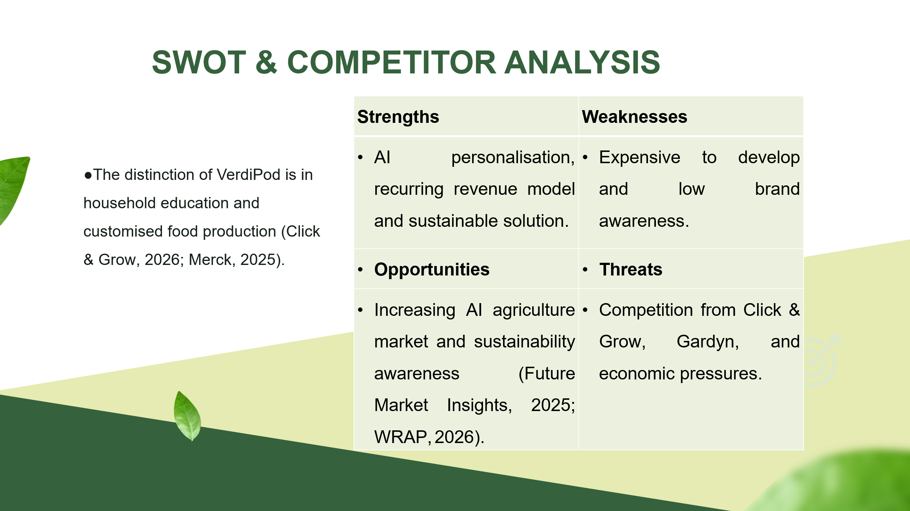
- Strengths: AI personalisation, recurring revenue model and sustainable solution.
- Weaknesses: Expensive to develop and low brand awareness.
- Opportunities: Increasing AI agriculture market and sustainability awareness (Future Market Insights, 2025; WRAP, 2026).
- Threats: Competition from Click & Grow, Gardyn, and economic pressures.
- The distinction of VerdiPod is in household education and customised food production (Click & Grow, 2026; Merck, 2025).

Slide 5: Target Market & Marketing Strategy
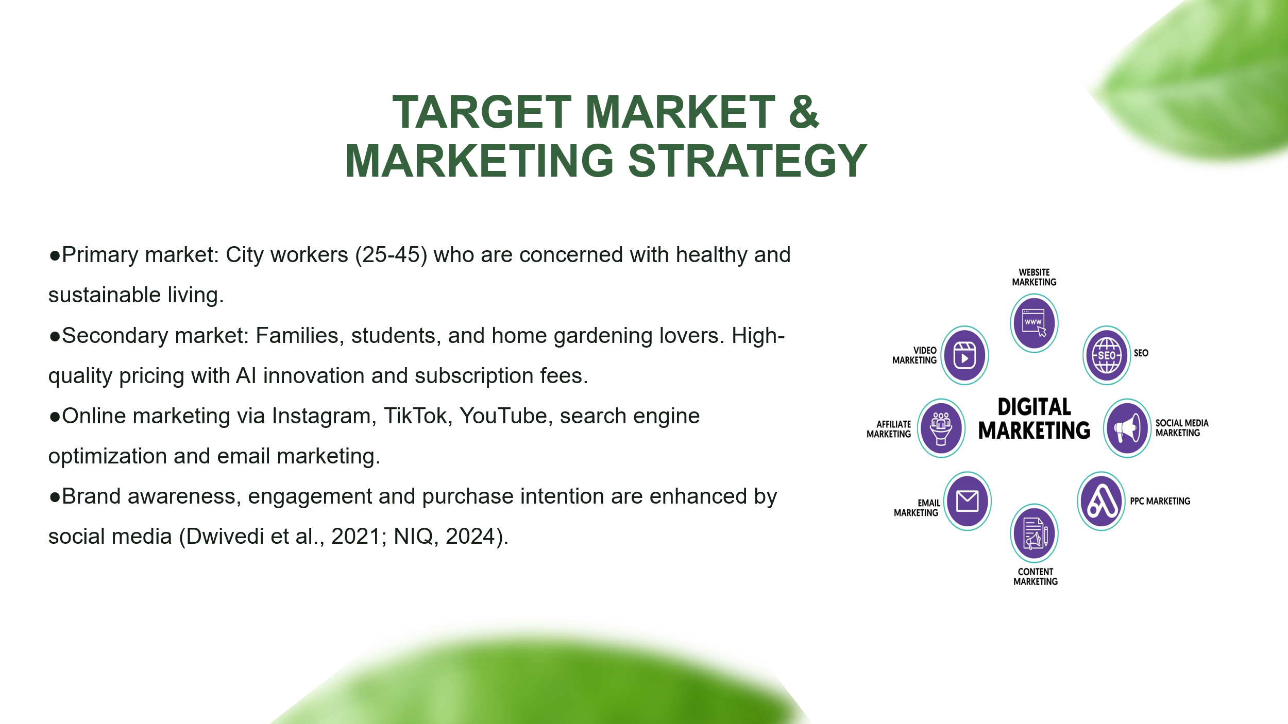
- Primary market: City workers (25-45) who are concerned with healthy and sustainable living.
- Secondary market: Families, students, and home gardening lovers. High-quality pricing with AI innovation and subscription fees.
- Online marketing via Instagram, TikTok, YouTube, search engine optimisation and email marketing.
- Brand awareness, engagement and purchase intention are enhanced by social media (Dwivedi et al., 2021; NIQ, 2024).

Slide 6: Financial Plan & Business Objectives
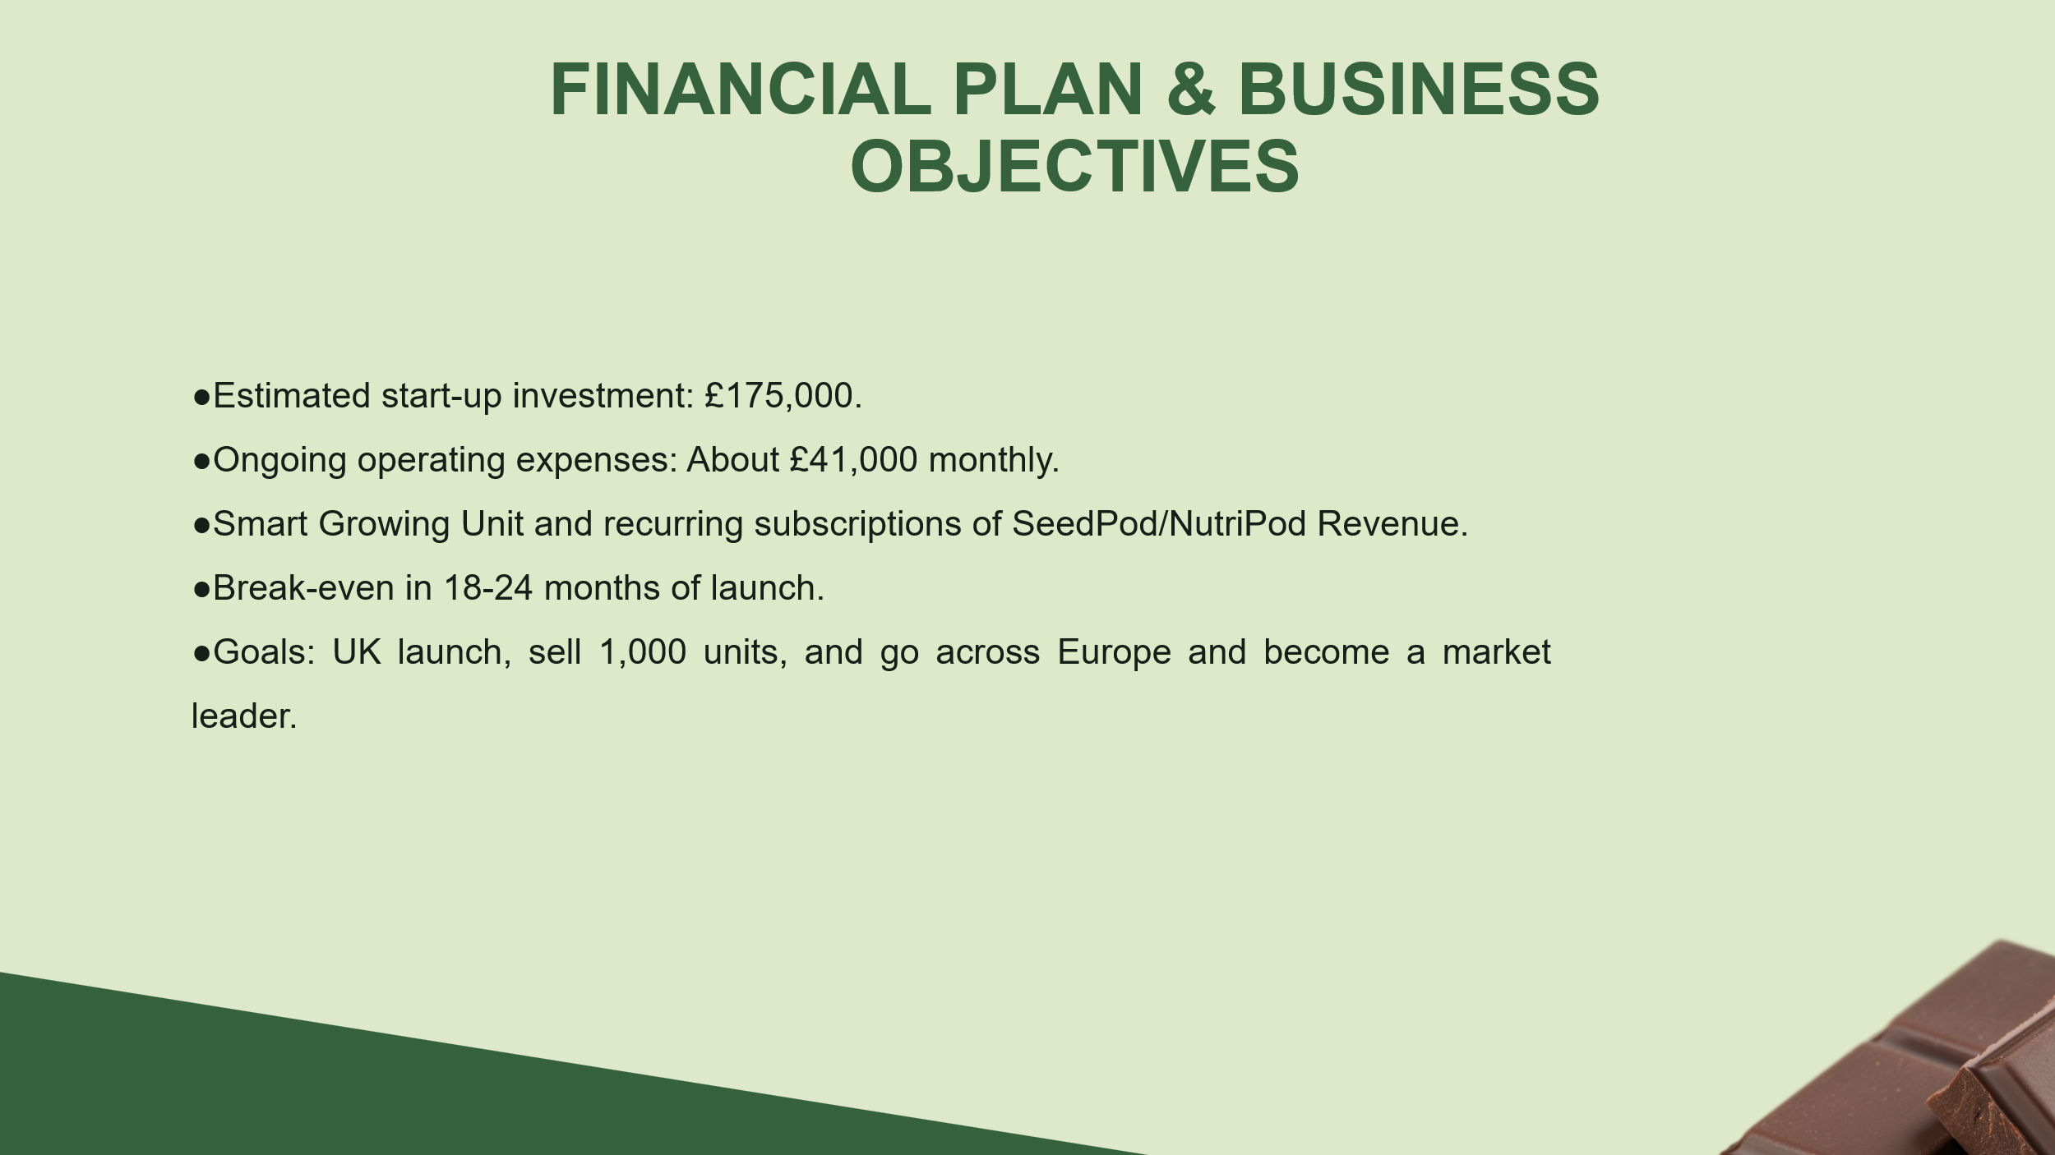
- Estimated start-up investment: £175,000.
- Ongoing operating expenses: About £41,000 monthly.
- Smart Growing Unit and recurring subscriptions of SeedPod/NutriPod Revenue.
- Break-even in 18-24 months of launch.
- Goals: UK launch, sell 1,000 units, and go across Europe and become a market leader.

Slide 7: Conclusion
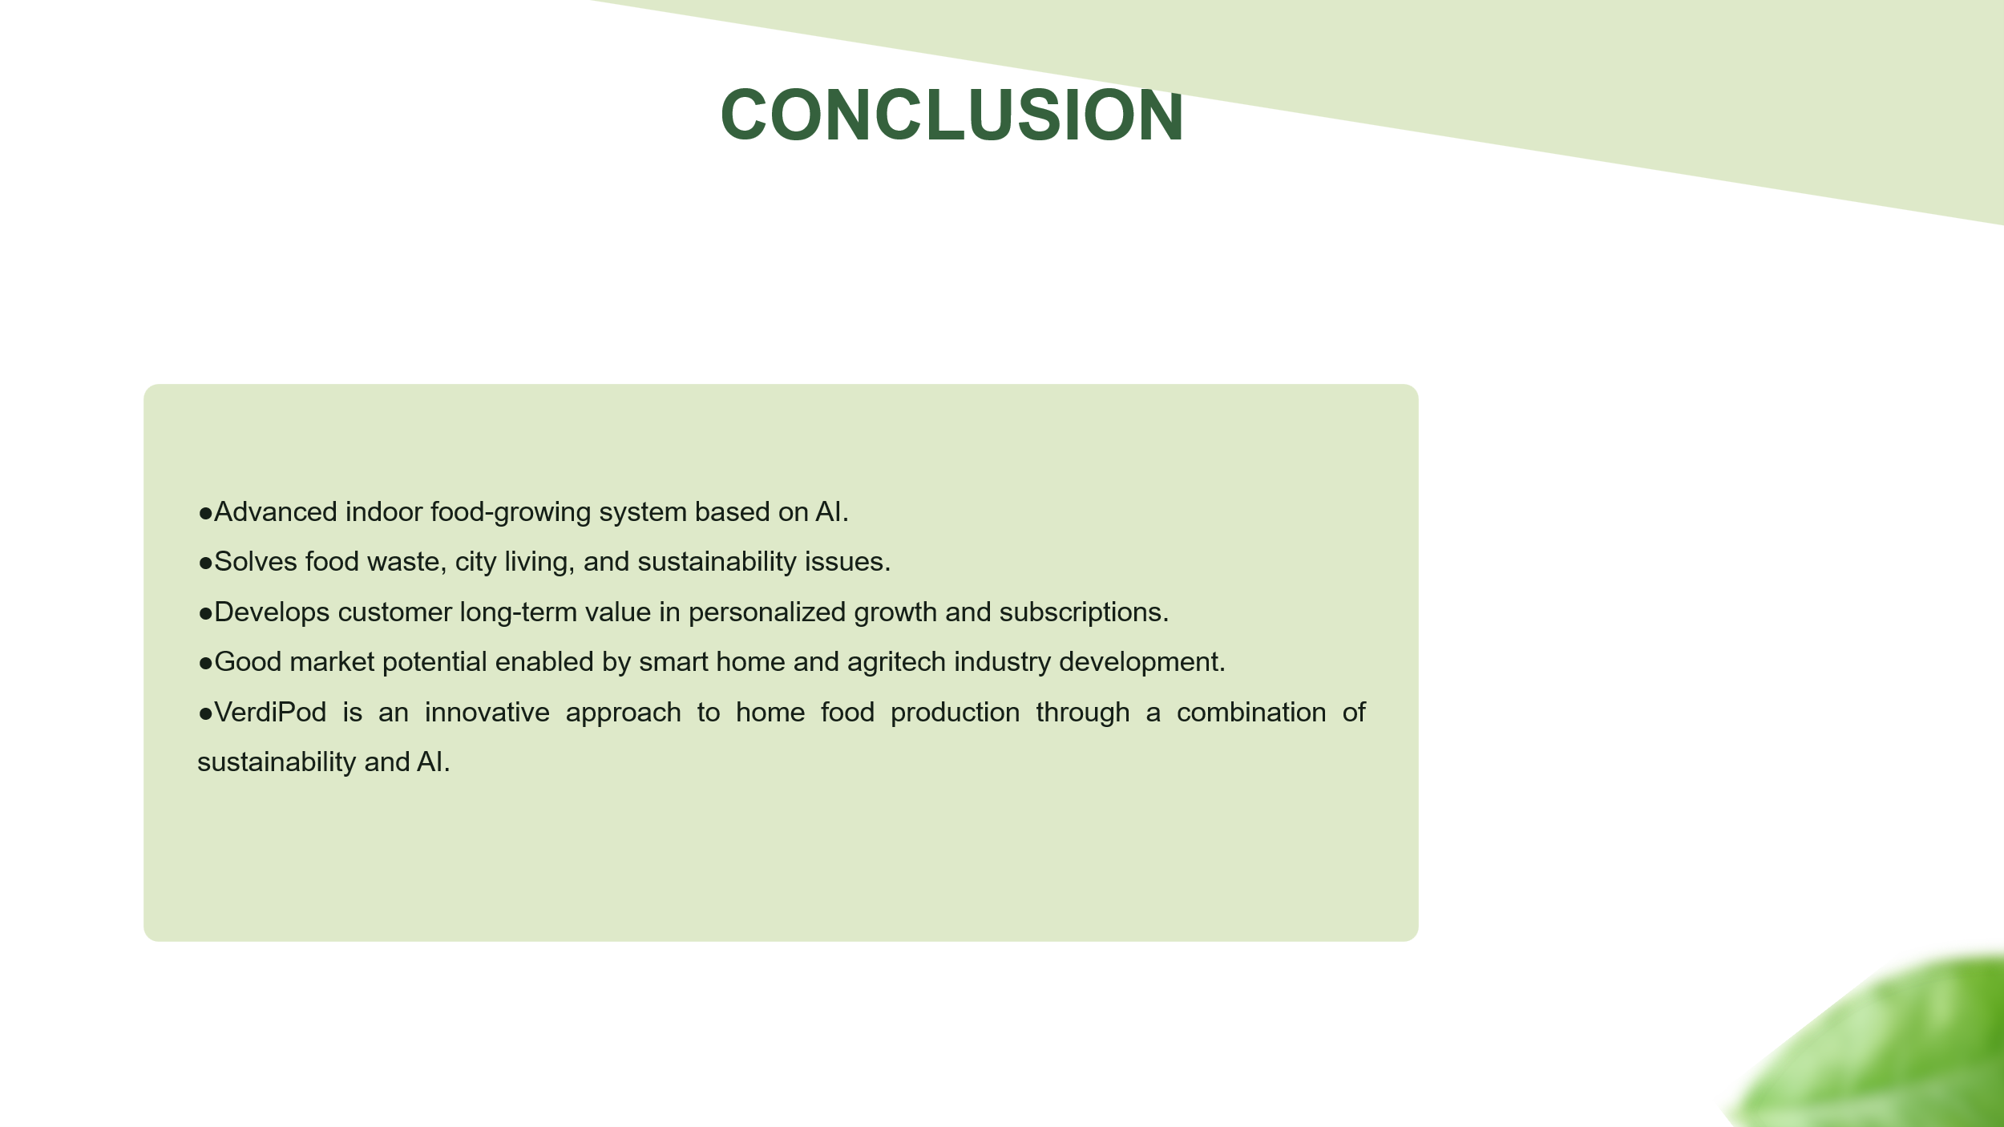
- Advanced indoor food-growing system based on AI.
- Solves food waste, city living, and sustainability issues.
- Develops customer long-term value in personalised growth and subscriptions.
- Good market potential enabled by smart home and agritech industry development.
- VerdiPod is an innovative approach to home food production through a combination of sustainability and AI.

Slide 8: References


