

BA (HONS) LEADERSHIP AND MANAGEMENT SKILLS FOR THE WORKPLACE
Module name: Developing Innovation and Creativity for Business Advantage BMSW6102 (JULY 2023)
TITLE: “DEVELOPMENT OF INNOVATIVE PRODUCT OR UNIQUE SERVICE PROPOSITION”
TASK 1 – INDIVIDUAL WRITTEN REPORT
TASK 2 AS APPENDIX: Narrated presentation
STUDENT NAME: MARIANA GOLEMANOVA
STUDENT ID: 2030688
LECTURER NAME: CHARLES NWAOGWUGWU
EXECUTIVE SUMMARY
Let me explain how and where the idea came from and why I decided to push up this to create a family company for business purposes! A few weeks ago, I was on a family holiday with my brother and all our children and his wife, of course. So then the idea came from my sister-in-law as she was dealing with neck pain all the time and occasionally I understood that all of us have the same problem, especially sitting for a long during work time, speaking on the phone. I found very brainstorming to combine the neck massager with headphones so we can relax while making phone conversations (all my family members are spending most of their time on the phone, excluding me- I am listening to loud music, that is why I need my headphones!). And after a short discussion, the decision was made! As every one of my family has his area of professional realization, I decided to collect all the skills and direct them to a successful innovative business. For example, my brother is the best finalist I have ever known, he will be Directing our finances, my oldest daughter will be managing the customer service department, the second one will be our accountant and the youngest one will be the designer of the website and all the reserved attributes of the company as our LOGO as well as will be leading the social and marketing team! I am best at Managing Organisation, so I will be the CEO of our company. Let me show you how was placed (the whole process of running) an innovative product into a successful business.
The market for neck massager headphones has increased rapidly because of the increasing awareness of health and wellness among today’s generations. Nowadays people are more interested in products that provide relaxation, comfort, and pain relief and which perfectly fit into their daily routine. Nowadays most of us are a long time talking to someone on phone calls or dealing with business conversations, or just listening to music. I and my family also have the same struggle with finding time to relax and that was the fundamental reason to try to find the best solution.

Table of Contents
INTRODUCTION 3
A) Neck massager headphones C & B 3
B) E-Commerce 6
C) Marketing 8
D) Privacy and data protection 11
CONCLUSION 12
REFERENCES 13
APPENDIX………………………………………………………………………………… …15

INTRODUCTION
The below report will discuss in detail a unique and innovative product that is perfectly suitable for retail stores. My suggestion is for a neck massager headphone with unique and innovative functions as well as features that will provide to the customers. The report will discuss the competitors available currently in the market of the product. Then will propose a detailed setup for the online website of the product C&B. Also, I will describe in detail the marketing strategy of my innovation. It will include a concrete determination of the target customers and different marketing strategies used by the company for the promotion of our product. Then at last will discuss privacy and data protection.

A) Neck massager headphones C&B
Neck massager headphones are a unique and innovative product that perfectly satisfies the needs and preferences of customers in the modern era. The neck massager provides neck massages with the option of headphones attached to it (Nasifoglu Elidemir, Ozturen, and Bayighomog, 2020). They are designed to provide a relaxing and therapeutic experience by incorporating massage nodes into the headphone band which provides massage to the neck and shoulder area of the body. The idea came to me from my family vacation, when due to an issue with the neck and shoulders of a member of my family, I realised that it is very useful if we can combine two devices in one -a massager and earphones or headphones.
Customers
Numerous customers will benefit from the product such as –
Office workers – Corporate employees who spend long hours sitting in a chair or working on a computer in the same position will find it very beneficial as they suffer neck and shoulder tension. Neck massager headphones will provide relief and relaxation during work breaks to the employees.
Travelers – The product is very beneficial for people who travel regularly whether by car, train, or bus. They experience discomfort due to long sitting and poor posture… Neck massager headphones offer a soothing massage experience while they travel.
Students – Students who spend extra time studying or working on assignments that later lead to neck and shoulder strain (Distanont, and Khongmalai, 2020). Neck massager headphones will provide a refreshing break and reduce stress for the students.
Distribution channels
Retail stores – The Company will partner with local retail stores in the UK and will mainly focus on the retail stores which deal in electronics items. It will help to provide exposure to the product.
Online platforms – The product will be available on all online platforms. Establishing an
e-commerce website to sell directly to customers is an effective strategy. Online marketplaces like Amazon, eBay, and other specialised wellness platforms will also be used for the product.

Name of neck massager headphone
CHILL & BUSINESS

Strategies to sustain the business.
I have chosen an open innovation strategy to run my business, as I believe that as a small family company, we could not afford all the action, needed to provide a successful innovative product, we will need partners for the processes such as engineering work, logistics, and technical support.
Product differentiation – The Company will continuously work to innovate and improve the neck massager headphone design and will work on customer feedback. I will try to stay ahead of competitors as this will help the company to attract new customers and retain existing ones.
Marketing and branding – Creating a strong brand identity through targeted marketing campaigns, social media presence, and influencer collaborations will enhance brand recognition and customer loyalty toward the product.

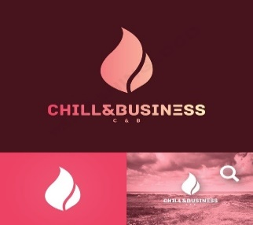
LOGO OF MY COMPANY

Customer satisfaction – The Company will provide excellent customer service by addressing queries quickly and offering warranties or return policies to the customers to build trust and ensure customer satisfaction.

Competitors
Some minor competitors are currently present in the market. Some of the start-ups and emerging companies are trying to focus on wearable technology or wellness products (Ali, and Anwar, 2021). They are planning to introduce neck massager headphones as part of their product lineup in the market.
To remain competitive in the market the company will focus on product differentiation, quality of the product, and customer experience. I could not identify a concrete competitor, but now I have two devices from unknown brands, which I will use to analyse which of their weaknesses I can use to win that competition. Following I will show a self-created picture of how they look and what kind of innovation of my product will succeed on the market.

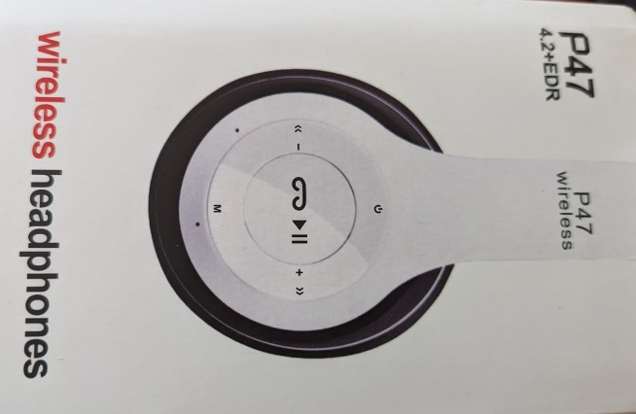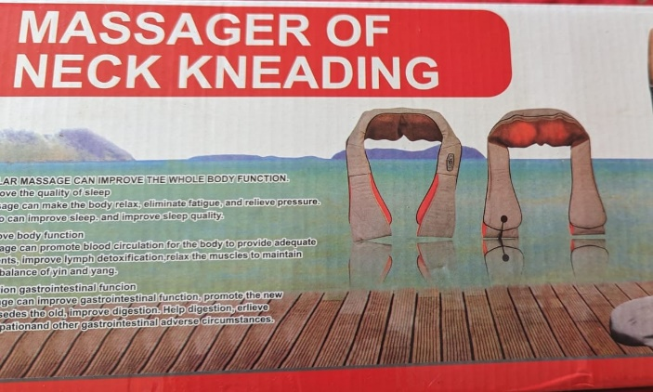
(self-created pictures)

My idea is to create some compact, light, and portable device with the functions of these two and on top of that with a smaller size and better sound. The current devices are heavy, uncomfortable, and too big. I will use those weaknesses as a UNIQUE SELLING POINT in my campaign. As shown in the next picture, our product will be more helpful, and modern, with a better price and promotion, and in the end, will be better placed in the market (marketing mix strategy – 4P). I will be following describe in detail why exactly we can win the competition with the current suppliers of both devices, combined by me in one.
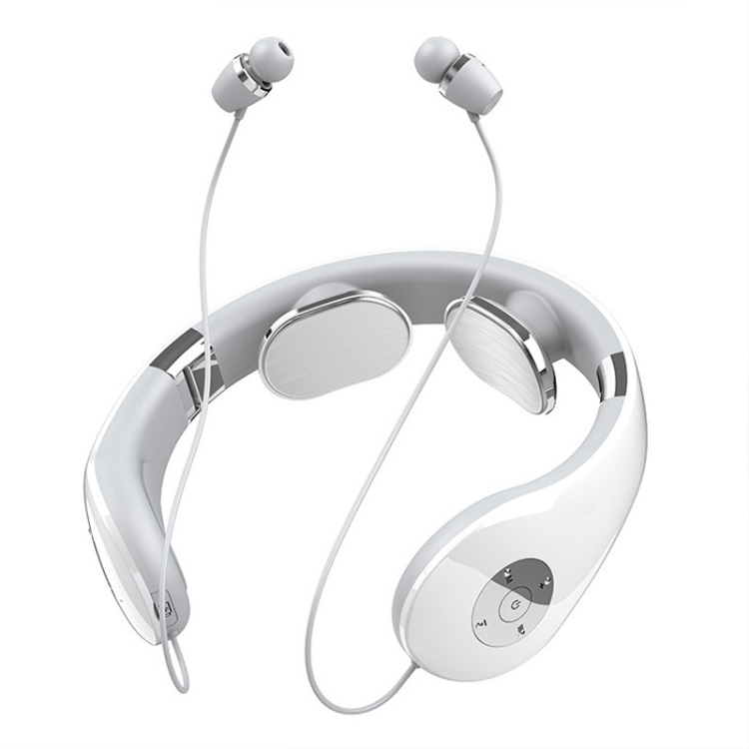
(My vision of the innovative product)

B) E-Commerce
The product will use Shopify as the SaaS e-commerce platform for marketing. Shopify offers a variety of customisable themes for marketing the product and an extensive ecosystem that allows easy integration of different functions. To reach a wide variety of audiences from larger parts of the world, the company will develop a website for marketing and selling the product. The home page of the website will include the introduction of the store and will show the functions and features of the neck massager (Ferreira, Coelho, and Moutinho, 2020). The product pages will include individual pages for each product which will include images, descriptions, specifications, and customer reviews. The website will have an option that will allow the customers to create their accounts on the website which will help them to track their orders. The website will have a strong search function and filter option which will provide a huge help to the customers to find specific products according to their preferences. The company will implement on-page SEO techniques to improve the website’s visibility on search engines. The company will set up social media profiles and run targeted marketing campaigns to promote the neck massager products. The website will offer discounts, promotions, and loyalty programs to attract and retain customers. Also, will provide a seamless shopping card system with options to edit the number of quantities and remove items according to the need of the customers. The website will have a checkout option that will have a streamlined and secure checkout process integrated with PayPal. The company will implement strong security and the payments accepted through PayPal will be aware of all the issues of PCI - DSS. The website will have an option for customer reviews (Azeem, and et. al., 2021). Customers who have bought the product will be allowed to leave their reviews and ratings for the product whether positive or negative. The website will implement an order management system to track orders and update customers on the status of their shipments, will also provide shipping cost estimation before the checkout process which will help the customers to know the final price of the product. The company will provide contact support for the customers, an option for live chat, or a dedicated support page to address customer inquiries related to the product. The website will integrate a marketplace feature to enable third-party sellers to list their neck massager products like Amazon and Flipkart (Zameer, Wang, and Yasmeen, 2020). The company will employ a strong technical team that will make sure to optimise the website for a smooth user experience on various mobile devices for customers. That team will regularly update it and plugins to patch security vulnerabilities. The website will implement SSL certificates to ensure secure data transmission and build trust with customers.

C) Marketing
The marketing strategy for the neck massager C&B will be advanced, innovative, and creative. The target customers of the product will be mainly students, travelers, and BUSSINESS owners.
Product differentiation
The unique selling point of the neck massager CHILL & BUSINESS is that it provides neck massages with the option of headphone attached to it. They are designed to provide a relaxing and therapeutic experience by using massage nodes in the headphone band which provides massage to the neck and shoulder area of the body (Quaye, and Mensah, 2019). There are no competitors available in the market that provides multiple functions in neck massager with such high quality. The product will fully satisfy the needs and expectations of the customers.
Target customers
The target audience for a neck massager product will include individuals who experience neck and shoulder tension due to multiple reasons such as long working hours, stress, physical activities, or age-related issues. Also, people interested in wellness and relaxation will be the potential customers of the product.
Students – The company will target students who are studying in colleges, schools, or high schools who spend extra time studying or working on assignments which then leads to neck and shoulder pain in their body. Neck massager headphones will provide a refreshing break and reduce the stress of the students.
Old age people – The Company will target old age people who are in search of comfort. People in old age value relaxation more and they happily spend their money on tools and provide which provide relax their bodies.
Office workers – The prime targets of the product will be the corporate employees who spend long hours sitting on a chair or working on a computer in the same position. The Product will be very beneficial for the employees as they hey suffer from neck and shoulder tension (Awan, Sroufe, and Kraslawski, 2019). Neck massager headphones will provide relief and relaxation during work breaks to the employees.
Travelers – The Company will target travellers who travel regularly whether by car, train, or bus. They face discomfort due to long sitting and bad posture. Neck massager headphones will offer a soothing massage experience while they travel.
Social media
Social media is considered the most crucial tool in today’s world for the promotion of any product as it is a very powerful to reach and engage with potential customers. The company will employ an advanced social media team for promoting and managing its presence on social media platforms. The company will create their profiles on multiple social media platforms such as Facebook, Instagram, and Twitter to showcase their product. It will be shared all the benefits and all the customer reviews with the post of the team. The social media marketing team will share all the useful content related to neck pain relief, stress reduction, and wellness to build a community around the brand. The team will collaborate with influencers and health/wellness bloggers to reach a wider audience.
Paid search engine marketing
The social media marketing team will use paid search engine marketing to target keywords related to neck pain, stress relief, and related terms. This strategy will ensure that when potential customers search for solutions, they find the neck massager product prominently displayed in their search results.

Customer journeys
It is very crucial to understand the customer journey from discovery to purchase and beyond. The social media marketing team of the company will try to attract potential customers through educational blog posts, social media content, and informative videos. The team will offer a free downloadable guide on neck pain relief to the audience. Once they show interest the company will retarget them with personalised ads. The team makes sure to simplify the purchase process and ensure excellent customer support post-purchase to encourage positive reviews and repeat business.
Email marketing
The social media marketing team of the company will build an email list through pre-launch promotion by offering incentives such as exclusive discounts or early access to the members included in the list (Arsawan, and et. al., 2022). The company will fully utilize email marketing as it helps to nurture leads, provide educational content, and send product updates. The team will segment the email list based on customer preferences and behaviors to deliver more relevant content.
Pre-launch promotion
The company will run teaser campaigns to generate excitement and curiosity about the product before the official launch. The company will use social media, email marketing, and influencers to promote the upcoming launch. The social media team of the company will collect email addresses by offering a sneak peek or early access to those who sign up.
Partnerships and collaborations
The company will collaborate with health and wellness practitioners, physical therapists, and fitness centers to promote the neck massager C&B. These partnerships with different brands will lead to endorsements and access to a targeted audience.
Loyalty programs
The company will implement a loyalty program to reward repeat customers and encourage referrals. The website will offer exclusive discounts, early access to new products, or a points-based system to increase customer engagement on their website.
Post-purchase engagement
The team will monitor and follow up with the customers who bought the product with greet them with personalized thank-you emails and requests for reviews from them (Na, Kang, and Jeong, 2019). The company will offer post-purchase support and engage them in a community where they can share experiences and ask questions about the product.
Pre-launch promotion
The company will run teaser campaigns to generate excitement and curiosity about the product before the official launch. The company will use social media, email marketing, and influencers to promote the upcoming launch. The social media team of the company will collect email addresses by offering a sneak peek or early access to those who sign up.

D) Privacy and data protection

Data protection act 2018/GDPR
The company will take care of the Data protection act of 2018 which makes the businesses more transparent and care for the data of the customers that the company has. This acts states when a data breach gets detected the company must notify all the people that are affected and supersizing power within the period of 72 hours (Pécriaux, and. et.al 2021). The mandates in GDPR (general data protection regulation) apply to all the data produced by the European Union (EU), whether the company is or not collecting the data in queries is located in the EU. All the people who lost data are stored in the EU, no matter if they are not EU citizens. The GDPR also states the noncompliance policies.
PECR (Privacy and electronic communication regulations)
This act sits along with the GDPR act discussed above and it is also related to data and privacy protection in relative to electronic communications. The company will be aware of the PECR to make sure that the data is safe. The company will follow this act and will take care of the things discussed below-
Consent needs – this states that the person should not undergo any loss if they deny consent. Consent must be asked for specific one thing at one time. The company will take care of this act and will follow this rule.
Opt-out provision – the person will be given the option to opt out of all the chosen ways of marketing communications. The person would be able to reset the policies and terms that are agreed before.
Erasure Right - the company will take care of the GDPR’s right to erasure and will make sure that the data is protected and by the customer’s request the data will be erased.
With keeping the data protection act in mind, the company will also provide the service to make secure access to the cloud provider (Le Pogam, and. et.al 2020). The data will remain safe and will not be interrupted. The access will be provided by using sensitive passwords and will be accessible with two-factor authentication systems. The traffic will be not transparent to secure the data of the customers and will be in transit to make sure the data of the customers do not get leaked.

CONCLUSION
The above report discussed in detail a unique and innovative product CHILL & BUSINESS neck massager with headphones which is perfectly suitable for retail stores. It completely explained all the information relevant to the process of creation and production and distribution of the new innovative product as well as analysed all the relevant factors and strategies. I have described the unique and innovative functions and features which the neck massager will provide to the customers in detail. As a part of the marketing strategy for the product, I have provided a full plan of action. Then at last the report discussed privacy and data protection.
In the end, I can add that my company, based on family members, will take its place on the market because I believe that we have created a very useful and modern product, that people will love!

REFERENCES
Books and journals

Ali, B.J. and Anwar, G., (2021). Business strategy: The influence of Strategic Competitiveness on competitive advantage. International Journal of Electrical, Electronics, and Computers. 6(2).
Arsawan, I.W.E., and et. al., (2022). Leveraging knowledge sharing and innovation culture into SMEs sustainable competitive advantage. International journal of productivity and performance management. 71(2). pp.405-428.
Awan, U., Sroufe, R. and Kraslawski, A., (2019). Creativity enables sustainable development: Supplier engagement as a boundary condition for the positive effect on green innovation. Journal of Cleaner Production. 226. pp.172-185.
Azeem, M., and et. al., (2021). Expanding competitive advantage through organizational culture, knowledge sharing, and organizational innovation. Technology in Society. 66. p.101635.
Distanont, A. and Khongmalai, O., (2020). The role of innovation in creating a competitive advantage. Kasetsart Journal of Social Sciences. 41(1). pp.15-21.
Ferreira, J., Coelho, A. and Moutinho, L., (2020). Dynamic capabilities, creativity, and innovation capability and their impact on competitive advantage and firm performance: The moderating role of entrepreneurial orientation. Technovation. 92. p.102061.
Le Pogam, A., and.et.al (2020). Strongyloides stercoralis disseminated infection in an HIV-infected adult.
Na, Y.K., Kang, S. and Jeong, H.Y., (2019). The effect of market orientation on performance of sharing economy business: Focusing on marketing innovation and sustainable competitive advantage. Sustainability, 11(3), p.729.
Nasifoglu Elidemir, S., Ozturen, A. and Bayighomog, S.W., (2020). Innovative behaviors, employee creativity, and sustainable competitive advantage: A moderated mediation. Sustainability. 12(8). p.3295.
Pécriaux, A., and.et.al (2021). Detection of microsatellite instability in a panel of solid tumors with the Idylla MSI Test using extracted DNA. Journal of clinical pathology. 74(1). pp.36-42.
Quaye, D. and Mensah, I., (2019). Marketing innovation and sustainable competitive advantage of manufacturing SMEs in Ghana. Management Decision. 57(7). pp.1535-1553.
Zameer, H., Wang, Y. and Yasmeen, H., (2020). Reinforcing green competitive advantage through green production, creativity, and green brand image: implications for cleaner production in China. Journal of cleaner production. 247. p.119119.

APPENDIX POWER POINT PRESENTATION Slide 1
Slide 2
Slide 3
Slide 4
Slide 5
Slide 6

Slide 7
Slide 8
Slide 9

Slide 10
Slide 11
Slide 12
Slide 13

Slide 14

