Student Name | Aneesah Zubair l
Student Number | 1809520
Module Number | BMSW 5104
Assignment Title | Project Planning and Management in workplace
Lecturer Name | Paul Ranson
Submission Date | 27/11/2020
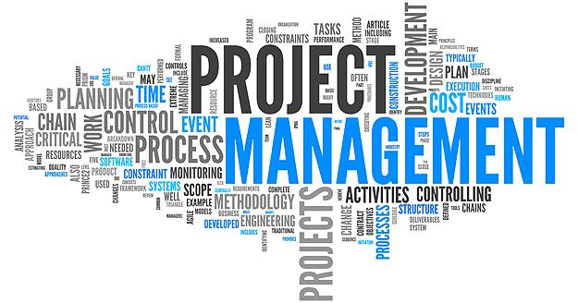
https://www.bing.com/
Table of content ……………………………………………………………………………………………….…Page 1)
Introduction and Vintners antique shop………………………………………………….Page 2)
Organisation stake holders………………………………………………………………… page3/4
Steering wheel and critical assessment……………………………………………………Page 5
Project management tools ……………. ……………………………………………….…Page 6/7
User stories/Trello……………………………………………………………………….…Page 8/9
Self-development/Conclusion…………………………………………………………….Page 10/11
References…………………………………………………………………………………………12

Introduction
The aim of this report is to produce an analysis based upon the business organisation, vintners antiques who are re- locating their business from a shop to a warehouse therefore, the main objective of this report is to create a business plan and use many elaborating tools that will help to measure the main aspect of the project and rather to look upon the problem instead of looking at the solutions. This report will consist upon many different methods in regards of reassuring that the organisation is being structed in a professional manor.
Vintners Antiques
The vintner’s antique shop is a traditional retro antique store that is based in Shirley, it attracts many customers, the type of customer’s who like the urban style of furniture to the customers that also like the classic styles.
The family run business has been made an offer by a warehouse in sparkhill who also are known to have a full stock in their warehouse.
Down below is a picture that shows the antiques that the business sells not only does the vintners Antiques but also garden wear. 

These are the stake holders of the organisation



Doreen Vintners
Is the business sponsor the vintner’s antiques have been passed down in generations therefore, Doreen is the family business owner who runs the business, she also follows the rules accordingly. She obtains 10 years of bank accounting experience therefore she is the company’s sponsor


Denis vintners
Is the main searcher/ founder of the antiques he has a great passion for retro antiqes


Suha madani.
Handles the customer services, she is an easy approchable inavidual who is very liked in the vinterners organisation.


Omar king
He is the genral all rounders specialist he has worked for the company sine was at young age thrrfore he knows the were about of the antiqe products within the shop.

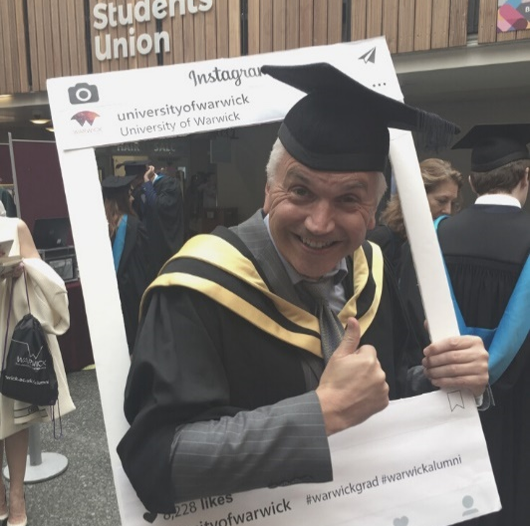
Paul ranson
Is a family friend of the vintners

Steering wheel.
Down below is a steering wheel it allows the abilty to capture the key strategies of the organisation it also allows a better understanging in regards of communication with the staff.

Critical assement of the risks assosiated within the project.
As this organisation is a family run business in many occasions the family may have personal issues due to not sharing the same interests or ideas as other member of the family. Therfore It may cause a potential risk in regards of working with the family itself it can be very demanding in regards of lack of intrest within the given aspirations of the family and also the members may not agree to certain deals which can be the cause of conflicts. It has been stated by the following Rafele, C., 2015. Applying the correct Communication skills and the development of information really aren’t easy tasks specifically whilst interacting within a family run organisation.
Moreover it is compulsary for the family to work in a professional manor at all times in order to build a successful business, Cornes, M., 2015. Another potential risk can be the fact of not having enough staff to cover as this is a family run bussiness therfore, if any of the staff is unavailable and there is a major deal that can take place would be cancelled moreover the vinters can benfit by hiring more staff for the future in regards of for when the staff members are on leave they can cover or have a temporary assistant.
Project management tools and techniques.
The main tools that will be used in this report are the following)
- Trello) Provides the ability to organise projects and allow the management to have a wider and better understanding upon where each individual is focusing upon. It also is a white board.

- User stories) A user story is a small unit of work/ framework it allows the ability to create an end goal. User story is also an informal, general approach that can help simplify about what an individual is trying to imply.

- Chevron technique) Allows an organisation to explain about the purpose of the business and also elaborates upon the goals that the business aim to achieve and also creates the ability to aspire in regard of creating a better understanding with many other organisations.

- Gannt chart/Project planner) Enables organisations to plan, manage , create, time tracking, and also analyse many aspects regarding upon planning and organising management projects.

- Iron triangle) Also called the triple constraint is a central concept which allows management to research and practice between key performances

Project plans/ communication with the stake holders. Gannt chart
Moving forward the stake holder Omar will be responsible for the roofing and electric. Once Doreen has arranged for a van driver , both Denise and Omar have agreed upon helping load the boxes into the van . Denise will be responsible for providing the electric for the Wearhouse. Suha is going to take up the responsibility for the business cards and also the signage. Doreen will be hiring and training the staff members. It has been stated by Buttrick, R., 2013. Many factors have contributed upon creating the most accurate tools in regard of strengthening the business sectors .

As the above project planer elaborates upon the time and duration the main highlighted ones are the ones that are nearly completed, and the other ones are still in progress. Project planning/ Gantt chart has created a better understanding in regards of simplifying the whole planning progress.
It has allowed the ability to acknowledge the major aspects which the stake holders may have had issues if the plan was not in place therefore the outcome has been successful for the vintners, family run organisation as they have overcome the major outcomes which can affect the business and the family circle. According to Treseler, M., 2020.Failure can be the most powerful source of progress that we possess therefore we have the courage to carefully examine what happened.

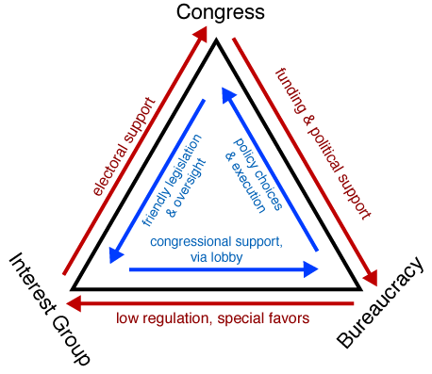

The above figure is an iron triangle ,allows the ability to manage a project by allowing the management to work within a budget, scope and also schedule. The iron triangle was created by Dr. Martin barnes in the mid-1980s it allowed many organisation managements to have an open view open the time, quality and also the scope of the organisation. The vintner family can also benefit from using this method in their organisation as it can help with time management and also allow the organisation to work in a better-quality atmosphere. It has been stated by the following Wysocki, R.K., 2011. In order to put project’s into prospective organisations must use different approaches in the sense of using different tools.

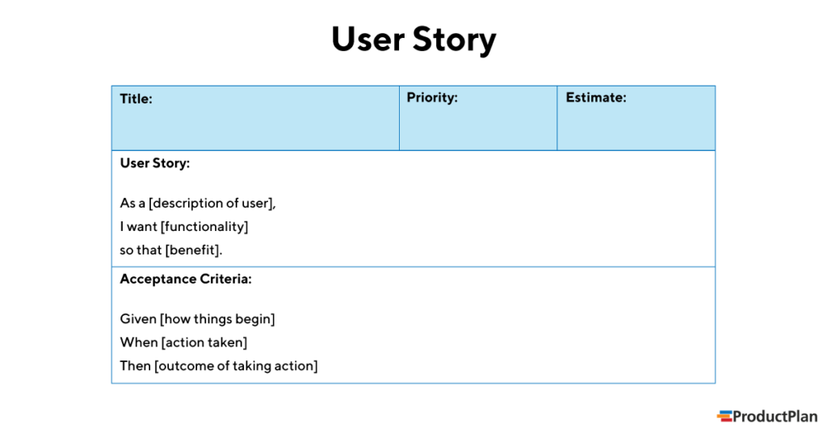
www.productplan.com/

The above figure is an example upon how the user stories can be applied within a management project. It allows the ability to prioritise the main key aspects that are needed to be highlighted in an organisation.
It has been stated by the following Brinkkemper, S., 2016, The user stories are increasingly popular due to the facts of user stories allowing the ability to capture requirements in an agile software development tool.

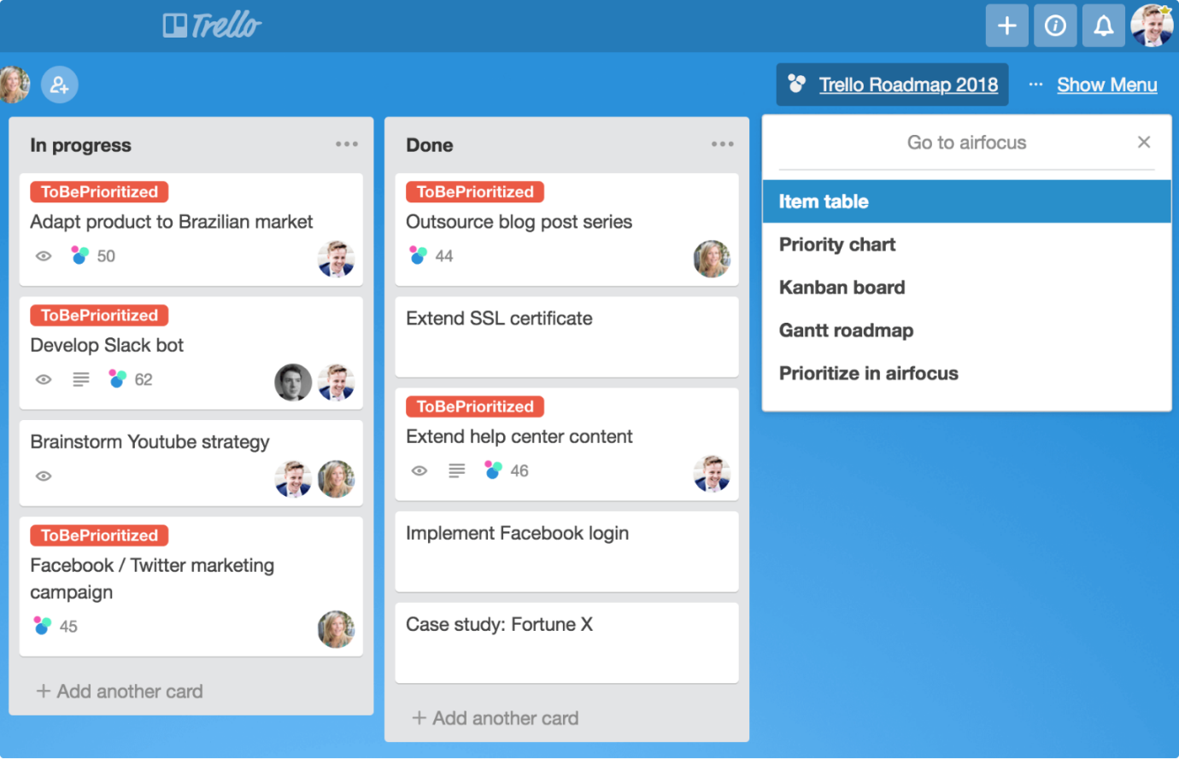

/www.bing.com/images/
The picture above is an example of what trello and also the chevron technique looks like. It has many benefits in regards of benefiting an organisation the vintners have also used this method in order to communicate amongst the stake holder within the organisation. It has been studied and documented by the following Johnson, H.A., 2017. Managing projects may be overwhelming at times, fortunately they are many free apps such as trello and also the chevron technique that can acquire further assistance in project managing these methods can assist project leaders in managing their workflow.
Personal reflection upon the ability of managing the vintner antiques project.
The main self -development aspect I would like to address is obtaining future training in regards of managing a project as due to lack of training within an organisation may cause many down falls and also may lead the company or the organisation to many dilemmas the main key aspect of the vintners organisations that were found whilst developing the plan was that the family run business, acknowledges each individuals ideas and aspect they also take into consideration of the family friends ideas who was Paul ranson as Doreen is a very easy going and is easy approachable . The vintners sponsor always keeps an open mind whilst receiving any feedback in regards of benefiting the company Denis and Omar also had a major job role as their jobs where to make sure that the antiques reached to the Wearhouse in sparkhill safely, Their tactic was very useful as the boxes where safely delivered and also made in time for the warehouse grand opening. According to Meredith, J.R.,2017,. Stake holders can either make or break a business.
Suha also managed to successfully apply the signage up before the Wearhouse opening. Doreen proved that she can be a great business sponsor by using all the correct tools/ methods in regards of obtaining a successful business the overall project management has worked out for the vintner’s antiques warehouse.
self- development for future projects.
In regards of self-development from a management’s perspective, i would like to obtain further training or even study, management programmes/ courses this will help upon achieving further goals and also upon gaining more knowledge in regards of business management. In order to be successful ln management planning, Down below shows a figure highlighting all the major aspects that I will be following in order to develop a better understanding and a greater potential in managing projects, According to Sjekavica, M., 2017. Project management success differs to many different aims and different aspirations.
self develment plan - Bing images

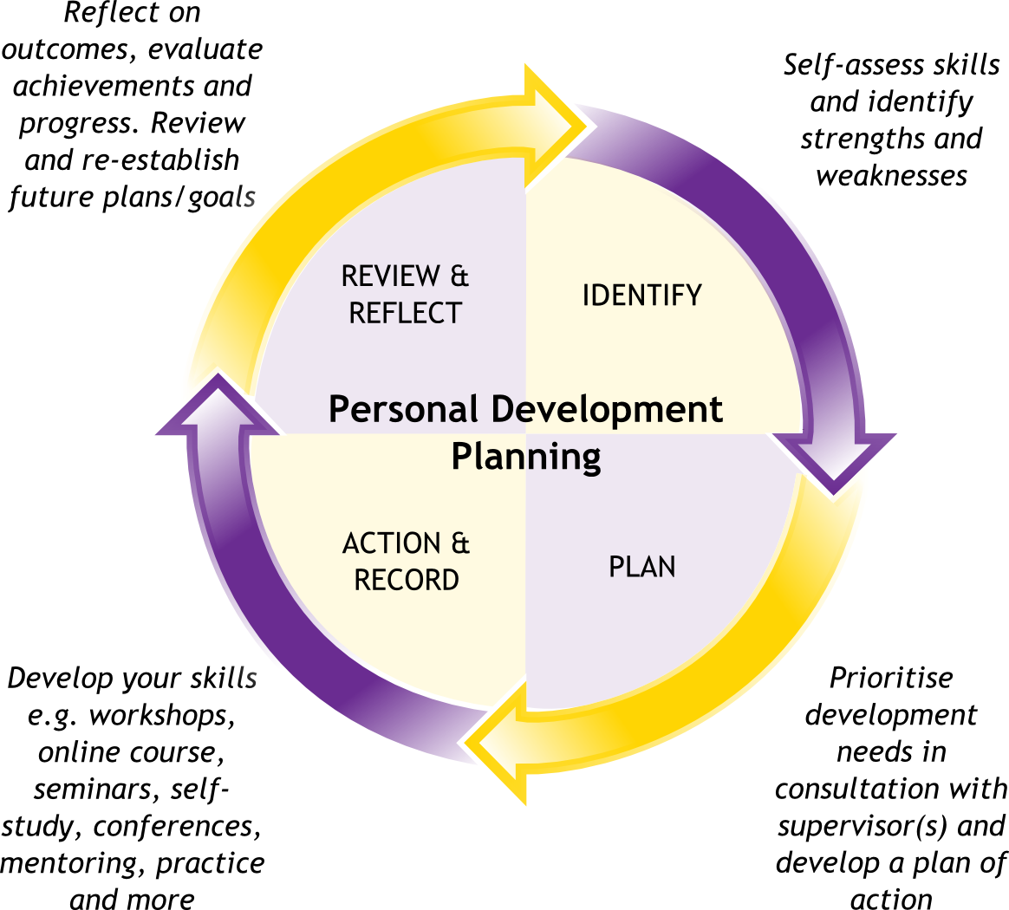

Self-development is an ongoing process that will allow me to innovate the way I process my skills and performance. A personal development plan will also allow me to self-reflect upon my skills in regards of my advantage and to improve my disadvantages therefore in order for me to be successful I will follow this method of self-development for future projects
Conclusion.
As an overall experience of project managing the outcome may always not be successful therefore the management should have an alternative plan. In regards of, if the plans do not meet the given structure therefore in order to meet the achieved goals the manager of the projects should always have an alternative solution. It has been stated by the following Heagney, J., 2016. Project management is the application of the knowledge which allows skills, tools and techniques, project activates can be achieved by applying these methods

References
Buttrick, R., 2013. The project workout: The ultimate handbook of project and programme management. Pearson UK.
Cagliano, A.C., Grimaldi, S. and Rafele, C., 2015. Choosing project risk management
techniques. A theoretical framework. Journal of risk research, 18(2), pp.232-248.
Heagney, J., 2016. Fundamentals of project management. Amacom.
Johnson, H.A., 2017. Trello. Journal of the Medical Library Association: JMLA, 105(2), p.209.
Lucassen, G., Dalpiaz, F., van der Werf, J.M.E. and Brinkkemper, S., 2016, March. The use and effectiveness of user stories in practice. In International working conference on requirements engineering: Foundation for software quality (pp. 205-222). Springer, Cham.
Meredith, J.R., Shafer, S.M. and Mantel Jr, S.J., 2017. Project Management: A Strategic Managerial Approach. John Wiley & Sons.
Moriarty, J., Manthorpe, J. and Cornes, M., 2015. Reaching out or missing out: approaches to outreach with family carers in social care organisations. Health & social care in the community, 23(1), pp.42-50.
Radujković, M. and Sjekavica, M., 2017. Project management success factors. Procedia engineering, 196, pp.607-615.
Treseler, M., 2020. Making Things Happen: Mastering Project Management.
Wysocki, R.K., 2011. Effective project management: traditional, agile, extreme. John Wiley & Sons.

