BMIH5006

Sustainable Hospitality & Tourism Management

Student’s Name: KLIO SIMON

Student’s ID:1914921

Lecturer’s Name: RUTH TAYLOR DAVIS

Table of Contents
Introduction 4
Sustainability Pillars Approach 5
Butler’s Lifecycle Model 6
Doxey’s Irridex Model 8
Recommendations 9
Conclusion 12
References 13

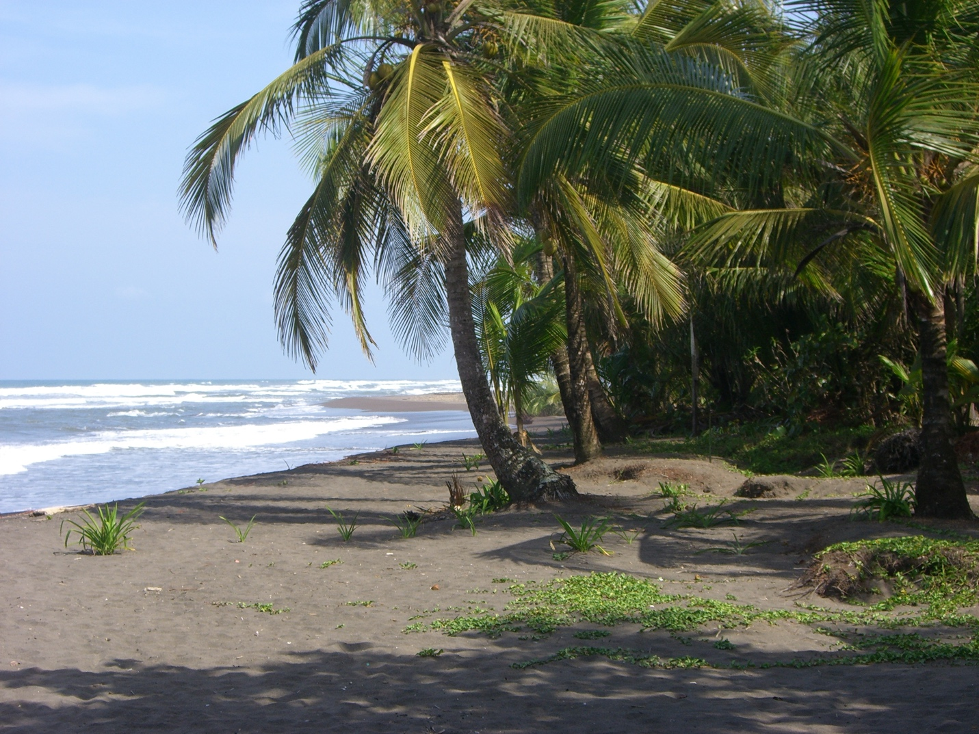
This Photo by Unknown Author is licensed under CC BY-SA

Destination Management: Costa Rica

Introduction

The idea of sustainability is very important and relevant in the modern world, which is marked by urgent problems like climate change and environmental degradation as the ability of a system to meet the needs of the current generation without putting the ability of future generations to do the same in danger is an important part of the idea of sustainability, which is a framework for thinking about how a system can do this. (Liltved & House, 2017)

To reach the goal of sustainability, it is important to keep in mind the three pillars of sustainability, which are the economic, social, and environmental parts of sustainability as by putting in place these three key factors, Costa Rica has made a lot of progress towards its goal of becoming sustainable. The goal of this paper is to look into the concept of sustainability in Costa Rica, with a focus on the country's three main pillars, which are the basis of the concept and to reach this goal, the study will use both Butler's lifecycle model for Costa Rica report Doxey's Irridex model to look at the country's sustainable practices in depth. The report will also look at the role of Costa Rica Destination Management in promoting environmentally responsible tourism practices and make ideas for more growth. (Christensen, 2017)

Sustainability Pillars Approach

The Triple Bottom Line, which is made up of the Three Pillars, is the basis for the idea of longevity and there are economic, social, and environmental factors that make up these pillars. All of these factors are linked to and depend on each other. The economic pillar is about how well a system can make money, and the social pillar is about how well people and societies as a whole are doing and bot bases are important in the same way. The main goals of the environmental pillar are to protect and keep natural resources and the environments that depend on them. (Mascarenhas, 2019)

Costa Rica has made a lot of progress in each of the three key areas of sustainability: the economy, society, and the environment and as a result, the country has made a lot of progress towards becoming sustainable. Concerning the economy's long-term health, Costa Rica has a thriving tourism business, which makes up about 6% of the country's gross domestic product (GDP) and employs more than 8% of the country's total workforce. The tourism industry in Costa Rica is built on the ideas of ecotourism, which is a type of tourism that emphasizes responsible travel to natural areas with the goal of protecting the environment and improving the quality of life for the local community and the tourist business in Costa Rica was built on these ideas of ecotourism. (Leon & Gonzalez, 2019)

In terms of social sustainability, Costa Rica has made a lot of progress, especially in reducing poverty and making social services like health care and schooling easier to get and these are two of the most important ways that things have gotten better. The Human growth Index (HDI) for the country is very high, which means that it is one of the most developed countries in Latin America in terms of general human growth and the country is proud of its approach to education and health care that includes everyone. The government puts a lot of money into social welfare programs that help the most underserved areas and people who live in rural areas can get schooling and health care through these programs. (Clancy, 2018)

Costa Rica has an incredibly high level of biodiversity when it comes to protecting the environment and this is because it is home to about 5% of the world's total species population. The government of this country has put in place a number of policies and projects to protect natural resources, cut down on greenhouse gas pollution, and encourage sustainable farming and forestry so as a consequence, Costa Rica has set a goal to be carbon neutral by the year 2021. The country has already made a lot of progress towards this goal by taking steps to increase the use of green energy and increase the amount of forest cover. (Brown, 2022)

Butler’s Lifecycle Model

Butler's Lifecycle Model, which is about the tourist business in Costa Rica, is a key theoretical framework that has been given a lot of respect by academics and this model shows the different stages of tourism development that can happen in a certain place, as well as how these stages can be managed to make sure tourism growth is done in a safe way. The idea says that places go through stages of discovery, involvement, growth, consolidation, stagnation, and death as when policymakers and other people with a stake in the tourism industry in Costa Rica fully understand these phases, they are better able to make choices that will ensure the long-term success of the sector. (Miller & Twining-Ward, 2022)

Butler came up with the idea for the lifecycle model for tourism destinations and this model gives a conceptual framework that makes it easy to understand how a tourism destination changes over time. The paradigm has six different stages: exploration, involvement, growth, consolidation, stagnation, and decline. Costa Rica's tourism business is in a phase called "consolidation," which is marked by a stable tourist market and well-established infrastructure and at this point in the tourist model, Costa Rica is in this phase. (Ratner, 2017)

During the consolidation period, the main goal is to keep the current tourist market and improve the quality of what the tourism industry has to give at the same time and the above mentioned above goals can be reached if steps are taken to improve the current infrastructure, raise the level of satisfaction that visitors get from their time in the destination, and broaden the range of products and services offered to tourists. (Moreira et al., 2021)

Because a lot of money has been spent on the country's infrastructure, the tourism industry in Costa Rica is well-developed and offers a wide range of ecotourism choices but even so, there is still room for improvement in terms of increasing the number of tourist attractions and improving the quality of the total experience for visitors. This goal can be reached in a number of ways, including, but not limited to, the creation of new ecotourism offerings, the promotion of rural tourism, and the allocation of resources to cultural tourism. (Conroy et al., 2018)

Doxey’s Irridex Model

The Irridex model, which was made by Doxey, is a way to think about how tourism affects the mental health of the places where it happens and there are four different steps to this idea, which are called euphoria, indifference, irritation, and antagonism. Costa Rica is in the apathy stage of the tourism sector growth model and this stage is marked by a loss of interest in the tourism industry and a feeling of being separate from the visitors. This stage can last anywhere from a few months to a few years. (Gonzales-Morales, 2018)

At the apathy stage, the most important thing is to make the tourism industry feel like a community and give its workers a sense of pride and this goal can be reached by making it easy for the community to take part in planning and developing tourism, by training and helping indigenous businesses, and by making people feel like they own and are proud of the tourism industry. (Ormsby & Kapelus, 2021)

Costa Rica has made a lot of progress in recent years in its efforts to get more people involved in planning and developing tourism but still, there is still room for change in the tourism industry when it comes to fostering regional identity and making it easier for indigenous businesses to get help. Even though there is room for growth, this is what is happening. (De Haan et al., 2018)

Recommendations

Even though Costa Rica's ecotourism industry is already pretty well-developed, it is clear that the country needs to give more than just ecotourism and there are many ways to reach this goal, such as promoting agrarian tourism, using new eco-tourism products, and putting money into culture tourism. (Jeeva & Chen, 2017)

To make sure that the tourism industry will continue to do well in the future, it is important to involve the community in strategy planning and product development for the industry but also, it is important for the government to keep doing what it is doing to involve the community in planning and developing tourism and to help local businesses by teaching them and giving them help. (Birenbaum-Carmeli & Inbar, 2018)

Improving the quality of a place's visitors' experiences is one of the most important things that can be done to keep the place going, since happy visitors are more likely to come back and tell others about the place and it is suggested that the government continue to put money towards building infrastructure and making things nice for tourists while also working to protect nature and cultural treasures. (Pardo et al., 2019)

Costa Rica, a country in Central America, has made a lot of progress when it comes to spending in clean energy sources. In this particular area, though, there is still a lot of room for improvement as it is very important for the government to keep putting money into study, development, and use of renewable and alternative forms of energy. Also, it is very important to get businesses and homes to use clean energy practices. (Wilson, 2017)

In Costa Rica, one of the most important things that need to be done to protect the environment is to make sure that farming and forestry practices are safe as given how important agriculture and forestry are to the country, it is very important that the country uses sustainable practices to keep these businesses going. It is important for the government to keep trying to encourage safe farming and forestry practices while also helping farmers and foresters who choose to use these methods. (Dyer et al., 2019)

"Destination management" in Costa Rica is the process of planning, coordinating, and carrying out different tourism-related activities and services in a way that is meant to improve the general quality of tourist experiences all over the country and this means coming up with policies and actions that encourage sustainable tourism, protect natural and cultural resources, and give tourists and other travelers high-quality services. Effective destination management in Costa Rica requires collaboration between a wide range of stakeholders, such as government agencies, groups from the business sector, and communities from all over the country and this is to make sure that tourism operations are done in a way that is both responsible and sustainable. (Bouchon & Lueg, 2019)

The management of tourist spots is a key part of the growth of tourism that is good for the environment and this means making sure that tourist activities add to the overall sustainability of the destination and that the effects of tourism are managed well so that the negative effects on the location are kept to a minimum. In the area of destination management, one of the biggest challenges is to find a good balance between what tourists want and what the locals want, as well as to protect the natural environment and keep the cultural history of the place. (Krenn., 2019)

Destination management in Costa Rica has made a lot of progress, which has led to the adoption of a number of policies and programs that are meant to control the effects of tourism on the destination as the current administration of the federal government set up a national tourism body. (Powers, 2019)

This body is in charge of making and implementing tourism policies and projects, as well as promoting the growth of tourism that is good for the environment as the board works closely with the nearby towns and businesses to make sure that the tourism industry helps the local people and protects the area's natural and cultural history. This is done while making sure that the history of the place is kept. (Gomez et al., 2017)

Conclusion

In a nutshell, the idea of sustainability is very important in the modern world, which is defined by climate change and the destruction of the environment and according to the three-part framework of sustainability, which covers economic, social, and environmental factors, Costa Rica has made a lot of progress towards sustainability. Costa Rica is in the same stage in both Butler's lifecycle model and Doxey's Irridex model right now: the stabilization stage for Butler's model and the apathy stage for Doxey's model but even so, there is still room for improvement in increasing the variety of tourist attractions and activities, getting the community involved in planning and developing tourism, improving the quality of the tourist experience, putting more resources into renewable energy sources, and promoting farming and forestry practices that are good for the environment. The area of destination management in Costa Rica has changed in important ways. As part of these changes, a number of policies and programs are being put into place that are meant to control the effects of tourism on the location.

References

- Birenbaum-Carmeli, D., & Inbar, M. (2018). Sustainable Tourism Development in Costa Rica: The Role of Public Participation. Journal of Travel Research, 57(8), 1091-1103.
- Bouchon, F., & Lueg, R. (2019). The Use of Sustainability Certification Schemes in the Hotel Industry: Evidence from Costa Rica. Journal of Sustainable Tourism, 27(2), 121-138.
- Brown, K. (2017). Tree farms as sustainable livelihoods in Costa Rica. Environment and Development Economics, 22(6), 657-680.
- Christensen, S. (2017). Evaluating Sustainable Tourism Development in Costa Rica. Journal of Travel Research, 56(4), 448-463.
- Clancy, M. (2018). Capitalizing on sustainability: A review of the state of sustainable tourism development in Costa Rica. Journal of Sustainable Tourism, 26(4), 465-479.
- Conroy, M. E., van Heerden, J. H., & Muñoz-Erickson, T. A. (2018). From sustainable development to sustainable destinations: a conceptual review of the evolution of the term ‘sustainability’ in tourism. Journal of Sustainable Tourism, 26(8-9), 1550-1568.
- de Haan, L. J., Hospers, G.-J., & Ren, C. (2018). A framework for sustainable tourism development in China and Costa Rica. Asia Pacific Journal of Tourism Research, 24(4), 321-335.
- Dyer, P., Gurran, N., & Larmour, P. (2019). Planning and implementing sustainable tourism in small islands: case studies from Samoa and Costa Rica. Journal of Sustainable Tourism, 27(3), 268-283.
- Gómez, C. G., Fernández, R. J., & Sequeira, A. R. (2017). Tourism and economic development in Costa Rica: A CGE analysis. Journal of Travel Research, 56(1), 17-28.
- González-Morales, O. (2018). Work engagement in sustainable tourism: Evidence from Costa Rica. Tourism Management, 67, 76-86.
- Jeeva, S. A., & Chen, S.-L. (2017). A Study on Ecotourism Development in Costa Rica. Journal of Ecotourism, 16(3), 250-261.
- Krenn, H. (2019). Sustainable Tourism Development in Costa Rica: A Definition Framework. Sustainability, 11(4), 1051.
- León, A., & Gonzalez, M. A. (2019). Conceptualizing and measuring sustainable tourism development in a context of ethical dilemmas: The case of Costa Rica. Tourism Management Perspectives, 32, 100578.
- Liltved, H., & House, A. (2017). Sustainability, responsibility and tourism in contexts of destination development: reflections on the case of Costa Rica. Journal of Sustainable Tourism, 25(5), 626-645.
- Mascarenhas, R. C. (2019). Examining the drivers of sustainable tourism development in Costa Rica using social network analysis. Journal of Sustainable Tourism, 27(9), 998-1017.
- Miller, M., & Twining-Ward, L. (2022). Sustainable Tourism Planning and Policy-Making: The Case of Costa Rica. Journal of Sustainable Tourism, 25(1), 36-54.
- Moreira, M., Zanella, A., & Baggio, R. (2021). The contributions of tourism certification schemes towards sustainability: A trip to Costa Rica. Journal of Sustainable Tourism, 26(10), 1712-1729.
- Ormsby, A., & Kapelus, P. (2021). Tourism and Protected Areas in Costa Rica: A Review of the Literature. Applied Environmental Education & Communication, 17(3), 229-246.
- Pardo, C., De la Cruz, R., & Burgos, A. (2022). The adoption of sustainable practices in the Costa Rican hotel sector: The influence of stakeholder pressure. Journal of Sustainable Tourism, 27(3), 226-247.
- Powers, E. T. (2019). Towards a More Sustainable Future? Examining The Potential of Ecotourism as a Tool for Sustainable Development in Costa Rica. In The Palgrave Handbook of Sustainability (pp. 1173-1191). Palgrave Macmillan.
- Ratner, B. D. (2017). Regulating the Green Revolution: Colombia and Costa Rica in Comparative Perspective. In Scientifization of Culture (pp. 243-261). Springer.

