Programme: Certificate of Higher Education in Skills for the Workplace
Students’ names: Claudia Madalina Mitu
Tincuta Bardas
Eduard Cristian Neagu
Module: Digital Skills and Research Methods
Module Code: BMSW4003
Module leader: Paul Ranson
Assignment title: Component 1 Research Methods – Presentation

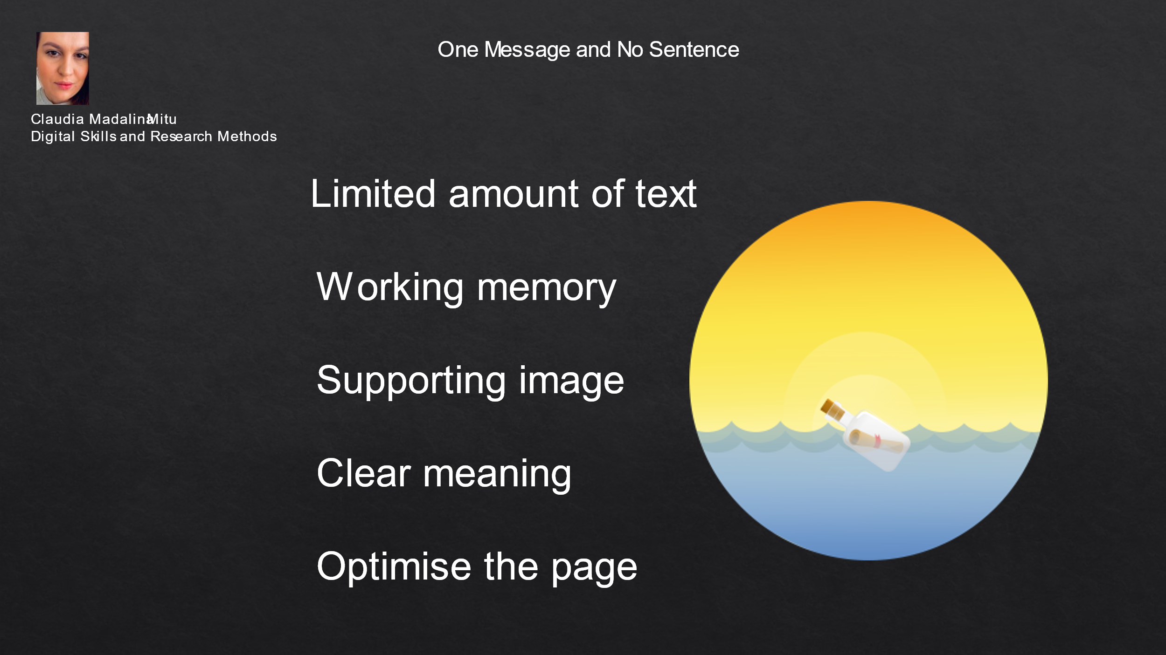

To have one message per slide, or one point per slide, is considered one of the biggest presentation trends (Stinson, 2016). The points are presented in a chronological order, just as in an instruction manual. Each step is broken down to simple pieces, in order to relax the working memory of the audience. According to Khoury (2021), value is added by the verbal presentation, which in this manner will be followed with attention by the audience. People usually retain only parts of a presentation (Malcolm, 2019) and that is why it is important to have on a slide only key information. Furthermore, research demonstrated that people forget almost everything they just heard, if and when there are two different messages at the same time. For this reason, there should be only one message per slide. The image is used as a support and increases the visual memory of the participants (Schurgin, 2018). People do not come to a presentation to read, but to hear a speaker. The key information clearly presented on a slide will help people understanding, their focus will follow the words of the speaker. According to Philips (2021), the audience should be able to comprehend the content of a slide in 10 seconds, as the content itself is used to support the verbal presentation. Just because one slide presents one message does not mean that it stands in isolation. The slides should flow from one to the next and have a clear transition. Creating the slides with a touch of humour or using a visual with no text will help the audience to focus on the presenter. The participants will need the speaker to understand what they are seeing. Afterall, PowerPoint was initially created to become a tool for visual representation of the content and not to replace the speaker (Khoury, 2021).

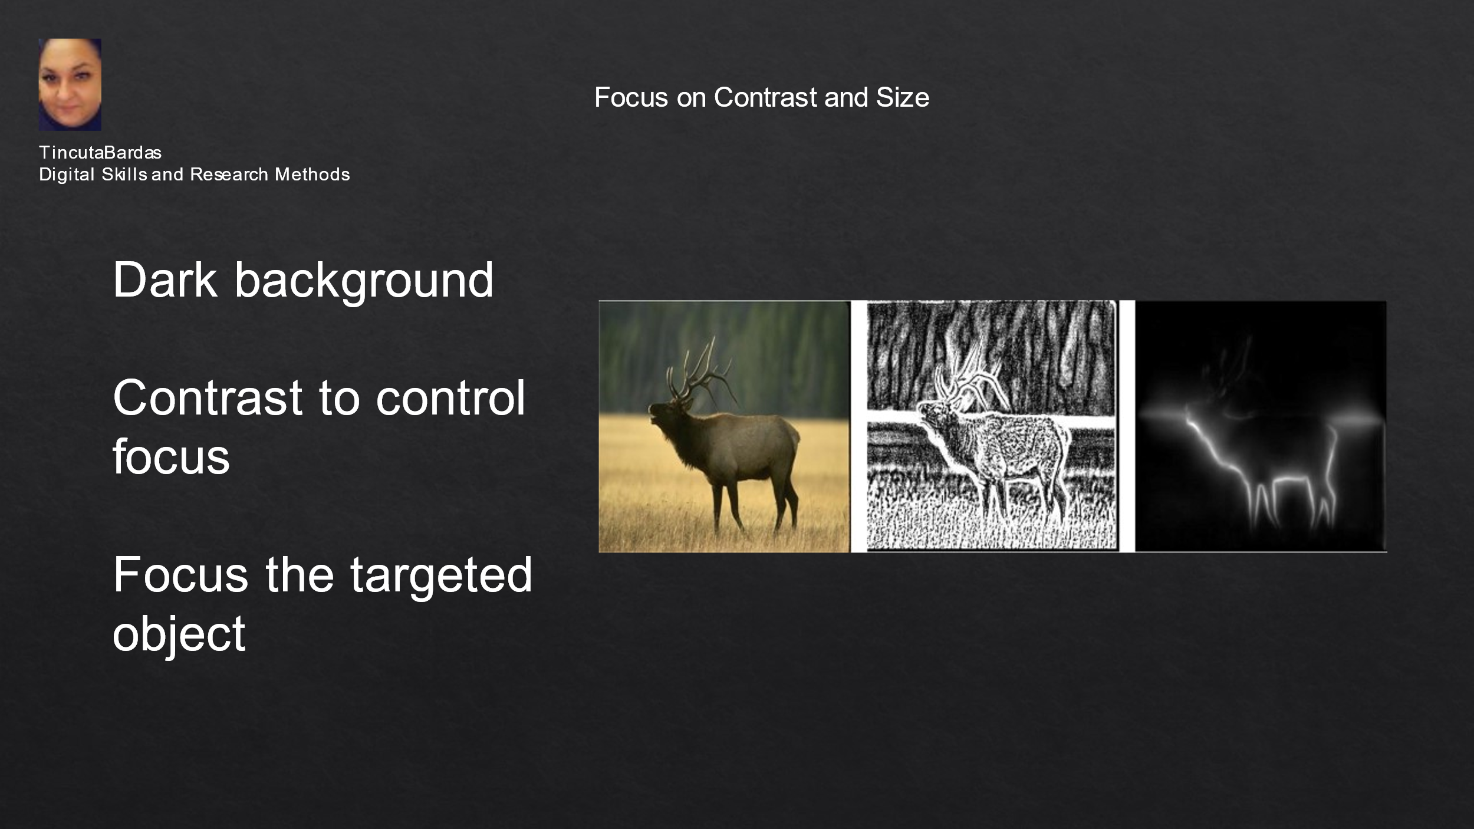

The quality and the flow of the content are as important as the dark background, together with the contrast and size of the text on a slide (Philips, 2021). Dark backgrounds should have light text and bright accent colours for the images. In this way, the audience can see the text and also the graphs or shapes on each slide. Today, most organizations dictate a template with corporate colours, as part of a branding initiative (Chan, 2019). If this is the case, there is not much choice. Still, a high contrast may be used for colours, between the background and the text or visuals. The contrast is useful when used on the size of the font. The headline or title will be smaller and the key information will be larger (Philips, 2021). Thus, the working memory of the audience will be successfully used and the audience’s focus will be controlled, reaching the targeted information (Smith, 2020). The eyes will follow the parts which are presented with a high contrast and thus the key information will be easily retained. The minimum size for the slide’s text is 24, and the contrast could be made with a Bold text, avoiding animation or flickering texts. It is important that the letters on slides are large enough, so most people can see them (Association of Research Libraries, no date). The most important part in the PowerPoint should be the biggest one in the slide. Furthermore, the devices which are used for a presentation, such as screen or TVs, together with the distance to the last row of chairs, are important features in deciding the size of the fonts. If there are used active links, they should resolve to the correct destinations. Overall, the PowerPoint presentations should be made fully accessible to every member of the audience.

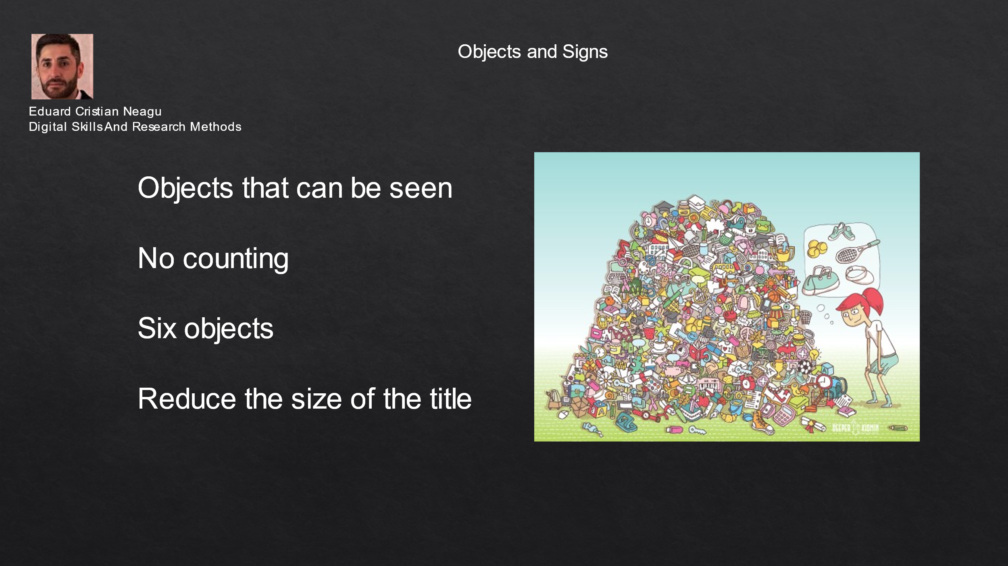

Researchers have demonstrated that the number of objects or items on a slide will lead people to count them, they need more time and energy, without retaining the necessary information (Colman, 2020). For seven or more items, people need to count, whilst for six or less, people just need to see, according to the same author. The aim of a PowerPoint presentation is to make people to follow the presenter (Barnard, 2018). If there are seven objects on the slide, researchers have shown that people need 500% more time and energy to comprehend the slide, and this is not the aim of any presentation (Philips, 2021). A simple rule states that six is the maximum of items that can be on a slide. For instance, instead of seven bullet points, there can be used five bullet points and an image, meaning six items or objects. And by reducing the size of the title, the objects will be larger and seen by the participants. According to Philips (2021), the five rules presented in this project, have a great positive impact on a presentation. Following these guidelines, the presentations may be part of a strategy and have relevant content. The objects may be aligned, ordered, grouped and rotated in various ways. Another explanation for this optimal number is that people’s perceptive limit is very low and the presenter should control the audience’s attention and focus it towards the key content (MindTools, no date). The presented five design principles will cognitively and psychologically optimise the PowerPoint slides (Philips, 2021).

