Module Code: LCLM4002_BIRM
Module title: Digital Skills
Student N and ID: Nasra Aman

My Screenshots/Photos

Screenshot/Photo 1
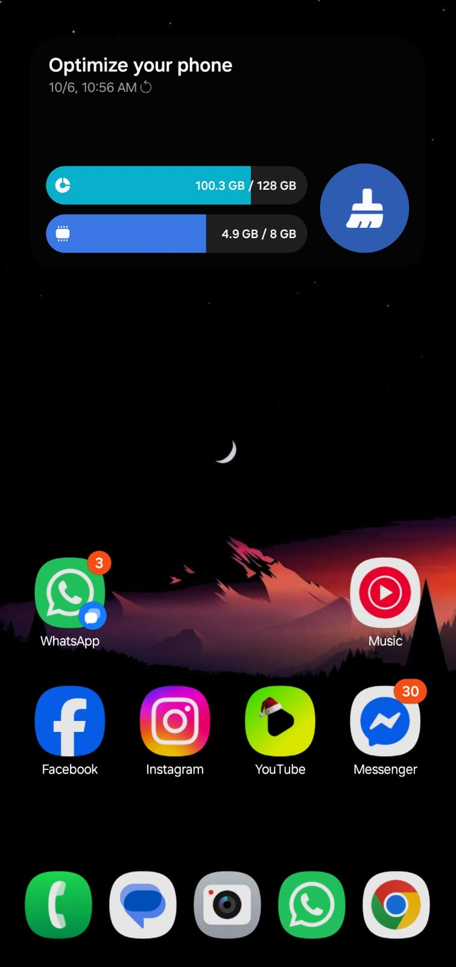
This is a screenshot of my phone. It shows that I use multiple digital applications in my digital life. I use different social media platforms, content consumption tools, and WhatsApp for communication.

Screenshot/Photo 2
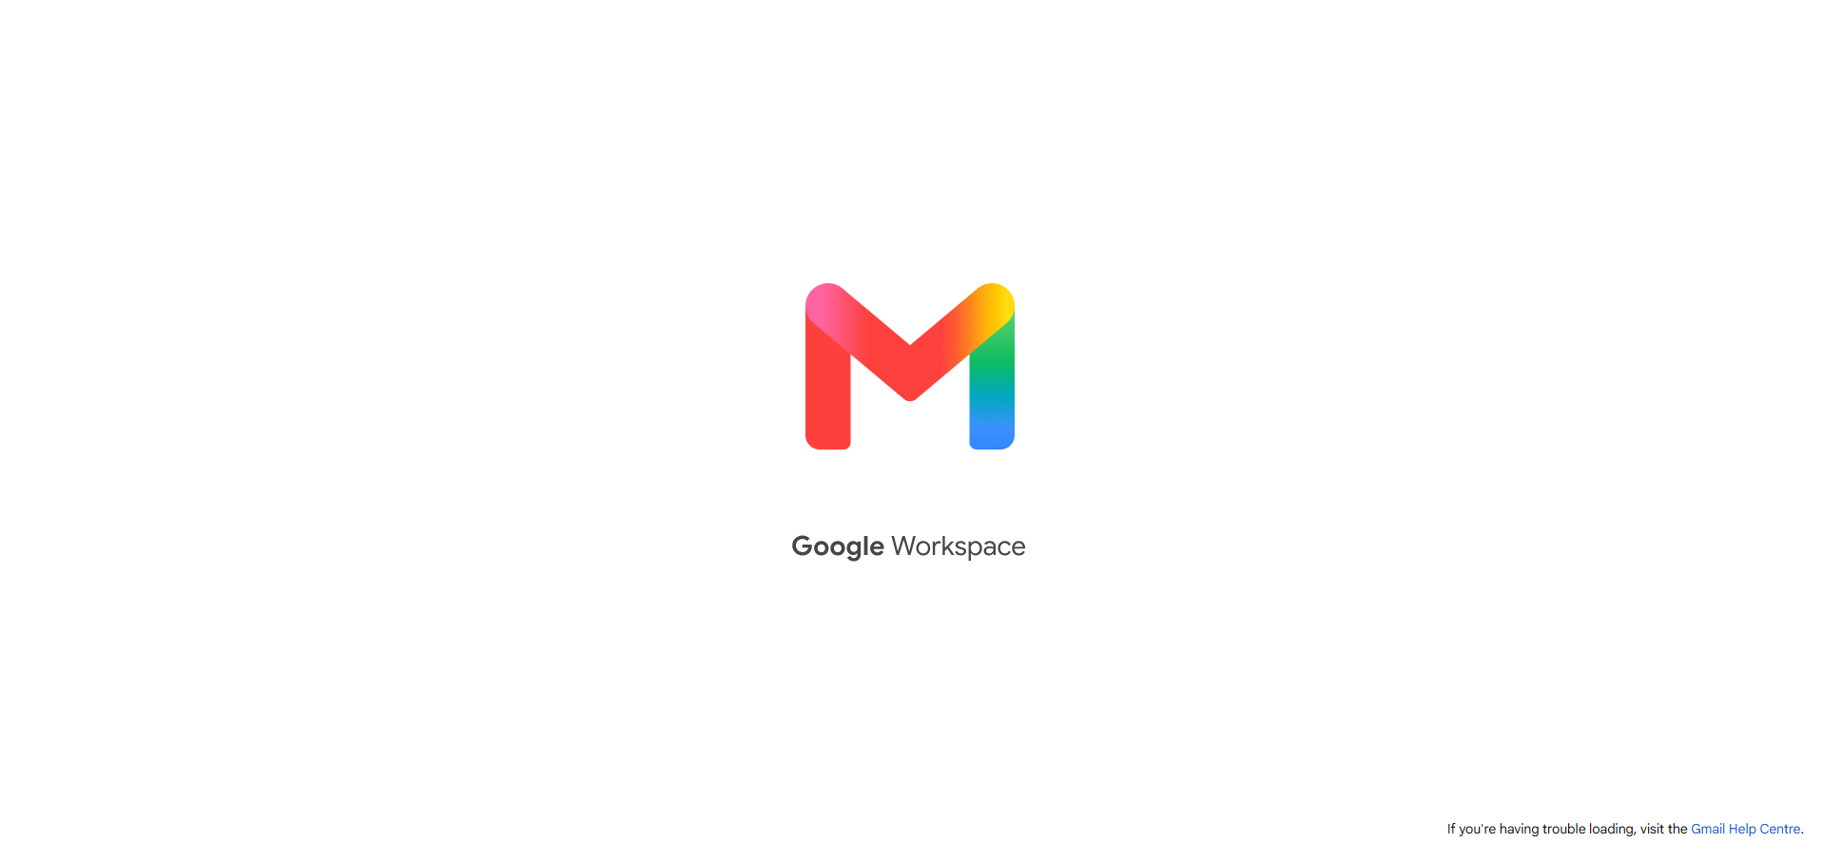
This screenshot was taken on my computer. This shows one of the most used applications called Gmail. It is an electronic mail service that allows me to send email easily and efficiently.

Screenshot/Photo 3
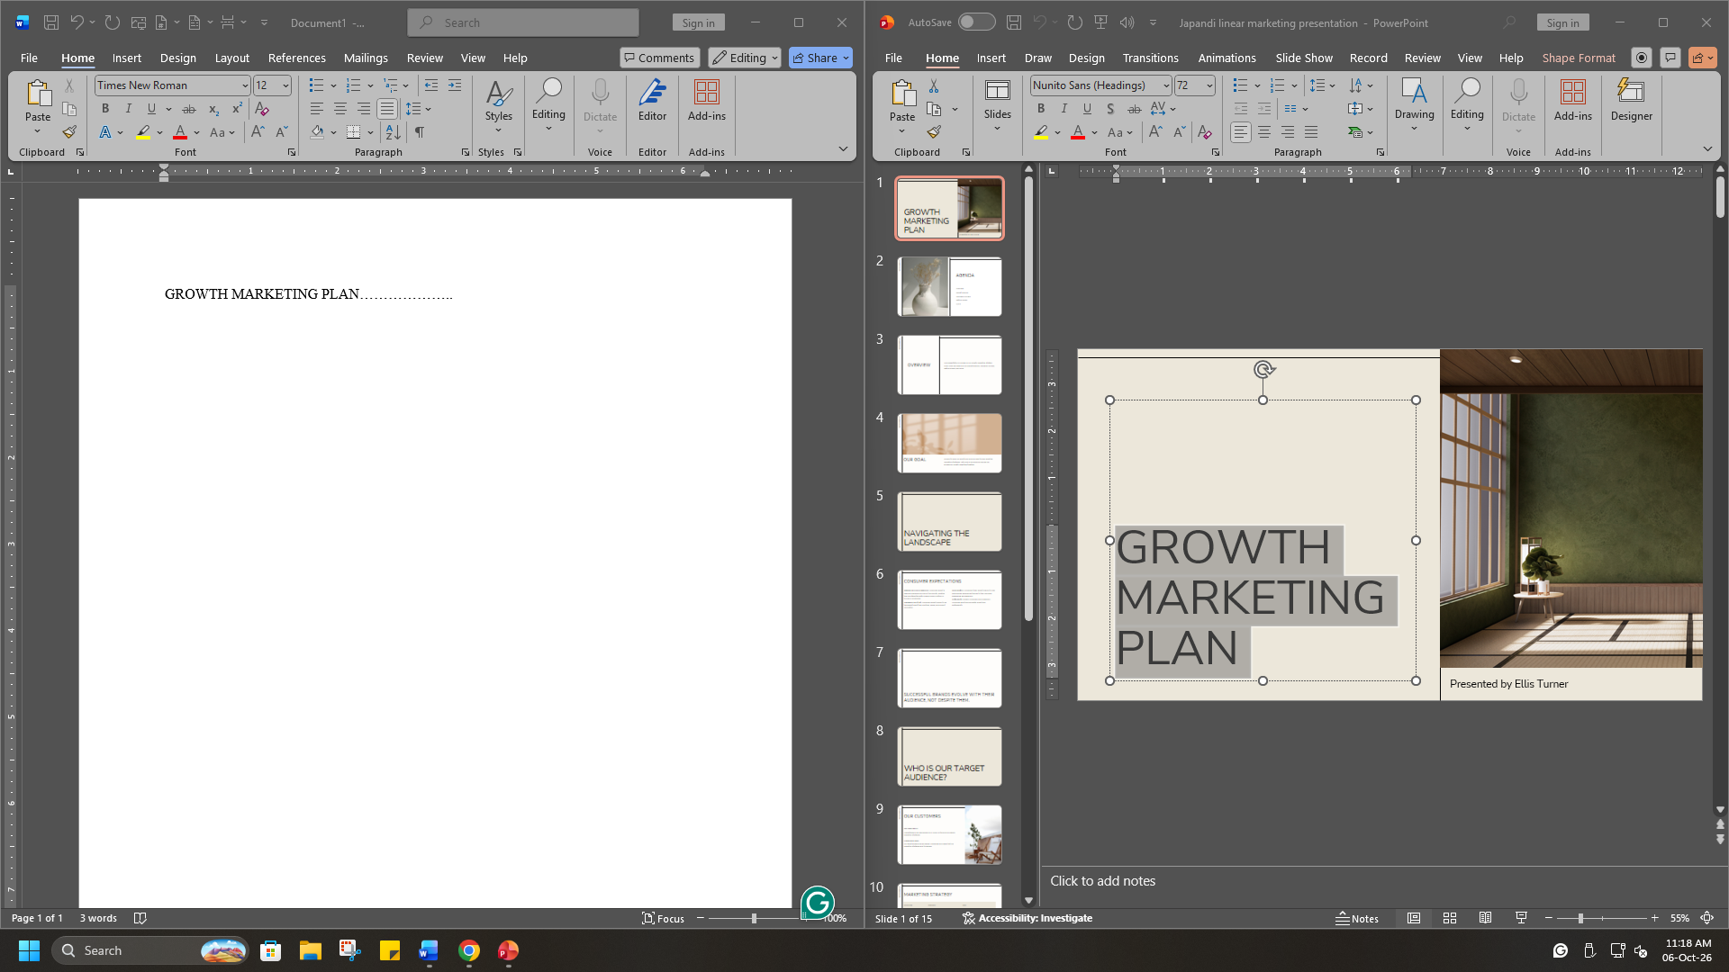
This screenshot shows the use of Microsoft Word and PowerPoint. They are powerful digital tools. They help to create documents and presentations. I intend to use them for my assignments in the future.

Screenshot/Photo 4
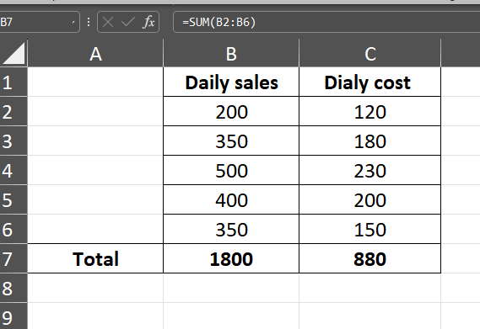
This is a very powerful digital tool called Excel. It is used for calculations and structuring large data. The screenshot shows that I am able to use this tool to make simple calculations using formulas such as =Sum(B2:B6).

Screenshot/Photo 5
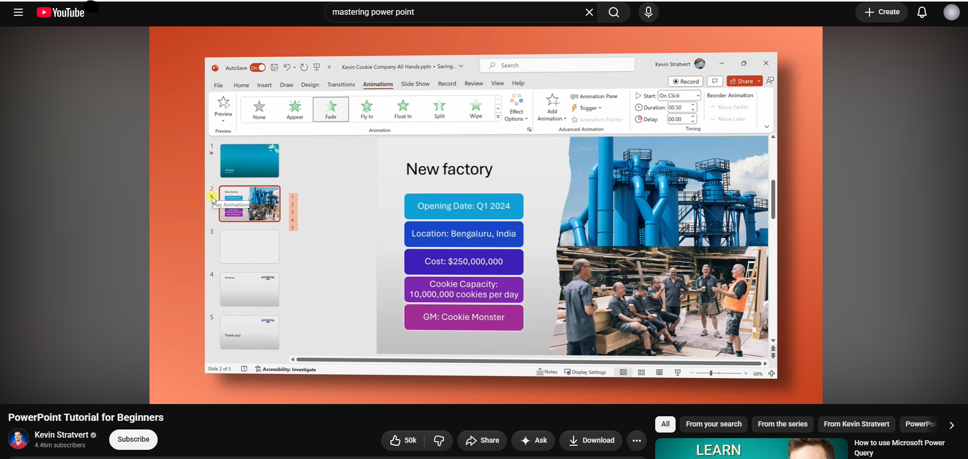
There is no limit to learning. So, to learn faster and effectively, I use different methods. The screenshot shows that I use the content-sharing platform YouTube to learn about the effective use of PowerPoint.

My Short Reflection
Digitalisation has become a part of everyday life. It has become very accessible. That is why I also use them in everyday life. I use applications such as social media and WhatsApp to communicate with my friends.
There are professional tools like PowerPoint, Word and Excel that help with my assignments. I also understand they will be important for me in future. Because in the professional landscape, I will need to use them to show my creativity and abilities.
But sometimes I lack the confidence to use those digital tools effectively. This may become a major reason for limiting my academic performance. So, I hope this module can help me overcome my limitation and learn about more digital tools.
There is no limit to learning digital tools. Each year, new and more advanced tools are being created. That is why I want to keep learning and improve my abilities to utilise digital tools. I believe they can support me in fulfilling my goals for the future.
I am also confident that engaging with the module will open a new path for me. I will be able to learn faster and more effectively. I will also be able to take advantage of the features those digital tools offer.

Submission Checklist
​​​ ☒ I added 4–6 screenshots
☒ I wrote short sentences for each screenshot
☒ I wrote my short reflection
☒ My work is my own
☒ My file opens correctly
​

