Task 1
Relevant areas of the National Policing Curriculum:
Understanding the Police Officer Role.

You must choose a policing incident in which you played a significant role with an offender/service user/victim and reflect on what happened.

Critically evaluate the strategic role of the College of Police in professionalising policing in the U.K.

Evidence how you are working to fulfil the role of a modern professional police officer now that you are in your final year of probation.

Critically reflect upon how your final year of probation has seen your role as a police officer change.

Consider the strategic Policing requirement, Policing Vision 2025, the Workforce Transformation 2018 and the College of Policing’s 5 Year Strategy.

2000 words (+/- 10%: include your actual word count at the end of each section)

ANSWER:

This essay shall aim to evaluate the role the College of Policing plays from a strategic perspective in relation to contemporary professional policing in the United Kingdom. It will also evidence how I as an individual am implementing ways and means of how to fulfil the expectations and demands imposed upon me as a police officer who is less than twelve months away from becoming fully operational. The following essay will include an emphasis on a personal and critical reflection on how my journey up until this point has evolved, how I have adapted to organisational changes and how my role in and of itself has altered since my training first began in 2022.

The College of Policing – a creation accredited to the then Home Secretary and representatives from various policing organisations - was established in 2012 and serves as the professional body for policing, covering England and Wales (College of Policing). The College of Policing was created to replace the existing training, guidance and development that was historically provided by the National Police Library and the National Policing Involvement Agency (NPIA). The primary objectives of the College of Policing are to enhance the professional and public ideals of British policing via the reinforcement of professional standards, expert training and an expectation on the individual of continuous improvement.

The police Code of Ethics – first introduced by the College of Policing in 2014 – is a set of values which provide statutory guidance to police officers for standards such as their uses of the application of force, for them to carry out orders and obey instructions, an emphasis on equality and diversity and, perhaps most important of all, a mandatory requirement for honesty and integrity in every aspect of their duties (College of Policing, 2014).

Fig.1 - The Code of Ethics 2014 (Wood, et al., 2022)

In 2024, the college updated the Code of Ethics for ethical policing in the United Kingdom and provides updated statutory ethical principles for all police members to adhere to, as well as guidance for professional behaviour. (College of Policing, 2024)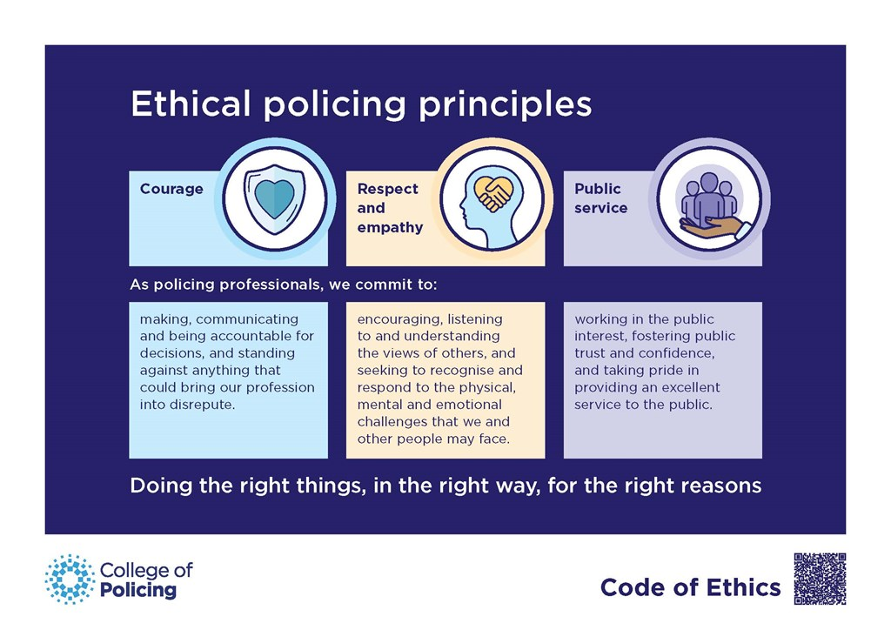
Fig.2 - Ethical Policing Principles, Code of Ethics 2024 – College of Policing

The College of Policing continues to evolve to meet the contemporary demands and requirements of police officers of today. In November 2014, it implemented a ‘Five-Year Strategy’ which was incorporated with;
- A vision to deliver ‘world-class’ levels of equipping its members with skills and knowledge to prevent crime, protect the public and secure public trust.
- A purpose to set standards of professional practice, to identify and promote good practice, promote ethics, values, and standards of integrity and to help police forces to work together towards the overall goal to protect members of the public and to prevent crime.
- An emphasis on the values of integrity by always maintaining professionalism, accountability when making errors and to uphold the Code of Ethics. To be respectful, open, and honest at all times with both peers and public.
- Ways of working – where decisions should always be made based on the best evidence possible.
- Working with partners – Where the professional body of the College underlines the importance of the Home Office, Police and Crime Commissioners (PCC’s), among others.

Dame Shirley Pearce, the Independent Chair for the College of Policing, regarding the plan, states that the changing demands in British policing now drive “an increase in professionalism and raising questions about the knowledge base, culture and leadership required for effective 21st century policing”.

From a strategic policing perspective, in 2012, then British Prime Minister Theresa May introduced a Strategic Policing Requirement to underline the importance of a police response to dangers at national and localised levels, which would thus guarantee a detailed, planned, and well-implemented response to terrorism, organised crime and public disorder. This plan has recently been updated as of 2023 and has introduced violence against women and girls as a national threat, as well as reaffirming the validity of the existing threats (Home Office, 2023).

From a workforce perspective within the police, the National Police Chief’s Council (NPCC) implemented the Workforce Transformation in 2018 with a view to launching a new profession in conjunction with the Policing Vision 2025 with a more representative workforce within the police which will align the right skills, powers and experience to meet contemporary requirements. The main and overarching objectives of this uplift were to continue to build a modernised culture of adhering to the Code of Ethics within the police, training and development through academia, an emphasis on professional and personal development and creating a leadership and management development model which equips leaders to meet future challenges among many others.

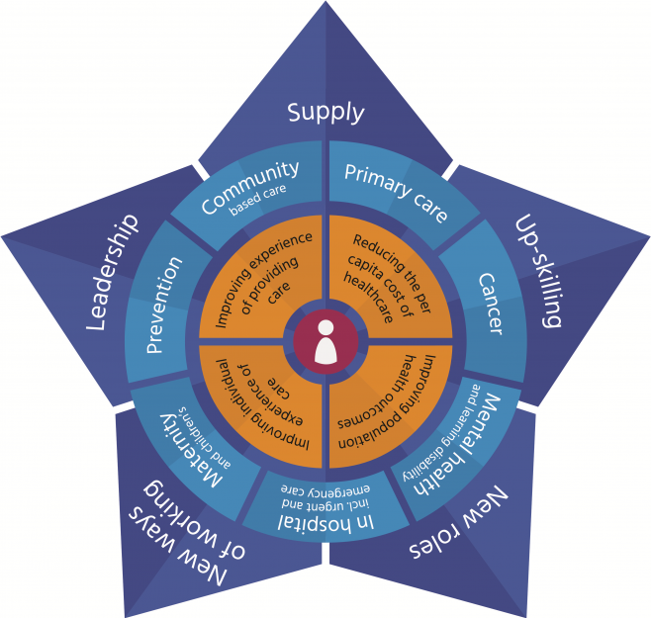

Fig.3 - The Workforce Transformation 2018 – npcc.police.uk

To augment steps taken by the College, the NPCC and by the British government, other professional bodies also implement steps to modernise policing to keep up to date with ever evolving and contemporary policing requirements. The previously mentioned Policing Vision 2025 was developed by the Association of Police and Crime Commissioners (APCC) and the NPCC with five key priorities for the reform of:

- Local policing (described as the ‘bedrock’ of British policing) with an emphasis and ambition to incorporate a more ‘multi-agency team’ dynamic to pool funds rather than addressing issues and problems with a ‘silo’ approach.
- Police officers to be better trained in internet and online criminality.
- An emphasis on specialist capabilities, like armed policing, surveillance and major crime investigations.
- A partnership with the College of Policing to deliver workforces the training and guidance required to equip them with the powers and skills required to meet these challenging requirements.
- The consolidation of resources such as Information Technology (IT) and Human Resources (HR) in cross-force units and integration with local authorities and emergency services to mitigate costs.

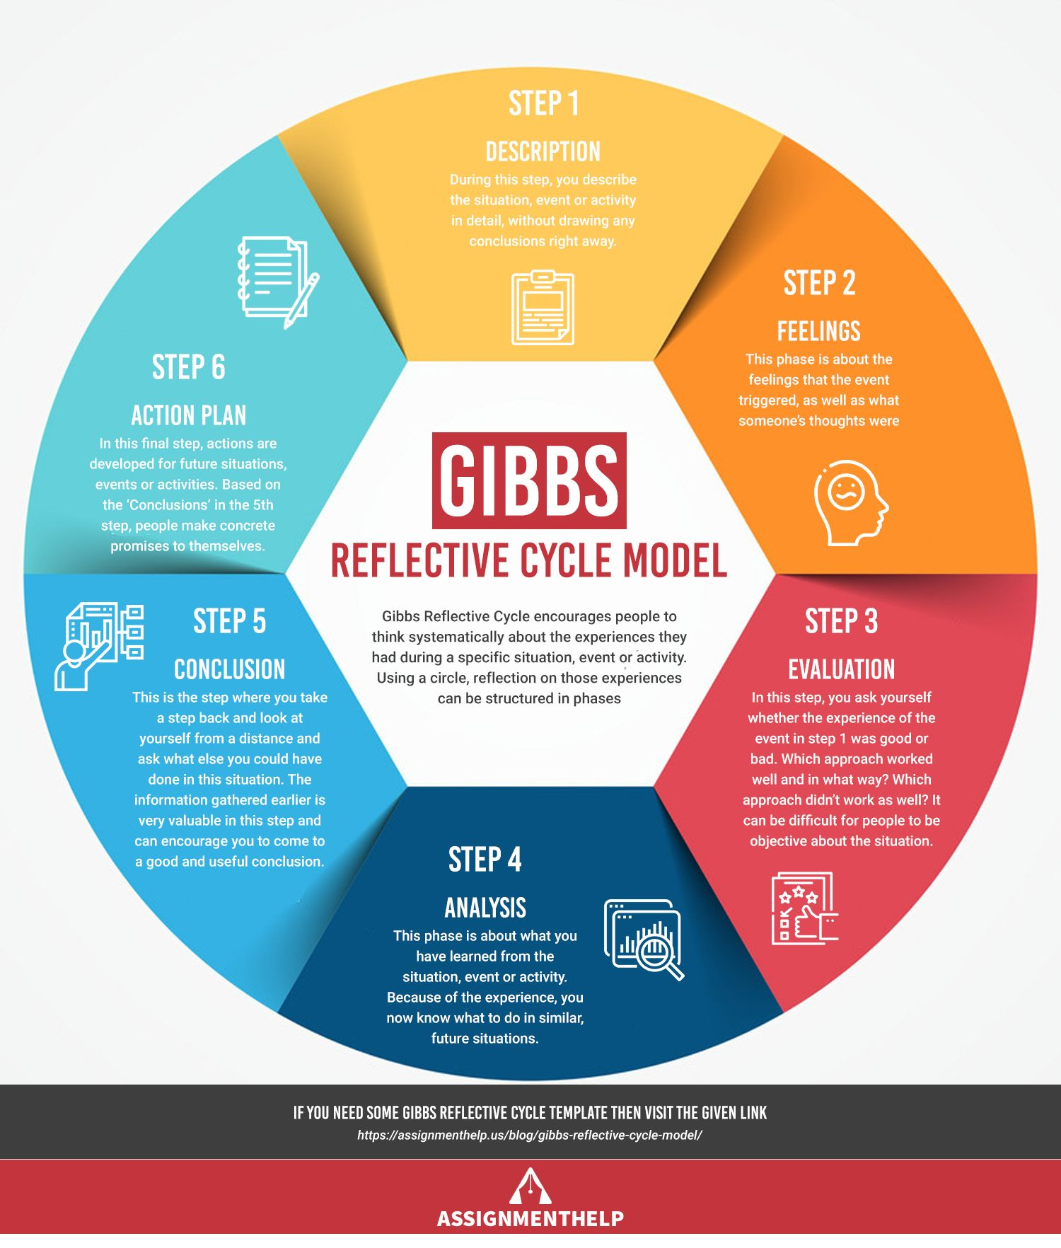
Fig.4 - The Gibbs Reflective Model

To ensure that I am consistently reflecting on my experiences throughout my policing career thus far, I have utilised the Gibbs Reflective Model (Gibbs, 1988) on many occasions. This model is a framework for examining experiences and learning from them. One such occasion involved a recent incident I attended where a female stated to my colleague and I that she had been physically assaulted by her neighbour following a dispute over their dogs running onto each other’s gardens. The female claiming to be the aggrieved was known to me from previous incidents and has previously been proved to be someone who embellishes or fabricates truths and is someone who suffers with a range of mental health problems. Having dealt with many domestic abuse-related incidents previously, I often take what the victim says at full face value and will arrest any person described as the perpetrator, with any potential investigation to be dealt with following the detained person’s processing and subsequent interview. On this occasion, I did this and arrested a male neighbour who had been identified by the female victim as I felt it was appropriate at the time. Colleagues had attended the area to assist while I was escorting the detained male into my police vehicle and by this point, due to the residential area of the arrest being an area known for an increased level of police presence, many neighbours had exited their properties and had been spoken to by my colleagues, delivering their accounts of what had happened. My sergeant subsequently requested that I de-arrest the male and the matter be dealt with a different way, given that the female victim had subsequently been identified as the person who had instigated the original argument between the neighbours, and that no assault had taken place. On reflection, I should have obtained more information and conducted more of a detailed investigation at scene into what happened and perhaps waited a little longer for colleagues to arrive. I could have also conducted enquiries for CCTV within the residential area to aide with the identification of any possible offences. In future, I will heed this oversight and will treat every incident involving any assault allegations on its own merits and utilise the National Decision Model (NDM) with more attention paid to gathering information and intelligence.

Conclusion

In conclusion, the College of Policing plays a vital role in setting standards to which I and every other member of the police forces of England and Wales are to adhere to, to mitigate or to improve the reputation of the police itself across the United Kingdom, but to emphasise the police’s core values such as transparency, professionalism and trust so that members of the public can feel confident in reporting incidents and, just as importantly, believed and fully supported when doing so. As evidenced, the importance of updating plans, schemes and legislation that is already in place is crucial to adhering changing demands from a policing perspective.

From a personal perspective, I continue to push myself daily while executing my duties. I treat every shift as an opportunity to learn, adapt and thrive and I do this by taking on board as much information as possible, whether it be learning how to deal with certain calls and situations or by learning from any shortcomings or mistakes I make along the way. I also try to be as dynamic as possible to continually adapt to any organisational changes and alterations to existing legislation so that certain methods that I may have previously implemented – which may become outdated or obsolete – are altered so that I am in full compliance and therefore free of the possible contravention of rules or regulation breaches. This is to ensure that I provide the best possible service to the public and towards my peers and colleagues. With the ongoing recruitment drives, which see the influx of new faces bringing with them new perspectives and new backgrounds and given that I am now over two years into my career, I find that I am quickly becoming a more experiences officer and perhaps someone that new officers can look to for advice and assistance in anything they may need to bed into their new careers themselves. I consider myself very approachable and friendly and I have always excelled when it comes to tutoring or passing on knowledge, dating back through all previous roles and vocations that I have undertaken, and also outside of a working environment. Not that long ago, I was in their position, so that I am able to empathetically bridge the gaps between themselves, myself and then towards my colleagues who vary from more experiences than I, to vastly more experienced than I am at present.

Following the completion of my initial training in September 2022 and since the beginning of my role as a response police officer, I have already witnessed transformations in policing. For example, with changes varying from minor and incremental, to major and national, I have had to adapt to cultural changes such as the correct gendering of members of the public and the sensitivity around the subject to a national speed limit change on many Welsh roads to 20 miles per hour. Changes, as I was quickly made aware within my first fortnight on response – with members of my new team leaving the job or moving to other teams – is and will forever be a regularity and a phenomenon that I will need to be prepared for and be able to adapt to throughout my future career within policing.

1,874 words

References
College of Policing (2014). THE PROFESSIONAL BODY FOR POLICING Five-Year Strategy. [online] Available at: https://library.college.police.uk/docs/college-of-policing/Five-Year-Strategy-2014.pdf. – Accessed 22/07/2024.
‌
Gibbs, G. (1988) Learning by Doing: A guide to teaching and learning methods. Further Education Unit, Oxford Brookes University, Oxford – Accessed 22/07/2024.

Home Office (2023). Strategic Policing Requirement 2023. [online] GOV.UK. Available at: https://www.gov.uk/government/publications/strategic-policing-requirement-2023. – Accessed 22/07/2024.

House of Commons Home Affairs Committee (2016). College of Policing: three years on Fourth Report of Session 2016-17. [online] Available at: https://publications.parliament.uk/pa/cm201617/cmselect/cmhaff/23/23.pdf. – Accessed 22/07/2024.

NPCC (2016). Police Chiefs and PCCs Set out a Vision for Policing in 2025. [online] Police.uk. Available at: https://news.npcc.police.uk/releases/police-chiefs-and-pccs-set-out-a-vision-for-policing-in-2025. – Accessed 22/07/2024.

Wood, D., Bradshaw, S., Dickens, T., Parker-McLeod, J., Simpson, F. and Weaver, G. (2023). Blackstone’s Handbook For Policing Students 2022. S.L.: Oxford University Press. – Accessed 22/07/2024.
‌

Task 2
Relevant areas of the National Policing Curriculum:
Communication Skills, social media, Communication Strategy

You must choose a policing incident in which you played a significant role with an offender/service user/victim and reflect on what happened.

Critically evaluate your experience of the use of social media as a means of informing and engaging with the community and promoting policy initiatives.

- Consider the force policy on using social media for professional information and engagement purposes.
- What social media platforms are used by policing?
- What are the benefits and risks of using social media?

2000 words (+/- 10%: include your actual word count at the end of each section)

ANSWER:

This essay shall aim to critically evaluate the use of social media platforms by police forces in England and Wales, with emphasis on how it is utilised to inform and engage with communities. Consideration will be given to the policies of using social media by police forces – which should be purely for information and engagement purposes, as well as social media platforms such as ‘X’ (formerly ‘Twitter’), Facebook, YouTube, Snapchat and Instagram and the benefits and risks of using them to reach a wider audience via electronic means.
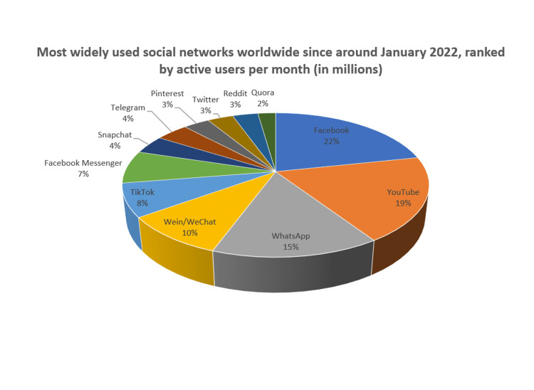
Fig.1 – Most widely used social networks worldwide. January 2022 – January 2023. Cureus, 2023
‘Social media’ is defined as a set of interactive internet applications (colloquially referred to as ‘apps’ – some of which are noted in the above graph) that facilitate creations and sharing of user-generated content (Davis, 2016) with an estimated 45% of the current world population currently having access to it via some form of online account (Storm, 2024). This number, when put into a context based within the United Kingdom only, is estimated to be as high as around 53 million people – just under 78% of people – currently on social media (Zivkovic, 2024), with this number surely rising exponentially year on year. In England and Wales, social media-specific offences include ‘trolling’, meaning online abuse from person to person which is often anonymous, ‘grooming’ which refers to the actions of a person who builds a bond with a child to gain sexual gratification or to sexually exploit the child and also online stalking, a form of harassment involving persistent unwanted contact. Those found guilty of these offences can be prosecuted under the Malicious Communication Act 1988 and the Communications Act 2003 (Crown Prosecution Service, 2017). There are, however many other forms of relevant legislation covering online offences.

Social Media use by the Police

As web-based technology evolves, police forces all around the world have invested heavily in their use of social media. Globally, between 2007 and 2017 in particular, police forces invested in the use of social media to engage with the public and guidelines were created as a means to train officers in this field (Fernandez, et al. 2017). The association of Chief Police Officers (ACPO), who state that “not only is social media a part of modern life”, but it gives police a platform to hold conversations with the public that cannot, or which may not be pertinent to conduct in person. ACPO also states that “there are some hugely productive uses of social media that support crime reduction and detection” and that the “speed and reach it gives us (as a police force) is a very powerful tool” (NPCC, 2014). Prior to this, the move of policing communication from the physical to the virtual (i.e. social media’) has been described as increasing constabularies relationship with the public, thus making the police more “open, participative and democratic” (Fink and Zerfass, 2010), (Avery and Graham, 2013). In keeping with the force’s social media policy, it is imperative that any member or officer posting any personal views make it clear that what they are posting is not a representative of the force or the community they serve, and that every effort must be made to not bring the police into disrepute.

Police forces in England & Wales often utilise Facebook to spread awareness of missing persons, off-road bikes and other risks to the public and general awareness of upcoming local events or other instances that could have either a positive or negative impact the wider community. Teams and groups within the policing world also use WhatsApp – a heavily secure and encrypted online communication service - on a daily basis, both in and out of work to stay connected. The benefits of this rather than traditional phone calls or SMS text messaging are that communication is instant and it allows for multiple people to be communicated with rather than having to pass information to each individual at a time.

In contrast to these positive and productive outcomes of social media and its use, there are evidently negative outcomes, within a policing context, there are several elements of risk. These risks are categorised by the Home Office (2013) into the following five elements:
- Breach of trust or confidence – Covering the disclosure of information obtained by the police – either about the police or its colleagues.
- Unauthorised disclosure of personal date – In keeping with the DPA (Data Protection Act) 2018 which has now implemented the (GDPR) General Data Protection Regulations (Gov.uk, 2018).
- Bringing discredit to the police force – On or off duty conduct which affects public confidence. Police officers should be mindful of the viral effect of the internet and social media when uploading any content.
- Revealing personal information – Increased vulnerability to harassment, corruption and blackmail. Police officers are expected to take provisions to maintain a sense of confidentiality with regards to their home addresses, phone numbers etc and are expected not to associate with the social media of criminals.
- Revealing operational material or tactics – The disclosure of tactics used by the police, including covert tactics, which may be prejudicial to investigations and subsequent arrests. Any breaches of this by police is an offence under The Official Secrets Act 1989.

The utilisation of social media and online sources by police forces to conduct searches for individuals believed to be involved in clandestine or criminal activity is referred to as ‘open source’ investigation. In keeping with Dr. Edmund Locard’s principle of exchange that ‘every contact leaves a trace’, or ‘footprint’ (Locard, 1920), as all police computer infrastructures are allocated their own unique internet protocol (IP) addresses, many modern criminals are easily able to determine whether police computers have searched for certain persons. This simple investigation on a criminal’s part could then hinder an investigation in significantly detrimental fashion.

Social Media use by the public

From a public perspective, social media incorporates many benefits and risks. Social media promotes knowledge sharing, provides a platform for people to stay in touch with friends, new and old, promotes free learning and can help communities with shared experiences. Where crime and reporting is concerned, social media can be utilised to report anonymously to put those who fear repercussions of reporting at ease. According to uSwitch data, as of 2022, 86% of people in the United Kingdom use their mobile phone to go online. This is compared to 28% in 2009 (Baker, 2024). This is clear evidence that the level of accessibility to a social media, and in turn, a reporting platform – for any member of the public regardless of levels of ‘tech-savvy’, or disability - is at an all-time high.

Due to its beneficial social aspects and opportunities, researchers have noted social medias positive individual impact on college students (Kim & Kim, 2017), those users experiencing low self-esteem (Ellison et al., 2007) and similarly an increased sense of “life satisfaction and civic engagement and participation” for ‘intense’ users of Facebook (Valenzuela et al., 2009) while it has been argued that social media has been shown to decrease mental health and well-being (Kanchan & Gaidhane, 2023).

In order to police the “wild west” online, the introduction of the Online Safety Bill by British parliament in 2021 aimed to create new offences and tighter rules to protect users, particularly children and those less technology ‘savvy’. Damian Collins, then chairman of the joint committee stated at the time that “what (is) illegal offline should be regulated online” (BBC, 2021). The aims of the bill were to create new offences to police the general distribution of ‘seriously harmful’ misinformation, an aim to decrease the level of ‘scam’ marketing, the making of content that promoted self-harm to be made illegal and for the introduction of a new offence named ‘cyber-flashing’ – or the sending of unwanted naked images. Prior to this proposal, nonconsensual pornography, also known colloquially, and more well known as ‘revenge porn’ was incorporated under the Criminal Justice and Courts Act in 2015. This was later amended by the Domestic Abuse Act in 2021 to include threats of any disclosure of private sexual photographs or films (College of Policing, 2022).

Conclusion

In conclusion, I have learned from research into this subject that the use of internet, social media and other online services within a policing context comes with a myriad of pros and cons. Its positive outcomes – such as its use to locate missing persons and to increase public awareness of criminals unlawfully at large - can be eclipsed by its pitfalls and the high amount of risk involved with its utilisation. Police officers must – at all times – pay close attention when using any social media with close adherence to guidelines published by ACPO (now NPCC) and the National Police Improvement Agency (NPIA), in addition to legislation such as the Computer Misuse Act 1990 (Crawford, et al. 2020). The Independent Office for Police Conduct (IOPC) warns that conduct that could bring any of the British police forces into disrepute through inappropriate or offensive behaviour conducted online either on or off duty by any serving police officer is deemed as completely unacceptable and could lead to investigation or worse, dismissal due to gross misconduct (IOPC, 2021). Due to my findings within this field, I shall always seek advice and guidance where possible in any use going forward and shall seek to read through any applicable literature if faced with any issues with my personal use of social media platforms.

To keep up to date with a modern world, with all of its existing and ever-advancing technology, the importance of police across the world moving with the times is imperative. Not only must the force represent the public for which it stands to protect in terms of equality and diversity, but so to must it mirror the high level of intricate electronic and internet-based crime with an adequate level of contemporary means with which to mitigate, investigate and to prosecute those guilty of committing such offences. I have discovered that, with the introductions of more safeguarding measures being put in place to protect members of the public while online – such as the proposal of and introduction of putting new offences into law – that there will be a much heavier workload for police to deal with in coming years, if the data included in this essay relating to mobile phone usage is anything to go by. I have also learned more about so-called ‘newer’ offences such as ‘revenge porn’ which have been born and have grown in line with the post-millennium rise of mobile phone and internet use and I believe that these learnings will benefit me greatly hen dealing with them in my policing career going forward. It is of critical importance that police forces adapt to these new crimes in line with the advances in technology and, in turn, all new laws and legislation put in place to protect the user.

1,806 Words

References

- Avery, E. and Graham, M. (2013) ‘Political public relations and the promotion of participatory, transparent government through social media’, International Journal of Strategic Communication, 7, 4, 274–91. – Accessed 23/08/2024.

- Baker, N. (2024). UK mobile phone statistics 2022. [online] Uswitch. Available at: https://www.uswitch.com/mobiles/studies/mobile-statistics/. – Accessed 02/09/2024.

- Crown Prosecution Service (2017). Cyber / online crime | The Crown Prosecution Service. [online] www.cps.gov.uk. Available at: https://www.cps.gov.uk/crime-info/cyber-online-crime. – Accessed 02/09/2024.

- Ellison N. B., Steinfield C., Lampe C. (2007). The beneﬁts of Facebook “Friends:” Social capital and college students’ use of online social network sites. Journal of Computer-Mediated Communication, 12, 1143-1168. – Accessed 02/09/2024

- Fernandez, M., Dickinson, T. and Alani, H. (2017). An Analysis of UK Policing Engagement via Social Media. Lecture Notes in Computer Science, [online] 10539, pp.289–304. doi:https://doi.org/10.1007/978-3-319-67217-5_18. – Accessed 23/08/2024.

- Fink, S. and Zerfass, A. (2010) Social Media Governance 2010: How Companies, the Public Sector, and NGOs Handle the Challenge of Transparent Communication on the Internet, Research Report, Leipzig, Germany: University of Leipzig and Fink & Fuchs PR, http://www.ffpr.de/newsroom/wp-content/uploads/2012/08/Social-Media-Governance-2010-Results-final.pdf - Accessed 23/08/2024.

- Government of UK (2018). Data Protection Act. [online] GOV.UK. Available at: https://www.gov.uk/data-protection. – Accessed 23/08/2024.

‌

- IOPC (2021). IOPC warns officers about inappropriate social media use | Independent Office for Police Conduct. [online] www.policeconduct.gov.uk. Available at: https://www.policeconduct.gov.uk/news/iopc-warns-officers-about-inappropriate-social-media-use. – Accessed 23/08/2024.

- Kanchan S, Gaidhane A. Social Media Role and Its Impact on Public Health: A Narrative Review. Cureus. 2023 Jan 13;15(1):e33737. doi: 10.7759/cureus.33737. PMID: 36793805; PMCID: PMC9925030. – Accessed 02/09/2024.

- Kim B., Kim Y. (2017). College students’ social media use and communication network heterogeneity: Implications for social capital and subjective well-being. Computers in Human Behavior, 73, 620-628. – Accessed 02/09/2024.

- National Police Chiefs’ Council (2014). Social media is a powerful tool for police to engage with the public. [online] Available at: https://news.npcc.police.uk/releases/social-media-is-a-powerful-tool-for-police-to-engage-with-the-public. – Accessed 23/08/2024

‌

- Mazzoleni, G., Barnhurst, K.G., Ikeda, K., Maia, R. and Wessler, H. (2016). The international encyclopaedia of political communication. Chichester, UK ; Malden, Ma: John Wiley & Sons. – Accessed 23/08/2024.

- Revenge pornography. (n.d.). Available at: https://assets.college.police.uk/s3fs-public/2022-07/Revenge-pornography-2021.pdf. – Accessed 02/09/2024.

- Roncacè, Scilla & Nicosia, Umberto. (2016). "...Every contact leaves a trace...", Locard 1920. – Accessed 23/08/2024.

- Storm, M. (2024). Social Media Definition: What It Is and Why It Matters. [online] WebFX. Available at: https://www.webfx.com/blog/social-media/social-media-definition/ - Accessed 23/08/2024.

- Valenzuela S., Park N., Kee K. F. (2009). Is there social capital in a social network site? Facebook use and college student’s life satisfaction, trust, and participation. Journal of Computer-Mediated Communication, 14, 875-901. – Accessed 02/09/2024.

- Zivkovic, J. (2024). UK Social Media Statistics and Facts [2024]. [online] Available at: https://cybercrew.uk/blog/social-media-statistics-uk/#:~:text=Interestingly – Accessed 23/08/2024.

‌

‌

Task 3
Relevant areas of the National Policing Curriculum:
Leadership and Teamworking

You must choose a policing incident in which you played a significant role with an offender/service user/victim and reflect on what happened.

Critically evaluate and evidence your flexibility in leadership style.

Critically analyse leadership strategies that you have developed to manage a range of different operational situations.

Consider leadership models commonly used in policing.
How were you able to apply a change in leadership style/strategy to reflect changing circumstances?

2000 words (+/- 10%: include your actual word count at the end of each section)

ANSWER:

This essay will aim to critically evaluate and evidence my flexibility in leadership style. It will also aim to analyse specific leadership strategies that I have personally adapted and developed to manage a vast array of different operational scenarios within a policing context, and how I have been able to adapt my own leadership styles to reflect these circumstances. The context and efficiency of existing leadership models – which are commonly used in policing – will be included, considered and analysed also.

Although the terms ‘management’ and ‘leadership’ are often regarded as having interchangeable definitions. Put simply, ‘management’ is generally the process of planning and control while ‘leadership’ is the process of people working to achieve a target, goal or objective as a collective (McCauley, 2024), or it is “the action of leading a group of people or an organisation” (Pandey, 2022). There are a number of different styles of management, ranging from a charismatic leader to a transitional leadership style. When implemented correctly, all of them can be effective management styles. (Miranda, 2023).
In any role that requires leadership, it is imperative to be dynamic and to possess the ability to adapt and react to change in situations, or, as research suggests “the most effective leaders switch flexibly among the leadership styles as needed” (Goleman, 2000).

As summarised by journalist Rebecca Knight in a Harvard Business Review, management styles of effective leaders can be categorised into six individual styles, these being:
- Coercive leadership style – Which demands immediate compliance from employees. This particular style is the “least effective in most situations”, according to Goleman. This is due to it being characterised as an authoritarian approach with a ‘do-what-I-say’ attitude exuded by a company’s leaders, thus resulting in short-term results with a negative and corrosive long-term impact on company culture and, in turn, a high employee turnover with a disinterested workforce.
- Authoritative leadership style – Which mobilises employers and persons towards a ‘vision’. This style sets clear guidelines while avoiding micromanaging, while placing trust into employees to work towards said ‘vision’ with a sense of autonomy and creativity. In direct contrast to coercive being the least effective kind of leadership, authoritative leadership is oft regarded as the most effective and inspiring of leadership styles.
- Pacesetting leadership style – Which involves expecting excellence and self-direction and holding oneself and others to high standards. This monkey-see-monkey-do style is self-explanatory but does come with its pros and cons. For example, Goleman states that the constant push for productivity and high-standards of work can create a “pressure-cooker work environment”.
- Affiliative leadership style – Which involves building emotional bonds and a sense of team spirit and camaraderie. Combining this approach with the authoritative style creates more balance by offering both support and direction.
- Democratic leadership style – Which involves creating consensus and harmony within a workforce by utilising less of a delegatory and authoritative approach when dealing with its employees, giving employees a lot more ‘freedom’ and sense of trust to strive for excellence without being spoon-fed or overly ordered around.
- Coaching leadership style – Which focuses on developing people for the future. This style is focused on individual growth as opposed to the growth of the overall team being a primary objective, echoing the adage that the value of the individual is greater than the overall sum of the parts. Individuals contributing their own individual skillsets and ideologies, as the way the combine adds a much greater quality from an intrinsic perspective (Sin Nam Lim, 2021).

These styles also feature - and have expanded upon - a model created by German American social psychologist Kurt Lewin in 1939. This model is referred to as Lewin’s Leadership Styles Framework, or more simply, Lewin’s Leadership Theory (Lewin, 1939). The genesis of this model has been disputed, with it being argued that it emerged following Lewin’s death in 1947 (Cummings, et al 2015).

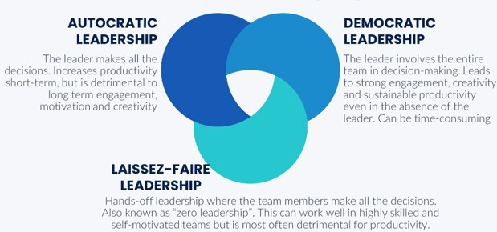

Fig. 1 – Kurt Lewin’s Leadership Styles – leadershipahoy.com

While comparing Lewin’s research with that of Rebecca Knight’s, Lewin’s appears to be a simplified version, with the three categories of styles forming umbrella terms which encompass those stated by Knight. Lewin’s ‘autocratic’ seems to include the ‘authoritarian’ and ‘coercive’ leadership styles described by Knight. ‘Democratic’ is self-explanatory as the name and style remains the same with both researchers, while Knight has introduced ‘pacesetting’, ‘affiliative’ and ‘coaching’ styles in the sixty-plus years since Lewin’s original psychological studies. Lewin also included the ‘Laissez-Faire’ style in his three-category model, with this being described as a “zero leadership” style where employees (or ‘team members’) make all of the decisions while the ‘leader’ simply acts as a ‘boss’ rather than a coach or a mentor to them.

In 2023, The College of Policing published guidance to set out leadership standards at five organisational stages. These range from stages one, two, three, four and stage five, featuring a spectrum containing ‘leadership foundations’, ‘first-line leaders’, ‘mid-level leaders’, ‘senior leaders’ and ‘executive leaders’ respectively (College of Policing, 2023). The college – following extensive engagement with the police forces of England and Wales – have also explored and devised six key elements which are expected of its leaders at all levels;

Inspiring common purpose – Where police leaders build a strong sense of values within the force and an engagement with members of the public and stakeholders. This is supported by a clearly defined vision, and it underpinned by the Code of Ethics.
Developing and valuing people – Where leaders demonstrate a strong commitment to the morale and emotional, physical and psychological wellbeing of its workforce. Leaders are also expected to promote an ethos of personal and professional development of individuals and to set an example with their own commitment to learning and adapting.
Building an inclusive workplace – In order to build a police force that best represents the community it serves, leaders are expected to create a wholesome working environment in which every member, irrespective of their circumstances, background and rank, role or position is treated fairly and equally.
Leading across boundaries – An expectation that police leaders are not constrained by a lack of personal skills, knowledge or a low-level of confidence to lead their teams beyond the boundaries posed by organisations and traditional hierarchies.
Performance and improvement – Police leaders promote continuous improvement and learning throughout the force and organisation to always seek better ways of serving the public.
Understanding self and others – This places an emphasis on a leader using their own personal experiences to improve their own leadership skills and performance, with an importance on the leader being as authentic and genuine as possible to convey a sense of humanity.

In terms of how I have been able to apply a change in leadership style and with that an alteration in strategy to reflect changing circumstances, I will refer to an incident that I recently attended during my nighttime economy. This specific incident I attended in the company of a newer member of the force, who had only been operational for around six months at the time, and a Special Constable. A Special Constable is a voluntary role within the police force where unpaid members of the public are expected work a minimum of 16 hours a month. They are sworn officers with full powers (Blackstones, pg.22, 2022).

During the early hours of my tour of duty, I was made aware of a fight that had broken out between two members of the public, with a member of nightclub door staff also being engaged in throwing punches. As a more experienced officer, I initially took it upon myself to take ‘the lead’ and to take charge of the situation, given that we were located in a highly populated area, surrounded by many members of the public who were intoxicated. Initially, the altercation simply appeared to be three males engaged in violence, but with quick dialogues with the public after separating the males, I was able to establish that the two males had been ejected from one of the clubs and the member of door staff has subsequently been caught up in the fight, before he had then decided it upon himself to continue to be aggressive and to continue to throw further punches and kicks into both males.

I have utilised the National Decision Model – featured in the below diagram - to incorporate and adapt a working strategy based on what information I could gather at the time, by continually assessing the threat and risk to evolve my working strategy, and to identify an internal list of options with a consideration for contingencies. As part of the investigation at scene, I have contemplated the viewing of CCTV and to my surprise, my less experienced colleague had already done so, and had quoted the use of necessary and proportionate self-defence in accordance with s.3 of the Criminal Law Act 1967 towards the male door staff member, before arresting him on suspicion of common assault, due to them “contravening their use of reasonable force”. Based on the CCTV, my colleague informed me that the other two males had not really done anything following their ejection and I have then subsequently given them dispersal orders to leave the area in accordance with s.35 of the Anti-Social Behaviour, Crime and Policing act 2014. This power states that any persons issued with the written must leave a specified area for up to 48 hours.

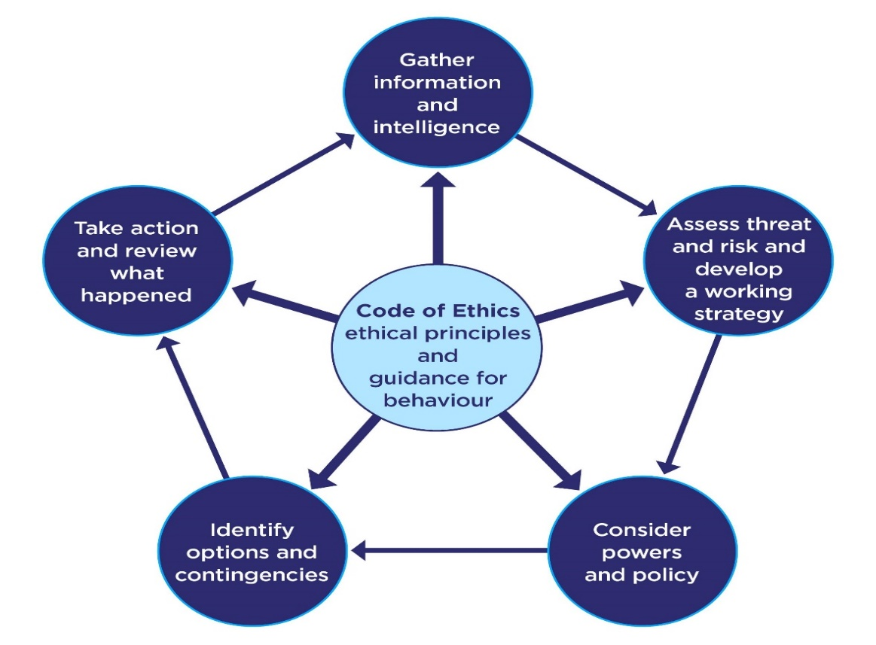
Fig.2: The National Decision Model (NDM) – College of Policing

Conclusion

When dealing with the nighttime economy incident, upon personal reflection I believe that at the time and given the circumstances, I initially utilised an autocratic (or authoritarian) leadership style, possibly believing that my colleagues would not be able to perform at a certain level. I was pleasantly surprised by their willingness and fortitude to get directly involved in the breaking up of the three involved parties without any prompting, and their intuition to conduct a prompt and effective investigation when I was engaged with other matters and before assisting officers could attend to deal with other members of the public. In future, I believe that I would adapt a more democratic leadership style and will show more belief and trust in my colleagues, whether they are known to me or not. I would choose to adapt this style as it encourages the engagement and creativity with new lines and ways of thinking that can be brought to the fore by others. Autocratic leadership is also described as being detrimental to long term engagement, and long-term engagement with my peers and colleagues is something that I personally strive for.

Having researched the College of Policing’s five-stages of leadership, at these early stages in my policing career I would consider myself to be at or near to stage two. A stage in which I am expected to lead colleagues to act in the public interest and prioritise public service, to personally uphold the police Code of Ethics (College of Policing, 2014), lead community engagement to build and maintain new and existing relationships with communities and partners, among others.
I believe that I am not currently expected to perform each of the level 2 expectations, as I am not in a supervisory role, with many of the seventeen ‘responsibilities’ seeming to centre around leading teams and allocating resources but do consider myself to shoulder the responsibility of effective leadership when new recruits are added to our team, and whenever I find myself working alongside less experienced or less confident officers.

1,891 words

References
- College of Policing (2023). Leadership standards. [online] College of Policing. Available at: https://www.college.police.uk/career-learning/leadership/leadership-standards. – Accessed 18/08/2024

- College of Policing (2024). Code of Ethics. [online] College of Policing. Available at: https://www.college.police.uk/ethics/code-of-ethics. – Accessed 18/08/2024.

- Cummings, S., Bridgman, T., & Brown, K. G. (2016). Unfreezing change as three steps: Rethinking Kurt Lewin’s legacy for change management. Human Relations, 69(1), 33-60 – Accessed 18/08/2024.

- Goleman, D. (2005). Emotional intelligence: Why It Can Matter More Than IQ. New York, Ny ; London: Bantam Books. – Accessed 18/08/2024.

- Knight, R. (2024). 6 common leadership styles and how to decide which to use when. [online] Harvard Business Review. Available at: https://hbr.org/2024/04/6-common-leadership-styles-and-how-to-decide-which-to-use-when. – Accessed 18/08/2024.

- McCauley, C. (2024). What Is Leadership? [online] CCL. Available at: https://www.ccl.org/articles/leading-effectively-articles/what-is-leadership-a-definition/. – Accessed 18/08/2024.

- Miranda, D. (2023). 10 Management Styles of Effective Leaders. [online] Forbes. Available at: https://www.forbes.com/advisor/business/management-styles/. – Accessed 22/08/2024

- Mind Tools (2022). Lewin’s Leadership Styles Framework. [online] www.mindtools.com. Available at: https://www.mindtools.com/aieezpa/lewins-leadership-styles-framework. – Accessed 18/08/2024

- Pandey, N. (2023). What is Leadership? Definition, Meaning & Importance | Emeritus India. [online] Emeritus - Online Certificate Courses | Diploma Programs. Available at: https://emeritus.org/in/learn/what-is-leadership/. – Accessed on 18/08/2024.
- Sin Nam Lim (2021). Sum Of The Parts (SOTP) Valuation. [online] Wall Street Oasis. Available at: https://www.wallstreetoasis.com/resources/skills/valuation/sum-of-the-parts-sotp-valuation – Accessed 18/08/2024.

‌

Task 4
Relevant areas of the National Policing Curriculum:
Coaching, Mentoring, Assessment

Critically reflect upon your three-year probation:

How have you benefited from mentoring and coaching?
How has it helped you to meet personal, professional and organisational goals?
How has it aided you to learn, develop and perform in the workplace?

Consider relevant coaching and mentoring definitions along with current coaching and mentoring theories used in policing.

How do you provide and receive feedback?

2000 words (+/- 10%: include your actual word count at the end of each section)

ANSWER:
Within this essay, I will aim to critically reflect upon my probationary period, which at the time of writing this is just over two years. In order to successfully be able to reflect upon my learnings and experiences thus far, I will be utilising Gibbs’ reflective cycle – which I am hoping will assist me to construct this essay. Throughout this essay, I shall also detail how I have benefitted from mentoring and coaching, how my tenure so far has helped me to meet goals (of a personal, professional, and organisational nature), and also how my limited experiences have aided my learning, development, and overall performance within the workplace.

Joining as a police constable at the age of 34, I felt great reservations about putting everything I had into my potential new career and was very aware that, given my age in comparison to the others in my cohort, I was also aware that those others in the group may be more academically apt than I was at the point of joining, as by this point I had been out of formal education for close to 7 years. I had left college in 2007 and had subsequently studied electrical installation between the years 2013 and 2015. I did however feel like I may have had a little to a lot more in terms of life experience that I could offer in place of academic achievement and in reflection, I do believe this benefited me greatly not just in training but performing tasks which focus solely on speaking to members of the public and when mentoring newer members of the force.

I quickly found that my expectations in the lead up to beginning training had been for the most part false and I soon found within a few weeks of the commencement of the learning that I felt very comfortable and full of confidence when spearheading topic after topic. Certain aspects of the training and certain topics I found easier to digest and compound to memory easier than others, with the learning of the very word-heavy legislation and certain quite complex laws. My by now tried and tested method of simply writing down the legislation sentence by sentence and reading it back over and over helped me to embed them into memory. I felt as if my favourite aspect of the training, aside from meeting and becoming friends with most of my training group, were the days where we were tasked with performing practical police real world-inspired scenarios. I found that I often performed to such a standard in these practical scenarios that I would often receive very good feedback from my trainers.

I learned a great deal about the means and techniques I had adopted during training, and how I used these techniques to remember things. Give my age, I was of the opinion that learning becomes more difficult with age (Harada, Love and Triebel, 2013). In an article published by Rasmussen University, styles of learning and the absorption of information is categorised into four distinct styles. These styles are ‘visual’ learners – where a person has a preference for visual learning such as observing pictures and diagrams, ‘auditory’ learners – who learn better when the subject matter is reinforced by sound, ‘kinaesthetic’ learners – who learn through experiencing or ‘doing’ things, and ‘reading/writing learners – who, according to the VARK modalities theory (Fleming and Mills, 1992) is where people tend to learn things better by writing things down. I would consider myself to be a ‘combination’ learner – meaning that I fall into more than one of the aforementioned categories – I believe that I am both a kinaesthetic learner, due to seemingly learning policing processes and procedures by conducting practical assessments, role-plays and scenarios, and also a ‘reading/writing’ learner, as I often used a large number of cue-cards to assist me with revision for tests and exams. The latter in particular I found helped me greatly in bedding information into my memory.

Following my successful completion of the initial six-month training phase, I was lucky enough to be placed in the same station that I had previously worked as a ‘Special Constable’ prior to joining as a police constable in March 2022. A ‘special’ constable forms part of the Special Constabulary force, consisting of warranted, uniformed officers who work on a voluntary basis, but possess the same powers as their ‘regular’ counterparts (College of Policing, 2020). I spent a year as a special constable prior to the commencement of my initial ‘regular’ training phase and was able to bring my learnings in this role with me to aide my transition and for large parts of the initial training itself. For large parts of the initial few weeks of joining ‘on division’, I felt the challenge of stepping out my comfort zone and into the ‘real-life’ world of policing, meaning that now all of my previous learning from the police-based scenarios in training would become much more vivid, potentially with much greater consequences should I make any mistakes or errors. I feel that during this transitionary phase, I could have performed much better and dealt with the ever-present thought in the back of my head that more would be expected of me in the role due to me having experience prior to joining the job full time. I feel like I could have perhaps applied myself in a better manner during these initial few weeks, with some of the mistakes I made now seeming quite trivial, such as a time I allowed an aggressive male back into an address rather than using a reasonable level force to refrain him from entering, this male had been removed from the address where his partner resided with him by my colleagues to prevent a breach of the peace. From an action plan perspective, and given what I know now in reflection, I would have dealt with this situation completely differently and would have utilised the National Decision Model (NDM) (College of Policing, 2013) and possibly even a ‘five-step’ appeal approach before contemplating arresting the male under the common law offence mentioned above. (Kiralfy et al., 2024). My reluctance to physically restrain the male incurred the wrath of my tutor and I learned greatly from their critical and firm feedback following this occurring.

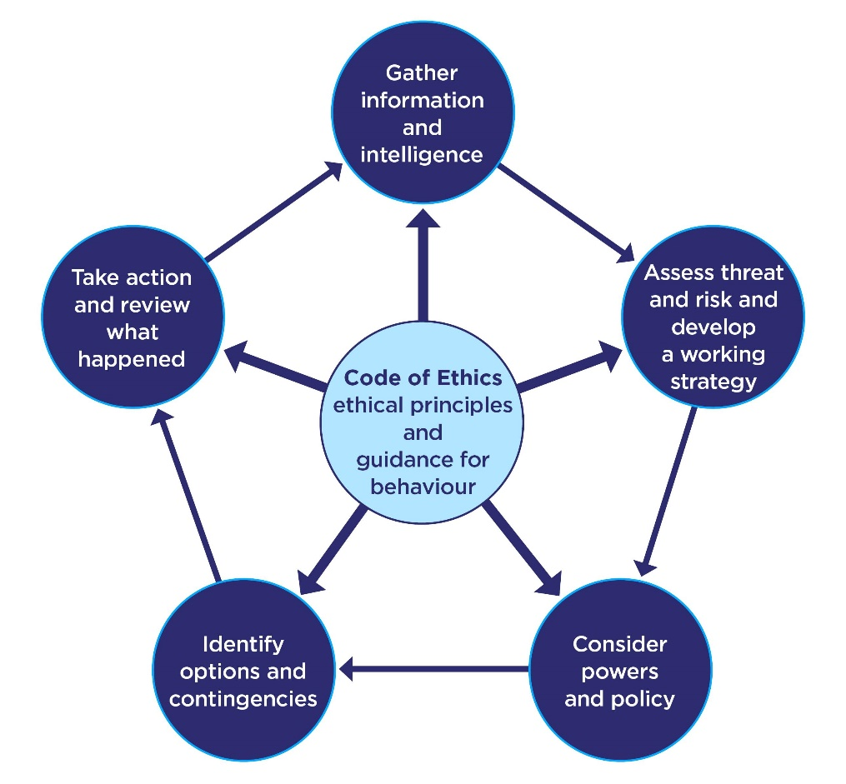
Fig1 - The National Decision Model – College of Policing

The start of a new role or profession is described as a daunting and stressful experience (Carter and Francis, 2001). As I had already completed a three-month training period, I felt that this helped massively to ease this potentially stressful experience as I wasn’t thrown into the proverbial ‘deep end’ instantly. An efficient ‘onboarding’ process of new employees will determine their experience and a manager can take a number of steps to ensure that new employee achieves success (Sibisi & Kappers, 2022). While the UK-wide organisation and sub-organisations of the British police service do not have ‘managers’ perse, I felt as though my induction into my division for my tutorship and subsequent operational phase were seamless due to how welcomed I felt coming into my station for the first time and the support that I received from the sector’s hierarchy, my new sergeant and new teammates was paramount to my integration.

I also built up a solid relationship with my tutor, who would go on to become a sergeant who would eventually leave his role as a response officer within my team. During my tutorship phase and my probationary period, my learning, development and overall performance has been noted and I feel as though I have become more and more relied on for assistance with issues of both a personal and professional aspect by my teammates, but I also feel much more confident in my abilities dealing with more complex issues and incidents. I feel as though the job has catered to my personal sense of drive towards learning and honing new skills and I have been able to learn and adapt new skills such as the ability to drive response cars to emergency calls and the ability to safely use certain tools to gain access to properties in the case of such emergencies. I also feel as if, outside of the role and job, I have increased in terms of overall maturity and whereas prior to the job I would sustain overwhelming amounts of feelings of adrenaline - and at times fear – during confrontational situations with another person, I now feel as though I am in a much more advanced state of self-control and confidence when dealing with said situations. I have benefitted greatly from the coaching and mentoring from the very start of my initial training in March 2022 to today. Workplace coaching is defined as ‘a professional helping relationship, focused on the goals of the coachee’ (Passmore & Lai, 2019) whereas – put simply – mentoring is defined in summary as a collaborative relationship between an experienced individual (the mentor) and a less-experienced individual (the mentee) which is focused on the latter’s personal and professional development (Dahlberg & Byars-Winston, 2019). Both coaching and mentoring require trust, empathy, and encouragement (MacAfee & Garvey, 2010). I feel like I have built great relationships with not just my initial trainers, but my tutor, inspectors, sergeant and teammates, many of whom I have become very close friends with and I continue to learn every shift.
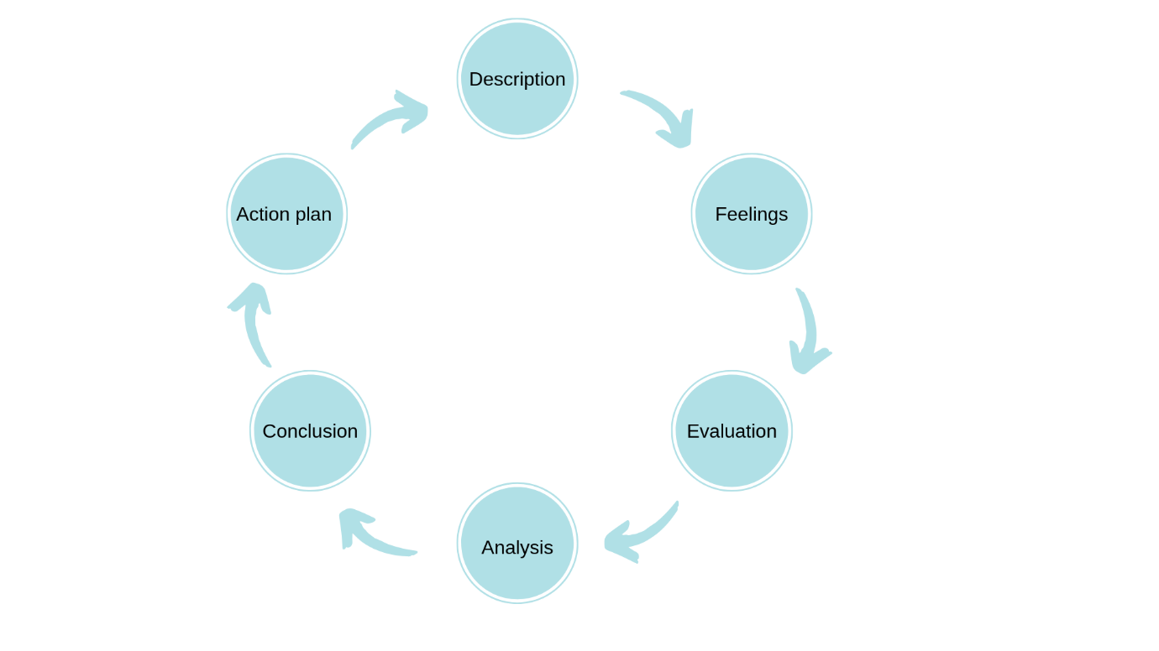
Fig.2 - The Gibbs Reflective Cycle – University of Edinburgh

I am now into my third and final year of the PCDA programme, and also my final year of my probationary period. I have successfully completed this period and have also achieved passes in both of the first two years of my university work. A vast combination of the learnings garnered from the tuition, coaching, and mentoring of not only my tutor, but from other members of my team and from a plethora of other members of the South Wales police family and the multitude of calls I have attended and dealt with to date, I find has really helped in my development and has augmented my levels of self-confidence. Where at the very beginning - despite having limited experiences as a Special Constable – I could be quite pensive when volunteering for certain tasks or calls. I have received praise from my sergeant and from other ‘acting’ sergeants who I have had the pleasure of working for and I have received appraisals from members of the public in the form of e-mails for how professionally I have assisted them during my initial period. Due to the constant influx of new officers, I am slowly finding myself transitioning into a more senior member of the force and I really enjoy passing on my experiences and wisdom to newer faces and probationary officers. I have always thrived on the mentoring and coaching of others, and this was instilled in me back from when I was an assistant manager in a previous vocation. This previous two years has seen a wealth of changes in my life, both privately and professionally and these changes have aided me to learn and to develop.

In summary, I am excited to continue with my development as a police officer within the organisation and am hoping to continue to learn new things and achieve new skills, both from the experiences from attending the myriads of different incidents I am expected to attend and by having the enthusiasm to attend courses to further my skill set. I have never shied away from seeking the assistance and feedback of my peers and I feel that this form of self-reflection assists me greatly as I achieve the perspective of other people. I may consider becoming a tutor when my probation is complete, as previously mentioned, I really like to teach as well as learn and I would like to do my part to ‘mould’ the newer and more inexperienced officers.

1,953 words

References

- Berkeley Well-Being Institute. (n.d.). Mentoring: Definition, Examples, & Best Practices​. [online] Available at: https://www.berkeleywellbeing.com/mentoring.html. – Accessed 01/05/2024

- Carter, M., & Francis, R. (2001). Mentoring and Beginning Teachers’ Workplace Learning. Asia-Pacific Journal of Teacher Education, 29(3), 249–262. https://doi.org/10.1080/13598660120091856 - Accessed 01/05/2024

- College of Policing (2013). National Decision Model. [online] Available at: https://www.college.police.uk/app/national-decision-model/national-decision-model. – Accessed 01/05/2024

- College of Policing (2020). Special constables. [online] College of Policing. Available at: https://www.college.police.uk/guidance/special-constables. – Accessed 05/04/2024

- Harada, C. N., Natelson Love, M. C., & Triebel, K. L. (2013). Normal cognitive aging. Clinics in geriatric medicine, 29(4), 737–752. https://doi.org/10.1016/j.cger.2013.07.002 - Accessed 05/04/2024

- Home Office (2023). Strategic Policing Requirement 2023. [online] GOV.UK. Available at: https://www.gov.uk/government/publications/strategic-policing-requirement-2023. – Accessed 22/06/2024

- Kiralfy, Albert Roland , Glendon, Mary Ann and Lewis, Andrew D.E.. "common law". Encyclopaedia Britannica, 3 Mar. 2024, https://www.britannica.com/topic/common-law. – Accessed 01/05/2024

- Macafee, D. and Garvey, B. (2010). Mentoring and coaching: what’s the difference? BMJ, 341, p.c3518. doi:https://doi.org/10.1136/bmj.c3518. – Accessed 01/05/2024

- Malvik, C. (2020). 4 Types of Learning Styles: How to Accommodate a Diverse Group of Students | Rasmussen College. [online] Rasmussen.edu. Available at: https://www.rasmussen.edu/degrees/education/blog/types-of-learning-styles/. – Accessed 05/04/2024

- NPCC (2017). Vision 2025 - One year on. [online] Police.uk. Available at: https://news.npcc.police.uk/releases/vision-2025-one-year-on. – Accessed 22/06/2024

- Othman, N. and Amiruddin, M.H. (2010). Different Perspectives of Learning Styles from VARK Model. Procedia - Social and Behavioural Sciences, 7(7), pp.652–660. – Accessed 05/04/2024

- The University of Edinburgh (2020). Gibbs’ Reflective Cycle. [online] The University of Edinburgh. Available at: https://www.ed.ac.uk/reflection/reflectors-toolkit/reflecting-on-experience/gibbs-reflective-cycle. – Accessed 05/04/2024
‌

‌
‌

‌

