

Task 1 – Reading Task Template
U 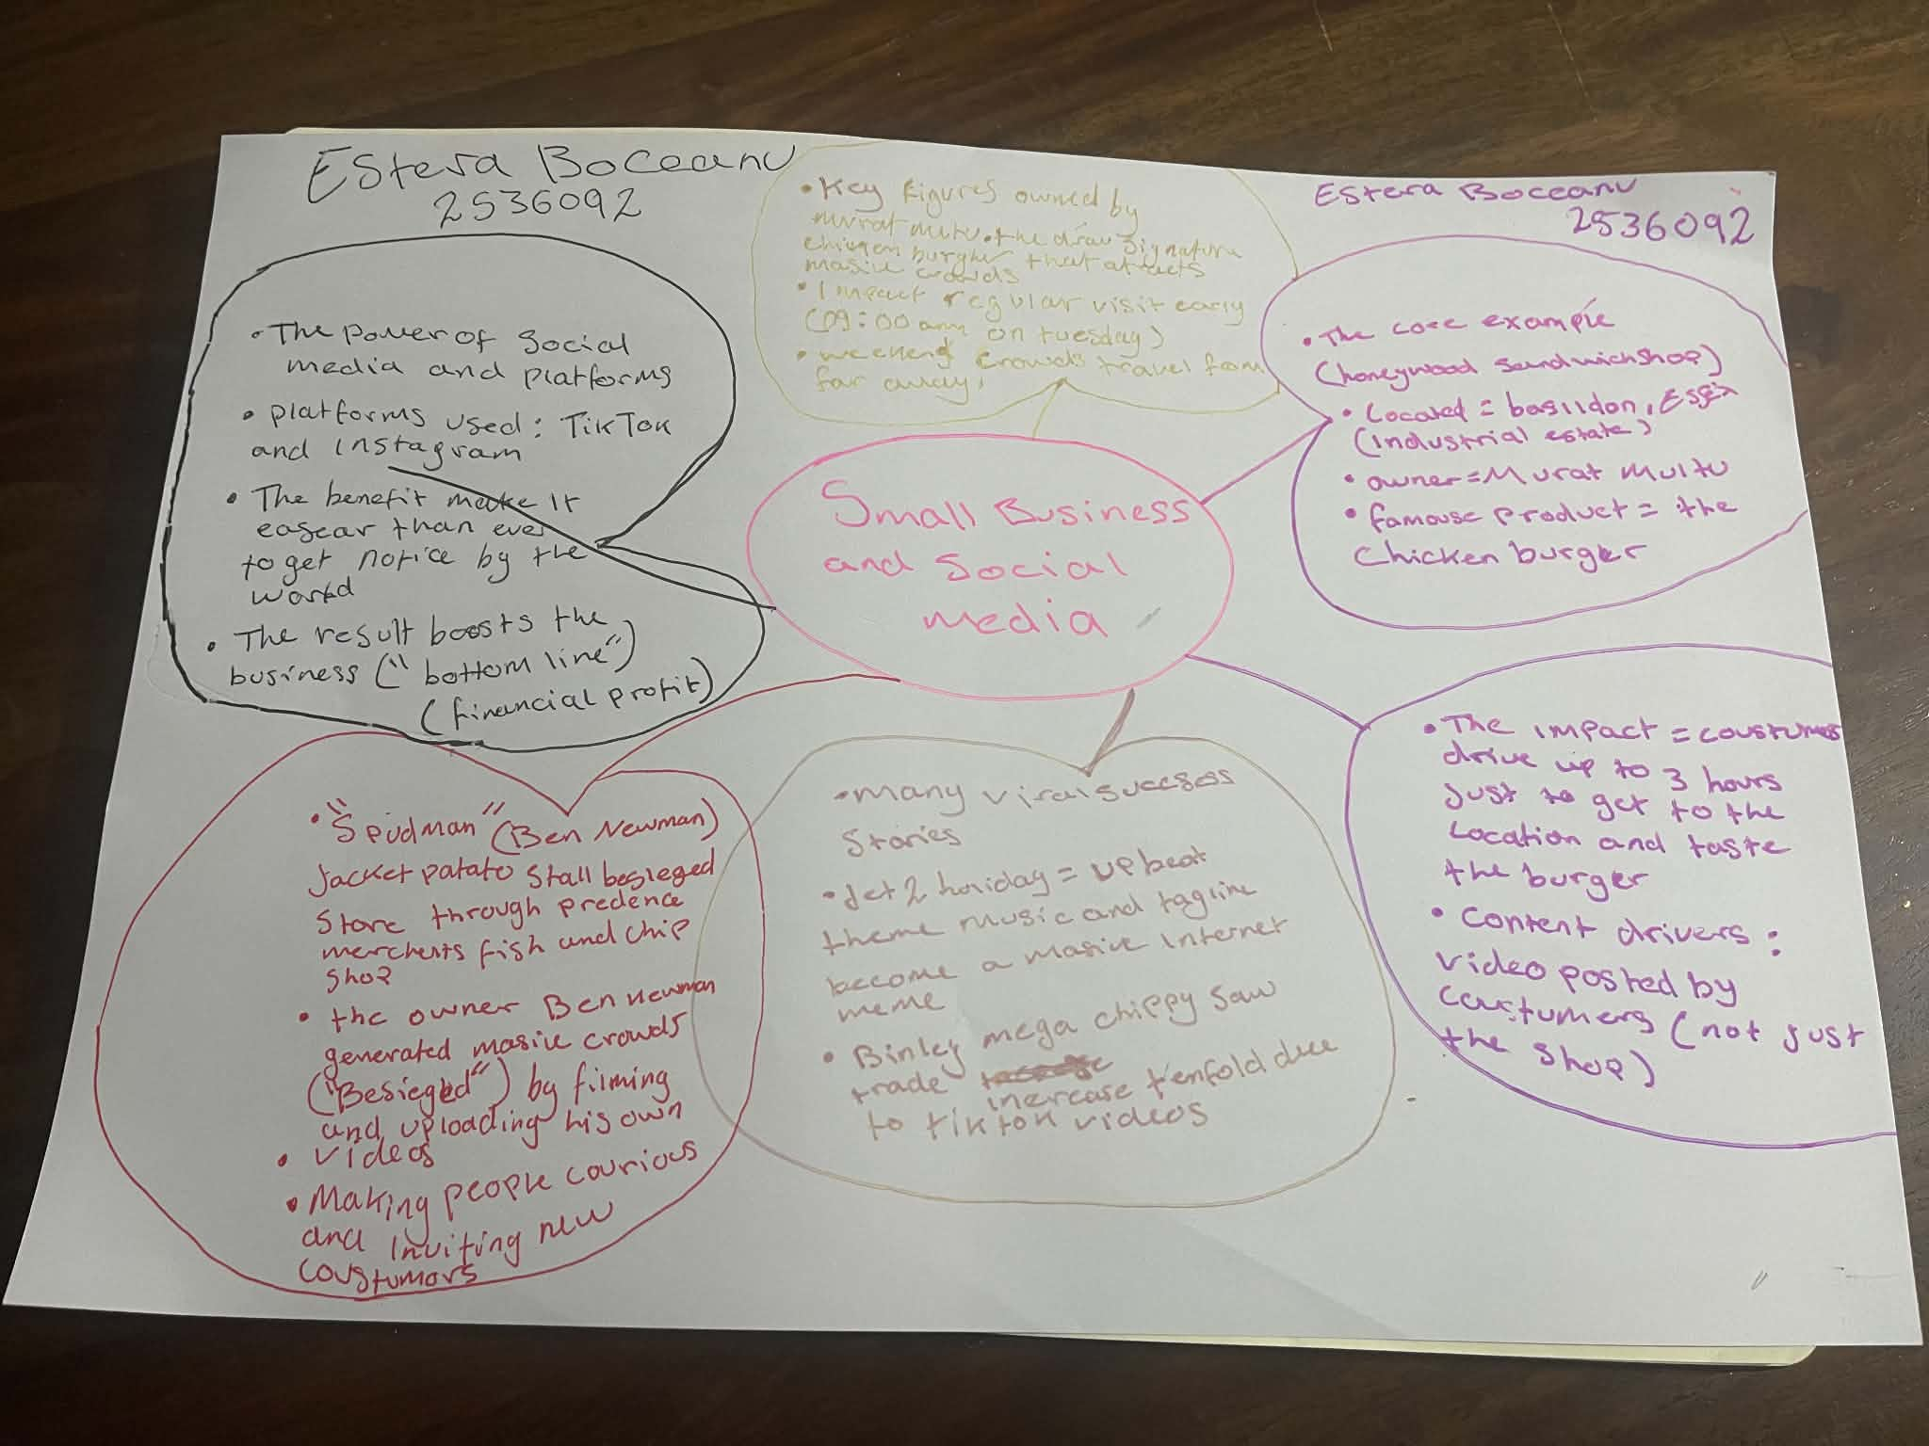
pload your photo of your A3 in-class notes here:

1. Answer these questions using the sentence starters below
a. What is the main idea of the text?
The main idea is that ; small businesses and social media
b. What are two key points?
One key point is ; the key figures owned by Murat Mutlu
Another key point is the draw a signature the chicken burger that attracts massive crowds
c. What part of the text did you find most important? Why?
The most important part is people travel from far away up to 3hours just to try the famous chicken burger
d. Was anything unclear or difficult to understand?
I was not sure about the notes and how to use the proper and how to make it in one sense to understand
e. How did your group help you understand the text better?
My group helped me by putting all the notes together and make sense and understanding
3. One sentence reflection
Question: What did you find challenging about this task?
The hardest part was the homework that we had to do I did not quite understand

