Name: Mavish Iyshia
Student:ID:2236706
Component 1- E-Portfolio ACCA4025_BIRM
Lecturer: Masud Siddiqui
Date Of Submission: 09.03.2026

Table of contents
Table of Contents
E-Portfolio link
Welcome Page………………………………………………………………………………………………2
Task 1 3
Screenshot of ‘Essential Skills’ 3
Screenshot of ‘Reflection’ 3
Task 2 4
Screenshot of mind map 4
Link to mind map 4
Link to the academic poster 5
Task 3 6
Screenshot of automatic referencing tool 6

E-portfolio link- Mavish Iyshia's Portofolio

Screenshot of E-Portfolio cover page/welcome page

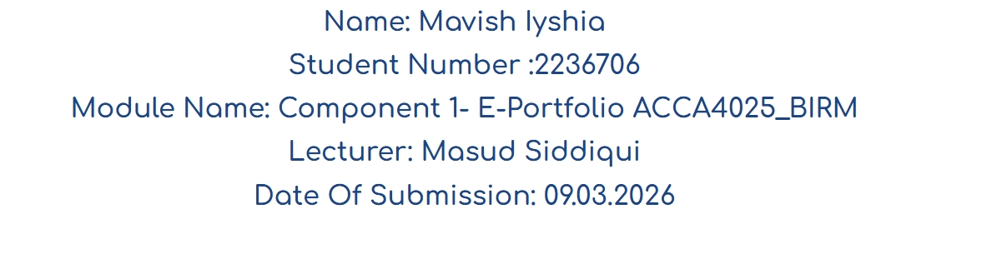


Task 1

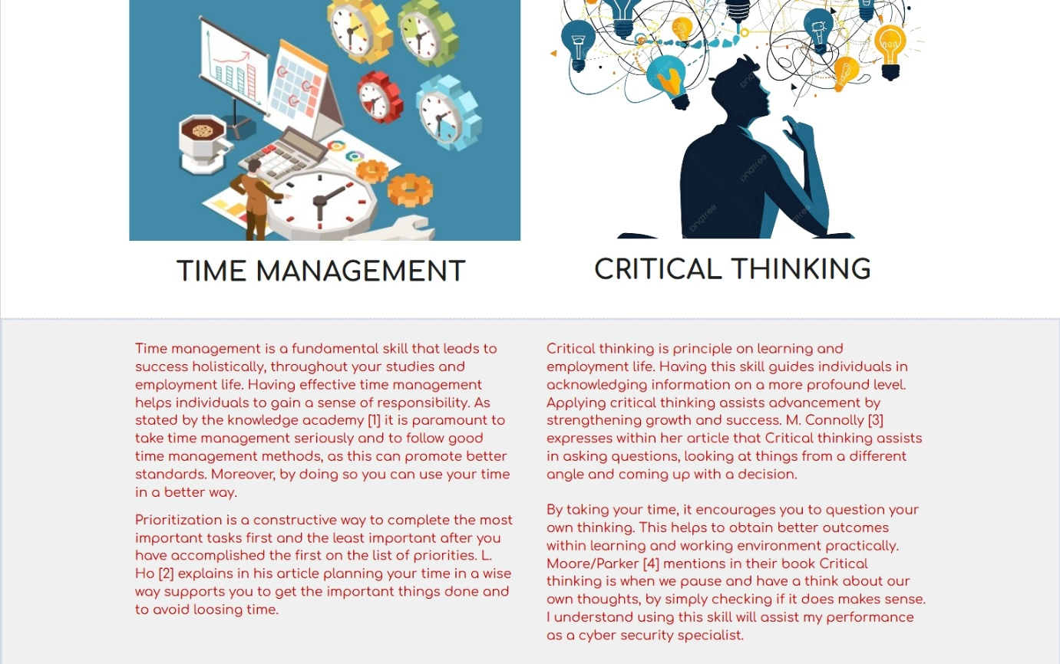
Screenshot of ‘Essential Skills’

Screenshot of ‘Reflection’
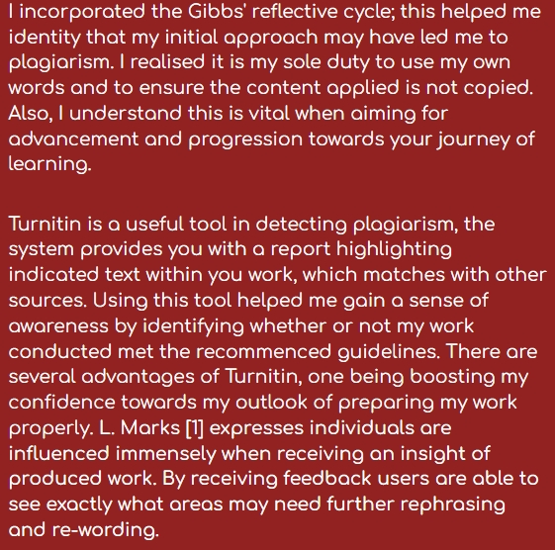
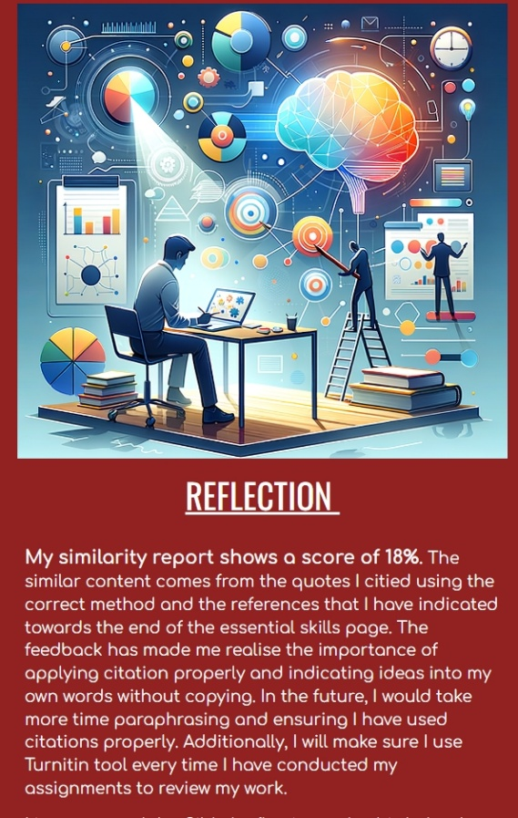

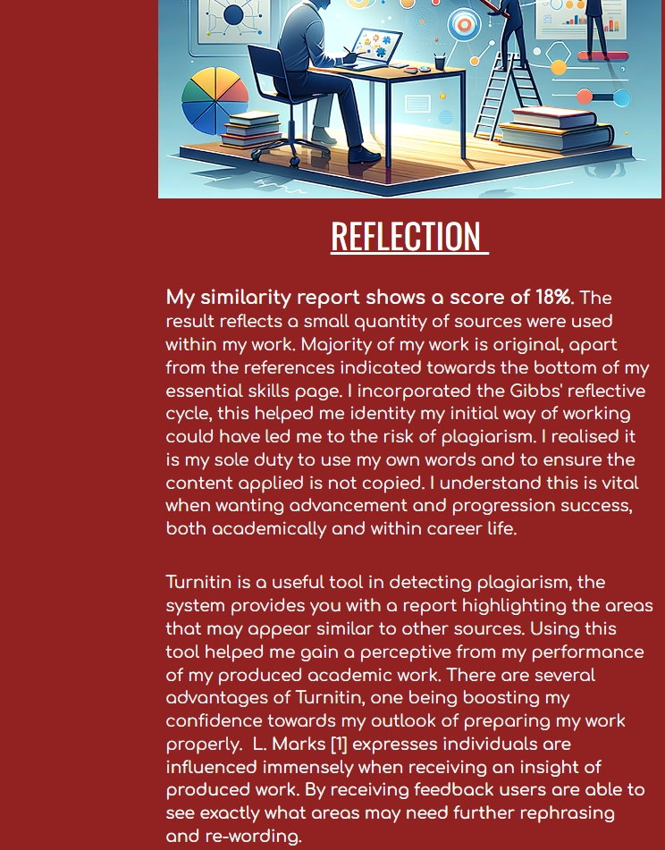
Task 2

Screenshot of mind map

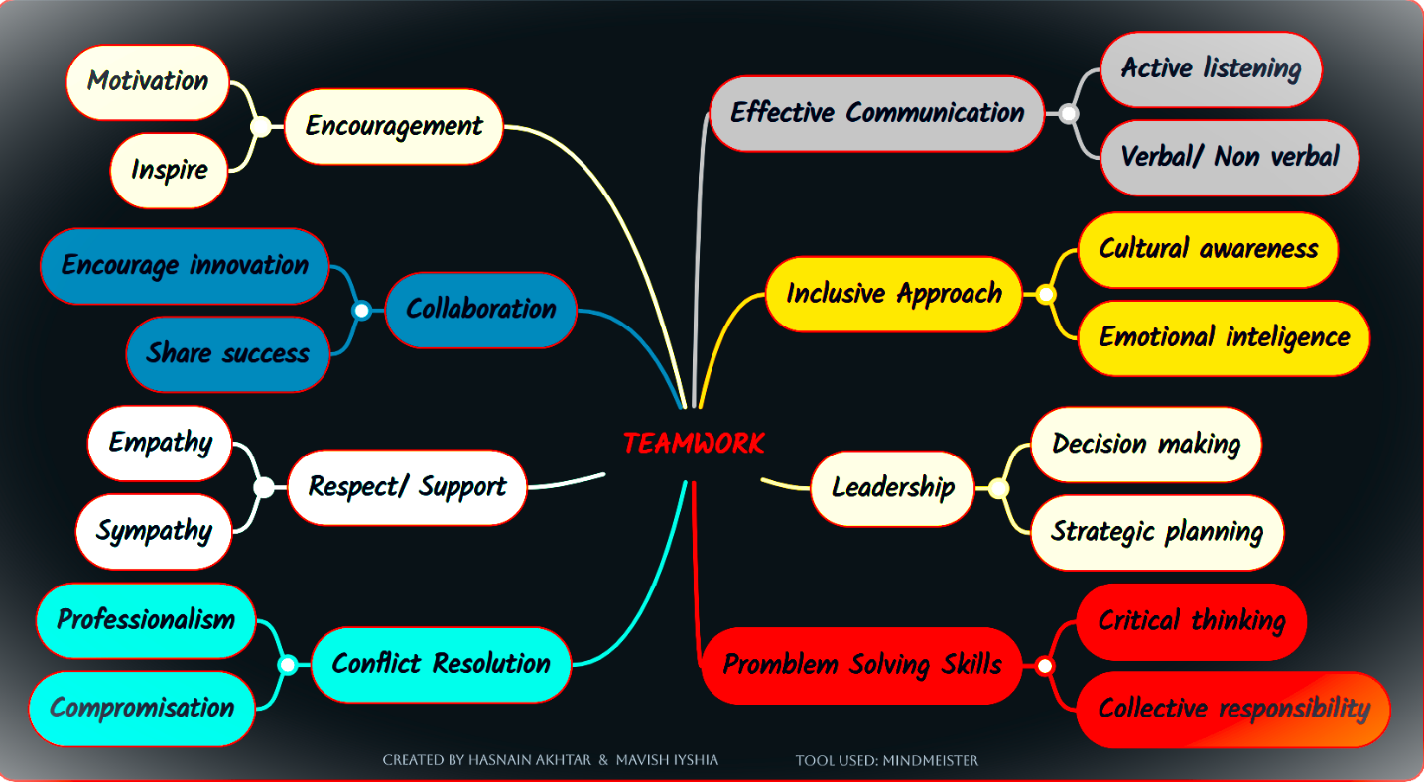

Link to mind map

https://mm.tt/map/3947473128?t=4XSdRoWWZ6

Screenshot of the academic poster

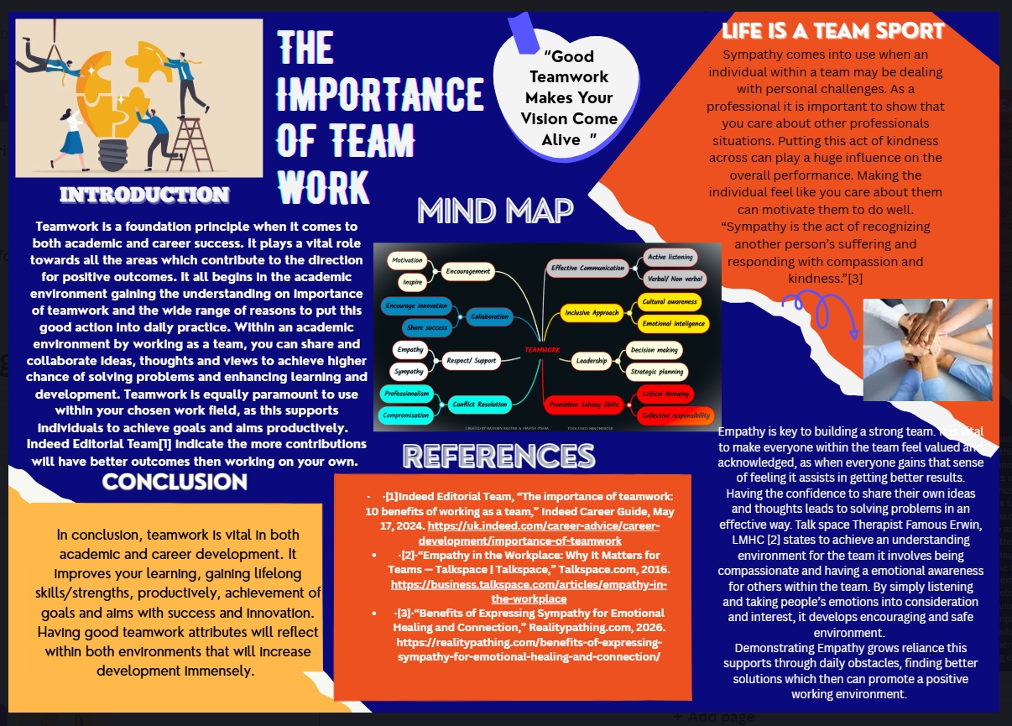

Link to the academic poster

https://www.canva.com/design/DAHBoB1KLjM/Y_XbGpSrQ9Ump7CO7ia7vQ/edit?utm_content=DAHBoB1KLjM&utm_campaign=designshare&utm_medium=link2&utm_source=sharebutton

Task 3

Screenshot of automatic referencing tool
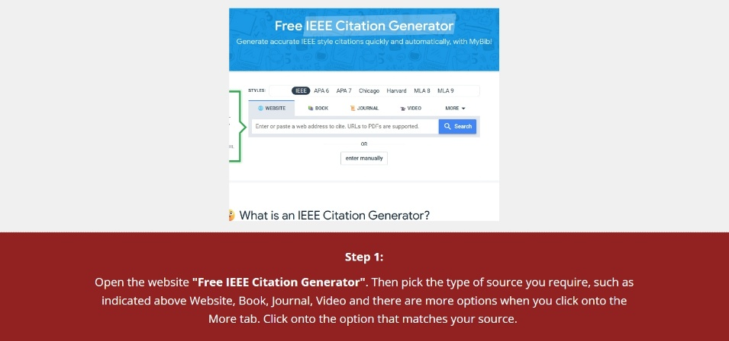

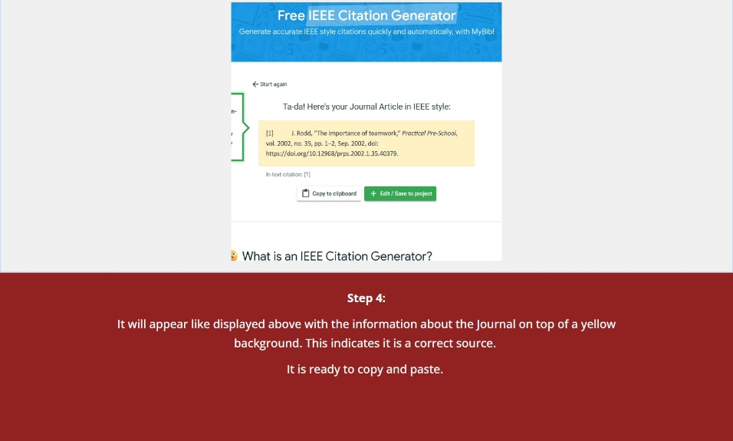
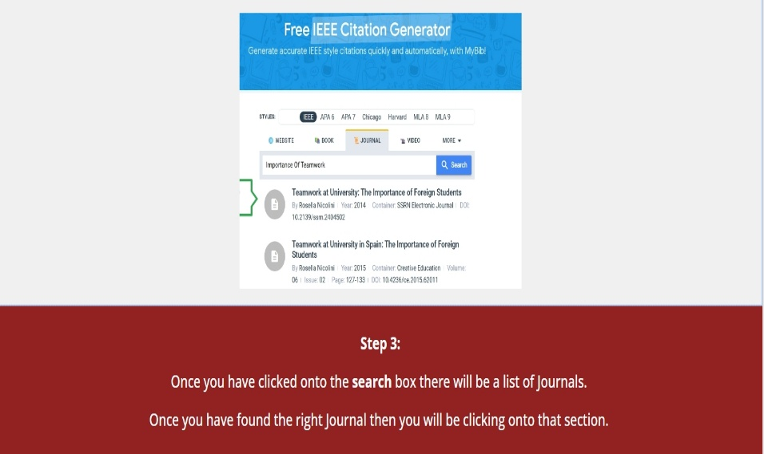
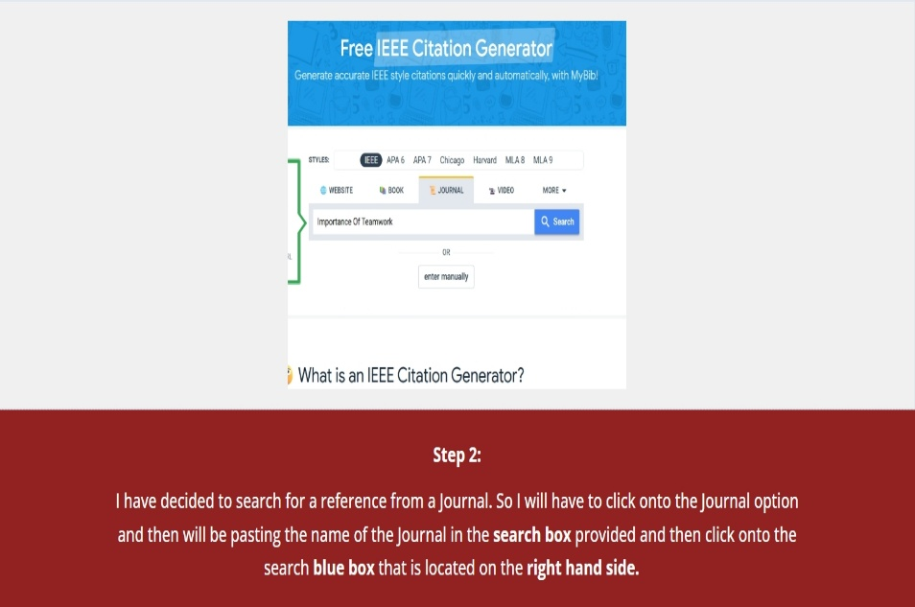
Task 4

Screenshot of each page of e-portfolio 
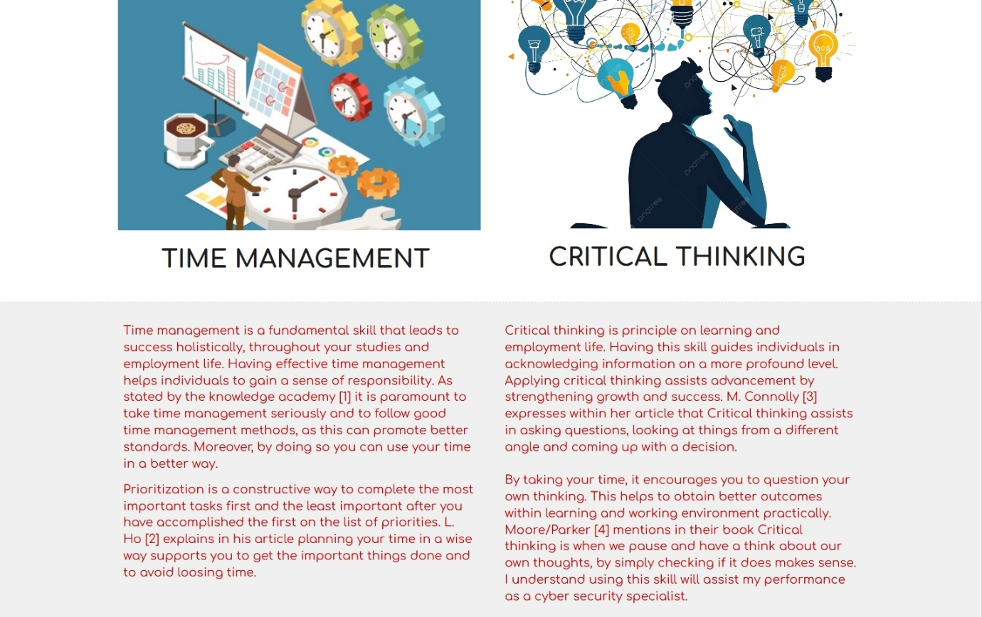
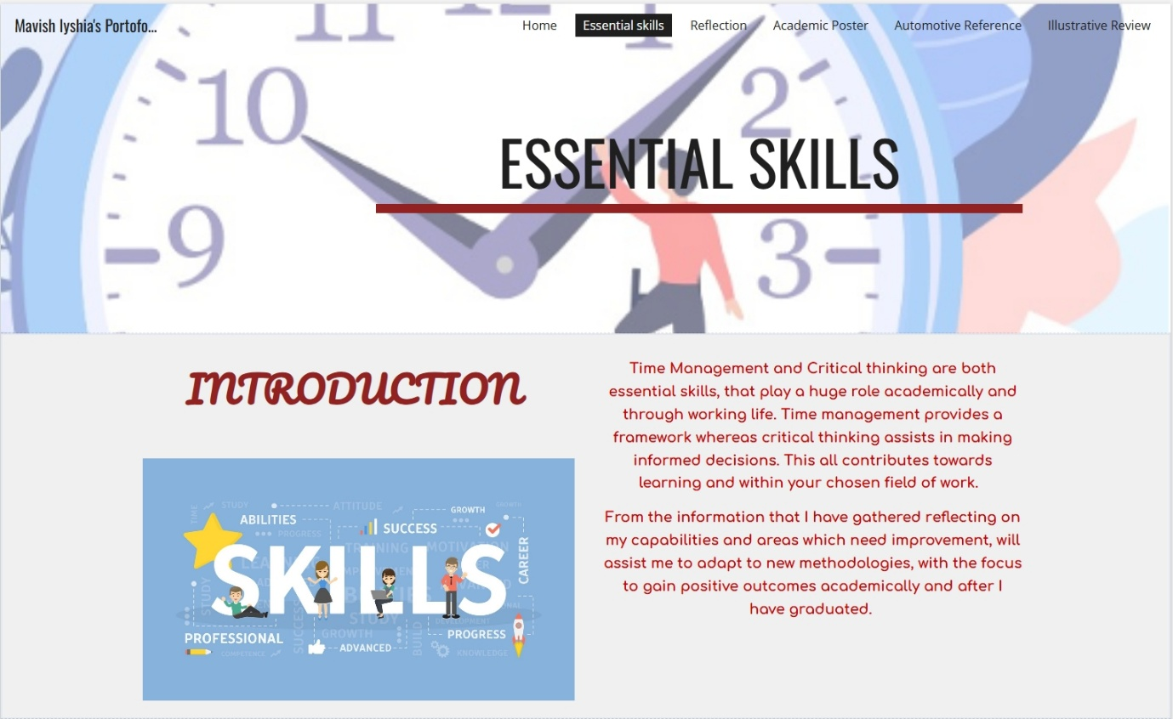
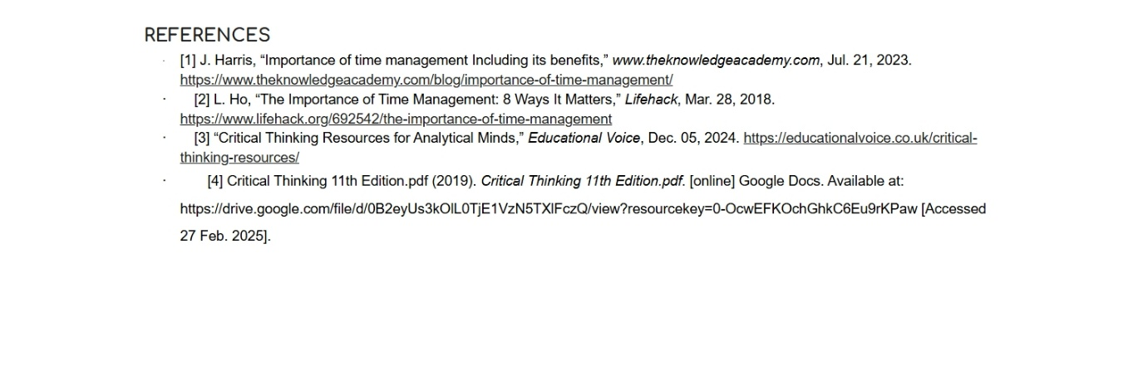

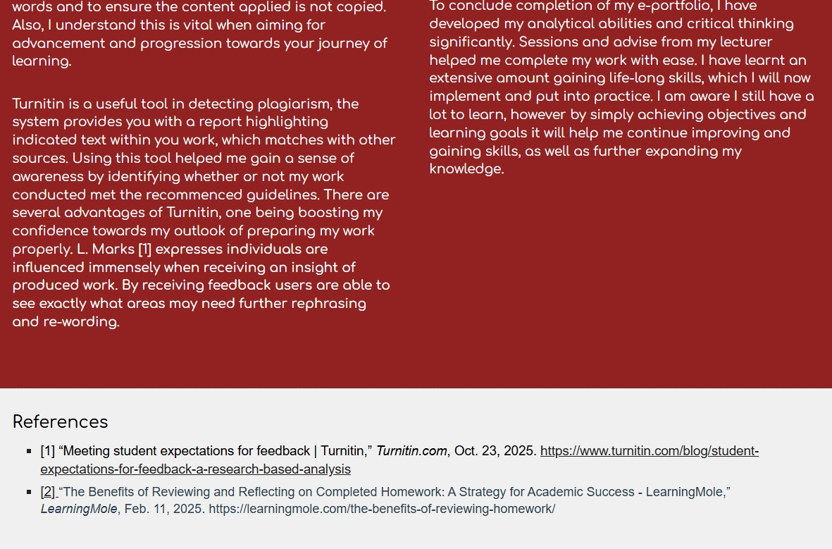
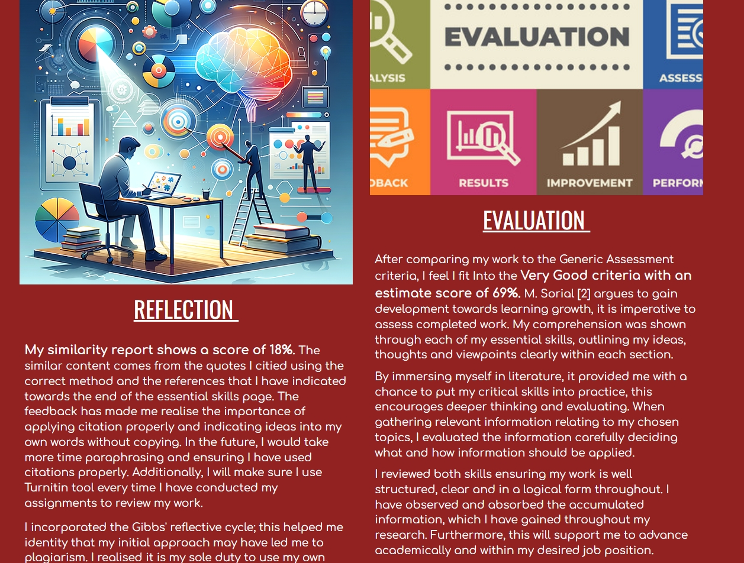
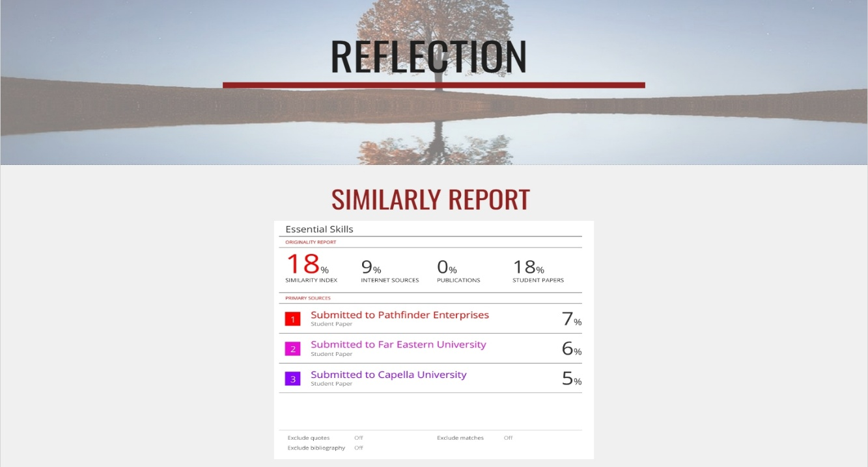


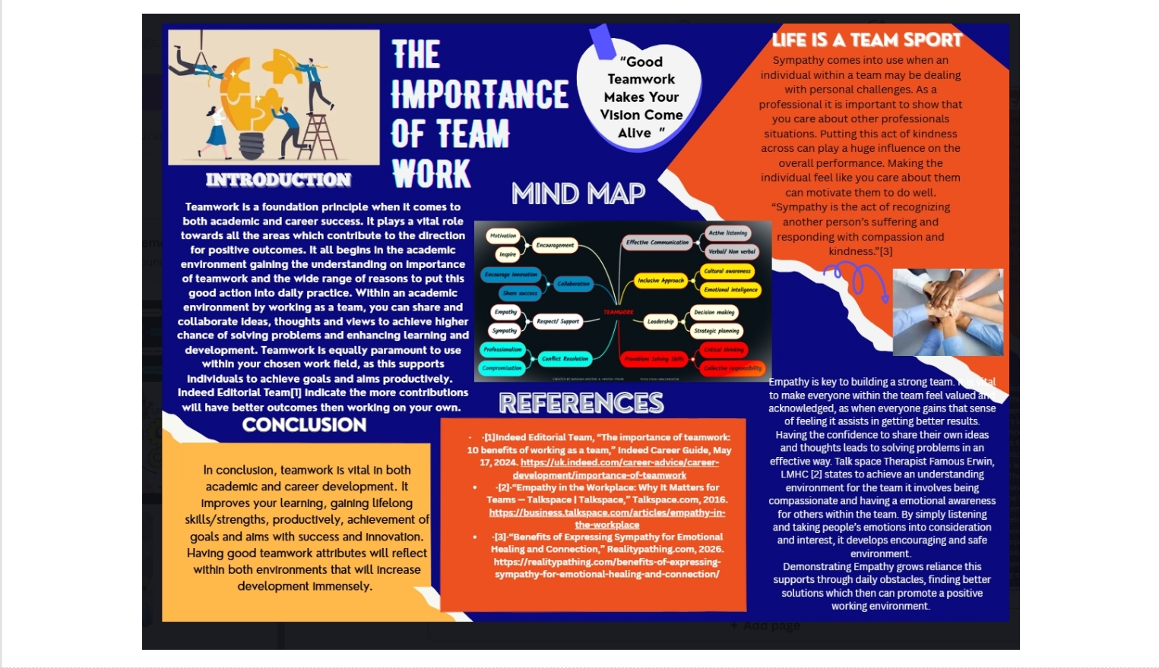

https://www.canva.com/design/DAHBoB1KLjM/Y_XbGpSrQ9Ump7CO7ia7vQ/edit




