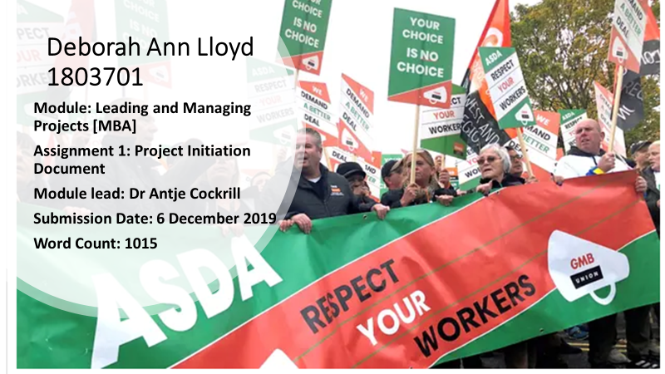

- Your name: | Deborah Ann Lloyd
- Name of (client) organisation | Asda
- Aim of project:
In no more than twenty words, state the overall aim of the project.

The aim of this feasibility study is to establish how Asda could retain and recruit staff after the enforcement of a new contract (Wood, 2019; Butler 2019).

- Objectives of project:
Lists up to four objectives that are each directly from the project aim. The objectives should be S.M.A.R.T (specific, measurable, achievable, realistic, time bound).

Objectives:

- An evaluation process to collect feedback from current staff employed at all Asda stores in South Wales over a four-week period.

- Discuss evaluation process and implement a pilot action plan with the aim to increase active engagement with employees thus increasing retention levels by 15% within 12 months. To include a monthly evaluation throughout.

- What is the business case for considering undertaking the project? Justify how achieving the project aim will advantage and benefit the business and its stakeholders.

The business case is to establish a pilot scheme, and if successful, it could then be distributed throughout Asda stores across the UK. The projects aim is to increase job satisfaction levels across stores in South Wales. Reports by Wood (2019) and Butler 2019) reveal that Asda has enforced a new contract with as many as 12,000 workers [supported by their union] refusing to sign the new deal. The deal, affecting 118,000 Asda employees includes the introduction of variable shift patterns, no more paid breaks, and employees being expected to switch between departments. Although employees will receive an annual increase in wages by 11%, more than 12,000 workers are refusing to sign with the threat of having their employment terminated. Those that have signed have done so because they fear being unemployed so close to Christmas. In addition to this, company reviews by current and former Asda employees reveal there to be an ongoing lack of progression and training across Asda stores dating back to 2016 (Glassdoor, 2019). (Appendix 1).

Stakeholders Analysis:

Stakeholders can be anyone who may be affected by the behaviour of the organisation (Freeman, 2010; Henry,2018). Due to word limits, only key stakeholders will be included in this analysis which is outlined in Figure 1:
Figure 1: Key stakeholders:

- Management: Liaise with and report findings from evaluation process
- Human Resource (HR): Analyse evaluation findings and advertise for employees to be involved in piloting the scheme
- Team Leaders: liaise with team leaders of findings and arrange staff meeting with shop floor workforce
- Inform the union of the pilot scheme to gain an insight and feedback
The idea:
To create a training programme, overseen by four key members of staff at each store [two for smaller stores] – training leads and HR leads for the training to be consistent. The idea is based on “Work-life fit: Employee training is the secret to flexible work success”, by Williams-Yost (2013). Albeit, the original idea was more about improving flexible working through training, the concept is adaptable in a way that it can be utilised for all training purposes. One of the benefits is to retain current employees through training based on motivation requirements, as the pay rise has not satisfied the needs of the current workforce. According to ACAS (2014) the cost of replacing an employee is about £30,000 taking into account loss of productivity, advertising and training. Also, there is a potential benefit in terms of recruitment, building a strong reputation going forward could result in Asda becoming one of the best companies to work for.
Motivation in the workplace:
According to Pink (2018) and McCord (2017) it is not always about money in terms of motivation, people also want to feel part of the team. They want to do a good job with the right team of people and be recognised for that good job.
Herzberg as cited in Mullins (2016, p. 232) realised two factors of motivation; motivators related to feelings of satisfaction and hygiene factors linked to the job itself. Table 1 is an example of these factors in relation to Asda employees.
Table 1: Asda employees motivation factors
Motivation Factors | Hygiene Factors
Progression/growth and achievement | Working conditions
Recognition | Level and quality of supervision and training

- Identify the risks associated with the project and how these could be overcome.

Table 2: Identifying the risks:

Risk | Reducing the risk
Lack of employee engagement | Appoint designated persons to communicate the process and discuss with employees how they could meet their goals. Utilise effective methods such as social media platforms
Breakdown in communication between key stakeholders to include trade union | Hold monthly evaluations for feedback, to update key stakeholders on project and ensure objectives are met

- List the resources you will need to make your project a success. These may include, people, time, cash, technology, data. Say why you need them and identify any constraints that you may encounter and explain how you would overcome these.

Resources:
People:
- Management – Project manager to discuss budget and overall plan, keeping in line with business model and needs of the organisation. Meetings to discuss progression of project
- HR – To deliver and discuss the initial evaluation process with project manager. To create a job description for the new roles. To keep a record of retention and recruitment to measure the outcome of the project
- HR Lead – This newly created role will involve working alongside the project manager and training lead to ensure all employees receive a consistent message of how the training will be implemented, evaluated and by whom
- Training lead – This newly created role will involve liaising with employees in order to identify the training to be delivered, to deliver the training, working alongside the project manager and HR lead to ensure consistency and design of training required
- Team leaders – To feedback the results of the training to the training lead in order to pinpoint any skills gaps. This includes the team leaders themselves
Technology:
Web designers to ensure these platforms are secure and reliable
- Intranet portal for e-learning
- Webinars to share training outcomes, address challenges and provide feedback to managers
- Data portal to analyse skills gaps and outcomes
- A retention and recruitment portal to evaluate outcomes and measure success of project
- Operationalisation

Give a brief outline how you will operationalise this project, including a rationale for a project management approach if appropriate, and as a minimum an appropriate time and task plan.

Action | Start Date | Finish Date | Evaluation (include when completed or state where this information can be found)
HR to circulate employee feedback forms and liaise with project manager | 2 January 2020 | To be completed by 30 January 2020
Project manager to arrange a key stakeholders meeting to discuss the project | 2 January 2020 | 2 January 2020
HR recruit for new roles | 2 January 2020 | 30 January 2020
Project manager, training leads and HR leads to design the training | 1 February 2020 | 28 February 2020
Key stakeholders meeting | 1 February 2020 | 1 February 2020
Project manager, training leads and HR leads to start delivering pilot scheme | 1 March 2020 | 1 March 2021
Key stakeholders to review pilot scheme monthly | 1April 2020 | 1 April 2021
HR to review retention and recruitment figures monthly and liaise with leading staff and project manager | 1April 2020 | 1 April 2021

References
ACAS (2014) Replacing an employee costs £30,000, report says. Available at: https://www.acas.org.uk/index.aspx?articleid=4857 (Accessed: 1 December 2019).
Butler, S. (2019) ‘Asda extends deadline for workers to sign new contracts: More than 120,000 hourly-paid staff given a week longer to sign deals or face the sack’, The Guardian, 2 November. Available at: https://www.theguardian.com/business/2019/nov/02/asda-extends-deadline-for-workers-to-sign-new-contracts(Accessed: 1 December 2019).
Freeman, E. R. (2010) Strategic management: a stakeholder’s approach. Cambridge University Press: Cambridge.
Glassdoor Asda Company reviews (2019a) Asda reviews. Available at: https://www.glassdoor.co.uk/Benefits/ASDA-Job-Training-UK-BNFT80_E10108_N2.htm (Accessed: 1 December 2019).
Glassdoor Asda Company reviews (2019b) Asda reviews. Available at: https://www.glassdoor.co.uk/Reviews/ASDA-Reviews-E10108_P5.htm (Accessed: 1 December 2019).
Henry, A. (2018) Understanding strategic management. Oxford: Oxford University Press.
McCord, P. (2017) Powerful: Building a culture of freedom and responsibility. United States of America: Silicon Guide.
Mullins J. L. (2016) Management and organisational behaviour. 11th edn. Harlow: Pearson Education.
Pink, D. (2018) Motivation video. Available at: https://www.bing.com/videos/search?q=dan+pink+motivation&view=detail&mid=BA71C5B7913B3B720B09BA71C5B7913B3B720B09&FORM=VIRE (Accessed: 28 November 2019).
Williams Yost, C. (2013) ‘Work-life fit: Employee training is the secret to flexible work success:’, Employee Benefit News, 27 (13). Proquest. Available at: https://search-proquest-com.ezproxy.uwtsd.ac.uk/docview/1438177181?accountid=130472&rfr_id=info%3Axri%2Fsid%3Aprimo (Accessed: 1 December 2019).
Wood, Z. (2019) ‘Asda announces pay rise as contract row continues: Union officials describe 18p hourly rate rise as smokescreen while 12,000 staff face losing jobs’, The Guardian, 29 October. Available at: https://www.theguardian.com/business/2019/oct/29/asda-announces-pay-rise-as-contract-row-continues (Accessed: 1 December 2019).

Appendix 1
Asda reviews (Glassdoor, (2019a)
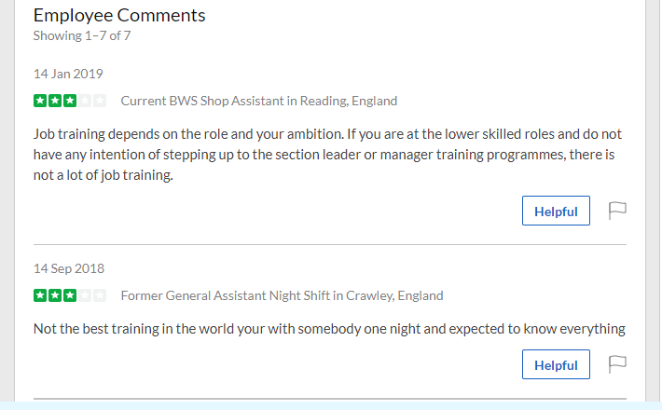
Employer reviews (Glassdoor, 2019b).


