Website Design
Introduction to Web and Database Concepts – ACCA4023
Carys Rebeca Newing
Student ID: 2014825
Table of Contents
1. Abstract 2
2. Requirements 2
3. Designs 2
a. Home Page/Landing Page 3
b. Packages 4
c. Gallery 5
d. Studio 6
e. Contact Me 7
4. Implementation 8
a. Home Page/Landing Page 8
b. Packages 9
c. Gallery 10
d. Studio 11
e. Contact Me 12
f. CSS Validation 12
5. Evaluation 14
a. Usefulness 14
b. Search Engine Optimisation 14
c. Accessibility 15
6. References 15
a. Website References 15
b. Photo References 16
7. Appendices 17
a. Style.css 17
b. Index.html 21
c. Packages.html 23
d. Studio.html 27
e. Gallery.html 29
f. Contact.html 33

Abstract

This report will focus on the scope and requirements as well as the design and heuristic analysis of a hand-crafted website to ensure that it complies to the clients and the users’ requirements.

Requirements

The website to be created alongside this documentation is for a photographer to be a place to advertise their work and to increase orders or requests. The use of it as a promotional tool will also feature links to their social media pages. The client has identified their requirements:
The Target audience will be adults looking for a photographer. The website will consist of three pages.
The first page will be some information about the photographer. It should consist of awards they have won, name, age and personal interests, news etc.
The second page will be a sample of the photographer’s work, this will include some images and some text describing their inspiration etc.
The third page will contain details relating to the photographer’s photo studio.
The fourth will contain details relating to the different packages that the photographer offers.
The final page will be a contacts page. Here there will be a standard made up of contact details.
The website theme will be dark, so black background with white and gold text.

Designs

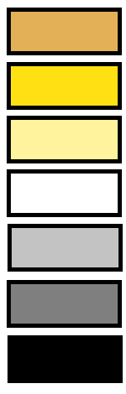
The client has already provided their logo which they use on their current social media. The colour scheme has been identified to reflect the colours in the logo which all complement each other, should a sixth colour be required a white colour will be used.

The site has been designed to flow and to support the artist’s work, below are the wireframes for each of the pages.

Site Map

Home Page/Landing Page

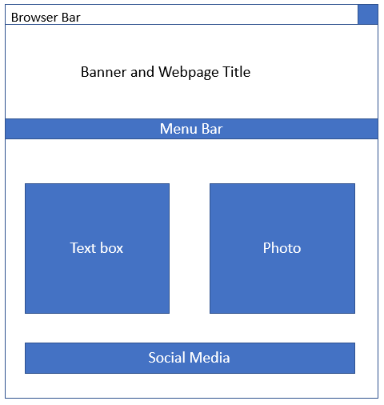

Packages

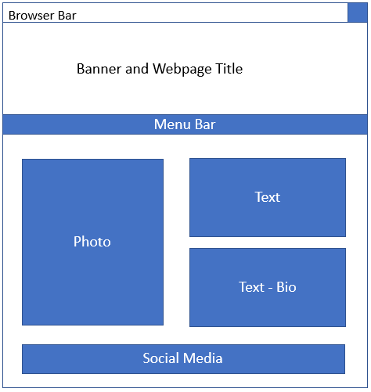

Gallery

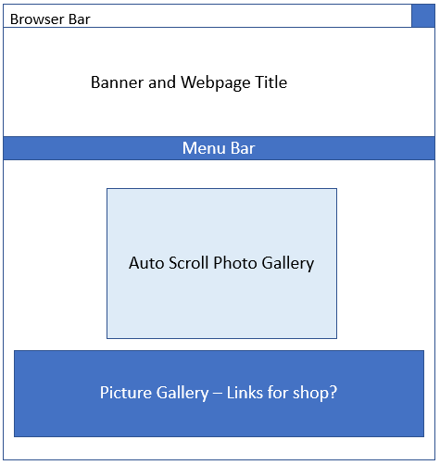

Studio

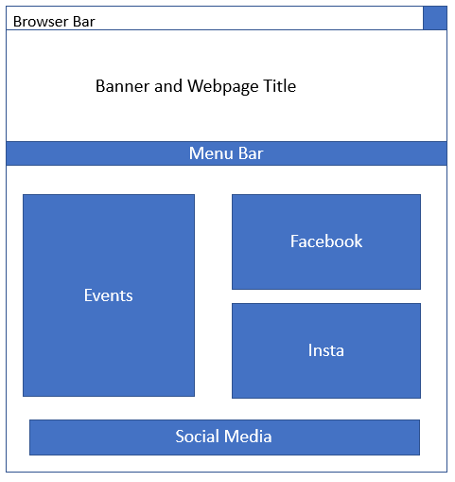

Contact Me

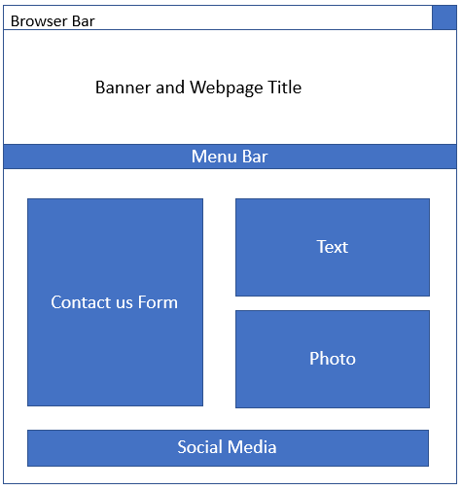

Implementation

Home Page/Landing Page

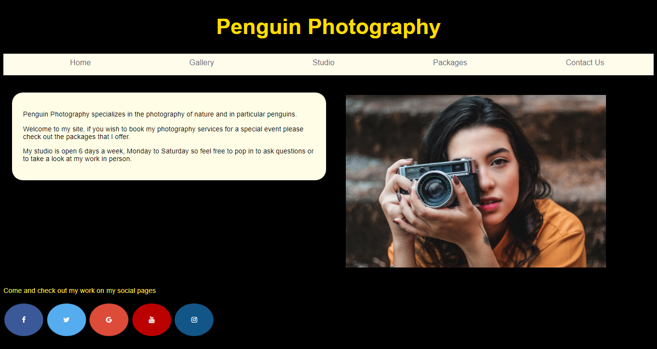

When using the Validation tool I received several errors:
Error | My Comments
Warning: Consider adding a lang attribute to the html start tag to declare the language of this document. | As shown in Appendices index.html this shows that I have declared the DOCTYPE as html and then also used the html tag.
Error: Element box1 not allowed as child of element body in this context. (Suppressing further errors from this subtree.) | The box is set to appear in the body of the site so not sure why this has triggered as an error, but I will look to rectify this in any further iterations of the website.
Error: Bad value .\Photos\photographer.jpg for attribute src on element img: Backslash ("\") used as path segment delimiter. | I have tried removing this however the photo then is shown as a broken link.
Error: Stray start tag footer. | The footer tag was used after the body tag was closed.

Packages

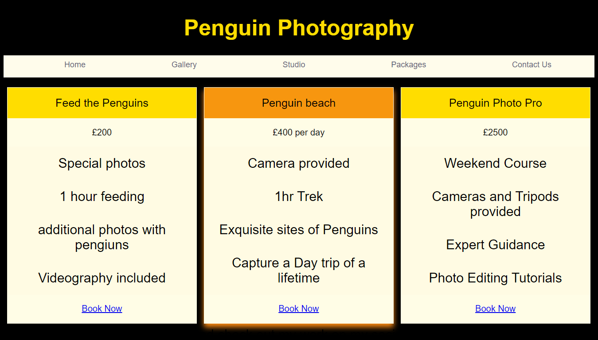
This is reactive based on the browser size, there is also a glow that appears around the item that the user is hovering over.

When using the Validation tool I received several errors:
Error | My Comments
Warning: Consider adding a lang attribute to the html start tag to declare the language of this document. | As shown in Appendices index.html this shows that I have declared the DOCTYPE as html and then also used the html tag.
Error: Stray start tag footer. | The footer tag was used after the body tag was closed.

In did have an error relating to a nav tag however this is because I missed closing it and the issue was easily rectified.

Gallery

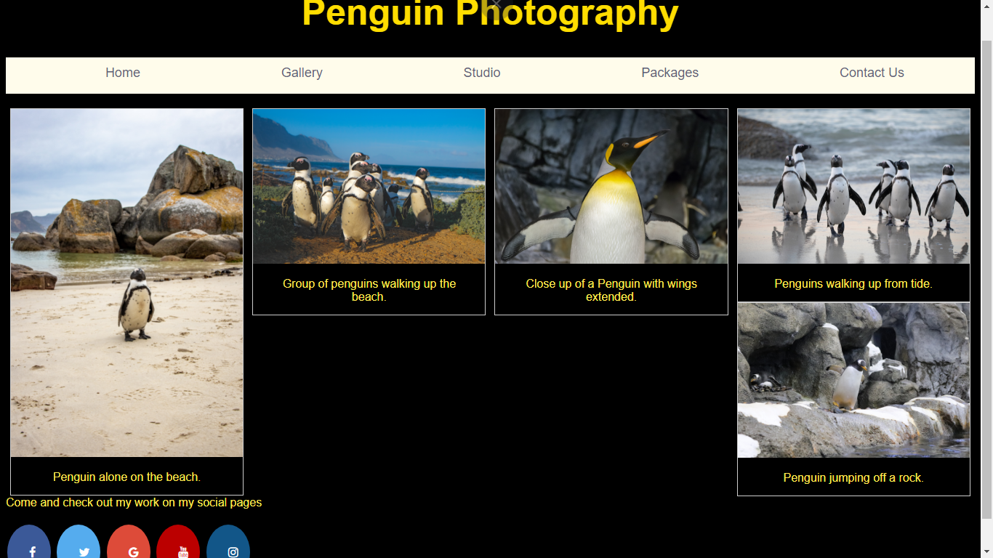

When using the Validation tool I received several errors:
Error | My Comments
Warning: Consider adding a lang attribute to the html start tag to declare the language of this document. | As shown in Appendices Gallery.html this shows that I have declared the DOCTYPE as html and then also used the html tag.
Error: Element box1 not allowed as child of element body in this context. (Suppressing further errors from this subtree.) | The box is set to appear in the body of the site so not sure why this has triggered as an error, but I will look to rectify this in any further iterations of the website.
Error: Bad value .\Photos\Gallery\rock_hopping.jpgfor attribute src on element img: Backslash ("\") used as path segment delimiter. | I have tried removing this however the photo then is shown as a broken link. This error occurred for all photos on the page
Error: Stray start tag footer. | The footer tag was used after the body tag was closed.

Studio

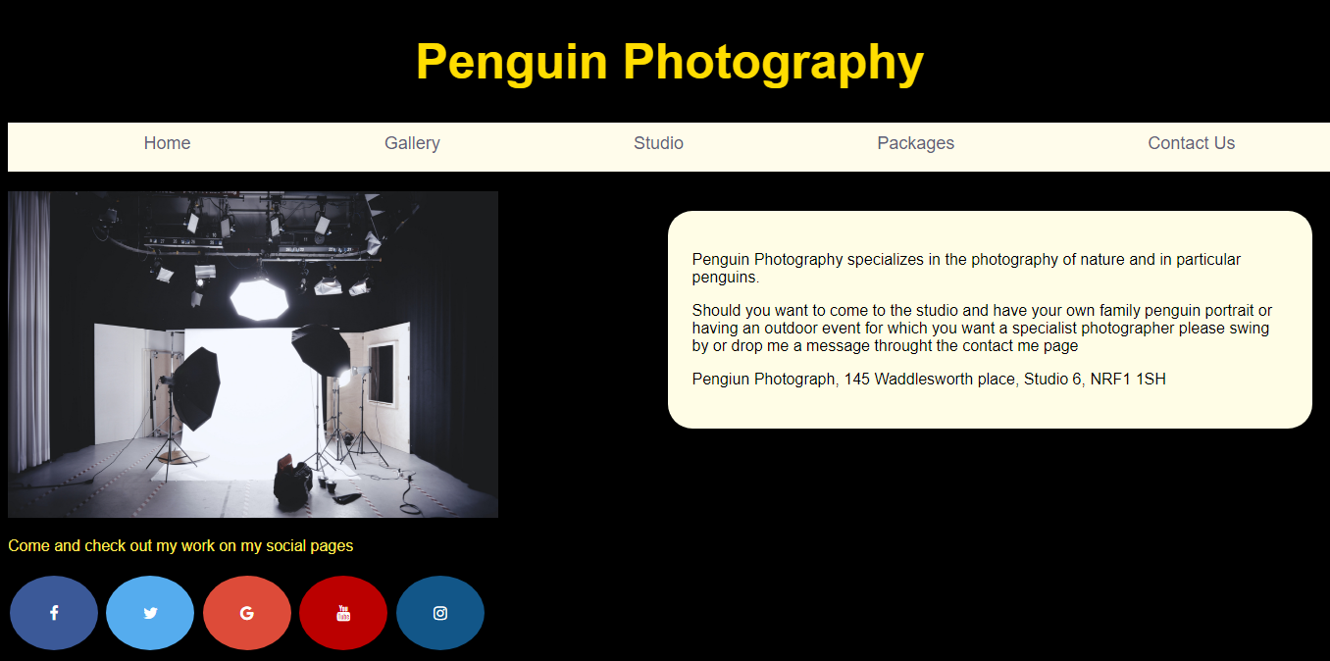

Error | My Comments
Warning: Consider adding a lang attribute to the html start tag to declare the language of this document. | As shown in Appendices Gallery.html this shows that I have declared the DOCTYPE as html and then also used the html tag.
Error: Element box2 not allowed as child of element body in this context. (Suppressing further errors from this subtree.) | The box is set to appear in the body of the site so not sure why this has triggered as an error, but I will look to rectify this in any further iterations of the website.
Error: Bad value .\Photos\Photo_Studio.jpg for attribute src on element img: Backslash ("\") used as path segment delimiter. | I have tried removing this however the photo then is shown as a broken link. This error occurred for all photos on the page
Error: Stray start tag footer. | The footer tag was used after the body tag was closed.

Contact Me
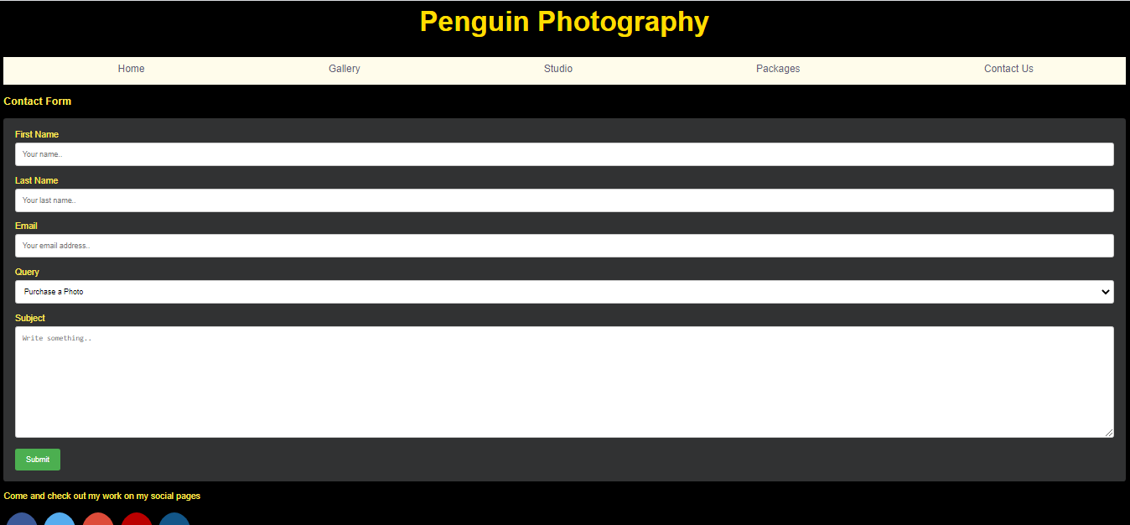
I have had to zoom out to capture a reasonable shot of the site when on the Contact us page, this page works much better when viewing on a smaller screen.
Error | My Comments
Warning: Consider adding a lang attribute to the html start tag to declare the language of this document. | As shown in Appendices Gallery.html this shows that I have declared the DOCTYPE as html and then also used the html tag.
Error: Stray start tag footer. | The footer tag was used after the body tag was closed.

CSS Validation

Error | My Comments
Error: margin: only 0 can be a unit. You must put a unit after your number.  From line 117, column 13; to line 117, column 14  font-size: 50px;↩ margin: 30; /* a  . | This can be fixed by adding a unit to the margin such as a % or a px
Error: p: Parse Error.  From line 147, column 2; to line 148, column 1  on: none;↩ font-size: 18px;↩}↩↩</styl | This was meant to apply to the paragraph tags but it appears to be generating an error rather than applying to the text in the paragraph tags.
Error: Parse Error.  From line 147, column 2; to line 148, column 1  on: none;↩ font-size: 18px;↩}↩↩</styl | This error does not appear to give much information as to what it is regarding however I believe that this could be linked to the paragraph error tag that was mentioned above.

Evaluation

Usefulness

A websites usefulness is conveyed by assessing the heuristics of the website which consists of the site’s functionality, useability as well as the content. There are 10 evaluation heuristics that a website can be assessed against, they consist of:
- Visibility of the system status
- Match between the system and the real world
- User control and freedom
- Consistency
- Error Prevention
- Recognition rather than recall
- Flexibility and efficiency of use
- Aesthetic and minimalist design
- Help users recognise, diagnose, and recover from errors
- Help and documentation
As well as analysing the heuristics of the site, a site can undertake usability testing either by peers or by consumer review groups. These reviews can consist of user explorative sessions, assessments or by using comparative sessions in which two versions of a site will be critiqued by the reviewee.
By doing so a web designer can identify downfalls on the website and any elements that would be impractical for their users or it impacts any accessibility issues. All 10 of the heuristics can be used to assess a websites usefulness and each in different ways and whilst a website does not have to be tested against all the heuristics, they can be used to ensure that the website has the correct support and provides the user with a good experience by maintaining consistency where possible on the website.

Search Engine Optimisation

Search Engine Optimisation (SEO) is used to identify where a page will display in the search engine’s results page (SERP), this is a method to direct web traffic to the site based on the amount of the searched key words that appear on the site.
There are four major types of SEO that can be used on a site to increase the websites visibility and presence in the SERP, and they are:
- Keywork research or selection
- Search engine indexing
- On-page optimisation
- Off page optimisation
SEO typically involves the use of crawlers that will read the robot.txt file that is attached to every website, these crawlers can also collect information, index, and analyse the information to determine where the website should be ranked by the search engine. Whilst SEO is used in most cases for legitimate sites it can also be poisoned to enable a malicious site to appear higher up the ranked lists which in turn would result in more traffic being directed to the site.
Without any SEO a site would be difficult to find unless the user is directed there via an advert or has the address of the website they wish to visit. The digital presence of the site often relies on the SEO performed when assessing the digital marketing schemes and a variety of techniques can be used to enable a site to rise the SERP.

Accessibility

A websites accessibility is important as approximately 1 in 5 people in the UK have a disability of those who do, 80% are a hidden disability. With diversity of devices that are being used websites need to be reactive to ensure that their users can still interact with the site. Whether this is by including large text options, or by using alternative text for images or even using high contrast colour options. All are providing accessibility options for the users as some may use website readers or text to speech or dictation tools when interacting with forms.
Accessibility is the ability to include all people or users regardless of the language, location, abilities or hardware and software. By considering these potential barriers when creating a website, it can prevent a badly designed or interfaced website from going live and excluding users. Some of these barriers can be temporary such as an injury, or even situational such as bright sunlight or even slow internet connections as they can all restrict a user’s interactions and access to the site.
According to the W3C and the WCAG 2.0 there are four main principles that are used to assess the accessibility of a website and they are:
- Perceivable
- Operable
- Understandable
- Robust
In many ways this sits hand in hand with the usability of the site and the 10 heuristics that the usability can be tested against. The WCAG 2.0 indicates that without these four principles acting as the foundation of website accessibility users with disabilities would encounter issues that could prevent them from accessing the web.

References

Website References

Churm, T. (2012). An Introduction To Website Usability Testing - Usability Geek. [online] Usability Geek. Available at: https://usabilitygeek.com/an-introduction-to-website-usability-testing/.
Nielsen, J. (1994). 10 Heuristics for User Interface Design: Article by Jakob Nielsen. [online] Nielsen Norman Group. Available at: https://www.nngroup.com/articles/ten-usability-heuristics/.
Veglis & Giomelakis, 2019. Search Engine Optimization. Future internet, 12(1), p.6. https://whel-primo.hosted.exlibrisgroup.com/permalink/f/mqg008/TN_cdi_doaj_primary_oai_doaj_org_article_9b7d937d93bc498489abb18c448c5fe3
Search Engine Land (2017). What Is SEO / Search Engine Optimization? - Search Engine Land. [online] Search Engine Land. Available at: https://searchengineland.com/guide/what-is-seo.
w3c_wai (2019). Introduction to Web Accessibility. [online] Web Accessibility Initiative (WAI). Available at: https://www.w3.org/WAI/fundamentals/accessibility-intro/#:~:text=Web%20accessibility%20means%20that%20websites.
https://validator.w3.org/
https://www.w3schools.com/howto/howto_css_pricing_table.asp
https://www.w3schools.com/howto/howto_css_social_media_buttons.asp
w3c_wai (2019). Introduction to Web Accessibility. [online] Web Accessibility Initiative (WAI). Available at: https://www.w3.org/WAI/fundamentals/accessibility-intro/#:~:text=Web%20accessibility%20means%20that%20websites.

Photo References

File name | File Description | Website Reference
Gallery Folder
Photographer.jpg | Woman with a camera | www.pexels.com
Alone_on_beach.jpg | Lone penguin on beach | www.pixabay.com
beach_gang.jpg | Group of penguins | www.shutterstock.com – used a free trial
Central_Penguin.jpg | Penguin with flippers outstretched | www.pexels.com
Peng_Beach_strut.jpg | Group of penguins walking across the beach | www.pexels.com
Peng_Chick.jpg | Penguin chick huddled under parent | www.pexels.com
Penguin_and_Gull.jpg | Gull in flight next to a penguin (on the ground) | www.pexels.com
rock_hopping.jpg | Penguin jumping up onto a rock | www.pexels.com
Photo_Studio.jpg | Photography Studio | www.pexels.com

Appendices

Style.css
body { /* this applies to all contents in the body tags of the html */
font-family: Helvetica;
background-color: #000; /* this sets the colour to black for the backgrounds */
color: #FFE957; /* this sets the text colour to a pale gold for the backgrounds */
}
header {
display: flex;
width: 90%;
height: 10vh;
margin: auto;
align-items: center;
}
nav {
margin-top: 20px;
margin-bottom: 20px;
margin-left: 0;
margin-right: 0;
background-color: #FFFCEB ;
color: #000;
text-align: center;
height: 50px;
font-size: 30px;
}
footer {
margin: 0px;
height: auto;
}
.fa {
padding: 30px;
font-size: 50px;
width: 30px;
text-align: center;
text-decoration: none;
margin: 5px 2px;
border-radius: 50%;
justify-content: space-around;
display: flex;
}
.fa:hover {
opacity: 0.7;
}
.fa-facebook {
background: #3B5998;
color: white;
}
.fa-twitter {
background: #55ACEE;
color: white;
}
.fa-google {
background: #dd4b39;
color: white;
}
.fa-youtube {
background: #bb0000;
color: white;
}
.fa-instagram {
background: #125688;
color: white;
}
.nav-links {
justify-content: space-around;
list-style: none;
display: flex;
}
.nav-link {
color: #5f5f79;
font-size: 18px;
text-decoration: none;
}
box1 { /* this applies to all boxes with the box1 tag */
float: left;
margin: 20px;
border-radius: 25px;
background:#fffde6 ;
padding: 25px;
width: 45%;
height:40%;
color: #000;
}
box2 { /* this applies to all boxes with the box1 tag */
float: right;
margin: 20px;
border-radius: 25px;
background:#fffde6 ;
padding: 25px;
width: 45%;
height:40%;
color: #000;
}
h1{ /* this applies to all h1 referenced tags*/
font-size: 50px;
margin: 30; /* all sides of the box will have a margin of "0" */
color: #ffdd00;
text-align: center;
}
h2{ /* this applies to all h2 referenced tags */
font-size: 30px;
margin: 0; /* all sides of the box will have a margin of "0" */
color: #ffdd00;
p { /* this applies to all paragraph tags */
font-size: 15px;
}
/* The "Sign Up" button */
.button {
background-color: #4CAF50;
border: none;
color: white;
padding: 10px 25px;
text-align: center;
text-decoration: none;
font-size: 18px;
}

Index.html
<!DOCTYPE html>
<html>
<head>
<title> Penguin Photography </title>
<link href="style.css" rel="stylesheet">
<link rel="stylesheet" href="https://cdnjs.cloudflare.com/ajax/libs/font-awesome/4.7.0/css/font-awesome.min.css">
</head>
<body>
<h1> Penguin Photography </h1>
<nav>
<ul class="nav-links">
<li><a class="nav-link" href="index.html"> Home </a></li>
<li><a class="nav-link" href="gallery.html"> Gallery </a></li>
<li><a class="nav-link" href="Studio.html"> Studio </a></li>
<li><a class="nav-link" href="Packages.html"> Packages </a></li>
<li><a class="nav-link" href="contact.html"> Contact Us </a></li>
</ul>
</nav>
<box1>
<p> Penguin Photography specializes in the photography of nature and in particular penguins. </p>
<p>Welcome to my site, if you wish to book my photography services for a special event please check out the packages that I offer.
</p>
<p> My studio is open 6 days a week, Monday to Saturday so feel free to pop in to ask questions or to take a look at my work in person.</p>
</box1>
<p>
<img src=".\Photos\photographer.jpg"
alt="female photographer holding camera in front of her"
style="width:40% ;height:40%;padding:25px;" />
</p>
</body>
<footer>
<p> Come and check out my work on my social pages </p>
<a href="https://en-gb.facebook.com" class="fa fa-facebook"></a>
<a href="https://twitter.com" class="fa fa-twitter"></a>
<a href="https://www.google.co.uk/" class="fa fa-google"></a>
<a href="https://www.youtube.com/" class="fa fa-youtube"></a>
<a href="https://www.instagram.com" class="fa fa-instagram"></a>
</footer>
</html>

Packages.html
<!DOCTYPE html>
<html>
<head>
<title> Penguin Photography </title>
<link href="style.css" rel="stylesheet">
<link rel="stylesheet" href="https://cdnjs.cloudflare.com/ajax/libs/font-awesome/4.7.0/css/font-awesome.min.css">
<style>
* {
box-sizing: border-box;
}
/* Create three columns of equal width */
.columns {
float: left;
width: 33.3%;
padding: 8px;
}
/* Style the list */
.price {
list-style-type: none;
border: 1px solid #fffde6;
margin: 0;
padding: 0;
-webkit-transition: 0.3s;
transition: 0.3s;
background-color: #fffbe3
}
/* Add shadows on hover */
.price:hover {
box-shadow: 0 8px 12px 0 rgba(255, 140, 18)
}
/* Pricing header */
.price .header {
background-color: #ffdd00;
color: black;
font-size: 25px;
}
/* List items */
.price li {
border-bottom: 1px solid #fffbe3;
padding: 20px;
text-align: center;
}
/* Grey list item */
.price .grey {
background-color: #fffde6;
font-size: 20px;
}
/* Change the width of the three columns to 100%
(to stack horizontally on small screens) */
@media only screen and (max-width: 600px) {
.columns {
width: 100%;
}
}
</style>
</head>
<body>

<h1> Penguin Photography </h1>
<nav>
<ul class="nav-links">
<li><a class="nav-link" href="index.html"> Home </a></li>
<li><a class="nav-link" href="gallery.html"> Gallery </a></li>
<li><a class="nav-link" href="Studio.html"> Studio </a></li>
<li><a class="nav-link" href="Packages.html"> Packages </a></li>
<li><a class="nav-link" href="contact.html"> Contact Us </a></li>
</ul>
</nav>
<div class="columns">
<ul class="price">
<li class="header">Feed the Penguins</li>
<li class="grey">£200</li>
<li>Special photos</li>
<li>1 hour feeding </li>
<li>additional photos with pengiuns</li>
<li>Videography included</li>
<li class="grey"><a href="#" class="button">Book Now</a></li>
</ul>
</div>
<div class="columns">
<ul class="price">
<li class="header" style="background-color:#f7960f">Penguin beach</li>
<li class="grey">£400 per day</li>
<li>Camera provided</li>
<li>1hr Trek</li>
<li>Exquisite sites of Penguins</li>
<li>Capture a Day trip of a lifetime</li>
<li class="grey"><a href="#" class="button">Book Now</a></li>
</ul>
</div>
<div class="columns">
<ul class="price">
<li class="header">Penguin Photo Pro</li>
<li class="grey">£2500</li>
<li>Weekend Course</li>
<li>Cameras and Tripods provided</li>
<li>Expert Guidance</li>
<li>Photo Editing Tutorials</li>
<li class="grey"><a href="#" class="button">Book Now</a></li>
</ul>
</div>
</body>
<footer>
<p> Come and check out my work on my social pages </p>
<a href="https://en-gb.facebook.com" class="fa fa-facebook"></a>
<a href="https://twitter.com" class="fa fa-twitter"></a>
<a href="https://www.google.co.uk/" class="fa fa-google"></a>
<a href="https://www.youtube.com/" class="fa fa-youtube"></a>
<a href="https://www.instagram.com" class="fa fa-instagram"></a>
</footer>
</html>

Studio.html
<!DOCTYPE html>
<html>
<head>
<title> Penguin Photography </title>
<link href="style.css" rel="stylesheet">
<link rel="stylesheet" href="https://cdnjs.cloudflare.com/ajax/libs/font-awesome/4.7.0/css/font-awesome.min.css">
</head>
<body>
<h1> Penguin Photography </h1>
<nav>
<ul class="nav-links">
<li><a class="nav-link" href="index.html"> Home </a></li>
<li><a class="nav-link" href="gallery.html"> Gallery </a></li>
<li><a class="nav-link" href="Studio.html"> Studio </a></li>
<li><a class="nav-link" href="Packages.html"> Packages </a></li>
<li><a class="nav-link" href="contact.html"> Contact Us </a></li>
</ul>
</nav>
<box2>
<p> Penguin Photography specializes in the photography of nature and in particular penguins. </p>
<p>Should you want to come to the studio and have your own family penguin portrait or having an outdoor event for which you want a specialist photographer
please swing by or drop me a message throught the contact me page </p>
<p> Pengiun Photograph, 145 Waddlesworth place, Studio 6, NRF1 1SH </p>
</box2>
<img src=".\Photos\Photo_Studio.jpg"
alt="Studio Set up for Photography"
style=" width:500px;height:333px;"
>
</body>
<footer>
<p> Come and check out my work on my social pages </p>
<a href="https://en-gb.facebook.com" class="fa fa-facebook"></a>
<a href="https://twitter.com" class="fa fa-twitter"></a>
<a href="https://www.google.co.uk/" class="fa fa-google"></a>
<a href="https://www.youtube.com/" class="fa fa-youtube"></a>
<a href="https://www.instagram.com" class="fa fa-instagram"></a>
</footer>
</html>

Gallery.html
<!DOCTYPE html>
<html>
<head>
<title> Penguin Photography - Gallery </title>
<link href="style.css" rel="stylesheet">
<link rel="stylesheet" href="https://cdnjs.cloudflare.com/ajax/libs/font-awesome/4.7.0/css/font-awesome.min.css">
<style>
div.gallery {
border: 1px solid #ccc;
}
div.gallery:hover {
border: 1px solid #777;
}
div.gallery img {
width: 100%;
height: auto;
}
div.desc {
padding: 15px;
text-align: center;
}
* {
box-sizing: border-box;
}
.responsive {
padding: 0 6px;
float: left;
width: 24.99999%;
}
@media only screen and (max-width: 700px) {
.responsive {
width: 49.99999%;
margin: 6px 0;
}
}
@media only screen and (max-width: 500px) {
.responsive {
width: 100%;
}
}
.clearfix:after {
content: "";
display: table;
clear: both;
}
</style>
</head>
<body>
<h1> Penguin Photography </h1>
<nav>
<ul class="nav-links">
<li><a class="nav-link" href="index.html"> Home </a></li>
<li><a class="nav-link" href="gallery.html"> Gallery </a></li>
<li><a class="nav-link" href="Studio.html"> Studio </a></li>
<li><a class="nav-link" href="Packages.html"> Packages </a></li>
<li><a class="nav-link" href="contact.html"> Contact Us </a></li>
</ul>
</nav>
<div class = "responsive">
<div class="gallery">
<a target="_blank" href=".\Photos\Gallery\Alone_on_beach.jpg">
<img src=".\Photos\Gallery\Alone_on_beach.jpg" alt="Penguin alone on the beach" width="600" height="400">
</a>
<div class="desc">Penguin alone on the beach.</div>
</div>
</div>
<div class = "responsive">
<div class="gallery">
<a target="_blank" href=".\Photos\Gallery\beach_gang.jpg">
<img src=".\Photos\Gallery\beach_gang.jpg" alt="Group of penguins walking up the beach" width="600" height="400">
</a>
<div class="desc">Group of penguins walking up the beach.</div>
</div>
</div>
<div class = "responsive">
<div class="gallery">
<a target="_blank" href=".\Photos\Gallery\Central_Penguin.jpg">
<img src=".\Photos\Gallery\Central_Penguin.jpg" alt="Close up of a Penguin with wings extended" width="600" height="400">
</a>
<div class="desc">Close up of a Penguin with wings extended.</div>
</div>
</div>
<div class = "responsive">
<div class="gallery">
<a target="_blank" href=".\Photos\Gallery\peng_Beach_strut.jpg">
<img src=".\Photos\Gallery\peng_Beach_strut.jpg" alt="Penguins walking up from tide. with sea in the background" width="600" height="400">
</a>
<div class="desc">Penguins walking up from tide.</div>
</div>
</div>
<div class = "responsive">
<div class="gallery">
<a target="_blank" href=".\Photos\Gallery\rock_hopping.jpg">
<img src=".\Photos\Gallery\rock_hopping.jpg" alt="Penguin jumping off a rock" width="600" height="400">
</a>
<div class="desc">Penguin jumping off a rock.</div>
</div>
</div>
</body>
<footer>
<p> Come and check out my work on my social pages </p>
<a href="https://en-gb.facebook.com" class="fa fa-facebook"></a>
<a href="https://twitter.com" class="fa fa-twitter"></a>
<a href="https://www.google.co.uk/" class="fa fa-google"></a>
<a href="https://www.youtube.com/" class="fa fa-youtube"></a>
<a href="https://www.instagram.com" class="fa fa-instagram"></a>
</footer>
</html>

Contact.html
<!DOCTYPE html>
<html>
<head>
<title> Penguin Photography - Contact us! </title>
<link href="style.css" rel="stylesheet">
<link rel="stylesheet" href="https://cdnjs.cloudflare.com/ajax/libs/font-awesome/4.7.0/css/font-awesome.min.css">
<style>
body {font-family: Arial, Helvetica; }
* {box-sizing: border-box;}
input[type=text], select, textarea {
width: 100%;
padding: 12px;
border: 1px solid #ccc;
border-radius: 4px;
box-sizing: border-box;
margin-top: 6px;
margin-bottom: 16px;
resize: vertical;
}
input[type=submit] {
background-color: #4CAF50;
color: white;
padding: 12px 20px;
border: none;
border-radius: 4px;
cursor: pointer;
}
input[type=submit]:hover {
background-color: #45a049;
}
.container {
border-radius: 5px;
background-color: #313233;
padding: 20px;
}
</style>
</head>
<body>
<h1> Penguin Photography </h1>
<nav>
<ul class="nav-links">
<li><a class="nav-link" href="index.html"> Home </a></li>
<li><a class="nav-link" href="gallery.html"> Gallery </a></li>
<li><a class="nav-link" href="Studio.html"> Studio </a></li>
<li><a class="nav-link" href="Packages.html"> Packages </a></li>
<li><a class="nav-link" href="contact.html"> Contact Us </a></li>
</ul>
</nav>
<h3>Contact Form</h3>
<div class="container">
<form action="/action_page.php">
<label for="fname">First Name</label>
<input type="text" id="fname" name="firstname" placeholder="Your name..">
<label for="lname">Last Name</label>
<input type="text" id="lname" name="lastname" placeholder="Your last name..">
<label for="email">Email</label>
<input type="text" id="email" name="email" placeholder="Your email address..">
<label for="Query">Query</label>
<select id="Query" name="Query">
<option value="purchase_photo">Purchase a Photo</option>
<option value="job_request">Request a job</option>
<option value="Other">Other</option>
</select>
<label for="subject">Subject</label>
<textarea id="subject" name="subject" placeholder="Write something.." style="height:200px"></textarea>
<input type="submit" value="Submit">
</form>
</div>
</body>
<footer>
<p> Come and check out my work on my social pages </p>
<a href="https://en-gb.facebook.com" class="fa fa-facebook"></a>
<a href="https://twitter.com" class="fa fa-twitter"></a>
<a href="https://www.google.co.uk/" class="fa fa-google"></a>
<a href="https://www.youtube.com/" class="fa fa-youtube"></a>
<a href="https://www.instagram.com" class="fa fa-instagram"></a>
</footer>
</html>

