Jack Hussey
1900103

ECAD4010
Researching the Learning:
What, how and what am I teaching?

A critical analysis and evaluation of the observation research tool ‘Leuven Scale’.

Task

Compare and contrast a range of literature (journals, blogs, government reports, websites, Estyn reports) related to observation of the learning environment within a Foundation Phase (FP) class. The learning environment may include indoor or outdoor spaces and resources. Observation should focus on a small group of learners, using the Leuven scale as a tool.

Table of Contents

Introduction 4
Literature Review 5
Methodology 7
Discussions and findings 8
Conclusions and recommendations 10
Reference List 12
Appendix 14

Introduction

‘Observations of children are vital. Because each child has a unique set of abilities and talents, observations in different situations capture these first hand’ (Early Years. Matters,2020). Within this piece of writing I will compare and contrast a wide range of literature which will relate to observation of the learning environment within the Foundation Phase.
The Curriculum for Wales by the Welsh Government believes the Foundation Phase ‘encourages children to be creative and imaginative, and makes learning more enjoyable and more effective’. The Foundation Phase encourages children to learn through a range of different experiences including play-based challenges, both continuous and enhanced provision and also the use of indoor and outdoor teaching.

Personally, I believe a mixture of both indoor and outdoor learning is crucial throughout the foundation phase. During my time on PTE 1, I became familiar of how well used the outdoor learning facilities were and that the reason behind this was because the teachers wanted the pupils to experiment and learn within different learning environments. However, within a well-balanced Foundation Phase setting it is important to have both enhanced and continuous provisions available as both provide a variety of different learning experiences and provide pupils with a variety of diverse skills to use.

Literature Review

‘Play and the outdoor environment were important in a Froebelian kindergarten’ (Pound, 2006). Friedrich Froebel, a theorist from Prussia was well known for his saying that ‘play is a child’s work’. Pound is suggesting that Froebel believed that the use of outdoor learning and play was crucial in a child’s education. Pound then mentions ‘Nature walks were part of provision he recommended. Her believed that space and light were essential to learning’

According to Pound, Margaret McMillian ‘developed the idea of the nursery school with open access to a garden. Margaret McMillan’s beliefs that an outdoor environment for pupils to learn was backed when she wrote ‘Children want space at all ages. But from the age of one to seven, space, that is ample space, is almost as much wanted as food and air. To move, to run, to find things out by new movement, to feel one’s life in every limb, that is the life of early childhood’ (Pound, 2006). This would suggest that McMillan had a strong feeling that Outdoor Learning was crucial within a child’s education.

Education Scotland believes ‘Learning outdoors is about engaging children and young people in many different ways’. Outdoor Education has a wide variety of benefits that enhance the learners understanding and development. One of the many benefits of outdoor education according to education Scotland is ‘connections are made experientially with the real world outside the classroom, helping to develop skills, knowledge and understanding in a meaningful context’. This would suggest that learning within a different environment can enhance a range of skills that might not be accessible within the indoor setting. Other benefits Education Scotland use within their report are that outdoor learning enhances the multi-sensory experiences which results in the pupils being able to retain knowledge effectively, working within an outdoor setting can actually act as a rich stimulus that develops creative learning and thinking.

Outdoor Learning also has its limitations and areas of doubt. Juliet Robertson, author of the book ‘Dirty Teaching’ names a number of doubts, fears and worries of outdoor learning while also providing a detailed solution to each limitation. Robertson lists ‘hate of being outside’ as the first limitation that a teacher could come across. Many will have developed an attitude of not liking being within an outdoor setting, but Robertson adds that these individuals should remember and focus on positive situations of being outside such as walking your dog, lying on a beach and gardening.

Sir David Attenborough once said “Natural outdoor environments can offer a very special kind of learning experience: the opportunity for discovery and learning through touching and feeling, the chance to explore and take risks, the stimulations of the fresh air and limitless skies. And yet, we are steadily depriving our children of these wonders” (Outdoor Classroom Play, 2018). Yet another disadvantage of outdoor learning is simply not the use of it, but the lack of it within our Foundation Phase settings. However, the new ‘Successful Futures’ report suggests the new curriculum allow pupils to ‘have access to play, leisure, sporting and cultural activities’.

Methodology

According to Evans (2020) the Leuven Scale was ‘First pioneered by Ferre Laevers and his team at Leuven University’. The Leuven scale is an observational tool that can help teachers/ adults to gain an understanding of ‘how focused and comfortable children are in the setting’ (Evans, 2020).

Laevers Leuven scale was made of 5 categories ranging from extremely low involvement and well-being up to extremely high involvement and well-being.
The Leuven Scales for Involvement and Well-being can be seen in Appendix 1 and 2.

A report issued by Northumberland County Council adds ‘If there is a consistent low level of well-being and or involvement, it is likely a child’s development will be threatened. The higher the levels of well-being and involvement we can achieve for the child, the more we can add to the child’s development. When there are high levels of well-being and involvement, we know that deep level learning is taking place’.

My research planning will be based on the question in which I aim to answer. This question is- To what extent does the outdoor learning environment provide opportunities for pupil involvements and learning?
For my research I will create an observation schedule too record data on during the observation based on the involvement of the pupils.
After careful consideration I had decided that I would record the involvement of the pupils each minute of the activity while using the Leuven scale to support my score.

The Observation Schedule will consist of 3 sections per pupil. The first containing the score of the pupil as observed every minute, the second including the overall score as observed and finally the third section dedicated to any additional comments and notes on the pupils involvement and well-being during the activity

A copy of the Observation Schedule can be seen at appendix 3.

Discussions and findings

When conducting research, it is important that we are being ethical. According to Evans (2020) being ethical involves knowing and using ethical principles of research while also understanding positionality. Evans (2020) also adds that the BERA (2018) guidelines include a number of the researcher’s responsibilities to participants which include consent/assent, right to withdraw, harm and privacy and data storage.

For my observation, I decided that I would focus on three different pupils and their level of involvement within the outdoor task. When analysing the set of results, I recorded during the observation there is a clear and wide range between the levels of involvement witnessed.

At the start of the activity Pupil A displayed extremely high signs of intense activity. This was displayed through concentration and a determination to get the task completed. Pupil A continued to demonstrate extremely high levels of involvement between minutes 3 and 4 where their creative skills become apparent and the pupil still appears very energetic. In the latter stages of the activity pupil A indicated significant signs of strong leadership skills as they were not afraid to suggest and voice their ideas.

The confidence displayed by pupil A throughout the observation is potentially down to the increased use of outdoor learning schemes such as The Eden Project and also Forest Schools. ‘Forest School is an inspirational process, that offers ALL learners regular opportunities to achieve and develop confidence and self-esteem through hands-on learning experiences in a woodland or natural environment with trees’ (Forest Schools, 2018).

Pupil B was the second pupil which I decided to observe throughout the outdoor learning activity. Pupil B appeared absent from the activity within the first two minutes, displaying no energy towards the task and scoring a ‘Extremely Low’ mark on the Leuven Scale. However, in between minutes 3 to 5 the pupil does begin to display an interest towards the task by helping the rest of the group to create their boat to ‘treasure island’. Within the final two minutes of the task involvement once again becomes extremely low as the pupil again appears absent and displays little energy towards the remainder of the task.
A copy of the completed observation schedule can be seen in Appendix 4

When reviewing the use of my observation schedule in recording of the pupil’s involvement, I was very pleased with the layout and the detail within the schedule template. I found it easy to fill in the observation schedule and when it came to reviewing the information, it was easy to compare the results against the Involvement Leuven Scale.

The Leuven scale has a number of advantages that help to gain a clear observation of a pupil. Evans (2020) added that the main advantages include that the Leuven scale has the ability to change the learning environment in response to the findings, including observation and assessment will give you a much deeper understanding of the child you care for and finally the Leuven scale is useful to make assessments of targeted children you are concerned about.

However, the Leuven scale also has its weaknesses and areas of concern. One of the main areas of weakness, I believe is that findings cannot show a true reflection of a pupil’s involvement during a particular setting. For example, a young child might not enjoy gardening but might display extremely high levels of activity using the outdoor facilities to create an obstacle course. Other disadvantages of the Leuven Scale suggested by Evans (2020) include there is a danger of becoming another ‘checklist’ in your observation, a one-off observation is not a valid observation due to children changing over time and lastly, the Leuven scale could become subject to Learner bias.

Conclusions and recommendations

Within the Introduction I mentioned my personal belief was that the use of both outdoor and indoor teaching was crucial in a pupil’s development. While completing this research task I have come to realise that this is not the case for all pupils. The results I collected from my outdoor observation came by surprise because maybe outdoor learning does not suite all pupils? Even though a huge variety of sources such as the BBC display ‘outdoor learning’ as ‘boosting children’s development’, this doesn’t necessarily mean that it boosts all children’s development. My findings demonstrated one pupil thriving from the outdoor activity and the task while the other pupil seemed very nervous and out of character in comparison to pupil A.
In conclusion to the research I conducted, I have witnessed both strengths and limitations of research which must be taken into account before research begins. The positives of research include the ability to gain an deeper understanding of a subject or other, an increase in self-learning and even the ability to expand our views on various topics. The research I have taken part in has also suggested a few limitations of research. Bias is the main limitation with sources purposely feeding out information which may not be accurate. Sample sizes and the time scale to complete the research can become potential limitations when conducting research. This is why it is crucial to have a strong plan so that research is carried out in a professional manor.

My main recommendation when conducting research would be if the Leuven scale is being used to observe a pupil, make sure it is carried out in a range of contrasting teaching environments to prevent inaccurate findings and an unfair profile of a pupil. Doing this would result in finding the pupils more favourable learning environment while motivating and praising them for their preferred setting.

The researched taken place within this piece of extended writing an in particular this module has given me the knowledge and understanding needed for my future potential practise. This research has developed my knowledge of the four different research dispositions (being sceptical, being ethical, being a skilled researcher and being part of an inquiring profession). This research has also given me the confidence of knowing I have a unique set of skills that allows me to be able to create and complete relevant and fair observation schedules. The schedules can then be used to monitor and track my future pupils, knowing that the feedback will be reliable, non-bias and provide a true reflection of a pupil’s involvement and well-being within the school setting.

Reference List

Early Years Matters (2020) Observation, Assessment and Planning.
Available at: http://www.earlyyearsmatters.co.uk/eyfs/a-unique-child/planning/.
(Accessed: 04th May 2020)

Welsh Government (2015) Foundation Phase Framework
Available at: https://hwb.gov.wales/storage/d5d8e39c-b534-40cb-a3f5-7e2e126d8077/foundation-phase-framework.pdf
(Accessed: 8th May 2020)

Pound, L. (2006) How Children Learn
London: MA Education LTD.

Education Scotland. (No date) Outdoor Learning
Available at: https://education.gov.scot/improvement/Documents/hwb24-ol-support.pdf
(Accessed: 12th May 2020)

Robertson, J. (2014) Dirty Teaching, A Beginner’s Guide to Learning Outdoors
Carmarthen: Independent Thinking Press

Outdoor Classroom Day (2018) “Not enough children learning and playing outside”
Available at: https://outdoorclassroomday.org.uk/2018/05/17/not-enough-children-learning-and-playing-outside/.
(Accessed: 12th May 2020).

Donaldson, G (2015) Successful Futures, Independent Review of Curriculum assessment and arrangements in Wales.
Available at: https://gov.wales/sites/default/files/publications/2018-03/successful-futures.pdf.
(Accessed: 12th May 2020)

Evans, A (2020) Introduction to the Leuven Scale
Available at: https://uowtsd-my.sharepoint.com/:p:/g/personal/alison_evans2_uwtsd_ac_uk/ERKj2t2ihbZLpQHCyoZQiCoB-NqidhjDLT_UH2CQ4HXrcw?e=y6iyZO
(Accessed: 13th May, 2020).

Northumberland County Council (2017) The Leuven Well-being and Involvement Scales
Available at: http://northumberlandeducation.co.uk/wp-content/uploads/2019/04/Well-Being-and-Involvement-Scales-1.pdf
(Accessed: 12th May 2020)

Forest Schools Association (2018) What is Forest School?
Available at: https://www.forestschoolassociation.org/what-is-forest-school/
(Accessed: 13th May 2020)

Evans, A (2020) Research Dispositions
Available at: https://uowtsd-my.sharepoint.com/:p:/g/personal/alison_evans2_uwtsd_ac_uk/EeetsCPFuMxJsStlvcgt094BczHUzmk3uDLvepJu_nExig?e=5OIEEy
(Accessed: 14th May 2020)

BBC News (2016) Outdoor learning ‘boosts children’s development’
Available at: https://www.bbc.co.uk/news/science-environment-36795912
(Accessed: 14th May 2020)

Evans, A (2020) BERA (2018) guidelines
Available at: https://uowtsd-my.sharepoint.com/:p:/g/personal/alison_evans2_uwtsd_ac_uk/EXjCUJhLIctJnQHMd2VRz-MBtVCMvbudEcOAOym6YRB7Mw?e=CpRS3D
(Accessed: 13th May 2020)

Appendix

Appendix 1
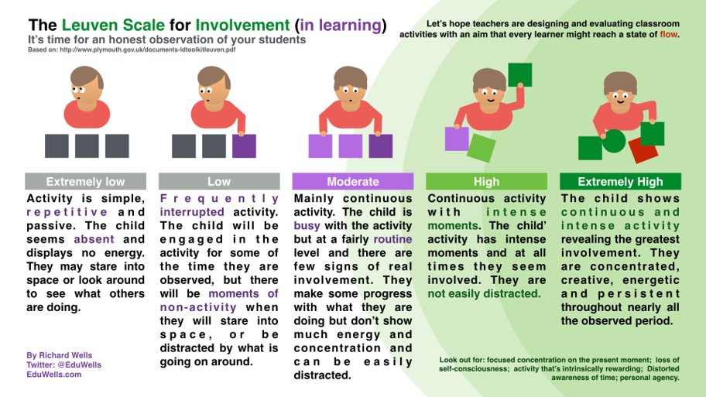

Available from: https://uowtsd-my.sharepoint.com/:p:/g/personal/alison_evans2_uwtsd_ac_uk/ERKj2t2ihbZLpQHCyoZQiCoB-NqidhjDLT_UH2CQ4HXrcw?e=y6iyZO

Appendix 2
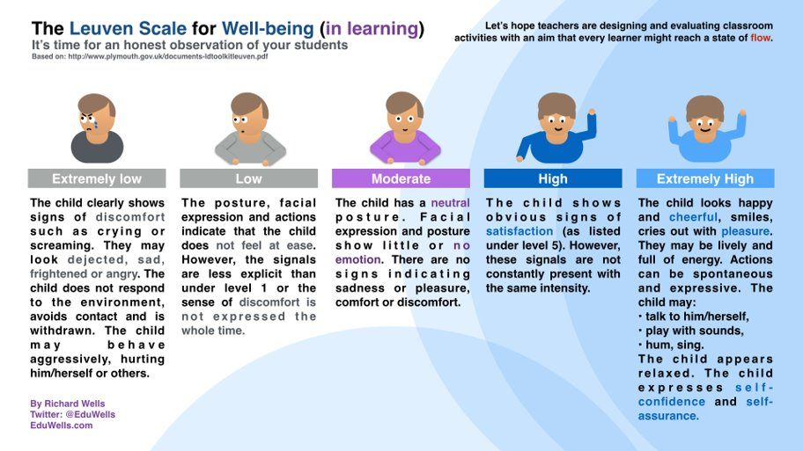

Available from: https://uowtsd-my.sharepoint.com/:p:/g/personal/alison_evans2_uwtsd_ac_uk/ERKj2t2ihbZLpQHCyoZQiCoB-NqidhjDLT_UH2CQ4HXrcw?e=y6iyZO

Appendix 3
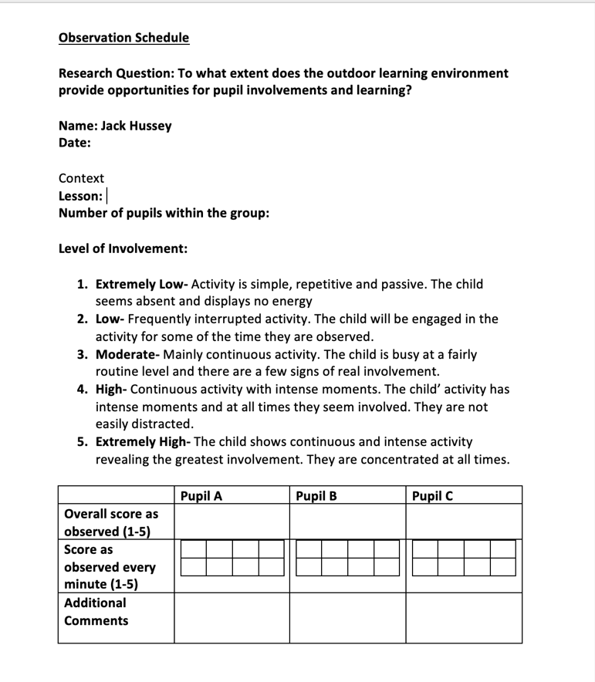

Available at: https://uowtsd-my.sharepoint.com/:w:/g/personal/1900103_student_uwtsd_ac_uk/EQN6eP91NktMuO0C_xoqeYsBn9Kk7PsgKaelADejtF8Yhw?e=ktwB6W.

Appendix 4



Available at: https://uowtsd-my.sharepoint.com/:w:/g/personal/1900103_student_uwtsd_ac_uk/Eb0Dfm8vV4ZMm_k-2102S6MBm30stQKUtXetydWhCzdoXw?e=eND

