Damion Richards
CIPD Number: 87220203
Total Word Count:

Damion Richards
CIPD Number: 87220203
Total Word Count: 2900
Task One

Executive Summary
This report describes the strategies that people practitioners can take in making effective analytical thinking in the process of making decisions. The reader will receive and overview of the many techniques and strategies that may be applied in HR and will instruct how to use these mechanisms to their best advantage.
Introduction
This report will, along with the help of several authors educate the audience on what evidence-based practice is and the different concepts and ethical theories that surround it. It will highlight the different approaches that can be used for analytical thinking and provide an assessment of a potential analytical technique that can be administered by businesses to identify future people related issues. Additionally, it will illustrate how these practices add value to organisations. It will demonstrate how analysing information about individuals to address business issues is the goal of people analytics and how a focus on these people related statistics can impact the value gained within organisations (CIPD,2022).

AC 1.1 – Evaluate the concept of Evidence-Based Practice
To compile this report, evidence-based practice has been researched, and the perspectives of several authors has been looked at. Evidence-based practice (EBP) in Human Resource Management (HRM) involves the making of HR decisions using the best available research evidence, organisational data, professional expertise, and stakeholder values (Rousseau, 2006). The adoption of EBP has become increasingly important as organisations seek to improve workforce performance and ensure fair, accountable people management. A key strength of EBP in HRM is its best ability to enhance decision quality. Research demonstrates that evidence-based selection methods, such as structured interviews and validated assessments, are more effective predictors of job performance that traditional approaches (Pfeffer & Sutton, 2006). Additionally, EBP supports HR’s strategic role by enabling data-driven evaluation of HR interventions, thereby strengthening HR’s credibility within organisations (Briner, Denyer & Rousseau, 2009). In conclusion, while EBP offers significant benefits to HRM, its effectiveness depends on thoughtful, context-sensitive application rather than rigid adherence to evidence alone. Technivara could use the six steps to evidence-based practice, since the 1990s, evidence-based practice has become and established standard in many professions. Despite offering different contexts, the approach to these six steps remains the same. It is important to note that following all six steps will not always be feasible, however, the more professionals can do – especially when making major or strategic decisions – the better (CIPD,2025).
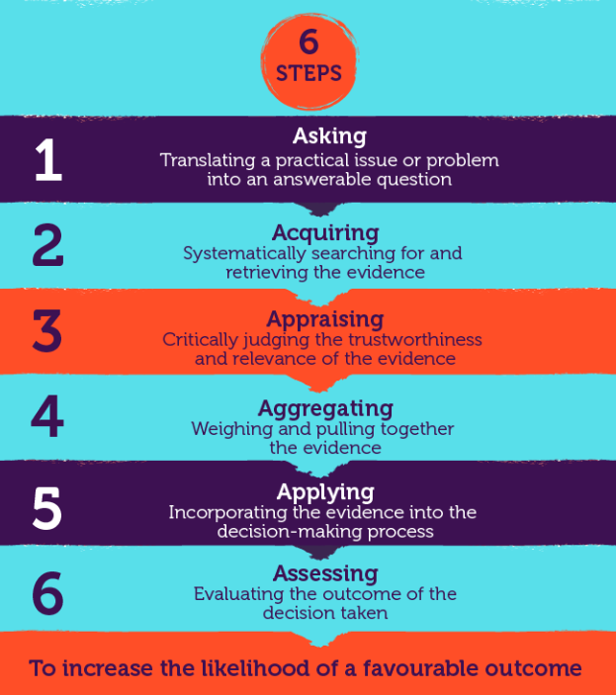
Another way in which Technivara could help with their sound decision making is to evaluate the four sources of evidence for people professionals. (CIPD,2025) suggest that before making an important decision or introducing a new practice, an evidence-based people professional should start by asking “What is the available evidence?” As a minimum, people professionals should consider the four sources of evidence. Evidence-based practice is about bringing together complementary evidence from different sources, including research and practice. A good aim for practitioners themselves is to become a curious consumer of research, understanding enough that one can ask probing questions, for example, about the strength of evidence and the size of impact. This is underpinned by skills in critical thinking, being clear about what questions are really of interest and what evidence will do the best job of answering those questions.
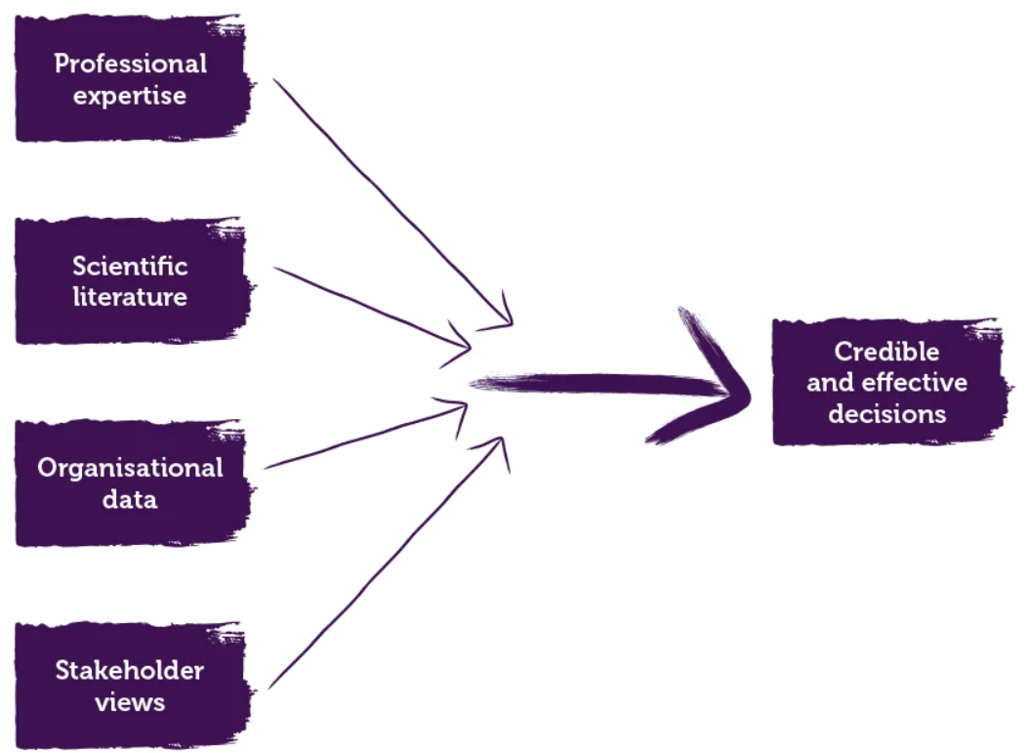

In summary, people professionals are often involved in solving complex organisational problems and need to understand ‘what works’ and ‘what makes sense’ to influence key organisational outcomes. The challenge is to pick reliable, trustworthy solutions and not be distracted by unreliable fads, outdated received wisdom or superficial quick fixes.
AC 1.2 Evaluate one analysis tool and one analysis method
This report will help Technivara analyse both an analysis tool and method that can be used in the decision-making process. Taylor and Woodhams (2022, p45-46) discuss the varying models and tools that can be used by organisations to form policy. These include SWOT Analysis, PESTLE, Porters Five Forces Model (1980) and the Horizontal Integration Strategy.
This report will help Technivara to focus on looking at the PESTLE model in attributing whether evidence used by organisation’s is trustworthy. PESTLE considers the external factors which include, economic, environmental, political and social factors. In business terms these include the impacts and response to political stability, the current state of the economy, current affairs and social trends, and the business response to technological innovation. The constantly changing of laws and legalities happening and the direct impacts businesses are having on the planet that we are leaving behind. This model can be used to help decision makers to make decisions based on differing scenarios and external factors that could affect business. Battista (CIPD, 2019), summaries that information regarding potential external impacts is thoroughly gathered during this method, giving it the ability to maximise opportunities and minimise risks by adapting to external scenarios.

The Five Forces Framework, like the PESTLE Model looks at the external factors. The model by Michael Porter focuses on how an organisation can gain competitive advantage by capitalising on the five key factors of that industry – its competitive rivals, new entrants, suppliers, customers and substitute products. As compared to the more conventional SWOT technique that looks at the internal advantages, disadvantages, possibilities, and dangers of a business organisations, the five forces and pestle model look at the external impacts that a business could be facing and the importance of adapting to new ways of thinking based on current affairs. Thus, concentrating on an external analysis, allows an organisation to focus on how it reacts to alterations in the environment outside (Goyal, 2020).
Tingsager and Smith (2022), suggest these tools alone are not enough to allow organisations to build strategy as they are often based on inaccurate external premise. Instead, they are put forward that there is no strategy that works for everyone, as the size and sector of an organisation can have varying outcomes.
Method
This report will now look at the different methods available to help Technivara in the process of determining decisions. It will focus on engagement and the significance of surveys and colleague interviews as an invaluable method in attaining evidence from within an organisation around colleague motivation and wellbeing. The CIPD (2021c), suggests engagement to be a vital component in the motivating the work force and gaining organisational commitment. Engagement surveys are a useful tool in attaining evidence from employees, however, can be subject to biases and vague information due to perception of confidentiality within the organisation.
A higher level of employee involvement and cooperation with high performance work processes are demanded by management (Gaille, et al, 2017). For example, Kavanagh (2014) claims, Travis Perkins has achieved the highest levels of safety and efficiency, thanks to the establishment of a society where workers are involved at every level with business goals. By providing people on the ground a voice to assist in problem solving, the emphasise communication and participation is particularly crucial in resolving a variety of difficulties. Kavanagh (2014) adds that by raising staff engagement levels across the board, the impact on the environment has improved. It is important for individuals to understand how this information is being utilised and the impact it has. Consiglio et al (2016), reiterates the importance of engagement within the workforce, in that social factors help shape a more positive and comfortable environment, which will increase work engagement.

AC 1.3 Main Principles of Critical Thinking
This report explores the main principles of critical thinking including analysis, evaluation, reflection, and reasoned judgement, and explains why these skills are essential for informed decision-making. It considers how evidence, assumptions, bias, and logical reasoning influence the quality of arguments and conclusions. The report then applies these principles to Technivara, demonstrating how critical thinking can support objective, balanced, and rational debate within this context. By using structed reasoning and credible evidence, individuals can assess different viewpoints more effectively and avoid unsupported claims. Overall, the report highlights how critical thinking encourages clearer understanding, fair discussion, and more reliable outcomes when engaging with complex or contested issues at Technivara. This approach ultimately strengthens communication, improves problem solving, and supports responsible decision-making in academic, professional, and real-world discussions, where clarity, accuracy, and open-minded evaluation are essential for stakeholders.
Critical Thinking is a skill, to both gather and examine evidence within HR. It is a dexterity that is used to critically analyse the opinions and arguments of others (CIPD 2019). Sternburg (1985, p194) claims, it can be broken down into 3 lenses – the first, a psychological view, can be used to distinguish whether an argument being made by someone is selectively portraying what they want to hear. Secondly, the philosophical view, how they formulate the arguments and viewpoints they are expressing to others. And lastly, the educational view, critiquing the concepts and viewpoints of others.
Lewis and Smith (1993, p134) disagree with sternburg’s thinking and argue that there are only two schools of thought in the critical thinking process – philosophy and psychology. They focus on the cognitive approach looking at how people think and look at behaviours critical thinkers can do to successfully examine evidence. Mcpeck (1981) disagrees with this thought process in that they suggest it boils down to intelligence of the practitioner in assessing the evidence.
By using these ideas, a critical thinker would be able to make the best decision with the evidence in which they are presented with. Armstrong and Taylor (2017) further enhance this idea, as they suggest critical thinking as a process of problem solving and analysing the quality of ideas. Schraw (2011, p327) reiterates the importance of the three schools of thinking when analysing evidence ands like Huitt (1998) suggests that critical thinking is a skill best mastered when learning a particular subject as it is simply not a skill one can learn alone. The description, analysis, and interpretation it offers determine the items worth (CIPD 2019).
AC 1.4 Decision making processes
This paper explores a range of decision-making processes that aim to support Technivara in achieving effective and informed outcomes. Decision-making models provide structured frameworks that enable organisations and practitioners to approach complex problems logically, analytically and creatively. By applying recognised theoretical models, practitioners can ensure that decisions are balanced, objective, and aligned with organisational goals.
One widely recognised approach is Edward de Bono’s Six Thinking Hats model, which promotes creative and structured problem-solving. This framework encourages individuals and teams to explore issues from multiple perspectives, reducing the likelihood of bias or premature judgement. The model categorises thinking into six distinct models, each represented by a coloured hat. The blue hat focuses on planning, organisation, and the overall management of the thinking process. The green hat encourages creative thinking and the generation of new ideas, while the red hat allows individuals to express emotions, intuition, and feelings related to the issue. The yellow hat concentrates on identifying benefits and positive outcomes, whereas the black hat is used to highlight risks, challenges, and potential problems. Finally, the white hat emphasises factual information, data, and evidence-based analysis (De Bono, 2019).
De Bono suggests that simplifying complex situations into distinct models of thinking enables practitioners to engage more effectively with information and avoid becoming overwhelmed by excessive detail. This structured simplicity allows individuals to approach problems systematically, thereby enhancing clarity and focus. Kivunja (2015) supports this view, arguing that the Six Thinking Hats model facilitates critical thinking by allowing individuals to examine problems from multiple angles. The flexibility of switching between different ‘hats’ encourages deeper analysis and adaptability, particularly when one approach proves ineffective. This process supports reflective thinking and continuous evaluation, both of which are essential in professional decision-making contexts.
Similarly, the Kepner and Tregoe decision-making model provides a structured method for analysing problems by dividing them into five core components: who, what, when, where and why. This framework promotes logical reasoning and systematic inquiry, helping practitioners identify root causes and potential solutions. By focusing on these key elements, decision-makers are better able to evaluate the impact of issues and select appropriate courses of action (Kepner & Tregoe, 2019. This structured approach supports consistency, transparency, and accountability within organisational decision-making.
However, Mulej et al (2012), caution that while such frameworks are valuable, they may become overly simplistic if applied without sufficient depth. Oversimplification can limit understanding and lead to incomplete or ineffective solutions. To address this, we can combine both quantitative and qualitative approaches to ensure decision-making processes that remain comprehensive and balanced. This integrated approach enables practitioners to consider both measurable data and contextual factors, enhancing the overall quality of decisions.
In conclusion, decision-making frameworks such as De Bono’s Six Thinking Hats and the Kepner and Tregoe models offer valuable tools for HR practitioners and organisational leaders. By breaking down complex issues into manageable components, these models promote clarity, critical thinking, and informed judgement. When used in combination with broader analytical approaches, they provide a robust foundation for effective decision-making, ultimately supporting organisational success and sustainable performance.
AC1.5 Ethical Theories and Perspectives
This report will look at the two different ethical perspectives that Technivara could use to inform and influence decision-making. Ethical practice is the application of ethical concepts to organisational behaviour (CIPD, 2022). This would apply to all dimensions of an organisation including, exercising social responsibility, the wellbeing of employees, taking measures to always be ethically minded, and always making decisions based on the right thing to do whilst acting with absolute transparency. It is claimed that when these values are taken seriously, the impact on both organisational KPI’s and colleague morale can transcend competitors. The CIPD (2015), recognises 8 lenses that can be used by organisations to make the right ethical decisions. These can be summarised as follows: Fairness Lens, Merit Lens, Markets Lens, Democracy Lens, Well-being Lens, Rights and Duties Lens, Character Lens and The Handing Down Lens. Giving consideration from these angles can be used to help organisations ensure that they are the right thing for both their share and the stakeholder as well as the employees by guiding the policy and looking at the potential consequences of our decisions if we did not ethically review workplace issues. Russell (CIPD) reaffirmed this notion in that they suggest organisations should always act with integrity and transparency in the workplace and that an ethically driven corporation could reach higher levels of reward and success.
Deontological theory, by contrast, focuses on two core ethical principles: duty-based and rights-based reasoning. It proposes that certain moral rules and obligations should always be upheld, regardless of the consequences of an action. Deontology therefore emphasises the protection of human rights and the importance of doing what is morally right in all circumstances. In comparison, utilitarianism evaluates the morality of an action solely based on its outcomes. Guided by the principle of utility, actions are judged according to the extent to which they maximise overall benefit within society. (Bentham, 1830, p4). As Foot (1985) argues, the ethical acceptability of an action can be determined by examining its consequences, particularly in relation to the happiness or wellbeing of the greatest number. Bench-Capon (2020) suggests that deontological reasoning represents a relatively straightforward approach, as it involves applying established rules and excluding prohibited actions from those deemed permissible. Despite their differences, both ethical frameworks can be applied to organisational practices such as, recruitment and selection, learning and development, and decision-making policies, by encouraging ethically informed choices and a commitment to doing what is right. Furthermore, effective managerial decision-making involves carefully evaluating the advantages and disadvantages of available options and exercising judgment to select the most appropriate course of action (CIPD, 2021c).
AC3.1 – Financial and Non-Financial Performance
This report aims to support Technivara in exploring effective methods for measuring both its financial and non-financial performance. By examining a range of performance indicators, the report will highlight how quantitative financial data, such as revenue, costs, and profitability, can be used alongside qualitative and non-financial measures, including employee engagement, customer satisfaction, and organisational satisfaction, to gain a balanced view of overall performance. This report will also consider the importance of evidence-based decision-making and how the use of reliable data can support strategic planning and continuous improvement. In addition, it will explore how different performance measures can be applied to assess efficiency, effectiveness and long-term sustainability within the organisation. By evaluating these approaches, the report will demonstrate how combining financial and non-financial metrics can provide deeper insights into organisational health and support informed management decisions. Ultimately, this report seeks to recommend practical and meaningful ways for Technivara to monitor performance and drive organisational success.
When evaluating evidence, it is essential to consider both financial and non-financial performance measures in order to gain a comprehensive understanding of organisational performance. The public sector comprises organisations that are owned, managed and funded by the government, whereas the private sector consists of businesses owned by individuals or shareholders and operates independently of government control. There are several key distinctions between the two sectors, including the higher level of transparency and accountability required within the public sector because of established norms and expectations. Consequently, public sector organisations must ensure that employees are treated fairly, consistently, and with respect.
Notably, the public sector often adopts a more bureaucratic approach, which can result in reduced flexibility in processes such as employment tribunals (Woodhams, 2022, p.26). Furthermore, HR practice within the public sector is frequently criticised for being outdated and overly bureaucratic, thereby limiting the value it contributes to organisational effectiveness (Woodhams and Taylor, 2022, P.25).
Benchmarking is important in both the public and private sectors. As highlighted by the CIPD (2022), benchmarking training activity and expenditure can help organisations refine their use of key performance indicators (KPIs) by identifying areas where resources are deployed efficiently and in ways that add value. In addition, collecting both customer and employee data is crucial, as this evidence can help explain organisational performance. Through initiatives such as employee engagement events and listening groups, organisations can focus on the development of softer skills that support employee performance, ultimately contributing to the achievement of financial targets and efficiency savings.

AC 3.2 Value added and ways of measuring impact
People practices can add significant value at Technivara by aligning employee capabilities with organisational goals, improving performance, and enhancing engagement. Effective recruitment and selection ensure the organisation attracts individuals with the right skills and cultural fit, reducing turnover and increasing productivity. Learning and development initiatives support continuous upskilling, enabling Technivara to remain competitive and innovative in a challenging market. Performance management practices help clarify expectations, provide feedback, and recognises achievement, which can motivate employees and improve outcomes. Wellbeing, inclusion, and employee voice practices can also strengthen commitment and trust, leading to higher retention and stronger employer reputation. The impact of these practices can be measured by people practitioners using both qualitative and quantitative metrics. These include employee engagement survey results, absence and turnover rates, performance data, skills assessments, and progression rates. Linking people data to business outcomes, such as customer satisfaction or profitability, helps demonstrate the value people practitioners to deliver at Technivara.
Effective and achievable HR strategies must be developed, communicated, and implemented for organisations to successfully achieve their strategic objectives. As Taylor and Woodhams (2022, p135) suggest, organisations must remain agile and well prepared to respond to future challenges. People practitioners therefore need to undertake their strategic roles within an increasingly volatile, competitive, and complex business environment.
However, organisational value extends beyond purely economic outcomes. The CIPD (2017) argues that value-based considerations are central to not only to organisational success, but also to how businesses engage with their workforce and the wider community. Value can be measured in several ways within organisations. While shareholder value is often linked to business models and strategic planning, the CIPD (2018) highlights that value is also created through people, as higher levels of employee satisfaction contribute to improved growth and healthier working environments.
By strengthening organisational capability within HR, practitioners can support strategy implementation and add value to the organisation. This value arises from a deep understanding of current organisational capabilities and business strategies, encompassing maintenance, risk mitigation, and continuous improvement activities, (Havard Business Review, 1992). Nevertheless, the CIPD (2017) notes that organisational value can be assessed in diverse ways, influenced by social, institutional, and stakeholder perspectives. Business models and frameworks are not always aligned, and corporate strategies may demonstrate imbalances in governance and stakeholder focus due to differing approaches to value creation and measurement.
Furthermore, the CIPD (2021), suggests that establishing clear links between organisational performance and effectiveness remains challenging, although evaluation outcomes can be supported through empirical evidence such as employee engagement survey data.
Name: Damion Richards
CIPD Number: 87220203
Word Count: 1000

Task Two
Executive Summary
This report discusses the importance of decision-making techniques in the analysis of both quantitative and qualitative data, as well as how people practitioners may utilise these strategies to address problems in people practice and guide informed decision-making.
Introduction
This paper will analyse the data at Technivara paying particular attention to the percentages of Leavers, Vacancies and positions filled. This data has been converted into percentage form for each of the departments.

AC 2.1 Interpret analytical data using appropriate analysis tools and methods
This Table depicts the total percentage of leavers against the total number of employees for each department at Technivara. I converted the data that was provided to me using an excel document, the formula I used was as follows, =C4/B4 ENTER and then to get a clearer percentage I used just the % button on excel. To help me create the above I again used the data that was provided to me and the percentages I created, highlighting the relevant data to help create the table above. I repeated the above steps for each part of the data from Techivara to show the leavers as a % of the total number of employees, vacancies as % of the total number of employees and finally positions filled as a % of the total number of employees.

Turnover and recruitment take up for Technivara 2024
 | Total in Department 2024 | Leavers for 2024 | Leavers as a % against total in each Department | Positions vacant | Vacancies as a % against total in each Department | Positions filled | Positions filled as a % of total in each Department
Audio technical Department | 26 | 6 | 23% | 8 | 31% | 3 | 12%
Offices and Administration | 15 | 4 | 27% | 5 | 33% | 5 | 33%
Research and Development | 8 | 1 | 13% | 4 | 50% | 4 | 50%
Quality control | 4 | 2 | 50% | 3 | 75% | 3 | 75%
Dispatch | 15 | 4 | 27% | 6 | 40% | 6 | 40%
Engineering | 35 | 8 | 23% | 8 | 23% | 3 | 9%
Casting Department | 6 | 3 | 50% | 5 | 83% | 2 | 33%
Sales & Marketing | 12 | 4 | 33% | 3 | 25% | 3 | 25%
Human Resources | 4 | 1 | 25% | 1 | 25% | 1 | 25%

AC 2.2 Present key findings for stakeholders from people practice activities and initiatives
Analysis of workforce data provided by Technivara highlights significant vacancy and attrition levels within Engineering, Audio Technical and Dispatch functions, presenting a strategic workforce risk. High turnover alongside sustained recruitment suggests that retention challenges rather than attraction difficulties. This indicates the need for strategic people practice response, incorporating workforce planning, retention strategies, leadership development, and career pathway design. Implementing these initiatives would improve workforce stability, reduce recruitment costs, enhance employee engagement, and support sustainable organisational performance.

AC 2.3 Recommendations
Through the analysis of the data, it has been highlighted that while facilitator competence and learning resources were rated highly, significant weakness exists in learner engagement, achievement of learning outcomes, and the transfer of learning outcomes in the workplace. Over 75% of respondents disagreed that they were able to engage meaningfully during session, and over 80% reported difficulty applying learning to their role. This indicates a disconnect between learning design and organisational performance objectives. According to research carried out by the (CIPD, 2025) organisations are increasingly turning to internal learning and development (L&D) to meet their talent requirements, and to retain employees. It is also noted that, employers are facing a complex landscape of evolving skills requirements alongside growing AI adoption. As automation changes job roles, people professionals must address widening skill gaps and foster continuous learning to ensure organisational success. Applying the AMO model and (Kirkpatrick,1959) evaluation framework suggest that although capability is developed, insufficient attention is given to motivation and opportunity, limiting behavioural change and return on investment. Consequently, redesigning learning interventions to incorporate interactive methods, improved alignment with performance management and structured post training support is essential to enhance effectiveness.

