The Towers Hotel and Spa
A Company Digital Marketing Evaluation
By Hannah Eve Thomas peters
P141415

Executive Summary
The Purpose of this report is to evaluate the digital marketing strategy of the Towers Hotel and Spa upon evaluating the hotel the author came to realise that the hotel didn’t have a strategy in place and so therefore needed one in order to successful market online through social media platforms and its website, the author decided to look at the website and Facebook for the hotel and found very little was happening if forms of marketing wise, An evaluation of the Hotels website is that its sole purpose is to be an information hub for its guests and potential guests with information about the company’s deals and promotions regarding tribute nights, spa treatments and Christmas bookings unless they book a regular stay at the hotel they direct customers to call the hotel’s reservation department regarding bookings or enquiries and the Hotels Facebook page even though they had many followers and likes their posts weren’t getting many hits all posts on social media are sales posts that lacked any humanity. The author made some recommendations to overcome these issues such as content being posted 3 times a week on all social media platforms as well as hiring someone to post relevant and timely content in high volumes, The author also recommended that in order to be more personal with their audience the Towers could adopt a blog to post to their website it could give a personal insight into the running’s of the hotel and with a behind the scenes access into the hotel operations and the what the staff have to do daily or to set up special events this can offer the followers an insight.

Contents

1 - Introduction | Page 4
2 - Towers Hotel and Spa | Page 5
3 - Strategy | Page 5
3.1 - Towers hotel and Strategy | Page 6
3.2 - RACE framework | Page 6
3.3 - Facebook | Page 7
3.4 - Blogging | Page 7
3.5 - Other strategies | Page 8
4 - Recommendations | Page 9
5 - Conclusions | Page 9
6 – Appendices | Page 10
6.1 - Appendix 1 | Page 10
6.2 - Appendix 2 | Page 10
7 - References | Page 11

1 - Introduction
The Oxford English dictionary (2008) defines marketing as “the action or business of promoting and selling products or services” it is believed that this definition of marketing is marketing explained in its simplest and most clinical form Kotler (2012) However insists that marketing is a science and is the art of “exploring, creating and delivering value to satisfy the needs of a target market at a profit. Kotler (2012) also believes that Marketing identifies the unfulfilled needs and desires of a target market and that marketing outlines, measures and qualifies the size of a company’s target market and profit potential and marketing is said to identify which segments the company is capable of serving the best and it also designs and indorses the most suitable products and services, it is believed that this is a reliable concept of what marketing is as it covers all aspects of the form of marketing especially market research and the needs and wants of the target market which are highly important to successfully capture an audience, and make a company profitable.
Digital marketing according to Chaffey (2012) is “achieving marketing objectives through applying digital technologies” this can include; managing a company’s online presence via their website, social media, search engine marketing, online advertising and E-mail marketing. This means applying a digital strategy to a marketing plan for a company to meet objectives.
The Author Believes that the internet has completely taken over everything individuals do and has consumed lives positively and in some ways negatively, in the last decade since the birth of the internet, digital technology has transformed the way we live, work and communicate and has become more important in the lives of individuals with individuals having over-dependence on devices such as smart phones, tablets and laptops. (ITV, 2017) Chaffey (2016) explains that “with over 3 billion people around the world regularly using the web to find products, entertainment and friends, consumer behaviour and the ways companies market to both consumers and businesses have changed dramatically” this means that in essence products and services are easier to get and has made the need for businesses to change how they market this has gone from traditional marketing which is marketer centric which includes cold emails, cold calling and interruptive ads to a more consumer centric way of inbound marketing which includes, Search engine optimisation, blogging and attracting.
In the United Kingdom, according to Hootsuite (2017) there are 65.31 million people living in the United Kingdom and 60.27 million use the internet making a penetration of 92% and 42 million are active social media users. (Hootsuite, 2017) so it could be said that marketing online may be vital to a business’s survival and being present on social media could help a business develop. See appendix 1.
2 - Towers Hotel and Spa
The Towers Hotel and Spa is Located in the Jersey Marine area of Swansea and is a large family-owned hotel, that boasts “high quality Accommodation, superb Meeting and Conference Facilities and a beautiful Spa and Pool”. The hotel is currently present on the social media platforms, Facebook and Twitter where they advertise deals and promotions running in the hotel however, this is all they do currently as well as a website produced for booking rooms and providing guests and potential guests with information.
the company aims to provide “high quality Accommodation, superb Meeting and Conference Facilities and a beautiful Spa and Pool, a warm, friendly welcome, excellent facilities and the highest standards of service and cleanliness ensure that your stay is a most pleasant one” (Towers Hotel, 2017)
For the purpose of this report the author will evaluate the company’s Facebook presence and its website this will help in identifying what their social media strategy is, what the company excels in doing regarding Facebook and website and what they need to improve.
3 - Strategy
Buchanan (2015) believes that “if you don’t have a strategy in place for your social media accounts, you’re setting yourself up for failure” this means that a company must have a strategy in place otherwise it can be pointless and not help in prompting business this statement as Chaffey (2016) emphasises that having “a digital marketing strategy is needed to provide consistent direction for an organisations online marketing activities so that they can integrate with its other marketing activities and support its overall business objectives”.
Currently the hotel does not have any form of digital marketing strategy put in place however does have a social media presence and website.

3.1 - Towers Hotel and Spa and it’s Digital Marketing Strategy
An evaluation of the Hotels website is that its sole purpose is to be an information hub for its guests and potential guests with information about the company’s deals and promotions regarding tribute nights, spa treatments and Christmas bookings unless they book a regular stay at the hotel they direct customers to call the hotel’s reservation department regarding bookings or enquiries. All information is up to date and relevant however the site is strictly professional with no form of humanity the hotel prides itself on being a “large family run hotel” and “Warm and friendly” but in the authors opinion has no real connection with its audience and doesn’t provide those qualities.
The hotels Facebook page, is highly popular with 7,825 people following and liking the company on its page, however the content is much the same as their websites with posts advertising upcoming events and promotions but posts are rarely popular with only a few likes and shares with each one plus all posts are sales posts which the author believes shows a lack of personality and humanity. According to McQueen (2017) an employee at the towers hotel believes that the hotel “doesn’t know how to post correctly” with “key Information missing, not straight to the point. Nothing is branded” so McQueen believes that the company could improve on their social media to increase following by using all information, being clear and concise and branding correctly. See appendix 2.

3.2 - RACE planning framework
Chaffey (2016) insists that the RACE framework is a “practical framework” developed to help manage and improve the commercial value that their organisations gain from digital marketing RACE comprises of four stages to aid in engaging prospects, consumers and fans with brands throughout the consumer lifecycle (Chaffey, 2016) These include;
Reach - Reach is the first step of the RACE process it involves building an awareness of a company’s brand, its products, and services on other websites and in other forms of offline media in order to build traffic and drive visitors to the web and its social media presences (Chaffey, 2016) this means getting content out on digital platforms such as Facebook, Instagram and Pinterest and even offline media like flyers and posters to draw people to research what your about as a company.
Act – Act or otherwise known as interacting - It's a part of the stage in encouraging interactions on a company’s websites and social media platforms to generate leads (Chaffey, 2016) this means It's all about persuading site visitors to take the next step, the next Action on their journey when they initially reach your site or social network presence.
Convert – achieve conversion to generate leads or sales (Chaffey, 2016) so this means that the process is to convert your audience in to buying into a company and its brand as a product or service with the exchanging of money.
Engage – Shape buyer relations through time to attain retention goals (Chaffey, 2016) this means that a company can over time create satisfied customers by developing long-term relationships with the consumers turning first-time buyers into lifetime customers therefore building customer loyalty and repeat business using communications on a company’s website, social media presence, email and direct interactions to boost customer lifetime value.

3.3 - Facebook
Social media marketing according to Chaffey is (2016) “monitoring and facilitating customer-to-customer interaction and participation throughout the web to encourage positive engagement with a company and its brands” this means that social media opens up communication links with consumers which in turn makes it easy to connect with businesses on a personal level.
Facebook According to unknown author (2017) is a global social media networking website founded by Mark Zuckerberg in 2004 and presently has 1.58 billion users signed up the networking service it is “where users can post comments, share photographs and links to news or other interesting content on the Web” this includes playing games, chatting live, and even stream live videos.
Facebook has been adopted by businesses to sell products and post content out to followers about their business this is verified by Qwaya (2017) who states that “It’s a great opportunity for a company to make online sales, get a following around the brand, create a platform where customers can discuss the products and, when done successfully, let people spread the word about your qualities.”
3.4 - Blogging
according to Chaffey A blog is a (2016) “personal online diary, journal or news source compiled by one person, internal team or external guest authors” blogging could be adopted onto the website to create a personal element Buchanan (2016) believes that blogging can be an affective form of digital marketing as it can promote a company’s brand effectively and give a behind the scenes insight to a business and its operations as long as a company “posts with purpose”.
Duermyer (2017) insists that blogging is a great tool as it can be used as a search engine optimization tool, Blogging can also provide an easy way to keep customers informed on what's going on, let them know about new deals, and provide tips. The more a customer comes to a company’s blog, the greater likelihood they are to spend money according to Duermyer also states that A blog allows a company to build trust and rapport with prospective customers. Not only can it allow the ability to show off what a company knows, building expertise and credibility because individuals can post comments and interact with a business, they can get to know and hopefully, will trust enough to buy. Blogs also have potential to make money. Along with products or services, blogs can generate income from other options, such as advertising and affiliate products.

3.5 - Other Strategies
Buchanan (2015) States that the method he uses regarding social media and digital marketing is the “321 method” which is a daily method where company’s post 3 posts a day that are value based this includes something educational such as a pdf, a video, a blog or an article on anything an individual can teach someone then 2 posts a day that are personal these can give insight into the company and the audience can relate to then final 1 post a day regarding a sale which must link to personal and value posts whereas the posts are less frequent the only type of posts the Towers put out to its audience is sales posts where this is correct it doesn’t engage with audiences as they don’t get to see anything they just receive posts about events they cannot relate to.
Buchanan (2015) also states that he goes by the a few guidelines to ensure more engaging audience and fanbase which includes, Brand personality which is to “be yourself” and let the company’s personality shine through whilst also being authentic and real Buchanan also says to be timely and relevant with content, content Buchannan believes should either educate, entertain or give insights with posts and when target audience listen to them and reply in a timely manner, the next rule Buchanan believes is to have conversations that matter this means to focus on engagement with the audience, asking the right questions and make people think, the next tip is to be deliberate with what you post and that a company should know what they are posting and why and lastly they should track their results, listening to audiences and watch how people react to content and all content should be sharing out the same information

4 - Recommendation
The Author recommends that the towers develop a strategy just like Buchanan such like the 321 methods or the race framework such as Chaffey as this will create greater success as their content that is already being posted out is not very popular as the author believes that they are just selling and not engaging in their audiences or following trends. The author suggests that content should be posted 3 times a week on all social media however it is appreciated that the staff already at the hotel do have jobs and to do more would take that are time consuming so someone will need to be hired in order to post content in high volumes daily or weekly
The author also recommends that in order to be more personal with their audience the Towers could adopt a blog to post to their website it could give a personal insight into the running’s of the hotel and with a behind the scenes access into the hotel operations and the what the staff have to do daily or to set up special events this can offer the reader an insight
the author also suggest that the hotel should invest in Instagram, Instagram is a photo sharing social media platform that allows uses to share photos company’s use to display products or services or give a face to the organisation such as staff doing activities and this could be adopted in the towers to show that warm friendly environment.
Another suggestion for the towers digital marketing strategy is to send emails out to subscribers on their site to tell them about deals and products that the hotel offer. This means that they can reach their audiences all the time.
5 - Conclusion
In conclusion The Towers Hotel and Spa is not operating its digital marketing at full potential the hotel needs to develop a strategy that works with them in order to ensure they bring in customers time and time again with the suggested changes of developing a strategy such as Race or the 321 method as well as hiring someone in a full time or part time position to fully handle digital marketing for the hotel the author also suggests that the hotel should have a blog as to be more personal with their audience as well as developing an Instagram account and sending emails to consumers can all help with engaging with the target market and develop relationships with them by turning first-time buyers into lifetime customers therefore building customer loyalty and repeat business using communications on a company’s website, social media presence, email and direct interactions to boost customer lifetime value.

Appenicies
Appendix 1 – Hootsuite breakdown
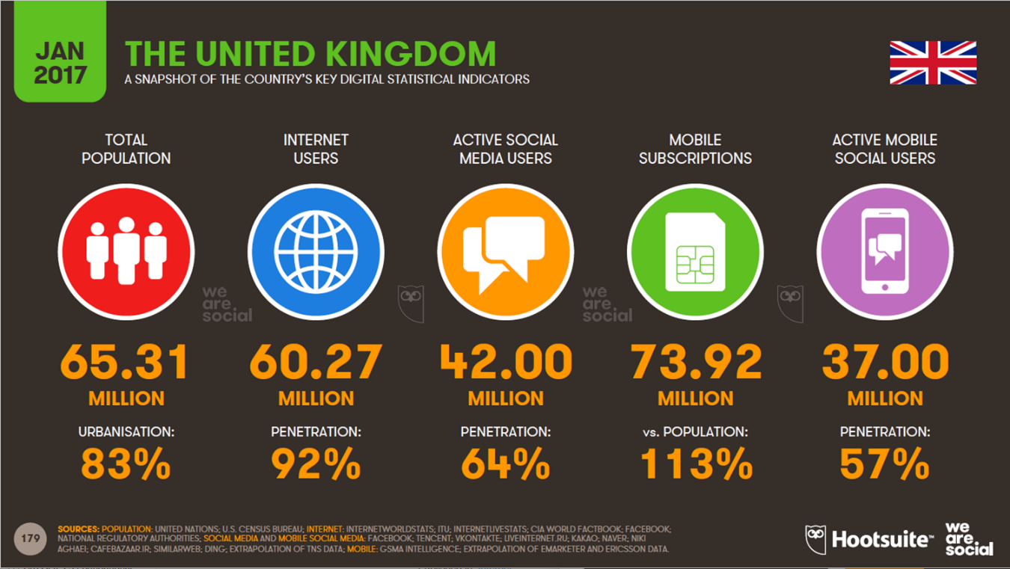
Appendix 2 – McQueen Facebook conversation
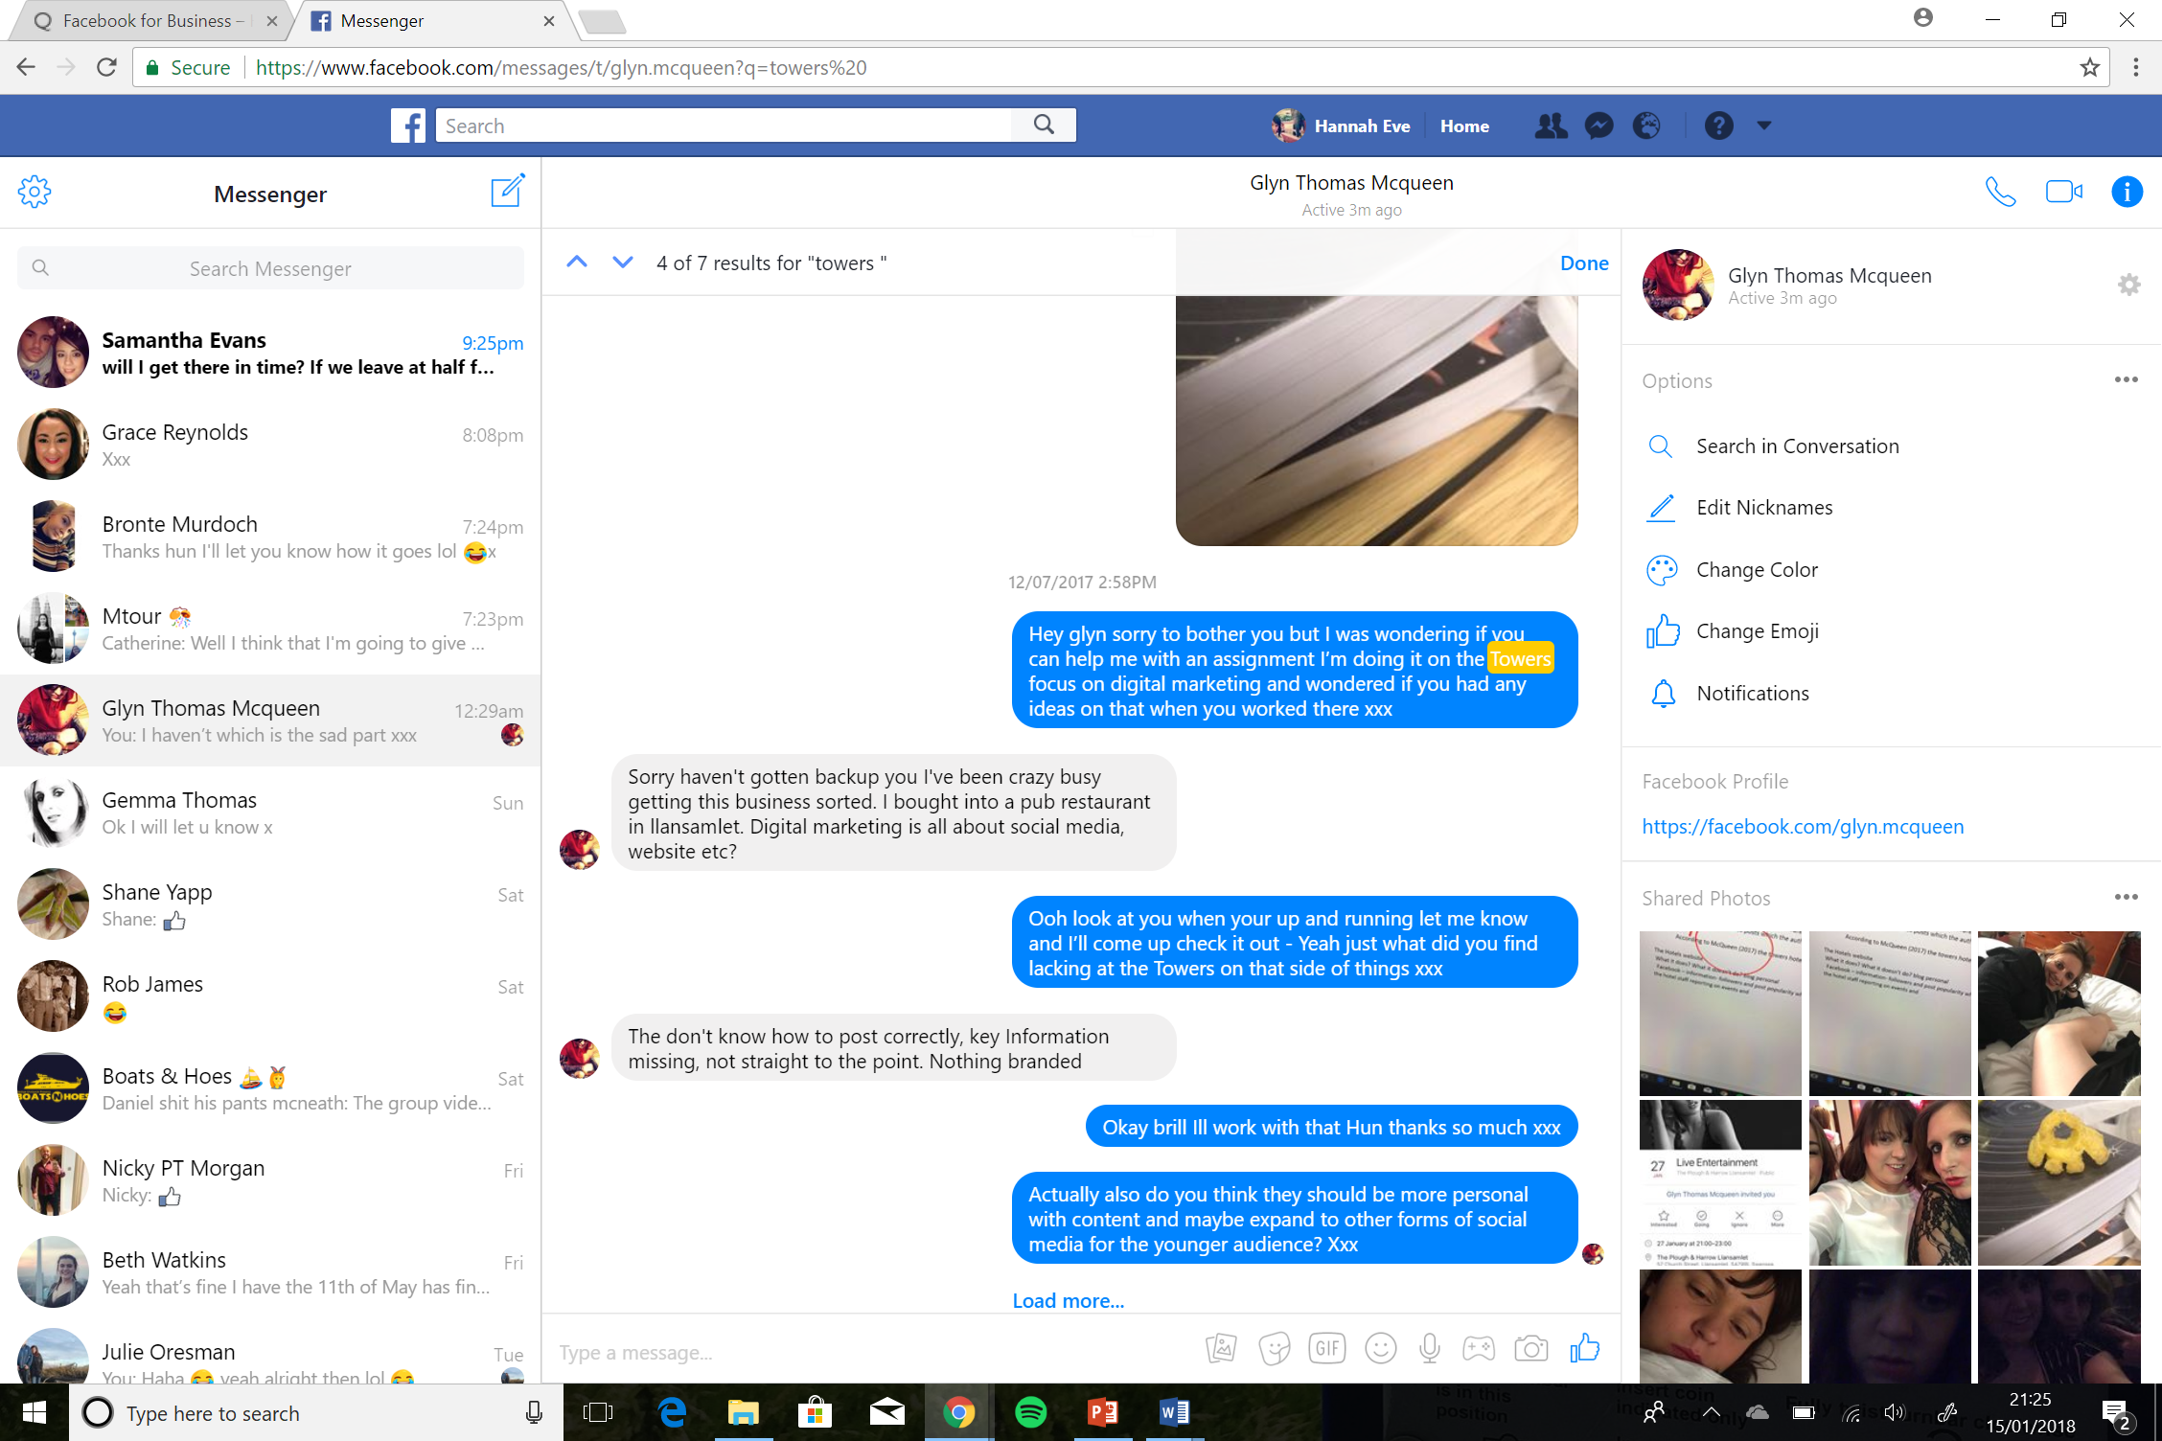
Refrences
Buchanan (2015) Available at: https://nathanbuchan.wistia.com/medias/ifi7i5twj1?embedType=async&videoFoam=true&videoWidth=640 (accessed on 10th January)
Chaffey (2016) Digital Marketing, strategy, implementation and practice, sixth ed. Pearson, Harlow
Duermyer (2017) what is blogging why is it so popular: Available at: https://www.thebalance.com/blogging-what-is-it-1794405 (accessed on 12th January)
Hootsuite (2017) Pico graph available at: MTOUR lecture 1new
ITV (2017) Tonight: Is Technology Taking Over Our Lives? available at: http://www.itv.com/news/2012-10-18/tonight-is-technology-taking-over-our-lives/ (accessed on 4th January)
McQueen (2017) Employee Facebook conversation
Qwaya (2017) Available at: https://www.qwaya.com/facebook-for-business (accessed on 13th January)
Towers (2017) Available at: http://www.thetowersswanseabay.com/ (accessed on: 2nd January)
Unknown Author (2017) What is Facebook?: available at: https://www.lifewire.com/what-is-facebook-3486391 (accessed on 12th January)

