BA Leadership and Management Skills for the Workplace
Coaching & Mentoring Skills for the Workplace
BMSK6005
Student Name: Marlena Lungu
Student Number: 1703949
Lecturer Name: Joanna Walsh

Table of Contents
1. Introduction 3
2. Coaching & Mentoring in the Context of Business Organization 4
2.1 Differences Between Coaching & Mentoring 4
2.2 Similarities in Coaching & Mentoring 6
2.3 Purpose of Coaching & Mentoring in the Workplace 7
3. Evaluating Model of Coaching & its Benefits for Developing Individuals’ Workplace Effectiveness 8
3.1 Analysing the Needs of Coaching in the Workplace 8
3.2 GROW Model of Coaching or Mentoring 10
3.2.1 Benefits of Implementing GROW Model 12
3.3 FUEL Model of Coaching or Mentoring 12
3.3.1 Benefits of FUEL model in Mentoring or Coaching 14
4. Evaluation of the Characteristics of an Effective Coach or Mentor 14
4.1 Critical Evaluation of Knowledge, Skills & Behaviors of an Effective Mentor 14
4.2 Importance of Managing Values & Relationship Power in Coaching or Mentoring 16
4.2.1 Managing values in Mentoring 16
4.2.2 Managing Relationship Power in Mentoring 17
5. Conclusion 19
References 20

1. Introduction
Coaching and mentoring are rapidly popular and is necessary in today's times as it can be used for both personal and professional development. Mentoring and coaching help the student to build a positive change and is a process of transferring the knowledge of mentor the individuals. In the case of business organizations or companies, coaching and mentoring profoundly facilitates the career growth of the employees, increases the employee performance and overall productivity of the organization (Carmel and Paul, 2015). Coaching and mentoring are necessary when the management notices gaps in employee performance. Different organizations use different model or process of training or mentoring their employees. to understand when mentoring of the employees is needed, the management must have knowledge about the importance, process, effectiveness of mentoring and the characteristics needs to be an effective mentor in the workplace. The purpose of this paper is to give an insight on mentoring & coaching, the purpose of coaching and mentoring, different models and their benefits in the context of a business organization, Zara, one of the largest fashion companies in the UK belongs to Inditex Zara UK is one of the largest fashion business organization in the world with more than 1700 outlet all over the world. Zara was founded in by Amancio Ortega in 1963 in Spain and the parent company of Zara is Inditex. The priority of Zara was to make luxury fashion products accessible to all, especially to the young generation. The recruitment policy by Zara is also more concentrated younger people. The success of Zara is mostly because of the service by their energetic employees in their different outlets worldwide. As employees are the main profit generator and understand the market more closely, they provide different coaching and mentoring facilities to the employees on a regular basis. They use different process or model of training, mentoring or coaching by conducting different employee development program such as Intent, Project Go!, training for internal teams etc.

2. Coaching & Mentoring in the Context of Business Organization
The necessity of coaching and mentoring is rapidly increasing in order to develop the skills of the employees in the workplace. International business organizations like Zara are conducting different coaching or mentoring facilities in order to increase the productivity and adaptability of the employees with new changes in the business world. Training and mentoring facilities in the workplace increase the job satisfaction of the employees, facilitate the personal and professional growth of the employees, enhance critical problem analysis and overall increases the productivity of the organization (Clutterbuck, 2014). Though coaching and mentoring usually serves the same purpose, but there is a distinct difference between the definition of coaching and mentoring.
According to Carmel and Paul (2015), coaching can be described as the process of learning and development in order to increase an individual’s performance. The management of Zara uses different coaching program such as In Talent, Project Go! Et. In order to coach the employees in the workplace, the skills of the coach are the most important elements. The coach needs to be skilled as well as should have the knowledge and understanding of different models, process, techniques of identifying performance gaps and coaching employees. on the other hand, mentoring can be described as the off-line help by one person to another in making the transition in learning different knowledge. Mentoring in Zara is usually done by the direct supervisor of the employees. The following section will give an insight into different similarities, differences and purpose of training and mentoring in the workplace.

2.1 Differences Between Coaching & Mentoring
Defining the term coaching precisely is difficult as the meaning of coaching can vary, and the userusually depends on the context. That’s why it is also difficult to distinguish between coaching and mentoring in the organizational context as both the term need skilled mentor or coach to guide the individuals or employees in the workplace (Connor and Pokora, 2014). Though mentoring and coaching serves the same purpose, the management of Zara uses coaching for developing the skills of employees to achieve a short-term objective and uses mentoring as a long-term investment on individual employees by promoting their personal development. Mentoring in Zara, the mentor needs additional skills to support the employees in the long run. Some key difference between coaching and mentoring can be identified from the definition we have discussed earlier and by analysing the employee development programs in the workplace of Zara.
Level of Formality: Coaching in the workplace is tends to be more formal such as a contract between different parties. Sometimes third parties are involved in the organization in order to coach the employees. on the other hand, mentoring is less formal then coaching it is usually the agreement between the employees and the organization (Cranwell-Ward, Bossons and Gover, 2013). the organization promises to care about the professional development of the employees while recruiting. The management of Zara uses outside organizations to coach employees on different skills such as presentation skills, training in a different area. On the other, they use their skilled coaches from the HR department to coach and guide their newly recruited employees. mentoring in Zara is mainly done the supervisors.
Length of Contract: The length of the contract between the parties is usually short. The duration of the contract may vary between 4 to 12 meetings or less than a year. As Zara usage different training sessions as a means of coaching, the coaching usually lasts three months (Dembkowski et al., 2015). On the other hand, the mentoring duration or length of the mentoring process is usually unspecified. The mentoring process in Zara usually the time of an employee working in the organization.
Outcome Focus: coaching is tending to be more performance-focused. It imposes a greater focus on short term skills or performance. Guiding employee in managing a task is an example of coaching in Zara. On the other hand, mentoring is more career-focused (Clutterbuck, 2014). It helps the employee in developing a personal professional career goal. Training on critical analysis, presentation skills, continuous performance analysis are examples of mentoring in Zara.
Level of Knowledge: usually coaches are more generalist and have a strong appreciation for commercial realities. On the other hand, mentors are more expert in the sector they are working in (HAMPTON, 2016). The mentors are usually the supervisor of the employees who have detailed knowledge about specific areas such as sales, marketing, financing, presentations, information etc. There are different mentors for different area of development in Zara, who are expert on something and have detailed knowledge about the specific area.
Client: the client of a coach within a workplace is usually two, the organization and the employees (Carmel and Paul, 2015). In coaching, employee needs to bring benefits to the organization in a short time. On the other hand, mentoring more typically have a single focus on the development of only the needs of the employees. To coach the employee in different area, the management of Zara usually hires third-party organization who needs to bring benefits for both the organization and employees. In in mentoring, the supervisor or the mentor only concentrate on personal development of the employees.
Support or Supervision: The supervision or support from coaches are usually more formal which may include in the agreement (Hawks, 2015). On the other hand, support or supervision from the mentors is usually based on the policy of organization. In Zara, the support or supervision in mentoring or coaching is usually based the HR policy of the organization.

2.2 Similarities in Coaching & Mentoring
As we have discussed some differences between coaching and mentoring, there are also some similarities between them. Both the coaching and mentoring are conducted independently by the line managers in Zara. These two processes of developing the professional growth of the employees are an honest and open relationship between the organization, employees and the coaches or mentors. The objective of coaches or mentors of Zara is to enable employee’s ability to adapt to a new approach as personal or professional development. From the personal development program of Zara by coaching and mentoring, some similarities can be found.
Encourage Self-Improvement: Coaching and mentoring encouraging the self-improvement within the employees. as both coaching and mentoring in Zara are a cooperative learning relationship, they create a positive change in the performance and lives of the employees (Kahneman and Egan, 2011). The coaching and mentoring facilities provided by the management of Zara motivate the employees to improve themselves to the upper level as it facilitates job promotion as they became more skilled.
Provide a Safe Setting for Sharing: Coaching and mentoring provides a safe setting to share knowledge between employees and mentors to employees (Law, 2011). In the formal structure of coaching in Zara, the employees have the proper environment to train themselves to the extent and in the informal mentoring session, the process facilitates the relationship between the employee and the supervisors of Zara which provide a safe setting for sharing information. the management of Zara gradually developed a knowledge or information sharing culture by coaching or mentoring the employees.
Increase Employee Performance: As both mentoring and coaching serves the same purpose, increasing the productivity and performance of the employee is the main and core area of concern (Holliday, 2016). By obtaining both mentoring and coaching, Zara increases the performance and productivity of their employee in the short run or for the long run. Though the mentors of Zara needs additional skills to support and supervise the employees in the long run.

2.3Purpose of Coaching & Mentoring in the Workplace
To survive in the ever-changing world of business. organizations must evolve themselves by learning on a continuous basis. Understanding employees needs, motivations or need for improvement is one of the most important tasks for the management to evolve effectively (NEALE, 2015). An organization with structure coaching and mentoring activities tends to be more effective in the market. Coaching and mentoring may serve different purposes. The key purposes fulfilled by mentoring and coaching in Zara are described below.
To Create a Culture of Learning: By promoting and executing different coaching and mentoring programs within the organization, the management automatically creating a culture that values learning and the development of the employees (Payne, 2011). when the employees have the opportunity of developing themselves by attending in coaching or mentoring programs, they know that their future in the organization is being invested by the management. Also, a culture of learning increases collaborative learning in the workplace where employees are always learning from those around him.
To Promote Personal & Professional Development: The core purpose of mentoring or coaching is to promote the personal as well as professional development of the employees (Law, 2011). The management of Zara uses different training programs to coach their employees in personal development such. It grows confidence in an individual to take more risk and learn more. It grows different from the professional skills of the employees. on the other hand, mentoring helps individuals to become more efficient in the workplace which is usually considered as a long-term investment on the employee.
To Decrease Stress & Anxiety: In an organization like Zara fashion, workforce and the customers are more diversified than in any other business or industry. So, facing different new difficulties in normal in these types of workplace. But when facing an issue at work, the employees may think before going to the manager as it shows his or her failure in handling an issue (NEALE, 2015). The teammates may not able help for different circumstances or the employee may have a problem with his or her supervisor or teammates. So, not able to share and solving the problem increases stress and anxiety in the employee. But in Zara, a mentor or coach is always there to listen to the issue and guiding the employee to overcome which reduces stress and anxiety.
To Increase Job Satisfaction and to Reduce Turnover: different studies on mentoring or coaching in the workplace shows that, structure mentoring and coaching facilities influence the job satisfaction of the newly recruited employees (Hawks, 2015). The mentor or coach’s relationship with the employees positively create a concrete change within the employee and the employee feels valued by the management. That’s why they are more likely to stay in the organization more which reduces job turnover. The structured mentoring and coaching program help the management of Zara to keep their employees motivated in the organization effectively.

3. Evaluating Model of Coaching & its Benefits for Developing Individuals’ Workplace Effectiveness
Mentoring or coaching in the workplace is becoming a common phenomenon for today’s business world. Most of the successful business organization are implementing different mentoring and coaching program in order to promote the personal and professional development of there employees (Pettinger, 2015). The different organization uses different models or process of coaching or mentoring in the workplace according to their HR policy and business strategy. Zara, as an international fashion business and the business, is more concentrated on the trends and young generation, the success of their business is their young and energetic workforce. The management of Zara follows a predetermined procedure of identifying the needs and scope of development and follows different models of coaching and mentoring according to the context.

3.1 Analysing the Needs of Coaching in the Workplace
Analysing the needs of coaching in the workplace is inevitable in the development of the employees personal and professional. Mentoring and coaching are a long-time investment by the organization on the employee’s future in the organization. as mentoring, special coaching needs coach and burger which is a cost for the organization itself (Rainbird, Fuller and Munro, 2017). That’s why analysing the needs of coaching is important before executing any employee development program in the workplace. The management of Zara follows a standard procedure to identify the gaps in employee performance and to identify the needs of coaching or mentoring. The process includes analysis of organizational needs, needs for completing a job task or individual performance analysis to identify the needs or scope of personal or professional development.
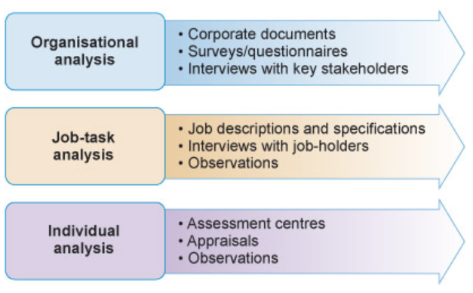
Figure 1: Level of analysis to identify the needs for coaching
(Source: Pettinger, 2015)
Organizational Analysis: The organizational analysis is encompassing with analysing the business strategy, or challenges facing by the organization. the main purpose of the organizational analysis is to evaluate how the organization is ready to deal with not only current challenges but also the skills needed to manage future challenges (Rainbird, Fuller and Munro, 2017). To identify the gaps or needs for development at the organizational level, the management can analyse different corporate documents, interviewing the stakeholders and conducting a survey in the workplace. The management of Zara interview the stakeholders and conduct survey’ son a monthly basis on its employees to identify the needs of coaching or mentoring at the organizational level. They also use the data from workforce planning activities to asses the impact of issues or gaps in employee performance.
Job-task Analysis: Job-task analysis is the process of analysing individual jobs and their roles or responsibilities to asses the gaps between their current performance or skills and their desired skills and capabilities (Pettinger, 2015). The first thing in analysing job-task to identify the needs of mentoring or coaching is to examine the job description and specification which provides the basis of decision about the skill gaps or gaps in capability levels. The management of Zara uses the job description and specification comparing with the in-job performance as the basis of analysing the needs of mentoring or coaching.
Individual Analysis: The purpose of the individual analysis is to identify the skills needed by the employee in order to facilitate his or her professional and personal development. The individual analysis is mostly done in every organization by using the performance appraisal system where the individual performance of employees is compared with their job descriptions (Payne, 2011). Zara also uses this process to identify the gaps between job description and performance. If the analysis reveals problems in employee performance, they recommend attending a coaching or mentoring program within the organisation.
After identifying the gaps in the skills and capabilities on employee’s performance, the different organization uses different model or process of coaching or mentoring their employees. The management of Zara uses three main types of model or process of mentoring and coaching depending on the context of the subject or area. The most common is the GROW model of mentoring or coaching, though there are more models are used on different occasions.

3.2 GROW Model of Coaching or Mentoring
As an international business organization with a diversified workforce, the most important role of the management is to coach the employees in the organization to do their best (Roberts, 2012). The GROW model of coaching and mentoring is a simple but very powerful framework for structuring coaching or mentoring in the workplace. The management of Zara uses the GROW model developed by Graham Alexander, Alan Fine & John Whitmore in 1980s. The GROW stands for Goal, Reality, options and will.
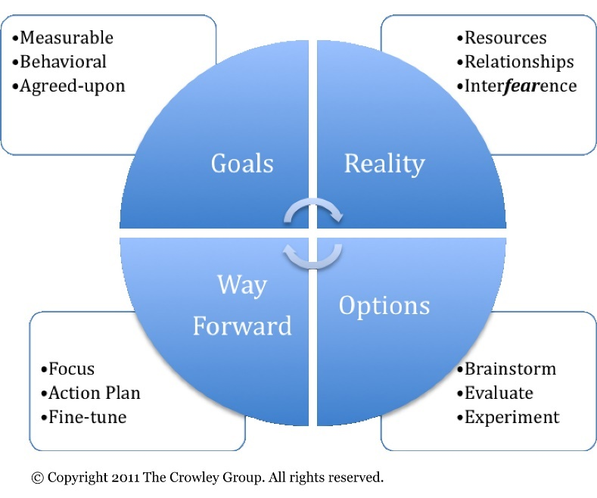
Figure 2: GROW model of coaching or mentoring
(Source: Clutterbuck, 2014)
Establishing the Goal: the first and most important step in mentoring or coaching is to identify the behaviour or skill of the employees that the management wants to develop or change (Roberts, 2012). The management of Zara structure this need for change or development as a goal that the organization as well the individuals wants to achieve. The management of Zara ensures that the goal is a SMART goal which is specific, measurable, attainable, realistic and bounded by time. When establishing a goal, the management should ensure the align the necessary of attaining this goal with organizational objectives or goals.
Examining the Current Reality: In the next step in the GROW model is analysing the current reality of employees needs and performance (Clutterbuck, 2014). Usually, the management of Zara uses survey, interview or observation techniques to evaluate the current performance of the employees. this is an important point or step in the model. Sometimes the coach or mentor is not fully aware of what the employee needs in order to develop themselves and miss some information while coaching or mentoring the employees. but analysing the current state of the employees helps them structuring the program content and developing a solution for the employees.
Exploring the Options: After analysing the current reality of the employee performance and identifying the gaps in skills and capabilities the management should explore different options of attaining the developed goals or objectives. Zara uses the employee’s ideas by brainstorming sessions in selecting options. Giving the opportunity of decision making, employees felt valued to the organization and them more motivated to develop themselves. Suggestions of team members or employees are important because they know about their needs more than the organization.
Way Forward: After examining the current reality in the workplace, identifying the gaps in capabilities or scope of development and analysing different options of attaining the goal, the employees of the organization and the management now have a good idea on how they achieve the goal or objectives (HAMPTON, 2016). But understanding the option or selecting the options is not enough in developing skills or performance. The management should guide the teammates or employees to commit to specific actions in order to move forward towards his goals and develop themselves as necessary. By assigning the employees to commit specific actions. The management of Zara boosts the motivation of the employees to learn more.

3.2.1 Benefits of Implementing GROW Model
Though the purpose of every model for coaching and mentoring serves the same purpose, there are some advantages in implementing a model from another. There are two main benefits of implementing the GROW model –
Enhance Workplace Culture: when individual employees are working towards attaining a goal in the organization, they are more likely to be engaged with the organization (Roberts, 2012). an engaged workplace leads to better performance and reduces in employee retention. The continuous learning process beside completing jib responsibilities enhance the learning culture of the workplace.
Facilitates Talent Management:By implementing the GROW model the management of an organization ensure the management of employee from every level throughout the cycle. Every employee is considered as the same in the GROW model (Clutterbuck, 2014). By implementing a continuous coaching program like the grow model ensures that know employees are left behind in terms of skill development.

3.3FUELModel of Coaching or Mentoring
Different coaching and mentoring model work by directing and questioning the employees to guide in developing the skills of the employees. The FUEL model of coaching and mentoring allows the individual to asses their situation and determine their own solution to take ownership and accountability for the outcome. The four-step FUEL model consists of framing the conversation, understanding the current state, exploring the desired state, and laying out a successful plan for coaching or mentoring. The management of Zara sometimes uses the FUEL model of coaching when they need to give the employee full freedom of developing their skills.

Figure 3: FUEL model of coaching or mentoring
(Source: Gilley and Gilley, 2010)
Framing the Conversation: Coaching or mentoring usually is an agreement between the organization and the employees or third-party organization and the employees (Law, 2011). Framing the conversation means setting the context and parameters of the program right from the beginning. In Zara, the conversation has three main contents in it, the purpose of the conversation between different parties, the process by which the organization or management will proceed and the desired outcomes of the session.
Understanding the Current State: In this stage, the organization or management must understand how the individual views their current state of performance or situation, the management should the understand the needs of the employees from their point of view (Gilley and Gilley, 2010). Asking open-ended and long leading questions to the employees helps to clarify the perspectives of the parties. The questions in Zara includes different issues, the reactions of the employees regarding these issues, the impact of the issues on them and on organizations.
Exploring Desired State: The management of Zara then asked the employees about their desired state or where they want to go or what they want to achieve. The desired state of the employees is the base of laying out a successful plan for executing a coaching and mentoring program in the workplace (Sloane, 2014).
Laying Out a Successful Plan: In the last stage of this model, the individual needs to formulate a plan for achieving their desired state or goal. The employees or the individuals in the organization need to develop a detailed plan, timetable and steps of how he or she is going to achieve the goal (Payne, 2011). As the individual develop their plan for developing themselves, they will be accountable for their own action in the outcome of the process. the plan or goal should be SMART.

3.3.1 Benefits of FUEL model in Mentoring or Coaching
Though there are many resemblances between the GROW model and the FUEL model of coaching and mentoring. FULE model sometimes has advantages over the GROW model. Benefits of implementing FUEL model within the organization are –
The FUEL model of coaching and mentoring is useful where the organization wants its employees to identify their problem on their own (Gilley and Gilley, 2010). The process gives the employees the freedom of choice in developing themselves in the professional life which motivates them in learning more.
When an organization implement GROW model within an organization, the responsibility of the outcome of the program or training session is all need to be carried out by the organization (Roberts, 2012). but in the FUEL model of coaching, the individuals are responsible for the outcome as they plan their own.

4. Evaluation of the Characteristics of an Effective Coach or Mentor
Effective mentoring skills need more characteristic than just a guardian for the employees. Different research shows that the mentors or the coaches need different skills and personal character to develop the skills on their mentees or coaches.

4.1 Critical Evaluation of Knowledge, Skills &Behaviors of an Effective Mentor
The different researcher has identified different skills and characteristics of an effective mentor to maintain the mentor and mentee relationship effectively (Sugars, 2010). The skills needed for an effective relationship between the employees and mentors can be understood by the diagram below. The core mentoring skills are discussed below according to the diagram.
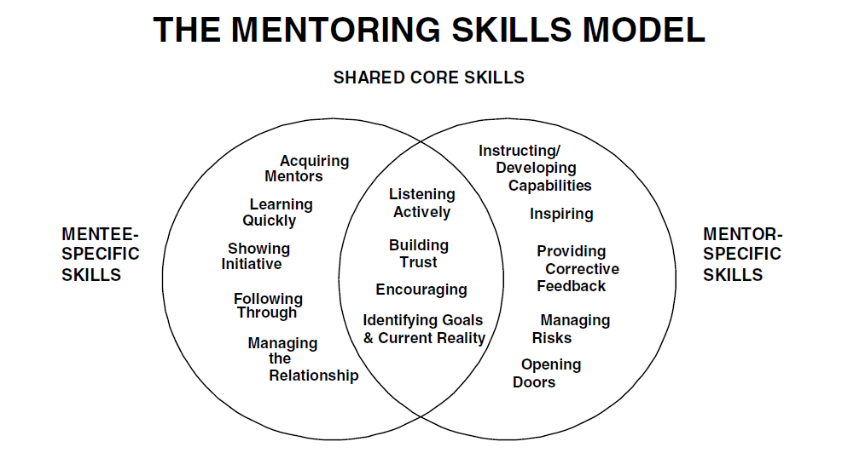
Figure 4: Core mentoring skills
(Source: White and Goldsmith, 2012)
Listening Actively: Active listening to the employees or mentees is the most fundamental and basic skills of an effective mentor (Sugars, 2010). When a mentor listens to his mentees with full concentration, the mentees will understand their concerns have been heard by the mentor. As a result, they will feel accepted and motivated which will build trust.
Building Trust: Effective training program is all about a good relationship between the mentor and mentees (White and Goldsmith, 2012). The more the employees or the mentees trust the mentor, the more they will be committed to the partnership of learning and developing themselves. The mentor in Zara builds trust by spending appropriate time with the mentees, admitting errors or by respecting the thoughts of the mentees.
Encouraging and Motivating: The most values skills of an effective mentor is the ability to motivate and encourage to develop themselves and learn newer things (Connor and Pokora, 2014). The mentors or coaches of Zara encourage the employees by recognizing their effort and giving positive feedback.
Identifying Goals and Current Reality: As an effective mentor, the mentor should be able to identify the vision, goals or desired state of the employees (Hawks, 2015). The mentors Zara talk to their employees or mentees about their dreams, mission, goals etc. to understand what they want from the mentor.
Instructing Capabilities: Instructing capabilities is more important in informal mentoring programs. But it is a common skill that every mentor needs to guide their mentees effectively. As mentoring in Zara usually conducted by the direct supervisor of the employees, they have a clear and effective instructing capability to motivate and guide the employees.
Providing Feedback: To motivate the employees or mentees in the process of personal or professional development, the mentors always try to give positive feedback to their mentees (White and Goldsmith, 2012). But it more important to provide corrective feedback. The mentors or supervisors in Zara provide corrective feedback to the employees in a positive way which will help the employees or mentees to sort out their errors by taking the feedback as an useful tool for their personal development.
Managing Risk: Finally, another most significant skill of an effective mentor is their willingness and capability of saving their employees or mentees from possible disasters or from doing errors. One of the most important tasks of a good mentor is to protect his mentees from doing unnecessary mistakes over and over (Sugars, 2010). The mentors in Zara manage different risks by making suggestions to help them avoid major mistakes, help them to prepare well, intervening in difficult situations.

4.2 Importance of Managing Values &Relationship Power in Coaching or Mentoring
Besides the core skills we of an effective mentor we have discussed earlier, there is two main areas of concern that an effective mentor needs to manage effectively is managing the values of the mentees and managing the relationship power with the mentees.

4.2.1 Managing values in Mentoring
Every individual working in an organization have their own values, beliefs and perspectives. In coaching or mentoring both the coach and the client or coaches have their own values. The given framework can be used to identify values of mentees and the values of mentors in a mentoring or coaching program according the employee development program of Zara.

Mentees Values: The employees of the organization may have different values or perspectives regarding their skill development process (Clutterbuck, 2014). The common values of the client or the mentees in Zara are the purposes of the program, the options from they can choose, the ability of making decisions in formulating their development plan, the ability taking actions to involve themselves more with the program and last but most importantly they need to achieve their predetermined goals by implementing the plan. While guiding, mentoring or coaching the employees of an organization the mentors of Zara try to manage these values of the mentees to make the relationship between mentor and mentees more effective.
Figure 5: Values of Mentees and Mentors
(Source: Carmel and Paul, 2015)
Mentors or Coaches values: Training or mentoring is a process of two-way communication between the employee or mentee and the mentor (White and Goldsmith, 2012). As the mentor of international business organization, they need to manage the values or perspectives of the mentees, the mentees also should encourage the mentor in practicing his values. But the values between them should not be contradictory to the training or skill development process. The employees of Zara give the mentors the floor to supervise, to provide service and sometimes to practice authority over the content of the program and over the employees.

4.2.2 Managing Relationship Power in Mentoring
The term relationship power can be described as any kind of dominance or practice of authority over the mentee or employees in mentoring or coaching. Besides managing the personal values of both the mentees and mentors, mentors may sometimes unaware of their intentions of practicing power (Carmel and Paul, 2015). The practice of power or dominance usually used as a tool for guiding the mentees or employees in Zara. But the relationship of power between these two parties must be at a moderate level and with the concern of both parties. The mentor should avoid the different negative practice of power such as –
The mentors should not impose their expertise or authority on the mentees. An effective mentor should not control the degree of challenges or pace of progress over the mentees. They should have control over their learning capability. The mentor or coach should not choose an activity or task or approach of mentoring with a little time (Cranwell-Ward, Bossons and Gover, 2013). The program or process should be designed with enough time to give feedback to the problems of mentees. The conversation in coaching or mentoring should not be interpreted by the mentor without proper clarification with the mentees and finally, the mentor should not seek praising or flattery from the mentees by any means.

5. Conclusion
Coaching and mentoring are becoming more common in the world of business, especially business operating at an international level with a diversified workforce. The term coaching and mentoring can be used intertangle, but they have their own merits and cons. A mentor in an organization will invest more time and concentration on the personal development of the employee. The mentoring process in a workforce is also targeted for long-term outcomes. A mentor helps the employees in transferring their lifestyles, mentality or performance and helps them to be more effective for the organization. on the other hand, coaches are more concern about achieving short term goals, and they are more specific outcome-based then mentors. Though mentors or coach have their differences they usually serve the same purpose in the workforce, to develop the personal and professional skills of the employees. But proper analyzing of employee’s gaps in skills is needed before conducting any coaching or mentoring program in the workplace. This paper will give an insight into the importance of coaching or mentoring, the process and model of mentoring and skills needed to be an effective or mentor for a workforce.

References
Carmel, R. and Paul, M. (2015). Mentoring and coaching in academia: Reflections on a mentoring/coaching relationship. Policy Futures in Education, 13(4), pp.479-491.
Clutterbuck, D. (2014). Everyone needs a mentor. 5th ed. Kbh.: Nota.
Connor, M. and Pokora, J. (2014). Coaching and mentoring at work: developing effective practice. 2nd ed. Maidenhead: Open University Press.
Cranwell-Ward, J., Bossons, P. and Gover, S. (2013). Mentoring: a Henley review of best practice. 4th ed. Basingstoke: Palgrave Macmillan.
Dembkowski, S., Eldridge, F., Hunter, I. and Whitmore, J. (2015). The seven steps of effective executive coaching. London: Thorogood.
Gilley, J. and Gilley, A. (2010). The manager as coach. Westport, Conn.: Praeger Publishers.
HAMPTON, G. (2016). PRACTICAL GUIDE TO MENTORING, COACHING AND PEER -NETWORKING. [Place of publication not identified]: ROUTLEDGE.
Hawks, M. (2015). Influencing without authority. 2nd ed. Chicago: Association of College and Research Libraries.
Holliday, M. (2016). Coaching, mentoring & managing. 4th ed. Petaling Jaya, Malaysia: Advantage Quest, Publications.
Kahneman, D. and Egan, P. (2011). Thinking, fast and slow. New York: Random House Audio.
Law, H. (2011). The psychology of coaching, mentoring and learning. 2nd ed. London: Penguin.
NEALE, S. (2015). EMOTIONAL INTELLIGENCE COACHING. [S.l.]: KOGAN PAGE.
Payne, V. (2011). Coaching for high performance. [New York?]: American Management Association.
Pettinger, R. (2015). Mastering employee development. 3rd ed. Basingstoke: Palgrave.
Rainbird, H., Fuller, A. and Munro, A. (2017). Workplace learning in context. 2nd ed. London: Routledge.
Roberts, M. (2012). Change management excellence. 3rd ed. Carmarthen: Crown Publishers.
Sloane, P. (2014). Innovative leader: how to inspire your team and drive creativity. 2nd ed. London: Kogan Page.
Sugars, B. (2010). The business coaches. Brisbane, Qld.: Action International.
White, D. and Goldsmith, M. (2012). Coaching leaders: guiding people who guide others. 2nd ed. San Francisco: John Wiley and Sons.

