Josh Richards (2305854)

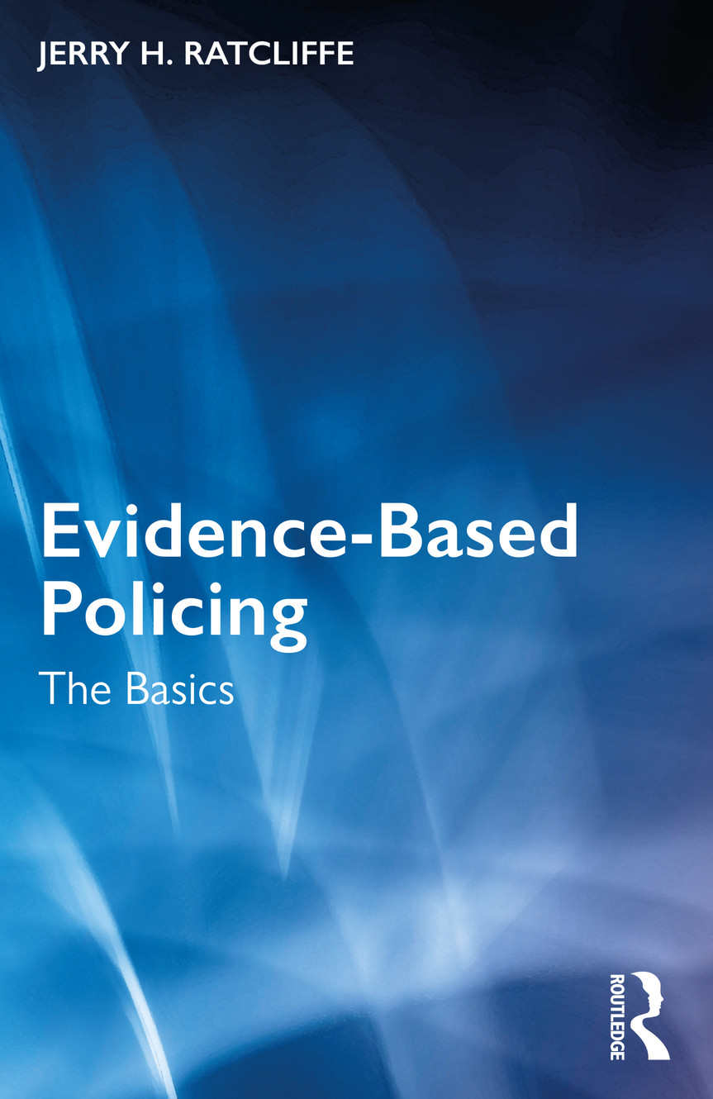
Principles of Evidence based Policing relating to problem solving techniques in a real-life scenario.

Contents
Introduction 2
Main Discussion 2
Code of Ethics 2
Conclusion 6
Reference List 7

Introduction

For this report, it will go over and cover a problem-solving technique, the main technique being the Code of Ethics. This technique will be used when applying the principle of Evidence-Based Policing. This technique will be used during this report to provide examples regarding a real-life policing scenario. Also, during this report, the main discussion will involve the real-life scenario listed and it will also cover the effectiveness of this scenario within the police force. It will also briefly go over the Code of Ethics model with a clear definition of what this model is, how it affects the police force and how this model will benefit the force and will include how it will be used in the real-life scenario that is chosen during the main discussion of this report. During this report, the real-life scenario that has been chosen to talk about and cover is Road Traffic Collisions.

Main Discussion

Code of Ethics

According to Devon and Cornwall Police (2023) the Code of Ethics is a code of practice, this code is the definition of the core values of policing and this code sets out the expected standards and behaviour for every staff member that works within the police force.
Within the Code of Ethics, there are a total of 9 policing principles and 10 standards of professional behaviour. 4 Key principles for policing principles are leadership, fairness, respect, and openness. 2 Key principles for Standards of Professional Behaviour are Honesty and Integrity and Duties and Responsibilities. According to Devon and Cornwall Police (2023) they indicate “The Code of Ethics helps guide us in the difficult decisions we make on a daily basis” This shows that the Code of Ethics play a crucial role within the police force as it has an important role to play in the decisions that are made in the police force, this is to ensure they meet their objectives by doing what is right and fair whilst aiming to provide the best quality of service to members of the public.
During the scene of a Road Traffic Collision the police would use leadership when taking charge of the situation, for example if they are dealing with a road traffic collision involving multiple cars and potential casualties it would be their role and responsibility to make sure the victims of the incident are safe whilst also securing evidence at the scene. They will also block off the roads to keep pedestrians safe. According to Police Service of Nothern Ireland (N.D.) During the scene the police main roles and responsibilities is ensuring the safety and wellbeing of everyone involved in and passing by the incident. They will also block off the roads to avoid anyone tampering with potential evidence at the scene. For example, when doing this police would take the lead in this sort of situation whilst waiting for other public services to arrive at the scene.
They would also use fairness when dealing with stressed family members of the victims of the accident by listening to both sides of the story and not being biased or taking sides and by also treating the family members fairly and equally and with the same amount of respect. According to College of Policing (2023) they state as a police service, police officers are required to show impartiality and fairness when dealing with the public, work colleagues and partners and when doing this, overall, it will be achieved by officers always being unprejudiced and fair no matter the situation they are in.
The Police would have respect when dealing with a Road Traffic Collision when dealing with family members at the scene as if there is family members at the scene who have witnessed one of their family members passing away at the scene of the collision, the police will show respect and empathy towards the family members as they know that they will be in a vulnerable state and grieving and they will offer the family as much support as possible. According to the Local Government Association (2024) they indicate that “Police staff do not abuse their powers and authority and respect the rights of all individuals”. This shows that no matter what scenario the police officers are in, they will always show respect to the victims of an incident and their family members and members of the public no matter the circumstances by being professional at all times and handling the situation professionally by always approaching it correctly and in the right manner and not doing anything to abuse their power or put their job at risk.
During the time of the incident, the police would show openness when they are dealing with this type of incident as if someone has been involved in a Road Traffic Collision with another vehicle with serious or minor injuries and the police are the first to attend the scene, they will stay with the victim and support them whilst also taking different types of evidence at the scene, such as any potential drugs or alcohol that maybe in the vehicle or on the person involved. They would do this to give them a clearer understanding as to how the crash may have happened and what might have caused it. Break the road safety charity (N.D.) states victims that have been involved in the collision can be tested for drugs or alcohol in their system before the incident had taken place along with a test of their eyesight. This can involve testing drivers with injuries if permission is granted by medical staff at the scene. By police helping the people involved in the collision and doing their job to a professional standard, it can show signs of openness within the public towards the police which is vital for the police force. North Yorkshire Police, Fire and Crime Commissioner (2024) state Openness and Transparency are important as they help to ensure trust within the public and the police force, this is due to the public seeing how the police deal with Road Traffic Collisions amongst other types of incidents and being able to see that the police can do their job properly and efficiently. Seeing this will improve the overall trust and respect of the public toward the police and improve public confidence. This is important in respect to policing.

The police would use honesty and integrity in a Road Traffic Collision when dealing with the victims of the incident and members of the public who potentially witnessed the collision and were nearby during the collision. (Gold,2017) states police officers are honest, act with integrity and will not do anything within the police to risk losing their job and putting their future within the job in jeopardy. During a Road Traffic Collision, the police would use honesty and integrity by treating everyone involved in the collision fairly and with respect in the situation and by not judging the situation at first sight by blaming certain individuals for what had happened and judging certain victims involved and taking sides and becoming one sided. According to College of Policing (2024) they indicate “We consider the different sides of a situation and ensure that each side is given equal consideration”. This shows that the police use honesty and integrity by making sure to be sensitive of the situation by not doing anything to escalate the situation. For example, pointing fingers or blaming anyone and doing their job correctly and being honest and showing integrity. By using honesty and integrity it allows the police to build relationships with victims of a Road Traffic Collision and their families and eventually this will improve the public's trust and confidence within the police. UK Parliament (2023) states evidence proves that over the years the public's trust and confidence within the police force in England and Wales has declined in the past few years which has had an impact on the public's relationship with the police.

The police would use Roles and Responsibilities when dealing with a Road Traffic Collision as their key role is to not only see to the victims involved but to also make sure the mess has been cleaned up and make sure that the road is also clear and safe for public use. Foxwell (2022) indicates debris, and any kind of glass should be removed safely off the road and out of the way and it is the polices role and responsibility to contact road crews to help clean up the road and the mess after the collision has taken place. Another role and responsibility for the police is to take pictures of the scene to use as potential evidence when needed. Foxwell (2022) states at the time of the incident another role of the police is to take photographs of the vehicles and potentially the road signs and number plates if needed. The police will do both things at the scene as clearing the road ensures public safety when the road re-opens and by taking photos at the scene, the photos can be used as evidence in court if required.

Conclusion

In conclusion, this report covered the key point regarding the Code of Ethics and what it is and how it works, along with the diverse types of policing principles and policing standards within the police force. It also covers the meanings of these several types of principles and standards of behaviour and talks about when they will be used in a real-life policing scenario with clear discussions of this within the main body of this report. As a result, when the police arrive at Road Traffic Collisions, they should continue to be consistent with the way they go about dealing with these incidents by not being unprofessional or getting complacent at any time to increase the public's faith and trust in the police.

Reference List

Break the road safety charity (N.D.) Section 8: The Police Investigation. Available at: https://www.brake.org.uk/how-we-help/get-help-if-a-crash-victim/information-and-advice-after-road-death-or-serious-injury/serious-injury-in-a-road-crash/section-8-the-police-investigation#:~:text=People%20involved%20in%20the%20crash,medical%20staff%20caring%20for%20them. (Accessed: 7 March 2024).

College of Policing (2023) Impartiality. Available at: https://profdev.college.police.uk/competency-values/impartiality/#:~:text=As%20a%20police%20service%2C%20we,being%20unprejudiced%2C%20fair%20and%20objective. (Accessed: 27 February 2024).

College of Policing (2024) Impartiality. Available at: https://profdev.college.police.uk/competency-values/impartiality/#:~:text=As%20a%20police%20service%2C%20we,being%20unprejudiced%2C%20fair%20and%20objective (Accessed: 7 March 2024).

Devon and Cornwall Police (2023) Code of Ethics. Available at: https://recruitment.devon-cornwall.police.uk/professionalism-and-support/code-of-ethics/#:~:text=The%20Code%20of%20Ethics%20is,everyone%20who%20works%20in%20policing. (Accessed: 27 February 2024).

Foxwell, T. (2022) The role of the police at the accident scene. Available at: https://www.adaptnetwork.com/lifestyle/role-of-police-at-the-accident-scene/ (Accessed: 7 March 2024).

Gold, E. (2017) Honesty and Integrity – Honestly different? Available at: https://www.ukpolicelawblog.com/honesty-and-integrity-the-same-thing/ (Accessed: 7 March 2024).

Local Government Association (2024) Police Staff standards of Professional Behaviour. Available at: https://www.local.gov.uk/our-support/workforce-and-hr-support/police/police-staff/police-staff-council-handbook/police-staff#:~:text=abuse%20their%20position.-,Authority%2C%20respect%20and%20courtesy,the%20rights%20of%20all%20individuals. (Accessed: 27 February 2024).

North Yorkshire Police, Fire and Crime Commissioner (2024) The importance of openness and transparency in policing. Available at: https://www.northyorkshire-pfcc.gov.uk/news/importance-openness-transparency-policing/#:~:text=Openness%20and%20transparency%20are%20both,particularly%20in%20respect%20of%20policing. (Accessed: 27 February 2024).

Police Service of Nothern Ireland (N.D.) Road Traffic Collision. Available at: https://www.psni.police.uk/report/road-traffic-collision#:~:text=At%20the%20scene%20Police%20will%3A,the%20cause%20of%20the%20collision. (Accessed: 7 March 2024).

UK Parliament (2023) Trust in the Police. Available at: https://post.parliament.uk/research-briefings/post-pn-0693/ (Accessed: 7 March 2024).

