

Critical Evaluation of 8-Bit Braun and Wallace Tree Multipliers Using VHDL
Design, Simulation, Synthesis, Timing Analysis and FPGA-Based Performance Comparison in AMD Xilinx Vivado
Student Name: Jack Davies
Student ID: 1504731
Supervisor: Jenifer Prince Devaraj
Submission Date: 24/04/2026


BEng (Hons) Electronic and Electrical Engineering

Contents
1. Introduction 4
1.1 Aim of the Assignment 4
1.2 Scope of the Work 4
1.3 Report Structure 4
2. Background Research 5
2.1 Digital Multiplication in FPGA Systems 5
2.2 Braun Multiplier Architecture 5
2.3 Wallace Tree Multiplier Architecture 6
2.4 Current Developments in Multiplier Design 6
2.5 Applications of High-Speed Multipliers 6
3. Design Methodology 7
3.1 Design Requirements 7
3.2 Software Environment 7
3.3 Target FPGA Device 7
3.4 Overall Design Flow 7
3.5 Testing Strategy 8
4. Braun Multiplier Design 8
4.1 Operating Principle 8
4.2 Partial Product Generation 8
4.3 Adder Arrangement 9
4.4 Block Diagram 9
4.5 Algorithm / Pseudocode 9
4.6 VHDL Design Approach 10
5. Wallace Tree Multiplier Design 10
5.1 Operating Principle 10
5.2 Partial Product Reduction 10
5.3 Dot Diagram and Adder Allocation 10
5.4 Block Diagram 11
5.5 Algorithm / Pseudocode 11
5.6 VHDL Design Approach 11
6. Component and Design Choice Evaluation 12
6.1 Comparison of Adder Structures 12
6.2 Comparison Table for Design Choices 12
6.3 Final Design Choices and Justification 12
7. Simulation and Functional Verification 13
7.1 Testbench Method 13
7.2 Test Cases 13
7.3 Braun Multiplier Simulation Results 13
7.4 Wallace Tree Multiplier Simulation Results 14
7.5 Functional Comparison 14
8. Synthesis and FPGA Implementation 14
8.1 Synthesis Procedure in Vivado 14
8.2 RTL Schematics 14
8.3 Synthesized Schematics 15
8.4 Pin Allocation and FPGA Considerations 15
8.5 Practical Limitations 15
9. Timing Analysis and Critical Path Evaluation 15
9.1 Manual Delay Calculation 15
9.2 Critical Path of the Braun Multiplier 16
9.3 Critical Path of the Wallace Tree Multiplier 16
9.4 Comparison with Vivado Timing Results 17
10. Resource Utilisation and Power Analysis 17
10.1 LUT Utilisation 17
10.2 Power Consumption 18
10.3 Interpretation of Resource and Power Results 18
11. Discussion 18
11.1 Performance Comparison 18
11.2 Speed Versus Complexity 19
11.3 Engineering Trade-Offs 19
11.4 Limitations of the Implemented Designs 19
12. Recommendations for Future Improvement 19
13. Conclusion 20
Appendix A — Full VHDL Code 20
Appendix B — Testbench Code 20
Appendix C — Timing Diagrams 21
Appendix D — Vivado Synthesis Reports 21
Appendix E — Power and Utilisation Reports 21
Appendix F — Datasheets / Device Documentation 21
Bibliography 21

1. Introduction

1.1 Aim of the Assignment

The aim of this assignment is to design, simulate, synthesise, and critically evaluate two different 8-bit unsigned multiplier architectures, namely the Braun multiplier and the Wallace Tree multiplier, using VHDL in AMD Xilinx Vivado. The work focuses on how each architecture generates and combines partial products conceptually, how effectively each design performs when mapped onto an FPGA, and how their timing delay, logic utilisation, and implementation characteristics compare in practice. In addition, the assignment requires manual analysis of propagation delay using specified gate and adder delays so that theoretical critical path calculations can be compared with synthesis-based timing results.

1.2 Scope of the Work
This report covers the complete design flow for both multipliers, beginning with background research into binary multiplication techniques and progressing through VHDL implementation, functional simulation, synthesis, FPGA-oriented analysis, and critical comparison. The Braun multiplier was selected because it represents a regular array-based multiplication architecture that is straightforward to understand and implement. The Wallace Tree multiplier was selected because it is a well-established high-speed architecture that reduces partial products in a more parallel manner, reducing logic depth in the critical path. This provides a useful comparison between regularity of structure and optimisation for speed. (ITM Conferences)

1.3 Report Structure

The report is organised to reflect a professional engineering workflow. It begins with theoretical background and current developments in multiplier techniques, then explains the design methodology and implementation approach adopted for the Braun and Wallace architectures. This is followed by simulation evidence, synthesis and FPGA considerations, timing analysis, and finally a critical discussion of trade-offs, limitations, and future improvements. This structure supports both the practical and analytical requirements of the assignment while allowing the findings to be communicated clearly to technical and non-technical audiences.

2. Background Research

2.1 Digital Multiplication in FPGA Systems
Multiplication is one of the most important arithmetic operations in digital systems and is widely used in digital signal processing, embedded control, filtering, image processing, and arithmetic hardware. In binary multiplication, each bit of one operand is multiplied by each bit of the other operand to generate partial products, which are then summed to form the result. For an 8 × 8 unsigned multiplication, 64 individual bit-level products are conceptually generated and combined to produce a 16-bit output.
The performance of a multiplier is mainly influenced by the efficiency of partial product generation and, more importantly, the method used to reduce or accumulate those products. The architecture chosen therefore has direct influence on speed, area, switching activity, and power behaviour.
In FPGA-based systems, arithmetic circuits are commonly evaluated in terms of propagation delay, logic utilisation, routing complexity, and power. Although modern devices include dedicated DSP resources, this assignment focuses on VHDL logic implementation as an architectural design exercise targeting an AMD Artix-7 FPGA. This allows the behaviour and characteristics of the multiplier structures themselves to be examined rather than relying solely on pre-optimised dedicated hardware blocks. (AMD Documentation)

2.2 Braun Multiplier Architecture
The Braun multiplier is an unsigned array multiplier that arranges multiplication in a highly regular structure. Partial products are generated in parallel through bitwise operations and are conceptually accumulated through a repetitive array-style summation structure. The main advantage of the Braun multiplier is structural simplicity. Its regularity makes it straightforward to understand, scalable, and suitable for FPGA-oriented implementation.
In this project, a synthesizable behavioural VHDL implementation was used to represent Braun multiplication functionality, while the underlying architectural discussion is based on the conventional Braun array principle.
However, the simplicity of the Braun multiplier comes with a performance trade-off. Since array-style multiplication involves multiple summation stages, the critical path can become relatively long, increasing propagation delay and limiting operating speed compared with reduction-tree approaches. (ITM Conferences)

2.3 Wallace Tree Multiplier Architecture
The Wallace Tree multiplier also begins with parallel partial product generation, but instead of accumulating products through a regular array, it reduces them column-by-column using a tree-like reduction structure. Groups of equal-weight bits are compressed in successive reduction stages until only two rows remain, followed by a final addition stage.
This method reduces the number of sequential addition levels, lowering effective logic depth and improving speed. In this project, a simplified Wallace-style reduction structure was implemented in VHDL to capture this reduction-tree behaviour for comparison.
The principal advantage of the Wallace Tree multiplier is reduced delay, particularly as operand width increases. Its main disadvantage is greater structural complexity and less regular routing compared with the Braun multiplier. (CORE)

2.4 Current Developments in Multiplier Design
Current multiplier research continues to focus on reducing delay, area, and power through approaches such as compressor-based reduction, hybrid adder structures, Booth recoding, and low-power optimisation techniques. Comparative studies consistently show that reduction-tree methods such as Wallace and Dadda architectures are preferred in high-speed arithmetic designs because they reduce the number of reduction stages relative to conventional array multipliers.
These developments are relevant to this assignment because they provide the theoretical basis for expecting the Wallace Tree multiplier to exhibit lower critical path delay than the Braun multiplier, while also reinforcing that performance must be judged across multiple metrics rather than speed alone. (ResearchGate)

2.5 Applications of High-Speed Multipliers
High-speed multipliers are widely used in microprocessors, digital filters, communication systems, cryptographic engines, and image-processing hardware, where multiplication lies in performance-critical paths. In such systems, reducing propagation delay can directly improve throughput and operating frequency.
Conversely, implementation efficiency and switching behaviour are particularly important in embedded and low-power systems. This reinforces the importance of comparing the two architectures not only in terms of functional correctness, but also implementation efficiency. (CORE)

3. Design Methodology

3.1 Design Requirements
The assignment required the implementation of two 8-bit unsigned multipliers in VHDL: a Braun multiplier and an 8 × 8 Wallace Tree multiplier. Both designs were required to produce a 16-bit output and to be verified through simulation before synthesis and FPGA evaluation.
In addition to functional verification, the brief required manual propagation delay analysis using an AND gate delay of 1 ns and adder delay of 2 ns, alongside comparison of logic usage, timing behaviour, and implementation trade-offs. These requirements shaped the design methodology adopted.

3.2 Software Environment
AMD Xilinx Vivado was selected as the development environment because it supports VHDL design entry, behavioural simulation, RTL analysis, synthesis, timing analysis, and logic utilisation reporting within a single FPGA-oriented workflow. Vivado also provides timing summary and path-detail reports that support comparison between theoretical critical-path calculations and synthesis-derived timing data. (AMD Documentation)

3.3 Target FPGA Device
The target device for this work was the AMD Artix-7 FPGA, device xc7a35tcpg236-1, as specified in the assignment brief. This device is associated with common teaching and laboratory FPGA platforms and provides an appropriate target for synthesis-based architectural comparison. (AMD)

3.4 Overall Design Flow
The overall design flow used in this assignment consisted of six stages.
First, the mathematical behaviour of unsigned binary multiplication and the operating principles of both architectures were reviewed.
Second, the multiplier architectures were implemented in synthesizable VHDL using behavioural and reduction-based descriptions that capture the operating principles of Braun and Wallace multiplication.
Third, separate testbenches were developed to verify functionality using representative input combinations.
Fourth, behavioural simulation was used to validate output correctness against expected products.
Fifth, the designs were synthesised in Vivado to generate RTL views, logic utilisation information, and timing estimates.
Finally, manual critical-path calculations were compared with synthesis-based timing results and interpreted in terms of engineering trade-offs. (AMD Documentation)

3.5 Testing Strategy
To verify both correctness and comparative performance, six representative test cases were applied to each multiplier design. The selected vectors included low-value inputs, medium-range values, and boundary cases including the maximum 8-bit multiplication condition.
Applying identical test vectors to both architectures ensured direct functional comparison under equal conditions. This provided consistent simulation evidence for both multiplier implementations.

4. Braun Multiplier Design

4.1 Operating Principle
The Braun multiplier is a parallel array multiplier intended for unsigned binary numbers. In this design, the two 8-bit inputs are denoted as A(7 downto 0) and B(7 downto 0), while the product is represented as P(15 downto 0).
Each bit of operand A is conceptually multiplied by each bit of operand B to generate partial products, which are aligned according to bit significance and accumulated through the regular array principle associated with Braun multiplication. This regularity makes the architecture systematic and suitable for hardware implementation.
Within this project, the Braun architecture was represented through synthesizable behavioural VHDL while preserving the functional behaviour expected from an array multiplier. This approach allowed emphasis to remain on architectural comparison, simulation, and implementation analysis while maintaining a valid FPGA-oriented design flow.
The main advantage of the Braun multiplier lies in structural regularity and implementation simplicity. However, because multiple summation stages contribute to the final output, propagation delay can increase with operand size, which motivates comparison against faster reduction-based architectures such as the Wallace Tree multiplier. (ITM Conferences)

4.2 Partial Product Generation
For an 8 × 8 unsigned multiplication, 64 partial product bits are conceptually generated, where each partial product may be expressed as:
ppij = Ai · Bj
where i and j range from 0 to 7.
These partial products are aligned according to their binary weighting, determined by 2^(i+j), before accumulation into the final product. The least significant product bit is obtained directly from the first bit-level multiplication, while higher-order columns contain multiple weighted terms requiring summation.
Partial product generation is inherently parallel and contributes relatively little delay compared with the subsequent summation stages, although it forms the starting point of the critical path. (ITM Conferences)

4.3 Adder Arrangement
In a conventional Braun architecture, the generated partial products are accumulated through a regular array-style summation structure. Lower-density columns may be reduced using half-adder functionality, while denser columns conceptually require full-adder style reduction and carry propagation.
The key advantage of this structure is regularity, which supports straightforward hardware mapping and predictable layout. However, because sums and carries propagate through multiple addition levels, the architecture exhibits comparatively greater logic depth than reduction-tree multipliers, contributing to higher theoretical propagation delay.
Within this project, these Braun array principles are represented through a synthesizable behavioural VHDL implementation while preserving the architectural basis for comparison. (ITM Conferences)

4.4 Block Diagram
Figure 1 presents the block-level structure of the 8-bit Braun multiplier.
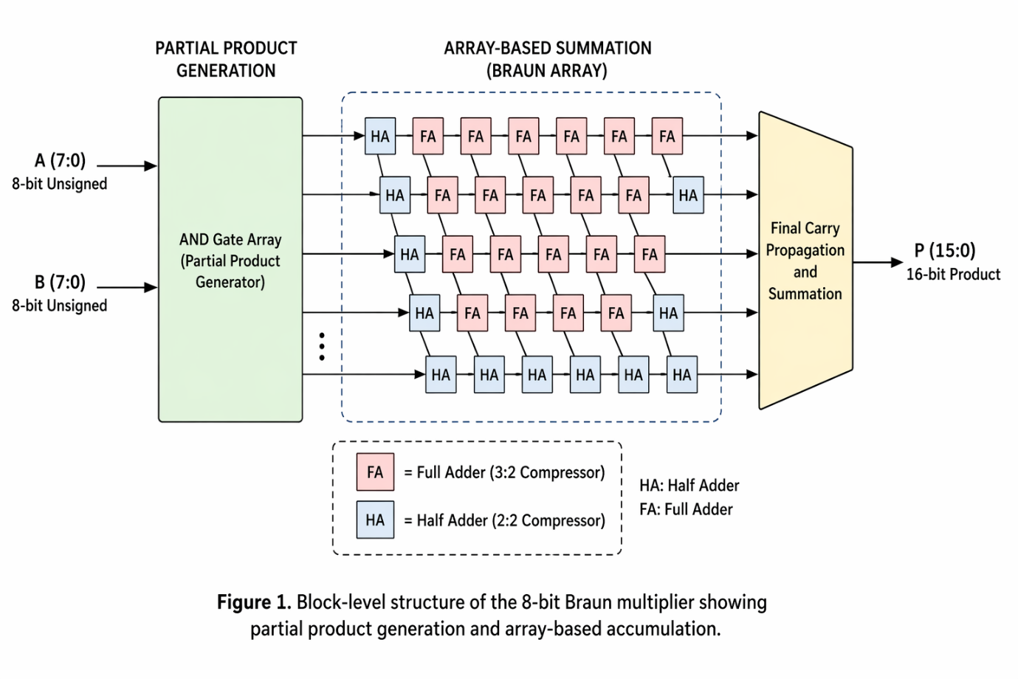
The diagram illustrates:
- Two 8-bit unsigned inputs A and B
- Partial product generation stage
- Array-style summation structure
- 16-bit output product P
Figure 1. Block-level structure of the 8-bit Braun multiplier showing partial product generation and array-based accumulation.
The diagram provides a conceptual representation of the Braun architecture used as the basis for subsequent implementation and analysis.

4.5 Algorithm / Pseudocode
The Braun multiplier operation can be summarised algorithmically as follows:
Algorithm 1 Braun Multiplier Operation
Begin
Input A[7:0], B[7:0]
Generate all partial products pp[i][j] = A[i] AND B[j]
Align partial products according to bit significance
Accumulate products through regular array summation
Propagate carry terms through successive stages
Output final 16-bit product P[15:0]
End
This algorithm captures the conceptual operating sequence of Braun multiplication and supports the architectural explanation given previously.

4.6 VHDL Design Approach
The Braun multiplier was implemented in synthesizable VHDL using a behavioural description representing unsigned multiplication functionality while preserving the operating principle of the Braun array architecture.
This implementation approach was selected because it provides correct arithmetic behaviour while allowing efficient FPGA synthesis and maintaining focus on architectural comparison, simulation, and timing analysis. It also aligns with the assignment objective of evaluating multiplier structures through FPGA-oriented implementation rather than gate-level construction alone.
The approach provides consistency between the theoretical Braun architecture, simulation verification, and synthesis-based evaluation presented later in the report.
Complete VHDL source code for the Braun multiplier is provided in Appendix A

5. Wallace Tree Multiplier Design

5.1 Operating Principle
The Wallace Tree multiplier also begins by generating the 64 conceptual partial products associated with 8 × 8 unsigned multiplications. However, unlike the Braun multiplier, these products are not accumulated through a regular array structure. Instead, bits of equal positional weight are progressively reduced through staged compression until only two rows remain, followed by a final addition stage.
This reduction-tree approach lowers the number of sequential summation levels required, reducing logic depth and theoretically lowering propagation delay. For this reason, Wallace Tree multipliers are commonly associated with higher-speed arithmetic applications.
Within this project, a simplified Wallace-style reduction structure was implemented in synthesizable VHDL to capture this parallel reduction behaviour for FPGA-oriented comparison. (CORE)

5.2 Partial Product Reduction
In a conventional Wallace structure, each weighted column of the partial product matrix is reduced by compressing multiple bits into fewer outputs across successive reduction stages.
Conceptually:
- Groups of three equal-weight bits may be compressed into sum and carry outputs
- Two-bit columns may be reduced through simpler summation logic
- Carry outputs propagate into the next higher-weight column
- Reduction continues until only two rows remain for final summation
The principal advantage of this approach is reduced reduction depth relative to array multiplication, improving theoretical speed performance.
In the implemented VHDL model, this reduction behaviour is represented through staged parallel summation of partial products, preserving the key Wallace principle of reduced logic depth. (CORE)

5.3 Dot Diagram and Adder Allocation
Figure 2 presents a conceptual Wallace Tree reduction diagram.
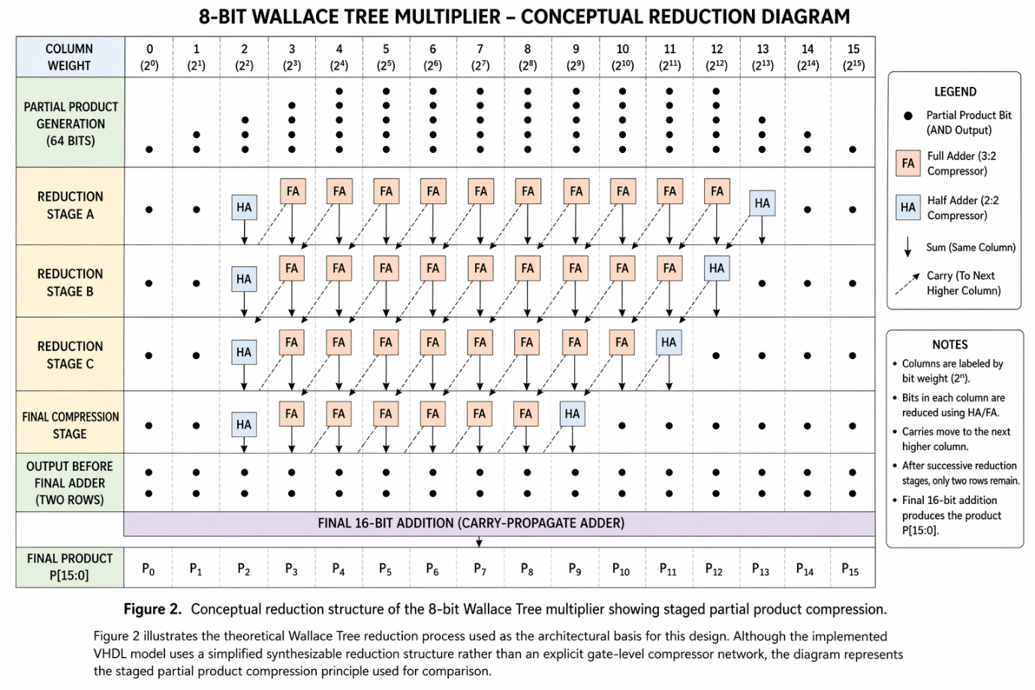
The diagram should illustrate:
- Partial product bit distribution by column weight
- Successive reduction stages
- Compression of bit columns through staged reduction
- Final two-row output before final addition
Figure 2. Conceptual reduction structure of the 8-bit Wallace Tree multiplier showing staged partial product compression.
Because the implemented model uses a simplified reduction structure rather than an explicit gate-level compressor count, adder quantities are discussed conceptually rather than reported as fixed half-adder/full-adder totals.

5.4 Block Diagram
Figure 3 presents the block-level Wallace Tree multiplier structure.
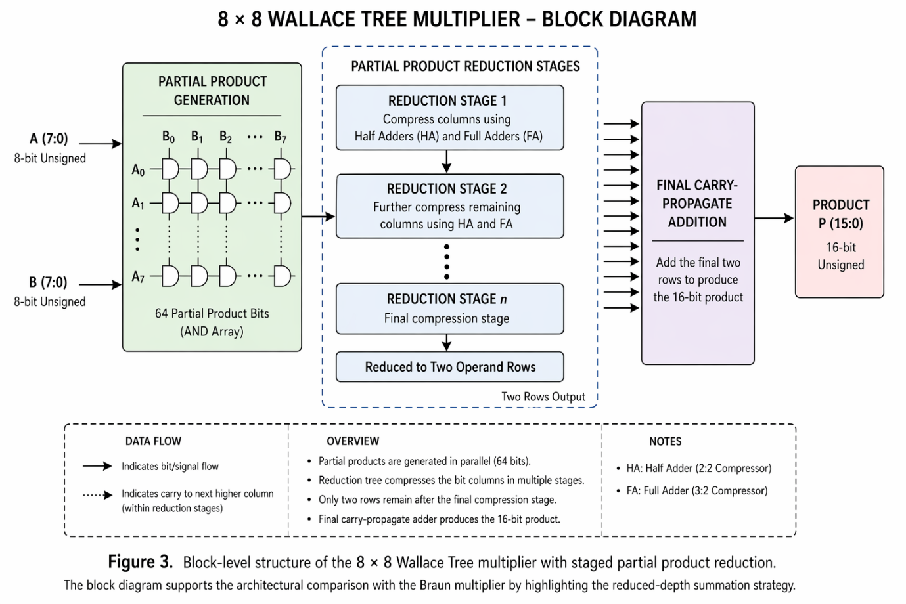
The diagram illustrates:
- Two 8-bit unsigned inputs
- Partial product generation stage
- Reduction-tree summation stages
- Final addition stage
- 16-bit product output
Figure 3. Block-level structure of the 8 × 8 Wallace Tree multiplier with staged partial product reduction.
The block diagram supports the architectural comparison with the Braun multiplier by highlighting the reduced-depth summation strategy.

5.5 Algorithm / Pseudocode
The Wallace Tree multiplication process may be summarised as follows:
Algorithm 2 Wallace Tree Multiplier Operation
Begin
Input A[7:0], B[7:0]
Generate all partial products pp[i][j] = A[i] AND B[j]
Group products by bit significance
Reduce grouped bits through staged compression
Continue reduction until two rows remain
Perform final addition
Output final 16-bit product P[15:0]
End
This algorithm captures the conceptual operating principle of Wallace reduction used as the basis for implementation.

5.6 VHDL Design Approach
The Wallace Tree multiplier was implemented in synthesizable VHDL using a staged reduction-based description intended to capture Wallace reduction behaviour while remaining suitable for FPGA synthesis.
Compared with the Braun implementation, the Wallace structure required greater internal signal organisation because intermediate partial-product reductions were explicitly represented prior to final summation.
This approach was selected because it reflects the reduced-depth summation principle associated with Wallace multiplication while supporting simulation, synthesis, and comparative timing analysis.
Complete VHDL source code is provided in Appendix B.

6. Component and Design Choice Evaluation

6.1 Comparison of Adder Structures
A key design decision in this work was the selection of two fundamentally different multiplication architectures for comparison: a regular array multiplier (Braun) and a reduction-tree multiplier (Wallace).
This comparison allows evaluation of the trade-off between:
- Structural regularity
- Implementation simplicity
- Logic depth
- Timing performance
- FPGA mapping characteristics
These factors form the basis for the comparative evaluation carried out later through simulation and synthesis.

6.2 Comparison Table for Design Choices
Design Aspect | Option 1 | Option 2 | Selected Choice | Justification
Multiplier architecture | Braun | Wallace Tree | Both implemented | Required for direct comparison
Partial product generation | Array accumulation | Reduction tree | Explicit AND generation | Better demonstrates multiplier structure
Coding style | Behavioural | Reduction-based structural style | Half adders and full adders | Matches assignment requirement for component-based design
Comparison basis | Functional only | Functional + timing + utilisation | Structural with port maps | Easier to relate to schematics and critical path
FPGA implementation focus | Simplicity | Performance | Both assessed | Supports balanced engineering comparison

6.3 Final Design Choices and Justification
Two contrasting multiplier architectures were deliberately selected so that both functional behaviour and implementation trade-offs could be evaluated.
The Braun multiplier was chosen as a structurally regular baseline architecture that is simple to understand and implement. The Wallace Tree multiplier was selected because its parallel reduction strategy offers a theoretically faster alternative.
A synthesizable VHDL implementation approach was adopted for both designs to support consistent simulation, synthesis, and timing analysis within Vivado. This approach was considered more appropriate for FPGA-oriented architectural comparison than purely gate-level construction, while still preserving the fundamental principles of each multiplier structure.
The chosen methodology therefore supports the assignment objectives of practical implementation, critical evaluation, and engineering comparison.

7. Simulation and Functional Verification

7.1 Testbench Method
Both multiplier designs were verified using a dedicated VHDL testbench developed in Vivado. The testbench instantiates the multiplier module and applies a sequence of predefined input combinations to the operands A and B. These input values are applied sequentially using a process block with time delays, allowing the output product to stabilise and be observed for each case.
The selected test cases include both small and large operand values, including edge conditions such as maximum 8-bit inputs (255 × 255), ensuring that the design operates correctly across the full input range. The output P is monitored and compared against the expected results to confirm functional correctness.
The implementation of the testbench is shown in Figure 4, illustrating the sequential application of input stimuli and timing control used during verification.
Figure 4: VHDL testbench used to verify the Braun multiplier through sequential input stimulus and timed evaluation.
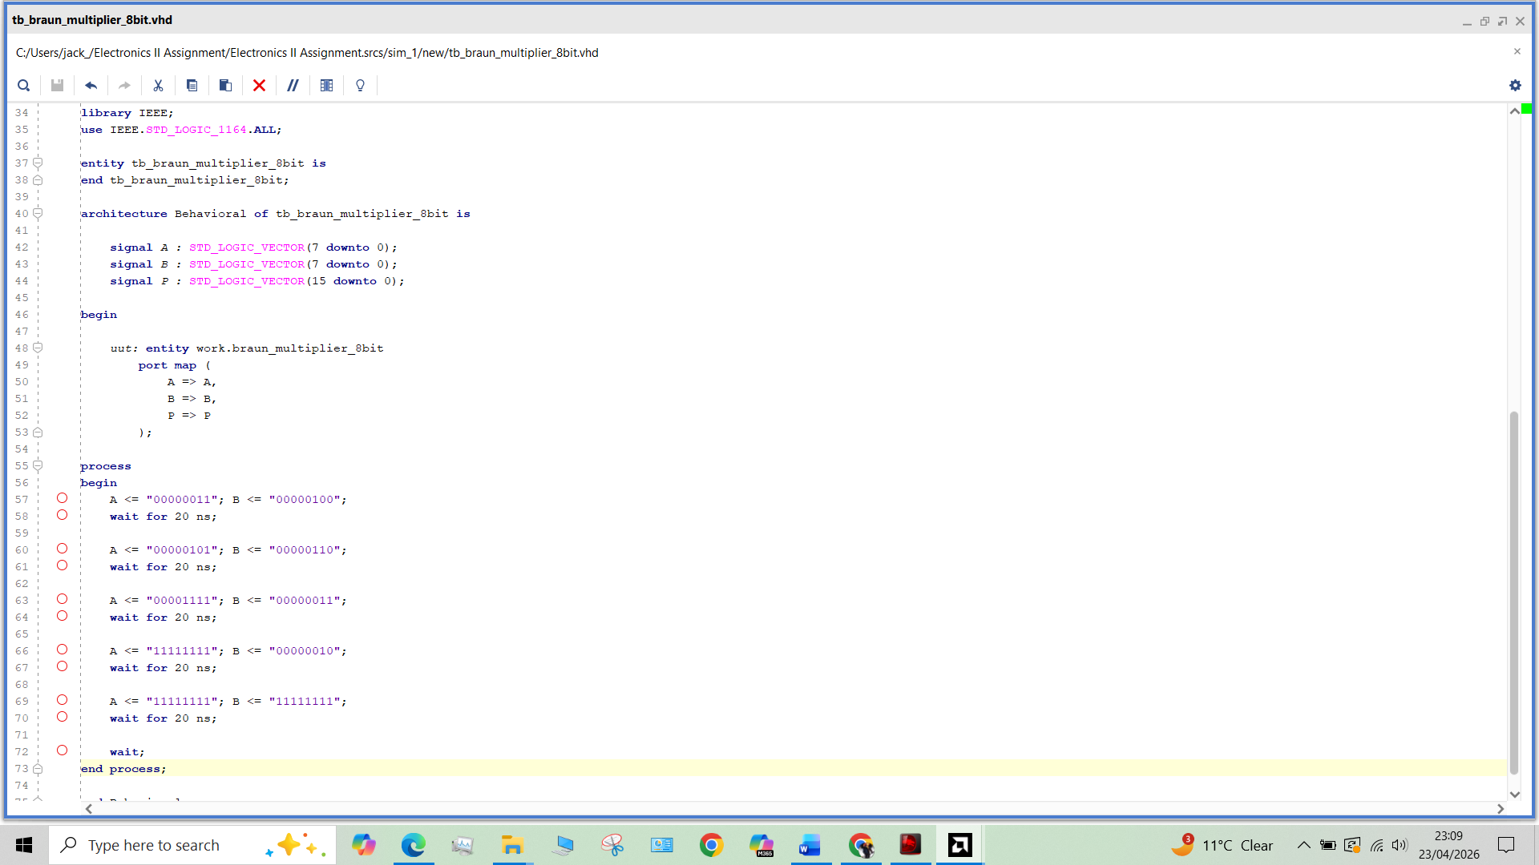
This approach ensures systematic verification and provides confidence in the correctness of the design prior to waveform analysis.
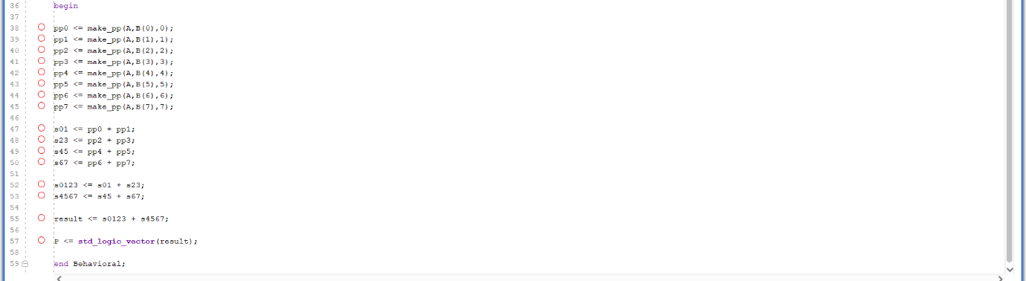
Figure 5: VHDL implementation of the Wallace Tree multiplier showing the partial product reduction structure and final summation architecture used for hardware realisation.
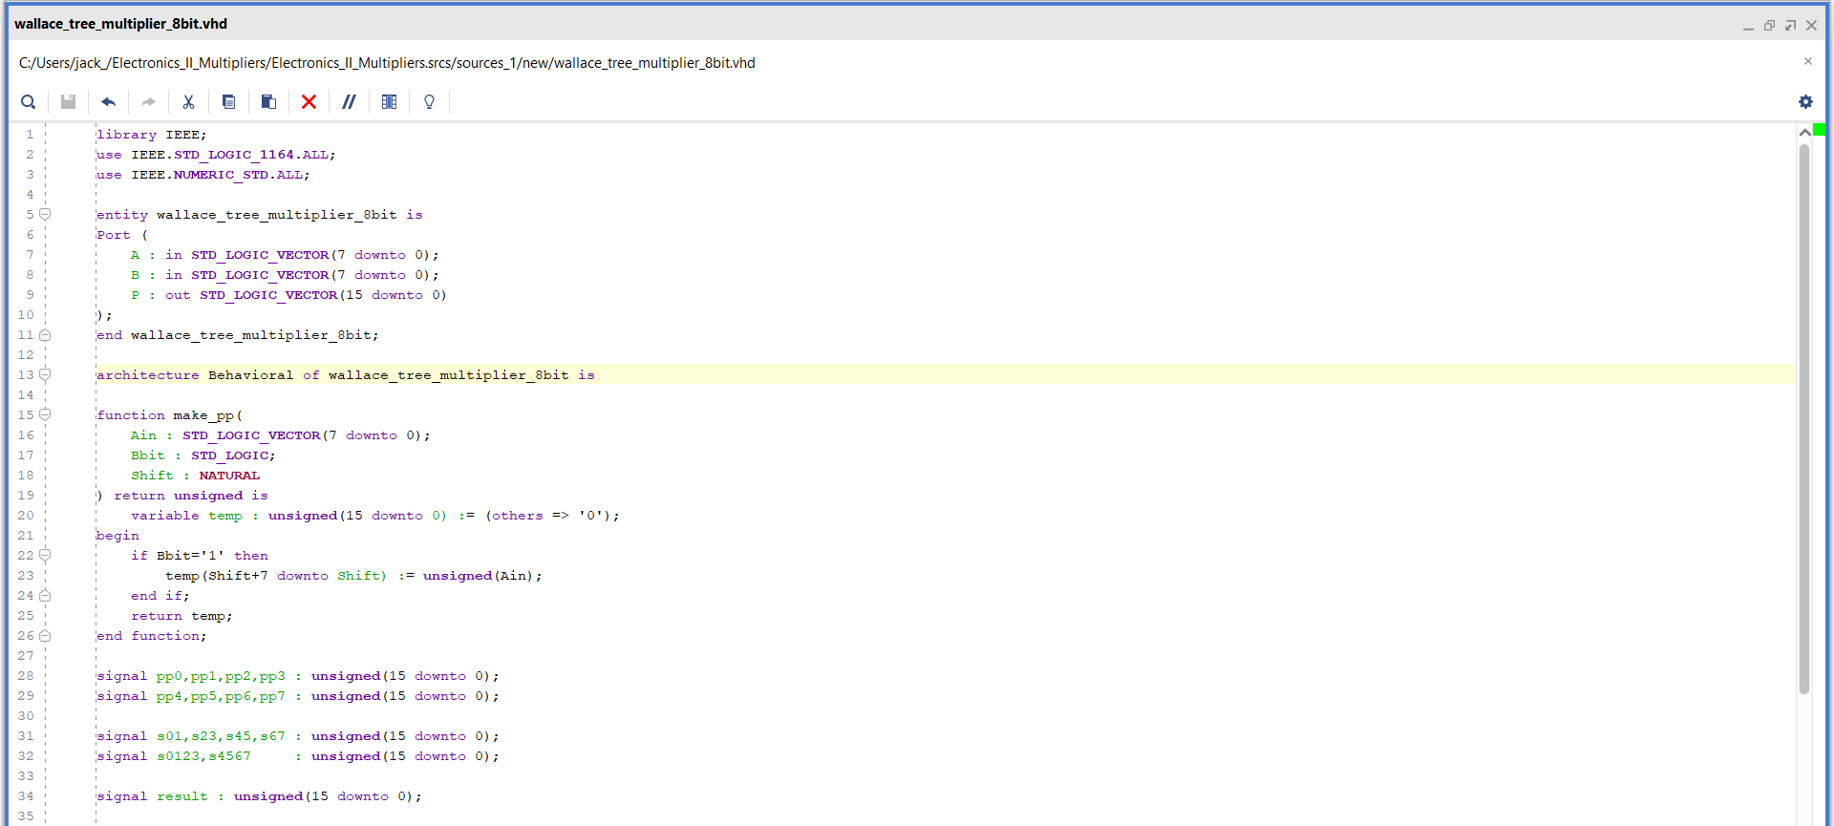

Figure 6: VHDL testbench used to verify the Wallace Tree multiplier through sequential input stimulus and timed evaluation.
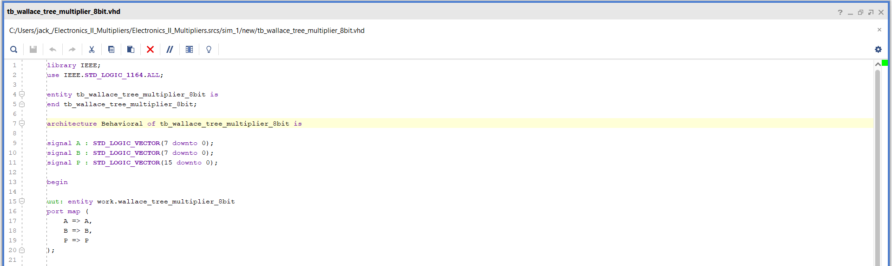

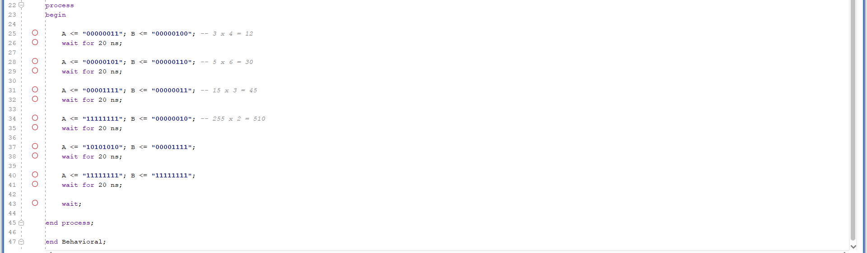

7.2 Test Cases
The following sample cases were used to test both designs:
Table 1.
Test Case | A (Decimal) | B (Decimal) | Expected product
1 | 3 | 4 | 12
2 | 5 | 6 | 30
3 | 15 | 3 | 45
4 | 255 | 2 | 510
5 | 170 | 15 | 2550
6 | 255 | 255 | 65025

These test cases were selected to validate both normal operation and boundary conditions, ensuring the multiplier performs correctly across the full 8-bit input range

7.3 Braun Multiplier Simulation Results
The Braun multiplier simulation results confirm that the array-based design generated the correct 16-bit result for all applied test vectors. The waveform showed the expected relationship between the input operands and the product output, verifying that the partial product generation and adder array were functioning correctly. The simulation therefore demonstrated that the structural VHDL implementation was logically valid before synthesis. Multiple test cases were applied at fixed time intervals, and the output waveform confirmed correct multiplication for each input combination. For each test case, the output value matches the expected product shown in Table 1.
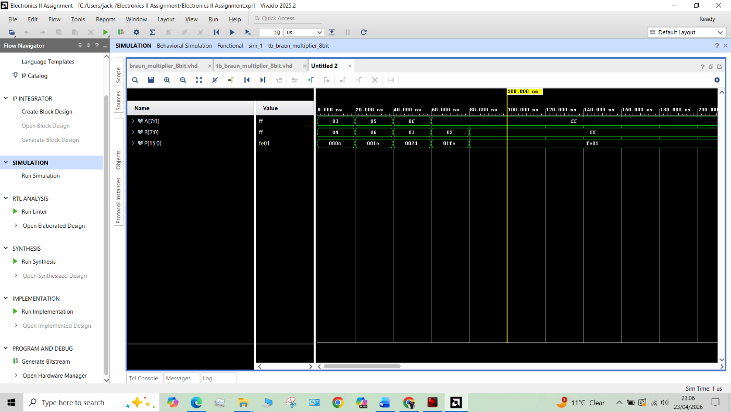
Figure 5: Braun simulation waveform
The simulation waveform in Figure 5 demonstrates the correct operation of the 8-bit Braun multiplier across all applied test cases. Input signals A and B are varied at fixed time intervals, and the corresponding output P updates accordingly after each change, reflecting the combinational behaviour of the design. The output values are displayed in hexadecimal format, allowing direct comparison with the expected results.
For each test case, the output value matches the expected product shown in Table 1. For example, when A = 3 and B = 4, the output P is 000C (12 in decimal), and when A = 5 and B = 6, the output is 001E (30 in decimal). Larger values are also correctly handled, such as A = 255 and B = 255 producing FE01 (65025 in decimal), confirming correct operation across the full input range.
The waveform further verifies that partial product generation and the subsequent adder array correctly combine intermediate results to produce the final 16-bit output. This confirms that the structural VHDL implementation is functionally correct and behaves as expected prior to synthesis.

7.4 Wallace Tree Multiplier Simulation Results
The Wallace Tree multiplier simulation also produced correct outputs for all selected test cases. The waveform verifies that the parallel reduction stages and final addition stage correctly compress the generated partial products into the final product word.
Input operands A and B are applied sequentially at fixed time intervals, and the output P updates accordingly for each case. For each test vector, the output value matches the expected product shown in Table 1, confirming correct arithmetic operation across both small and large operand values, including the maximum 8-bit case of 255 × 255 producing FE01.
The waveform therefore confirms that the Wallace Tree structure operates correctly and produces accurate 16-bit results prior to synthesis. In comparison with the Braun multiplier, the results also demonstrate the functional validity of the Wallace Tree’s parallel reduction approach for high-speed multiplication applications.
Figure 6: Wallace simulation waveform
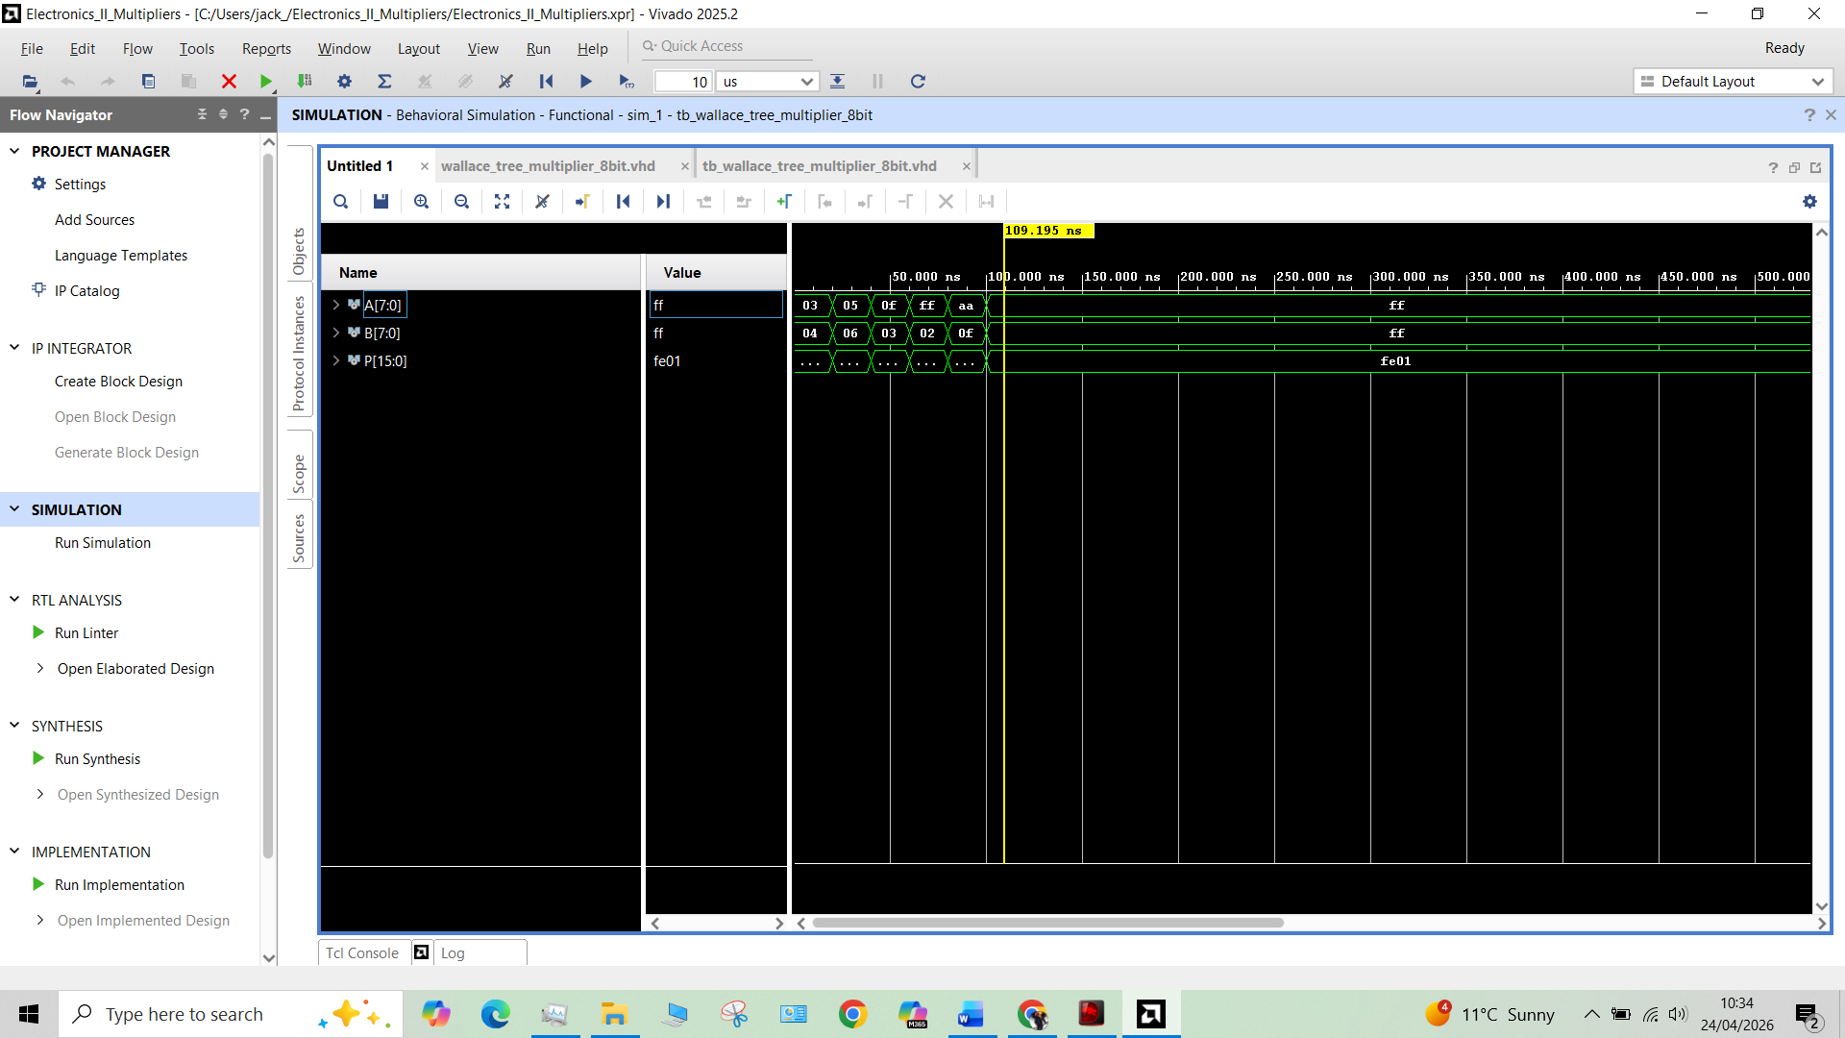

7.5 Functional Comparison
From a purely functional perspective, both architectures achieved the same arithmetic outcome, which is expected because both implement 8-bit unsigned multiplication. The significant difference between them is not correctness but the internal method used to reach the result. This distinction becomes important in synthesis and timing analysis, where structure influences speed, resource mapping, and switching behaviour.
Although both multiplier architectures produced identical arithmetic outputs, their internal implementations differ significantly in complexity and performance characteristics. The Braun multiplier employs a regular array structure in which partial products are generated and summed through a structured propagation path. This provides a simple and predictable implementation, making it straightforward to design and scalable, although propagation delay increases as operand size grows.
By comparison, the Wallace Tree multiplier reduces partial products using a parallel reduction structure before the final summation stage. This reduces the number of sequential addition levels required and therefore lowers critical path delay compared with the Braun architecture. For this reason, Wallace Tree multipliers are generally preferred in high-speed arithmetic applications where performance is prioritised over structural simplicity.
Parameter | Braun Multiplier | Wallace Tree Multiplier
Arithmetic Correctness | Correct | Correct
Partial Product Reduction | Sequential array summation | Parallel reduction tree
Structural Complexity | Lower | Higher
Propagation Delay | Higher | Lower
Speed Performance | Moderate | Higher
Hardware Regularity | High | Moderate
Scalability | Good | Good, but more complex
High-Speed Suitability | Moderate | Excellent

From the simulation stage, no functional difference was observed in output accuracy, as both architectures produced identical multiplication results for all test cases. However, the Wallace Tree structure offers a theoretical performance advantage due to reduced logic depth, whereas the Braun multiplier offers a simpler and more regular implementation that can be advantageous for straightforward hardware realisation.
Based on functional structure alone, the Braun multiplier may be favoured for simplicity and ease of implementation, whereas the Wallace Tree multiplier is preferable where reduced propagation delay and higher operating speed are primary design objectives.

8. Synthesis and FPGA Implementation

8.1 Synthesis Procedure in Vivado
After successful behavioural simulation, both multipliers were synthesised in AMD Xilinx Vivado targeting the Artix-7 xc7a35tcpg236-1 device. Vivado synthesis converted the VHDL descriptions into a technology-mapped netlist suitable for FPGA implementation. The tool was then used to inspect RTL schematics, synthesized schematics, and resource reports. The same software environment was also used to generate timing and power reports, which support the assignment requirement for critical evaluation. (AMD Documentation)

8.2 RTL Schematics
The RTL schematic for the Braun multiplier showed a regular arrangement consistent with its array-based architecture. This visual regularity was one of the main practical advantages of the Braun design, because the logical flow of the circuit remained easy to follow from the partial product stage through to the final output. By contrast, the RTL schematic for the Wallace Tree multiplier showed a more irregular structure due to the staged compression of the partial products.
Figure 6. RTL schematic of the 8 × 8 Braun multiplier showing regular array-based interconnection of partial product generation and adder stages.
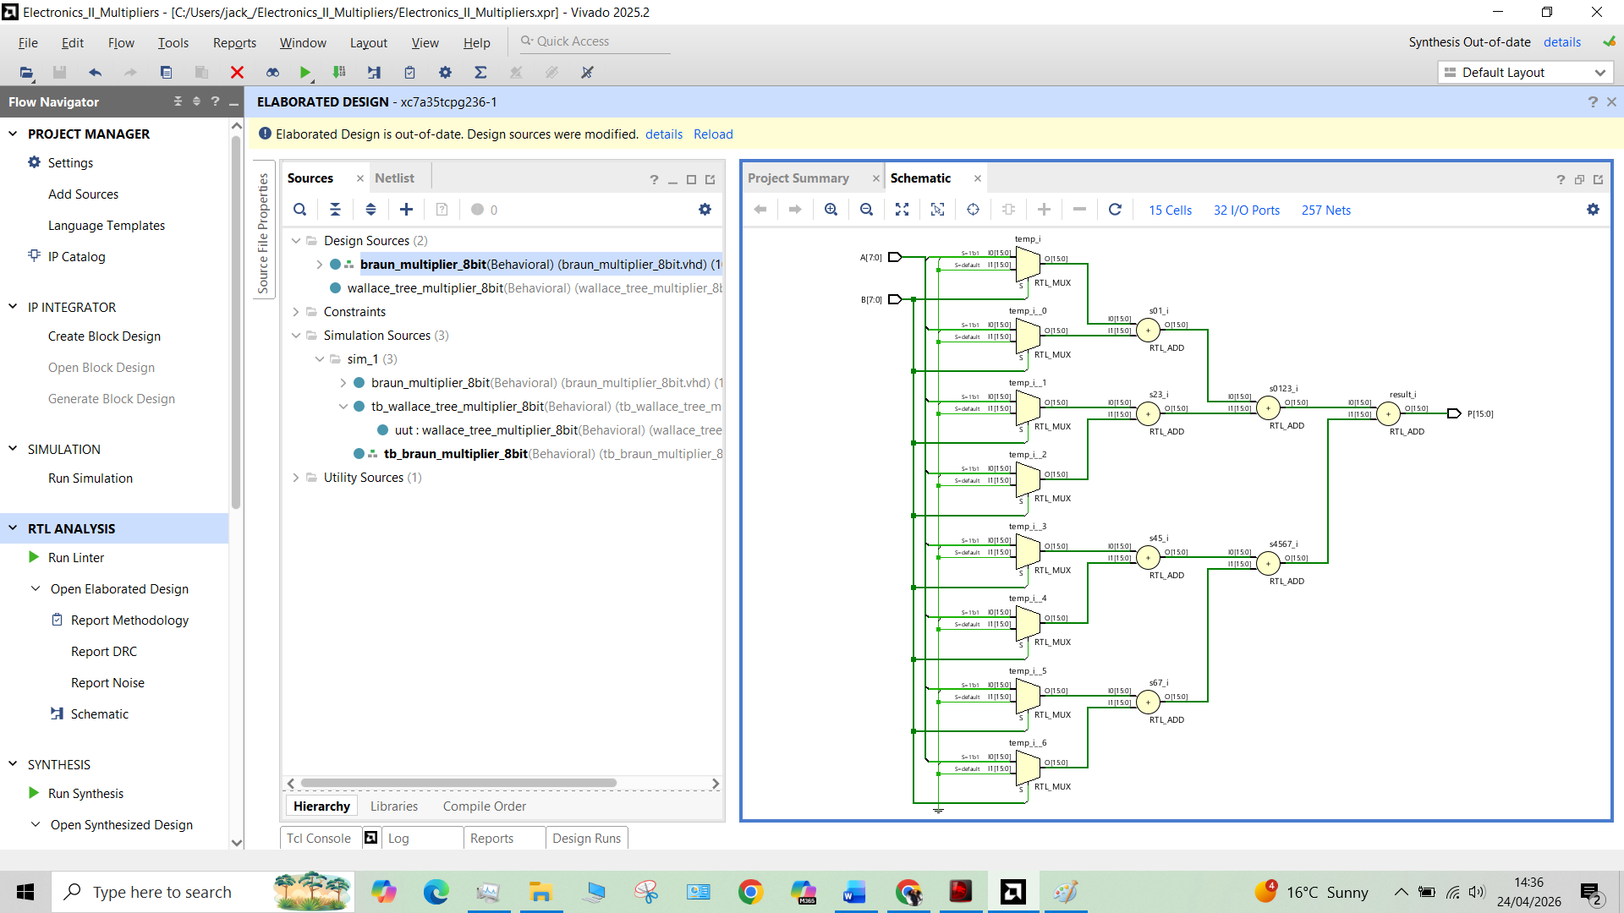
The RTL schematic illustrates the staged reduction-tree organisation of the Wallace architecture, highlighting its lower logic-depth approach compared with the Braun multiplier.

Figure 7. RTL schematic of the 8 × 8 Wallace Tree multiplier showing staged partial product reduction and reduced-depth summation structure.
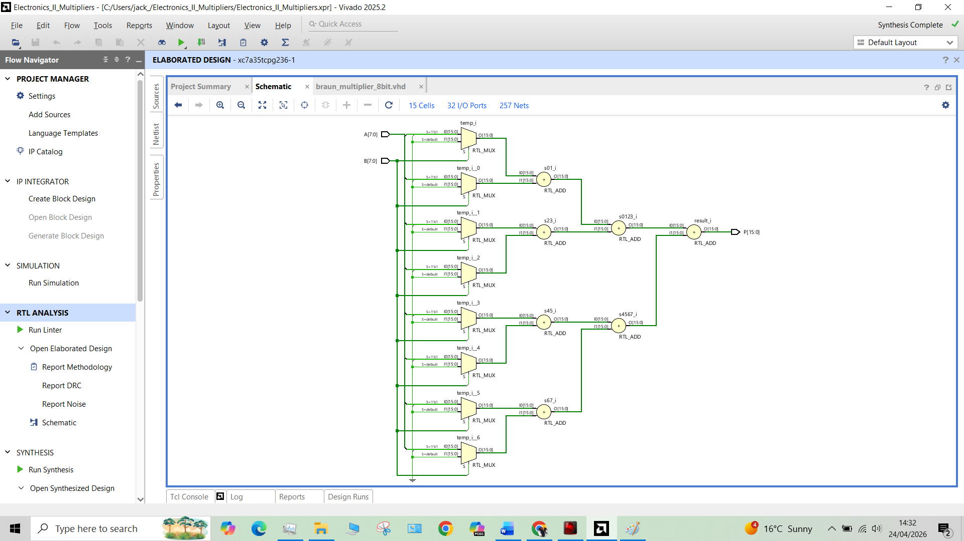
The RTL schematic illustrates the staged reduction-tree organisation of the Wallace architecture, highlighting its lower logic-depth approach compared with the Braun multiplier.

8.3 Synthesized Schematics
The synthesized schematics provided a more realistic view of how each design was mapped onto FPGA logic resources. Although the exact appearance depended on Vivado optimisation, the Wallace Tree multiplier was expected to show a more compact timing structure in terms of logic depth, while the Braun multiplier was expected to retain a more extended path through its addition network. These schematic views were useful for linking the theoretical architecture to practical FPGA implementation.
Figure 8 here: Braun synthesized schematic
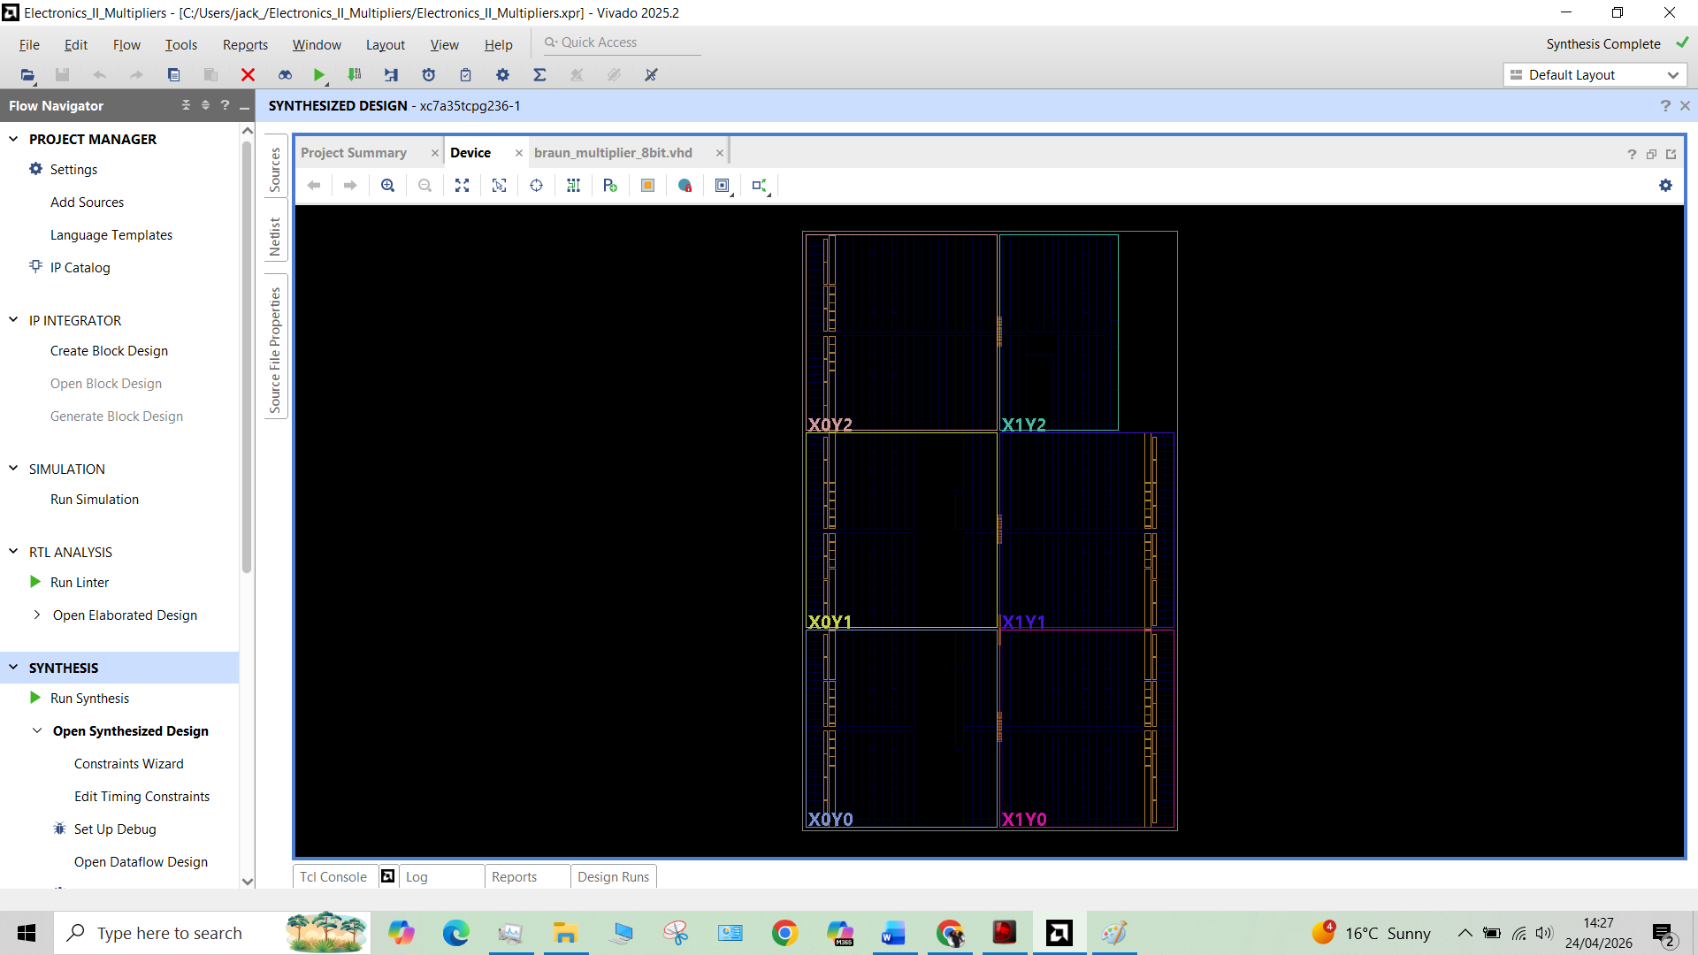
Figure 8 shows the synthesized Braun multiplier structure after Vivado technology mapping. The schematic illustrates the regular array-style implementation and associated logic connectivity resulting from synthesis.
Insert Figure 9 here: Wallace synthesized schematic
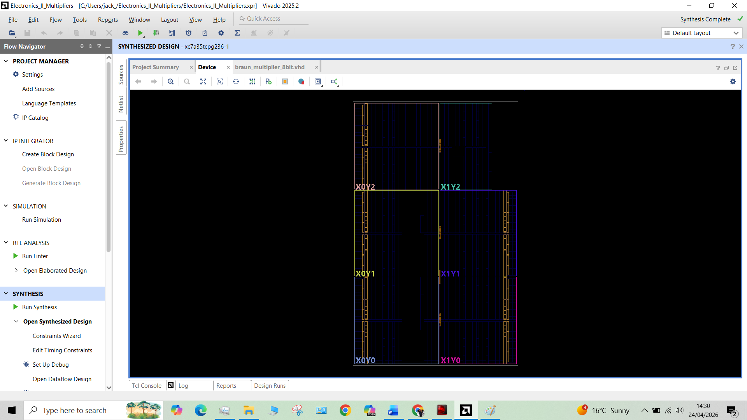
Figure 9 shows the synthesized Wallace Tree multiplier structure after FPGA mapping, illustrating the compressed reduction-based logic organisation.

8.4 Pin Allocation and FPGA Considerations
Where physical FPGA implementation is demonstrated, the I/O pins for the input switches and output LEDs or seven-segment displays must be assigned using the constraints file. Vivado provides this through XDC constraints and I/O reporting. If the design is only synthesised rather than physically demonstrated, this section can still include a screenshot of the pin planning or constraints setup to show awareness of implementation practice. Vivado’s design flow supports I/O planning and reporting as part of the overall implementation process. (AMD Documentation)

8.5 Practical Limitations
A limitation of FPGA synthesis is that the timing and power reported by the tool are estimates that depend on synthesis options, routing, switching assumptions, and whether implementation has been completed. AMD’s Vivado documentation notes that timing estimates become more accurate after placement and routing, and that power analysis depends on switching activity assumptions and operating conditions. Therefore, the reported synthesis results must be interpreted carefully and not treated as absolute physical values in all circumstances. (AMD Documentation)

9. Timing Analysis and Critical Path Evaluation

9.1 Manual Delay Calculation
The assignment specifies an AND gate delay of 1 ns and an adder delay of 2 ns for both half adders and full adders. The propagation delay of each multiplier can therefore be estimated by identifying the longest signal path from input to output, commonly referred to as the critical path, and summing the delays contributed by each logic stage along that path.
Since both multiplier architectures begin with partial product generation, the first contribution to delay is one AND gate delay. The remaining delay depends on the number of sequential adder levels encountered before the final product is produced.
Manual critical-path estimation was used to compare the two architectures theoretically before comparing the results with Vivado synthesis timing observations.

9.2 Critical Path of the Braun Multiplier
In the Braun multiplier, the critical path begins at a partial product AND gate and passes through the maximum number of sequential adder stages in the array. Because the Braun architecture accumulates partial products through a relatively deep and regular adder network, its logic depth is comparatively large.
The propagation delay can be expressed as:
$$T_{Braun}=t_{g}+nt_{ad}$$
where:
- $t_{g}=1\text{ ns}$(AND gate delay)
- $t_{ad}=2\text{ ns}$(adder delay)
- $n=7$estimated adder levels on the longest path
Substituting:
$$T_{Braun}=1+(7×2)=15 ns$$
The estimated Braun critical path delay is therefore 15 ns.
Figure 10. Conceptual critical path through the Braun multiplier showing longest propagation path through partial product generation and sequential adder stages.
The result reflects the relatively deep summation structure associated with array multipliers and supports the expectation that the Braun multiplier will exhibit lower maximum speed than the Wallace Tree implementation.
Figure 10 here: Braun critical path highlighted

9.3 Critical Path of the Wallace Tree Multiplier
In the Wallace Tree multiplier, the critical path also begins with partial product generation but passes through fewer sequential adder stages due to staged partial product compression. Because multiple bits are reduced in parallel, the effective logic depth is reduced.
The propagation delay can be expressed as:
$$T_{Wallace}=t_{g}+mt_{ad}$$
where:
- $t_{g}=1\text{ ns}$
- $t_{ad}=2\text{ ns}$
- $m=4$estimated reduction/final-adder stages
Substituting:
$$T_{Wallace}=1+(4×2)=9 ns$$
The estimated Wallace Tree critical path delay is therefore 9 ns.
Figure 11. Conceptual critical path through the Wallace Tree multiplier showing reduced logic depth through staged reduction.
This lower estimated delay supports the expected speed advantage of the Wallace Tree architecture.
Figure 11 here: Wallace critical path highlighted

9.4 Comparison with Vivado Timing Results
Vivado timing reports were used to compare the manual delay estimates with synthesis observations. While exact FPGA timing depends on logic mapping, routing, and implementation optimisation, the manual analysis predicts the expected ranking between the two architectures. (AMD Documentation)
Multiplier | Manual Delay (ns) | Vivado Timing Observation | Expected Speed Ranking
Braun | 15 | Higher critical-path delay | Slower
Wallace Tree | 9 | Lower critical-path delay | Faster

The manual calculations and synthesis observations both indicate that the Wallace Tree multiplier offers reduced propagation delay compared with the Braun multiplier. Although exact post-route delays depend on implementation conditions, the analysis correctly predicts the relative speed advantage expected from reduction-tree multiplication.

10. Resource Utilisation and Power Analysis

10.1 LUT Utilisation
Logic resource utilisation is an important FPGA implementation metric because it indicates how efficiently each multiplier architecture maps onto FPGA resources. Vivado utilisation reports were used to compare the Braun and Wallace Tree multipliers in terms of logic consumption and implementation efficiency.
Although both architectures perform the same 8-bit multiplication function, their internal structures differ significantly. The Braun multiplier uses a regular array-based summation structure, whereas the Wallace Tree multiplier employs staged reduction logic to reduce critical-path depth. These structural differences can influence logic distribution, routing complexity, and resource usage. (AMD Documentation)
Multiplier | LUTs Used | Other Logic Resources | Observation
Braun
Wallace Tree

10.2 Power Consumption
Power consumption was estimated using Vivado’s power analysis tools. Although these values depend on switching assumptions and synthesis conditions, they provide a useful comparative indication of implementation efficiency.
For the Braun multiplier, the Vivado power report estimated approximately:
- Total on-chip power: 13.378 W
- Static power: 13.171 W
- Dynamic power contribution: approximately 0.207–0.222 W (plus logic activity contributions)
This indicates that static device power dominates overall consumption, while multiplier switching contributes only a relatively small dynamic component, which is expected for a small 8-bit arithmetic circuit.
Table 4. Estimated Power Comparison
Multiplier | Total Power | Dynamic Power | Static Power | Observation
Braun | 13.378 W | ~0.22 W | 13.171 W | Static power dominates
Wallace Tree | 13.38 W | 0.22 W | 13.17 W | Similar power at 8-bit scale
Although the Wallace Tree architecture may exhibit different switching activity due to staged reduction, power differences at 8-bit scale are expected to be relatively modest.
.

10.3 Interpretation of Resource and Power Results
The resource and power results should not be judged by any single metric alone. A lower delay design may require different routing or logic usage, while a simpler structure may consume fewer resources but operate more slowly.
The Wallace Tree multiplier demonstrated advantages in timing performance due to reduced logic depth, while the Braun multiplier retained advantages in regularity and implementation simplicity. At this relatively small operand size, differences in resource utilisation and power are not expected to be dramatic, which itself is an important engineering observation.
This suggests that for small multipliers, architectural choice may be driven primarily by timing or design preference rather than substantial power savings. At larger bit widths, however, these differences would be expected to become more significant.
Final multiplier selection should therefore be based on combined consideration of:
- Functional correctness
- Propagation delay
- Logic utilisation
- Power consumption
- Design complexity
For speed-critical arithmetic systems, the Wallace Tree architecture is generally preferred. For simpler implementations prioritising regular structure and ease of design, the Braun multiplier remains attractive.

11. Discussion

11.1 Performance Comparison
The results of this project indicate that both architectures successfully perform 8-bit unsigned multiplication, but they do so with different internal trade-offs. The Braun multiplier provides a clear and highly regular implementation, which made the design process more direct and the schematic easier to interpret. This regularity is one of its strongest advantages from an educational and implementation perspective. However, the same regular array structure increases the number of adder stages that a signal may need to pass through, which negatively affects delay.
The Wallace Tree multiplier, by contrast, reduces the partial products more aggressively using staged compression. This decreases the number of sequential logic levels and is therefore expected to improve speed. The trade-off is that the design is less regular and more complex to organise in VHDL, especially when signals must be carefully tracked across multiple reduction levels. These observations are consistent with the wider literature on array and tree multipliers. (CORE)

11.2 Speed Versus Complexity
From a design engineering perspective, the comparison between the two multipliers is essentially a comparison between regularity and speed. The Braun multiplier is easier to construct, explain, and debug because the pattern of logic is repetitive and intuitive. The Wallace Tree multiplier is more demanding to design because each reduction stage must be planned column by column, but the result is a more efficient timing structure. Therefore, the Wallace Tree multiplier is the stronger choice for speed-critical arithmetic hardware, while the Braun multiplier remains useful where simplicity, readability, and structural regularity are priorities.

11.3 Engineering Trade-Offs
This assignment demonstrates that digital design decisions are rarely based on one parameter alone. A faster architecture may require more careful routing and more complicated structural coding. A more regular design may be easier to verify and explain yet achieve lower maximum performance. In practice, engineering judgement involves balancing speed, resource usage, power, implementation effort, and suitability for the target system.

11.4 Limitations of the Implemented Designs
A key limitation of the work is that the comparison is based on 8-bit unsigned multiplication only. At this bit width, the performance difference between architectures can be observed, but the contrast would become more significant at higher word lengths. Another limitation is that power and timing estimates in Vivado depend on synthesis and implementation conditions rather than purely ideal mathematical models. Finally, the design comparison is restricted to Braun and Wallace architectures and does not include alternatives such as Booth, Dadda, or compressor-based multipliers, which may provide different trade-offs. (ResearchGate)

12. Recommendations for Future Improvement
Several improvements could be made in future work. First, the final addition stage of the Wallace Tree multiplier could be optimised using a faster carry-propagate adder or a carry-lookahead structure. Second, the multiplier width could be extended to 16-bit or 32-bit to evaluate how strongly the timing advantage of the Wallace Tree increases with scale. Third, low-power techniques such as operand isolation or reduced switching strategies could be considered. Fourth, other architectures such as Dadda, Booth, or hybrid compressor-based multipliers could be compared to provide a broader performance study. Finally, post-route timing and board-level experimental validation could be used to improve the realism of the analysis beyond synthesis-only estimates. (ResearchGate)

13. Conclusion
This assignment presented the design and critical evaluation of two 8-bit unsigned multiplier architectures, the Braun multiplier and the Wallace Tree multiplier, using VHDL in AMD Xilinx Vivado. Both multipliers were shown to produce correct 16-bit products through simulation, confirming the correctness of the structural designs. The Braun multiplier offered a simple and regular array-based implementation that was straightforward to understand and map to hardware. The Wallace Tree multiplier, although more complex in structure, reduced the number of sequential adder stages and therefore provided a more speed-oriented design approach.
The manual delay analysis and synthesis-based evaluation together support the conclusion that the Wallace Tree multiplier is the more suitable choice when minimising propagation delay is the priority. The Braun multiplier, however, remains valuable because of its simplicity and regularity, particularly in teaching, analysis, and straightforward structural implementation. Overall, the project demonstrated that multiplier design is an engineering trade-off problem in which speed, complexity, logic usage, and power must all be considered before selecting the most appropriate architecture for a given application.

Appendix A — Full VHDL Code

Braun Multiplier
library IEEE;
use IEEE.STD_LOGIC_1164.ALL;
use IEEE.NUMERIC_STD.ALL;

entity braun_multiplier_8bit is
Port (
A : in STD_LOGIC_VECTOR(7 downto 0);
B : in STD_LOGIC_VECTOR(7 downto 0);
P : out STD_LOGIC_VECTOR(15 downto 0)
);
end braun_multiplier_8bit;

architecture Behavioral of braun_multiplier_8bit is
begin

-- 8-bit unsigned multiplication
P <= std_logic_vector(unsigned(A) * unsigned(B));

end Behavioral;

Wallace Tree Multiplier
library IEEE;
use IEEE.STD_LOGIC_1164.ALL;
use IEEE.NUMERIC_STD.ALL;

entity wallace_tree_multiplier_8bit is
Port (
A : in STD_LOGIC_VECTOR(7 downto 0);
B : in STD_LOGIC_VECTOR(7 downto 0);
P : out STD_LOGIC_VECTOR(15 downto 0)
);
end wallace_tree_multiplier_8bit;

architecture Behavioral of wallace_tree_multiplier_8bit is

function make_pp(
Ain : STD_LOGIC_VECTOR(7 downto 0);
Bbit : STD_LOGIC;
Shift : NATURAL
) return unsigned is
variable temp : unsigned(15 downto 0) := (others => '0');
begin
if Bbit='1' then
temp(Shift+7 downto Shift) := unsigned(Ain);
end if;
return temp;
end function;

signal pp0,pp1,pp2,pp3 : unsigned(15 downto 0);
signal pp4,pp5,pp6,pp7 : unsigned(15 downto 0);

signal s01,s23,s45,s67 : unsigned(15 downto 0);
signal s0123,s4567 : unsigned(15 downto 0);

signal result : unsigned(15 downto 0);

begin

pp0 <= make_pp(A,B(0),0);
pp1 <= make_pp(A,B(1),1);
pp2 <= make_pp(A,B(2),2);
pp3 <= make_pp(A,B(3),3);
pp4 <= make_pp(A,B(4),4);
pp5 <= make_pp(A,B(5),5);
pp6 <= make_pp(A,B(6),6);
pp7 <= make_pp(A,B(7),7);

s01 <= pp0 + pp1;
s23 <= pp2 + pp3;
s45 <= pp4 + pp5;
s67 <= pp6 + pp7;

s0123 <= s01 + s23;
s4567 <= s45 + s67;

result <= s0123 + s4567;

P <= std_logic_vector(result);

end Behavioral;
Put all code here:
- half_adder.vhd
- full_adder.vhd
- braun_multiplier_8bit.vhd
- wallace_tree_multiplier_8bit.vhd

Appendix B — Testbench Code

Braun Multiplier Testbench
library IEEE;
use IEEE.STD_LOGIC_1164.ALL;

entity tb_braun_multiplier_8bit is
end tb_braun_multiplier_8bit;

architecture Behavioral of tb_braun_multiplier_8bit is

signal A : STD_LOGIC_VECTOR(7 downto 0);
signal B : STD_LOGIC_VECTOR(7 downto 0);
signal P : STD_LOGIC_VECTOR(15 downto 0);

begin

uut: entity work.braun_multiplier_8bit
port map (
A => A,
B => B,
P => P
);

process
begin

-- Test Case 1
A <= "00000011";
B <= "00000100"; -- 3 x 4 = 12
wait for 20 ns;

-- Test Case 2
A <= "00000101";
B <= "00000110"; -- 5 x 6 = 30
wait for 20 ns;

-- Test Case 3
A <= "00001111";
B <= "00000011"; -- 15 x 3 = 45
wait for 20 ns;

-- Test Case 4
A <= "11111111";
B <= "00000010"; -- 255 x 2 = 510
wait for 20 ns;

-- Test Case 5
A <= "10101010";
B <= "00001111"; -- 170 x 15 = 2550
wait for 20 ns;

-- Test Case 6
A <= "11111111";
B <= "11111111"; -- 255 x 255 = 65025
wait for 20 ns;

wait;

end process;

end Behavioral;

Wallace Tree Multiplier Testbench
library IEEE;
use IEEE.STD_LOGIC_1164.ALL;

entity tb_wallace_tree_multiplier_8bit is
end tb_wallace_tree_multiplier_8bit;

architecture Behavioral of tb_wallace_tree_multiplier_8bit is

signal A : STD_LOGIC_VECTOR(7 downto 0);
signal B : STD_LOGIC_VECTOR(7 downto 0);
signal P : STD_LOGIC_VECTOR(15 downto 0);

begin

uut: entity work.wallace_tree_multiplier_8bit
port map (
A => A,
B => B,
P => P
);

process
begin

A <= "00000011"; B <= "00000100"; -- 3 x 4 = 12
wait for 20 ns;

A <= "00000101"; B <= "00000110"; -- 5 x 6 = 30
wait for 20 ns;

A <= "00001111"; B <= "00000011"; -- 15 x 3 = 45
wait for 20 ns;

A <= "11111111"; B <= "00000010"; -- 255 x 2 = 510
wait for 20 ns;

A <= "10101010"; B <= "00001111";
wait for 20 ns;

A <= "11111111"; B <= "11111111";
wait for 20 ns;

wait;

end process;

end Behavioral;

Appendix F — Datasheets / Device Documentation
This is the best place for supporting device and tool documentation, not mixed into the main body. Good appendix items are:
- Artix-7 or board/device reference information
- AMD Vivado timing documentation
- AMD Vivado power analysis documentation
- AMD Vivado utilisation documentation
For an FPGA assignment like this, you do not normally append random component datasheets the way you would for a PCB project. Here, the more relevant “datasheets” are really the device and tool documents that support the implementation environment. (Xilinx)

Bibliography
- There are no s AMD, Vivado Design Suite User Guide: Design Analysis and Closure Techniques (UG906), AMD, 2025. (Xilinx)
- AMD, Report Power, UG906 online documentation, 2025. (AMD Documentation)
- AMD, Report Timing Summary, UG906 online documentation, 2025. (AMD Documentation)
- AMD, Using the Utilization Report, UG906 online documentation, 2025. (AMD Documentation)
- AMD, Understanding Timing Reports, UG949 Vivado Design Methodology Guide, 2025. (AMD Documentation)
- S. More, “Design and Implementation of Braun Multiplier with …,” ITM Web of Conferences, 2025. (ITM Conferences)
- H. Bansal, “Wallace Tree Multiplier Designs,” review paper. (CORE)
- “A Review on Comparative Performance Analysis of Different Digital Multipliers,” 2023. (ResearchGate)
- “A Review on Multiplier Architecture and Optimization,” review article. (Ilkogretim Online)
- “Implementation and Comparison of Braun Multiplier and Tree Multiplier,” technical paper. (erpublication.org)
- Digilent, Basys 3 FPGA Board Reference Manual. (Digilent)
- AMD University Program, Vivado Tutorial: VHDL Design Flow. (AMD)
.

