Portfolio of work

Oslava Chougleva
Student number:2028217
Programme: Certificate in Higher Education Skills for Workplace
Module code: BMSW 4005
Lecture name: Dr Crisford Chogugudza
Title of task 3 -Reflective portfolio

1)
What is the impact of my skills and competencies by using Johari Window and Personal Development Plan?
Personal skills: Hardworking, Caring, Dedicated, Loyal, Honest and Helpful.

The ability to work with other people is a skill, which requires a lot of knowledge about yourself. To evaluate my skills and competencies using them, there was the need to investigate my relationship with others. How we behave with others forces us to be more aware of ourselves. (Luft and Ingham, 1961) Johari Window model, which was developed in the 1950s, is a valuable model that can assist me with acknowledging how to become more open and socialise with others. There are four panes of the window.
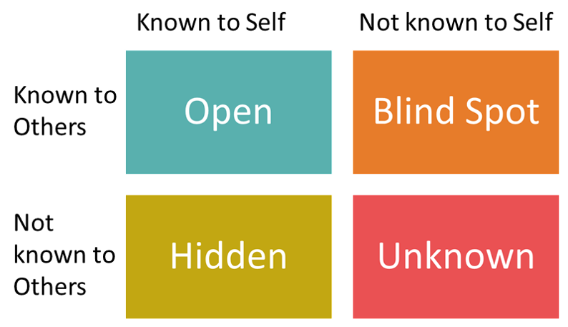

Fig1 (Source: www.healthynumbers.com.au)

The open area is aware of who I am. Values like attitude, behaviour and lifestyle also tell what other people know about me. Hidden areas are factors that could be considered shared with others as this could establish trust. Blind area is what others think of me, but I am unaware of it. Unknown Area is the unconscious of what we are; the importance of this area is that as we expand other windows, we can reduce this area and be less concerned about your behaviour. (Saxena, 2015)
Self-reflection by implementing Personal Development Plan enables me to think about what I have done right and wrong throughout my experience. Starting by looking for potential skills improvements by finding suitable education programs, I will evaluate my presentation skills and create a plan for future personal or career development. (Beausaert et al., 2013)

Personal Development Plan
Goals | Time | Activities | Success Criteria | Resources
My goals are to complete my Level 4 and process into Leve5/6 and graduate. | 2021-2025 | Going to University two days for a week and 30 hours additional study | Achieving Certificate and Diploma | £54000
Enrol on courses -Word-Microsoft, Counselling | 2023-2025 | Online www.learndirect.com  One hour per night | Be more competitive and able to assist clients | £237.27
Improve my reading and writing skills | 2023-2025 | Reading books for two hours twice a week | It will have positive impact and reduce the stress
Start looking for a Social Worker jobs | 2024-2025 | Weekend | Finding a job is the way can bring studies into the practice
Start thinking to senior positions | 2028-2030 | 10 hours per week | It will help me seek future development of my skills and have more responsibilities | £2000

2)
What are the manager’s responsibilities?
The opportunity to manage an organisation brings the responsibility of creating effective teams, which provides the need to establish trust and knowledge among the team members. This included but is not only limited to personalities, preferences and abilities, which
will be highly beneficial in allocating team roles. I will take responsibility for recruiting new staff and the required development of the existing staff. Adopting fundamental theories and models to assess and select employees that are committed and have the necessary skills and knowledge suitable to meet organisation needs can lead to staff high performance and establish good connections with the company.
Assessing current staff will be my priority. To do this, I will use Gibbs’s Reflective Cycle model, which Graham Gibbs developed in 1988. Following the six stages of the model, presented as a cycle, will allow me to understand my team by investigating their experience as a team or as individuals (Reflection Toolkit, 2022). The description is the starting point; it is essential for staff/individuals to disclose all the situation details. We will know what was happening, what was done, or what other people did by providing such information. Assessing the way, they feel: I would like to learn more about how they felt; by encouraging them to express their emotions and discussing their experience, it potentially can make them understand other people’s views about some experiences. Evaluation would be the next stage. By doing this, people would be able to express their view of the experience, positive or negative outcomes from experience, and the causes of the experience. An analysis is to make people understand the in-depth experience they had. By doing this, people better understand the experience they had.
In conclusion, by providing the opportunity for the staff to finalise and think about their experience, they could consider what could be done for others’ positive experiences, how they would react if they had some experience and improvements (Markkanen, P. et al. 2020). An action plan is required following previous stages that will provide us with the information collected and individuals challenging their point of view. Afterwards, I will be confident that a better-unbiased communication is established with staff and create a new approach to developing a working attitude (Paterson and Chapman 2013).
According to Isabel Briggs Myers, "It is up to each person to recognise his or her true preferences." (MBTI®). Carl Jung's theory of psychological types was developed in 1920, the idea is built on the principle that different types of human consciousness possess unique characteristics and activities by creating different styles, we can understand people behaviour and personality. Applying Jung’s theory as a base, the MBTI theory, which was developed by Kathrine Cook Briggs and her daughter Isabel Briggs Mayers, called The Mayers-Briggs Type Indicator (MBTI), was published in 1962; it is an indicator that is widely accessible and used to individuals and groups.
The main suggestion of the MBTI indicator is based on the idea that distinct types of human thought have unique variations and actions and identify the way they select their interest, need, values and motivation. (McCaulley, 1974) It also assumes that human necessities establish awareness and a good decision-making system. Using four principles of MBTI indicators such as Extroversion or Introversion, Sensing or Intuition, Thinking or Feeling, and Judgment or Perception, we can generate 16 personalities. To recognise them, we use code or letters. See Fig1 Each of the letters in combination represents different characteristics, in variety is a personality type. See Fig 2.
This theory will help me assess the existing staff and can be used after hiring the new staff. As we perform the test, we will have additional information, which was not disclosed or available during the hiring process. Acknowledging differences amongst individuals will help me recognise their basic personalities and create trust. The way they would fit within the organisation will impact the communication and reduce to minimum internal organisations conflicts. Having the available information will assist know who is suitable to work in a team and co-operate better with the company’s norms and build a team with members who are participating so the goals can be achieved, l as well will be able to recognise specific personality, which will be more effective by completing single tasks. It is essential to reduce resources by matching personality with a suitable position and manners, which also could impact the working environment (Dubey, Banerjee and Dubey, 2019). One of my concerns is that the MBTI indicator is not recognised in the academic world. As an example, many professionals such as counsellors or psychotherapists cannot use it. (Behaz and Djoudi, 2012).

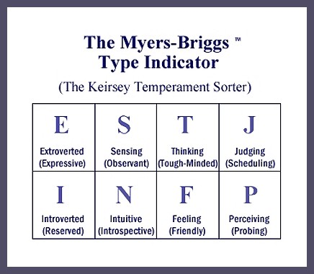
Fig 1(n.d.) (Source www.healthynumbers.com.au)
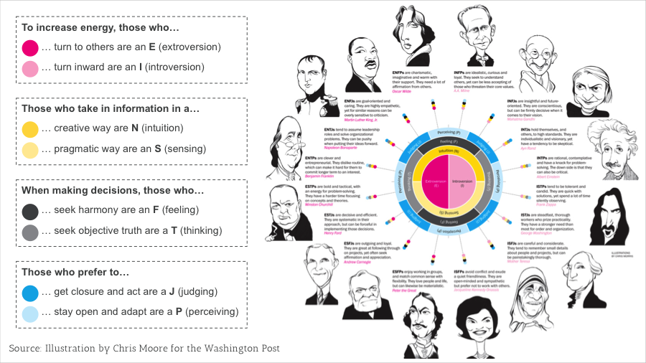
This Photo by an Unknown Author is licensed under CC BY-ND
Fig 2 (Moore) (Source .www.Thisisxy.com)

3)
Open book assessment was to access and highlight my skills for how good I am in researching for information, memorising, thinking, and representing my point of view. Using the case study and the need to connect it to the exam question was good practice for me. It highlights many areas I need to improve, such as more writing practice under pressure, note-taking, reading relevant materials and time management. The assessment shows that I was not well prepared for the task. I did not read enough and better understand the case study and take more notes, which could have a more positive outcome on the exam day (Cahill-Ripley, 2015). The positive experience is close to real-life professional practice and provides valuable knowledge, which I can expand further and develop my skills. It will have a positive impact on my other essential skills as well. I will require those skills in my future professional career. I could do it better if I had more knowledge of what is necessary for an open book assessment, but I am learning from experience. If I have an open book assessment again, I will do it well prepared. I am doing to do in advance the searches related to the case study/exam. I will be better organised with notetaking and develop significantly better reading and writing skills. Making clear notes and connecting them to the studies and searching in advance for available sources on the websites will reduce my stress and improve exam results. It will make me feel more engaged with research and achieve better marks, but more importantly, I will evolve crucial skills (Aziz, Mahboob and Saleem, 2020).
Mock Interview was another part of my learning during this module. The prerequisite of having a search for Social Work jobs and reading the details of the job description was required. I had a task to create a CV, which I later used for my Mock interview. I have mixed emotions about the outcome of this interview. It was helpful because studying this is
fundamental for my future professional career, However, I did not feel very confident during the interview because I was asked questions I did not participate. I do not know how well or bad I did during the interview as I still have not received any feedback, which prevents me from reflecting on it. However, future interviews to attend will make me more confident. Reading, asking the people around me for advice, and watching education programs is what I will do for my chances to present better myself and gain a job.
UK Employment Legislation is the link between employers and employees. Equality act 2010, Health and Safety, Employment Law, Employment Rights Act 1996, Data Protection Act 2018 are some of the essential laws regulating our professional lives. It is necessary to know those laws to protect our employees' rights regarding how the recruitment process is organised. An employment contract is a critical part of the relationship between employer and employee and the obligation of both parties. Health and Safety law ensures that working conditions are suitable and do not expose employees to risks. Data Protection Act regulates how the employer is protecting our data, also, as an employee, I have legal obligations to store and keep data that I have collected during my duties. Studying those laws made me realise how well the law protects me. Living and working in diversely environments and communities requires treating people equally, fair and without any prejudiced feelings based on faith, colour or religion (Cameron, 2013). I am going to expand my study on those laws because as a future employer, employee or working as a social worker; I will be able to advise my clients what their rights or responsibilities are.
Neil Fleming’s VARK model was developed in 1987 to assist the students in recognising better the way they learn. It has four learning styles visual, auditory, reading/writing, and kinaesthetic.
(Beausaert and Raemdonck, 2021) Awareness of my learning style helped me understand my feeling related to the education I am doing. The difficulty I have with writing assessments, notetaking and everything involving writing was my learning style Auditory. I was engaging a lot in class but most likely missed a lot of notetakings, which consensually could have an impact on my written exams. I am going to create a plan of less talking in class, develop better writing habits and increase my attention level.
Swot Analyses is credited to Albert Humphrey, who developed the model in the 1950s. The model covers four essential areas of your self-awareness: Strengths, Weaknesses, Opportunities and Threats; it can be used everywhere. As humans, we want to know about ourselves and how we feel, manage, or plan our lives.
It was beneficial for me because it revealed the urgency of having a strategy. I can analyse my strengths, weaknesses, opportunities, and threats by having a plan. Creating a frame will help grow my confidence as I am aware of my strengths. There is an urgency to reduce my weakness and explore the available opportunities. By increasing my confidence, I can achieve different personal or professional satisfaction levels. (Gong, Rong and Wang, 2019).
I will enter a highly demanding, fast-changing work environment; I will need all the skills learned so far. By having regular feedback, I will be much more self-aware of my strengths and weakness, which will diminish my unsatisfaction and highlight directions that need improvement.

Reference:

- Aziz, A., Mahboob, U. and Saleem, T., 2020. Benefits of Reflective Writing in Health Care through the Vivid Lens of HouseOfficers. MedEdPublish. Available at doi.org/10.15694/mep.2020.000060.1
- Beausaert, S. at el (2013). Effect of using a personal development plan on learning and development. Journal of Workplace Learning, 25(3), pp.145-158.Available at. doi:10.1108/13665621311306538
- Beyaz, A. and Djoudi, M., (2012). Adaptation of learning resources based on the MBTI theory of psychological types. International Journal of Computer Science Issues (IJCSI), 9(1), p.135.
- Cameron, S., (2013). The business student's handbook: skills for study and employment. Available at: https://www-vlebookscom.ezproxy.uwtsd.ac.uk.(Accessed 6 April 2022).
- Cahill-Ripley, A., (2015). Innovative assessment methods in law: the value of open-book exams as a catalyst for improving teaching and learning in the law school. The Law Teacher, 49(2), pp.206-218. https://doi.org/10.1080/03069400.2015.1016724
- Dubey, B., Banerjee, P. and Dubey, A. (2019). Introduction. In: 2019. Inkblot Personality Test: Understanding the Unconscious Mind, First Edition end, Mathura Road, New Delhi: SAGE Publications Pvt Ltd. pp. 3-20 Available at: https://dx.doi.org/10.4135/9789353287771.n1> (Accessed 30 Mar 2022)
- Fig 1 www.healthynumbers.com.au/wp-content/uploads/2019/10/j
Fig 2 Moore, C. www.Thisisxy.com.Available at: www.thisisxy.com/sites/default/files/styles.(Accessed1 April 2022].
- Gong, Q., Rong, L. And Wang, H., (2019). China’s Manufacturing Strategy Choice: An Integrated Strategic Analysis Framework Combining Swot and Logical Growth Models. Asian Economic and Financial Review, 9(11), Pp.1290-1305Available at Doi: 10.18488/Journal.Aefr.2019.911.1290.1305
- Lejeune, C., Beausaert, S. and Raemdonck, I. (2021) ‘The impact on employees’ job performance of exercising self-directed learning within personal development plan practice’, International journal of human resource management, 32(5), pp. 1086–1112.Available at Doi:10.1080/09585192.2018.1510848
- Luft, J. and Ingham, H., (1961). The Johari Window: a graphic model of awareness in interpersonal relations. Human relations training news, 5(9), pp.6-7.
- Markkanen, P. et al. (2020) ‘A reflective cycle: Understanding challenging situations in a school setting’, Educational research (Windsor), 62(1), pp. 46–62. doi:10.1080/00131881.2020.1711790.
- Mc Caulley, M., (1974). Available at: www.semanticscholar.org/paper/The-Myers-Briggs-Type-Indicator-and-the-Process.Mc Caulley. (Accessed 1 April 2022].
- Markkanen, P. et al. (2020) ‘A reflective cycle: Understanding challenging situations in a school setting’, Educational research (Windsor), 62(1), pp. 46–62. doi:10.1080/00131881.2020.1711790.
- Mc Caulley, M., (1974). Available at: www.semanticscholar.org/paper/The-Myers-Briggs-Type-Indicator-and-the-Process.Mc Caulley. (Accessed 1 April 2022].
- Sonker, J, and Shukla. P, (2019). Self-Awareness: Switch yourself into the inner world of reality. www.researchgate.net. Available at www.researchgate.net/profile/Jooli-Sonker/publication/340502316(Accessed 5 April 2022)
- Paterson, C. and Chapman, J., (2013). Enhancing skills of critical reflection to evidence learning in professional practice. Physical Therapy in Sport, 14(3), pp. 133-8. Available at DOI: 10.1016/j.ptsp.2013.03.004
- Saxena, P., (2015). Johari Window: An effective model for improving interpersonal communication and managerial effectiveness. SIT Journal of Management, 5(2), pp.134-146.
- The University of Edinburgh. (2022). Reflection Toolkit. Available at: www.ed.ac.uk/reflection.(Accessed 29 March 2022].

