University of Wales
Trinity Saint David

Software Development

Georgi Markov
2012155

PART A (UNDERSTANDING)

Variables [1][2]
Variables are used for various reasons. They are used to label different data, commonly labelled with descriptive names for a more efficient comprehension, whether individually or between groups. But the main purpose of a variable is to store information. Once stored, it can be then referenced and manipulated if needed later on. It is important that variables are labelled properly, as it makes code reading as well as using easier – naming variables is often a daunting task for any developer.
As Python is both strongly and dynamically typed programming language. Dynamically typed in the sense that variables have no types, but instead objects (values) do. Strongly implies that values cannot change unexpectedly (for instance, a string with only numbers would not automatically change to an integer.

Example of variables:
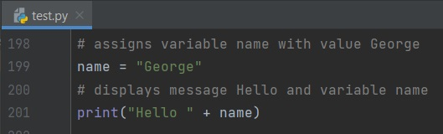

Output:
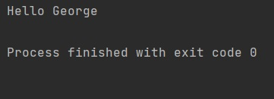

If/else statements [3]
If/else statements are used in decision making when certain conditions are required. These statements incorporates the logical conditions from mathematics, e.g. equal (==), less than (<), and so on. They are used when code is needs to be executed only if certain condition is met.

Syntax of if statement
if condition/s:
code to be executed if condition/s met

Syntax of if/else statement
if condition/s:
code to be executed if condition/s met
else:
code to be executed if condition/s false

Syntax of if/elif/else statement
if condition/s:
code to be executed if condition/s met
elif condition/s:
code to be executed if condition/s in ‘if’ statement’ not met but satisfied in ‘elif’
else:
code to be executed if condition/s false

The following is an example of if/elif/else statement:
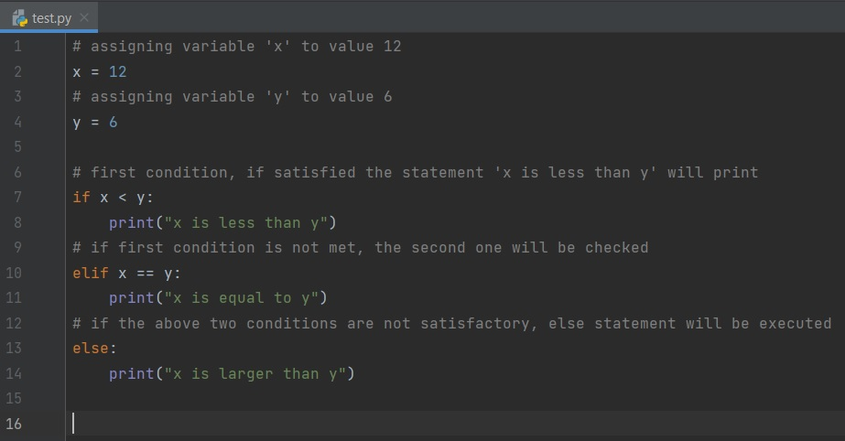
Often, more than one statement might be needed, and if/else allows for that. In the example above, variable x is assigned to value 12, and y to 6. As general concept, the program runs the code from top to bottom, line by line.
It first checks if the first condition is satisfactory, if not it moves on to the second. ‘Elif’ and ‘else’ are optional, meaning in the instance where only if is included, the program will still execute without errors – if the condition is not met, a blank outcome will be shown. The initial idea is if/else, meaning ‘if’ assigning a condition, and if not met, ‘else’ will be executed no matter. But due to multiple conditional testing, only two conditions cannot accommodate the need. Therefore, the ‘elif’ statement acts as another ‘if’ statement – unlimited ‘elif’ statements can be added. Below is the result of the execution:
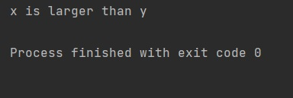
As seen above, the ‘else’ statement was executed. The first and second conditions did not meet satisfactory position of the testing, so the third got executed.

Example of if/else with multiple conditions
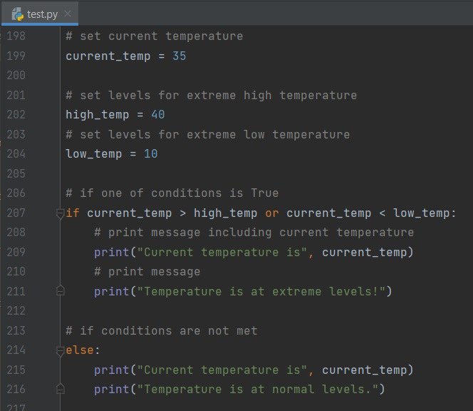
In this instance, there are two conditions in the if statement. When ‘or’ is used between the two conditions, one of either must be satisfied in order for the if statement to be executed. If ‘and’ is replaced instead, both conditions would have to be satisfied for if to execute.
The current temperature is 35 so the ‘else’ statement is executed. But if the current temperature is set to above 40 or below 10, then the if statement would be executed.

Loops [4]
Loops are used to iterate sequences or objects. For loops are used to iterate through sequences. They iterate once per item, until executed. On the other hand, while loops can iterate endlessly as long as a condition is satisfied – consequently, the loop stops when a condition is no longer satisfactory, or a specific stop condition is reached (such as break).

Syntax of ‘for’ loops:
for var in iterable:
statement/s to be executed
Syntax of ‘while’ loops:
while condition:
statement/s to be executed

The following is an example of a for loop, used to list every item from a list of tropical fruits:
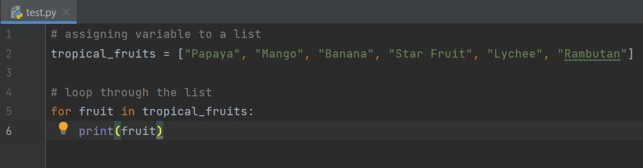

The variable tropical_fruits is assigned to multiple strings, a list in this scenario (square brackets are used to create [lists]). The for loop iterates each item. The ‘fruit’ in this instance is irrelevant, meaning any name could have been assigned – fruit is conveniently descriptive for the particular case.
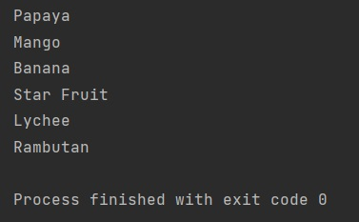
Output from for loop

Next is an example of a while loop, used to increment and store data until a limit is reached:

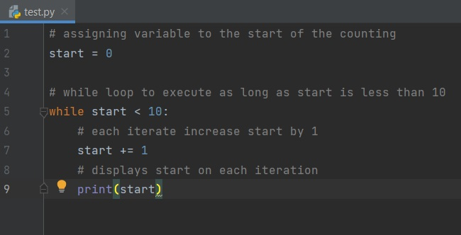

Variable ‘start’ sets the start number – this could be anything between 0 and 10, if 10 or more the condition would be already met and nothing will be displayed. The while loop will iterate as long as start is has not reached 10. Start+=1 is the same as saying start = start + 1, meaning add one to start, and with every iteration, one is added to start - this is how the value of the variable increases.

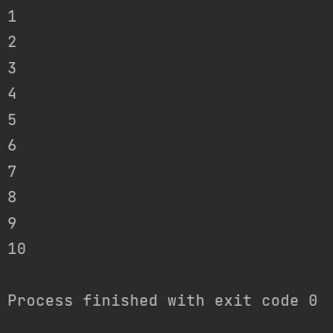
Output from while loop

PART B (IMPLEMENTATION)

Exercise 1
Logical algorithm 1:
Step1: declare 4 input variables
Step2: assign while loop to 3rd input variable to enforce digits ONLY
Step3: assign while loop to 4th input variable to enforce digits ONLY
Step4: print general message including input variables
Step5: print summary of input data
copy/paste allowed
# variable requesting an input of car maker
car_maker = input("Please enter the car maker: ")
# variable requesting an input of car madel
car_model = input("Please enter the car model: ")
# variable requesting an input of car mileage
mileage = input("Please enter the car mileage: ")

# while loop iterating as long as mileage is anything but digit
while mileage.isdigit() == False:
# displays message if condition met
print("Mileage can only be in numbers, please try again.")
# variable requesting an input of car mileage if condition met
mileage = input("Please enter the car mileage: ")

# variable requesting an input of car doors
n_doors = input("Please enter the number of car doors: ")

# while loop iterating as long as n_doors is anything but digit
while n_doors.isdigit() == False:
# displays message if condition met
print("Number of doors can only be in numbers, please try again.")
# variable requesting an input of car doors if condition met
n_doors = input("Please enter the number of car doors: ")

# prints f-string message including all 4 input variables
print(f"\nThis is the {car_model} by {car_maker}."
f"\nCurrently it is on {mileage} mileage,"
f" and has {n_doors} doors.")
# displays summary of all 4 input variables
print (f"\nSummary:\n"
f"Maker: {car_maker}"
f"\nModel: {car_model}"
f"\nMileage: {mileage}"
f"\nDoors: {n_doors}")

Exercise 1 Output
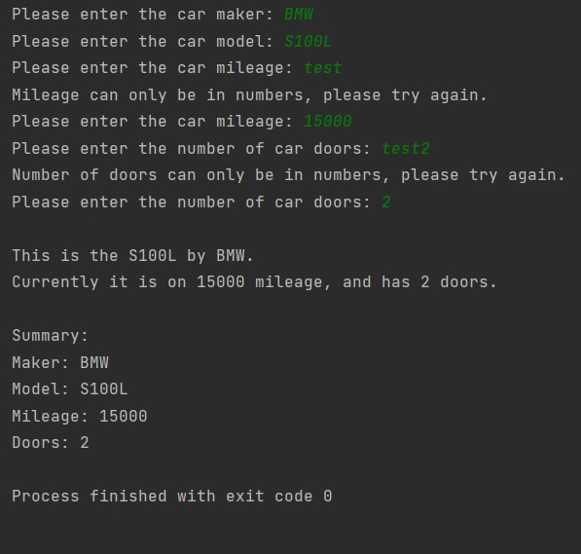

Exercise 2
Logical algorithm 2:
Step1: assign 2 input variables (measurements)
Step2: assign variable to a list (set optimal growth)
Step3: assign variable to a list (values from initial 2 input variables)
Step4: add function for calculating maximum carrots for growth
Step5: import math module for round down numbers
Step6: declare variable within function for calculation and print
Step7: call function

copy/paste allowed
# importing math module for rounding down values
import math

# assigns x variable to an input request
x = input("Enter first measurement: ")
# assigns y variable to an input request
y = input("Enter second measurement: ")

# a list containing standard size of optimal growth per carrot
carrot = [8, 8]
# storing inputs into a list variable of integers
area = [int(x), int(y)]

# a function calculating the number of carrots for growth
def division(area):
# mathematical calculation extracting only whole carrots
new = (math.floor(area[0] / carrot[0])) * (math.floor(area[1] / carrot[1]))
# displays outcome
print(new)

# executes function
division(area)

Exercise 2 Output
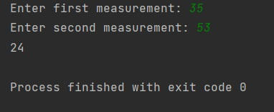

Exercise 3
Logical algorithm 3:
Step1: declare input variables for 5 items and 5 prices (split)
Step2: assign variable to a list of the 5 items
Step3: assign variable to a list of the 5 prices (float)
Step4: print summary of items and prices
Step5: import math module for round down numbers
Step6: declare variable for sum function and print
Step7: declare variable for discount (sum times the discount %)
Step8: declare variable for discounted price (price after extracting discount)
Step9: print discount price (rounded)
copy/paste allowed
# prints a message
print("\nExample: banana 14.2 apples 8..")
# request input for all items
item1, price1, item2, price2, item3, price3, item4, price4, item5, price5 = input("Enter 5 products with their respective prices: ").split()

# creates list from the inputs of products
item_list = [item1, item2, item3, item4, item5]
# creates list from the inputs of prices
price_list = [float(price1), float(price2), float(price3), float(price4), float(price5)]

# displays a summary of products including prices
print(f"\nProducts:"
f"\n{item1}: {price1}"
f"\n{item2}: {price2}"
f"\n{item3}: {price3}"
f"\n{item4}: {price4}"
f"\n{item5}: {price5}")

# assigns variable to sum function of prices
sum = sum(price_list)
# prints sum
print("Total price is: " + str(sum))

# calculates discount price
discount_price = sum * 0.15
# calculates price after discount is taken off
discount = sum - discount_price
# prints sum after discount, rounded to 2 decimals
print("Total price after discount: " + str(round(discount, 2)))

Exercise 3 Output
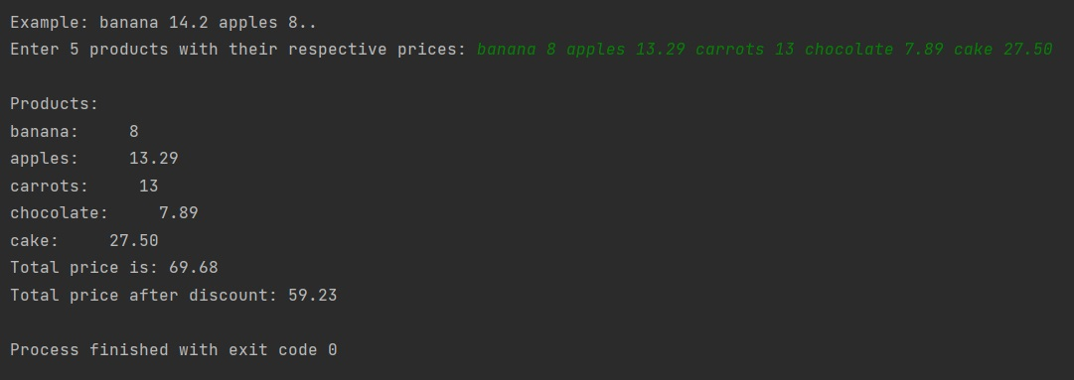

Exercise 4
Logical algorithm 4:
Step1: set initial board – 15 values (assign variable)
Step2: import random for generating random numbers
Step3: assign variable to a random value between 1 and 16
Step4: insert random value as a 0 into initial board (assign variable)
Step5: set lives (number of trials) to a variable
Step6: print new board game (including the insert value)
Step7: declare input variable
Step8: iterate (while loop) game and set condition for iteration (input not equal to random)
Step9: set lives to decrease on each iteration and when reach 0 to break the loop
Step10: print new board game and guess input on each iteration
Step11: set try/except if input is not an integer
Step12: set if statement if user input equals random
Step13: set to insert value of user input into board game (use try/except for errors)
Step14: add new condition to while loop
Step15: set if statement for input variable for another game if random equals user guess
Step16: set if statement for input variable for another game if out of lives

copy/paste allowed
# module for generation of random numbers
import random

# a list representing the initial board game (15 zeros)
board_game = [0, 0, 0, 0, 0, 0, 0, 0, 0, 0, 0, 0, 0, 0, 0]
# variable assigning random generator between 1 and 16
random = random.randint(1, 17)
# inserts random value into the list
insert = board_game.insert(random, 0)
# assigns lives counter
lives = 3
# displays board game
print("", board_game[0:4], "\n", board_game[4:8], "\n", board_game[8:12], "\n", board_game[12:16])
# input variable for a guess
guess = input("Please enter your guess: ")

# iterating until user guesses correctly random value
while guess is not random and guess != "dhuDhFIhIfifjIFJ4rdFNfIKFnD":
# checking if input value is an integer
try:
guess = int(guess)
# ValueError catches if input not an integer
except ValueError:
print("Only numbers allowed.")
guess = input("Please enter your guess: ")
continue
# 'if' statement if the user has guessed correctly
if guess == random:
print("\nYOU WIN, CONGRATS!!!")
# guessed number replaces zero with itself
board_game[random - 1] = random
print("", board_game[0:4], "\n", board_game[4:8], "\n", board_game[8:12], "\n", board_game[12:16])
print(f"Lucky number is {random}")
# requesting for another game
again = input("\nWould you like to play again? ")
# if yes, lowering all input values
if again.lower() == "yes":
# if yes in input, guess value changes second condition in while loop
guess == "dhuDhFIhIfifjIFJ4rdFNfIKFnD"
# restarts lives to 3 again
lives = 3
continue
# if no, lowering all input values
if again.lower() == "no":
print("\nThank you for playing!")
# moves execution to break clause
pass
else:
print("\nI will take that as a no, thank you for playing!")
pass
# while loop breaks, stopping the game
break
# substitutes zero with guess input in the board game
try:
board_game[guess - 1] = 1
# raises an IndexError if number is out of positional range (0<x<17)
except IndexError:
print("Position must be between 1 and 16.")
guess = input("Please enter your guess: ")
continue
# displays modified board game after guess
print("", board_game[0:4], "\n", board_game[4:8], "\n", board_game[8:12], "\n", board_game[12:16])
# lives decrease by 1 on each iteration/guess
lives -= 1
print(f"\nYou have {lives} left")
if lives == 1:
print("Last chance")
# when lives equal zero user fails the game
if lives == 0:
print("\nNo more lives, you lost!")
print(f"The correct position was {random}.")
# requesting for another game
again = input("\nWould you like to play again? ")
# if yes, lowering all input values
if again.lower() == "yes":
# if yes in input, guess value changes second condition in while loop
guess == "dhuDhFIhIfifjIFJ4rdFNfIKFnD"
# restarts lives to 3 again
lives = 3
continue
# if no, lowering all input values
if again.lower() == "no":
print("\nThank you for playing!")
# moves execution to break clause
pass
else:
print("\nI will take that as a no, thank you for playing!")
# while loop breaks, stopping the game
break
# guess input on each iteration/guess
guess = input("Please enter your guess: ")

Exercise 4 Output
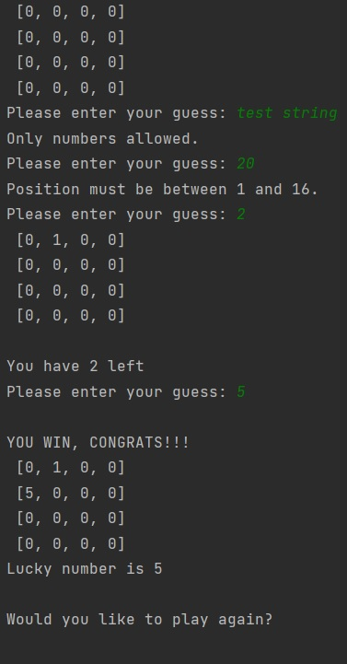 | 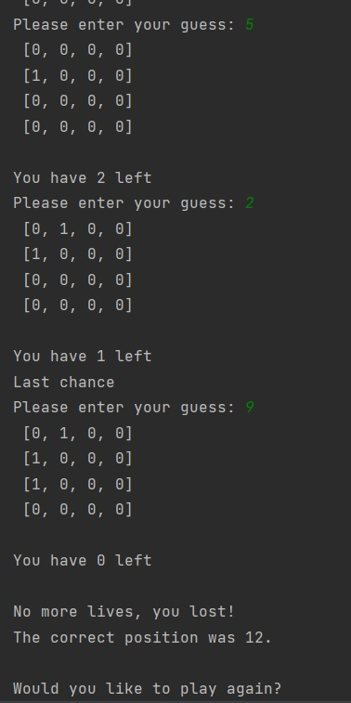
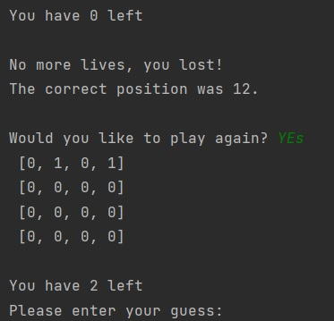 | 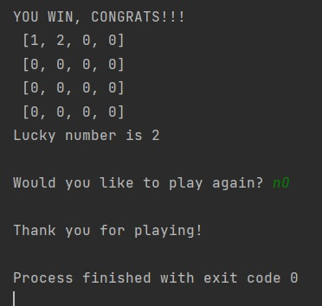

References
[1] Fox P. (unknown), Khan Academy, Storing data in variables, address: https://www.khanacademy.org/computing/ap-computer-science-principles/programming-101/storing-variables/a/assigning-variables [accessed: 28/04/21]
[2] Bitesize Team (unknown), BBC Corp, Constants, variables and data types, address: https://www.bbc.co.uk/bitesize/guides/zc6s4wx/revision/5#:~:text=Variables%20are%20data%20values%20that,is%20used%20to%20hold%20data. [accessed: 28/04/21]
[3] Unknown (unknown), W3School, Python If ... Else, address: https://www.w3schools.com/python/python_conditions.asp [accessed: 29/04/21]
[4] Sharpened Products (3 Feb 2016), Tech Terms, Loop, address: https://techterms.com/definition/loop#:~:text=In%20computer%20science%2C%20a%20loop,functions%2C%20and%20many%20other%20things.

