A written report for developing
Workplace and critical thinking in Boots
(BMSW5001_LON)

Written by; Nursima A. Ingilan
Student id#1713705

llll

Lecturer: Kenny Tang

Table of contents

ABSTRACT…………………………………………………………….. O3
INTRODUCTION……………………………………………………...03
COMPANY OVERVIEW ………………………………………….. O3
DEFIINITIONS OF BELIEFS………………………………………. O4
DIFINITIONS OF ATTITUDES AND VALUES
……………………………………………………O5
IMPACT OF BELIEFS, ATTITUDES AND VALUES
IN WORKPLACE …………………………………………………… O6
CRITICAL THINKING ………………………………………………. O7
THINKING HATS METHOD………………………………………. O8
ROLE IN THE WORKPLACE………………………………………. 09
HUMAN RELATIONS APPROACH ……………………………. 10
SCIENTIFIC MANAGEMENT ……………………………………. 10
BUREAUCRACY MANAGEMENT ……………………………… 11
FUNDAMENTAL PRINCIPLES OF
BUREAUCRACY ……………………………………………………… 12
MASLOW HIERARCHY OF NEEDS …………………………… 13
CONTINGENCY THEORY …………………………………………. 14
SYSTEM THEORY ……………………………………………………. 15
CONCLUSION …………………………………………………………. 16
REFERENCE LIST ………………………………………………………17

Abstract
Workforce diversity has been growing rapidly in UK right after the world war 2 and other part
Of the world like US, Singapore, middle east and everywhere. If you travel often you will recognised plenty of immigrant working abroad for various reason some of them are to earn money for living other are for business matter but in the case of big city like US, Paris or London even New York you might find plenty of part time student working somewhere in the sales department to sustain their financial needs and cost of living. However, here in UK in most cases are the settler or immigrant from all over the globe who moved here to make a change hoping to have a quality lifestyle and has been part of the community who was born and raised from their great ancestors one example is the current mayor of London his father originally from Pakistan who moved here to UK and hope to have a better future and it happened fact that this country has been labelled as the diversified country having over populated in London alone with ethnic minority.

Introduction

The aims of this writing are to evaluate the dissimilarity between beliefs, values and attitudes
Within the organizational context, critically assess the impact on the workplace behaviour
As well as applying the critical assessment of an appropriate management theories providing
Workplace scenario in a chosen organization on how beliefs, attitudes and values systems successfully attained to achieve the shared goals of the certain organization within no matter how a person raised differently, culturally according to their beliefs, attitude and values. In the next chapter we are going to assimilate the secret behind into working in a diversified community without taking a lot of emotional disturbance to promote a sustainable and balance and how management theories shape our culture despite of having brought up with different beliefs, attitude & values.

Company overview
Boots started in 1849 by John Boot. After his father death in 1860, Jesse Boot, at age of 10
helped his mother run the family herbal medicine shop in Nottingham which later incorporate Boot and Co. ltd in 1883 become Boots pure drug company. In 1888 InterPharm pharmaceutical created in Netherlands.1901 Charles R. Walgreen purchases the drugstore where he had worked as pharmacist in Chicago U.S. in. 1909 Walgreen Co. is formed and it began to expand his second store. 1922 Walgreens invented the malted milkshake, 1927 traded stocks become publicly. In 1930’s they open its 1,000 stores inside UK, including launches cosmetics no7, UniChem group for pharmaceutical products, and the making of Soltan Lotion and in 1951 they opened the first trialled self-service in London. Later they expand to Puerto Rico and become the first major drugstore chain in US around 1968. Today Boots is a leading drugstore in UK along with Superdrug having huge number of employees of 56,000 in UK 1900 in Ireland with Boots optician as subsidiaries specialised in Healthcare

 Variety of beauty products and household products including baby stuff. Their mission & vision is
This Photo by Unknown Author is licensed under CC BY-NC-ND
- to be the first choice for pharmacy, well-being and beauty -caring for people and communities around the world.
- Help people across the globe lead healthier and happier lives.

What are beliefs?
The definition of beliefs is the power of beliefs that causes things to happen in our lives. Most
people define beliefs as inward convictions, a feeling of certainty about what something means. They are what you hold dear and are rooted within. A belief is both mental and emotional feeling.
Author like Anderson & De Silva ;2009 said that beliefs is an internal feeling that something is true, even though that belief maybe unproven or irrational. (Anderson & De Silva, 2009).
For example having visited by loved ones in a dream it could be a sign that you need to give a charity act whatever he/she fancy the most and buy and give it to someone it could be food or clothing anything that don’t cost much to pay tribute on their behalf.

Attitudes
an attitude is a way a person expresses or applies their beliefs and values.
Other words it is a person expression through words and behaviour. However, in most cases
A person could inherit their behaviour from the people who brought them up, it can be a parent, surrounding, the type of environment they are with, guardian or the people whom they spent time the most with as a growing factor.
According to owlcation.com an attitude is arise from inner framework of values and beliefs developed overtime. It described as hypothetical constructs that represent a person’s like or dislike for anything.

What are values?
Values is a measure of the worth or importance a person attaches to something; our values are often reflected in the way we live our lives.
According to Business dictionary values is an important and lasting beliefs or ideas shared by the members of a culture about what is good or bad, desirable or undesirable. Values have major influence on a person’s behaviour and attitudes, and it is serve as a broad guideline in all situations. One example is university conduct is a form of values.

Dissimilarity between beliefs, attitude and values
According to courses.lumenlearning.com beliefs, attitude and values are interrelated. However, it has a significant role in our lives. An attitude is your immediate disposition towards a concept or object. Your attitude can change easily and frequently as well as dramatically according to the response of your mind While beliefs are any ideas based on your previous experienced and convictions may not be necessarily a logic or a fact. And for values are a core concepts and ideas of what we consider good or bad, right or wrong.

Evaluation
Beliefs, values and attitudes are three different words. However in forming an individual behaviour they are linked and correlated together although it tend to have a different role of contribution in our lives for example in values anything that we think important to us as a person it could be our family, friends, home, car, relationship, gold etc that holds value even tiny things that’s not really important however because of the memories. picture is one of the living proofs that holds memories or values to us all we kept picture in a safe place laminate even put it on frame post it on the wall for example because its valuable. According to fearless soul.com here are the top ten human values;
- Health and energy considered as the main significant factor of human values for us can act accordingly having a healthy mind and energetic.
- Love being loved and valued are the most important in life. When you love someone or something it inspires you to do and get things easily because it gives you the courage.
- Gratitude & appreciation giving thanks and being appreciated it means a lot.
- Kindness & compassion it has been said no matter how ugly you think you are kindness makes a person the most beautiful in the world.
- Integrity the more your honest people will respect you a lot as you can keep your word.
- Giving giving is an act of caring for others.
- Growth developing yourself into someone better than it was never stop making change it can be physical, behaviour or striving to achieve your dreams.
- Peace your smile can change someone mood and it can bring peace to everyone you meet.
- Family is everything.
- Happiness is having contentment in life.

Beliefs is whatever you think is true in your own beliefs as I’ve said earlier is the inward convictions/ internal feelings. In olden days specifically my tribes people believe that you are not allowed to cut the nails after 6 pm it would be advisable on the daytime only as we believe it bring bad luck in our home. However, this kind of statement can be a true or false statement it is just a part of our culture/ traditions. Modern people tend to don’t follow beliefs and everything instead
Scientifically they focus on what their eyes see, touch their hand feel & witness called scientology they also beliefs god don’t exist. attitude is a product of values and beliefs of a person. How he/she brought up it depends on what type of environment, school, institution, role model moulded them. In most cases the person who we become or develop into, is depend on what type of people who raised us. So surrounding yourself with people who are optimistic in life like for example if you happen to have a friend who likes to go to church eventually you will end up having the same habit of going to church together although we are the boss of our own self we can navigate ourselves to wherever and whatever we Wanted to be but it’s the influence that drives us to do things good or bad.

The effects of beliefs, attitude and values in workplace
“Liberal such as John Stuart Mill argued a century and a half ago that the only purpose for which power can be rightfully exercised over any member of a civilised community, against his will is to prevent harm to others.” (J.R Shackleton, 2017).
As a customer assistant in Boots high- street Kensington working with other people especially in this huge company with culturally equipped it requires patience, openness, as well as understanding, respect for one another and high- level of communication skills for us to succeed and overcome difficulty in workplace in human relation.
Five core values in workplace;
- Integrity
- Respect
- Responsibility
- Sportsmanship
- Servant leadership

What is critical thinking?
- is an activity which entails more than the skills of logic analysis.
- It involves questioning the assumptions underlying customary, habitual ways of thinking and acting.
- Then being ready to act and think differently based on this critical thinking questioning.

According to Tom Chatfield, 2018. Critical thinking is setting out actively to understand what is really going on by using reasoning, evaluating evidence and thinking carefully about the process of thinking itself. particularly in workplace, critical thinking is crucial whether you are in a higher position or a starter it doesn’t make any difference as a human this is what makes us a unique creation of because we can able to think critically and act solution to the problem by generating ideas first then carefully analyse the situation.
- Critical thinking is triggered by a positive and negative event.
- Critical thinking is emotive as well as rational.
e.g. own beliefs, values and ideas.

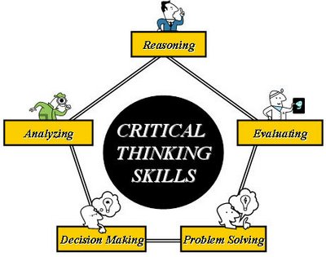
This Photo by Unknown Author is licensed under CC BY-SA

The contrast of creative thinking and critical thinking?

Creative thinking is the process to generate ideas, tries to create something new, according to Thepeakpreformancecenter.com creative thinking is divergent while critical thinking is convergent. Creative thinking is focused on possibilities, while critical thinking focused on probability.
Critical thinking is a process that emphasizes a rational basis for what we believe and provides standard and procedure for analysing, testing and evaluating our beliefs. (Rudinow & Barry, 1994). Another author quotes that critical thinking is the development and use of information beyond memory and repetition. (Peter Morgan,2017) he also indicates that someone is demonstrating critical thinking is when;

- Can identify gap and errors, assumptions and weaknesses in others work.
- Can provide a strong argument for a particular view and taking a particular course of action.
- Provide a clear and sometimes detailed interpretation of situation and events.

There are 6 conceptual tools to enhance critical thinking in workplace as well as in making decision for whatever reason this DE BONO 6 THINKING HATS METHOD was invented by Doctor Edward de Bono in 1980’s to enhance critical thinking skills especially in managing decision in workplace. The six thinking HAT represents different colour in order to recognise which hat is best to wear for every situation by mentally wearing them workers can easily focus or redirect thoughts the conversation, or in the meeting.

As shows in the picture below each hat represents significant factor in directing or assessing problem. The white hat is to focus on data, information what to know or needed analyse just the facts. Then the yellow hat focus on the positivity by being optimism
Explore the benefit, keep team’s decision moving. Black hats symbolize caution and critical thinking on the bad points. This hat identifies weak spots in order to prepare
Contingencies in workplace. Green hat is all about creativity, option, possibilities, solution to a problem, the freewheel thinking and classic brainstorming. And the blue hat is used to manage the thinking process. It ensures the six thinking Hat guidelines are observed or follow the last but not the least the Red hat, the red hat signifies feelings, hunches and intuition- the place where emotions are placed without explanation. Trying to anticipate responses of others who may not know the extent of your reasoning.

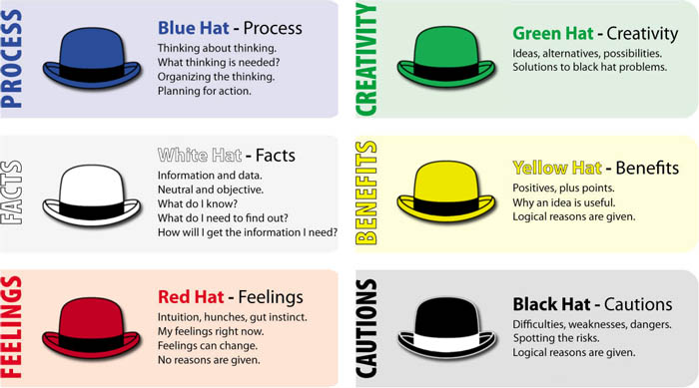
This Photo by Unknown Author is licensed under CC BY-SA

My role in a workplace
As a sales assistant in Boots high street Kensington I got the special opportunity to work with people coming from different culture and beliefs, apart from working with European people
And other part of Asian like Bangladesh, Indian and Pakistan the range of ages employed in this company has a large number too due to the variety of products and ranges of cosmetic line as well as the pharmacy section and ages population in UK is rising. however, working in this kind of organisation would be tough at the beginning to dealt for non- unexperienced luckily, as an experienced sales person who used to worked in different type of private organisation before but not in a huge company as compare to Boots, I am able to handle working in a team where task are rolled every day when you just don’t focus on single task for some reason every team helps you achieve the goals for the day to maintain and well organised the shop floor but at the beginning it can be difficult to adjust as you get to know your colleagues the process of getting to know one by one inside the workplace as it matter to make friends and mandatory to develop a good relationship within the organization knowing their behaviour is important to you so you’ll know how to adjust yourself for the benefit of both parties. Along with customers assistance to the highest level being able to give the best of I can to serve and offer the help in the best way I can.

THE FOLLOWING MANAGEMENT THEORIES THAT EXPLAIN BREIFLY THE
PROS AND CONS IN MY ORGANIZATION.

Human relations approach

human relations is a process of training of employees, addressing their culture needs, fostering a workplace culture and resolving conflicts between different employees and management.
The Hawthorne studies founded by Elton Mayo and Fritz Roethlisberger in 1920 in western electric company aim to re- focus on managerial strategy incorporating the socio- psychological Aspects of human behaviour in organization. They discovered that workers were highly responsive to additional attention from their managers, those people work in a team are becoming more responsive to social factors in their work as well as financial motives are important, social status are equally important factors in working productivity. (courses.lumenlearning.com)
In my workplace, human relation approach are common practice especially the new employee I can relate looking back when I started to join the organization. We seek attention and help, social interaction to make feel belong and settled inside the organization. I felt that way as per my experience as concern and I really think that is very helpful too so no one should feel isolated and helpless at the same time.

Pros and cons

The pros of using human relation approach would be the increase the positivity in workplace, unity among co- workers, job get done through reaching out one another as well it bring motivation to employee to come to work additionally increase social bond or friendship.
However, there could be a competition here favouritism may develop between manager and employee or between co- workers itself might be because of individual achievement. Here are some issues on human relation approach
- Lack of research and data to support relationship backed with fulfilling needs and satisfaction.
- Managers still control – fear of misuse and manipulation by management.
- Problem with relationship between worker satisfaction and productivity.

Scientific management
The process of approaching various aspects of organization in a scientific manner using scientific tools such as research, management and analysis.

“Frederick Winslow Taylor father of scientific management thinker who established the principles of scientific management that sometimes referred today as Taylorism that which differed from traditional initiative and incentive methods of management”
(https://www.bl.uk>people>frederick
According to business.com Frederick Taylor’s scientific management theory, also called the classical management theory emphasizes efficiency, much like Max Weber’s. however, according to Taylor, rather than scolding employees for every minor mistake, employers should reward workers for increase productivity.

This type of management are likely adapted in various organization not just in my present workplace especially nowadays, as it helpful in shaping the company future activity to determine whether they are doing well and keeping on track for both employee and consumers.
Although some researches like Henry Gantt introduced the rate system, bonuses, incentive wage plans to improve the production system.
While Frank & Lilian Gilbreth promote the idea of regulation and consistency in the workplace as well as effective training for the workforce that still adopted today in every organization especially for the new employee as it helps to enhance employee creativity and learned new skills.

Pros and cons
the pros of having scientific management is provide a higher degree of excellence in a branch management of well -trained employee, improve layout, routine, scheduling in so on at store keeping and accounting. The method of work introduced new system or updated like what we’ve known today for example the customer relation management that has been widely used in every organization in keeping track with customer the introducing various market strategic. Furthermore, the workforce tend to get high wages enhanced earnings and improved the standard of living for those who are in a higher position. However, the cons of adapting the scientific management is affecting the loss of individuals initiative by means of standardization, secondly speeding of workers that can affect the mental conditions of employee by structural changes in the organization. Autocratic bosses means those who are in a high position take control and lessen the interest and responsibility of the workers by giving orders or instruction so as like workers look like a robot in performing task and being spoon feed.

Bureaucracy

A German sociologist, lawyer, at the same time economist by the name Max Weber
Define Bureaucracy as” Rationalization of the society”. Bureaucracy is one of three classical management theory apart from scientific management and human relations approach however they aren’t similar due to the fact this bureaucracy is literally rule of the office.

A bureaucracy according to Investopedia.com is typically refers to an organization that is complex with multi layered systems and processes. These systems and procedures are designed to maintain uniformity and controls within the organization.

There are two fundamental principles of bureaucracy

Rule based power

Rule – based power is a decision making or maker models that novices to make decision like an expert. It is generally accepted that having the relevant information is one of the factors that allows us to make more effective decisions. Hence, they are called an expert. ( www.decision-making-confidence. For example, the manging consultant, investor and those who are in a higher position.

Function of public activities

Public sector:
Guarantees funding
Legitimacy

Private sector:
Infrastructure economic system
Taxation

Non- profit organization
The non-profit organization are those charity like Oxfam, cancer UK and other charitable foundation to promote public interest. Whose intention is to support people in need could be in the country or abroad to reach out to those less fortunate in life like in Africa, Asia like Nepal in other poor country as well as reaching out to those who are affected of nature calamity, health nowadays charity focus on growing epidemic of cancer and other serious illness such as HIV and AIDS.

Pros and cons

Bureaucracy is practiced in my organisation hence it is a huge company as well due to the fact it has branch all over UK and abroad who run by large mass and regulations, responsibility is mandatory, our management and staff mostly are professional with higher degree, open minded people, it also provided security for the staff like holiday on rotation, life insurance. And upgraded salary according to the length of stay.
The cons of Bureaucracy management theories is that competency in the workplace, complications of workloads for workforce, that so called additional forms to fill out and evaluations, the less freedom to make a decisions because rules or laws are being dictated by superior.

- Hierarchy
Abraham Maslow’s one of his four theories formulated the hierarchy of needs theory in 1960’s that most widely known as theory of motivation. He was a psychologist and proposed that within every person is the five hierarchy of needs. As seen on the illustration the top priority of individual is the Physiological needs such as breathing the need to live, food, water, sex, sleep and other physics requirements such as stability. Second is the safety of body, assurance, job, resources, health and belonging like property. Social needs which include affection, being loved, acceptance, and friendship and intimacy. And of course, the esteem needs such as internal factors like self-respect, confidence, and achievement, the external factors such as recognition by others. And the last but not the least is self-actualization where the needs for growth and achieving one’s potential moral value in life.

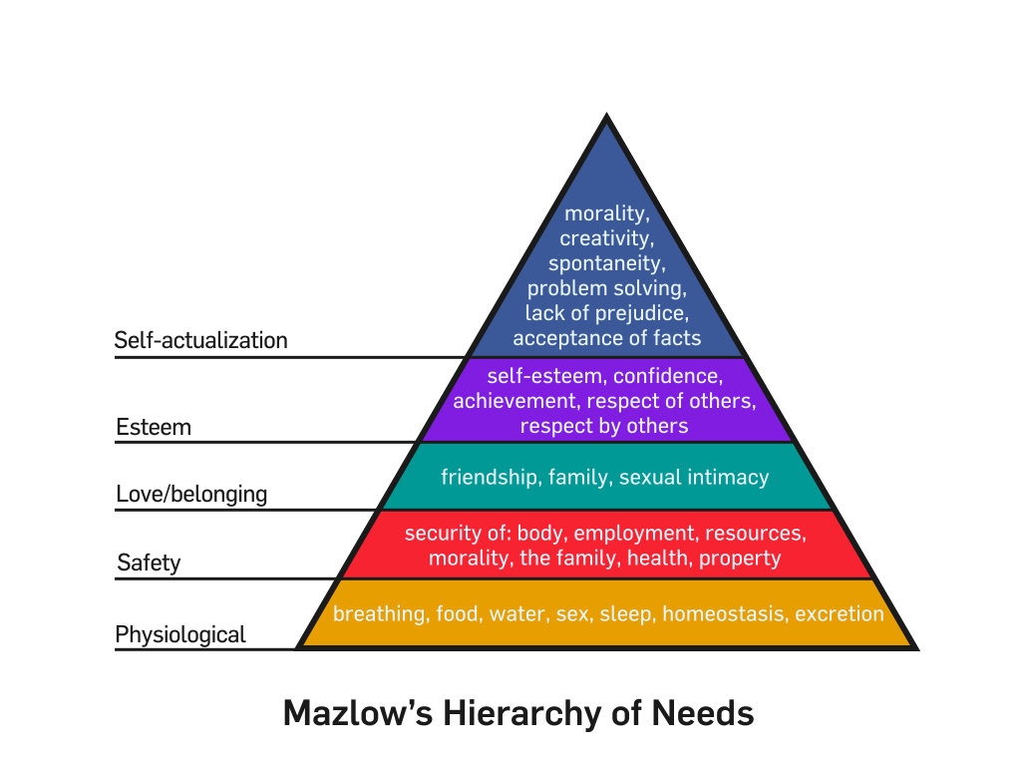
This Photo by Unknown Author is licensed under CC BY-SA

Contingency theory

Tom Burns & George Stalker developer of the contingency theory conduct an experiment to see how environment affect firms organizational and management systems. at the same year Joan Woodard conducted a study to determine how technology affects organizational structure. Besides Fred E. Fiedler considered the father of contingency theory emphasized in His book “A theory of leadership effectiveness” in 1967, in which he launched his Methods to define types of work situations where certain leadership styles appropriate than others. (smallbussiness.chron.com)

Contingency Theory it is the idea that the organizational structures and control systems that managers choose to depend on (i.e. are contingent) characteristics of the external environment in which the organization operates and has to adapt to meet the demands.

Key concept of the contingency theory

- Focus on determining the best management approach for any given situation (the best fit)
- Two types of environment: stable (little to no change) and innovative (great changes)
- Two types of management systems: mechanistic (similar to bureaucratic classical theory) and organic (non-bureaucratic, similar to human relations management)
- In a stable environment mechanistic works best, in an innovative environment organic works best.
- Organizational structure is affected by technology.

Contingency theory is quite applicable in my workplace along with other organization because it could benefits in both internal and external environmental factor where it is essential to maintain the needs to balance to a sustainable business operation without a doubt external factor of business is one of the key essential management has to recognise whether it is safe and have the potential the business to prosper knowing the type of community, economical factor, political and sociological factor that co- related to the business operation.

Pros and cons

the contingency theory is dynamic in nature, it give authorization to the managers to
revolutionise the policies according to the economic status or social changes. Besides it is helpful for the manager to enhanced their skills by putting into action in the field of leadership and decision making process as well as, a good option for the employee to have because they are being involved in fostering the workplace by sharing their ideas and opinions in this case they feel valued and increase loyalty to the company in recognising workforce as a contributor to the success of industry. The cons of contingency theory is that is a complex approach although it may seem simple approach however, it difficult to practice due to the fact that it is reactive in nature. Contingency theory is similar to situational leadership style.

System theory

The system theory was proposed by biologist Ludwig Von Bartalanffy in 1940’s. Bartalanffy reacted against reductionism and it was furthered by Ross Ashby in 1964. The general systems
Theory all work within the variety of system such as structural systems, (a road network), functional systems (academic systems) Social systems (work group) information system (a class or course).

What is a system theory
A system theory is a set of objects or elements that interact to achieve a specific goal. A system is more than the sum of its parts; its properties emerge from the relationship among
Its parts and from the systems relationship to the environment.
Systems are arranged hierarchically, so every system is a super system for systems contained within it and a subsystem for systems containing it.
All systems are more or less similar.
“System theory, also called the system of science, is the multidisciplinary study of systems to investigate phenomena from holistic approach. Systems which can be natural or man -made and living or non-living, are found in many aspects of human life. (www.goodtheraphy .org> types).

Like other theory, system theory hence is it a system of science where it can change according to the environmental factor, according to uniassignment.com the inputs within the organisation are aspects such as people, materials, information, finance and so on. The conversion or transformation is looking at production and marketing, controlling, planning and the future of the company.

Pros and cons
The pros of adapting this theory provide a detailed information, reduced errors, save time.
However, the cons can be time consuming as well because of that specific goal, continuously monitoring, expenses, and follow the system.

Conclusion
We learned and understand the true meaning of the beliefs, attitudes and values at the beginning of this chapter and how it affects in workplace that manifest our own. We came to recognised the difference of its significant factor as well as we had evaluated its uses and how it affects in the workplace especially coming to work in a diversified community to achieve the shared goals although everyone carry their own beliefs, attitudes and values at the same time knowing it is crucial to realised respect and openness to one another is truly the key to
Have a harmonious relationship. Secondly is the importance of critical thinking skills in the workplace is truly can change everything in fact as a human being able to create and generate ideas is what makes us a human truly unique creation of god as an exceptional, the ability to solve problem in an orderly manner however it might be difficult for some reason with the variety of techniques that has been discovered or developed by the expert in over the decade for us to follow like the DE BONO six hat method is quite useful in handling the tough situation in workplace. Besides critical thinking is a fundamental aspect as a human although everyone has its own manifesting their way of life. However, it has been said that CT skills are quite dominating especially in workplace.
Furthermore, using workplace as an essay report for the author uncomplicated to handle the case and related to maximise the study in understanding the different management theories through addressing each pros and cons in the organizational effect whether it would be applicable or useful in workplace or what type might depend on the kind of organisation run, we discussed several theories the advantages and disadvantages like the human resources is pretty much applicable in the case of Boots to adapt the theory because it focus on accommodating the employee developing and maintaining a good relationship among workers, and scientific theory, more broad about presence any organisation would be glad in adapting this theory as it more on social trends and take bureaucracy is classic however this is most likely adapted by government or huge firm because of its function, while as contingency theory is dealing with both internal and external factor of the organisation last but not the least is a system theory . this system more focus on the phenomena time consuming, external factor in a scientific way so every theory has its advantages and disadvantages and its significant factor and which type of organisation should be specifically to use and adapt perhaps its all come down to management.

REFERENCE LIST

Anderson, M., De Silva, S., (2009). Believes, Values, Attitudes, Me and Ltd.
(online) available from https//: www.Bussinessdictionary.com (accessed on July
14, 2019)

(online) available from https//: www.bl.uk>people>Frederick (accessed on July
18, 2019)
(online) available from https//: www.course.lumenlearning.com (accessed on Aug
14,2019)
(online) available from https//: www. decision-making-confidence. (accessed on Aug
21, 2019
(online) available from https//: www. goodtheraphy.org types. (accessed on Aug 19, 2019)

Peter Morgan. (2017). In the Business Students Guide to Study and employability
London: SAGE PUBLICATIONS LTD. Ch4 pp69

JR Shackleton. (2017). In working to rule: The damaging economics of UK employment
Regulation. London: LONDON PUBLISHING PARTNERSHIP LTD

Tom Chatfield. (2018). In Critical Thinking. London: SAGE PUBLICATIONS LTD

(online) available from https//: www.smallbusiness.chrom.com. (accessed on Aug 21,2019)

(Online) available from https//: www.owlcation.com (accessed on July 22,2019)

