Intro to 3D Modelling
3D Modelling Showcase Video
Juliette McManus
BA Animation & VFX
Student ID: 2502030

Contents
Task 1 – Video Presentation 2
Video Link: 2
Screenshot: 2
Download Link: 2

Task 1 – Video Presentation

Video Link: https://youtu.be/PjVEmpzZGqs

Screenshot:
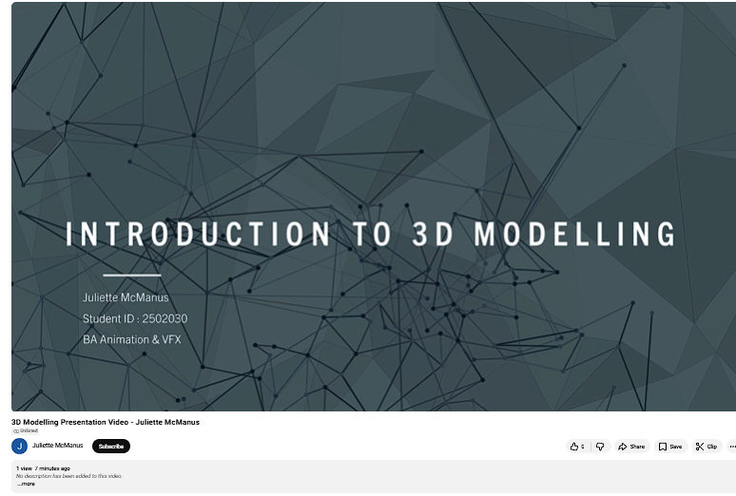

Download Link:
https://uowtsd-my.sharepoint.com/:v:/g/personal/2502030_student_uwtsd_ac_uk/IQCRAtuKojW-SKljB609qCLcAY68YqAncWF0XK5VGUqYRJI?nav=eyJyZWZlcnJhbEluZm8iOnsicmVmZXJyYWxBcHAiOiJPbmVEcml2ZUZvckJ1c2luZXNzIiwicmVmZXJyYWxBcHBQbGF0Zm9ybSI6IldlYiIsInJlZmVycmFsTW9kZSI6InZpZXciLCJyZWZlcnJhbFZpZXciOiJNeUZpbGVzTGlua0NvcHkifX0&e=6ffTR9

