
+===

ACCA 6020: Independent Project
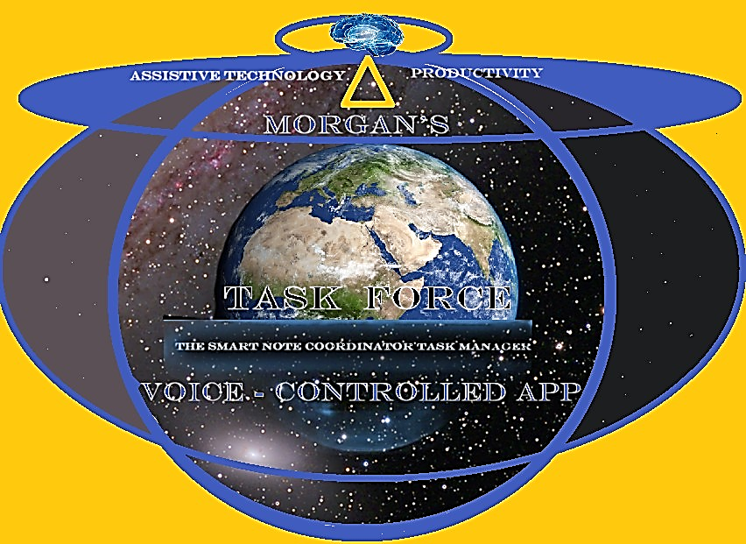

TASK FORCE APP DEV Project Proposal

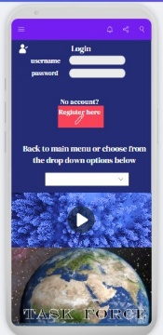
Morgan Dora 2327894

Lecturer: Renuga Ramakuyar

BSc Applied Computing

University of Wales, Trinity Saint David, London Campus, E14 4HA, Canary Wharf
Written: 30 July 2026, Brighton, United Kingdom by Morgan Dora.
Supervisor: Fahad Ahmed

Abstract
My proposed project is an assistive mobile application called Task Force, which combines AI-assisted automation with Python-based logic to support individuals experiencing executive function challenges. The motivation for this project is informed by my own experiences as an individual with autism and ADHD, providing insight into the difficulties that many neurodivergent adults and students face in their day to day lives.
Many people with ADHD, autism, and related conditions experience challenges with task initiation, time management, organisation, prioritisation, and maintaining routines. Existing productivity applications often assume that users can consistently plan and self-manage their activities, which may not be suitable for individuals with executive function difficulties.

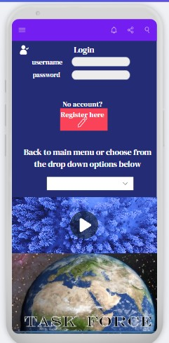

Table of Contents
Introduction 3
1. Project proposal research and description 4
1.1 Expected outcomes and deliverables 4
1.2 Research areas 4
1.3 Description of proposed application 4
1.4 From Problem Identification to Solution Design 5
1.5 Research 7
1.5.1 Research aim 7
1.5.2 Research Objectives: 7
2. Project Design 8
2.1 Research implementation in the Development Approach 8
2.2 Proposed Technical Architecture 8
2.3 Architecture 9
2.4 AI Automation Layers 10
2.5 Data Collection and Analysis Plan 10
3. Resources and planning 11
4. Conclusion 13
Appendices 16

Introduction

Attention-Deficit Hyperactivity Disorder (ADHD) is a neurodivergent disorder, and it is associated with persistent difficulties in attention regulation, impulse control, and executive functioning. These challenges can affect an individual's ability to plan, initiate tasks, prioritise responsibilities, manage time effectively, and complete activities in educational, professional, and everyday settings.
Autism Spectrum Disorder (ASD), on the other hand, is a neurodevelopmental condition that can affect communication, social interaction, and self-expression. For adult students, these challenges may influence classroom participation, collaboration with peers, and adaptation to academic environments. In some cases, difficulties with emotional regulation and anxiety can create additional barriers to learning and career progression, potentially reducing opportunities for educational and professional success.
“Attention deficit hyperactivity disorder (ADHD) is a childhood‐onset disorder characterised by inattention, hyperactivity, and impulsivity. ADHD can persist into adulthood and can affects individuals' social and occupational functioning, as well as their quality of life and health. ADHD is frequently associated with other mental disorders such as substance use disorders and anxiety and affective disorders” [1]
“Attention-Deficit Hyperactivity Disorder (ADHD) is a common, genetically transmitted neurological disorder, with onset in childhood, probably mediated by decreased brain dopaminergic functioning.”[2]
“Autism spectrum disorder (ASD) is the most challenging developmental disorder that affects the social skills, language—communication… [3]
“People with attention deficit-hyperactivity disorder (ADHD) are affected by the disorder through-out their lifetimes.” [6]

Project proposal research and description

Expected outcomes and deliverables

The deliverables will be a functional Flutter prototype, Python/FastAPI backend, database and automation design, documented source code, requirements and test evidence, evaluation findings, and recommendations for future development.

Research areas

- Python programming | - Fast api
- PostgreSQL | - Flutter
- Android, IOS, and multi-platform | - AI automation engine in Python
- Machine learning (ML) | - Large Language models (LLMs)

1.3 Description of proposed application
The proposed application aims to provide practical support through task management, AI-assisted task breakdown, reminders, calendar integration, and voice input within a simple, accessible interface. The goal is to significantly reduce cognitive overload and help users manage everyday responsibilities more effectively without overwhelming the actual user. The system will be developed using a user-centred approach, consisting of a Flutter-based mobile front end for cross-platform access, a Python/FastAPI backend, and a confirmation-based automation engine that maintains user control over automated actions. The design and requirements will be informed by research into assistive technologies, human-centred artificial intelligence, and mobile application development. The prototype will be evaluated through usability, accessibility, functional, and performance testing. Ethical considerations, including privacy, transparency, informed consent, data minimisation, and user autonomy, will be incorporated throughout the development process. The expected outcome is a minimum viable product (MVP) together with recommendations for the future development of responsible AI-assisted tools that support neurodivergent individuals in managing tasks, routines, and daily life and activities.

1.4 From Problem Identification to Solution Design

The rapid growth of computing and artificial intelligence has created new opportunities within applied computer science to investigate neurodevelopmental challenges and develop technology-based solutions. These technologies have the potential to support individuals, particularly adult learners, by addressing difficulties associated with executive functioning, task management, and productivity.
“In a world where AI-powered products continue to evolve, people are looking for ways to improve user experience by exploring ways to integrate technology output and human interaction. Our commitment is to redefine this by providing innovative solutions designed specifically for people with Attention Deficit Hyperactivity Disorder (ADHD).” [4]
“There is much research for improving the accuracy and classification of ASD using computational intelligence.” [3]

Recent studies suggest that adults with ADHD often face task-management challenges that are influenced by emotional, social, and environmental factors, rather than simply a lack of motivation. Research shows that many individuals rely on support from other people, personalised routines, and external reminders to stay organised. Findings also indicate that AI tools may be more effective when they provide flexible, personalised support that adapts to individual needs instead of enforcing rigid schedules and productivity methods.
Source: Not Just Me and My To-Do List": Understanding Challenges of Task Management for Adults with ADHD and the Need for AI-Augmented Social Scaffolds (Chen, Jingruo; Meng, Yibo; Nie, Kexin)

“CSCW and Human-Computer Interaction (HCI) have increasingly recognized the importance of designing systems that accommodate neurodiversity.” [5]
This is the problem that requires attention and solution, so that's why there is a need to develop adaptive task-management tools that can help users organise their tasks while providing motivation, encouragement, and personalised support. This need informed the design decisions and technology choices made during the development of the proposed application, ensuring the system can adapt to individual user requirements and support effective task management.
The proposed application is planned to be developed as an assistive productivity and daily support tool for neurodivergent users. It focuses on helping users manage functional challenges through planning, reminders, structured support, and accessible interaction.

“The ADHD productivity app represents a comprehensive solution tailored to enhance the productivity and emotional well-being of its users. Through features like emotion detection and the Pomodoro timer, the app empowers individuals with ADHD to better manage their time, focus, and mental states.” [4]

Task Force will be assistive rather than diagnostic, minimise stored data, explain AI-generated suggestions and require confirmation before creating reminders or calendar actions.
The identified gap is therefore not an absence of productivity applications, but limited evidence concerning integrated and user-controlled mobile support that combines low-friction capture, AI-assisted task decomposition and practical follow-through for adults with ADHD. This project will address that gap by designing and evaluating a minimum viable prototype consisting of a Flutter mobile interface, a Python/Fast API backend and a narrow automation engine.

Research

1.5.1 Research aim
To design, develop and evaluate an ethical and accessible AI-assisted mobile prototype that supports adults with ADHD in capturing, breaking down, scheduling and completing everyday tasks while retaining control over automated actions.

1.5.2 Research Objectives:

- Review current assistive and productivity applications to identify areas where support for people with ADHD, autism, and related conditions could be improved, or developed
- Investigate and analyse, the executive function difficulties experienced by neurodivergent adults and students, focusing on task initiation, time management, organisation, prioritisation, and maintaining routines.

- Critically analyse several relevant scholarly, governmental and industrial sources and derive a prioritized set of functional, accessibility, security and ethical requirements before implementation.
- Design and implement an MVP during the planned development phase, incorporating task capture, AI-assisted task breakdown, reminder and calendar suggestions, optional voice input and confirmation-based automation.
- Evaluate the prototype using repeatable functional, usability, accessibility, reliability and performance criteria, including at least ten representative task scenarios and ethically approved participant feedback where feasible.
- Analyse the findings and produce evidence-based recommendations concerning privacy, security, scalability and future multi-agent feature before final submission.

2. Project Design

2.1 Research implementation in the Development Approach

“The project will follow a design-science research methodology because its purpose is to build and evaluate a computing artefact addressing an identified problem.”[7]
Development will be iterative: requirements will be derived from the literature, converted into user stories and acceptance criteria, implemented in short increments, and reviewed after each test cycle. This approach permits design decisions to be traced to evidence while allowing the prototype to be revised when testing reveals problems.
Develop a minimum viable product of Task Force using Flutter for the mobile application and Python with FastAPI for the backend. Design a simple, accessible, and user-centred mobile application that reduces cognitive overload and helps users manage tasks independently. Implement key features such as task management, AI-supported task breakdown, reminders, calendar integration, voice input, and confirmation-based automation that keeps users in control.
Apply ethical principles throughout the project, including privacy, transparency, informed consent, data minimisation, and user autonomy.
Evaluate the prototype through usability, accessibility, functional, and performance testing to measure its effectiveness and identify opportunities for future development.

2.2 Proposed Technical Architecture

The proposed architecture uses a Flutter mobile client, a Python/Fast API service, PostgreSQL storage and a narrow AI automation layer. Cross-platform development can reduce duplicated Android and iOS work, although maintainability and consistency still require care.
“Hybrid applications combine the advantages of both types of the development of applications (web and native), and the best choice is to create cross-platform applications.” [8]
Flutter guidance recommends separating interface and data layers to support testing.
“Separation of concerns is the most important principle to follow when designing your Flutter app. Your Flutter application should split into two broad layers, the UI layer and the Data layer.
Each layer is further split into different components, each of which has distinct responsibilities, a well-defined interface, boundaries and dependencies. This guide recommends you split your application into the following components:
Views, View models, Repositories, Services” [9]
Fast API supports asynchronous communication with databases, calendar services and model endpoints. [10]
The first release will use an API-accessible model or a local model served through Ollama, keeping model access behind the backend rather than embedding credentials in the mobile client. [11]
The MVP will support task entry, AI-generated task decomposition, editable priorities, reminder and calendar suggestions, optional voice capture and explicit approval before an action is committed. Flutter accessibility guidance will inform semantic labels, text scaling, color contrast, touch-target size and screen-reader testing.
“Ensuring that apps are accessible to a broad range of users is an essential part of building a high-quality app. Applications that are poorly designed create barriers to people of all ages. The UN Convention on the Rights of Persons with Disabilities states the moral and legal imperative to ensure universal access to information systems; countries around the world enforce accessibility as a requirement; and companies recognize the business advantages of maximizing access to their services.” [12]
Advanced functions such as photo analysis, health recommendations and autonomous multi-agent actions are excluded from the MVP because they would increase ethical and technical risk without first establishing the value of the core workflow.

2.3 Architecture

Mobile App: Flutter, Android + iPhone
Backend: Python + FastAPI
Database: PostgreSQL
Ai automation: Ai logic.py
Mobile, backend, and automation must be integrated gradually

2.4 AI Automation Layers
The local Python system that sits between the user and the AI model. An AI Automation logic engine, written in Python, that can make decisions and take actions appropriately.
- User
- Task Force Mobile App
- Python API
- Automation Engine
- AI Model
- Actions
Automation example:
User Input: "I need to prepare for travel to university tomorrow." The AI automation engine:
Understands intent, creates a task list, adds calendar events, sets reminders, checks the weather, and suggests a departure time. Actions will be executed by the local AI logic system automatically

2.5 Data Collection and Analysis Plan

Objective | Data to be collected | Analysis
1. Requirements | Search records, source-quality notes and requirement traceability | Thematic synthesis and prioritisation
2. Development | User stories, build logs, acceptance tests and defect records | Pass rates, defect categories and revision history
3. Evaluation | Scenario completion, errors, latency, SUS scores and comments | Descriptive statistics and thematic coding
4. Recommendations | Consolidated technical, usability and ethics findings | Cross-objective synthesis and gap analysis

Table 1. Data collection and analysis plan

3. Resources and planning

Development requires a Windows computer, Android emulator or test device, and access to scholarly databases. Ollama or another controlled model endpoint will support AI testing. The work will be managed through weekly milestones, a requirements backlog, version control and a risk register. The schedule reserves the final weeks for evaluation and reporting.
Technologies to be Used:
- Python | - FastAPI
- PostgreSQL | - Flutter
- AI logic and decision engines | - Lang Graph (for AI workflows)
- GitHub | - Ollama

Functional (essential) and non-functional requirements:

- Prototype of the local AI assistant
- Users can create, view, edit, and delete tasks.
- Users can assign deadlines, priorities, and categories to tasks.
- The app provides AI-assisted task breakdown to turn large tasks into smaller, manageable steps.
- Users can set reminders and receive notifications for upcoming or overdue tasks.
- The app supports recurring tasks and routine management.
- The app integrates with a calendar so users can view tasks alongside scheduled events.
- Users can use voice input to add tasks or reminders.
- Users can mark tasks as complete and track progress.
- Automated actions require user confirmation before they are carried out.
- User task data is stored securely for later access and continued use.
Non-Functional Requirements

- The app will provide a simple, clear, and accessible interface that will reduce cognitive overload.
- The app will work effectively on mobile devices using a Flutter-based front end.
- The main features will respond quickly and run smoothly without noticeable delays.
- Task data will be saved accurately, and reminders will work consistently.
- User privacy will be protected through secure data handling, minimal data collection, and clear consent options.
- The system will clearly show when AI or automated features are being used.
- Users will remain in control of all automated actions.
- The system will be easy to maintain through a modular architecture using Flutter for the front end and FastAPI for the back end.
- The system will be scalable, allowing future features to be added without major redesign.
- The prototype will be tested for usability, accessibility, functionality, and performance.

4. Conclusion

Task Force will be developed as an assistive productivity and daily-support application for neurodivergent users rather than as a diagnostic system. It will help users manage executive-function challenges through task planning, AI-assisted task breakdown, reminders, calendar support, voice input and accessible interaction.
The project addresses the need for an integrated and user-controlled application that provides practical support without relying on rigid productivity methods. The proposed MVP will consist of a Flutter mobile interface, a Python/FastAPI backend and a focused automation engine. To protect user autonomy, the system will minimise stored data, explain AI-generated suggestions and require confirmation before creating reminders or calendar actions.
More advanced capabilities will be considered only after the core application has been tested and shown to be reliable, accessible and useful.

References
[1] X. Castells, L. Blanco‐Silvente and R. Cunill, "Amphetamines for attention deficit hyperactivity disorder (ADHD) in adults," vol. 2018, no. 8, pp.CD007813, Aug 9 2018, doi: 10.1002/14651858.CD007813.pub3. Available at: https://www.cochranelibrary.com/cdsr/doi/10.1002/14651858.CD007813.pub3.
[2] P. H. WENDER, L. E. WOLF and J. WASSERSTEIN, "Adults with ADHD," vol. 931, no. 1, pp.1–16, Jun 2001, doi: 10.1111/j.1749-6632.2001.tb05770.x. Available at: https://www.ncbi.nlm.nih.gov/pubmed/11462736.
[3] D. Pavithra, A. N. Jayanthi, R. Nidhya and S. Balamurugan, "Autism Screening Tools with Machine Learning and Deep Learning Methods: A Review," in Tele-Healthcare, United States: John Wiley & Sons, Incorporated, 2022, pp. 221–247. doi: 10.1002/9781119841937.ch10Available: http://ebookcentral.proquest.com/lib/SITE_ID/reader.action?docID=7021595&ppg=243&c=UERG
[4] S. N. Bhandarkar, et al., "Productivity App for ADHD Affected People", 2024 IEEE 3rd International Conference on Data, Decision and Systems (ICDDS), pp. 1–5. [Online]. doi: 10.1109/ICDDS62937.2024.10910758.
[5] J. Chen, Y. Meng and K. Nie, ""Not Just Me and My To-Do List": Understanding Challenges of Task Management for Adults with ADHD and the Need for AI-Augmented Social Scaffolds," Apr 20, 2026, doi: 10.48550/arxiv.2603.17258. Available at: https://arxiv.org/abs/2603.17258.
[6] R. A. Barkley, "Major life activity and health outcomes associated with attention-deficit/hyperactivity disorder," vol. 63 Suppl 12, pp.10, 2002, Available at: https://www.ncbi.nlm.nih.gov/pubmed/12562056.
[7] K. Peffers, T. Tuunanen, M. A. Rothenberger and S. Chatterjee, "A Design Science Research Methodology for Information Systems Research," vol. 24, no. 3, pp.45–77, Dec 1, 2007, doi: 10.2753/MIS0742-1222240302. Available at: https://www.tandfonline.com/doi/abs/10.2753/MIS0742-1222240302.
[8] P. R.M.de Andrade, A. B. Albuquerque, O. F. Frota, R. V Silveira and F. A. da Silva, "Cross Platform App: A Comparative Study," vol. 7, no. 1, pp.33–40, Feb 28, 2015, doi: 10.5121/ijcsit.2015.7104. Available at: https://www.proquest.com/docview/1677961422.
[9] docs.flutter.dev, "Guide to app architecture," 2026, Available at: https://docs.flutter.dev/app-architecture/guide.
[10] FastApi. "Concurrency and async / await." [Online]. Available: https://fastapi.tiangolo.com/async/
[11] Ollama. "Ollama, "API Introduction,"." docs.ollama.com. [Online]. Available: https://docs.ollama.com/api/introduction
[12] Flutter. "https://docs.flutter.dev/ui/accessibility." https://docs.flutter.dev/ui/accessibility. [Online]. Available: https://docs.flutter.dev/ui/accessibility

Appendices

The full document includes 1724 words excluding citations and quotes. The abstract section is 106 words. Since the Abstract does not count as word count, the total number of words excluding the Abstract section is: 1724-106= 1618 words. The university allows plus or minus 10 %. That is 150 words. The allowed word count is 1500. Therefore, it is allowed 1650 words. That is 32 words below the maximum allowed. The document includes 12 citations from various sources: academic peer-reviewed journals, books and, due to technical features not written in books, I also applied website sources.

