

Managing Enterprise in the 21st Century

Business Plan

Traditii Romanesti

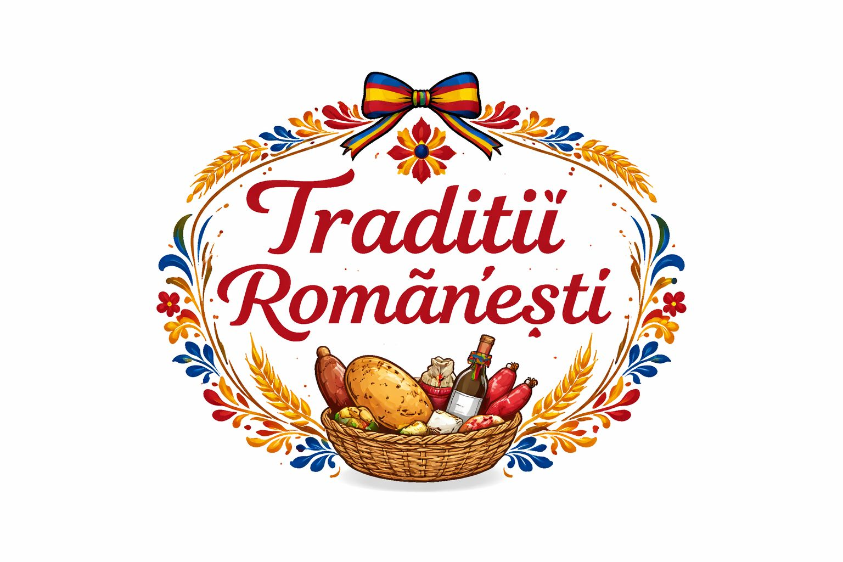

Submission Date: 30.03.2026
Lecturer: Dr Charles Oham
Student name : Beatrice Elena Petrache

Table of Contents
Executive Summary 4
Business Concept 5
Business Description 5
Product Description 5
Business Objectives (SMART Objectives) 5
Short-Term Objectives (less than a year) 5
Long-Term Objectives (More than a year) 5
Market Analysis and Marketing Plan 6
Market Analysis (Competitors, Customers, Target Groups) 6
PESTEL Analysis 6
SWOT Analysis 6
Marketing Mix (4Ps) 6
Management Team 7
Management Team and Their Background 7
Organisational Chart 7
Key Milestones 7
Financial Plan (One Year) 8
Sources of Finance 8
Cash Flow Forecast 8
Sales Forecast 8
Cost of Production Forecast 8
Break Even Analysis 8
Operations and Management Plan 9
Production of Good and Service 9
Technology Plan 9
Human Resource Plan 9
Expansion Plan 9
Reference List 10
Appendices: 11

Executive Summary

The business idea is to open a Romanian mini market in London that focuses on traditional products and serves the Romanian community.
The store will offer a wide range of Romanian food, drinks and seasonal products, with a strong emphasis on authenticity and tradition. It aims not only to provide products, but also to create a familiar and welcoming space for customers.
The business will be located in an area with a strong Romanian presence and will use social media and community-based promotion to attract customers.
Financially, the business is expected to become stable within the first year, with the goal of recovering the initial investment and building a loyal customer base.
Overall, the business has strong potential due to the consistent demand for Romanian products and its clear focus on tradition and community. Executive Summary

Business Concept

The idea of this business is to open a Romanian mini market in London that focuses on traditional products and everyday essentials. The store is designed to serve the Romanian community by offering familiar tastes and a convenient shopping experience. At the same time, it aims to attract a wider audience interested in Eastern European products. The concept combines accessibility, tradition and a strong connection to the local community.

Business Description

The business will operate as a medium-sized Romanian mini market, focused on selling traditional food products and drinks. It will be set up in a busy area of North London, where there is a strong Romanian community.
The store will be open daily and will offer a simple and efficient shopping experience. Customers will be able to find both essential products and more specific items that are not always available in regular UK supermarkets.
The business will be managed directly by the owner, especially in the early stages, allowing better control over daily operations, stock and customer service. As the business grows, additional staff may be hired to support the workload.

Product Description

The store will offer a wide range of Romanian products, including traditional meats, cheeses, bakery items, sweets, snacks and drinks.
The focus will be on products that customers already know and trust, but also on items that are harder to find in other shops. The goal is to create a place where people can easily find what they miss from home.
A key part of the business will be the focus on traditional and seasonal products. During important holidays such as Christmas and Easter, the store will introduce special Romanian products and traditional packages. This is not just about selling products, but about bringing back the feeling of Romanian traditions and creating something familiar for the community.

Business Objectives (SMART Objectives)

The main objective of this business is to successfully open and establish a Romanian mini market in London within 6 months.
Another key objective is to build a steady flow of customers from the beginning, mainly through social media promotion and Romanian community groups.
The business also aims to recover the initial investment within the first year by maintaining consistent sales and controlling costs.
In addition, an important objective is to create a loyal customer base that returns regularly and recommends the store to others.

Short-Term Objectives (less than a year)

In the short term, the focus is on launching the business and making it known within the local community.
The first objective is to secure a suitable location and fully set up the store, including stock, equipment and licences.
Another goal is to attract the first customers through online promotion, especially on social media and Romanian Facebook groups.
The business also aims to reach a stable level of daily sales within the first few months and to understand customer preferences in order to adapt the product range.

Long-Term Objectives (More than a year)

In the long term, the main goal is to grow the business and become a well-known Romanian store within the community.
One objective is to expand the product range, especially with more traditional and seasonal Romanian products based on customer demand.
Another important goal is to build a strong and loyal customer base that supports the long-term success of the business.
The business may also develop further by introducing online orders or delivery services.
In the future, there is also the possibility of opening another location if the business proves to be successful and stable.

Market Analysis and Marketing Plan

Market Analysis (Competitors, Customers, Target Groups)
The market for Romanian products in London is mainly driven by the Romanian community, which continues to grow. This creates a steady demand for traditional food, especially products that are not easily available in mainstream UK supermarkets.

- Market Segmentation
The market can be divided into several groups. The main segment includes Romanian individuals and families living in London who prefer traditional food and are looking for familiar tastes from home.
Another segment includes Eastern European customers who share similar food preferences. There is also a smaller group of local customers who are interested in trying international or traditional products.
- Targeting
The primary target audience of the business is the Romanian community. This group is the most relevant because they are more likely to buy these products regularly and already have a connection with Romanian food and traditions.
This segment is also easier to reach through Romanian social media groups and local communities, making promotion more effective.
- Positioning
The business will position itself as a traditional Romanian store that offers authentic products and a familiar shopping experience.

What makes it different from competitors is the strong focus on Romanian traditions, especially during holidays, when the store will offer specific products and traditional packages. The aim is not only to sell products, but to create a place that feels closer to home for customers.
- Reaching Your Audience
The business will mainly use social media to reach its customers, especially Romanian Facebook groups and platforms like Instagram. These are the easiest ways to connect directly with the target audience.
Promotion will also include special offers, especially during holidays such as Christmas and Easter, when demand is higher. Word-of-mouth will also play an important role, as satisfied customers are likely to recommend the store to others.

PESTEL Analysis

FACTOR | IMPACT ON BUSINESS
POLITICAL | The business must follow UK regulations related to food safety, hygiene and retail operations. These rules are manageable but must be respected from the beginning.
ECONOMIC | High costs in London (rent, suppliers) can affect profitability, but the constant demand for Romanian products creates a strong opportunity for stable income.
SOCIAL | A large Romanian community in London supports demand for traditional products. Customers are looking for familiar tastes and cultural connection.
TECHNOLOGICAL | Social media (especially Facebook groups and Instagram) will be essential for promotion. Technology will also help with stock management and payments.
ENVIRONMENTAL | Using recyclable packaging and reducing food waste can improve the image of the business and attract more environmentally aware customers.
LEGAL | The business must comply with laws regarding product labelling, food safety and storage. Licences and permits will be required before opening.

SWOT Analysis

The business has several strong points, mainly its focus on traditional Romanian products and its connection with the Romanian community. It offers products that are not always easy to find in regular supermarkets, which makes it more attractive for customers looking for familiar tastes. The focus on seasonal and traditional products, especially during holidays, is also an important advantage.
At the same time, there are some weaknesses, especially at the beginning. As a new business, it will not have an established customer base and will depend on promotion to become known. In addition, costs such as rent and stock can be quite high, and managing perishable products requires careful attention.
There are also good opportunities for growth. The Romanian community in London is large and continues to grow, which creates constant demand. There is also potential to attract other customers interested in international products. In the future, the business could expand by introducing online orders, delivery services or even opening another location.
However, there are also some threats. Competition from other Romanian or Eastern European shops may affect sales. Large supermarkets can attract customers with lower prices, even if they do not offer the same level of authenticity. Economic changes and rising costs may also impact the stability of the business.

Marketing Mix (4Ps)

Product
The business will offer a wide range of Romanian products, including traditional meats, cheeses, bakery items, sweets and drinks. The focus will be on authentic products that customers recognise and trust.
A key element will be the introduction of traditional and seasonal products, especially during important holidays such as Christmas and Easter. These products will help the business stand out and create a stronger connection with customers.
Price
The pricing strategy will be based on offering good value for money, keeping prices affordable for the Romanian community while still ensuring profitability.
Prices will remain competitive compared to other Romanian shops, and special offers or discounts will be introduced during certain periods, especially holidays, to attract more customers.

Place
The store will be in a North London area with a strong Romanian community, making it easily accessible to the target audience.
A good location is important to ensure a steady flow of customers. In the future, the business may also consider offering online orders or delivery services to increase accessibility.

Promotion
Promotion will mainly focus on online platforms, especially Romanian Facebook groups and social media such as Instagram.
The business will also use word-of-mouth, local promotion and special offers to attract customers. Holiday promotions and traditional product packages will play an important role in increasing sales and building customer loyalty.

Management Team

The management team will consist of the owner and two full-time employees. This structure allows the business to operate efficiently daily while covering all working hours.

Management Team and Their Background

The business will be managed by the owner, who has a good understanding of the Romanian community in London and the demand for traditional products. Being part of this community offers a clear advantage, as it allows a better understanding of customer needs and preferences.
The owner has strong organisational and communication skills, which are important for managing daily activities such as stock control, supplier coordination and customer interaction.
In addition, living in London and being familiar with the local environment helps in adapting the business to the market and making practical decisions.
The motivation to build a stable business based on Romanian traditional products supports the long-term development of the store.

Organisational Chart

The organisational structure of the business will be simple in the initial stage due to the small team size. The owner will have the main role and will oversee all aspects of the business, including stock management, supplier coordination and customer interaction.
Employees will have operational roles, focusing on sales, product organisation and maintaining cleanliness and order within the store.
As the business grows, the structure may become more developed, with the introduction of more specific roles such as stock management or store supervision.

Key Milestones

Several key milestones have been identified to support the development of the business from the initial idea to full operation.
The first stage involves business planning, including defining the concept, developing the business plan and setting the required budget.
The next step is identifying and securing a suitable location in an area with a strong Romanian community.
This is followed by obtaining the necessary licences and permits, as well as setting up the store and purchasing equipment.
An important stage is establishing relationships with suppliers and securing the initial stock.
At the same time, marketing activities will begin, mainly online, in order to attract the first customers.
The official opening of the store represents a key milestone, followed by a period of stabilising sales and adjusting the product range based on customer demand.
In the longer term, the focus will be on business growth, expanding the product range and potentially introducing additional services.

Financial Plan (One Year)

The financial plan explains how the business will manage its finances during the first year of operation. It provides a realistic estimate of income and expenses, as well as how the store can remain stable and grow over time.
In the first year, the main goal is to recover the initial investment and achieve a stable level of sales. At the beginning, expenses will be higher, as they will include rent, stock, equipment and other operating costs.
Revenue will come from product sales, and the success of the business will depend on its ability to attract and retain regular customers. Careful stock management and minimising losses will also play an important role in maintaining financial stability.
Overall, if the business is well organised and adapted to market demand, it has strong potential to become profitable within the first yea

Sources of Finance

The business will be funded mainly through personal savings, which allows more control and flexibility, especially in the early stages. Using personal funds also reduces the pressure of having to repay loans immediately.
If needed, additional financial support could come from a small bank loan or other external funding options, mainly to support initial costs such as rent, equipment and stock
This approach allows the business to start in a stable way while still having the option to expand financially if required.

Cash Flow Forecast

The cash flow of the business will depend on daily sales and how well expenses are managed. In the beginning, there may be fluctuations, as the business is still building its customer base.
Income will come from daily product sales, while expenses will include rent, stock purchases and general running costs. The aim is to maintain a steady flow of income that covers all expenses and gradually increases over time.
By keeping a close eye on spending and avoiding unnecessary costs, the business can maintain a healthy cash flow and avoid financial difficulties.

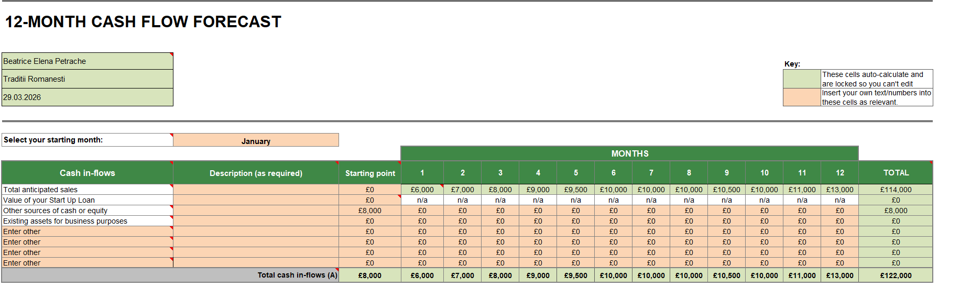

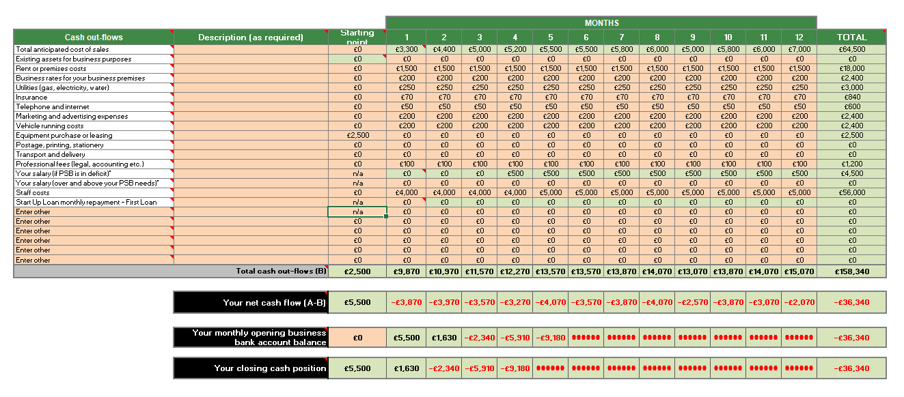

Sales Forecast

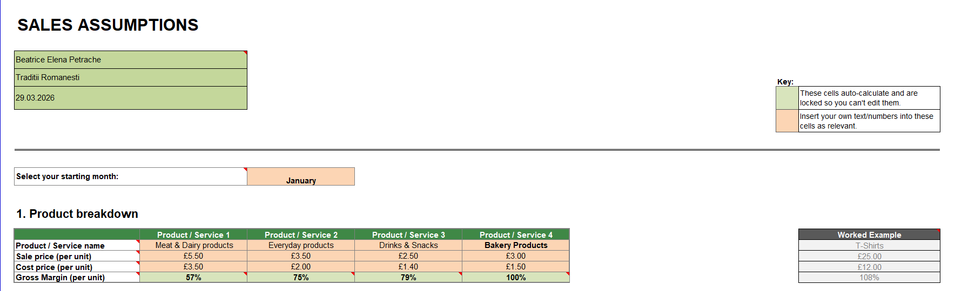

The sales forecast is based on estimated daily sales for each product category, which increase gradually over time as the business becomes more established. In the first months, sales are lower, but they grow steadily as more customers become aware of the store. Higher sales are expected during peak periods, especially towards the end of the year, when demand for traditional Romanian products increases. Overall, the forecast shows a stable growth in sales and a consistent level of customer demand.
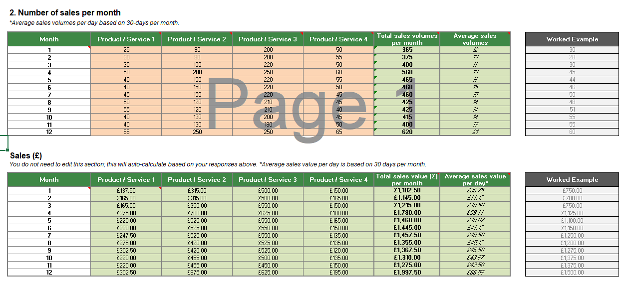

Cost of Production Forecast

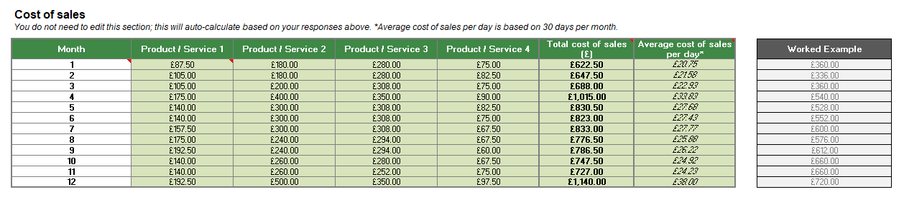
The cost of production forecast is directly linked to the level of sales, as higher sales require more stock. The main costs come from purchasing products across all categories, including meat, dairy, everyday goods and bakery items. In the beginning, costs are lower due to lower sales volumes, but they increase gradually as the business grows. The forecast shows that costs remain proportionate to sales, allowing the business to maintain a stable profit margin over time.

Break Even Analysis

The break-even point represents the moment when the business covers all its costs and starts to generate profit. Based on the estimated sales and costs, the business is expected to reach break-even once a consistent level of daily sales is achieved. In the first months, profits may be lower due to higher initial costs such as equipment and setup. As sales increase and costs become more stable, the business is expected to move into profit. Reaching break-even within the first year is realistic if the business maintains steady customer demand and manages expenses carefully.

Operations and Management Plan

Production of Good and Service

The business will focus on selling products rather than producing them. All products will be sourced from Romanian and Eastern European suppliers and then sold directly in the store. The service aspect of the business will focus on customer experience, product availability and maintaining a clean and organised environment. The aim is to provide a simple and pleasant shopping experience for customers.

Technology Plan

The business will use basic technology to support daily operations, including a POS (point of sale) system for payments and sales tracking. Stock management will also be supported through simple digital systems to keep track of inventory and avoid shortages. Social media platforms such as Facebook and Instagram will be used for promotion and communication with customers.

Human Resource Plan

In the beginning, the business will operate with a small team, including the owner and 2 employees. The owner will be responsible for managing the business, while the employees will support daily activities such as serving customers, organising products and maintaining the store. As the business grows, more staff may be hired, depending on the workload and customer demand.

Expansion Plan

In future, the business has the potential to grow by expanding its product range and attracting more customers. There is also the possibility of introducing online orders or delivery services to make the business more accessible. If the business performs well, another long-term option could be opening a second location in a different area of London.

Reference List

- Office for National Statistics (ONS) (2023) Population of the UK by country of birth and nationality. Available at: https://www.ons.gov.uk (Accessed: 26 March 2026).
- Statista (2024) Number of Romanian nationals living in the UK. Available at: https://www.statista.com (Accessed: 26 March 2026).
- Kotler, P. and Armstrong, G. (2021) Principles of Marketing. 18th edn. Harlow: Pearson.
- Burns, P. (2016) Entrepreneurship and Small Business: Start-up, Growth and Maturity. 4th edn. London: Palgrave Macmillan.
- Mintel (2023) UK Food and Drink Market Trends. Available at: https://www.mintel.com (Accessed: 26 March 2026).
- BBC News (2023) UK cost of living and its impact on small businesses. Available at: https://www.bbc.co.uk (Accessed: 26 March 2026).

Appendices:

The appendices section includes supporting materials used throughout the business plan. All tables and data, such as the cash flow forecast, sales assumptions and analysis models , have been integrated within the relevant sections of the report rather than presented separately. This approach allows the information to be clearly linked to each part of the business plan and improves overall readability.

