
Current trends of business intelligence

student name
student Id

TABLE OF CONTENTS

TABLE OF CONTENTS 1
INTRODUCTION 2
CURRENT TRENDS OF BUSINESS INTELLIGENCE 3
Data Visualization 3
Data Mining 4
Data Manipulation 5
Data Warehousing 5
SaaS and Cloud Adoption 6
CONCLUSION 8
REFERENCES 9

INTRODUCTION

Business intelligence (BI) has seen a revolution in the last ten years as data has surged and grown significantly, giving everyone access to the cloud. Finally, interactive business dashboards with actionable and perceptive data visualisations overtook spreadsheets. A rise of self-service analytics democratised the data value chain, making complex analytics accessible to all users instead of just analysts.
Although the decade 2021 was a hugely significant one for the business analytics sector, the BI landscape is changing and the game is being played today with new trends to watch. BI techniques and technologies will get more and more specialized in 2022 (Golfarelli, 2005).
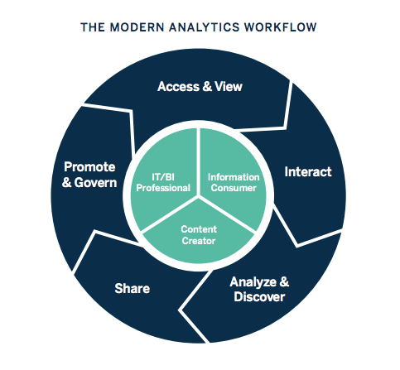
Figure 1 Business Intelligence: A Complete Overview [1]

With the aid of contemporary BI dashboard software, businesses are no longer debating if data visualizations enhance analyses but rather what is the best approach to communicate each data story. Data security and information discovery, which combines clean, secure data with an easy-to-understand display, will be the focus of 2022. Additionally, it will be a decade of AI and cooperative business intelligence. In this report, We will be discussing about the current trends in the Business Intelligence which are useful in different ways and can be helpful in managing data.

CURRENT TRENDS OF BUSINESS INTELLIGENCE

Data Visualization

Data visualisation can be used by business users to comprehend their enormous data collections. They benefit from their ability to identify novel patterns and data errors. By deducing any meaning from these patterns, the users can advance by concentrating on areas that display red flags. The business then advances as a result of this process.
Data visualisation aids in understanding by giving the information a visual perspective via maps or graphs. Mirchandani & Gaur(2019) contend that as conscious beings can more easily understand the data, it is easier to identify trends, patterns, and outliers in large data sets.
It is the capacity to graphically display the data. For instance, when we instruct our young children, we force them to learn everything through data visualization—pictures that are embedded within books.
Tools for Data Visualization
1. Tableau
2. Power BI
3. Microsoft Excel

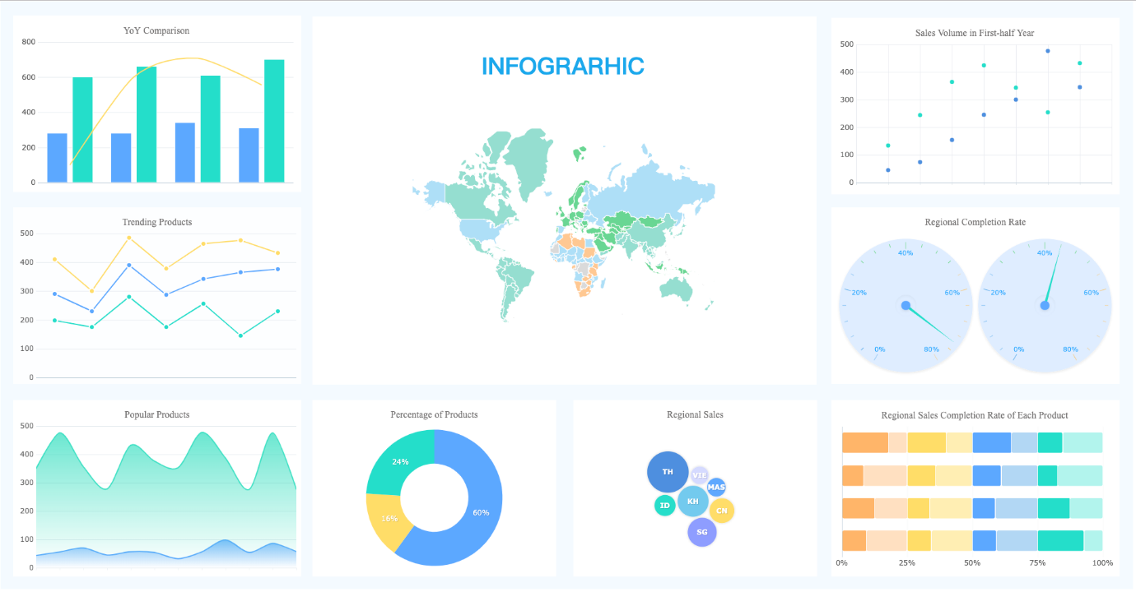
Figure 2 Data Visualization [2]

Data Mining

Data mining is a method used by businesses and sectors to turn inaccurate data into insightful findings. They utilise this tool to look for commonalities in a vast amount of data in order to understand more about their clientele.
Data mining is crucial to business since it is utilized to transform unprocessed data into insights that can be used for decision-making. Software is used by data engineers to find patterns that help them analyse consumers (Boland et.al, 2015).
It is the process of looking for patterns and connections in data to help businesses make better business decisions. Data mining can be employed to pinpoint sales trends, develop more successful marketing campaigns, and accurately predict customer loyalty.

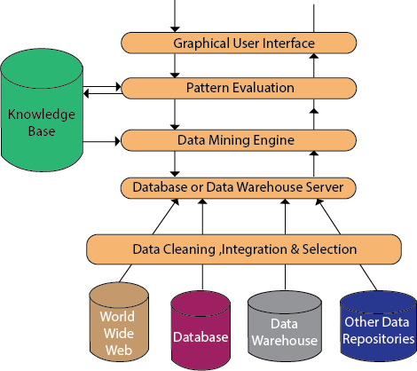
Figure 3 Data Mining Architecture [3]

Global competition is more-fierce, driven by customers shifting requirements and preferences in a market that is getting more crowded.
Data mining is a type of algorithm that uses strategic marketing to provide the right information structure. Data mining techniques can be incorporated into the prototype system's operations.

Data Manipulation

For the operation and optimization of businesses, data manipulation is an essential task. You must be able to interact with the information in the manner you require it in order to effectively use it and translate it into usable insights, such as by analysing financial information, customer behaviour, and trend analysis.

Consistent information: By presenting data consistently, it can be more simply structured, read, and understood (Harrison et.al, 2015). You may not have a clear image when merging information from various sources, but you can make sure the data is appropriately structured and stored by using procedures and data manipulation.

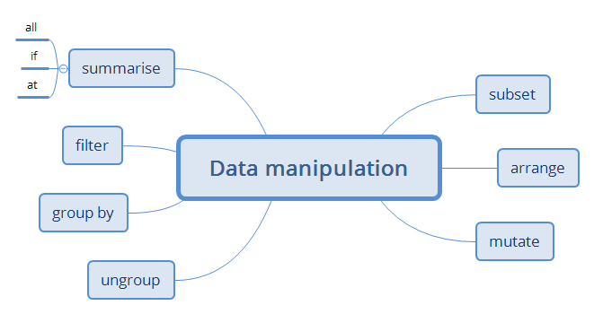
Figure 4 Data Manipulation [4]

Business intelligence uses a number of procedures, including modelling, data manipulation, data cleansing, modelling, and managing reporting for the information. The most recent advancements in data manipulation in BI do not favour using the earliest methodologies.

Data Warehousing

Data from various sources is kept in a system referred to as a data warehouse. Data warehouse platforms, which differ from database systems in that they include historical data, make it easier for business leaders to analyze data over a specific time period.
According to Kabakchieva (2013), the key trends in analytics, BI, and data are for 2022. For five years in a row, data quality, and master information management have been named the most significant trend. This is consistent with the results of earlier BARC polls, which consistently demonstrate that businesses struggle with inadequate data quality.

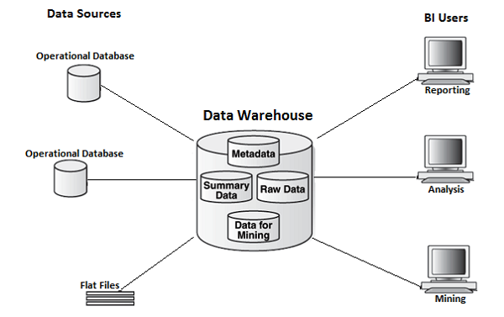

Figure 5 Data Warehousing [5]

SaaS and Cloud Adoption

Organizations are increasingly utilising cloud-based solutions like online file combinations, repositories, and customer relationship management (CRM) software (Salesforce) (Dropbox, Box). Business intelligence and SaaS will assist enterprises address problems based on cost-efficiency and the most latest software, which puts pressure on resources and lessens competitiveness (Vanani & Jalali, 2017).

Like other cloud services, cloud BI applications are simple to use. Because they didn't require any hardware or software installations, their deployment was quick and easy. Applications for the cloud are expanding quickly as a result of a rise in business users.

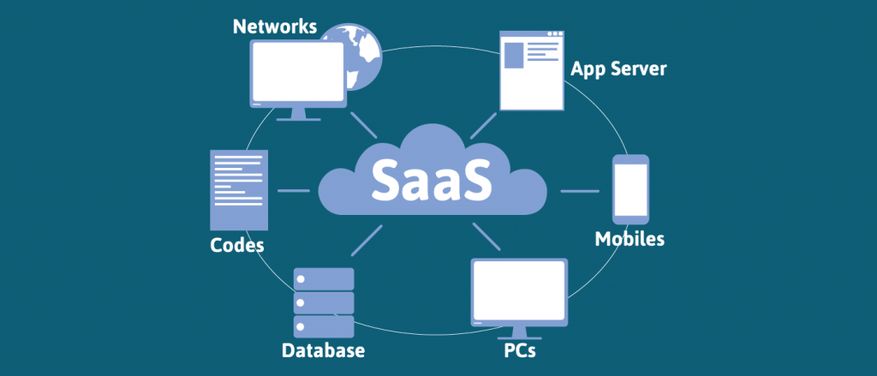
Figure 6 SaaS Cloud Adoption [6]

SaaS is a software delivery strategy that provides businesses with a lot of flexibility and cost-effectiveness, making it a very dependable choice for many company models and industries (Obeidat et.al, 2015). Because of its ease of use, user availability, security, and extensive connectivity, it is also well-liked by enterprises.

CONCLUSION

Overall, it can be said that business intelligence is a type of technology that aids in making data more comprehensible and visual.
In addition to making the business smarter, raw data is evaluated and managed in this technique. For the BI, there are many advantages, like improved customer satisfaction and simple decision-making. Additionally, MS Excel is favoured over the power BI tool. The approaches for data management and a secure method of keeping it are some of the business intelligence trends that are covered in numerous points.

REFERENCES

Boland, G.W., Thrall, J.H. and Duszak, R., 2015. Business intelligence, data mining, and future trends. Journal of the American College of Radiology, 12(1), pp.9-11.
Golfarelli, M., 2005. New trends in Business Intelligence. In miproBIS (pp. 15-20).
Harrison, R., Parker, A., Brosas, G., Chiong, R. and Tian, X., 2015. The role of technology in the management and exploitation of internal business intelligence. Journal of Systems and Information Technology.
Kabakchieva, D., Stefanova, K. and Yordanova, S., 2013. Latest Trends in Business Intelligence System Development. In Proceedings of International Conference on Application of Information and Communication Technology and Statistics in Economy and Education (ICAICTSEE) (p. 212). International Conference on Application of Information and Communication Technology and Statistics and Economy and Education (ICAICTSEE).
Mirchandani, A. and Gaur, B., 2019. Current trends & future prospects of social media analytics in business intelligence practices. Journal of Content, Community and Communication, 5(9), pp.123-130.
Obeidat, M., North, M., Richardson, R. and Rattanak, V., 2015. Business intelligence technology, applications, and trends.
Vanani, I.R. and Jalali, S.M.J., 2017. Analytical evaluation of emerging scientific trends in business intelligence through the utilisation of burst detection algorithm. International Journal of Bibliometrics in Business and Management, 1(1), pp.70-79.

[1] https://www.tableau.com/learn/articles/business-intelligence
[2] https://www.finereport.com/en/data-visualization/data-visualization-2.html
[3] https://www.javatpoint.com/data-mining-architecture
[4] https://xmind.app/m/d42D/
[5] https://www.tutorialspoint.com/cognos/data_warehouse_overview.htm
[6] https://www.fingent.com/blog/cloud-service-models-saas-iaas-paas-choose-the-right-one-for-your-business/

