  Component One:  What are the key skills required when working in the housekeeping team? 750 words (+/- 10%)  Contribution to Overall Module Assessment: 25% | Student No: | 2210266
 | Module Title: | Operating Hotel Facilities
 | Module Code: | BMIH4006
 | Lecturer: | Chris Walkin
In the hospitality sector, housekeeping is essential for keeping things tidy and leaving a good first impression. To be successful in my role as team leader in the housekeeping department, I have learned that I need to have certain skills. In this personal reflection, I will talk about the important skills you need to have on a housekeeping team, how I have used them in the past, and how you can apply what you've learned in the classroom.
Paying close attention to detail is one of the most important skills for the housekeeping team. Housekeepers should have a meticulous eye for detail to ensure that no area is missed during the cleaning process. A high level of cleanliness in guest rooms, common areas, and facilities requires this ability. Working at a high-end hotel taught me the value of meticulous attention to detail, including the proper folding of towels, the orderly placement of amenities, and the thorough cleaning of all surfaces. This kind of thoughtfulness goes a long way toward ensuring the happiness of your guests (Mullins and Dossor, 2013).
Time management is another important ability. Housekeepers are frequently tasked with meeting stringent deadlines and must learn to effectively manage their time in order to do so. schedule management skills guarantee that all cleaning tasks are completed on schedule, facilitating a seamless guest check-in and giving the housekeeping staff enough time to clean thoroughly. Working in a busy resort taught me the value of time management because it required me to set priorities, allot resources wisely, and meet deadlines to get rooms ready for guests (Fallon and Rutherford, 2010).
Housekeepers also need good communication skills. Clear communication aids front desk, housekeeping, and other departments. Communicate room assignments, requests, and status updates clearly. Clear and straightforward communication allows housekeepers to communicate maintenance issues, inventory needs, and guest complaints immediately. To help my team work together and solve difficulties, I encouraged open communication (Tesone, 2010).
Housekeepers must be adaptable to handle last-minute room requests and customize cleaning regimens for guests. I have had to adjust the cleaning plan last minute to accommodate VIP guests or unexpected events. Flexibility helps housekeepers handle routine and unexpected changes (Wood, 2013).
Housekeeping demands physical endurance, resilience, and other skills. Due to lifting, standing, and repeating tasks, housekeeping is physically taxing. Housekeepers who maintain their vigorous throughout their shifts leave a clean building. As cleaning staff team leader, staying fit and taking frequent breaks and drinking enough water have benefited me a lot (Raghubalan and Raghubalan, 2016).
Housekeeping workers can improve their performance and contribute to the success of their organisations by applying theoretical knowledge while working in the industry. For instance, a pleasant work atmosphere that encourages motivation and dedication among the cleaning staff can be created by applying the theoretical knowledge on employee engagement mentioned in Bridger's "Employee Engagement: A Practical Introduction" (Bridger, 2018). Team leaders can boost employee happiness and output by learning the concepts of employee engagement and implementing strategies including offering acknowledgement and opportunity for advancement (Sharma, Chaudhary, and Singh, 2019).
Connecting academic understanding with practical examples from the industry and one's own life is essential for successful application. In my previous role as a team leader, I was able to put into practice efficient cleaning techniques and guarantee compliance with industry standards by reading "Housekeeping Management" by Casado (2012). To ensure a high standard of cleanliness at all times, we developed detailed check-lists, held training sessions, and performed routine inspections.
In addition, I implemented the principles of managing hotel operations outlined in Vallen and Vallen's ( 2012) "Managing Hotel Operations" to make the most of the housekeeping team's available resources. Implementing efficient communication channels and intelligently assigning duties based on individual skills were also crucial factors in achieving this goal.
In hospitality, housekeeping skills are crucial. Hotel guests expect basic cleanliness and hygiene. Housekeeping affects reputation, repeat business, and guest satisfaction. Leiter and Bakker (2010) found that engaged employees make satisfied consumers. Housekeeping staff must be engaged and have the right skills to deliver exceptional service, maintain cleanliness, and meet client expectations (Bridger, 2018).
In conclusion, cleaning requires a wide range of skills, including focus, organisation, communication, flexibility, and physical stamina. These skills help hospitality professionals clean, satisfy guests, and adjust to industry changes. Employee engagement, hospitality management, and service operations management can help housekeeping professionals improve their work, improve their workplace, streamline their operations, and improve the organisation. This is a crucial topic in the hotel industry because housekeeping skills directly affect customer satisfaction, safety, and reputation.

Word Count | 756

Component Two:
Problem | Why did it happen? | What are you going to do? | How will you prevent this from happening in the future? | What measures would you introduce to improve team effectiveness?
Insufficient staffing: The housekeeping crew may not have had enough people to do a thorough job of cleaning all the rooms in the allotted period. | The hotel probably failed to provide the housekeeping crew enough people to handle the work, so they probably had to rush through it. | The hotel does not have enough cleaning workers, so I will inform management about the problem and ask for more help. | I will evaluate the housekeeping department's staffing needs on a regular basis to make sure there are enough people to do the job. | There will be less room for misunderstanding and more opportunity for productivity if everyone on the housekeeping team knows their respective roles and tasks.
Lack of clear communication: Possible breakdown in communication between the front desk and housekeeping staff contributed to the room being neglected or overlooked. | This could be due to a lack of clear communication between the front desk and the housekeeping staff, which may have resulted in some rooms being overlooked during cleaning. | Problematic lack of communication between the front desk and housekeeping staff; to remedy this, I will develop a more formalized approach of sharing information on guest arrivals and room assignments. | I will institute a clear and efficient system for communicating between the two departments, including frequent meetings and electronic communication tools to communicate room assignments and any modifications or updates. | I will schedule regular team meetings to encourage open communication, inform team members on cleaning processes and standards, and address any questions or issues that may arise. The team's hard work and progress will be celebrated and acknowledged at these gatherings.
Inadequate training: Some members of the team may not have gotten proper training on cleaning techniques, leading to inconsistency or a lack of quality in the cleaning they provide. | Cleaning standards and procedures may have been inconsistently applied because the housekeeping staff was not adequately trained. | I will schedule training sessions to update the team's knowledge of cleaning methods, stressing the value of paying close attention to detail and maintaining consistent quality standards. | I will design a complete training program for new hires and regular training sessions for existing team members in order to improve their skills and knowledge of cleaning processes and standards. | I will set up a method for giving team members honest feedback and coaching to help them develop their abilities and skills. There will be regular one-on-one meetings and formal performance reviews where you can share your thoughts and get feedback from your manager.
Time constraints: The housekeeping staff may have felt rushed for time and taken short-cuts or neglected some areas of the room. | There may be time constraints on the housekeeping staff due to the hotel's high occupancy or a short turnaround between guests' check-out and check-in. | Due to time limits, I will collaborate with hotel management to evaluate current room cleaning times and suggest changes as needed to ensure that rooms are cleaned thoroughly. | Time is of the essence, therefore I'll coordinate with the front desk and hotel management to set reasonable room turnover times that still allow for careful cleaning without sacrificing guest satisfaction. | I intend to foster a spirit of cooperation and cooperation among the housekeeping staff. We may accomplish this by creating a setting where team members feel safe to rely on and help one another, as well as by planning team-building activities and supporting cross-training.
Lack of quality control: Inadequate quality assurance procedures may not have been in place to ensure that guest rooms are cleaned to the required standards on a regular basis. | Substandard cleaning procedures may have gone undetected due to a lack of regular inspections or quality control assessments. | Cleaning standards are not being consistently enforced due to a lack of quality control measures; to remedy this, I will institute a system of random room inspections by team leaders or supervisors. | I implemented quarterly inspections, staff engagement, and my supervision to improve quality assurance. I will also encourage people to work hard and clean well. | I will provide my team members more freedom and independence by giving them more responsibility and authority over their work. This will have a multiplicative effect on their drive and sense of ownership over their work.

Component Three:
Contribution to Overall Module Assessment: 50%
Your task is to create and prepare a presentation following the detailed scenario provided below.
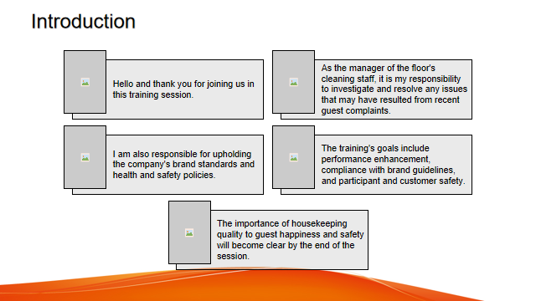

Training Notes: Introduction
Hello and thank you for joining us in this training session. As the manager of the floor's cleaning staff, it is my responsibility to investigate and resolve any issues that may have resulted from recent guest complaints. I am also responsible for upholding the company's brand standards and health and safety policies.
The training's goals include performance enhancement, compliance with brand guidelines, and participant and customer safety. The importance of housekeeping quality to guest happiness and safety will become clear by the end of the session.
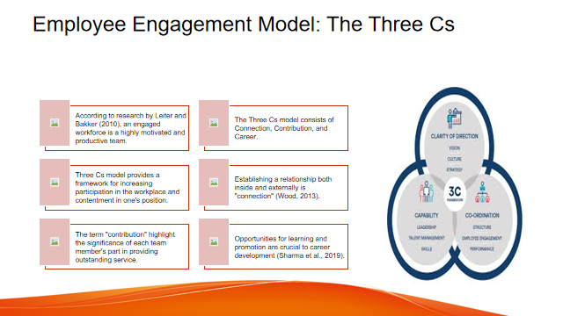

Training Notes: Employee Engagement Model: The Three Cs
According to research by Leiter and Bakker (2010), an engaged workforce is a highly motivated and productive team. The Three Cs model, which consists of Connection, Contribution, and Career, provides a framework for increasing participation in the workplace and contentment in one's position.
Establishing a relationship both inside and externally is what is meant by "connection" (Wood, 2013). Harmony in the workplace can only be achieved through open lines of communication, collaborative problem solving, and sympathetic coworkers.
The term "contribution" was coined by Raghubalan and Raghubalan (2016) to highlight the significance of each team member's part in providing outstanding service.
Opportunities for learning and promotion are crucial to career development (Sharma et al., 2019). Employees must be engaged and dedicated to their work when their efforts to improve professionally are encouraged and rewarded.
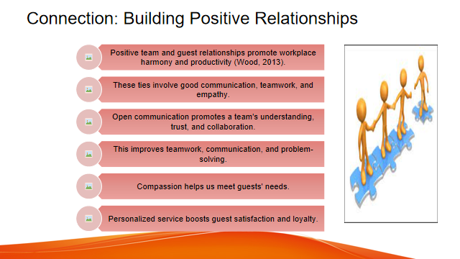

Training Notes: Connection: Building Positive Relationships
Positive team and guest relationships promote workplace harmony and productivity (Wood, 2013). These ties involve good communication, teamwork, and empathy.
Open communication promotes a team's understanding, trust, and collaboration. This improves teamwork, communication, and problem-solving.
Compassion helps us meet guests' needs. Personalized service boosts guest satisfaction and loyalty.
This lesson will help you understand how interpersonal relationships produce strong, motivated cleaning crews. Role-playing gives us practice resolving client issues and demonstrating our communication skills, which are crucial for building and maintaining good relationships with coworkers and customers.

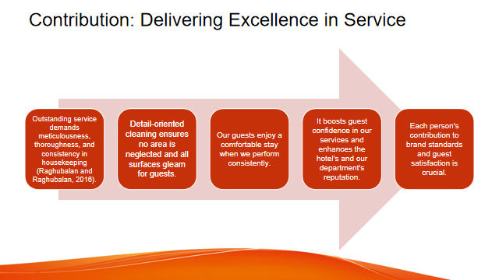

Training Notes: Contribution: Delivering Excellence in Service
Outstanding service demands meticulousness, thoroughness, and consistency in housekeeping (Raghubalan and Raghubalan, 2016). Your efforts to uphold our brand values and satisfy our guests are acknowledged, no matter how small.
We meticulously clean and tidy all guest rooms and public spaces. Detail-oriented cleaning ensures no area is neglected and all surfaces gleam for guests.
Our guests enjoy a comfortable stay when we perform consistently. It boosts guest confidence in our services and enhances the hotel's and our department's reputation.
Each person's contribution to brand standards and guest satisfaction is crucial. By improving housekeeping detail and consistency as a team, we can better serve our clients.

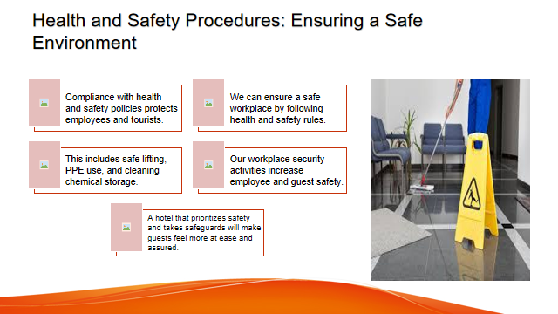

Training Notes: Health and Safety Procedures: Ensuring a Safe Environment
Compliance with health and safety policies protects employees and tourists. These rules protect housekeepers.
We can ensure a safe workplace by following health and safety rules. This includes safe lifting, PPE use, and cleaning chemical storage.
Our workplace security activities increase employee and guest safety. A hotel that prioritizes safety and takes safeguards will make guests feel more at ease and assured.
The importance of health and safety practices is stressed throughout the training to ensure guest and worker safety. These guidelines ensure everyone enjoys health and safety practices.

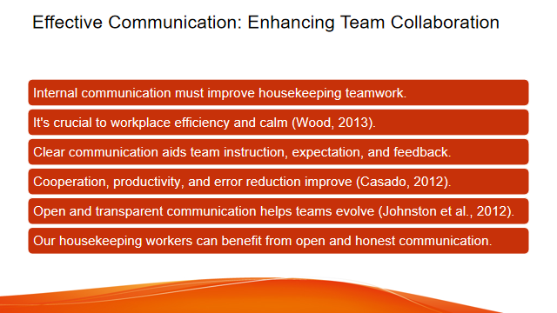

Training Notes: Effective Communication: Enhancing Team Collaboration
Internal communication must improve housekeeping teamwork. It's crucial to workplace efficiency and calm (Wood, 2013).
Clear communication aids team instruction, expectation, and feedback. Cooperation, productivity, and error reduction improve (Casado, 2012).
Effective communication requires attentive listening. Listening and understanding others' thoughts and feelings to create trust (Fallon and Rutherford, 2010).
Open and transparent communication helps teams evolve (Johnston et al., 2012).
Communication skills let team members express themselves, resolve conflict, and work together. Team output and customer satisfaction improve.
Our housekeeping workers can benefit from open and honest communication.

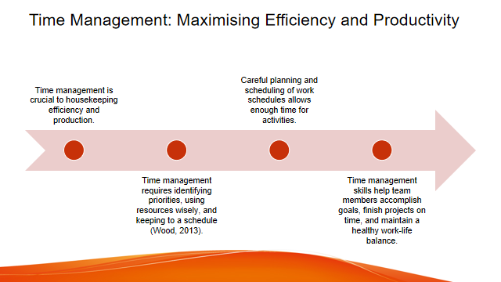

Training Notes: Time Management: Maximising Efficiency and Productivity
Time management is crucial to housekeeping efficiency and production. Time management requires identifying priorities, using resources wisely, and keeping to a schedule (Wood, 2013).
Careful planning and scheduling of work schedules allows enough time for activities. Projects are finished on time, and operations function smoothly (Raghubalan and Raghubalan, 2016).
Time management tactics including to-do lists, reasonable goals, and time-saving technology boost productivity (Cottrell, 2019).
Eliminating interruptions improves concentration and saves time (Quick, 2020). Delegation increases team productivity (Vallen and Vallen, 2012).
Regularly examined and changed time management approaches allow for ongoing development and priority changes (Tesone, 2010).
Time management skills help team members accomplish goals, finish projects on time, and maintain a healthy work-life balance.

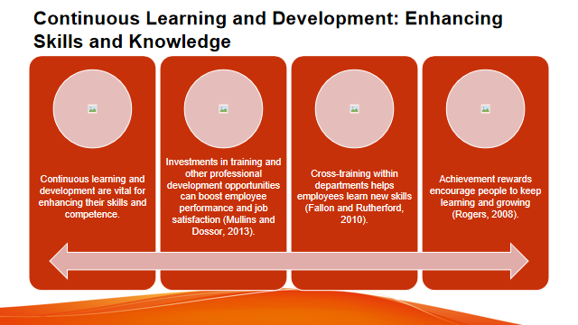

Training Notes:Continuous Learning and Development: Enhancing Skills and Knowledge
In order for housekeepers to perform well and adapt to industry developments, ongoing learning and development are vital for enhancing their skills and competence.
Investments in training and other professional development opportunities can boost employee performance and job satisfaction (Mullins and Dossor, 2013).
Team members can adjust to market changes using workshop, seminar, and online courses (Jones, 2010).
Cross-training within departments helps employees learn new skills (Fallon and Rutherford, 2010).
Achievement rewards encourage people to keep learning and growing (Rogers, 2008).
Creating a learning culture that rewards knowledge sharing and teamwork boosts employee morale and creativity (Sharma et al., 2019).

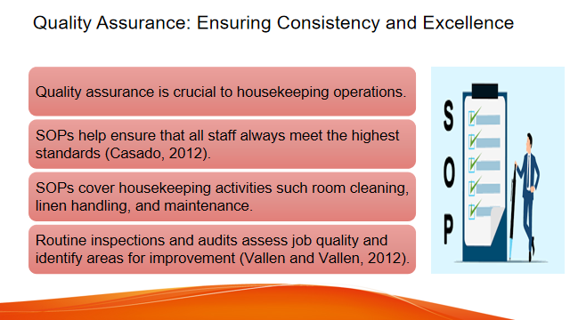

Training Notes: Quality Assurance: Ensuring Consistency and Excellence
Quality assurance is crucial to housekeeping operations because it ensures service consistency and precision, which boosts customer satisfaction and loyalty.
SOPs help ensure that all staff always meet the highest standards (Casado, 2012). SOPs cover housekeeping activities such room cleaning, linen handling, and maintenance.
Routine inspections and audits assess job quality and identify areas for improvement (Vallen and Vallen, 2012). These checks keep guest areas tidy and functional.
Questionnaires and comment cards can collect guest feedback and identify issues (Wood, 2013). Listening and acting on input can improve guest experience.
Continuous training emphasizes quality assurance and skill development.
Quality assurance and guest satisfaction were major learnings for our housekeeping team.

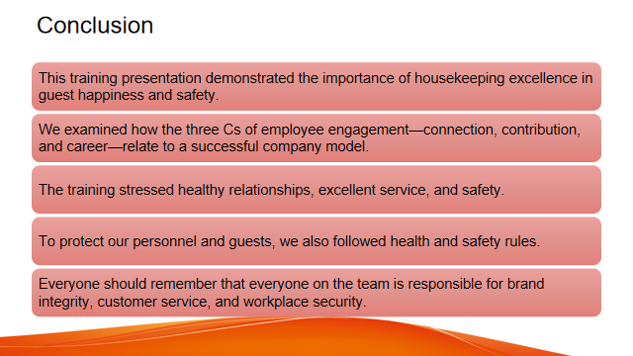

Training Notes: Conclusion
This training presentation demonstrated the importance of housekeeping excellence in guest happiness and safety. We examined how the three Cs of employee engagement—connection, contribution, and career—relate to a successful company model. The training stressed healthy relationships, excellent service, and safety.
During training, we learned that housekeeping duties must be done carefully, thoroughly, and consistently to meet brand standards and make guests happy. To protect our personnel and tourists, we also followed health and safety rules.
Everyone should remember that everyone on the team is responsible for brand integrity, customer service, and workplace security.

References
Bridger, E. (2018) Employee engagement: a practical introduction. 2nd ed. HR Fundamentals. London: CIPD and Kogan Page.
Cottrell, S. (2019) The Study Skills Handbook. 5th ed. London: Red Globe Press.
Leiter, M. P. and Bakker, A. B. (2010) Work Engagement : A Handbook of Essential Theory and Research. Hove [England]: Psychology Press.
Mullins, L. and Dossor, P. (2013) Hospitality Management and Organisational Behaviour. 5th ed. Harlow: Pearson.
Raghubalan, G. and Raghubalan, S. (2016) Hotel Housekeeping - Operations And Management. 3rd ed. India: Oxford University Press.
Quick, L. (2020) Managing Events. Real Challenges, Real Outcomes. London: SAGE Publications Ltd.
Casado, M. (2012) Housekeeping Management. London: Wiley.
Fallon, M. and Rutherford, D. (2010) Hotel Management and Operations. London: Pearson.
Ferdinand, N. and Kitchin, P. (2017) Events Management - An International Approach. 2nd ed. London: SAGE Publications Ltd.
Johnston, R., Clark, G. and Shulver, M. (2012) Service Operations Management. London: Pearson.
Zhang, Y., Li, D. and Sun, B., 2015. Do housekeeping genes exist?. PloS one, 10(5), p.e0123691.
Jones, T. (2010) Professional Management of Housekeeping Operations. London: Wiley.
Rogers, T. (2008) Conferences and conventions a global industry (2nd ed., Events management series). Oxford ; Boston: Butterworth-Heinemann.
Sharma, N., Chaudhary, N. and Singh, V. (2019) Management Techniques For Employee Engagement In Contemporary Organisations. Hershey, Pennsylvania: IGI Global.
Tesone, D. (2010) Principles Of Management For The Hospitality Industry. 1st ed. London: Routledge.
Vallen, G. and Vallen, J. (2012) Managing Hotel Operations. London: Pearson.
Wood, R. (2013) Key Concepts in Hospitality Management. London: Sage.

