Counselling Skills & Approaches
ECPs5010
Professional Placement Portfolio
plus 1,000-word Reflective Written Summary

Table of contents
Reflective Commentary | 2
Evidence 1 Background Information | 4
Section A: Information sheet | 5
Section B: Placement tasks and activities | 6
Evidence 2 Reflective Logs | 7
Evidence 3 Research Development Process | 8
Section A: Literature research | 9
Section B: Development of interview questions | 12
Section C: Interview Schedule and Questions | 13
Section D: Developing IAT words and phrases | 16
Evidence 4 BACP Ethics form | 17
Appendices | 18
References | 19

Reflective Commentary
In this reflective commentary, I will be reflecting on my time in placement following the Gibbs reflective cycle (Gibbs, G. (1988). Over the last 3 months, I have been taking part in a placement that is based at the University of Wales Trinity St Davids. The placement is a research-based placement. The placement is being run by a psychology lecturer. I have been working alongside one of my classmates. The topic that we have been researching is the menstrual leave policy. We have been researching things surrounding this policy such as; opinions on menstrual leave within the workplace and opinions on menstruation in the workplace and in general. Before beginning this placement I had never heard of menstrual leave. When the psychology lecturer told me about this placement and what it would include I was excited to learn more about the topic. At the beginning of the placement, we were given a placement activity Gaant chart (see appendices). This is an excel document that helped us see all of our placement activities. It also showed us how long we should spend on each activity and when we should finish the activities.
The first activity we had was to search for systematic literature. In order to do this we had to understand what systematic literature was. Once we understood what the activity was we found it very interesting. We were looking for terms of relevance to menstrual leave. It was very interesting to see what was already written about menstrual leave. The second activity was to do an individual presentation of the literature terms that we had decided upon. This gave us the opportunity to discuss our personal opinions on menstrual leave. We read articles and studies to see what the common literature terms were for menstruation then presented what we found to each other. This helped us to learn what we both had found and to develop our research skills. We then went on to research previously reported attitudes towards period-related products and terminology. We researched articles, studies and news reports to see what the attitudes are towards period-related products. We also researched what terminology was commonly used throughout these findings. After researching we made a shared document and wrote up a summary of our findings. We then sent this to our lecturer and she gave us feedback and told us how we could improve our research and if we needed to add anything to our document. We then discussed methodology ideas, and whether our research was going to be qualitative or quantitative. We then had to make a list of words, and find images, terminology and phrases that may be relevant to using a quantitative study. Then we constructed qualitative interview questions. After doing this we handed our questions to the lecturer and she helped us to develop our questions to ensure they weren’t leading or closed. The last activity we have done on the Gaant chart is having the opportunity to see an IAT. We took part in an IAT and then we saw how they were made. We then discussed how our IAT would look if we constructed one for opinions on menstrual leave and menstruation in general.
Throughout my placement, I have felt many different emotions. My first feeling was relief. I was very relieved when my lecturer told me she had a placement opportunity for me. I felt nervous at the beginning of my placement as I had just returned to university after a 4-year break. I hadn’t taken part in any type of research and it was something new. I was worried that I wouldn’t be able to complete the placement activities at a high standard. Although I was feeling nervous I was also feeling excited. I had never heard of menstrual leave. And learning about it was very exciting. I saw this as a beneficial placement for me as a woman to learn about something that could eventually be something that I have access to. Throughout the placement, I discussed menstruation with my classmate with whom I worked alongside. My classmate is a male, and we both had very different views on menstruation. At times I felt very awkward discussing and explaining menstruation. On the other hand, there were times when I felt very intrigued to learn how he saw it from his point of view. I felt very motivated to take part in the research activities as I was interested in the topic.
I have learned many new things during my time on placement. I have also developed many skills. I have learned how to research correctly and how to use google scholar. I have used my research skills throughout my placement and I am very glad that I have been able to strengthen these skills. I have also developed my communication skills, as previously mentioned I discussed menstruation a lot during placement with my classmate. These conversations could get awkward due to my classmate being male. I have learned how to explain something without patronising someone. This will benefit my counselling skills as I can show that I am non-judgmental and aware of how I speak to others.
To conclude, I have enjoyed my placement. I have found it very interesting to research a topic that I feel is personal to me. The results of the research shocked me. Learning that many people either don’t discuss menstruation or are uneducated. After researching menstruation leave it has become clear to me that many people, mainly males, don’t understand menstruation at all. We discussed that this might be because of sexual education lessons being gender specific, this has become something I am very interested in and I am proud that I have been a part of this research.
Although the placement frame has ended. I have decided to continue with the placement in the next semester. I am looking forward to taking part in the interview process. This will also help me to develop my counselling skills when asking a client a question and how I react. I am also looking forward to developing the research that we already have and assisting to write up a report. In order to ensure that my work will remain at a high standard I will make sure that I participate in all research skills workshops if any become available to me.

References
Gibbs, G. (1988). Learning by doing: A guide to teaching and learning methods. London: Further Education Unit.

Evidence 1 – Background Information

Section A: Information sheet

Section B: Placement tasks and activities

Before beginning the placement an information sheet had to be handed to a psychology and counselling lecturer for them to understand what our placement was including. When the placement began a placement activity document was made. This included all the activities / tasks we had to do during our placement. This made it very easy to understand what I had to do.

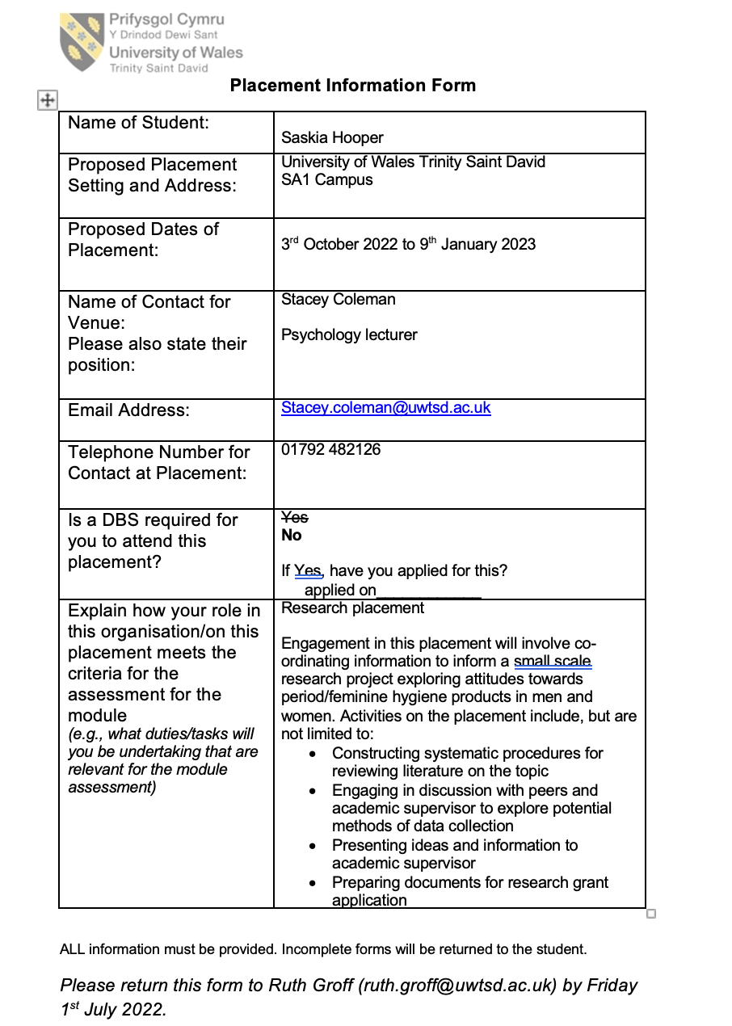
Section A: Information Sheet

Section B: Placement Tasks and Activities

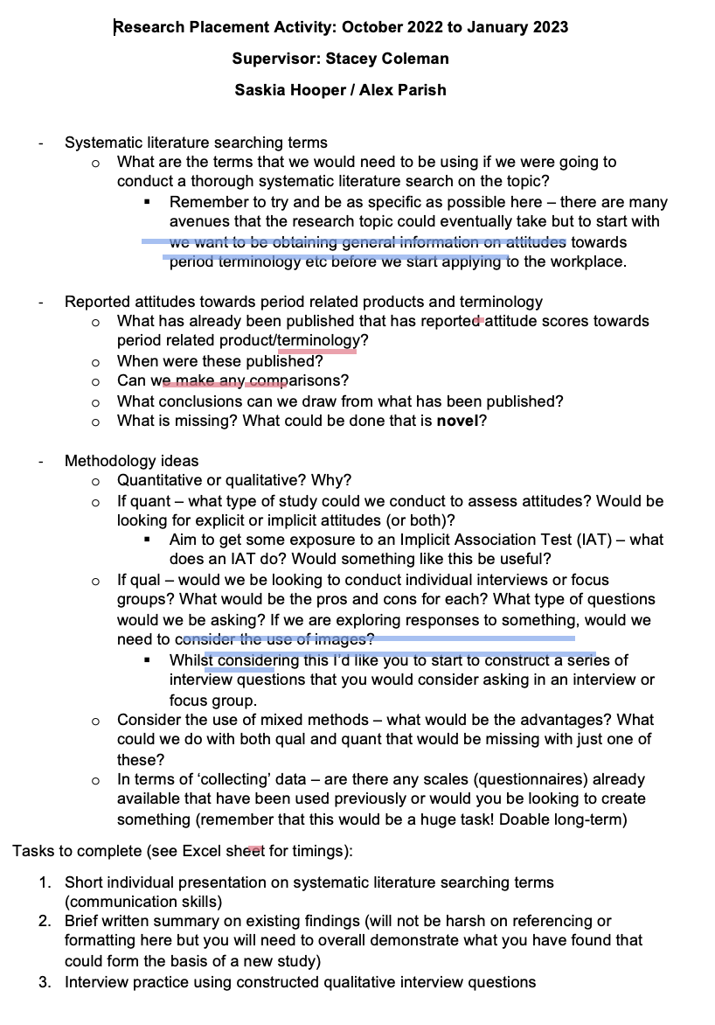

Evidence 2 – Reflective Logs

Date  (Stated by semester weeks) | Description of Task | Reflection
Weeks 1 - 3 | Systematic  Literature  Searching – terms of relevance | At the beginning of this task, I felt very confused as I didn’t know what a systematic review was. After researching and then gaining an understanding of what needed to be done, I enjoyed this task. It was surprising to see the general opinion on periods and how many different opinions there are.
Weeks 2 - 4 | Researching previous reported attitudes towards period related products and terminology | Researching previous attitudes towards periods was a very interesting task. I read many articles and reports and was very shocked that many women refuse to discuss their periods with other people. I was also shocked at the number of men who didn’t fully understand what a period was or how it affects women.
Weeks 5 -7 | Construction of qualitative interview questions | This task was challenging. It was hard to think of questions that weren’t leading. It was also hard to think of questions that weren’t planting an idea of what we were looking for.

Evidence 3 Research Development Process

Section A: Literature Research

Section B: Development of Interview Questions

Section C: Development of Interview Schedule

Section D: Developing IAT Words and Phrases

During the placement, we researched literature that discussed menstrual leave and opinions on menstruation We found out what terms were used to discuss menstruation and what types of opinions people had on menstruation within the workplace. This is where we learned that some women hide their menstruation and don’t feel comfortable speaking about it. After reviewing the literature, we moved on to thinking about interview questions. We came up with the first round of questions, and then with help from the lecturer we adapted the questions to be better suited and to make sure they weren’t leading. The new questions can be seen in the interview schedule. Lastly, we thought of words that we could use in an IAT to make a test to see the opinions on menstruation.

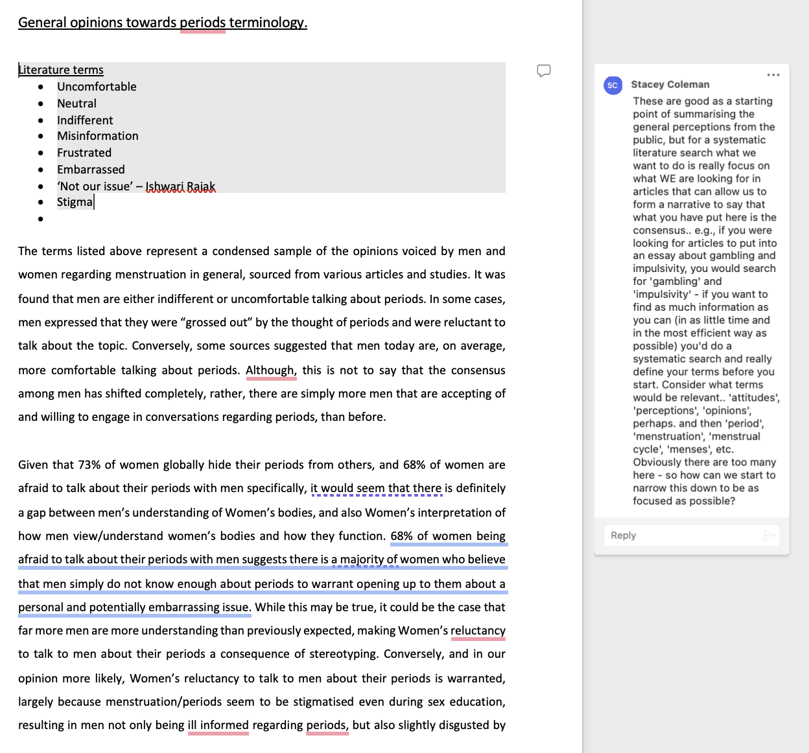
Section A: Literature Research
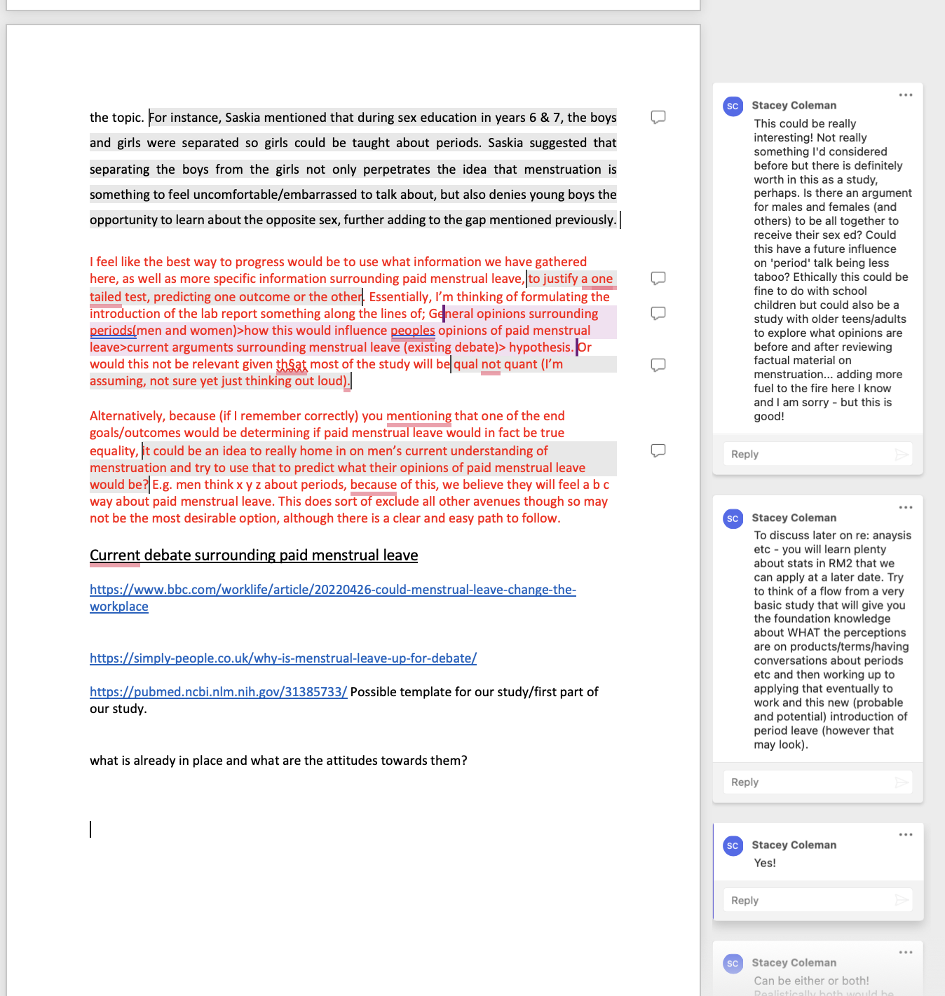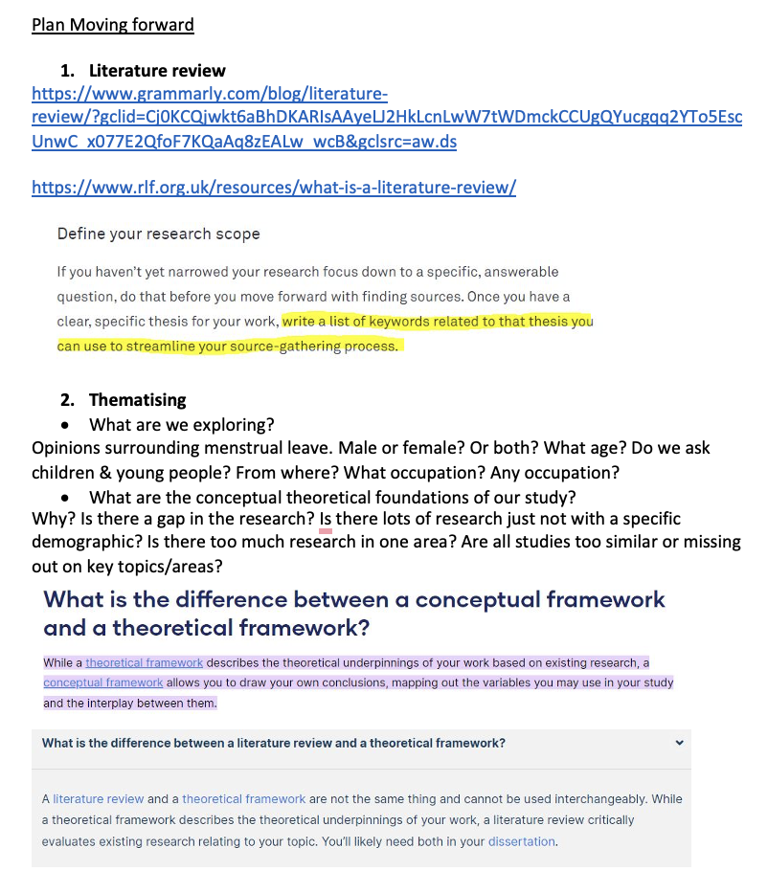

Section B: Development of Interview Questions

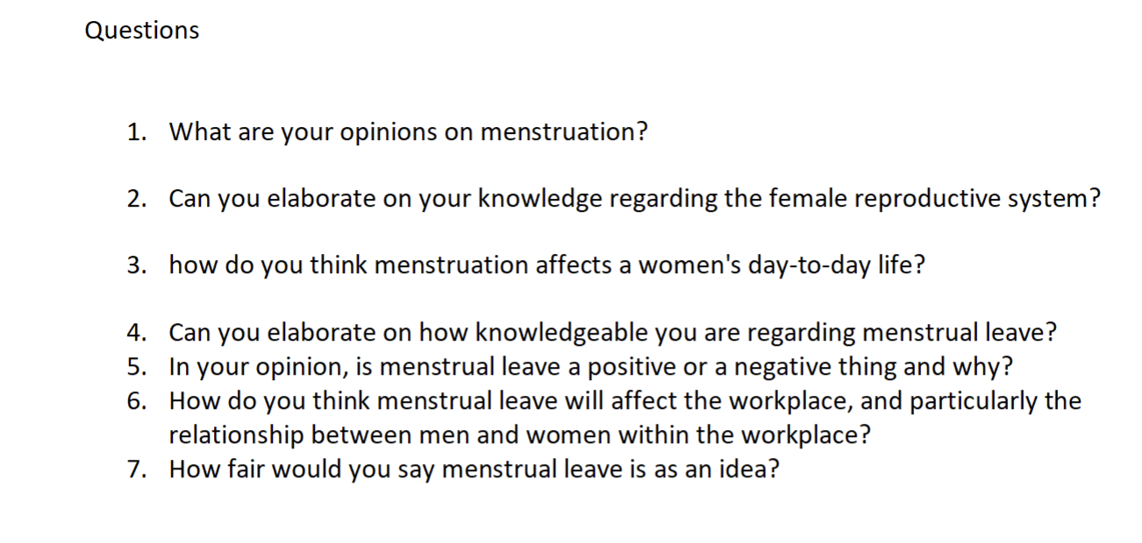

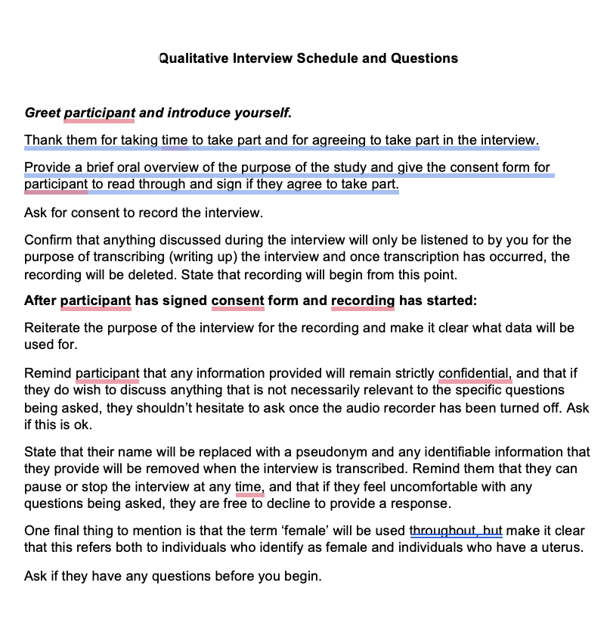
Section C: Development of Interview Schedule
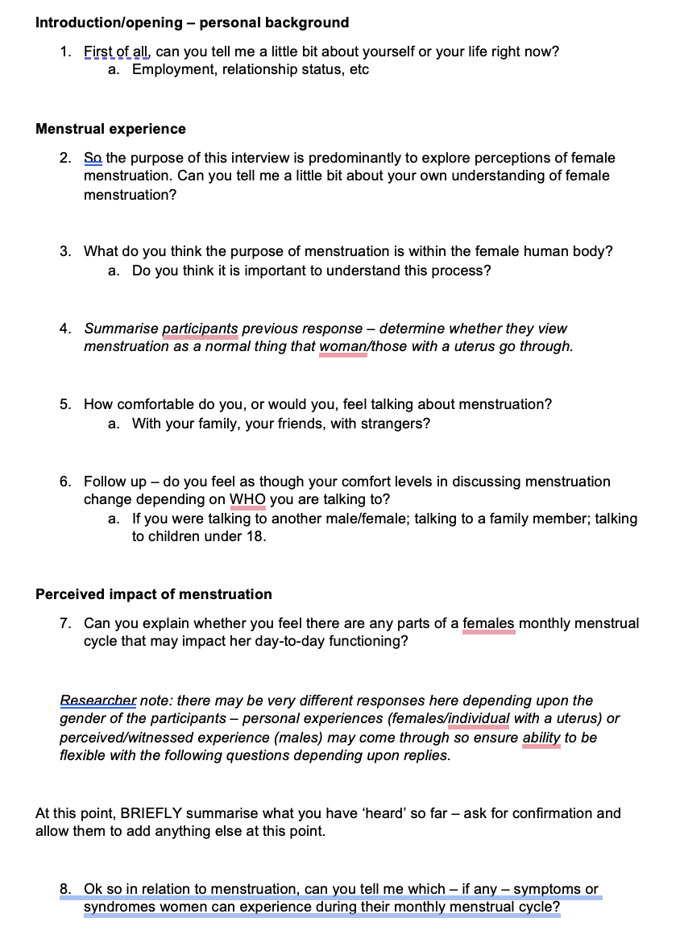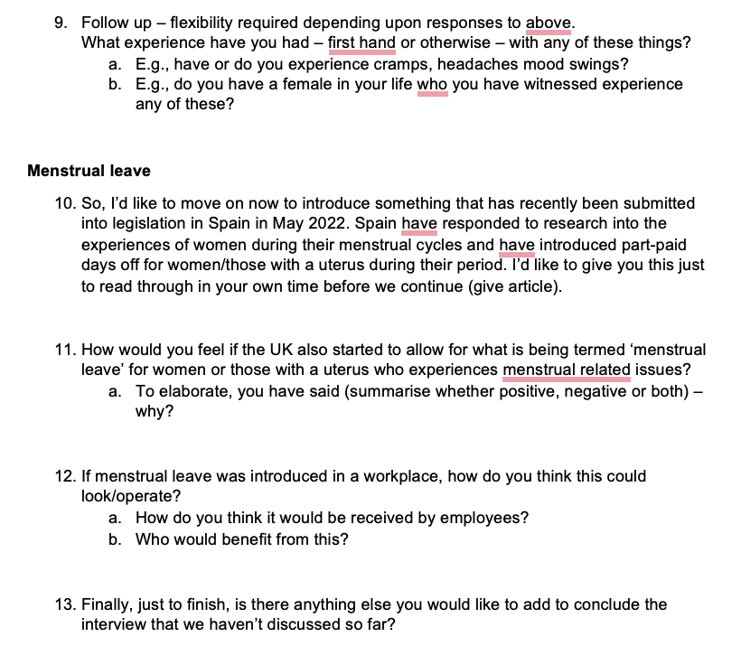

Section D: Developing IAT Words and Phrases

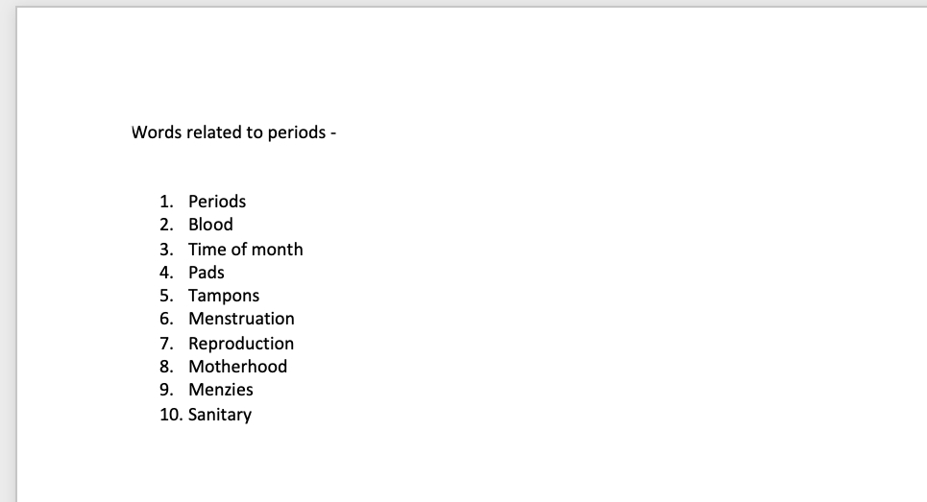

Evidence 4 BACP Code of Ethics

The University of Wales Trinity St David’s psychology and counselling course follows the BACP code of ethics. These were followed throughout the placement.

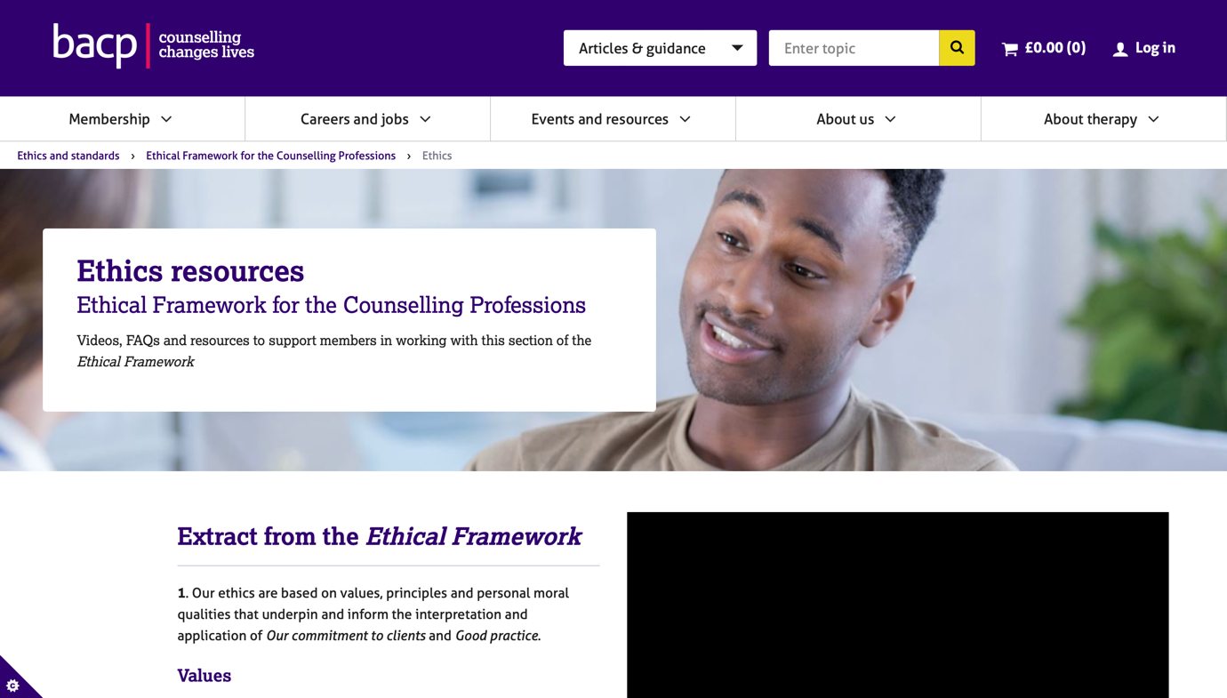

Appendices

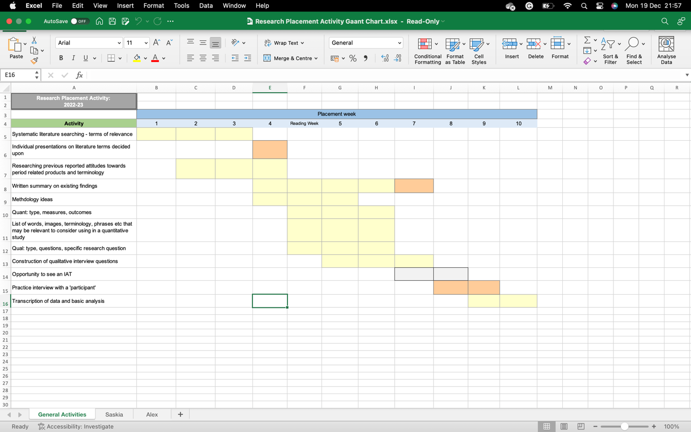

References
Gibbs, G. (1988). Learning by doing: A guide to teaching and learning methods. London: Further Education Unit.

