Business plan for professional grooming salon Pooch Tails
managing enterprise in the 21st Century
Milda Jankauskaite
student id 2020751
Date 02/12/2021
2021
Contents
Planning a start-up 3
Name and legal structure 3
Location 3
Equipment 5
Mission statement and objectives 6
Business overview 6
Service of the business 7
Market research 7
Service offered 8
Human resources 9
Marketing strategy 10
Financial recourses 11
SWOT analysis 11
Cash flow forecast 12

Planning a start-up

Name and legal structure

Setting up "Pooch Tails" under a sole trader is based on the pros of the ownership that eliminate the other options for running a family business. Sole trader businesses can have employees but legally or rightfully cannot be owned by someone else. Even though staff can be dealing with day-to-day challenges, the legal right to make decisions is in the owner's hands at the end of the day (Clark, 2010). It gives freedom to steer the business in the way it is wanted. Furthermore, 100% of the profits generated by the company belongs to the legitimate owner. One of the most significant advantages is a simple setup process to become a sole trader. The legal structure can easily be changed to a private or public limited company in terms of business growing successfully. Before deciding the legal structure to start up with, this point has been considered because the all the way around process, from a limited company back to a sole trader, has a lot of complications. Therefore, as a first-time business runner, the focus is to minimize risks and keep to the idea that there are always more possibilities to grow and further change the company accordingly (Bank, n.d.).
On the other side, the disadvantage of being a sole trader has been considered as well. The most significant disadvantage of owning an unincorporated business is that it has unlimited liability, and therefore, the owner takes responsibility for debts in a case of business failure. Furthermore, it could be said that there is no separation between you and the company, and it means that personal and business assets count as one. For example, on the verge of bankruptcy, the bank has the legal right to possess personal possessions. Additionally, In the event of an employers' accident in the workplace, the owner is to settle any legal proceedings (Korchak, 2014).
Even though that profit belongs to the owner, the government taxes as a single person and not the company. A disadvantage that comes hand in hand is that accessing funds is more complex, and therefore business expansion is slower without additional capital (Green, 2020).

Location

The salon is located on the high street in Caerphilly, ahead of Caerphilly Train station. The full address is Eastgate Market Street, Caerphilly, CF81 1NX. The place meets requirements to have a close parking space for customers and a business van. Furthermore, the site is suitable for the disabled and has a step-free entrance. Additionally, the property is mid-terrace two-store retail premises providing generous sale space on the refurbished ground floor. Storage, kitchen, and WC facilities are on the first floor, where a cosy sitting area will be set up. The total internal area is 560sq ft (51.93 sq m).
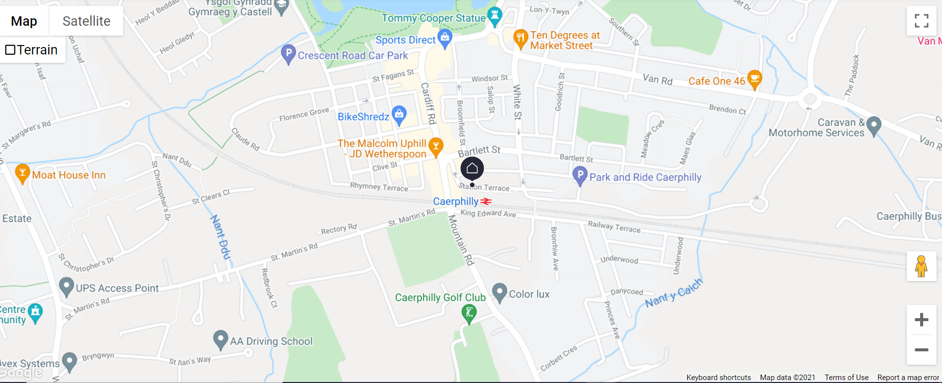




All pictures are exported from Google.

Equipment

Proper tools can maximize the practice and guarantee that they can service a wide variety of dog breeds. The list of must-haves for the grooming salon is long and expensive:
- Bath (£400-£1000)
- Grooming table (£100-£1000)
- Blaster (£200-£800)
- Finishing Dryer (£400-£700)
- Scissors (£250 for 3 - £1000)
- Cages (£35-£350)
- Sterilisers (£80)
- Leads & Nooses (£80)
- Coat King (£15-£20)
- Combs (£10)
- De-Shedding Tools (£40)
- Slicker Brushes (£20)
- Blood stopper (£7)
- Nail Clippers (£15)
- Ear Powder (£5)
- Clipper Oil (£5)
- Comb attachments (£20-£25 per set)
- Clipper Blades (£30 per one blade)
- Clippers (£200-£400)
- Shampoo (£25)

Mission statement and objectives

Business overview

The business mission is to provide the highest quality service in a stress-free environment for dogs. Our goal is to create a positive association to grooming for dogs and their owners by treating them with love and kindness. We employ a professional and human approach to build social value and engage the community to spread willingness and become keen for those who have not been so lucky.
The business purpose goes beyond a profit and aims to grow social awareness and spread the word across the community. Social profit is thought of as not important as financial performance. However, the purpose resonates with the brand where employees and customers will buy into. Creating a social value will naturally create an engagement in a workforce that directly increases productivity that is equal to profit (Gua & Wolfgang Bielefeld, 2014). By embedding social value, the business will help reduce the number of homeless pets and shelter occupancies and support volunteering.
It is known that, like many other institutions in Wales, animal rescue centres were drastically affected by the Covid-19. The income drop was horrendous due to public fundraising restrictions and door-to-door activities (Thomas, 2021).
Therefore, Pooch Tails will partner up with the rescue centre and provide a professional grooming service. The partnership aims to help rescue dogs find a new home and not let the story repeat. The business will be working individually with anxious and aggressive dogs towards adopting and de-sensitizing them to the grooming process. Dogs with past traumatic experience require many precautions and knowledge of useful techniques and tools that could help minimize the risk.

Service of the business

Market research

The dog grooming industry for many years has not been taken seriously and has shallow standards. There hardly were rules and regulations, which allowed anyone with a set of tools and scissors to claim to be a professional dog groomer. However, a turning point in the industry had happened, and considerations of a better approach to the education of pet stylists were employed, resulting in new standards. Groomers have finally been respected for their depth of expertise, excellent skills, and professional work results (View, 2018).
Surprisingly, the groomers' qualification opens quite different business opportunities such as mobile grooming business, salon, or even work from home option is available (Guerrero, 2017). The decision to set up a salon was based on the market research and weighted advantages and disadvantages of having a mobile and home-based grooming room. One of the advantages of having a high street salon is that significant profit can be reached rapidly as it allows to have more groomers and get more dogs done simultaneously. However, challenges cannot be avoided in walk-in dog grooming salons. Branding itself has to be very carefully considered to the target market, which apparently can either attract or lose business (Academy, n.d.).
Furthermore, it requires the capability to multitask the running of administration and reception tasks with grooming. However, if well designed, it creates an image of a reputable place, and customers expect an exceptional professional standard .
A high street salon is generally lower prices but a more environmentally friendly option than the mobile grooming salon. However, a more structured working routine can be followed in a salon that is essential for a start-up to get some trust from customers and fulfil books with appointments (Insurance, n.d.).
Relying on the last four years (2016-2019) survey results, Wales are in the fourth position on the regional dog population in the UK (Bedford, 2021). Owing to the fact, that the lockdown resulted positive increase of households with a pet. People feel satisfaction by taking a good care of their dogs, and the market reflects a demand for added value products, and services in the pet care industry (Westgarth, 2016).

Service offered

The analysis of competitors business types and services they offer has led to the decision to expand the market that businesses can serve by making collect and drop off services available. On top of that, the research has indicated that in South Wales, no salon offers do-yourself facilities. Therefore, the business will offer to book a do-yourself appointment, which includes all necessary tools. The advantage is that the service can work without an employee, and installed facilities pay off immediately. The other benefit is a convenience that eliminates waiting for an appointment with a groomer time.
People are progressively treating pets as family members, relying on them for the company and fulfilment feeling. This should be considered, as the changed perception of pet care makes the grooming industry very challenging (Bedford, 2021). The business target is providing the highest grooming service and paying extra attention to their owner. Those whose limited time is welcome to work in the sitting area while their pet is being pampered.
Complete grooming package contains double bathing, blow-drying, brushing, ear cleaning and nail cutting, and body shaping is excluded for smooth-haired breeds.
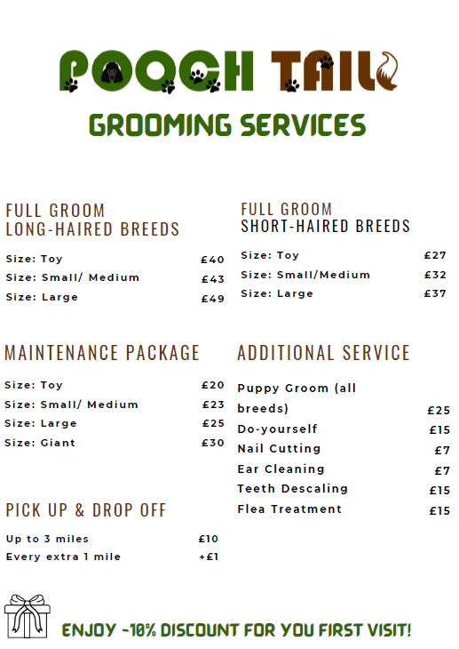

Human resources

Because households with pets in the United Kingdom stayed relatively stable between 2011 and 2018 and balanced between 45-47%, the global pandemic in 2020-2021 resulted in a positive increase of 18% in pet ownership levels (Statista, 2021). Thus, the business is willing to operate in a high demand era, and therefore the company will start with two groomers, including myself. For the first year, I will not be paying any salary for myself, and the other team member will be self-employed and paid £10 per hour.
Furthermore, for running a collect & drop off pet service, the business needs a van driver. Still, while it is at a very early stage and has not built a trustworthy image yet, the high demand for using this service is not expected, and therefore willing to manage with a family member in place. As the interest and customers increase, the employment of a driver is included in the business projection. The driver will a national minimum wage per hour £8.91 (Searle, 2021).

Marketing strategy

The subject of marketing is quite challenging, although it has a massive value in the business. The main objectives for "Pooch Tails" marketing strategy are to keep it ethically balanced, and represent business purpose, connect story and values, rather than overwhelming customers with a variety of promotions available at the same time. No matter how good a product or a service is if nobody knows you exist (Sommer, 2018).
Therefore, while premises are in the refurbishment stage, the attractive looking van with branding and opening dates will be released on the road to make people aware of the new grooming place in the town.
Nowadays, no business can do without being accessible on social media. Not surprisingly, a Facebook account will help access customers quickly, engage with the community the company will be serving and build brand awareness. Businesses will upload engaging content before and after grooming pictures day-to-day to appear in customers' feeds. Another activity that involves people commenting, liking, and sharing will be asking which cut you prefer or like the most in a particular breed (Bottela, et al., 2020).
Since LinkedIn is the number one social site for business-to-business sales, its growth will continue even more. The account will be set up to promote or cross-promote with other businesses and discuss the social value "Pooch Tails" creates. Having an account in LinkedIn helps to be ranked outside of the platform due to its credibility when typing the business name in the search (Rubayet, 2019).
In order to be broadly accessible, the website is essential. This will work as a tool to expose the business to exciting opportunities and connections. Blog posts will educate the audience on topics that directly relate to the trade. The website will have search engine optimization with keywords put on the website to be ranked in Google searches (Chotikitpat, et al., 2015).
On top of that, some small marketing campaigns will be employed to increase business performance and the quality of the service. Finally, to make the marketing campaign work more effectively, reframing measurables to clients will be based on annual survey feedback.

Financial recourses

Business finance can lift the idea from the ground and get business going. However, the fact should not be forgotten that business is new. Owing to the fact that business requires initial investment such as equipment, vehicle, and refurbishment of the premises, a start-up loan of £25,000 will be taken. For that amount of borrowed money business will be paying £3999.20 of interest within 5 years. That comes to £483.32 monthly repayments (Bank, 2021). However, being a sole trader eliminates protection of a personal wealth. However, obstacles are not avoidable and only £5000 will be put into the business out of savings account, and the rest left for unforeseen expenses. In terms of business expand, a strong credit history is a key to justify decisions. Making a loan payment could be challenging for new business start-ups, and there are a big risk of failure due to lacking business experience . Angel financing and crowdfunding is not highly expected due to business concept (Capital, 2021).

SWOT analysis

With any new business, there are some threats to consider and be mindful of the potential rewards. The SWOT analysis focuses on the dog grooming industry to identify existing gaps, challenges, and fields to grow and assets.
STRENGTHS | - Pooch Tails is the only salon that offers do-yourself service in the area, resulting in less competition.
STRENGTHS | - Collect & drop off service expands a market share and enhances the number of clients.
STRENGTHS | - Can offer lower costs as a start-up and provides the same service as mobile grooming.
STRENGTHS | - Thoughtful salon solutions that welcome customers to work in the salon while their dogs are pampered.
STRENGTHS | - Creating social value and giving back to the community.
STRENGTHS | - Educating people by sharing a regular blog post about pet care.
WEAKNESSES | - Absence of brand recognition, as the market is entirely up of established and franchised brands.
WEAKNESSES | - Low budget and high start-up costs.
WEAKNESSES | - Absence of business experience.
WEAKNESSES | - No business connections with suppliers.
OPPORTUNITIES | - A profitable company that let develop other opportunities.
OPPORTUNITIES | - Business expansion by opening new salons or employing more staff.
OPPORTUNITIES | - A branding strategy that could develop the franchise of the business and prospects for stylists to grow under the brand name.
THREATS | - Significant competition in the industry and high standards.
THREATS | - Heightened utility, material, rent costs.
THREATS | - Downturns in the economy reflect household budget cutbacks.

Cash flow forecast

Cashflow foreseeing is the blood for business. Otherwise, a company can fail without reaching a triumph. Covid-19 made insights difficult as consumer demand changes changed, raw material costing changed, and general downturn in trading terms appeared. Pooch Tails will be concentrate on adding customers to the books in the first half a year, by offering some discounts, and therefore enormous profit is not expected. In month six, a driver's employment is scheduled for possibly increased collect & drop off service. For the first year, salary will be only paid for another team member, but not for the business owner. The start-up loan considered as reasonable as possible to lower down monthly repayments.
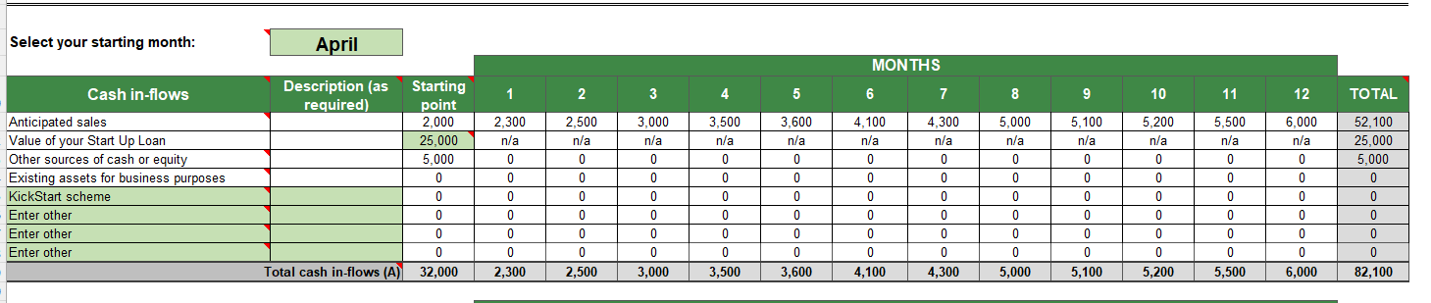

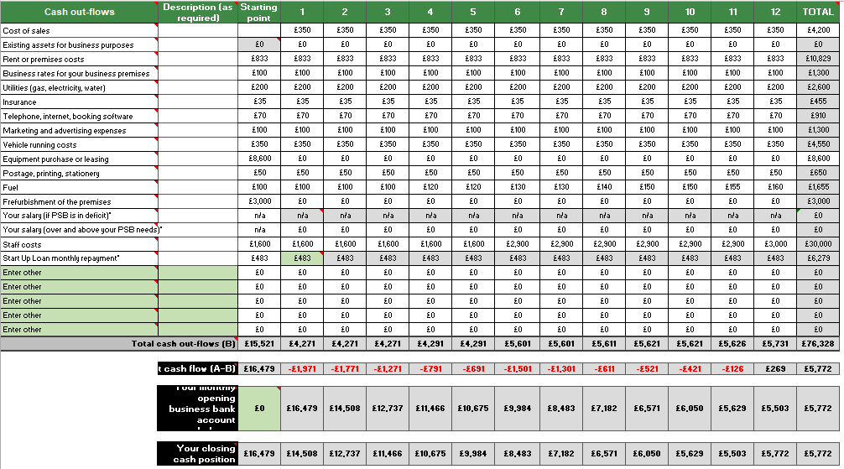

References
Academy, G., n.d. Setting up a dog grooming bussiness: advice and bussines plans. London: GroomArts Academy.
Academy, G., n.d. UK Pet Industry Statistics, London: GroomArts Academy.
Bank, B. B., 2021. Start up loands. [Online]
Available at: https://www.startuploans.co.uk/loan-repayment-calculator/
[Accessed 30 November 2021].
Bank, B. B., n.d. The essential guide to becoming a sole trader. [Online]
Available at: https://www.startuploans.co.uk/business-advice/essential-guide-to-becoming-a-sole-trader/
[Accessed 15 November 2021].
Bedford, E., 2021. Consumer spending on pets and related products in the United Kingdom (UK) from 2005 to 2020 (in million GBP), s.l.: Statitsta.
Bedford, E., 2021. Share of households owning pets by type and region in the United Kingdom (UK) from 2016 to 2019, s.l.: Statista.
Bottela, C.-D., Wiese, M. & Martinez-Climent, C., 2020. A framework for Facebook advertising effectiveness: A behavioral perspective. Science Direct, Volume 109, pp. 76-87.
Capital, W., 2021. The Pros and Cons of Receiving a Startup Business Loan. [Online]
Available at: https://www.forafinancial.com/blog/working-capital/pros-cons-startup-business-loans/
[Accessed 28 November 2021].
Chotikitpat, K., Prachyanun, N. & Sunantha, S., 2015. echniques for Improving Website Rankings with Search Engine Optimization (SEO). Advanced Science Letters, October, pp. 3219-3224.
Clark, G., 2010. Business start up and future planning. Brighton: Emeral Publishing.
dogs, G. n. f., 2016. Dogs Really Are Man's Best Fried: 71% of U.S. Males Own a dog, s.l.: Good news for dogs.
Green, J., 2020. Sole Trader vs Limited Company: How to set up a business, s.l.: Smeloans.
Gua, C. & Wolfgang Bielefeld, 2014. Social Entrepreneurship: an evidence based-based approach to creating social value. s.l.:John Wiley & Sons.
Guerrero, V., 2017. Mobile Business Retailing: Driving Experiential Learning on Campus. Journal of Marketing Education, 40(1), pp. 56-65.
Insurance, P. B., n.d. How to Start up a dog grooming bussiness. s.l.:Pet Bussiness Insurance.
Korchak, J., 2014. Disadvantages of a Sole Trader, s.l.: Inform Direct.
Rubayet, A., 2019. Effectiveness of LinkedIn as marketing tool, Bangladesh: BRAC Univeristy Instituional Repository.
Searle, J., 2021. National Living Wage 2021 Wales: When is the increase, how much is it, s.l.: The National.
Sommer, h., 2018. Market Orientation of News Startups. The Journal of Media Innovations, 4(2), pp. 1-35.
Statista, 2021. Share of households owning a pet in the United Kingdom (UK) from 2011/12 to 2020/21*, s.l.: Statista Department.
Thomas, B. J., 2021. Why Wales needs more sanctuary regulation more than ever, s.l.: RSPCA News.
View, G. R., 2018. Pet Grooming Products Market Size, Share & Trends Analysis Report By Type (Shampoo & Conditioner, Shear & Trimming Tools, Comb & Brush), By Distribution Channel (Offline, Online), By Region, And Segment Forecasts, 2019 - 2025, s.l.: Grand view reasearch.
Westgarth, J., 2016. Petcare - UK - July 2015, s.l.: Mintel.

