Name of student: Anca Mirela Dula (2112863)
Name of Lecturer: Tushara Balendran
Date: 07/01/2022
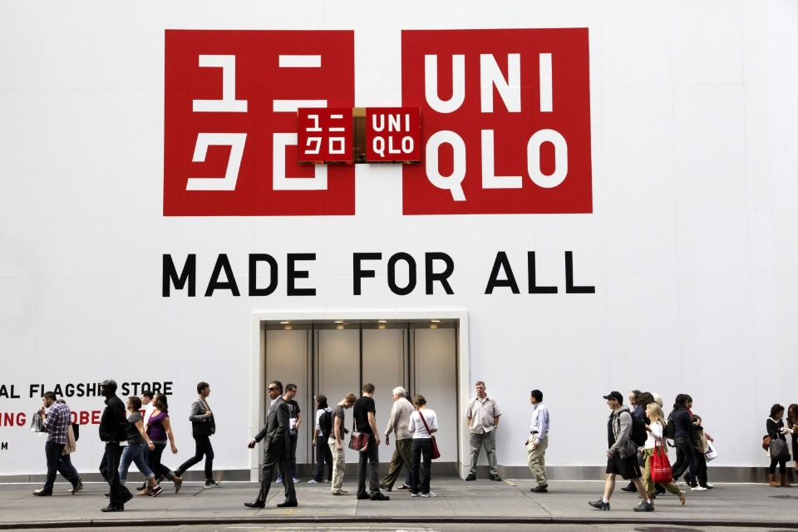
Marketing Fundamentals (LCBB4004)

Table of contents

Contents
Table of contents 1
Introduction 3
Marketing process 3
Situation analysis 3
Company Analysis 3
Objectives 4
Strategy 5
Control 5
PESTLE 5
Political 6
Economic 7
Social 7
Technological 7
Environmental 8
Conclusion PESTLE 9
SWOT analysis 9
Strength 9
Weakness 10
Opportunity 11
Threat 11
Conclusion SWOT Analysis 12
References 13

Introduction
UNIQLO
The first UNIQLO store opened its doors in June 1984, proving the success of the SPA (Specialty store retailer of Private label Apparel) manufacturer retailer model controlling the entire process from product planning, production, distribution, and marketing. UNIQLO enjoyed (and continues to enjoy) superb growth by providing high quality casual wear at remarkably affordable prices for men, women, and kids.

Marketing process

“Marketing is the management process responsible for identifying, anticipating, and satisfying consumers' requirements profitably.”
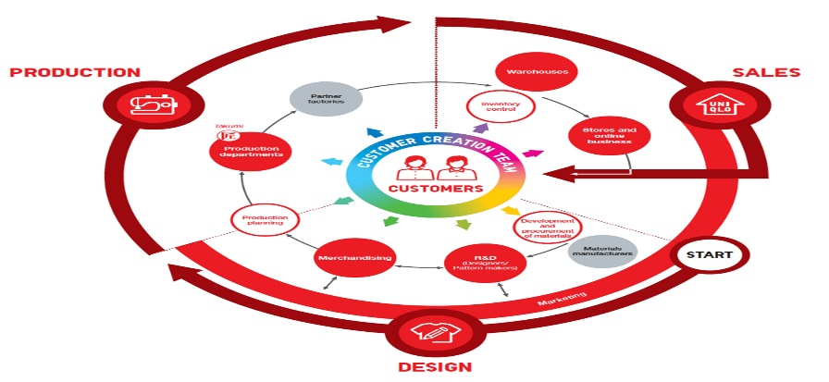
Uniqlo is doing right when it’s come their marketing strategy, each season Uniqlo has promotional campaigns for products such as Heattech, Ultra-Light Down, AIRism, and Bra-tops, during the campaigns it promotes high quality products through Tv, email, social media, and flyers. The company can produce many products due to the well-established plan production-distribution-retail. Uniqlo leverages today's increasingly digital world to communicate directly with customers and quickly transform their desires into actual products.

Situation analysis

Company Analysis

Uniqlo is a casual clothes company, providing unique design, good quality and affordable prices for every pocket. Offers classic clothes such as: T-shirt, sweatshirts, leggings, jeans etc. Uniqlo CEO, Tadashi Yanai, has declared his goal for Uniqlo by 2020 is to have $50 billion in sales and $10 billion in profits. Given Uniqlo's rapid growth in sales over the past few years, they might meet Yanai's goal. According to the Economist, Uniqlo has seen a 22% increase in annual sales growth percentage as of 2009.
They keep basic items longer because they do not have a “fashion shelf life” and through this management plan they are able to keep supplier costs low. They have also created a creative and clever way of advertising on their Pinterest page; they created over 100 fake Pinterest pages to create an animation effect with graphics they have on their sites. So, when users scroll down, the images look like an animated film strip. It has garnered a lot of positive feedback as creative exposure for the expanding Uniqlo brand.

Objectives

Uniqlo have certain objectives that have been key contributors to the company to progress

- Increase market share – All the market efforts are used to increase sales through new or even old customers to keep the market share growing.
- Establish of brand – Brand reputation and positioning in one of the main objectives of the market and the company invest money to set a good position of brand.
- Increase sales- The company is trying to increase sales by introducing a new product that does not exist on the market or to improve the quality of other existing products.
- Get existing customers to buy more- It involves selling products with a few free gifts to keep customers and to keep selling the older products.
- Improve customer loyalty – The market can use more product information to keep customers loyal for longer time.
- Bring in new customers – In order to bring new customers, the company must investigate the needs and desires of new customers to attract them and keep them for a long period of time.

Strategy
While other companies are trying to bring the latest fashion trends to market, Uniqlo is applying a good strategy that helps them stay unique and are focuses on three goals:
- Product development and improvement
- Bring the technology in front
- High quality and innovative materials on the market
Uniqlo’s brand message and has a clear vision: “Uniqlo is a modern Japanese company that inspires the world to dress casual and does not focus on fashion like other companies do. The phrase ‘’Made for all’’ helps to win more customers because it shows that, doesn’t focus on one group, no matter what ethnicity, gender, and age you have, the clothes are made for everyone and are simple, even universal and can be worn anywhere in anytime.
Uniqlo have a good balance between price and quality and helps to maintain same number of customers increased during the time. Uniqlo manage to stay on the market also due to the unique design they produce but also to the fact that they also have certain popular products that they do not take out of the market because are in the top and are selling well.

Control

The control inventory department is maintaining verry high because the inventory is made weekly, to maintain a high level of product in the store, and then dispatching necessary inventory and new products to fulfil orders, to keep a good satisfaction of customers and to help them to find what they are looking for.
Every end of season the marketing department is ensure that the price changes help company to clear all stock of clothes which are left and maintain a good coordinate of inventory.

PESTLE

According to Perera (2017), PESTEL is an effective model that organizations usually apply to examine the potential opportunities and threats as well as prepare the appropriate strategies for the impacts of external factors on their operation. Oxford College of Marketing (2016), states that influence levels caused by factors in the business environment are unstable. This change can create new opportunities or threats to a business. Thus, the PESTEL analysis ought to be conducted at regular intervals since outside factors are consistently evolving.

Political

The political factors play a huge role in business, in international investment decisions but also for Uniqlo-Supply, the political environment and other factors such: democracy, governance system and institution, low etc., have an impact on business and long-time sustainability.
Due to the trade war with South Korea, Japanese goods have been witnessing boycott from South Korean customers which is decreasing the sales at Fast Retailing’s Uniqlo stores. According to report from Nikkei, sales in South Korea accounted for around 8% of sales of Uniqlo which has now fell 40% Y-O-Y in July and August 2019. Another analysis by J.P Morgan analyst stated that the South Korean business will witness a double-digit decline in sales and almost 40% fall in operating profit.
The company has set up oversees expansion as its primary strategy for growth in the face of a lagging Japanese home market. The company has also been forced to reduce its operating profit outlook by 11% owing to the effects of bad relations between Tokyo and Seoul. Korea, with the largest number of oversees Uniqlo stores after China, has always been an important market for Fast Retailing.

Economic

Uniqlo must evaluate some economic factors that it has on the market but also the factors that it wants to introduce, the income level, the growth rate but also the inflation rate. However, Japan is seeing a slowing economy due to several economic policies like low interest which have led to a deflationary economy. With people stopping purchases each time prices go up, retailers like Fast Retailing cannot raise prices, leading to the creation of a non-conducive market and slow growth for the company. Fast Retailing has sought to combat this by focusing more on international market sales.

Social

One way by which a brand can improve its image and social standing is by engaging in Strategic collaborations with designers and initiating celebrity endorsements. Uniqlo also uses celebrity endorsements to promote the brand’s image and connect with the masses. Uniqlo chooses only those celebrities who can fulfil its requirements of resilience and strong character. International wheelchair tennis champions Shingo Kaieda and Gordon Reid are thus a perfect choice to represent the brand. Uniqlo has used its technological expertise in materials, design, patterns, and functionality to create game wear that is specifically suited to the needs of these brand ambassadors. The brand also has Ayumu Hirano, Roger Federer, Kei Nishikori, and Adam Scott as its global ambassadors. Apart from this, the brand has also collaborated with designers to help it achieve greater awareness in markets where it has low penetration, like the US and European markets. The brand had worked with designer Alexander Wang in 2008 to create a five-piece dress collection.

Technological

Industries around the world including the retailing industry are increasingly adopting technology as a means of achieving greater efficiency and lower operating costs. Fast Retailing, the world’s third-largest casual clothing retailer, has also partnered with two robotics start-ups, Mujina Inc. and Exotic Solutions SAS to achieve automation in its warehouses which will lead to faster picking and shipping processes. This integration of robotics is expected to help the company significantly improve its logistics and overcome several of its inefficiencies that were causing the brand to lag its global competitors. Fast Retailing has also been working on taking its brand Uniqlo to a greater digital level by integrating its e-commerce and physical store operations. The Ariake Project uses AI to analyse customer product search and purchase history, which allows the brand to present its customers with customized search results. The Style Hint app has also enabled UNIQLO and GU customers to browse through globally trending looks and discover new style through image searching.

Environmental

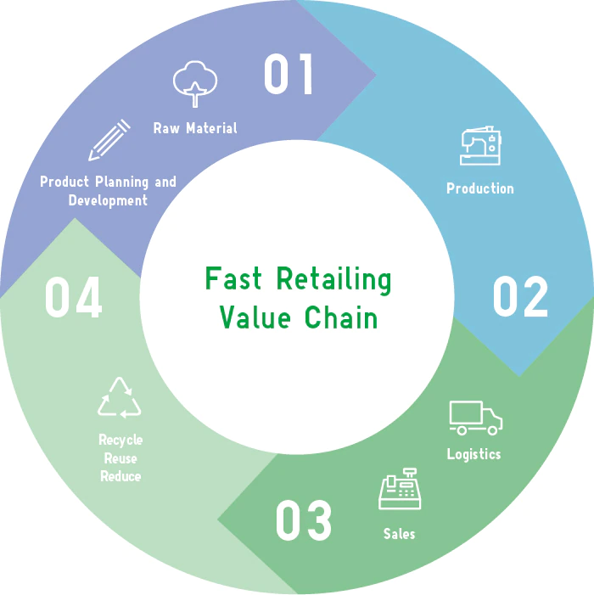

Every company has different standards of environment and protection, for example a textile company does not have the same level of pollution as an oil company for example. Uniqlo use raw and recycle materials to provide new specific clothes, reduction of water and energy used in stores, reduction of water use in product finishing, improving logistic efficiency and
uses bags of recycled paper.

Conclusion PESTLE
In conclusion, the PESTLE factors help the organisation to prepare in the six external factors and to improve the decisions, aspects, and management of the business.

SWOT analysis

Strength

The Fast-Retailing Group being the world’s largest manufacturer and retailer of private- label apparel is well known for offering high-quality, reasonably priced clothing. It manages everything from procurement, design, production to retail sales. The pillar band UNIQLO operates in almost 22 counties with 2200 employees.
With the growth of customers and to make them to buy something at any time, but without visiting the physical store Uniqlo build a platform that allows customers to use digital technologies holistically, Uniqlo Harajuku was launched in June 2020 and makes possible fashion and culture of fashion. This store is the world's flagship sales space linked to Style Hint, a mobile app that lets users’ style.
GU brand offers apparel that symbolizes fun fashion at extremely affordable pricing, which attracts people of all generations. Thus, Fast Retailing is focusing on expanding its portfolio with on-trend products that are not only cost-effective but help in maximizing customer enjoyment.
Automation is the key to address issues like labour shortages, storage costs, and lags in delivery. Thus, Fast Retailing has invested significantly in automating its warehouses globally. Consequently, the apparel giant transformed its business model from “Selling what we produced” to “Producing only what we can sell.” This new headquarter has the capability to integrate 1,000 employees from different divisions in the same workspace and connecting them through a common digital platform. From planning and production to marketing and logistics all these divisions could be placed on the same floor. Uniqlo incorporates a stylish range of warm clothing due to the fabric being thin and comfortable in comparison to the standard traditional warmth clothing segment. Additionally, AIRism (a soft fabric with quick-drying inner fabric), Life Wear (a blend between casual and sportswear), and UV Cut (material designed to prevent 90% of ultraviolet rays from reaching the wearer) technologies are some of the exceptionally innovative Uniqlo products. Tadashi Yanai has been quoted to say that Apple is its largest competitor because of the company’s desire is to be the most innovative company in the world.

Weakness

The Jabba Garimindo factory in Indonesia was a supplier factory of Fast Retailing for its Uniqlo brand, which announced bankruptcy in 2015, affecting nearly 4000 workers. The closure of the factory led to a massive revolt of workers demanding their settlement of severance pay and final salaries. Despite the company dissolving its relationship with the factory in 2014, and apparently setting up all dues with the factory in a timely manner, Fast Retailing faced protest outside Uniqlo stores in Japan and Hongkong for the same issue. Jabba Garmindo was accused of labour rights abuses, the firing of pregnant workers, and the harassment of trade union members. Instead of taking up a stand for the factory workers, Uniqlo distanced itself from the scenario and its exit led to Jabba Garmindo’s collapse into bankruptcy. The Uniqlo brand is being embroiled in an ongoing workers' rights case for more than five years now. As of 2020, nearly 2000 of the workers are fighting to claim nearly $5.5 million as severance pay.

Opportunity

China, Southeast Asia, and India are amongst world's global economic growth centres and the company aims to expand its footprint in these regions by setting up new stores. In Asian market, Fast Retailing is already ahead of the curve and has huge potential for future growth due to its well-established business platform here. China and Asia are one of the most densely populated regions, especially with middle-income population, this presents golden opportunity for company to consolidate its growth in this region, which is more than 10 times the size of Japan.
The Fashion Apparel Market across the world is significantly growing from a decade, in 2020 the industry has attained a y-o-y growth of nearly 6% and is expected to witness immense growth with a CAGR of 5.5% during the period from 2020 to 2025. The market is full of cutthroat competition and the companies fighting for market share can stay ahead of the pack with innovative technological developments that improves production efficiency and product lifecycle. Automating factories can be beneficial in the long run to cut-down overhead expenses and time lapse. Especially the inclination towards online shopping has been booming lately. Thus, with introduction of the highly popular Style Hint app, UNIQLO and GU's customers can now check out different looks from around the world and collect new style ideas through image searching. Further, the information acquired through Style Hint helps UNIQLO and GU to understand consumer preferences and patterns which could be utilized to drive sales online and physical stores.
Currently only 1% of second-hand textiles are being recycled into new clothes, however recycling trend has huge potential to drive growth in the apparel market. Specifically, manufacturers with better and innovative technologies solutions and fashionable apparel made from recycled materials will be cornering the market. Thus, Uniqlo needs to invest in brand awareness to make its customers understand its Life Wear concept and convey its corporate aim to create a sustainable society.

Threat

The global apparel market remains highly competitive, with constant entries of apparel brands in the market the competitive pricing pressure and fight for the market share are skyrocketing. Rising customer expectations, advancement in technology, social transformation, demand for convenient shopping options, etc. are the most trending factors of the retail apparel market that are contributing to the cut-throat competition amongst companies fighting for market share. Particularly, Fast Retailing group's potential customers are ordinary consumers, who are keenly selective when it comes to products, services, and prices. Their buying pattern is clearly 'quality at affordable price.' Hence Fast retail engages in intense competition with rivals both domestically and internationally, who can attract the group's customers with their competitive pricing.
The pandemic has left disastrous trails on the entire world drastically affecting businesses. Covid-19 led to the temporary closure of Fast Retailing’s stores in markets worldwide over a period of a few months and knocked customer visits lower as people refrained from going out. Particularly, Uniqlo Japan's 311 stores were closed during the period from late March through early May 2020. The overall business performance worsened and recorded impairment losses on stores and others of 23.0 billion yen for the FY2020
Additionally, domestic reasons, like the government’s endeavour to reduce reliance on debt for growth in 2017 have also led to an economic slowdown in China. With 35% of Uniqlo’s profits coming out of China, it has been a major growth market for Fast Retailing. However, an economic slowdown or any sort of uncertainty in the Chinese market will have a significant adverse effect on Fast Retailing and largely, Uniqlo's business.

Conclusion SWOT Analysis

Doing a thorough SWOT analysis can help business with their position and gain a better image of the brand. Identifying opportunities and strengths helps the company to make better decisions to progress and make the best plans.

References

References
Anh Pham, C. N.(2021). Entering the Finnish Market 2021, s.l.: Bachelor’s thesis, UAS.
Japanase, (2020). About us. [Online] Available at: https://www.fastretailing.com/eng/about/links/
[Accessed 25 11 2021].
Japanese, (2020). Fast Retailing. [Online] Available at: https://www.fastretailing.com/eng/group/strategy/uniqlobusiness.html[Accessed 02 12 2021].
Shinjo, M. (2020). Fast Retailing company annual report 2020, Japan: Hong Kong Exchanges and Clearing Limited and The Stock Exchange of Hong Kong Limited (the “Stock Exchange”).

