

STUDENT NAME: Sameena Hassan
MODULE CODE: LCBB6006
ASSEMENT TYPE: PROJECT
COMPONENT 1
LECTURE NAME: SHUJUN XIAO

Table of Contents
Introduction 3
Aim 4
SMART Objectives 4
Project Outputs / Deliverables 5
Project Outputs / Deliverables Table 6
Stakeholders and Communication Plan 8
Table 2: Key Project Milestones 10
Resource Hours and Cost Estimation 11
Conclusion 11
References (Harvard Style) 12



Project Plan: Organising a Charity Marathon Event

Introduction

The proposed project is the organisation and delivery of the Charity Marathon Event for social awareness and fundraising. The charity marathon is an organized event, within defined timeframes that necessitate the active coordination of effort with stakeholders, in addition to resource planning for the purpose of achieving desired goals. According to Kerzner (2017), a project is a temporary endeavour undertaken to create a unique product, service, or result, which aligns with the nature of organising a one-time fundraising event. This project aims to raise funds for charitable organisations working within an established framework of community engagement, awareness, and corporate social responsibility. It is well-established that fundraising activities such as marathons work well to galvanise community engagement for organisational presence (Getz & Page, 2016). In addition, project-based approaches consider well known constraints regarding time, cost and scope of deliverables (the “triple constraint”) (PMI, 2021). This is conducted as part of the non-profit or community-based organisation that is looking to boost its fundraising capabilities and better establish a network of stakeholders. For the organisation a climate of accountability, transparency and planning are required. Adopting structured processes and procedures for project management helps ensure proper plan integration and risk management and track the success. Thus, charity marathon is a fundraising campaign however more than just one; it is a social venture driven by organisational purpose and in the service of community development objectives. In project management literature, there is a clear separation between project aim, objectives, and scope of an endeavour.

Aim

The overall aim of the Charity Marathon Event is to raise funds and awareness for a selected charitable cause while promoting community participation and healthy lifestyles.

SMART Objectives
- To raise a minimum of £50,000 in charitable donations within three months of the event launch.
- To secure at least 300 registered participants by the registration deadline.
- To obtain sponsorship from a minimum of five local businesses before the event date.
- To achieve 80% participant satisfaction as measured through post-event surveys.
- To deliver the marathon event within the approved budget and scheduled timeline.

Scope
This includes event planning and coordination, route selection and permits, marketing and promotion, participant registration, sponsorship management, volunteer coordination, health and safety compliance, and post-event evaluation. Excluded from scope: long-term management of raised funds by the charity, infrastructure development beyond temporary event setup, and future recurring marathon events. Clearly defines specific parts, thus allowing the project focus, accountability, and measurable performance outcomes.
It is a project outputs / deliverable.
Deliverables are a product of project management that is either tangible or verifiable. Any unique and measurable product, result or capability that needs to be completed to meet project requirements is defined as deliverable according to Project Management Institute (PMI, 2021). Deliverables are by nature outcome oriented, not process oriented, and thus stand in stark contrast to activities, effort or general objectives. Distinguishing these activities from the deliverables you produce, i.e., when the activity of designing the event route, testing registration systems is explained, etc., is crucial. Activities comprise what steps are taken to create deliverable, and deliverables are results of those actions (Kerzner, 2017). They can be, say, described as a “working hard” or “coordinating effectively,” but they are not anything that might be described as effort; effort doesn’t make a tangible output. Furthermore, deliverables are unique from objectives, which outline what the intended outcome would be (ex. 'increase community engagement’). Objectives are intended to articulate the desired outcomes while deliverables are tangible objects or outcomes that are added at the very center of those objectives: the tangible artefacts or results that help us fulfill them (PMI, 2021).
The high-quality deliverables for the Charity Marathon Event project are as follows:
- Approved Project Charter and Event Plan.
- Secured event permits and insurance documentation.
- Confirmed sponsorship agreements and partnership contracts.
- Marketing materials (digital campaigns, posters, and social media content).
- Operational marathon route with safety signage and medical stations.
- Participant registration database and race kits.
- Post-event financial report and evaluation report.
Each of these deliverables is specified, measurable, and verifiable at the end of the project.
Establishing well defined deliverables improves accountability, allows for performance monitoring, and aids in communication with stakeholders. Structured identification of deliverables, according to Kerzner (2017), leads to improvements in Project Control as outputs are directly linked to scope and stakeholder expectations. Hence, well-defined deliverables provide critical guarantees for the execution and review of the charity marathon project.

Project Outputs / Deliverables

Deliverables in project management are defined as tangible or verifiable outputs to fulfil the project requirements. The Project Management Institute (PMI, 2021) defines a deliverable as a unique and measurable product, result, or capability that must be completed to achieve project objectives. Deliverables unlike activities or effort, stand out as completed end goals do not work done to make them. The clarity of deliverables reinforces scope control, accountability and stakeholder alignment (Kerzner, 2017).

Step 1: Major Deliverables (Noun Form)
- Project Charter
- Event Management Plan
- Risk Management Plan
- Marketing and Communication Materials
- Sponsorship Agreements
- Regulatory Permits and Insurance Certificates
- Participant Registration System
- Volunteer Management Plan
- Marathon Route Design and Safety Infrastructure
- Medical Support Plan
- Race Kits
- Financial Statement
- Post-Event Evaluation Report
Step 2: Explanation of Deliverables
The Project Charter that authorises the charity marathon and a rationale for which to build a project from the outset, which the project sponsor and manager employ to legitimize their decision-making. To ensure the project is implemented successfully, the Event Management Plan outlines operational procedures and project timelines. Safety and compliance with this plan is complemented by potential threats and their mitigation strategies identified during the Risk Management Plan. The marketing team employs Marketing and Communication Materials (e.g. digital marketing campaigns and promotional posters) to reach participants and sponsors. Sponsorship Agreements enable a legally binding indication of funding or in-kind funding, to protect against the loss of resources. The Regulatory Permits and Insurance Certificates show adherence to legal and safety standards. Both the Participant Registration System (for data management and participant tracing) and the Volunteer Management Plan (for roles and responsibilities) also give you the ability to manage efficiently your operational resource allocation. With its Marathon Route Design and Safety Infrastructure for participant safety and logistical feasibility, the Medical Support Plan forms emergency preparedness measures.

Project: Organising a University Open Day

Project Outputs / Deliverables Table
Deliverable | Description | Primary Users | Importance to the Project
Event Programme Schedule | A detailed timetable outlining presentations, campus tours, workshops, and information sessions during the open day. | Event organisers, academic staff, speakers, attendees | Ensures coordination of activities, prevents scheduling conflicts, and enhances visitor experience.
Venue Booking Confirmation | Official documentation confirming venue allocation, room capacity, and layout approval. | Event planners, facilities management, university administration | Provides formal confirmation of space availability and ensures compliance with health and safety regulations.
Marketing and Promotional Materials | Printed and digital materials such as flyers, posters, email campaigns, and social media advertisements. | Marketing team, prospective students | Increases event awareness, supports recruitment objectives, and maximises attendance.
Attendance Registration System | A digital or manual system used to collect and manage attendee registration data. | Administrative staff, attendees | Enables efficient data management, attendance tracking, and post-event communication.
Post-Event Evaluation Report | A formal report analysing attendance numbers, participant feedback, and overall event performance. | University management, event organisers | Supports performance assessment, accountability, and continuous improvement for future events.

The deliverables on the table above are the physical and material output that have been described in project implementation for university open day project in a positive sense. According to project management theory, deliverables are defined as unique products or results produced to fulfil project requirements and demonstrate progress toward completion (Project Management Institute, 2021). Clearly defined deliverables add structure, accountability, and alignment with stakeholder expectations. The Event Programme Schedule is an operational document, which provides a structured breakdown of the process as to the organization of the activities, as well as the sequence and time of these activities. Successful coordination among Academic Team members, speakers and support with each other in the event to minimise scheduling clash so that the result enhances their visitor experience. The Venue Booking Confirmation is formal proof to support space booking and capacity/safety compliance. This documentation is vital to legal certainty and logistics planning. Marketing and Promotional Materials are strategic communication instruments to enhance attendance and attract prospective students. Recruitment goals and institutional visibility hinge on effective promotional outputs. The Attendance Registration System is a data product that provides efficient participation and post-event communication. Accurate gathering of data guides decision making and performance analysis. Finally, a Post-Event Evaluation Report provides an organized evaluation of attendance rates as well as participant feedback, performance results over the event and overall effectiveness. Evaluation reports are critical for organizational learning and continual improvement (Kerzner, 2017). Together, these deliverables convey a well-structured and results-oriented way of handling the university open-day formally as a project.

Stakeholders and Communication Plan

Stakeholder management is key to project success, as stakeholders are also able to impact or be influenced by the outcome of the project itself. Structured communication strategies should be used to systematically identify, analyse and engage stakeholders (Project Management Institute, 2021). Typically, the power–interest grid is used to categorize stakeholders based on their level of authority (power) and their degree of concern (interest) in the project (Mendelow, 1991). This model also allows prioritisation and appropriate communication. Internal stakeholders of the university open day project are the project sponsor, the university management, the academic staff, and the event management team. There are also external stakeholders such as prospective students, parents, suppliers, and local authorities. Stakeholders with high power and high interest need to be managed closely and stakeholders with low power but high interest need to be informed. Transparent communication about schedules, risks, budgets, and performance updates fosters transparency and minimizes resistance (Kerzner, 2017).

Stakeholder | Type | Power–Interest Classification | Information Needed | Frequency | Communication Method
Project Sponsor | Internal | High Power – High Interest (Manage Closely) | Budget updates, risks, progress reports | Bi-weekly | Meetings, formal reports
University Management | Internal | High Power – Medium Interest (Keep Satisfied) | Strategic updates, compliance reports | Monthly | Executive reports, meetings
Academic Staff | Internal | Medium Power – High Interest (Keep Informed) | Event schedule, roles, logistics | Bi-weekly | Email, briefing meetings
Event Team | Internal | Medium Power – High Interest (Manage Closely) | Task updates, timelines | Weekly | Team meetings
Prospective Students | External | Low Power – High Interest (Keep Informed) | Event details, registration info | Regular | Email, social media
Parents | External | Low Power – Medium Interest (Keep Informed) | Safety, schedule, facilities | Pre-event | Email, website
Suppliers | External | Medium Power – Medium Interest (Keep Satisfied) | Delivery schedules, payment terms | As required | Email, phone
Local Authorities | External | High Power – Low Interest (Keep Satisfied) | Compliance documentation, permits | At approval stages | Formal documentation

Activities, Work Breakdown Structure (WBS) and Milestones Table

Project: Organising a University Open Day

According to the Project Management Institute (2021), a Work Breakdown Structure (WBS) hierarchically decomposes project scope into manageable components. The table below presents the project phases, activities, tasks, and associated milestones in structured format.

Table 1: Project Phases, Activities and Tasks (WBS)
Phase | Activity | Key Tasks
Initiation | Project Approval | Develop business case; Appoint project manager
Planning | Event Planning | Define objectives; Develop event schedule
 | Venue Arrangement | Identify venues; Confirm booking and layout
 | Risk Planning | Identify risks; Develop mitigation plan
Execution | Marketing Implementation | Design promotional materials; Launch campaign
 | Registration Management | Develop registration system; Monitor registrations
 | Event Delivery | Coordinate staff; Manage on-day operations
Monitoring & Control | Performance Monitoring | Track attendance; Monitor budget
Closure | Evaluation & Reporting | Collect feedback; Prepare final report

Table 2: Key Project Milestones
Milestone | Phase | Significance
Project Charter Approved | Initiation | Formal authorisation of the project
Venue Booking Confirmed | Planning | Secures event location and logistics
Marketing Campaign Launched | Execution | Public promotion begins
Open Day Successfully Delivered | Execution | Core event completed
Post-Event Evaluation Report Submitted | Closure | Project formally concluded

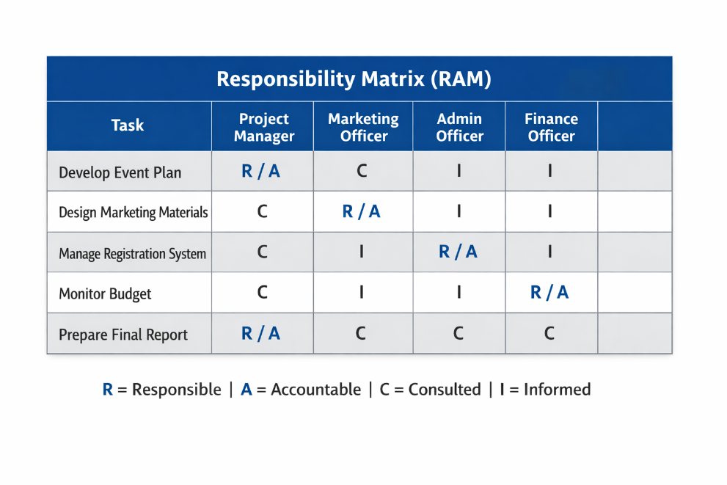

Resource Hours and Cost Estimation
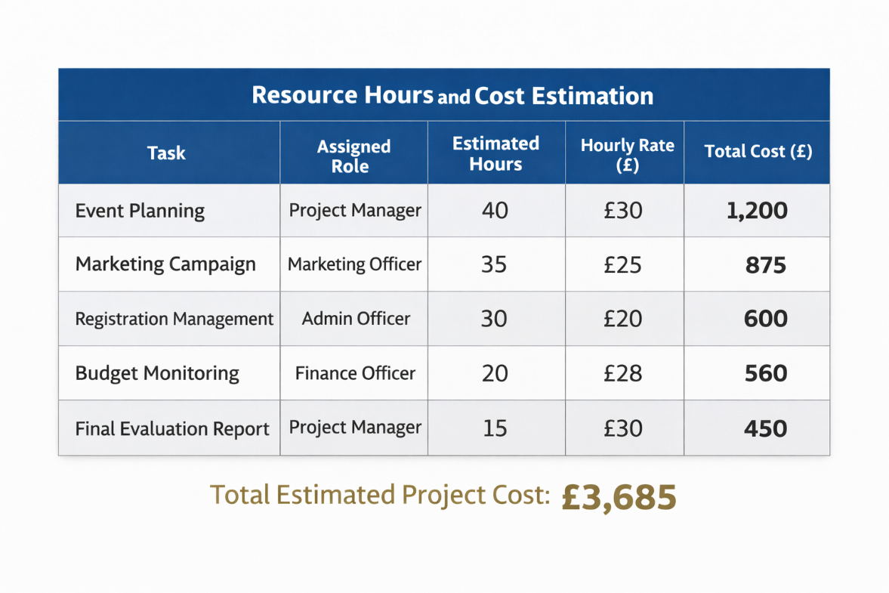

Conclusion
In summary, following common principles of project management, the charity marathon has been organized as a formal project. The goal, SMART objectives, scope boundaries, deliverables, way of engaging with stakeholders, Work Breakdown Structure (WBS), milestones, and resources allocated all illustrate the systematic planning and control elements of the project. An effective structure for stakeholder alignment as well as financial estimation and responsibility matrices add to accountability and transparency as well. The incorporation of recognised frameworks, such as those endorsed by the Project Management Institute (PMI, 2021) and Kerzner (2017), enhances the probability of successfully completing the marathon given the time, cost, and quality constraints set forth, as well as successfully delivering fundraising and engaging the community.

References (Harvard Style)
Doran, G.T. (1981) ‘There’s a S.M.A.R.T. way to write management’s goals and objectives’, Management Review, 70(11), pp. 35–36.
Freeman, R.E. (1984) Strategic management: A stakeholder approach. Boston: Pitman.
Getz, D. and Page, S.J. (2016) Event studies: Theory, research and policy for planned events. 3rd edn. London: Routledge.
Kerzner, H. (2017) Project management: A systems approach to planning, scheduling, and controlling. 12th edn. Hoboken: Wiley.
Lock, D. (2020) Project management. 11th edn. London: Routledge.
Maylor, H. (2010) Project management. 4th edn. Harlow: Pearson.
Mendelow, A.L. (1991) ‘Stakeholder mapping’, Proceedings of the 2nd International Conference on Information Systems, pp. 407–428.
Meredith, J.R., Mantel, S.J. and Shafer, S.M. (2017) Project management: A managerial approach. 9th edn. Hoboken: Wiley.
Project Management Institute (PMI) (2021) A guide to the project management body of knowledge (PMBOK® Guide). 7th edn. Pennsylvania: PMI.
Turner, J.R. (2014) Handbook of project-based management. 4th edn. New York: McGraw-Hill.

