

BMSW4005 Professional Career Development

Skill, Knowledge, and Experience: The Everlasting Keys to Success in the Workplace.

Module: PROFESSIONAL CAREER DEVELOPMENT
Module code: BMSW4005
Lecture Name: AFZAL MUNNA
Assignment Title: PROFESSIONAL CAREER DEVELOPMENT Task 2 – Report (2,000 words)
Student Number: 2023024
Student Name: MARIA VITOROI

TABLE OF CONTENTS

INTRODUCTION 3
KOLB LEARNING STYLE 3
GIBBS REFLECTIVE CYCLE 4
PESONAL DEVELOPMENT PLAN 6
ROLE- PLAYING 7
CONCLUSION 8
REFERENCES 9
APPENDIX 10

INTRODUCTION
The requirements of the twenty-first century differ from those of the past. People must be prepared for the rapid changes that are occurring because of technology, and they must adapt to new conditions, cultivate new skills, and be more flexible to achieve the goals they set.
In an increasingly dynamic and competitive socioeconomic, cultural, and work environment, providing students with theoretical and practical knowledge is insufficient. Rather, as Pollit (2001) points out, there is a need to develop a more flexible workforce capable of adapting to changing conditions, being accountable, and thinking for itself. According to Mckenna et al. (2009), reflexive learning is a method that leads to reflection on all sources of knowledge that can contribute to understanding a situation, including personal sources and experiences. According to Colomera et al. (2013), reflective learning methodology encourages critical thinking and analysis of students' potential, proposing both improvement strategies and new strategies for overcoming problems that arise during the learning process. According to their findings, this appears to assist students in identifying their own learning needs as well as better understanding how they may value future learning.
What exactly is reflection?
The goal of reflection is to comprehend what is already known and to incorporate new information, resulting in knowledge, new meaning, and a higher level of comprehension (Moon, 2004). Reflection, according to Boud, Keogh, and Walker (1985), is a conscious gaze and thought about experiences, actions, emotions, feelings, and reactions, followed by interpretation in order to learn from them. On reflection, both authors' descriptions are similar. It is a deliberate and systematic approach to reflecting on experiences with the goal of learning and changing behaviour. Reflection should challenge a person's understanding of themselves, their attitudes, and their behaviour in order to expose any prejudices, allowing that person to become more critical of their practise and world views (Jasper & Rolfe, 2011).

KOLB LEARNING STYLE
Kolb (1984) defines learning as having four stages: concrete experience, reflective observation, abstract analysis, and active experimentation.

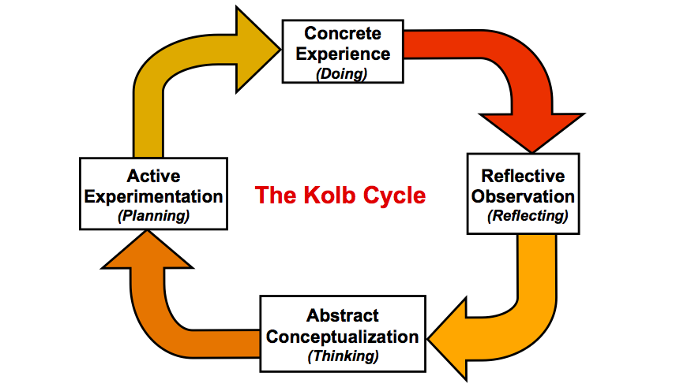
According to Kolb (1984), learning is an integrated process in which each stage supports and feeds the next. You can enter the circle at any point and walk it logically.
Individual differences in learning approaches based on individual preference for using a combination of these dialectical modes are referred to as learning styles. Divergent, assimilative, convergent and adaptive learning styles are the four main types. Divergent students prefer specific experience and contemplative observation, while assimilated students prefer abstract conceptualization and contemplative observation. Convergent formulas are based on abstract concept and active experimentation, while adaptive formulas are based on active experimentation and concrete experience.
The stability and endurance of these dynamic states is determined not only by an individual's genetic traits or characteristics, but also by the demands of their environment. The way we respond to each new event influences our choices and decisions, which in turn influence the events we encounter in the future (Kolb, 1984: 63–64). The environment in which this process of self-creation takes place is heavily influenced by culture.

GIBBS REFLECTIVE CYCLE
One of the most well-known cyclical models of reflection, it guides you through six stages of delving into an experience: description, feelings, evaluation, analysis, conclusion, and action plan.
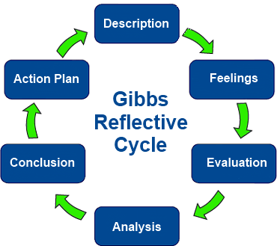
1. Describe. The therapist describes what occurred.
2. Emotions Thoughts and feelings that occurred at the time and were later explored
3. Evaluation An analysis is carried out in the form of identifying what was positive and challenging about the experience.
4. Examine. This analysis entails attempting to make sense of the situation and recognising the impact it had on the therapist's professional practise.
5. Finally, Literature is searched, and colleagues are consulted at this time (though it can happen at any point in the cycle) to better understand the situation and determine what else could have been done.
6. Action plan. A future action plan is developed, outlining alternative approaches in the event that this or a similar situation arises in the future.
In 1988, Graham Gibbs developed the Gibbs Reflex Circle to structure experience-based learning. It provides a framework for learning, and because it is cyclical, it is especially suited for repetitive experiences, allowing you to learn and plan based on what went well or bad.
This model is a good way to get out of a predicament. This could be a single event or a recurring situation, such as meeting with a team that you need to work with. Gibbs initially advocated its use in repetitive situations, but these steps and principles also apply to individual experience. When launched as a stand-alone activity, the action plan can be broadened, and you can see how to implement your findings in the future.
These cycles can be used to analyse and reflect on a situation, habit, practice, or method of service. Models can be used at different times for convenience or deeper reflection. Both emphasize the importance of reading the literature and discussing the situation with other people, who may be colleagues, service users, managers, or family and friends. According to Mann et al. (2009), one of the most influential elements for developing meditation is guidance and feedback from supportive peers.

PESONAL DEVELOPMENT PLAN
A Personal Development Plan (PDP) is a type of self-evaluation and self-reflection tool that is widely used in higher education and the workplace. It can, however, be a beneficial exercise in your love life.
"Any road to success must begin with a plan," says Fiona Tasker, a dermatologist in London. A Personal Development Plan (PDP) will assist you in identifying learning needs as well as personal aspirations and outlining ways to achieve them. There are three main parts:
"First, assess your learning requirements and establish SMART goals (specific, measurable, achievable, relevant, and time-bound)." When deciding on your goals, try to choose areas that interest you, preferably ones that you enjoy, as you will be more likely to devote yourself to and enjoy the tasks. Include a deadline for achieving your objectives. If you're having trouble identifying areas for improvement, talk to your supervisor or consider starting a peer support group to promote and improve reflective learning and goal setting.
"Then make a list of training activities that will assist you in reaching your objectives."
"For example, attending classes, conferences, and meetings, or completing e-learning modules, or learning from seniors or peers."
Finally, consider how you will demonstrate that you have met your objectives. This can be achieved through reflections, course modules or eLearning certificates, diary, grades or comments.
After you've completed these three steps, consider how effective your PDP has been and whether there are any areas that haven't been addressed or haven't worked. Learning must be driven by reflection, and your completed PDP should serve as a foundation for future plans."
"A personal development plan is a dynamic and structured process of nurturing skills," says Mano Manoharan, a consultant perinatal psychiatrist at the South London and Maudsley NHS Trust. It is about reflecting on your current learning and performance and making future plans. It provides direction and is necessary at all stages of a career.

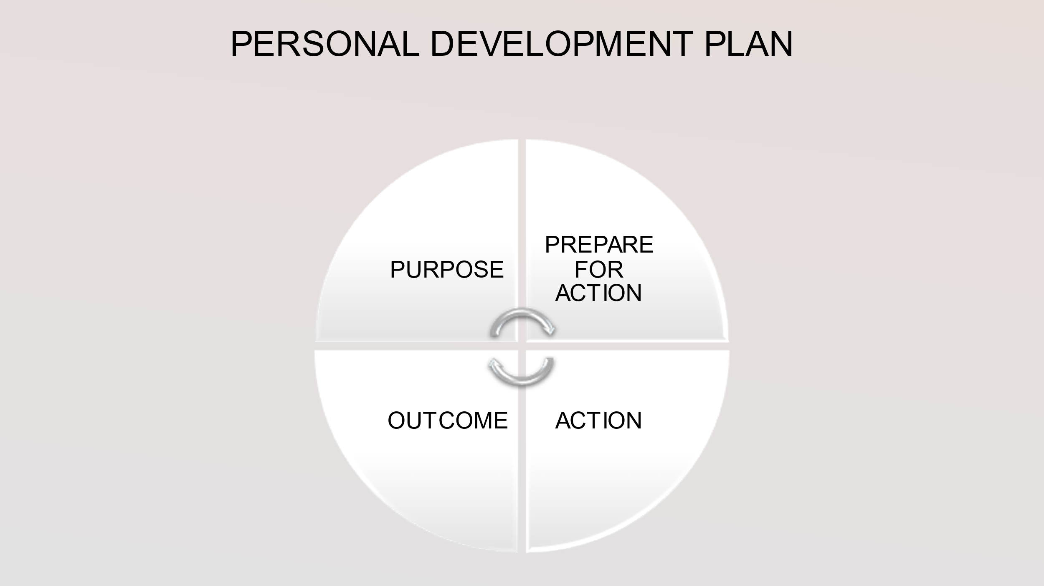
For example, my personal development plan (PDP) starts with the purpose and then moves on to the actions. I intend to put in a lot of effort to achieve this goal. Then comes what you did because of these actions, which I eagerly anticipated, and finally the outcome.
So, my goal is to advance professionally. I will obtain the CHE for the Workplace for this purpose. I intend to gain new skills, broaden my knowledge, gain more experience, and further my studies in Finance and Accounting.
Action- I am currently enrolled in courses at UWTSD to obtain the CHE in workplace skills, such as writing assignments and creating Power Point presentations, Role Play, communicating with new people, and reading books to expand my vocabulary.
Outcome-I received an excellent study environment and learning outcome. As a result, I now have new skills, such as being more patient and properly organising my time. I've seen how I've grown in technology, and by that, I mean that I now know how to use my computer to find reliable sources, and of course, I've learned the process of online learning.
Setting short- and long-term SMART goals requires a high level of self-awareness in order to identify and address any skill gaps. They can, however, demonstrate how an individual considers and perceives their own working environment, as well as their ability to comprehend the changes that are occurring.
The search for new information and how that information is then used to develop an individual's own skills and knowledge base will be critical components.
PDPs, while a written document, demonstrate an intellectual approach to development, and reflection on learning experiences is essential if they are to become a dynamic action plan. A well-planned PDP can serve as the foundation for a successful and fulfilling career.

ROLE- PLAYING
Role-playing is an experiential learning activity in which participants assume roles and experience the consequences of their own and others' actions (van Ments, 1999). Role-playing has been shown to be effective in achieving learning outcomes in the domains of affective, cognitive, and behavioural learning (Rao & Stupans, 2012). Role-playing was extremely beneficial "because if I want to work here, I need to learn how to handle this type of interview." Role-playing can also elicit feelings of anxiety, rejection, and personal failure (Tomkins & Ulus, 2016). It is difficult, if not impossible, to predict how much emotional reaction an experience-based learning activity will elicit (Gilmore & Anderson, 2011).
As a result, when instructors dive into role-playing without adequate preparation and knowledge of potential pitfalls, they can quickly become tossed around in the waves of emotional reactions.
Role play simulation contributes to the development of confidence or conviction in individuals that they can practise their professions, as well as to the development of professional identity.
The practise of effective communication skills and concepts through role play simulations aided in the integration of their newly acquired skills and approaches into a variety of settings, including the workplace. Learning transfer from the classroom to personal life was a common occurrence.
Moving forward with role-playing will require courage and determination as I learn to deal with emotions, uncertainty, and loss of control in the classroom.
To begin, I must follow the steps for creating a welcoming learning environment. Furthermore, I need to improve my ability to learn through emotions while also dealing with my emotional reactions.

CONCLUSION
When I looked back on myself before starting the university programme, I noticed that I had met several of the goals I had set for myself. Some skills existed, such as time management, respect, listening, and honesty. However, because of the programme, I grew as a person, learning new skills such as patience and becoming more familiar with technology. The most difficult challenge I faced was adapting to online learning, knowing the fundamentals of computers, and being faced with so many new things that I admit I was scared at first. Another challenge I faced was a lack of social relationships, as I am a social person who is unfamiliar with these new circumstances.
Problems, pain, distress, and uncertainty characterise work. There are many things to learn and many mistakes to make, so becoming a skilled and experienced worker cannot exist without challenges and disappointments. However, we must never stop broadening our horizons, remaining open-minded, evolving, and expanding our knowledge. The world around us is changing at a rapid pace, and people must constantly evolve and adapt; after all, as Charles Darwin stated, "it is not the strongest species, nor the most intelligent, but the most adaptable to change that survive."

REFERENCES
Colomera, J., Pallisera, M., Fullana, J., Burriel, M. P. and Fernández, R., 2013. Reflective Learning in Higher Education: A Comparative Analysis. Procedia - Social and Behavioral Sciences. October, vol. 93, pp. 364-370.
Ellwood, Fiona (2011). Understanding the importance of a personal development plan. Dental Nursing, 7(3), 160–163. doi:10.12968/denn.2011.7.3.160

Gibbs G (1988). Learning by Doing: A guide to teaching and learning methods. Further Education Unit. Oxford Polytechnic: Oxford. Published (11 Nov 2020)
McLeod, S. A. (2017, October 24). Kolb - learning styles and experiential learning cycle. Simply Psychology.
Pollit, D., 2001. A flexible workforce for the modern economy; the role of education and training. Education and Training. Vol. 43, No. 7, pp. 345‐376.
Paterson, Colin; Chapman, Judith (2013). Enhancing skills of critical reflection to evidence learning in professional practice. Physical Therapy in Sport, 14(3), 133–138.
Rimmer, Abi (2018). How do I prepare a personal development plan?. BMJ, (), k4725–. doi:10.1136/bmj.k4725
Simy Joy; David A. Kolb (2009). Are there cultural differences in learning style?.33(1), 69–85
Taylor, Vicki Fairbanks (2018). Afraid of the Deep: Reflections and Analysis of a Role-Play Exercise Gone Wrong. Journal of Management Education, (), 105256291880287–. doi:10.1177/1052562918802875

APPENDIX





